Add links that could be useful for the project

GOOGLE MAPS API

Set the map boundary

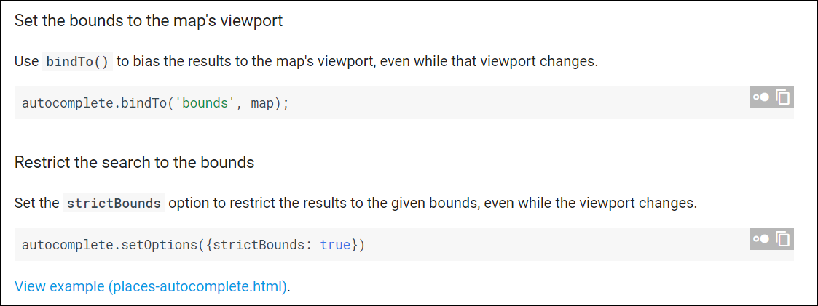

<https://developers.google.com/maps/documentation/javascript/places-autocomplete>