class4.R

louis

2024-01-23

#My first R script  
  
x <- 1:50  
plot(x, sin(x))

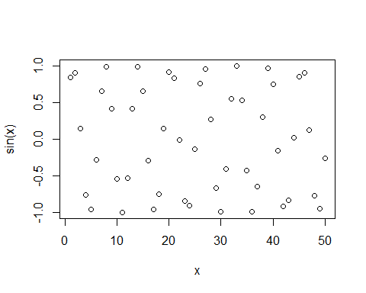

plot(x, sin(x), type="l") #change type of plot to line

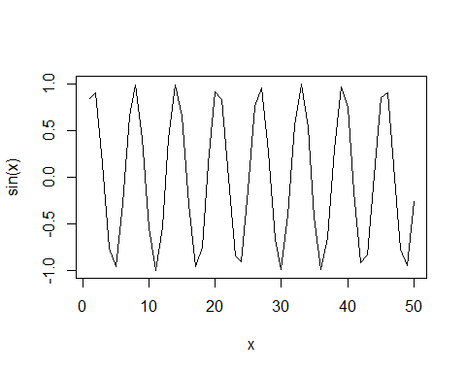

plot(x, sin(x), type="l", col = "blue") #change line color to blue

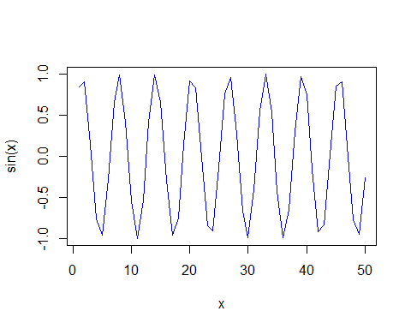

plot(x, sin(x), type="l", col = "blue", lwd = 2) #change thickness of line

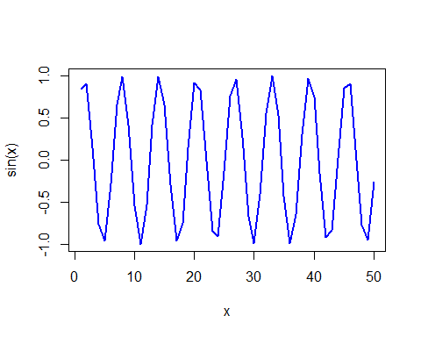

plot(x, sin(x), type="l", col = "blue", lwd =2, xlab="HELLO") #change axis title

