Data Mining Project (40 pts)

Data mining is the process of sorting through large amounts of data and picking out relevant
information. It is usually used by business intelligence organizations, and financial analysts, but is
increasingly being used in the sciences to extract information from the enormous data sets generated
by modern experimental and observational methods.
You have a file table.csv, which is a file with Google stock prices.
A csv file stands for "comma separated values".
This means that values in the file are separated by comma.
If you were to open it in notepad++ it looks like:
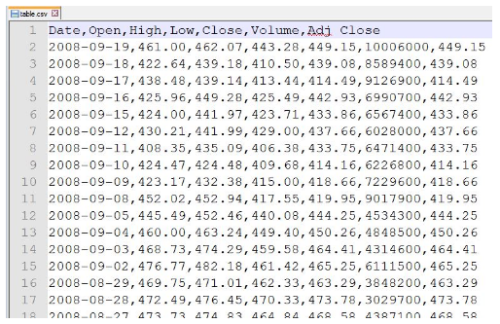
If you open this file in Excel, it looks like this:
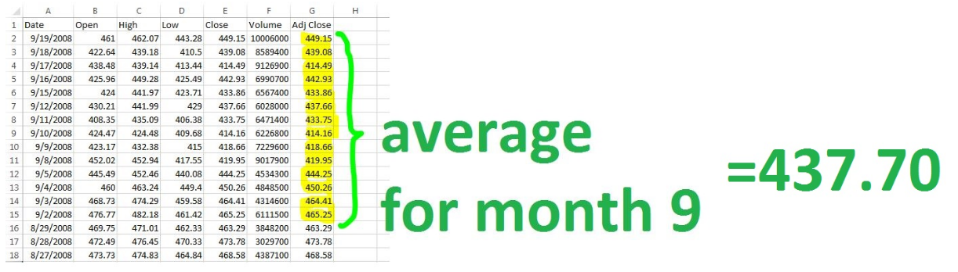

Write a python 3.* (not any version python 2.*) program to calculate the average for each month of every year, using the template below:

#name: get_data_list
#param: FILE_NAME - the file's name you saved for the stock's prices
#brief: get a list of the stock's records' lists
#return: a list of lists
def get_data_list (FILE_NAME):
return

#name: get_monthly_averages
#param: data_list - the list that you will process
#brief: get a list of the stock's monthly averages and their corresponding dates
#return: a list
def get_monthly_averages (data_list):
return

#name: print_info
#param: monthly_average_list - the list that you will process
#brief: print the top 6 and bottom 6 months for Google stock
#return: None

def print_info (monthly_average_list):
return

# call get_data_list function to get the data list, save the return in data_list

# call get_monthly_averages function with the data_list from above, save the
# return in monthly_average_list

# call print_info function with the monthly_average_list from above
You will calculate the averages for every month, store them in a list, and then show the list to the user:
monthly_average_list[ 0] = ['Month', 'Year', 'Average']
monthly_average_list[ 1] = ['09', '2008', '437.70']
monthly_average_list[ 2] = ['08', '2008', '485.91']
monthly_average_list[ 3] = ['07', '2008', '510.03']
monthly_average_list[ 4] = ['06', '2008', '556.32']
monthly_average_list[ 5] = ['05', '2008', '575.92']
monthly_average_list[ 6] = ['04', '2008', '497.58']
monthly_average_list[ 7] = ['03', '2008', '440.33']
monthly_average_list[ 8] = ['02', '2008', '503.80']
monthly_average_list[ 9] = ['01', '2008', '611.81']
monthly_average_list[10] = ['12', '2007', '695.40']
monthly_average_list[11] = ['11', '2007', '676.37']
monthly_average_list[12] = ['10', '2007', '635.39']
monthly_average_list[13] = ['09', '2007', '540.43']
monthly_average_list[14] = ['08', '2007', '509.83']
monthly_average_list[15] = ['07', '2007', '532.48']
monthly_average_list[16] = ['06', '2007', '515.02']
monthly_average_list[17] = ['05', '2007', '473.01']
monthly_average_list[18] = ['04', '2007', '472.50']
monthly_average_list[19] = ['03', '2007', '452.91']
monthly_average_list[20] = ['02', '2007', '467.22']
monthly_average_list[21] = ['01', '2007', '490.58']
monthly_average_list[22] = ['12', '2006', '473.50']
monthly_average_list[23] = ['11', '2006', '485.63']
monthly_average_list[24] = ['10', '2006', '440.53']
monthly_average_list[25] = ['09', '2006', '397.06']
monthly_average_list[26] = ['08', '2006', '377.09']
monthly_average_list[27] = ['07', '2006', '403.53']
monthly_average_list[28] = ['06', '2006', '393.59']
monthly_average_list[29] = ['05', '2006', '383.80']
monthly_average_list[30] = ['04', '2006', '413.78']
monthly_average_list[31] = ['03', '2006', '358.87']
monthly_average_list[32] = ['02', '2006', '370.00']
monthly_average_list[33] = ['01', '2006', '445.71']
monthly_average_list[34] = ['12', '2005', '418.95']
monthly_average_list[35] = ['11', '2005', '399.14']
monthly_average_list[36] = ['10', '2005', '322.47']
monthly_average_list[37] = ['09', '2005', '304.24']
monthly_average_list[38] = ['08', '2005', '286.92']
monthly_average_list[39] = ['07', '2005', '298.21']
monthly_average_list[40] = ['06', '2005', '287.55']
monthly_average_list[41] = ['05', '2005', '239.71']
monthly_average_list[42] = ['04', '2005', '199.21']
monthly_average_list[43] = ['03', '2005', '181.16']
monthly_average_list[44] = ['02', '2005', '195.01']
monthly_average_list[45] = ['01', '2005', '192.85']
monthly_average_list[46] = ['12', '2004', '181.77']
monthly_average_list[47] = ['11', '2004', '177.50']
monthly_average_list[48] = ['10', '2004', '153.23']
monthly_average_list[49] = ['09', '2004', '113.23']

