Python Files, Sunspots
Write a program which reads the data from sunspots.txt :
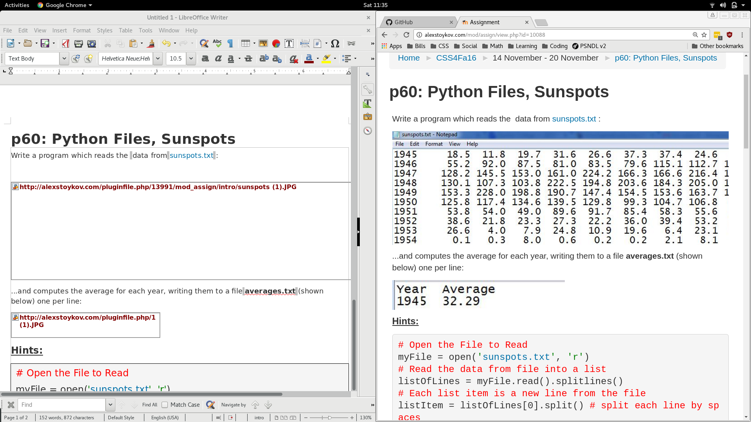
...and computes the average for each year, writing them to a file averages.txt (shown below) one per line:
Hints:
# Open the File to Read
myFile = open('sunspots.txt', 'r')
# Read the data from file into a list
listOfLines = myFile.read().splitlines()
# Each list item is a new line from the file
listItem = listOfLines[0].split() # split each line by spaces
print(listItem) # shows list of strings ['1945','18.5','11.8',...,'28.4']
# Convert each of the strings to float in order to do math with them!
# to cast a string '18.5' into an float 18.5 use
float('18.5')
Some more hints:
# how to make an empty list
newList = []
# how to fill the list with 10 numbers
for i in range (0,10):
newList.append(i)
# how show the 10 numbers from that list
for i in range(0, len(newList)):
print(newList[i])

