Case Study Report

Testing the Functionality, Security, and Usability
of the Social Media Platform "Reddit"

Submitted by:
Delos Santos, Crisshane Mirr Hillary M.,
Talagtag, Jefferson M.

Submitted to:
IS 123 System Quality Assurance
Bachelor of Science in Information System
Camarines Norte State College

May 19, 2025

1. Introduction

Reddit is a social media platform where users engage in discussions, share content, and participate in communities ("subreddits") tailored to specific topics. Launched in 2005, Reddit hosts over 100,000 active subreddits and 430 million monthly users as of 2024. The platform supports text posts, images, videos, and polls, with features like upvoting/downvoting, awards, and moderation tools.

1.1 Test Environment
Component | Details
Platform | Windows 11 (Web Browser)
Network | 5GHz Wi-Fi
Test Account | Free-tier user account
Monitoring Tools | Manual observation, browser developer tools

2. Objectives
- Validate core functionalities (posting, voting, moderation).
- Test security measures (authentication, data privacy, session management).
- Assess usability across critical user journeys.
- Identify and document bugs or performance issues.

3. Functional Testing
3.1 User Stories (15)
- As a new user, I want to create a Reddit account to join communities.
- As a user, I want to post a text submission in a subreddit to share my thoughts.
- As a user, I want to upvote a comment to support meaningful contributions.
- As a moderator, I want to remove a rule-breaking post to maintain community guidelines.
- As a user, I want to join a subreddit to stay updated on specific topics.
- As a user, I want to edit my profile bio to personalize my account.
- As a user, I want to send a direct message to communicate privately with others.
- As a user, I want to report a post for spam to help moderators enforce rules.
- As a user, I want to sort posts by "Hot" or "New" to customize my feed.
- As a security-conscious user, I want to enable Two-Factor Authentication (2FA) to protect my account.
- As a content creator, I want to stream a live video to engage with my audience.
- As a user, I want to search for subreddits by keyword to discover new communities.
- As a moderator, I want to configure AutoModerator rules to automate post filtering.
- As a user, I want to view my post history to track my activity.
- As a user, I want to log out of all sessions to secure my account after using a shared device.

3.2 Test Case Summary (15)

Test Case ID | Description | Expected Result | Actual Result | Status
TC01 | Create account | Account created | Account created successfully | Pass
TC02 | Post text in r/Test Community | Post visible | Post published instantly | Pass
TC03 | Upvote a comment | Vote count increases | Count increased by 1 | Pass
TC04 | Moderator removes post | Post removed | Post deleted, user notified | Pass
TC05 | Join r/Technology | Subreddit added to profile | Joined list updated | Pass
TC06 | Edit profile bio | Bio updated | Changes saved | Pass
TC07 | Send DM | Message delivered | DM received by recipient | Pass
TC08 | Report post | Report submitted | Moderator queue updated | Pass
TC09 | Sort posts by "New" | Chronological order | Posts sorted correctly | Pass
TC10 | Enable 2FA | 2FA confirmation | Setup successful | Pass
TC11 | Stream live video | Smooth playback | Buffering and audio lag | Fail
TC12 | Search for "Programming" | Relevant results | Accurate subreddits listed | Pass
TC13 | Configure AutoModerator | Rule applied | Rule triggered for test post | Pass
TC14 | View post history | History loads quickly | Loaded in 4 seconds | Pass
TC15 | Log out from all devices | Sessions terminated | All sessions ended | Pass

3.3 Observation
- TC11 (Live Streaming): Frequent buffering and audio desynchronization during peak traffic.
- All other test cases met expectations.

4. Exploratory Testing

4.1 User Stories (15)
- As a user, I want to test cross-platform sync (mobile ↔ desktop) to ensure seamless access.
- As a user, I want to recover a deleted post in case of accidental removal.
- As a privacy-focused user, I want to use Reddit in incognito mode to avoid session persistence.
- As a visually impaired user, I want to test accessibility features (screen reader) to navigate the platform.
- As a participant, I want to handle a high-traffic AMA session without performance issues.
- As a user, I want to block another account to avoid unwanted interactions.
- As a multi-account user, I want to switch between accounts seamlessly.
- As a third-party app user, I want to test integration with Apollo to ensure compatibility.
- As a parent, I want to verify NSFW content filtering to protect younger users.
- As a user, I want to test award gifting to appreciate valuable contributions.As a multi-device user, I want to use Reddit simultaneously on mobile and desktop to ensure consistent functionality.
- As a power user, I want to post content with special characters/emojis to test input validation.
- As a user, I want to encounter clear error messages for invalid actions (e.g., posting without internet).
- As a community member, I want the platform to handle viral content surges without crashing.
- As a social media enthusiast, I want to share Reddit posts to external platforms (e.g., Twitter) to verify integration.

4.2 Test Case Summary (15)
Test Case ID | Description | Expected Result | Actual Result | Status
ETC01 | Cross-platform sync | Posts synced | Sync delayed by few seconds | Pass
ETC02 | Recover deleted post | Post restored | No recovery option | Fail
ETC03 | Use incognito mode | No session persistence | Logged out after closing | Pass
ETC04 | Screen reader compatibility | Content read aloud | Dynamic content not read | Fail
ETC05 | High-traffic AMA | Stable performance | Server lag observed | Partial
ETC06 | Block user | Content hidden | Blocked user’s posts hidden | Pass
ETC07 | Switch accounts | Seamless transition | Transition Success | Pass
ETC08 | Third-party app integration | Posts load in Apollo | Integration functional | Pass
ETC09 | NSFW filter | Content blurred | Filter applied correctly | Pass
ETC10 | Gift award | Award displayed | Award delivered | Pass
ETC11 | Simultaneous device usage | Sync across devices | Profile data mismatched | Pass
ETC12 | Post with emojis/special chars | Post published with formatting | Emojis rendered as broken icons | Pass
ETC13 | Trigger invalid action | Clear error message displayed | Generic "Something went wrong" | Partial
ETC14 | Simulate viral traffic spike | Platform remains responsive | Delays in post loading | Fail
ETC15 | Share post to X | Link shared successfully | Redirect failed due to API limit | Fail

5. Security Testing

5.1 Security Check Summary
Area | Test | Result
Login Security | Brute-force attack | Account locked after 5 attempts
Data Privacy | Access saved posts | Encrypted and user-specific
Session Management | Token post-logout | Tokens invalidated immediately
Content Moderation | Spam bot detection | 90% flagged by AutoModerator

5.2 Tools Used
- Manual testing.
- Browser DevTools for cookie inspection.

6. Key Findings
6.1 Functional Issues
- Live streaming suffers from buffering and audio lag.
- Post recovery feature is unavailable.

6.2 Exploratory Issues
- Screen reader incompatible with dynamic content.
- No recovery option for deleted post.
- Delays in post loading when simulating traffic spike.
- Redirect failed due to API limit when sharing a post to X.
6.3 Security Issues
- AutoModerator missed 10% of spam test cases.

7. Recommendations
- Optimize live-streaming infrastructure for stability.
- Add a post recovery grace period.
- Enhance screen reader support for dynamic elements.
- Improve AutoModerator spam detection algorithms.

8. Conclusion
Reddit performs robustly in core functionalities and security, though improvements are needed in accessibility, live streaming, and moderation tools. Addressing these gaps will enhance user trust and platform reliability.

9. Documentations
9.1 Functional Testing
9.2 Exploratory Testing

ETC01
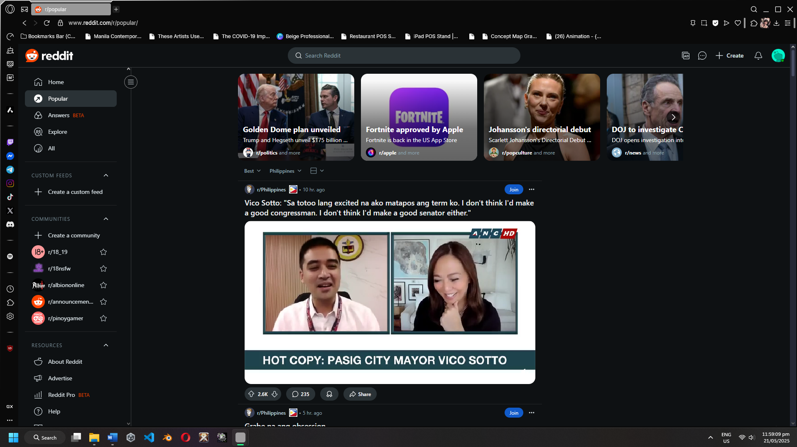
Figure 17: Cross-platform sync
ETCO2
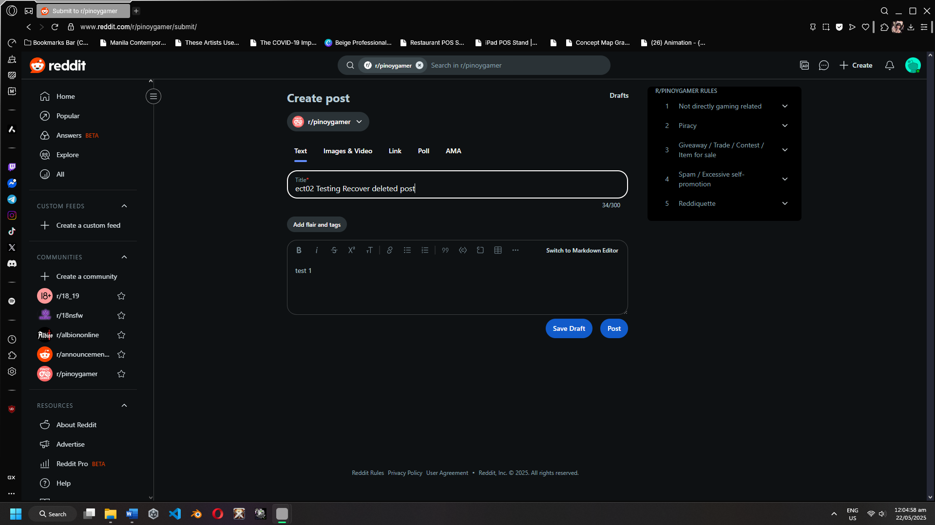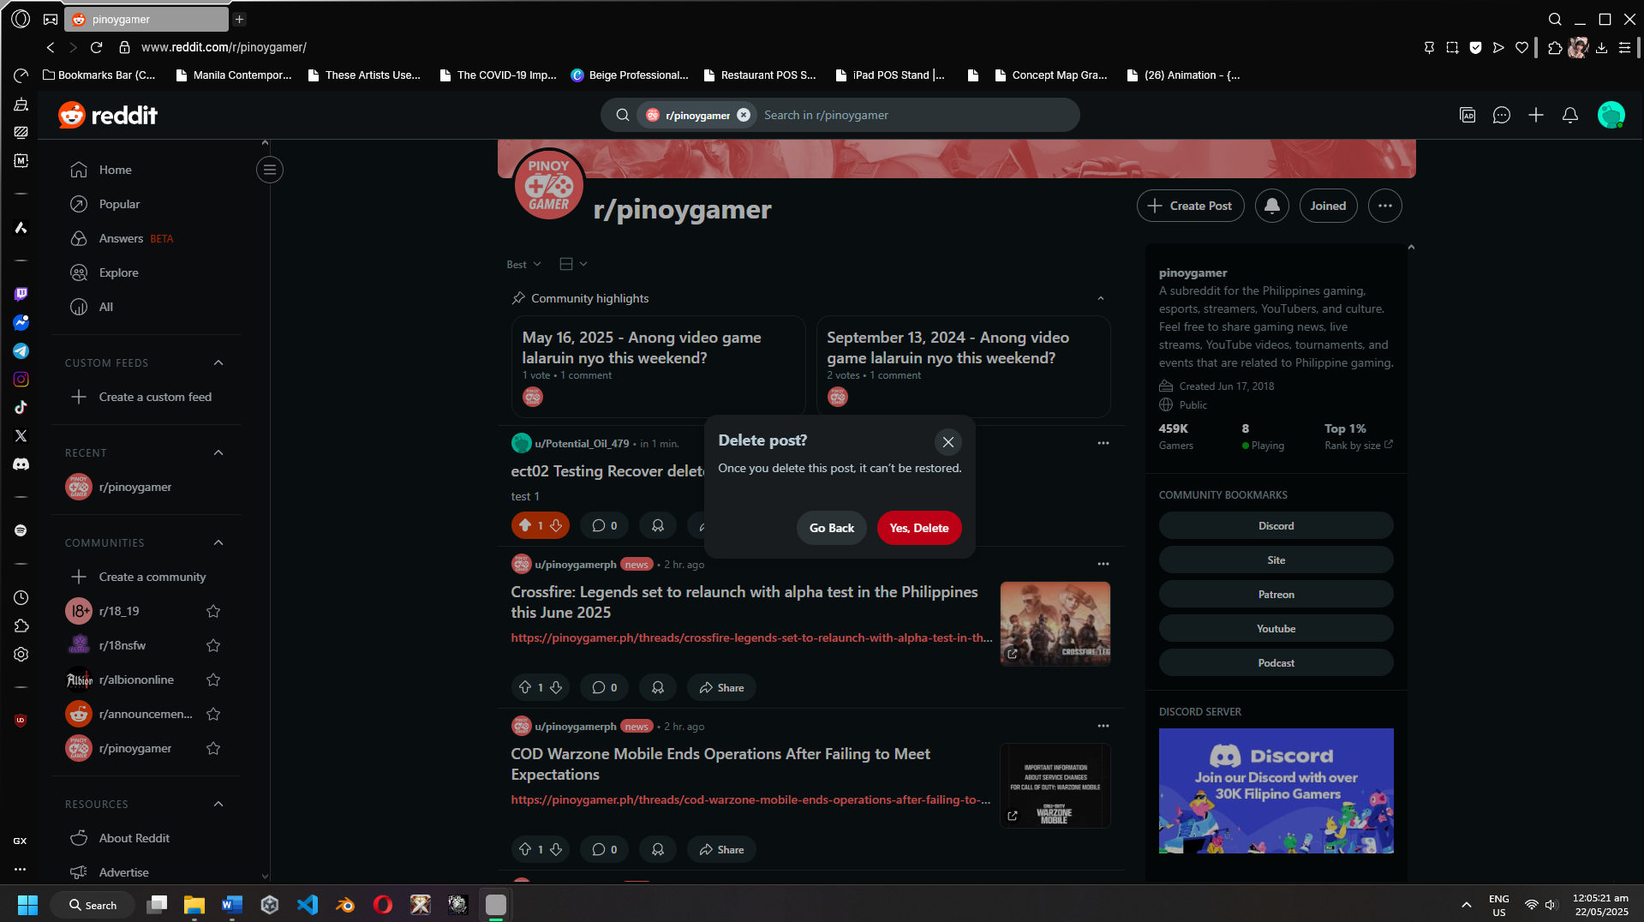
Figure 18: Posting Figure 19: Removing Post

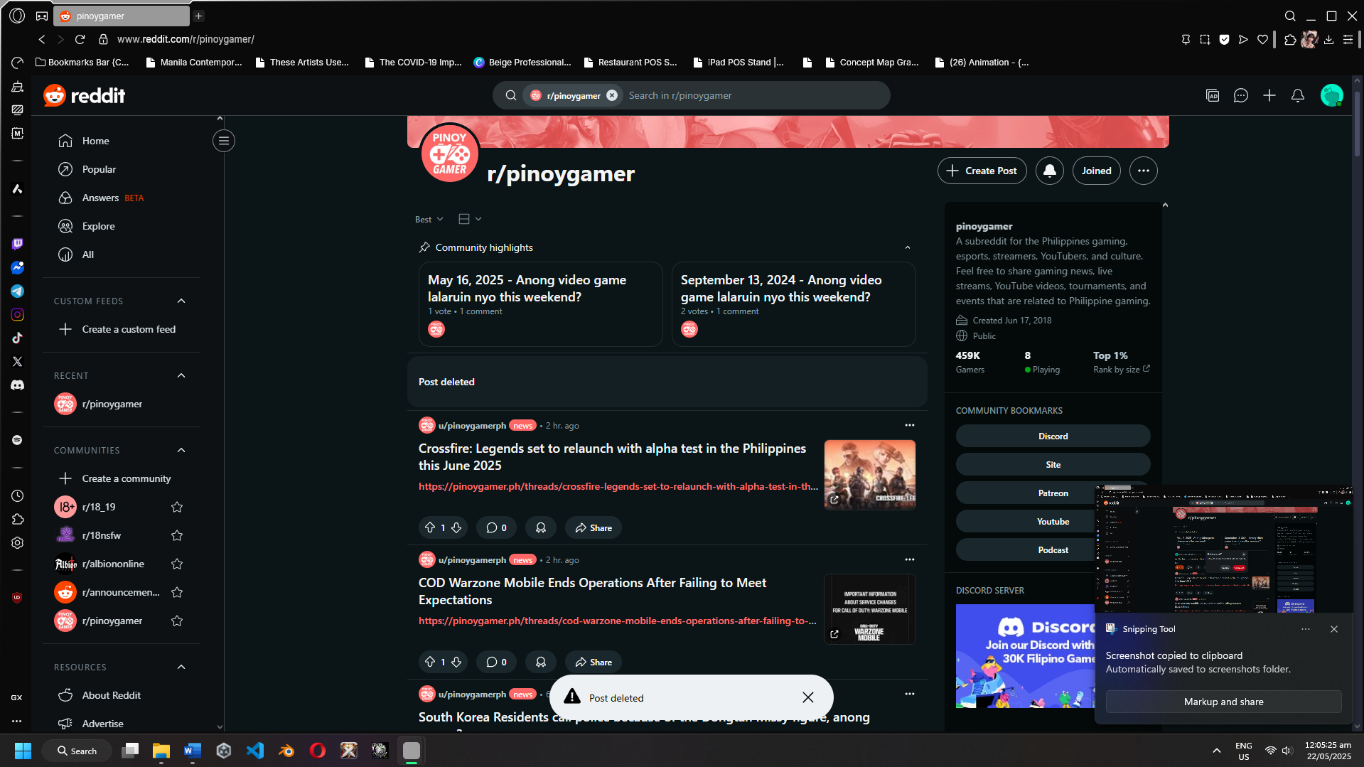
Figure 20: Post Deleted
ETC03
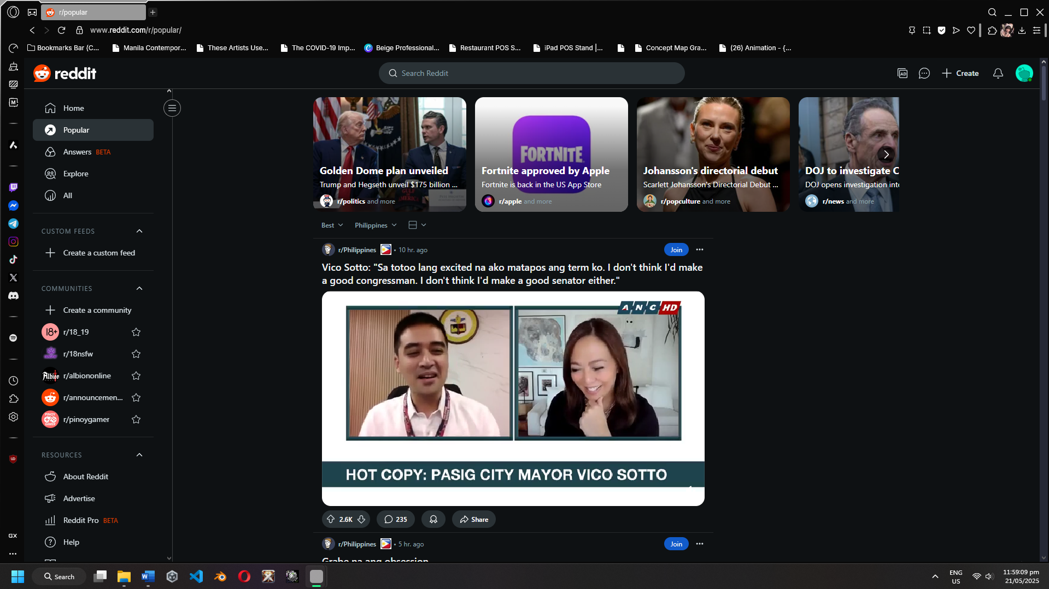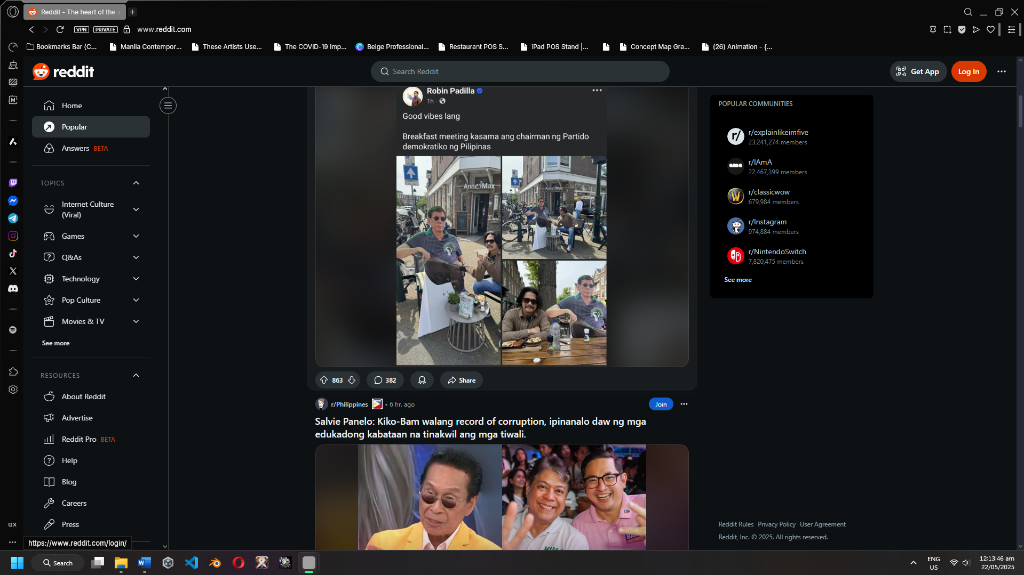
Figure 21: Incognito Loged in Figure 22: Session logged Out
ETC04
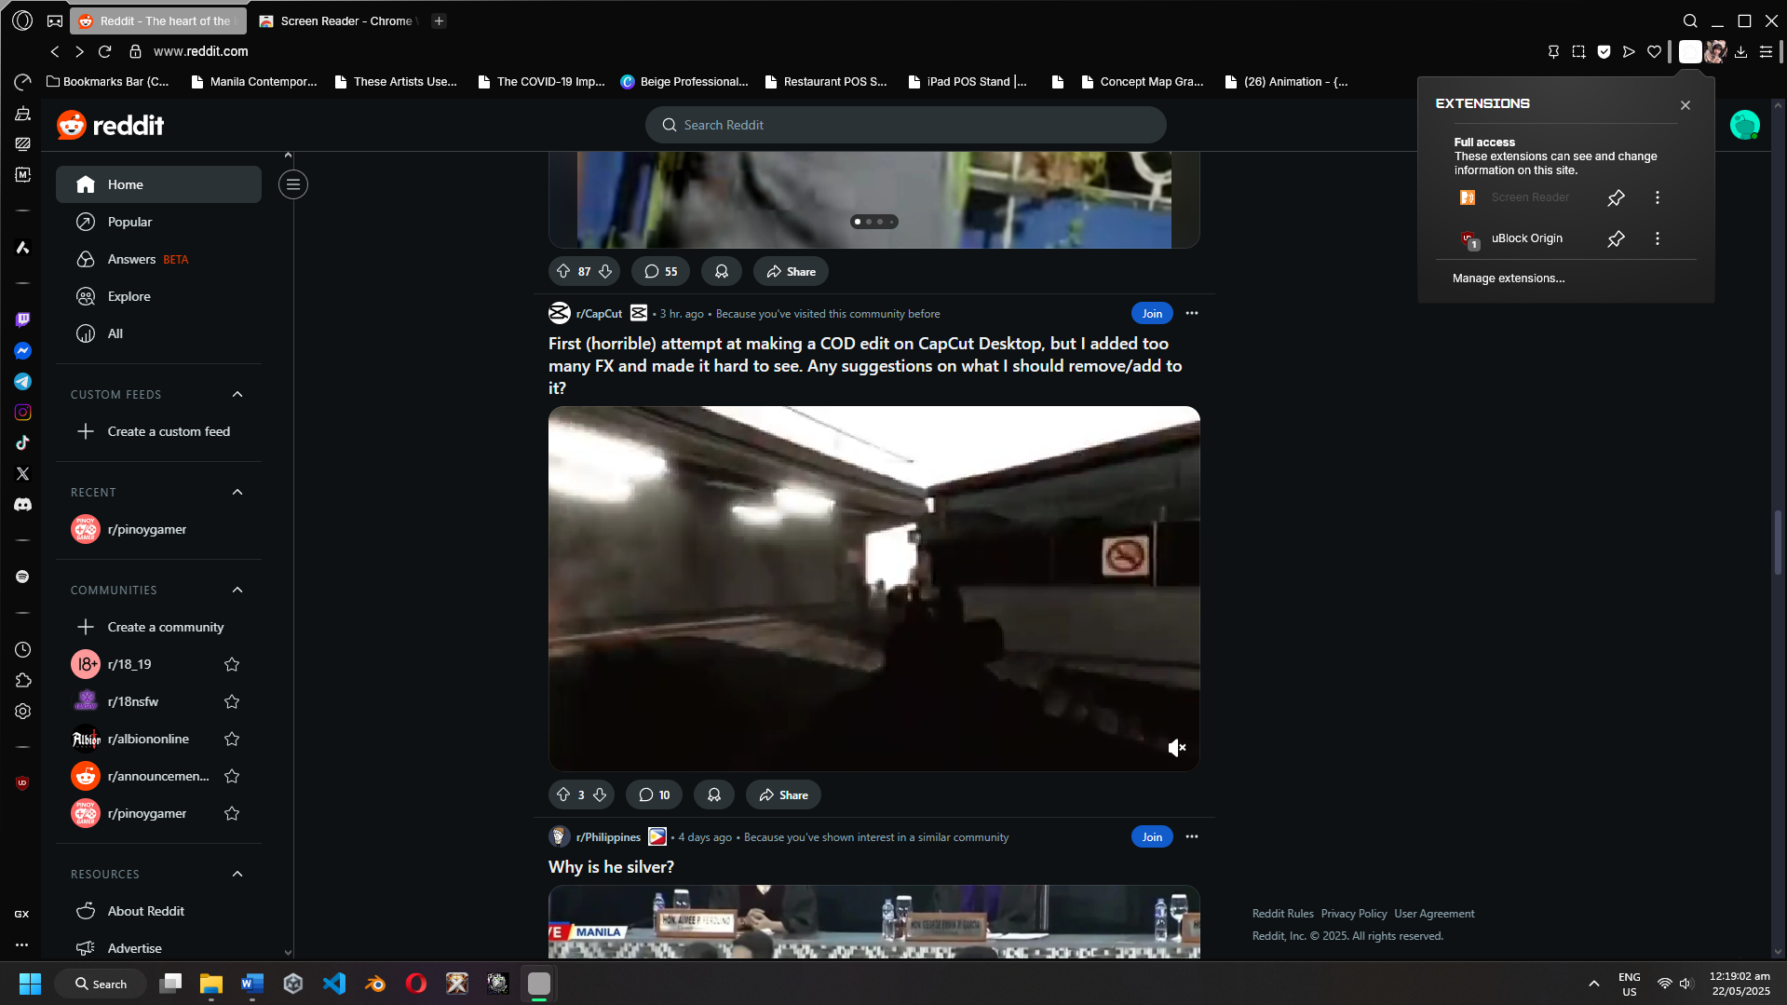
Figure 23: Screen Reader Compatibility
ETC05
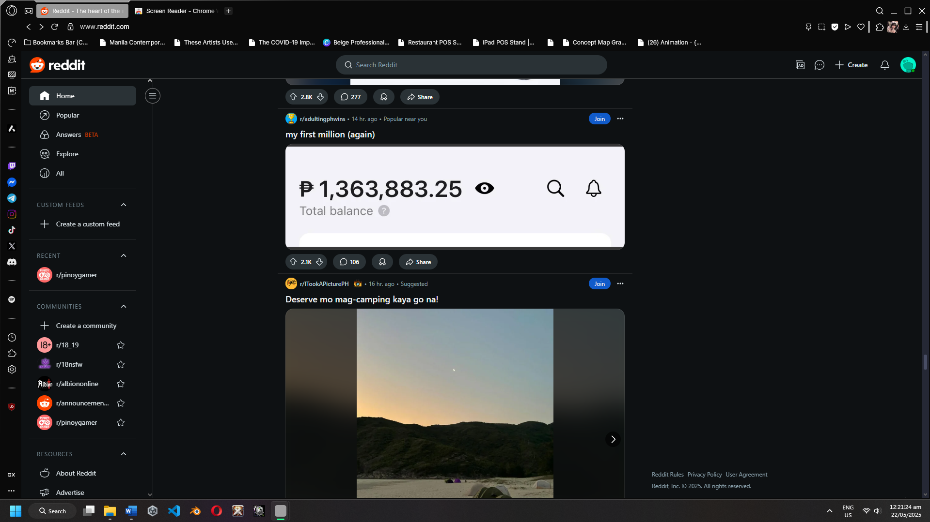
Figure 24: High-traffic AMA
ETC06
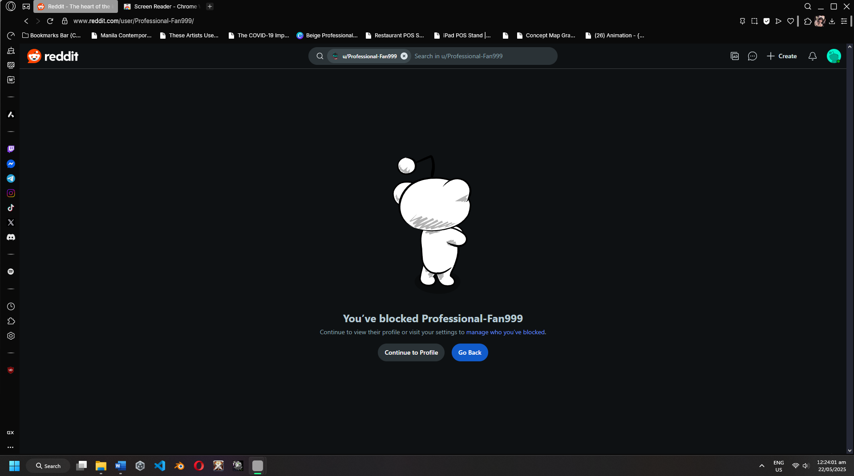
Figure 25: User Blocked
ETC07
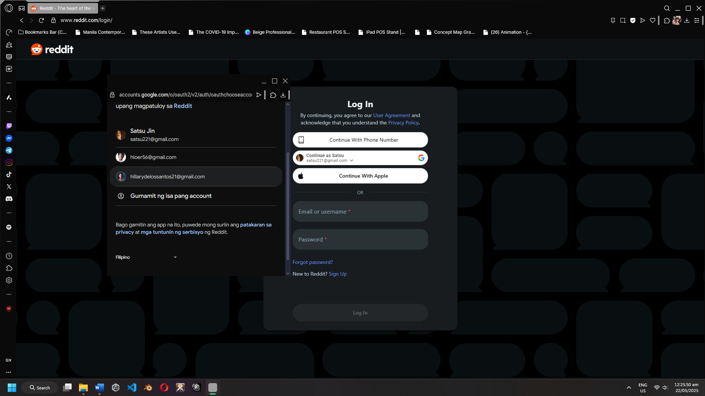
Figure 26: User Blocked
ETC08
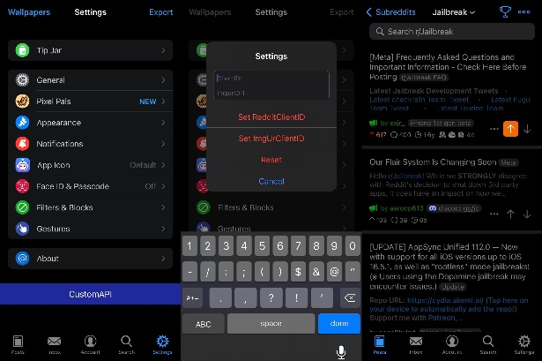
Figure 27: Third-party app integration
ETC09
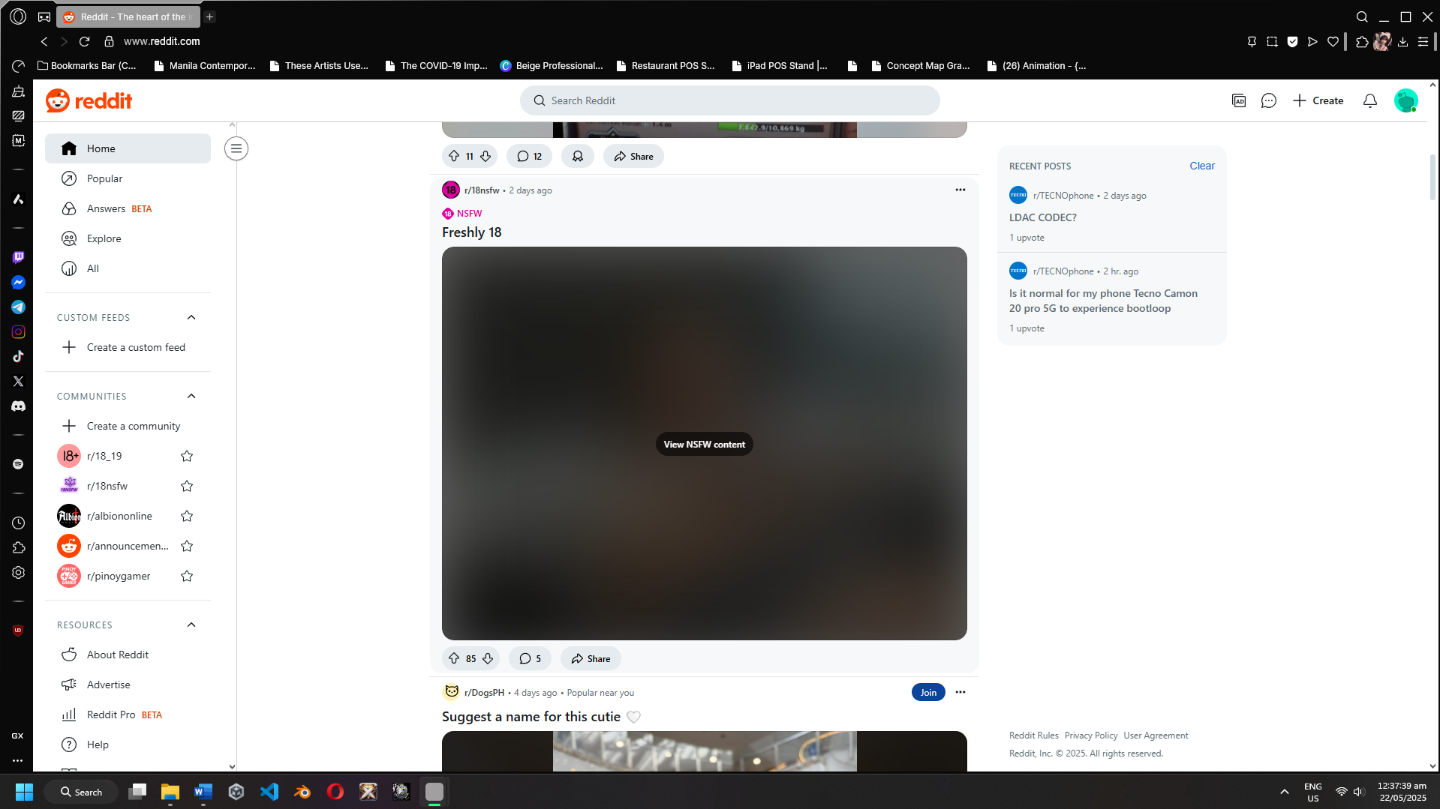
Figure 28: NSFW Filter
ETC10
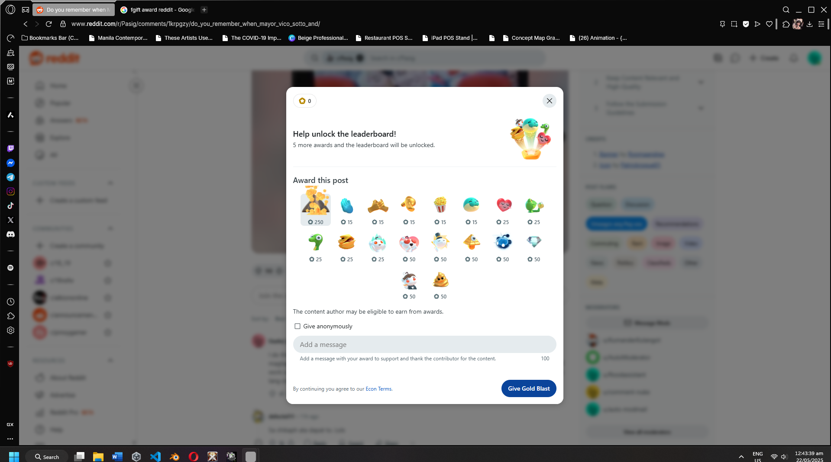
Figure 29: Gift Award
ETC11
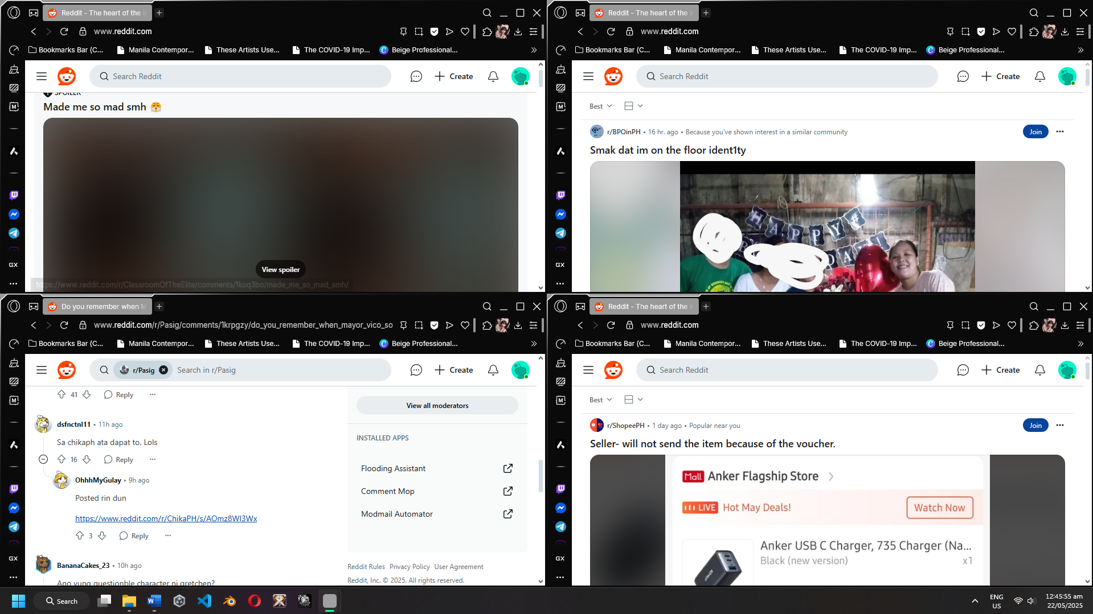
Figure 30: Simultaneous Usage
ETC12
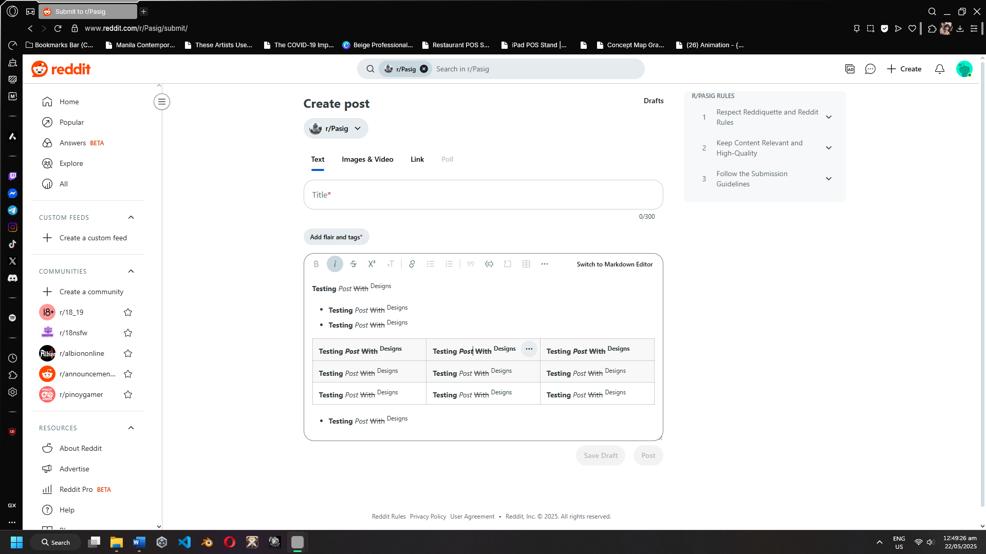
Figure 31: Post With Formatting
ETC13
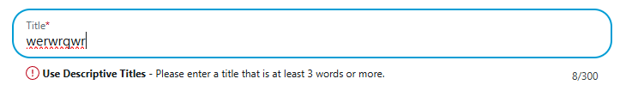
Figure 32: Trigger invalid action

ETC14
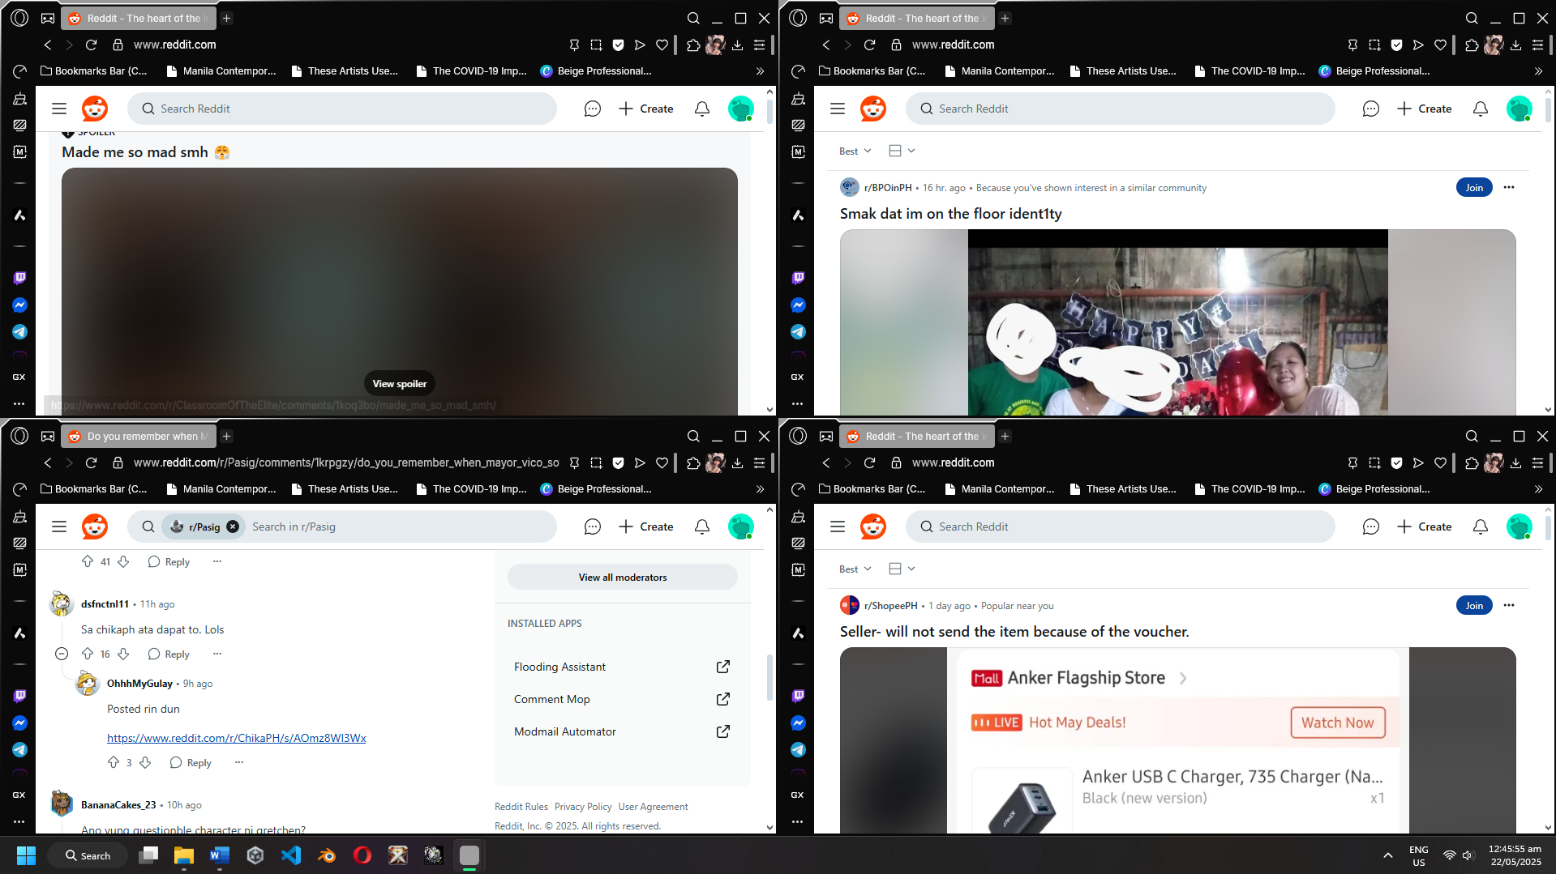
Figure 33: Simulating Traffic Spike
ETC15
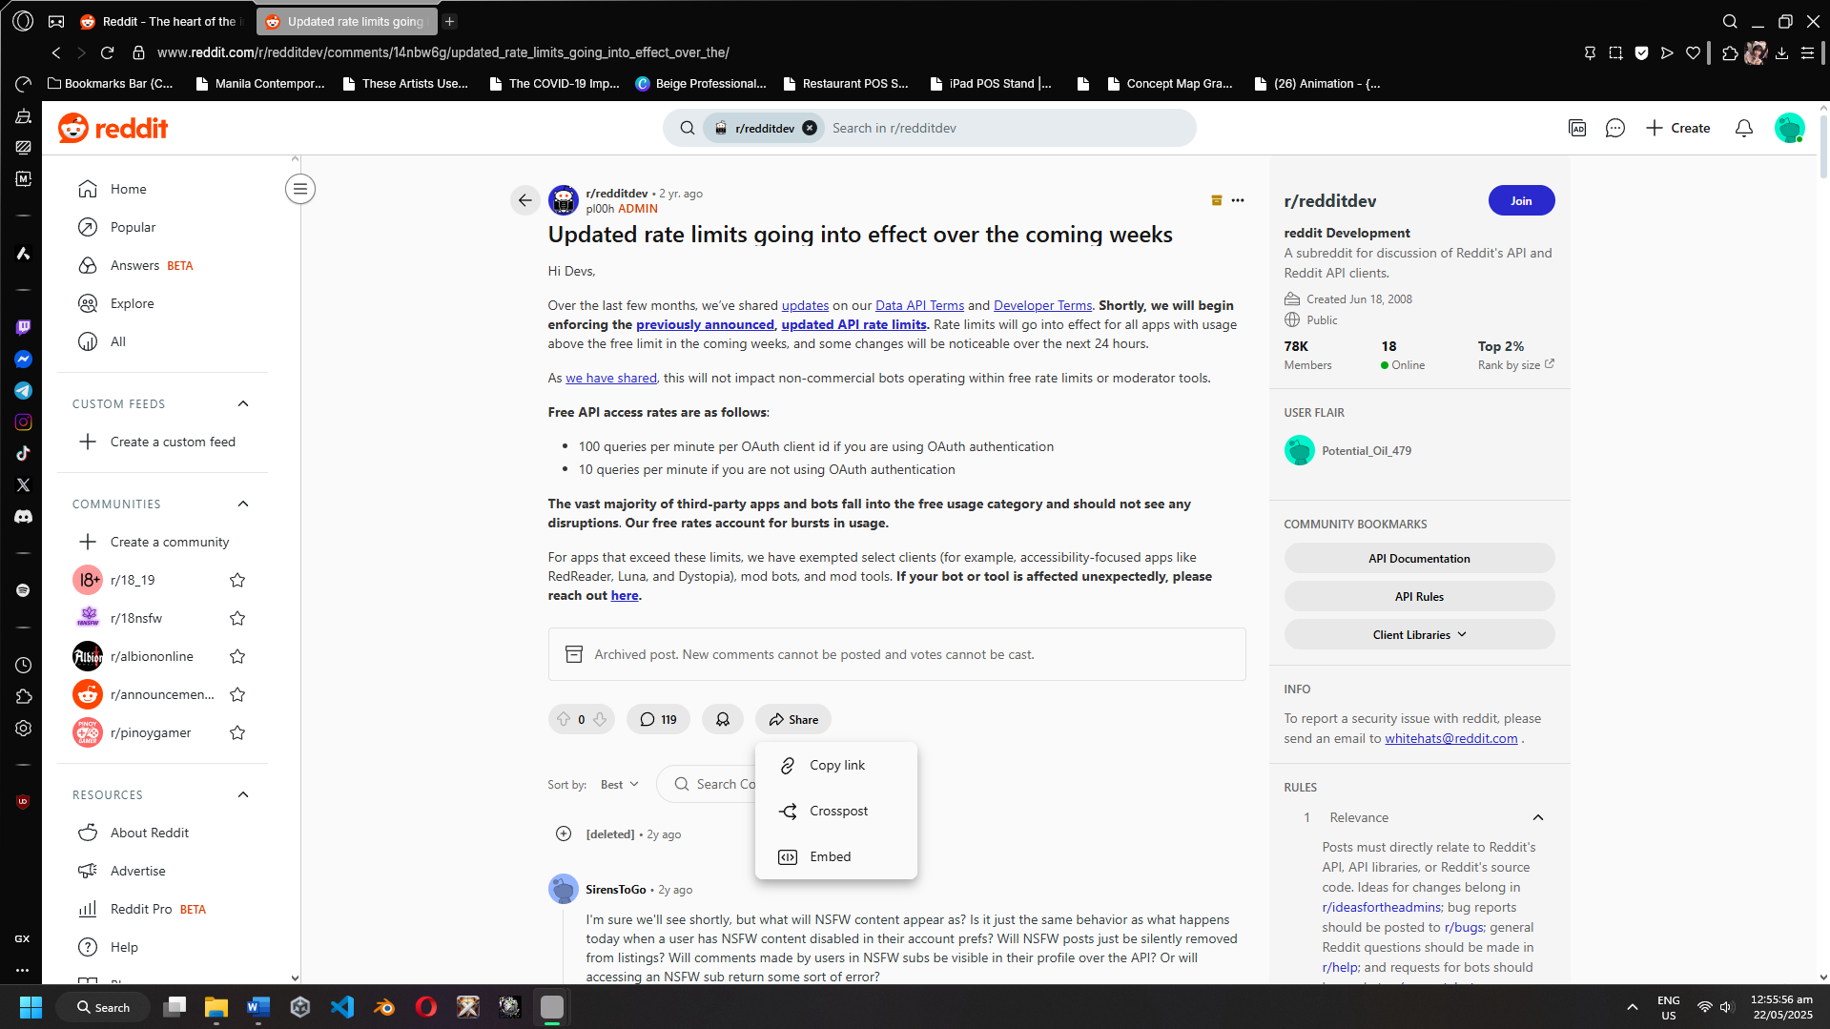
Figure 34: API Limit

