# Introduction

The Gulf of Lion is a hotspot of productivity in the Mediterranean Sea, crucial for wildlife like seabirds [1, 2, 3]. Its wide continental shelf, freshwater and nutrients discharge from the Rhone River,

wind-driven upwelling, and water circulation contribute to its high primary production [4, 5, 6, 7]. This productivity supports significant fish resources [8] that seabirds rely on for food [9]. Seabirds travel from colonies as far as 500 km away to forage in these waters [6, 9], highlighting the conservation importance of this area beyond the Gulf itself.

Mediterranean seabird community is characterized by a low species richness but a high degree of endemism [10]. Furthermore, some species, and subspecies that use the Gulf of Lion are considered threatened either at the national or global level, such as the Yelkouan shearwater, Balearic shearwater, and European storm petrel. Mediterranean seabirds face multiple threats both on land and at sea. On land, predation by feral cats and black rats on eggs, chicks, and adults poses a significant risk [11, 12]. At sea, they are vulnerable to accidental bycatch by fisheries [9, 13], food shortages due to fishing activities [8, 14], various pollutants [15, 16, 17], and disturbances caused by offshore infrastructure [18]. The Gulf of Lion serves as a hub for commercial fishing [8], tourism, and recreational activities making it an area where seabirds are particularly impacted by human-induced threats [2].

In addition to existing threats, new human activities are planned in the Gulf of Lion, including offshore wind farm projects [19]. While offshore wind energy is expected to significantly contribute to renewable energy development, its impact on seabird populations is a major environmental concern [18, 20, 21, 22]. Offshore wind farms affect seabirds through direct collision mortality [20, 22] and through population displacement due to disturbance created by the wind turbines and associated activities [21, 22]. Furthermore, wind farms alter the local ecosystem by changing wind and water circulation [23], transforming seabed communities [24], and restricting fishing activities [25]. These changes often make the area less attractive to seabirds, but in some cases, resources can become more abundant, making the area more appealing to certain species [26, 27]. However, while a wind farm attracting more seabirds could provide new feeding opportunities, it also increases the risk of collisions [27].

To effectively mitigate the future impact of wind farms on seabird populations in the Gulf of Lion, assessing the spatial risk of seabirds to these installations is crucial [28]. This requires understanding the spatial distribution of seabird species within the assessment area. However, a comprehensive assessment of seabird distribution at the scale of the Gulf of Lion has not been conducted previously. Previous studies have estimated seabird distribution in the French Mediterranean Exclusive Economic Zone (EEZ) [3, 29]. Still, these studies were either not conducted at the species level [3] or focused on only a few seabird species [29]. To be comprehensive, the assessment of species distribution should encompass a broader range of species. In the Gulf of Lion, several programs have collected data on seabirds from 2011 to 2023 [3, 30]. Most of the data consists of count data collected during boat or aerial. For a few species GPS-tracking data is also available. Combining all these data allowed us to have a comprehensive and representative assessment of seabird distribution.

The most reliable method to combine several data sources is to develop integrated species distribution models [31, 32, 33]. Each data source was collected using different protocols, for example, the number of observers and the counting platforms vary between each survey. The probability of detecting all the species and all the individuals of one species at each site is dependent on the protocol used. Integrated species distribution models allow to take these differences into account [31, 32, 33]. Integrated models are often hierarchical models [32], i.e. a sequence of related models ordered by their conditional probability structure [34]. In hierarchical models, there are one or more intermediate levels involving latent variables. In our case, the models have a component for the observations and a component for the ecological state of our system [32, 34]. The component for the observation is different for each data sources, while the component for the ecological state is the same across all data sources. The idea behind this being that each observation protocol give a different representation of the same reality.

Depending on the available data and the specific ecological question, different classes of species distribution models can be employed. Occupancy models [34, 35, 36] are suitable if only detection/nondetection data are available, or if the ecological focus is on the presence or absence of a species at a site. These models provide information on the occurrence areas of a species. When count data are available and the ecological focus is on the abundance of a species at each site, N-mixture models can be utilized [34, 37, 38]. Abundance can also be modeled with distance-sampling or capture-recapture methods, but our data lack the necessary information for these approaches. Both occupancy and N-mixture models have a hierarchical structure and estimate detection probability. To guide public policy or understand species distribution, either model can be used. Occupancy models are more widely used than N-mixture models [39], mainly due to the type of data they require. While N-mixture models can provide more detailed information, occupancy models might be sufficient in some cases [40] and could even serve as a surrogate for abundance estimation [41], particularly for rare species with low density [40]. However, this is less likely to be the case for seabirds. Additionally, occupancy models are often easier to fit [40]. Few studies have compared these two methods directly, and it would be interesting to know if the use of detection/non-detection data could be sufficient in the context of wind farm planning.

Spatial distribution can be determined not only from count data but also from positions acquired by GPS devices [42]. As the quantity and variety of data increase, there’s a growing trend of using diverse data types to model species distribution [33]. However, employing a model-based approach to combine disparate data is not yet common practice. Movement data is traditionally used to study habitat selection through a used-availability design, which compares the proportion of observations in different habitat types to the availability of those habitats across the landscape [42, 43]. Although not its primary focus, habitat selection analysis can also provide insights into species distribution [42].

Count and GPS data capture complementary aspects of animal space-use [1]. Count data provide broad-scale population-level information, while GPS data offer detailed, fine-scale information for a few individuals. Several studies have attempted to combine information from GPS and count data to determine species distribution, particularly in seabird research [1, 44, 45]. However, none of these studies utilized a model-based approach. Lauret et al. (under review) [46] developed a method to combine telemetry and count data into a single model. This model is hierarchical, incorporating a component for count data using an N-mixture model and a component for movement data through a Resource Selection Function (RSF), the most commonly used method in habitat selection analysis [43].

In this study, we apply this model to species for which both types of data are available.

Assessing the distribution of seabird species is the first and most crucial step in creating a spatial indicator of seabird vulnerability to wind farms. However, to effectively guide public policy, it is essential to produce a synthetic overview of seabird vulnerability within the assessment area. This synthesis is complex because the final indicator must account for both species distribution and the risks posed by future wind farm installations, which is strongly species dependent [27, 20, 47]. To address species-specific differences, a vulnerability index was calculated for each species using the approach developed by Furness et al. (2013) [22] and Bradbury et al. (2014) [47]. This index considers the conservation status of the species and metrics determining collision and habitat loss risk [22]. The final vulnerability map is created by taking a weighted average of all species distribution maps, with each species weighted by its respective vulnerability index [45, 47].

The aim of this study is twofold: (1) to determine the distribution of several seabird species within the Gulf of Lion and use these predictions to assess their spatial vulnerability to future wind farm installations; and (2) to explore the results of seabird distribution and spatial vulnerability obtained from different modeling techniques that utilize various data types, to provide recommendations for future data collection plans. To achieve these objectives, species distribution was modeled using integrated occupancy and integrated N-mixture models. These models combined at-sea observations from four different programs. Species distribution was also derived from GPS-tracking data, either independently or in combination with at-sea observations.

# Methods

## Study area and data

### Study area

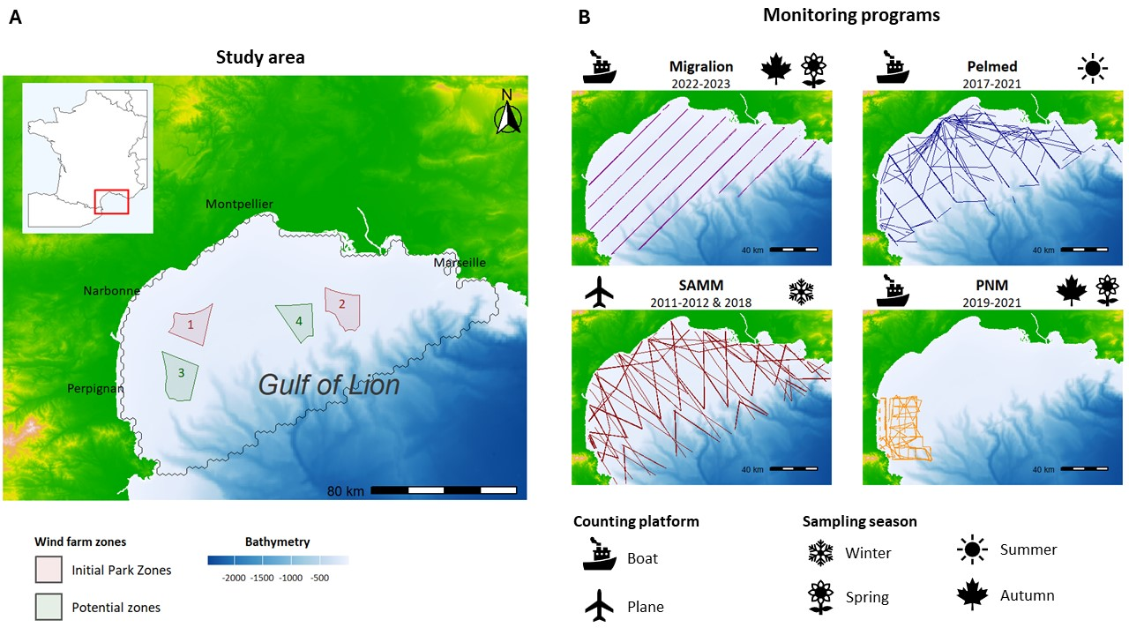

**Fig.1: Study area and transect lines - (A)** Location of the Gulf of Lion. The colored area represents future wind farm zones. Red zones (1, 2) were chosen to receive the first farms and their extension. Green zones (3, 4) are potential zones for future projects. The black line delimits the study area and corresponds to the continental shelf. **(B)** The transects followed by each monitoring program. Migralion program was performed during April and September 2022 and 2023. PELMED (PELagic MEDiterranean) was conducted during July 2017 to 2021. SAMM (Survol A´erien de la M´egafaune Marine, Aerial Sensus of Marine Megafauna) was done during winter between 2011-2012 and 2018-2019. PNM (Parc Naturel Marin) designates data collected by the Marine Natural Parc of the Gulf of Lion. It’s important to note that not every transect was sampled during each campaign.

The Gulf of Lion is in the north-western Mediterranean Sea (Fig.1). It is one of the most productive areas in the Mediterranean Sea, due to a combination of freshwater input by the Rhone River [4, 5] and small-scale upwellings created by winds [48]. The study area was determined based on suitability to receive wind farms, which is mainly driven by the bathymetry. In consequence, the study area coincides

with the continental shelf. The total area considered for the study had a surface of approximately 17,300 km². Within this area, assessment units were defined by 1380 hexagonal cells with a size of 12,6 km². All the ecological parameters are estimated at the scale of the grid cells, thus each grid cell defines a ’site’. Grid resolution was chosen to have a ratio of approximately 1 cell with detection for 10 cells without any detection on average for each species.

### Seabirds at-sea monitoring

Count data were collected from four different programs, as summarized in 1. Observations were conducted using strip-transect methodology (Fig.1) [49, 50, 51], employing ships or aircraft as counting platforms.

**Table 1:**

|  |  |  |  |  |
| --- | --- | --- | --- | --- |
| Program | Years | Period of the year | Area covered | Counting platform |
| Migralion | 2022-2023 | Spring and autumn | Gulf of Lion | Boat |
| SAMM | 2011-2012 & 2018-2019 | Summer and winter | French ZEE | Aerial |
| Pelmed | 2017-2021 | Summer | Gulf of Lion | Boat |
| Megaobs | 2019-2021 | Early summer and late autumn | National Marine Parc of The Gulf of Lion | Boat |

SAMM (Survol Aerien de la Megafaune Marine, Aerial Census of Marine Megafauna) [29, 52], was the only aerial survey. It was conducted from November to February 2011-2012 and from January to February 2019, covering the entirety of the French Exclusive Economic Zone. Although this aerial survey also occurred during the summer of 2012, it was not replicated and thus not used in our study, as our models require replicated data.

PELMED is an annual survey primarily assessing small pelagic fish resources [30]. This campaign occurred every summer from late June to early August.

We also utilized data from the Marine National Park (PNM) of the Gulf of Lion, a large marine protected area. Surveys have been conducted twice a year since 2019, in autumn and late spring.

Data from Migralion was collected in 2022 and 2023, twice a year around April and September.

All these programs collected data at the species level, but in some cases, species identification was too difficult, leading to aggregation into the same category. This affected Balearic shearwater (*Puffinus mauretanicus*) and Yelkouan shearwater (*Puffinus yelkouan*), both labeled as small shearwaters, as well as Pomarine skua (*Stercorarius pomarinus*) and Arctic skua (*Stercorarius parasiticus*), labeled as small skuas. The datasets contained sufficient information to model the distribution of twelve different species 3.

Seabirds’ distribution could change between seasons and some species are only present in the study area during a part of the year [29, 52]. For these reasons, our analysis was split into two periods: breeding season (from April to August) and non-breeding season (from September to March).

### Telemetry data

Movement data within the Gulf of Lion was available for four species: Scopoli’s shearwater, Yelkouan shearwater, Yellow-legged gull, and Sandwich tern. For the Migralion project in 2021 and 2022, 51 Scopoli’s shearwaters, 39 Yelkouan shearwaters, and 22 Sandwich terns were tagged at their nesting colonies on Riou Island near Marseille, in Port-Cros, and at the Etang de Thau near Montpellier, respectively, all located in the South of France. Additionally, 106 Yellow-legged gulls were tagged with GPS in 2021 in the Natural Park of Camargue as part of ??? project.

Our set of used locations was obtained by retaining only those within the study area and resampling them to one location per hour. This resampling is crucial to avoid spatial autocorrelation between successive locations. The data were divided into breeding and non-breeding seasons, consistent with the seasons defined by the count data. For each actual location, we simulated 10 available points, or ”pseudo-absences,” uniformly distributed across the study area. We chose a uniform distribution because we considered the entire area to be equally accessible to seabirds, given its small size compared to the distances seabirds can travel.

### Environmental data

|  |  |
| --- | --- |
| Variable | Description |
| Bathymetry | Seabed depth  (in m) |
| Distance | Distance to the coast (in km) |
| Slope | Slope of the seabed  (in degree) |
| Seasonal  SST | Sea Surface Temperature for each season (in °C) |
| SSS | Sea Surface  Salinity (in |
| SSH | Sea Surface Height above geoid (in m) |
| Chlorophyll | Chlorophyll-A concentration (in mg/m3) |
| Current velocity | Sea water velocity  (in m/s) |

Equ2: **Environmental covariates used in the study.**

We extracted environmental variables from the E.U. Copernicus Marine database [53, 54] (https://data.marin and MARSPEC database [55] (http://www.marspec.org). A total of 8 geophysical and biotic covariates were included and are listed in Tab.2 (see also Appendix I Fig.5 for maps). Covariates choice was based on knowledge about seabirds and frequently used covariates for seabird distribution modeling [**louzao 2009**, 29, 56, 57, 58, 45].

The dynamic variables were obtained with monthly temporal resolution and averaged values were calculated from 2011 to 2023, covering the oldest to most recent seabird data available. We also computed the standard deviation for each covariate from the monthly temporal resolution and considered it as a measure of temporal variability of the covariate value. Sea Surface Temperature (SST) showed great seasonal variability, thus average values were calculated for each season. We extracted covariate at the spatial scale of each grid-cell. When the correlation between two covariates was too high (*R*2 *>* 0*.*8), one of the covariates was excluded from the selection procedure. Were excluded in priority covariates highly correlated with more than one variable, and standard deviation before mean values.

## Mapping seabird at-sea distribution

### Seabirds occupancy modeling with detection/non-detection data

We initially employed occupancy modeling [35] to estimate seabird distribution in the Gulf of Lion.

The fundamental concept of this modeling approach is to consider the occurrence of a species as a Bernoulli random variable where the success is the species presence, and the success probability is the presence probability *ψ* [34, 35].

### Latent process

Let’s consider J sites, each surveyed K times. We denote *Zj* the true occupancy state at site j, where *j* ∈ 1*,...,J*. *Zj* = 0 if the species is absent and *Zj* = 1 if it is present. This latent occurrence variable is assumed to follow a Bernoulli process [35]:

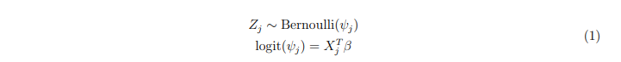Here, *ψj* represents the probability of species presence at site j. The presence probability is modeled by logistic regression of site-specific environmental covariates *Xj*, with *β* being a vector of regression coefficients [34, 35].

### Observation process

The non-detection of a species at a site does not necessarily mean it is not using that site. The observation process can yield false absence (*Y* = 0) while the species is occupying a site (*Z* = 1) (false negative errors). Species can be missed by the observers or absent at the time of survey while it is using this site (D´enes 2015) (an individual of a mobile species with a large home range may regularly use a site but be absent from it at the time of survey because it is visiting part of its home range outside of the sample unit) Not accounting for imperfect detection could lead to wrong inferences [34, 59, 60, 61].

Let *Yj,k,r* be the observed detection (1) or non-detection (0) at site j during survey k for dataset r. Each dataset has its own bias and detection probability, which is why the observation process is modeled separately for each data source. However, the observation process is conditional on the latent process described in 1, which is common and shared for all data sources. For a data source r, the detection/non-detection data arises from a Bernoulli process conditional on the true latent occurrence process:

Where *pj,k,r* is the detection probability at site j for replicate k and dataset r. In our model, the detection probability depends on one covariate: the length of the transect crossing the cells j at replicate k for dataset r. This covariate is a measure of the sampling effort.

### Model fitting

This model was implemented in R (ref) using the package spOccupancy [62], allowing fast computation, and easy model selection. Models were fit in a Bayesian framework, we ran 3 MCMC chains with 30,000 iterations each and a burn-in of 3,000 iterations. Convergence was checked by verifying

that *R <*ˆ 1*.*1 [63].

### Model selection

To have the most accurate prediction on seabird distribution as possible to inform wind farm policies, the selection procedure aimed to maximize the predictive power of our models. For this purpose, we evaluated model performance using two criteria: the Widely Applicable Information Criterion (WAIC) and k-fold cross-validation. In k-fold cross-validation, the model is fitted k times, each time excluding a fraction J/k of the data, with J being the total number of sites. Then, predictions are made on the sites excluded from model fitting. Predictive performance is assessed by computing the difference between real site values and predicted values using the deviance [64]. When predictive scores were too close (*difference <* 3), we chose the model with fewer covariates.

Testing all possible models was computationally intensive, so we implemented a selection procedure in four steps:

* First, for each covariate, we tested whether adding a quadratic effect or applying a log transformation improved the predictive performance of a one-covariate model. Quadratic effect allows to take into account the existence of optimal value rather than linear effect for some covariates.
* Second, we divided the covariates into three thematic blocks and tested all possible combinations within each block, selecting the one with the best predictive performance. The three blocks were: the static covariates, the covariates linked to sea surface temperature, and the other dynamic covariates.
* Then, with the three covariate blocks resulting from step two, we tested whether combining all three blocks improved performance, or if two or even one block yielded the same predictive performance.
* In the final step, we evaluated whether incorporating a spatial autocorrelation structure would enhance predictive performance. In many cases, considering spatial autocorrelation improves prediction quality and results in more accurate maps [65]. The spOccupancy package offers various spatial covariance models (spherical, exponential, and Gaussian) [62], which we tested.

### Seabirds abundance modeling with count data

In a second time, we tried to infer seabird abundance using N-mixture models [38, 37]. Similarly to occupancy models, N-mixture models have a hierarchical structure where the observation is defined conditional on the latent process describing the true abundance [38, 37].

### Latent process

Let *Nj* represent the true abundance at site j. This latent variable is assumed to follow a negative binomial distribution:

Where *λj*, the mean of the distribution, is a function of site-specific covariates. A negative binomial distribution was prefered to a Poisson distribution to take overdispersion of the count data into account, the negative binomial allowing the standard deviation and the mean to be different (the variance is *λ* + *λ*2*/κ*). Overdispersion is frequent with seabirds counts as individuals aggregate in great number at the same place for many species. *κ* is the overdispersion parameter.

Normal prior are assigned to coefficients *β* (*β* ∼ *N*(0*,*1)) and an uniform prior for *κ* (*κ* ∼

*Unif*(0*,*100)).

### Observation process

Again, we employ an integrated model with a separate model for each dataset to accommodate differences in the observation process. The real number of individuals at a site is consistent across all datasets, but the number of observed individuals varies for each dataset. The observed number of individuals is assumed to follow a Binomial distribution conditional on the true number of individual *Nj*:

**

In other words, each individual at site j has a probability *pj,k,r* of being detected. Detection is considered independent for each individual. The detection probability *pj,k,r* is a function of the sampling effort, measured by the length of the transect crossing the cells.

### Model fitting

This model was implemented using Nimble package [66]. We ran 3 MCMC chains with 100,000 iterations each and a burn-in of 10,000 iterations. Convergence was checked by verifying that *R <*ˆ 1*.*1 [63].

### Model selection

To ensure comparability between models, we used the same set of covariates for all models. The selection procedure was performed exclusively with the occupancy model.

### Integration of telemetry data for relative space-use modeling

Lastly, we integrated GPS data with count data into a single model by combining an N-mixture model with a Resource Selection Function.

### GPS data with Resource Selection Function

Movement data take the form of a set of locations, subset in used locations and available locations. Let’s denote *Kj* the variable describing the location j. *Kj* = 1 for used locations and 0 for the available locations. *Kj* is considered to result from a Bernoulli draw:

Where *λj* is the probability for a location being used knowing its environmental covariates values

(*λj* = *P*(*Kj* = 1|*Xj*)). *λj* is modeled as a logistic regression of location-specific covariates and regression coefficients *β*. Coefficients *β* represent the strength of the selection on the associated covariates.

To take population heterogeneity into account, a random effect is added on slope coefficients *β*. Let’s I denote the total number of individuals, and take an individual *i* ∈ [1;*I*], we have:

*βi* ∼ *Normal*(*β,τ*) (6)

With *β* being the slope coefficient and *τ* a parameter quantifying the inter-individual variability regarding habitat selection on the associated covariate.

To complete the Bayesian specification of the model, normal priors are assigned to *β*, and uniform priors to *τ*.

Here, we used Resource Selection Function (RSF), a particular case of habitat selection function, where the logistic regression of used *Ks* = 1 and available *Ks* = 0 location is fitted simultaneously on

the entire dataset.

### Data integration: N-mixture and RSF

N-mixture and RSF both quantify habitat selection through the use of generalized linear regression on covariates X. Based on previous work [42, 43] showing that these models are similar to Inhomogeneous Poisson Point process (IPP), Lauret et al. (under review) [46] proposed to integrate these two data sources in a single model using IPP as a unifying framework. IPP describes the stochastic distribution of points in space when the expected density of points is correlated to environmental covariates. IPP reflects the intensity *λ* of a spatial point process over a defined study area. N-mixture and RSF do not estimate the same IPP intensity *λ*. In RSF, the intercept has no biological meaning and only the relative habitat selection is estimated. Then N-mixture and RSF estimate the same relative intensity of the IPP. IPP intensity *λ* being determined by slope coefficients *β*, coefficient estimates should be consistent between RSF and N-mixture. The integrated model keeps the hierarchical structure of the N-mixture and the logistic regression of the RSF and jointly estimates *β* parameters.

The model is divided into the N-mixture submodel:

**

And the RSF submodel:



Model implementation, fitting, and selection were carried out in the same manner as for N-mixture models, both for the RSF alone and for the integrated RSF and N-mixture model.

Vulnerability index

Scientific name Common name

|  |  |  |  |
| --- | --- | --- | --- |
|  |  | Breeding season | Non-breeding season |
| *Calonectris diomedea* | Scopoli’s shearwater | 2.2 | 1.7 |
| *Chroicocephalus ridibundus* | Black-headed gull | 7.2 | 2.7 |
| *Fratercula arctica* | Atlantic puffin |  | 2.6 |
| *Hydrocoloeus minutus* | Little gull |  | 10 |
| *Hydrobates pelagicus melitensis* | European storm-petrel | 3.5 |  |
| *Larus melanocephalus* | Mediterranean gull | 6.3 | 7.3 |
| *Larus michahellis* | Yellow-legged gull | 10 | 7.6 |
| *Morus bassanus* | Northern gannet |  | 2.3 |
| *Puffinus mauretanicus &*  *Puffinus yelkouan* | Small shearwaters | 2.7 | 2.7 |
| *Stercorarius pomarinus &*  *Stercorarius parasiticus* | Small skuas |  | 3.3 |
| *Sterna hirundo* | Common tern | 2.9 |  |
| *Sterna sandvicensis* | Sandwich tern | 4.8 | 3.7 |

**Table 3: Species and their associated vulnerability index.** Blank space indicates no score for a species at a certain period due to its absence from the area.

## Mapping seabirds’ vulnerability to wind farms

### Vulnerability indexes

The synthetic index constructed to evaluate species risk to offshore wind farms integrates three main aspects of seabird vulnerability [47, 22]:

1. **Conservation Status (CS):** Defined in [67], this score combines species status and representativeness of French populations. Species status is based on the worst IUCN Red List rankings or population trends. At the same time, representativeness is measured by the percentage of the global population in France and on the Mediterranean coast. Different representativeness values are defined for the breeding and non-breeding period as seabirds’ distribution can vary greatly between these periods [67, 3]. CS is the mean between representativeness and vulnerability.
2. **Risk of Collision** was evaluated with four criteria: the estimated percentage of time flying at blade height (Alt); flight maneuverability (Man); percentage of time spent flying (Ptf); and a nocturnal Activity Score (Noc).
3. **Risk of Displacement** is calculated using two criteria: the sensibility to disturbance by wind turbines, boats, and helicopters (Dis) and habitat specialization score (Spe). The vulnerability index is computed as follows [22]:

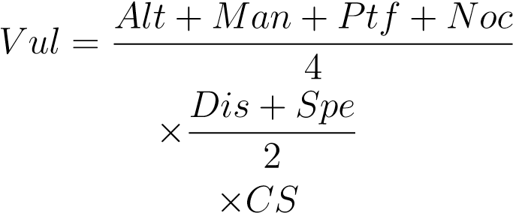

Vulnerability indexes for every species are indicated in Tab.3

### Vulnerability maps

To create a single vulnerability map, all the maps are combined, using the vulnerability index as a weighting factor. With occupancy maps, the seasonal seabird vulnerability *SV* at site *j* and season

is defined as:

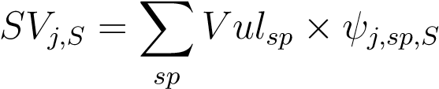

where *ψj,sp,S* represents the space-use probability of site *j* by species *sp* during season *S*.

With abundance maps, the seasonal seabird vulnerability *SV* at site *j* and season *S* is defined following Bradbury et al. (2014) [47]:

**

These calculations are performed for the breeding (B) and non-breeding (NB) seasons. The final vulnerability map is obtained by averaging the two seasonal maps at each site:

*SVtot* = mean(*SVB,SVNB*)

This approach ensures that both breeding and non-breeding seasons contribute to the overall assessment of seabird sensitivity. *SVtot* was then centered-reduced to obtain a relative vulnerability score over the entire study area. The mean of relative vulnerability is 0, positive values indicate area

with higher vulnerability and negative values indicate locations with lower risk.

# Results

## Comparison of seabird occurrence and abundance modeling

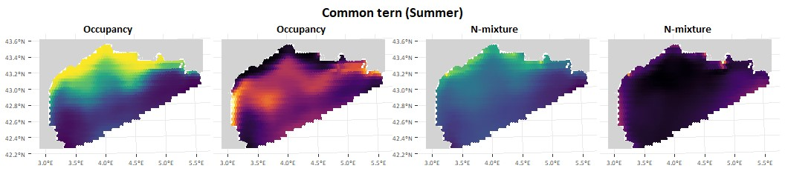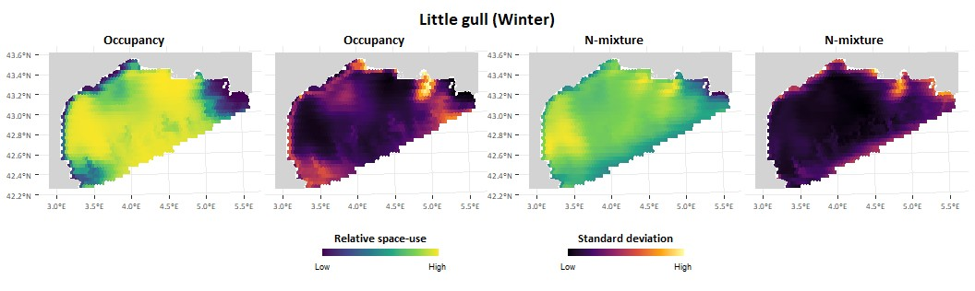

**Fig.2: Common tern and Little gull distribution in the Gulf of Lion.** At-sea distribution for these species was estimated using an occupancy model with detection/non-detection data and an N-mixture model with count data. The figure shows the distribution maps and the associated standard deviation on the prediction.

All models used were able to effectively differentiate between less used and most used areas, showing good concordance with observable patterns in the data. The models selected after the model selection process are summarized in Appendix B, Table X. Models that included spatial autocorrelation resulted in low predictive performance and overfitting, so the final models did not incorporate a spatial autocorrelation structure.

The results for occupancy and N-mixture models are presented for four representative species:

Common Tern and Little Gull in Table 2, and Yellow-legged Gull and Small Shearwaters in Table 3. Results for other species are provided in Appendix C, Figure XX.

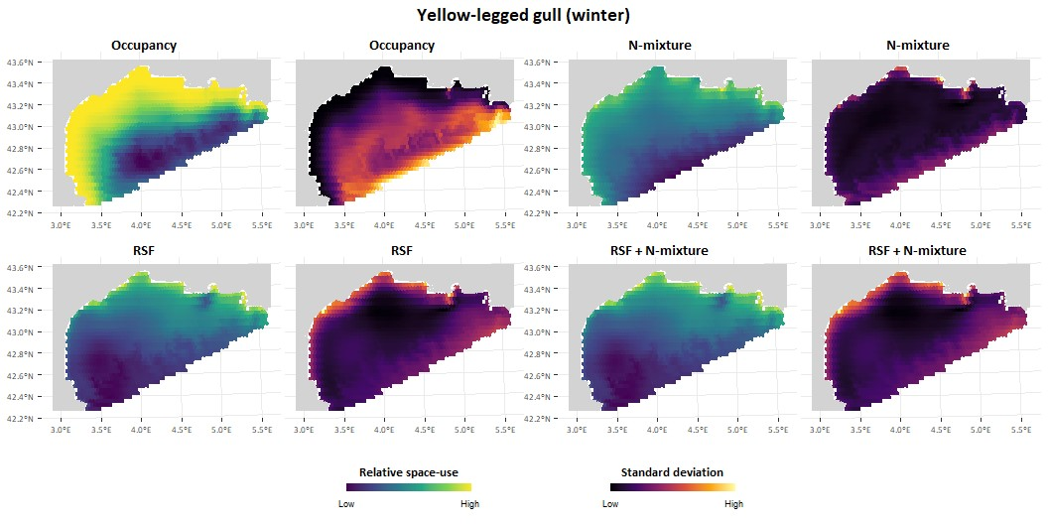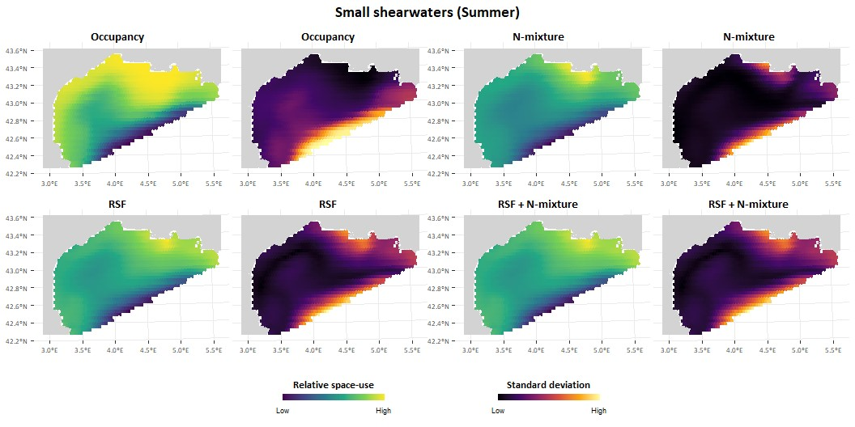

**Fig.3: Yellow-legged gull and small shearwaters distribution in the Gulf of Lion.** For these species, distribution was estimated in four different ways: using an occupancy model with detection/non-detection data, an N-mixture model with count data, a Resource Selection Function (RSF) with movement data, and an integrated model combining both movement and count data (RSF + N-mixture). The maps show the relative space-use and the associated uncertainty on the results, computed as the standard deviation on the prediction.

**Common Tern.** The estimated distributions from each method show similar patterns. However, the abundance estimates indicate a much more coastal distribution. While Common Terns can be found slightly offshore, the majority are concentrated along the coast and in the lake behind the coastline.

**Little Gull.** The patterns from each method are quite similar, with highly used areas on the west and east sides of the Gulf, far from the coast. The main difference arises in the center of the Gulf and the slope area, where species occurrence is predicted to be high, but abundance is estimated to be medium.

**Yellow-legged Gull.** Similar to the Common Tern, the distribution based on occurrence and abundance shifts towards the coast. Yellow-legged Gulls are the most abundant species in the study area and can be found almost everywhere. However, they remain very coastal, with most individuals staying near the coast.

**Small Shearwaters (Yelkouan and Balearic Shearwaters).** Both occurrence and abundance are predicted to be high near the Rhone mouth. The species is expected to occur over a much wider area than the places where high individual abundance is found.

## Comparison and integration of movement data with count

The results obtained from movement data using RSF are consistent with those derived from count data. For both Yellow-legged Gulls and small shearwaters, the maps produced are similar (refer to the appendix for other species). However, a notable difference is observed for the Yellow-legged Gull: the map based on telemetry data displays a West-East pattern with very low predicted space use in the western part of the Gulf, whereas the N-mixture model predicts similar space use for both the western and eastern parts of the Gulf. In other word, predicted space-use is higher on the eastern side with RSF, which coincide to the side where Yellow-legged gulls were equipped. Regarding the integration of movement and count data (RSF + N-mixture), the model results appear to be influenced more by the movement data than by the count data.

## Seabird spatial vulnerability to wind farm

The species with the highest vulnerability scores are the Little Gull, the Mediterranean Gull, and the Yellow-legged Gull in winter (non-breeding season), and the Yellow-legged Gull, Black-headed Gull, and Mediterranean Gull in summer (breeding season) (Table 3).

Seasonal variation in the spatial distribution of relative vulnerability is minimal, regardless of the methods used for species distribution (Fig. 4). The main difference appears in the western part of the Gulf, where there is an increased risk during winter due to the presence of the Little Gull during this period.

Across the entire area, higher vulnerability values are observed near the coast. On the maps based on abundance, vulnerability rapidly decreases with increasing distance from the coast, whereas it remains higher over a larger area with occurrence modeling. A strong effect of the Rhone River, near the Camargue region, is also visible. Apart from the distance-to-coast effect, the maps obtained with the two modeling approaches seem to be in agreement.

The results on the maps also reflect when looking at the relative vulnerability of the different areas considered for wind farm locations (Fig. 4). With abundance modeling, vulnerability rapidly decreases with distance from the coast, so Zones 3 and 4 show a relative vulnerability equivalent to that of the whole study area. In contrast, Zones 1 and 2 have a much higher risk than the rest of the study area.

This is because Zone 1 is relatively close to the coast, and Zone 2 is near the mouth of the Rhone River, where productivity is high.

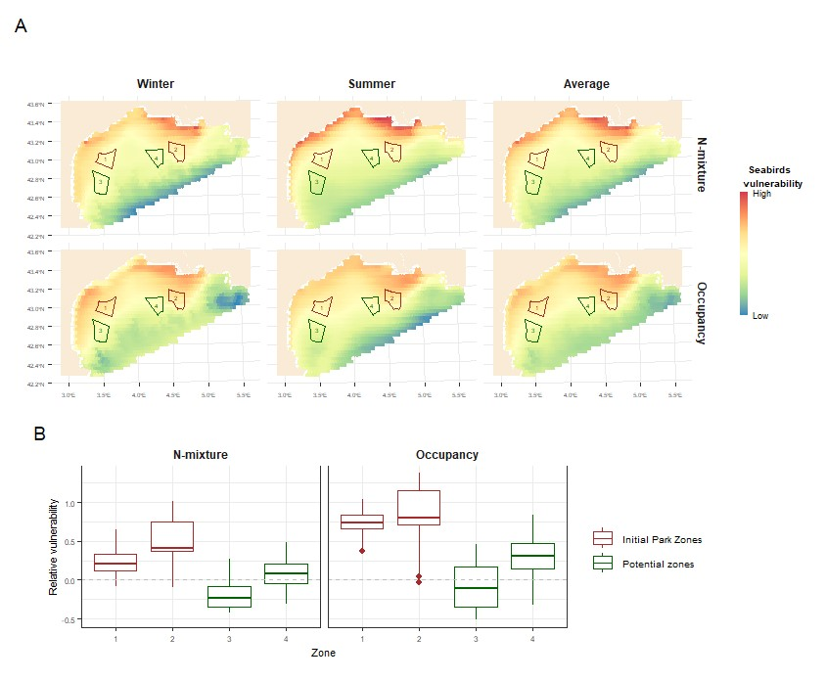

**Fig.4: Wind farm vulnerability maps.** (A) These maps illustrate the relative spatial vulnerability of seabirds to wind farms during two seasons and on average. The vulnerability maps were derived from species distribution maps using two types of models: Occupancy and N-mixture. Each row shows the results for each model. (B) Average vulnerability in areas proposed for wind farms, again using both the N-mixture and Occupancy models for species distribution. The grey line represents the mean vulnerability across the entire study area.

**4 Discussion**

# References

1. M. Louzao et al. “Combining vessel-based surveys and tracking data to identify key marine areas for seabirds”. *Marine Ecology Progress Series* (Sept. 28, 2009). doi: [10.3354/meps08124.](https://doi.org/10.3354/meps08124)
2. Marta Coll et al. “The Mediterranean Sea under siege: spatial overlap between marine biodiversity, cumulative threats and marine reserves”. *Global Ecology and Biogeography* (2012). doi: [10.](https://doi.org/10.1111/j.1466-8238.2011.00697.x)

[1111/j.1466-8238.2011.00697.x.](https://doi.org/10.1111/j.1466-8238.2011.00697.x)

1. Emeline Pettex et al. “Using large scale surveys to investigate seasonal variations in seabird distribution and abundance. Part I: The North Western Mediterranean Sea”. *Deep Sea Research Part II: Topical Studies in Oceanography*. Abundance, distribution and habitats of Atlantic and Mediterranean marine megafauna (July 1, 2017). doi: [10.1016/j.dsr2.2016.11.008.](https://doi.org/10.1016/j.dsr2.2016.11.008)
2. Julie Gatti et al. “The Rhone river dilution zone present in the northeastern shelf of the Gulf of Lion in December 2003”. *Continental Shelf Research* (Oct. 1, 2006). doi: [10.1016/j.csr.](https://doi.org/10.1016/j.csr.2006.05.012)

[2006.05.012.](https://doi.org/10.1016/j.csr.2006.05.012)

1. Marion Fraysse et al. “Intrusion of Rhone River diluted water into the Bay of Marseille: Generation processes and impacts on ecosystem functioning”. *Journal of Geophysical Research: Oceans* (2014). doi: [10.1002/2014JC010022.](https://doi.org/10.1002/2014JC010022)
2. Josep Maria Gili et al. “Description of the ecology of the Gulf of Lions shelf and slope area and identification of the areas that may deserve to be protected” (2013). doi: [10.13039/ 501100000780.](https://doi.org/10.13039/501100000780)
3. B. Espinasse et al. “Defining zooplankton habitats in the Gulf of Lion (NW Mediterranean Sea) using size structure and environmental conditions”. *Marine Ecology Progress Series* (June 23, 2014). doi: [10.3354/meps10803.](https://doi.org/10.3354/meps10803)
4. D. B˘anaru et al. “Trophic structure in the Gulf of Lions marine ecosystem (north-western Mediterranean Sea) and fishing impacts”. *Journal of Marine Systems* (Feb. 1, 2013). doi:

[10.1016/j.jmarsys.2012.09.010.](https://doi.org/10.1016/j.jmarsys.2012.09.010)

1. Carles Carboneras. “Seabirds in the Gulf of Lions shelf and slope area” (2013).
2. Richard Zotier, Vincent Bretagnolle, and Jean-Claude Thibault. “Biogeography of the marine birds of a confined sea, the Mediterranean”. *Journal of Biogeography* (1999). doi: [10.1046/j.](https://doi.org/10.1046/j.1365-2699.1999.00260.x)

[1365-2699.1999.00260.x.](https://doi.org/10.1046/j.1365-2699.1999.00260.x)

1. E. Bonnaud et al. “Feeding Ecology of a Feral Cat Population on a Small Mediterranean Island”. *Journal of Mammalogy* (Aug. 20, 2007). doi: [10.1644/06-MAMM-A-031R2.1.](https://doi.org/10.1644/06-MAMM-A-031R2.1)
2. L. Ruffino et al. “Invasive rats and seabirds after 2,000 years of an unwanted coexistence on Mediterranean islands”. *Biological Invasions* (Aug. 1, 2009). doi: [10.1007/s10530-0089394-z.](https://doi.org/10.1007/s10530-008-9394-z)
3. K. Laneri et al. “Trawling regime influences longline seabird bycatch in the Mediterranean: new insights from a small-scale fishery”. *Marine Ecology Progress Series* (2010).
4. Philippe M. Cury et al. “Global Seabird Response to Forage Fish Depletion—One-Third for the Birds”. *Science* (Dec. 23, 2011). doi: [10.1126/science.1212928.](https://doi.org/10.1126/science.1212928)
5. Carolina Sanpera et al. “Audouin’s gull chicks as bioindicators of mercury pollution at different breeding locations in the western Mediterranean”. *Marine Pollution Bulletin* (June 1, 2007). doi: [10.1016/j.marpolbul.2007.01.016.](https://doi.org/10.1016/j.marpolbul.2007.01.016)
6. Marina Codina-Garc´ıa et al. “Plastic debris in Mediterranean seabirds”. *Marine Pollution Bulletin* (Dec. 15, 2013). doi: [10.1016/j.marpolbul.2013.10.002.](https://doi.org/10.1016/j.marpolbul.2013.10.002)
7. Chris Wilcox, Erik Van Sebille, and Britta Denise Hardesty. “Threat of plastic pollution to seabirds is global, pervasive, and increasing”. *Proceedings of the National Academy of Sciences* (Sept. 22, 2015). doi: [10.1073/pnas.1502108112.](https://doi.org/10.1073/pnas.1502108112)
8. Stefan Garthe and Ommo Hu¨ppop. “Scaling possible adverse effects of marine wind farms on seabirds: developing and applying a vulnerability index”. *Journal of Applied Ecology* (2004). doi:

[10.1111/j.0021-8901.2004.00918.x.](https://doi.org/10.1111/j.0021-8901.2004.00918.x)

1. Minist`ere de la transition ´ecologique. *Projets de parcs ´eoliens flottants et de leurs raccordements en Mer M´editerran´ee. Synth`ese du dossier de saisine de la Commission nationale du d´ebat public*. 2020.
2. Sue King. “Seabird collision (2019). In: Perrow, M.R. (ed.) Wildlife and Wind Farms, Conflicts and Solutions. Vol. 3 Offshore: Potential effects, Chapter: 9.” Pelagic Publishing, Exeter, UK, Sept. 5, 2019. isbn: 978-1-78427-131-2.
3. Nicolas Vanermen and Eric W.M. Stienen. “Seabird displacement (2019). In: Perrow, M.R. (ed.) Wildlife and Wind Farms, Conflicts and Solutions. Vol. 3 Offshore: Potential effects, Chapter: 8.” Pelagic Publishing, Exeter, UK, Sept. 5, 2019. isbn: 978-1-78427-131-2.
4. Robert W. Furness, Helen M. Wade, and Elizabeth A. Masden. “Assessing vulnerability of marine bird populations to offshore wind farms”. *Journal of Environmental Management* (Apr. 15, 2013). doi: [10.1016/j.jenvman.2013.01.025.](https://doi.org/10.1016/j.jenvman.2013.01.025)
5. Go¨ran Brostro¨m et al. “Atmosphere and ocean dynamics (2019). In: Perrow, M.R. (ed.) Wildlife and Wind Farms, Conflicts and Solutions. Vol. 3 Offshore: Potential effects, Chapter: 3.” Pelagic Publishing, Exeter, UK, Sept. 5, 2019. isbn: 978-1-78427-131-2.
6. J. Dannheim et al. “Seabed communities (2019). In: Perrow, M.R. (ed.) Wildlife and Wind Farms, Conflicts and Solutions. Vol. 3 Offshore: Potential effects, Chapter: 4.” Pelagic Publishing, Exeter, UK, Sept. 5, 2019. isbn: 978-1-78427-131-2.
7. Delphine A. Coates et al. “Short-term effects of fishery exclusion in offshore wind farms on macrofaunal communities in the Belgian part of the North Sea”. *Fisheries Research* (July 1, 2016). doi: [10.1016/j.fishres.2016.02.019.](https://doi.org/10.1016/j.fishres.2016.02.019)
8. Volker Dierschke, Robert W. Furness, and Stefan Garthe. “Seabirds and offshore wind farms in European waters: Avoidance and attraction”. *Biological Conservation* (Oct. 1, 2016). doi:

[10.1016/j.biocon.2016.08.016.](https://doi.org/10.1016/j.biocon.2016.08.016)

1. Nicolas Vanermen et al. “Seabird avoidance and attraction at an offshore wind farm in the Belgian part of the North Sea”. *Hydrobiologia* (Sept. 1, 2015). doi: [10.1007/s10750-014-2088-x.](https://doi.org/10.1007/s10750-014-2088-x)
2. Martin R. Perrow. “Wildlife and Wind Farms, Conflicts and Solutions. Vol. 3 Offshore: Potential effects.” Pelagic Publishing, Exeter, UK, Sept. 5, 2019. isbn: 978-1-78427-131-2.
3. C. Lambert et al. “How does ocean seasonality drive habitat preferences of highly mobile top predators? Part I: The north-western Mediterranean Sea”. *Deep Sea Research Part II: Topical Studies in Oceanography* (July 2017). doi: [10.1016/j.dsr2.2016.06.012.](https://doi.org/10.1016/j.dsr2.2016.06.012)
4. BOURDEIX Jean-Herv´e. “PELMED - PELAGIQUES MEDITERRANEE” (1985).´ doi: [10.](https://doi.org/10.18142/19)

[18142/19.](https://doi.org/10.18142/19)

1. David A. W. Miller et al. “The recent past and promising future for data integration methods to estimate species’ distributions”. *Methods in Ecology and Evolution* (2019). doi: [10.1111/2041210X.13110.](https://doi.org/10.1111/2041-210X.13110)
2. Robert J. Fletcher Jr. et al. “A practical guide for combining data to model species distributions”. *Ecology* (2019). doi: [10.1002/ecy.2710.](https://doi.org/10.1002/ecy.2710)
3. Nick J. B. Isaac et al. “Data Integration for Large-Scale Models of Species Distributions”. *Trends in Ecology & Evolution* (Jan. 1, 2020). doi: [10.1016/j.tree.2019.08.006.](https://doi.org/10.1016/j.tree.2019.08.006)
4. “Applied Hierarchical Modeling in Ecology: Analysis of Distribution, Abundance and Species Richness in R and BUGS”. Ed. by Marc K´ery and J. Andrew Royle. Academic Press, Jan. 1, 2020. isbn: 978-0-12-823768-7. doi: [10.1016/B978-0-12-809585-0.12001-0.](https://doi.org/10.1016/B978-0-12-809585-0.12001-0)
5. Darryl I. MacKenzie et al. “Estimating Site Occupancy Rates When Detection Probabilities Are Less Than One”. *Ecology* (2002). doi: [10.1890/0012-9658(2002)083[2248:ESORWD]2.](https://doi.org/10.1890/0012-9658(2002)083%5B2248:ESORWD%5D2.0.CO;2)

[0.CO;2.](https://doi.org/10.1890/0012-9658(2002)083%5B2248:ESORWD%5D2.0.CO;2)

1. Alan H. Welsh, David B. Lindenmayer, and Christine F. Donnelly. “Fitting and Interpreting

Occupancy Models”. *PLOS ONE* (Jan. 10, 2013). doi: [10.1371/journal.pone.0052015.](https://doi.org/10.1371/journal.pone.0052015)

1. J. Andrew Royle. “N-Mixture Models for Estimating Population Size from Spatially Replicated Counts”. *Biometrics* (2004). doi: [10.1111/j.0006-341X.2004.00142.x.](https://doi.org/10.1111/j.0006-341X.2004.00142.x)
2. Lisa Madsen and J. Andrew Royle. “A review of N-mixture models”. *WIREs Computational Statistics* (2023). doi: [10.1002/wics.1625.](https://doi.org/10.1002/wics.1625)
3. Laurentiu Rozylowicz et al. “Occupancy and N-mixture modeling applications in ecology: A bibliometric analysis”. *Global Ecology and Conservation* (Apr. 1, 2024). doi: [10.1016/j. gecco.2024.e02838.](https://doi.org/10.1016/j.gecco.2024.e02838)
4. Robert J. Ward et al. “Optimising monitoring efforts for secretive snakes: a comparison of occupancy and N-mixture models for assessment of population status”. *Scientific Reports* (Dec. 22, 2017). doi: [10.1038/s41598-017-18343-5.](https://doi.org/10.1038/s41598-017-18343-5)
5. D.I. MacKenzie and J.D. Nichols. “Occupancy as a surrogate for abundance estimation — Animal Biodiversity and Conservation” (Mar. 29, 2007).
6. Geert Aarts, John Fieberg, and Jason Matthiopoulos. “Comparative interpretation of count, presence–absence and point methods for species distribution models”. *Methods in Ecology and Evolution* (2012). doi: [10.1111/j.2041-210X.2011.00141.x.](https://doi.org/10.1111/j.2041-210X.2011.00141.x)
7. Joseph M. Northrup et al. “Conceptual and methodological advances in habitat-selection modeling: guidelines for ecology and evolution”. *Ecological Applications* (2022). doi: [10.1002/eap.2470.](https://doi.org/10.1002/eap.2470)
8. Clara P´eron et al. “Importance of coastal Marine Protected Areas for the conservation of pelagic seabirds: The case of *Vulnerable* yelkouan shearwaters in the Mediterranean Sea”. *Biological Conservation* (Dec. 1, 2013). doi: [10.1016/j.biocon.2013.09.006.](https://doi.org/10.1016/j.biocon.2013.09.006)
9. Per Fauchald et al. “Mapping seabird vulnerability to offshore wind farms in Norwegian waters”. *Frontiers in Marine Science* (Mar. 13, 2024). doi: [10.3389/fmars.2024.1335224.](https://doi.org/10.3389/fmars.2024.1335224)
10. Valentin Lauret, Nicolas Courbin, and Aur´elien Besnard. “Comparing and integrating movement and counts data to estimate animal habitat selection” ().
11. Gareth Bradbury et al. “Mapping Seabird Sensitivity to Offshore Wind Farms”. *PLOS ONE* (Sept. 11, 2014). doi: [10.1371/journal.pone.0106366.](https://doi.org/10.1371/journal.pone.0106366)
12. Claude Millot. “Circulation in the Western Mediterranean Sea”. *Journal of Marine Systems* (Apr. 1, 1999). doi: [10.1016/S0924-7963(98)00078-5.](https://doi.org/10.1016/S0924-7963(98)00078-5)
13. Gr´egoire Certain and Vincent Bretagnolle. “Monitoring seabirds population in marine ecosystem: The use of strip-transect aerial surveys”. *Remote Sensing of Environment*. Earth Observations for Marine and Coastal Biodiversity and Ecosystems Special Issue (Aug. 15, 2008). doi: [10.](https://doi.org/10.1016/j.rse.2008.01.019)

[1016/j.rse.2008.01.019.](https://doi.org/10.1016/j.rse.2008.01.019)

1. L. L. Eberhardt. “Transect Methods for Population Studies”. *The Journal of Wildlife Management* (1978). doi: [10.2307/3800685.](https://doi.org/10.2307/3800685)
2. Mark L. Tasker et al. “Counting Seabirds at Sea from Ships: A Review of Methods Employed and a Suggestion for a Standardized Approach”. *The Auk* (July 1, 1984). doi: [10.1093/auk/ 101.3.567.](https://doi.org/10.1093/auk/101.3.567)
3. Sophie Laran et al. “Seasonal distribution and abundance of cetaceans within French watersPart I: The North-Western Mediterranean, including the Pelagos sanctuary”. *Deep Sea Research*

*Part II: Topical Studies in Oceanography*. Abundance, distribution and habitats of Atlantic and Mediterranean marine megafauna (July 1, 2017). doi: [10.1016/j.dsr2.2016.12.011.](https://doi.org/10.1016/j.dsr2.2016.12.011)

1. Gianpiero Cossarini et al. “High-Resolution Reanalysis of the Mediterranean Sea Biogeochemistry (1999–2019)”. *Frontiers in Marine Science* (Nov. 29, 2021). doi: [10.3389/fmars.2021.](https://doi.org/10.3389/fmars.2021.741486)

[741486.](https://doi.org/10.3389/fmars.2021.741486)

1. Romain Escudier et al. “A High Resolution Reanalysis for the Mediterranean Sea”. *Frontiers in Earth Science* (Nov. 24, 2021). doi: [10.3389/feart.2021.702285.](https://doi.org/10.3389/feart.2021.702285)
2. Elizabeth J. Sbrocco and Paul H. Barber. “MARSPEC: ocean climate layers for marine spatial ecology”. *Ecology* (2013). doi: [10.1890/12-1358.1.](https://doi.org/10.1890/12-1358.1)
3. Juan Serratosa et al. “Environmental Drivers of Seabird At-Sea Distribution in the Eastern South Pacific Ocean: Assemblage Composition Across a Longitudinal Productivity Gradient”. *Frontiers in Marine Science* (Feb. 5, 2020). doi: [10.3389/fmars.2019.00838.](https://doi.org/10.3389/fmars.2019.00838)
4. Blanca Sarzo et al. “Modelling seabirds biodiversity through Bayesian Spatial Beta regression models: A proxy to inform marine protected areas in the Mediterranean Sea”. *Marine Environmental Research* (Mar. 1, 2023). doi: [10.1016/j.marenvres.2022.105860.](https://doi.org/10.1016/j.marenvres.2022.105860)
5. Steffen Oppel et al. “Comparison of five modelling techniques to predict the spatial distribution and abundance of seabirds”. *Biological Conservation*. Seabirds and Marine Protected Areas planning (Nov. 1, 2012). doi: [10.1016/j.biocon.2011.11.013.](https://doi.org/10.1016/j.biocon.2011.11.013)
6. Gurutzeta Guillera-Arroita et al. “Ignoring Imperfect Detection in Biological Surveys Is Dangerous: A Response to ‘Fitting and Interpreting Occupancy Models’”. *PLOS ONE* (July 30, 2014). doi: [10.1371/journal.pone.0099571.](https://doi.org/10.1371/journal.pone.0099571)
7. Jos´e J. Lahoz-Monfort, Gurutzeta Guillera-Arroita, and Brendan A. Wintle. “Imperfect detection impacts the performance of species distribution models”. *Global Ecology and Biogeography* (2014). doi: [10.1111/geb.12138.](https://doi.org/10.1111/geb.12138)
8. Marc K´ery. “Towards the modelling of true species distributions”. *Journal of Biogeography* (2011). doi: [10.1111/j.1365-2699.2011.02487.x.](https://doi.org/10.1111/j.1365-2699.2011.02487.x)
9. Jeffrey W. Doser et al. “spOccupancy: An R package for single-species, multi-species, and integrated spatial occupancy models”. *Methods in Ecology and Evolution* (2022). doi: [10.1111/ 2041-210X.13897.](https://doi.org/10.1111/2041-210X.13897)
10. Andrew Gelman and Donald B. Rubin. “Inference from Iterative Simulation Using Multiple Sequences”. *Statistical Science* (Nov. 1, 1992). doi: [10.1214/ss/1177011136.](https://doi.org/10.1214/ss/1177011136)
11. M. B. Hooten and N. T. Hobbs. “A guide to Bayesian model selection for ecologists”. *Ecological Monographs* (2015). doi: [10.1890/14-0661.1.](https://doi.org/10.1890/14-0661.1)
12. J´erˆome Gu´elat and Marc K´ery. “Effects of spatial autocorrelation and imperfect detection on species distribution models”. *Methods in Ecology and Evolution* (2018). doi: [10.1111/2041210X.12983.](https://doi.org/10.1111/2041-210X.12983)
13. Perry de Valpine et al. “Programming with models: writing statistical algorithms for general model structures with NIMBLE”. *Journal of Computational and Graphical Statistics* (Apr. 3, 2017). doi: [10.1080/10618600.2016.1172487.](https://doi.org/10.1080/10618600.2016.1172487) arXiv: [1505.05093[stat].](https://arxiv.org/abs/1505.05093%20%5Bstat%5D)
14. OFB and GISOM. *Identification et priorisation de la responsabilit´e de chaque sous r´egion marine pour les enjeux ornithologiques.* 2020.

|  |  |
| --- | --- |
| **I Appendix A**  **Fig.5: Environmental covariates.** |  |
| **II Appendix B** |  |