|  |  |
| --- | --- |
| Date: |  |
| Name: | Louis Page |
| Course: | Econ 1730 |
| Section: | 1730-01 |

**Chapter 11 - Monopoly**

**For you own study be prepared to define and give an example or a brief explanation for each of the following key terms:**

imperfect competition, monopoly, monopolistic competition, oligopoly

patent, copyright, intellectual property

**Please list out and answer the following questions:**

1. Why isn’t a monopolist a price taker?

A monopolist is not a price taker because they are the only one in the market, so they make the price. There is no other entity to determine any price changes so the monopolist does not have to take or react to any price changes from competition.

1. A. To sell more what must a monopolist do?

When a monopolist’s marginal cost is equal to its marginal revenue it is maximizing profits. There is an equilibrium which must be balanced to maximize profits. If the objective is to sell more products, there must be a decrease in price per unit.

B. What does this mean in terms of marginal revenue?

Marginal revenue will go down as more units are produced due to the law of diminishing returns.

1. What situation allows for a natural monopoly to exist?

When there is a limit on a certain resource so it becomes difficult for a competitor to compete with the established industry leader. The start up costs are too high for another competitor to enter the market.

1. If there is only one producer of a service due to a natural monopoly, how do societies ensure that the natural monopolist does not earn large monopoly profits?

Societies control monopolies through oversight and regulation put forth by the government.

5 .  Using the following graph:

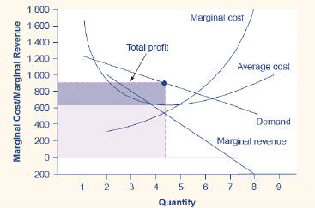

a - How does the monopolist determine the production level that will maximize profits? (Meaning what determines the quantity that the monopolist will produce?)

The maximum profits that can be achieved occur where demand intersects where marginal cost and marginal revenue are equal and intersect.

b - At this quantity how does the monopolist determine the price to charge in the market?

They determine the price to charge by looking at average cost at the marginal intersect and increasing that number to meet the demand curve.

c - In this situation does the monopolist earn economic profits?

Yes because demand is higher than the intersection of marginal cost and marginal revenue so the price can be moved up to meet demand.

1. In question five is the monopolist price higher than if the market were competitive?  Is price higher than MC?

Yes the price is higher than it would be because they have to meet demand and have found that they are most efficient at making the product at a cost that is lower than what demand requires so they have the ability to increase price to meet demand.

7.  Using The following graph and table:

A. What is the total profit of producing 4 units?

$900.00

B. What is total profit of producing at level 5 units?

$700.00

C. Which quantity should the monopolist choose to produce?

4

D.  What can you say about the relationship of MR and MC at the fifth unit?

MR has gone past being efficient and MC is also getting too high to be efficient.

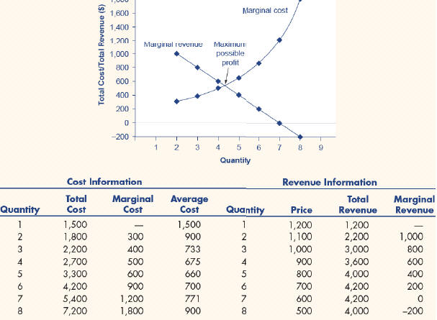

8.  The following exhibit, shows the profit maximizing quantity and resulting quantity, profit, total revenue and total cost for a monopoly market.

Using the following exhibit explain how the monopoly market’s results are different, when compared to what the results would have been if the market was in perfect competition:

As the market is monopolistic, the MR=MC equilibrium is at a point where in order to meet demand, there is an opportunity to increase the price dramatically because people will still demand it at that price, while the cost of producing it is relatively low. If it was a perfectly competitive market the other competitors would be able to eat away at the profit margin by increasing quantity supplied while keeping average cost relatively the same. This would cause individual profits to be lower because it is effectively lowering the demand curve from a monopolistic point of view.

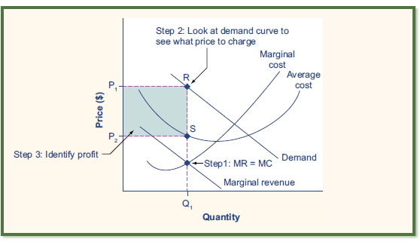

1. In general what is different in terms of quantity of output between the two markets?

In a monopolistic industry there is one supplier so quantity will always be higher for that one supplier than it would be in a perfectly competitive market.

1. In general what is different in terms of price in the two markets?

Price in both would be driven by the demand curve but in a perfectly competitive market the average cost would be closer to the price because there are many suppliers so their fixed costs would all compound resulting in more cost overall for the same quantity produced.

1. What does this mean in terms of producer and consumer surplus?

In a monopolistic market there would be a lot of producer surplus.

1. Which market would have greater net consumer and producer surplus?

Monopolistic would have greater producer surplus and perfectly competitive would have greater consumer surplus.

**Chapter 12**

**For your own study define the following terms:**

monopolistic competition. oligopoly, cartel

**Questions:**

Q1.  A monopolistic competitor has some elements of monopoly and some elements of competition. How does entry of additional monopolistic competitors into a market affect economic profits?

Economic profits will go down, naturally. There will be a considerable startup costs for any competitor and product differentiation will also play a part in limiting any profit losses for the main company.

Q2.  The textbook states, "Thus, a monopolistically competitive industry will produce too small a quantity of a good and charge a higher price for it than would a perfectly competitive industry."  Explain how this is means that monopolistic competition is not productively efficient?

The monopolistic industry is in a sense selfish. It is doing whats best for itself without thinking of whats best for everyone. In a perfectly competitive market, everyone is forced to think about everyone else so there tends to be a more productive and efficient use of resources.

Q3.  Does product differentiation in monopoly competition make us better or worse off? Why?

Overall product differentiation makes us worse off. There may be more choices but choosing between them becomes too difficult at a point and people will become confused.

Q4.  If you were an oligopolist and from only an economic standpoint would you want to act as a cartel?  Why?

I would operate as a cartel because it would essentially be the same as a monopoly while maybe being a bit less efficient and perhaps creating the illusion of competition. Cooperation would be key however in order to keep the prices high across the industry.

**Chapter 13**

Q1. Define antitrust laws.

Otherwise known as competition laws, they essentially make it very difficult for businesses to act nefariously and discourage predatory business practices.

Q2. Why is it in the interest of consumers to enforce antitrust laws? (Your answer should include how completion helps increase consumer surplus.)

Antitrust laws are there to protect the consumer. They make it so that predatory monopolies cannot exist and essentially extort money out of the consumer.