Examples

# Common Header

(2024-10-12)

#r "C:\projects\JXMath\JXMath\bin\Debug\net8.0\JXMath.dll"

#r "C:\projects\JXMath\JXMathWPF\bin\Debug\net8.0-windows\JXMathWPF.dll"

using static System.Console;

using JXMath;

using JXMathWPF;  
  
using static JXMath.Globals;

# Visualization

## Histogram

(2024-10-12, 2025-03-29)

var rv = new RandomVariableSet();

rv.Add_NormalRV(0, 1);

var data = rv.Sample(10000);

var histogram = new Histogram(data);

new HistogramViewer(histogram).ShowDialog();

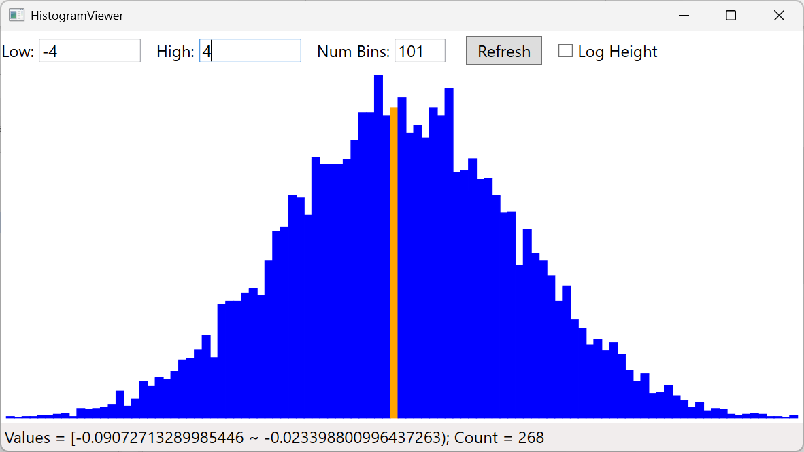

## XYPlot

(2025-05-04)

var x = MakeArray(-10, 0.01, 10);

Func<double, double> f = x => x * x;

var y = f.Eval(x);

var viewer = new XYPlot();

viewer.AddData(x, y, "y = x^2");

var x2 = MakeArray(0, 0.01, 10);

f = x => Math.Pow(x, 0.5);

y = f.Eval(x2);

viewer.AddData(x2, y, "y = sqrt(x)", "v");

f = x => Math.Pow(x, 3);

y = f.Eval(x);

viewer.AddData(x, y, "y = x^3", "g");

viewer.ShowDialog();

