**Using Tina Lag Block to Simulate the Op Amp Open Loop Response**

If Spice model is not available from the manufacturer, an op amp’s frequency response can be approximated by Tina’s lag block.

The following comes from the [TLV271 datasheet](tlv271.pdf):

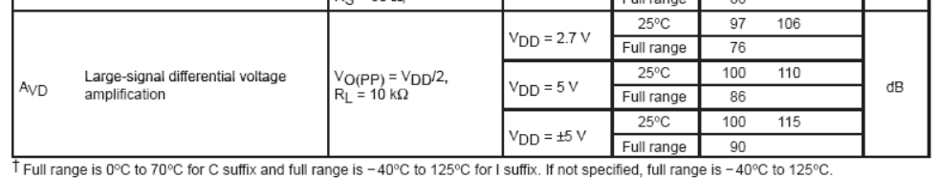

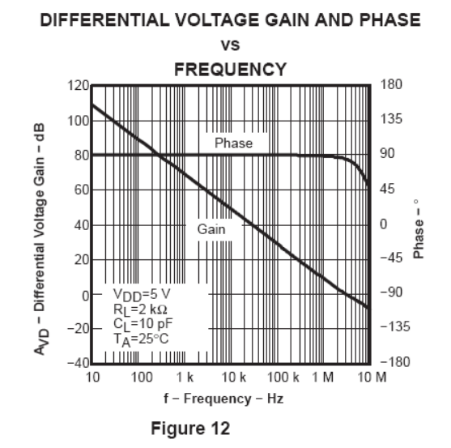

The open loop gain is taken to be 100 dB, the minimum value from the datasheet for VDD = 5V.

The frequency plot shows that the first pole is at around 1 Hz, or even earlier --- because by 10 Hz, the phase is already 90 degrees. The second pole is around 10 MHz

100 dB is a gain of 100,000. This is simulated using a voltage controlled voltage source.

To create a pole at 1 Hz, use a delay block and set the time constant to 1/(1*2*π) = 159ms

Tina circuit file is [here](amplifier_open_loop2.TSC)

Tina circuit screen shot:

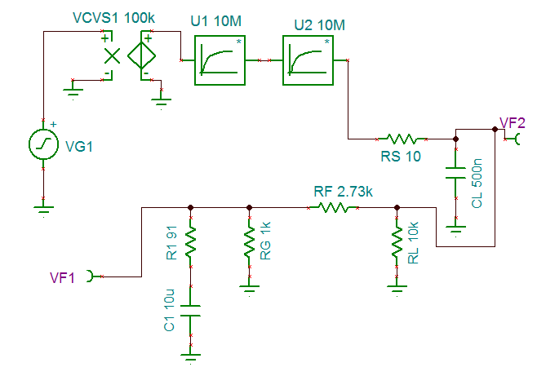

When the TI Spice model is used, loop gain becomes unity at 16 kHz, with a phase margin of 44 degrees.

With the Tina lag block, the loop gain becomes unity at 2.99 kHz, with a phase margin of 82 degrees. The difference is related to the quantity of the open loop gain. The shape of the Bode plots are the same though. So both models will lead to similar conclusions on what C1 and R1 should be used for compensation.

Bode plot using Tina’s lag model to simulate open loop gain:

