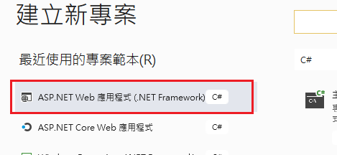

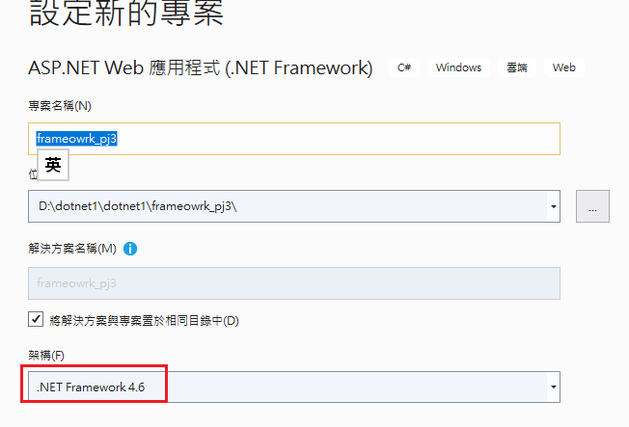

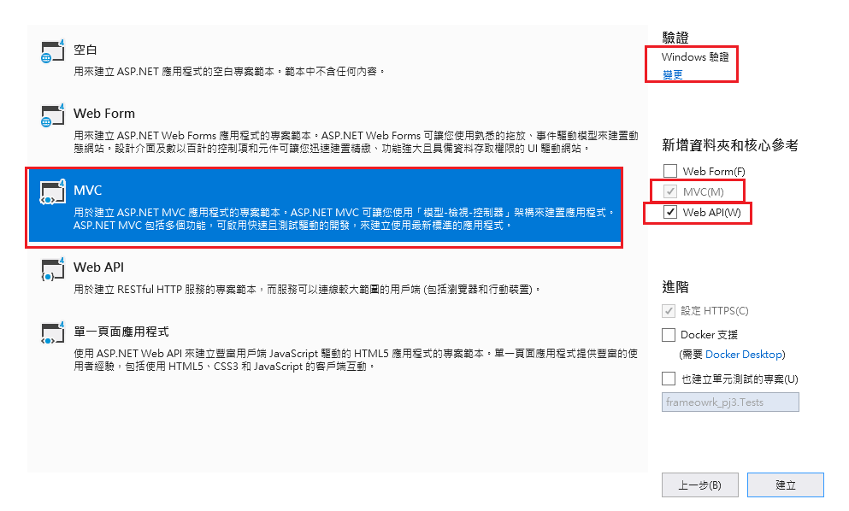

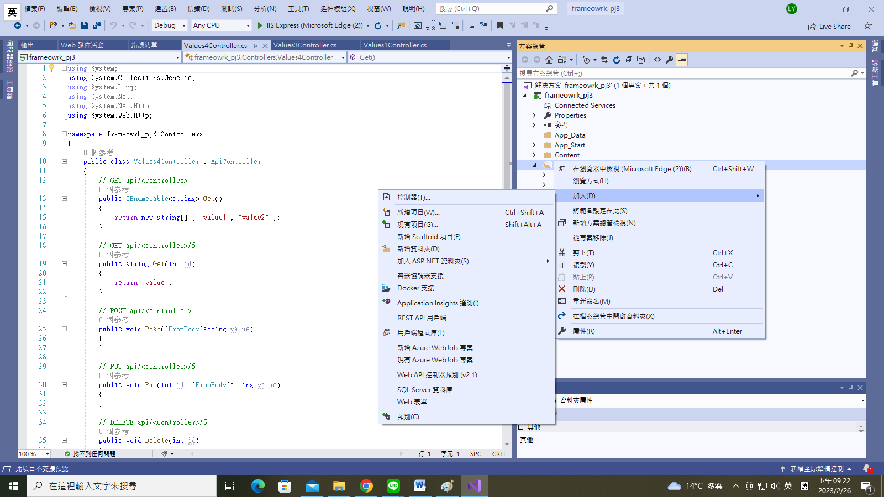

<https://localhost:44392/api/Values5>

https://blog.miniasp.com/post/2012/10/12/ASPNET-Web-API-Force-return-JSON-format-instead-of-XML-for-Google-Chrome-Firefox-Safari

Global.asax 檔案的 Application_Start()

public class MvcApplication : System.Web.HttpApplication

{

protected void Application_Start()

{

AreaRegistration.RegisterAllAreas();

GlobalConfiguration.Configure(WebApiConfig.Register);

FilterConfig.RegisterGlobalFilters(GlobalFilters.Filters);

RouteConfig.RegisterRoutes(RouteTable.Routes);

BundleConfig.RegisterBundles(BundleTable.Bundles);

GlobalConfiguration.Configuration.Formatters.XmlFormatter.SupportedMediaTypes.Clear();//這行

}

}