Energy Efficiency of Rover Locomotion on Granular Terrain: A Comparative Modeling Study
Oliver Cheng¹, Yolanda Fan², and Yixuan Liang³
¹Sage Hill School, chengoliver86@gmail.com
²Concord Academy, yolandafan22@gmail.com
³Oaks Christian School, louisyixuan0921@gmail.com

Abstract
Energy availability constrains the range, science return, and survivability of planetary rovers. This study compares conventional rolling, inchworming, and screw-propelled locomotion using cost of transport and dimensionless scaling relations for cohesionless granular media. The analysis is a secondary-data modeling study: wheel parameters are refitted to seven rolling and four inchworming markers in GRC-1, and the helical benchmark uses ten published measured–predicted pairs in BP-1. The original two-term traction closure is retained, with travel reduction distinguished from kinematic wheel slip. Motion resistance, actuator overhead, terrain slope, and 10,000 paired scenario draws are included. At flat-ground duty 0.10, the baseline scenario medians are 0.250 for rolling and 0.168 for inchworming, a 32.7% reduction conditional on the assumed resistance and power closures. The resistance-halving assumption is tested separately rather than treated as a measured property. A complementary check of published whole-vehicle energy curves gives 3.0% and 5.2% held-out mean absolute percentage error when observed travel reduction is supplied. Published helical scaling predictions give 3.9% power and 5.3% speed error. The modeled duty and slope walls remain extrapolations, and energy boundaries differ between studies. The evidence supports terrain-dependent use of inchworming as a complement to rolling, while leaving a universal three-mode ranking and Mars performance limits unresolved.
Keywords: planetary rover; granular locomotion; inchworm locomotion; screw-propelled vehicle; cost of transport; dimensional analysis; scenario sensitivity; Mars

1. Introduction
Surface mobility is an energy-management problem as much as a mechanical-design problem. A rover must convert limited stored or generated energy into scientifically useful displacement while preserving margin for thermal control, communications, computation, and instruments. Solar irradiance at the mean orbital distance of Mars is approximately 43% of that at Earth—not “43% less”—and atmospheric dust can further reduce photovoltaic output and deposit material on panels [3]. Although radioisotope power systems reduce dependence on sunlight, the power available to mobility remains finite. Reducing the energy required per unit weight and distance can therefore increase traversable range or preserve energy for science operations.
Wheeled locomotion remains the dominant architecture for Mars rovers because it is mechanically mature, controllable, and efficient on competent terrain [5], [10]. Its weakness appears on loose granular surfaces and slopes, where sinkage and slip dissipate energy and can lead to immobilization [4]–[6]. The same wheel rotation then produces less forward travel, while the powertrain continues to consume energy. A mobility design that increases drawbar pull at a given slip—or achieves the required traction at lower slip—may improve both energy efficiency and operational robustness.
Inchworming, also called push–pull or inching locomotion, alternates between anchored and moving wheel groups. The anchored group develops a stable soil wedge while the other group advances; the roles then switch [7]–[9]. Experiments with the Scarab rover showed that this gait can increase traction and recovery capability, especially under high drawbar demand. It is not intended to replace rolling in every situation: cyclic actuation is slower and introduces actuator losses. Its potential value is task-dependent.
Screw-propelled vehicles (SPVs) use counter-rotating helical pontoons that continuously engage the granular medium. They can remain mobile in very loose soils in which conventional wheels lose traction [12], [20]. Their three-dimensional soil deformation and large sheared volume, however, can require substantial mechanical power. Their practical value may therefore lie in terrain accessibility rather than minimum energy use.

1.1 Research gap
The literature establishes the mechanics of each mode separately, but it does not provide a fully controlled, same-platform comparison of rolling, inchworming, and screw propulsion under identical mass, geometry, soil, gravity, speed, and external load. Directly comparing raw power values from different experiments would be misleading. This study addresses part of that gap by using the dimensionless cost of transport (CoT) and dynamically similar scaling families. It also makes the remaining non-comparabilities explicit rather than treating them as negligible.

1.2 Research question and contribution
The research question is: Within the range supported by published experiments, how does the modeled mechanical energy efficiency of rolling, inchworming, and screw-propelled locomotion change with transport duty and slope on cohesionless granular terrain?
The study contributes four elements:
- a corrected dimensional-accounting framework for wheel, inchworm, and helical locomotion;
- a common CoT formulation that separates scale invariance from cross-design equality;
- paired scenario-sensitivity propagation for rolling–inchworming comparisons; and
- an evidence-calibrated interpretation that distinguishes controlled wheel comparisons from the exploratory SPV benchmark.
The primary hypothesis is that inchworming will have lower CoT than rolling as duty and slope increase. The SPV analysis is treated as exploratory because only zero-duty data from a different test series are available.

2. Materials and Methods

2.1 Study design and evidence base
This is a comparative modeling study based on digitized results reported in prior experiments. It does not contain new rover tests. Seven rolling and four inchworming markers were reconstructed from Moreland et al. [7], Figure 4. The screw benchmark uses ten measured–predicted pairs for HGSL2 and HGSL3 from Thoesen et al. [20], Figure 4. The earlier dissertation [12] provides research context. A complementary energy check uses the whole-vehicle power-number curves in the NASA technical report [22].
The rolling–inchworming comparison is relatively strong because both modes originate from the same study and share a wheel platform and medium. The SPV comparison is weaker because the data come from another apparatus, another locomotor geometry, and zero external duty. Dimensional similarity can transfer performance within a geometrically and materially similar family; it does not erase differences among media, drivetrain definitions, or locomotion mechanisms.

2.2 Locomotion architectures
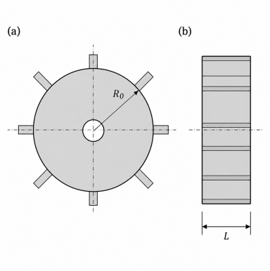
Straight-grouser wheel geometry used as the rolling reference.
Figure 1. Straight-grouser wheel geometry. The characteristic cross-sectional length and wheel width enter the scaling model.
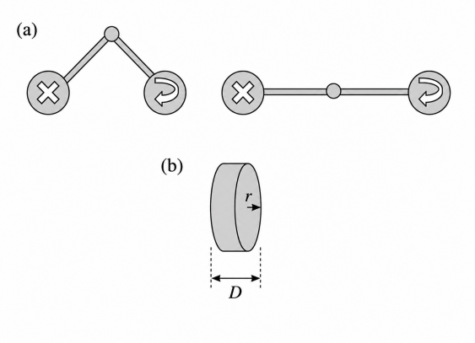
Scarab-type inchworm sequence showing alternating locked and rolling wheel groups.
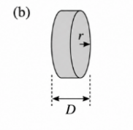
Companion wheel-state schematic for the inchworm cycle.
Figure 2. Inchworming concept. Locked wheels are anchors while the opposing wheel group advances; the groups alternate during a gait cycle [7]–[9].
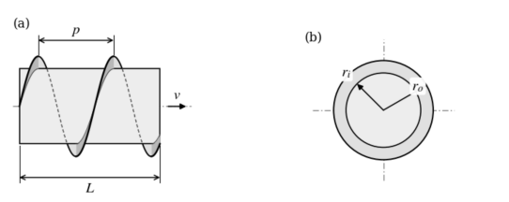
Screw-propelled vehicle geometry.
Figure 3. Screw-propelled vehicle. Counter-rotating helices generate axial thrust by shearing the surrounding granular medium [12], [20].

2.3 Variables and performance metric
Table 1. Principal variables
Symbol | Definition | Units
$P$, $V$ | time-averaged mechanical power and forward velocity | W; m s⁻¹
$M$, $g$ | vehicle mass and gravitational acceleration | kg; m s⁻²
$L$, $D$ | wheel characteristic length and width | m
$ω$, $t$ | wheel/screw angular speed and time | s⁻¹; s
$$ξ$$ | RFT stress-gradient parameter in $σ=α_{RFT}ξ\left|z\right|$ | N m⁻³
$μ$, $μ_{s}$ | grain–intruder and internal friction coefficients | dimensionless
$W_{0}$, $Δ$, $H$ | nominal wheelbase, wheelbase stroke, and body stroke | m
$Ω$, $γ$ | gait frequency and dimensionless gait definition | s⁻¹; dimensionless
$p$, $r_{i}$, $r_{o}$, $l$ | helical pitch, inner/outer radius, and screw length | m
$$ρ$$ | bulk density of the granular medium | kg m⁻³
$i, T$, $d$, $f_{r}$ | slip ratio, source-defined travel reduction, demanded duty, and motion-resistance coefficient | dimensionless
$$θ$$ | terrain slope | degrees or radians as stated
Mechanical cost of transport is defined as [16]
$$CoT=\frac{⟨P⟩}{Mg⟨V⟩}.$$
CoT is dimensionless and measures energy per unit weight per unit distance. Lower values indicate less mechanical energy used for the same supported weight and travel distance. This definition excludes solar conversion efficiency, battery losses, avionics, thermal loads, and most drivetrain losses unless they are already included in the source power measurement. Results should therefore be interpreted as locomotion-mechanics efficiency, not total mission energy. Power and velocity must be averaged over the same interval with positive net advance, preferably over complete gait cycles. The whole-vehicle electrical power number in [22] and mechanical shaft power in [20] use different measurement boundaries and are analyzed separately.

2.4 Assumptions and scope conditions
The model represents a dry, homogeneous, cohesionless granular bed. Grain-scale cohesion, electrostatics, moisture, crusts, rocks, wheel wear, thermal effects, transient acceleration, steering, and repeated-track compaction are omitted. RFT assumes that local intrusion stresses can be integrated over the locomotor surface and that the granular resistance gradient is proportional to gravity for a fixed material state [14], [15]. These assumptions are most defensible in a quasi-static or moderate-speed regime and may fail when inertial, cohesive, or nonlocal grain effects dominate.
GRC-1 is a silica-sand-based terrain-strength simulant [11], whereas BP-1 is crushed basalt [20]. They are not interchangeable. Their use in separate studies supports qualitative comparison only and does not justify transferring a numerical SPV value to GRC-1 or a particular Mars landing site.

2.5 Corrected dimensional analysis

2.5.1 Rolling
For rolling, power and velocity are represented as
$$\left[P,V\right]=h\left(D,L,M,ω,ξ,μ,μ_{s},g,t;f\right),$$
where $f$ denotes dimensionless wheel shape. Counting the two outputs, the dimensional and dimensionless quantities yields nine independent Π groups after reduction by the three base dimensions $M$, $L$, and $T$. A convenient representation is
$$\left[\frac{P}{Mg\sqrt{Lg}},\frac{V}{\sqrt{Lg}}\right]=Ψ​\left(t\sqrt{\frac{g}{L}},f,\frac{g}{Lω^{2}},\frac{ξDL^{2}}{Mg},μ,μ_{s},\frac{D}{L}\right).$$
Under the RFT width-linearity assumption, D enters the force scale linearly and the independent D/L dependence can be suppressed, but the group must first be identified. Full geometric similarity additionally requires s = r³; the stated width reduction is the extra RFT assumption that permits other mass-to-length scalings [14], [15].
For positive scale factors $r$, $s$, and $q$ applied to length, mass, and gravity,
$$\left(L',M',D',ω',g',t'\right)=\left(rL,sM,sr^{-2}D,\sqrt{\frac{q}{r}}ω,qg,\sqrt{\frac{r}{q}}t\right),$$
with $ξ'=qξ$ for a fixed granular material. Dynamic similarity then gives
$$⟨P'⟩=q^{3/2}r^{1/2}s⟨P⟩, ⟨V'⟩=q^{1/2}r^{1/2}⟨V⟩.$$

2.5.2 Inchworming
The inchworm model adds geometrically scaled gait variables:
$$\left[P,V\right]=h_{iw}\left(L,D,W_{0},Δ,H,M,ω,Ω,ξ,g,t;f,γ\right).$$
The dimensionless description includes $W_{0}/L$, $Δ/L$, $H/L$, and $Ω/ω$, in addition to the rolling groups. The complete Π bookkeeping gives twelve independent groups when outputs and the two dimensionless descriptors are counted; one group, $D/L$, is removed only after invoking RFT width linearity. Under
$$\left(W_{0}',Δ',H',Ω'\right)=\left(rW_{0},rΔ,rH,\sqrt{q/r} Ω\right),$$
all gait ratios remain invariant, and the same dimensional scaling for $P$ and $V$ follows. This result means that a dynamically similar inchworm family preserves CoT. It does not mean that rolling and inchworming have equal CoT; their dimensionless response functions differ.

2.5.3 Screw propulsion
For a helical craft with pitch $p$, radii $r_{i}$ and $r_{o}$, length $l$, and medium density $ρ$,
$$\left[\frac{P}{Mg\sqrt{pg}},\frac{V}{\sqrt{pg}}\right]=Ψ_{SPV}​\left(\frac{r_{i}}{p},\frac{r_{o}}{p},\frac{l}{p},\frac{ρp^{3}}{M},μ,μ_{s},\frac{g}{pω^{2}},t\sqrt{\frac{g}{p}}\right).$$
With $p'=ap$, $M'=bM$, $l'=\left(b/a^{2}\right)l$, $g'=qg$, and $ω'=\sqrt{q/a} ω$, the product $ρlp^{2}/M$ remains invariant. The predicted transformations are
$$V'=q^{1/2}a^{1/2}V, P'=q^{3/2}ba^{1/2}P.$$
The helical experiments support approximate within-family scaling [20]. Because the screw flow field is genuinely three-dimensional, this reduction is an empirical scaling approximation rather than proof that wheel RFT applies unchanged to helices. The transformation also requires $r_{i}$′ = a$r_{i}$ and $r_{o}$′ = a$r_{o}$ to preserve both radius-to-pitch ratios. Preserving the product ρlp²/M does not separately preserve l/p and ρp³/M unless b = a³. Suppressing their separate effects is an additional approximation to be checked against the helical experiments.

2.5.4 CoT invariance
Substitution of the dynamically similar transformations into CoT yields
$$CoT'=\frac{⟨P'⟩}{M'g'⟨V'⟩}=CoT$$
for each locomotion family under its own similarity conditions. This is the basis for transferring a geometrically similar laboratory result across size and gravity. It is not a license to transfer between different soils or locomotion architectures without additional validation.

2.6 Traction, travel reduction, and duty model
Kinematic wheel slip retains its usual definition:
$$i=1-\frac{V}{Rω},$$
Here i = 0 is ideal rolling and i = 1 is zero forward speed. The source traction curves instead use travel reduction T = 1 − ⟨V⟩/$V_{ref}$ relative to the source self-propelled reference [7]. Consequently T, not i, is used in the fitted closure below. Net traction is normalized as φ = DP/W, with W = Mg, and demanded transport duty is d = DP*/W.
A two-term closure was fitted to the rolling data:
$$φ_{roll}\left(T\right)=α\left(1-e^{-T/K}\right)+βT.$$
The inchworm closure is
$$φ_{iw}\left(T\right)=λφ_{roll}\left(T\right), λ=1.888.$$
For flat terrain, the operating travel reduction is obtained by solving φ(T) = d. Define normalized reference-speed power as Q = ⟨P⟩/(W $V_{ref}$). The retained CoT expressions are reduced energy scenarios: they assume $Q_{roll}$ = d + $f_{r}$ and $Q_{iw}$ = (d + η$f_{r}$)(1 + $ε_{act}$), then apply CoT = Q/(1 − T). Net drawbar data do not independently measure Q. With these explicit closures,
$${CoT}_{roll}\left(d\right)=\frac{d+f_{r}}{1-T_{roll}\left(d\right)},$$
$${CoT}_{iw}\left(d\right)=\frac{d+ηf_{r}}{1-T_{iw}\left(d\right)}\left(1+ϵ_{act}\right),$$
Here $ε_{act}$ is the inchworm actuator-overhead factor and η is an effective resistance factor. The original $f_{r}$/2 term is recovered at η = 0.5, used for the baseline. Alternating anchored wheels alone does not establish whole-cycle energy halving. A separate sensitivity analysis varies η from 0.5 to 1; these are selected scenario bounds, not experimentally estimated limits. Classical terramechanics motivates separating drawbar demand from motion resistance [18], [19], but does not identify these numerical energy parameters.
For a slope θ, assuming that the same traction closure transfers under normal-load normalization gives
$$φ\left(T\right)=tanθ+\frac{d}{cosθ}.$$
This normal-load transfer is an additional assumption beyond the flat-bed calibration. The retained slope-dependent energy scenarios are
$${CoT}_{roll}\left(d,θ\right)=\frac{sinθ+d+f_{r}cosθ}{1-T_{roll}\left(d,θ\right)},$$
$${CoT}_{iw}\left(d,θ\right)=\frac{sinθ+d+η\left(f_{r}cosθ\right)}{1-T_{iw}\left(d,θ\right)}\left(1+ϵ_{act}\right).$$
For the SPV, only the free-running benchmark is reconstructed. If a monotonic duty response is assumed, one would write
$${CoT}_{SPV}\left(d\right)≥{CoT}_{SPV}\left(0\right), d≥0,$$
as a scenario hypothesis. It is not established by the zero-duty data, so no loaded SPV curve or cross-study energy crossover is inferred.

2.7 Parameter estimation and scenario sensitivity
The fitted and assumed parameters are listed in Table 2. A single-term exponential saturation baseline, motivated by classical shear-mobilization relationships [17]–[19], is compared with the retained two-term closure. The parameters are fitted to seven rolling and four inchworming markers; they describe this small reconstructed dataset and do not identify a unique constitutive soil law.
Table 2. Model parameters
Symbol | Value or range | Role | Source/treatment
$$α$$ | 0.0718 | exponential traction amplitude | fit to seven rolling markers [7]
$$K$$ | 0.0175 | travel-reduction mobilization constant | fit to seven rolling markers [7]
$$β$$ | 0.1392 | high-travel-reduction linear term | fit to seven rolling markers [7]
$$λ$$ | 1.888 | inchworm traction multiplier | multiplier fit to four inchworm markers [7]
$$f_{r}$$ | 0.05–0.15; nominal 0.05 | motion resistance | assumed scenario range; not estimated from [18], [19]
$$ϵ_{act}$$ | 0.05–0.15; nominal 0.10 | inchworm actuator surcharge | assumed range; sensitivity parameter
All wheel CoT scenarios were evaluated in base MATLAB R2026a. Positive traction parameters were fitted by multistart nonlinear least squares using fminsearch, and the inchworm multiplier was fitted to its four markers. A bracketed root finder solved T ∈ [0,1). The baseline keeps η = 0.5 and samples $f_{r}$ uniformly from 0.05–0.15 and $ε_{act}$ from 0.05–0.15. Each draw supplies both modes, preserving paired comparisons. Fitted traction parameters remain fixed: the reported 5th–95th percentiles measure selected energy-parameter sensitivity, not fitted-parameter uncertainty or experimental confidence.
The analysis uses 10,000 draws with random seed 20260922. An expanded sensitivity case also samples η uniformly from 0.5–1. Values outside each mode’s observed travel-reduction range are marked as extrapolations. Robustness within either chosen scenario set does not establish robustness to unmodeled soil, geometry or actuator behavior.

2.8 Reproducibility and reporting boundaries
The accompanying package contains the source-derived points, coordinate mappings and reading bounds, fitted parameters, MATLAB code, random seed, solver tolerances, scenario draws, numerical outputs and execution logs. Graphical extraction bounds describe reading sensitivity, not trial-level confidence. Figure markers and time samples are not independent replicate experiments. All model computations were run in MATLAB; Python supports source extraction and document preparation.
For a complementary energy check, 16 time-matched rolling observations were reconstructed from [22], Figures 11–12. For each tire, Q0 = median[PN(1 − T)] at 20, 30 and 40 s predicts PN = Q0/(1 − T) at 50, 60, 70 and 80 s using observed T. The 10 s point is diagnostic. The source PN uses a 6 s moving average, so this checks an approximate conditional relationship; it does not validate the assumed duty-dependent Q in Section 2.6. The four later samples per tire are correlated within the same experiment. The helical check compares published scaling predictions with ten measured means [20]. The source power includes vehicle actuation and hotel loads [22], unlike the mechanical-power proxy in Section 2.6.

3. Results

3.1 Traction closure
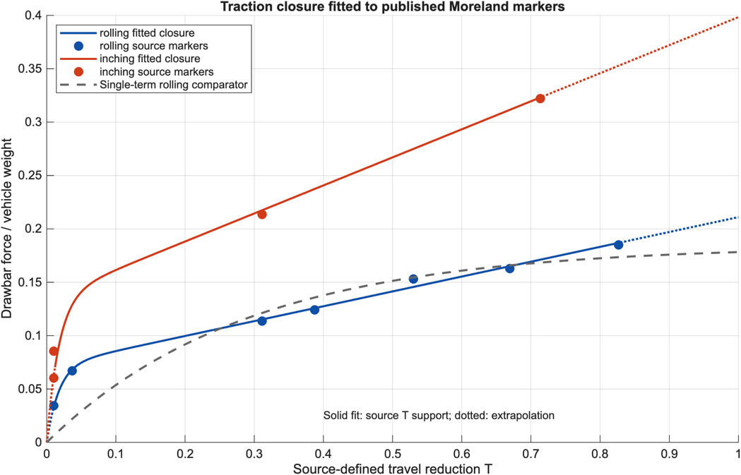
Reconstructed drawbar-pull ratio versus travel reduction and fitted rolling/inchworming closures.
Figure 4. Net traction coefficient versus source-defined travel reduction. The original two-term functional form is refitted to seven rolling and four inchworming markers [7]. Solid portions lie within observed travel-reduction support; dotted portions are extrapolations. The dashed curve is the single-term rolling comparator.
The fitted multiplier λ = 1.888 indicates greater net traction at a given travel reduction within this source. The two-term rolling fit has drawbar-ratio RMSE 0.0032, compared with 0.0212 for the single-term baseline; inchworm RMSE is 0.0116. These are fit residuals, not independent experimental validation.

3.2 Flat-ground duty sweep
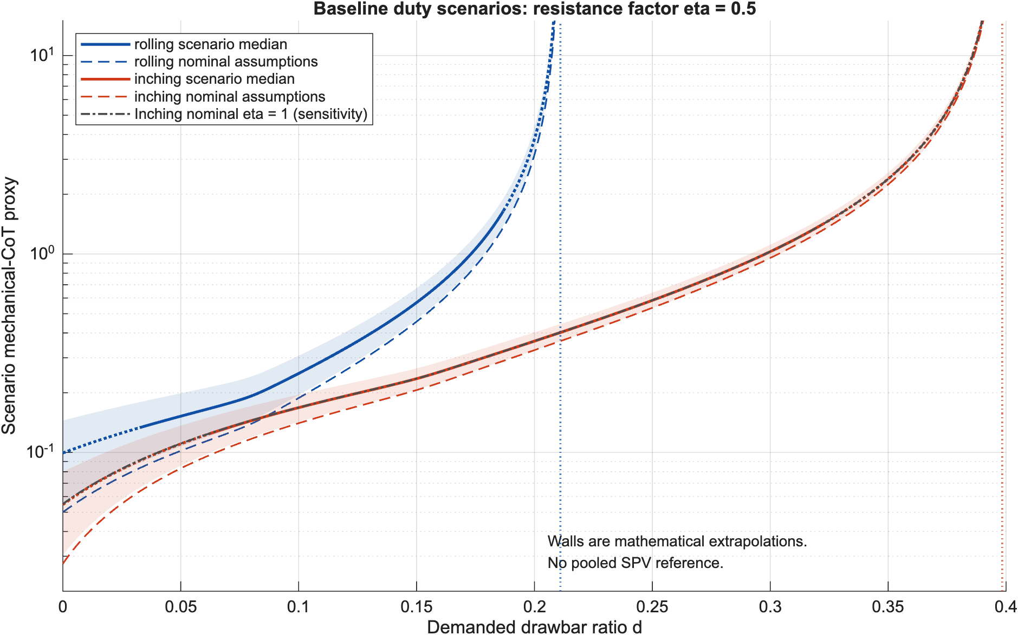
Scenario cost of transport as a function of demanded duty.
Figure 5. Modeled CoT proxy versus duty using the retained baseline η = 0.5. Shading shows 5th–95th scenario percentiles with fixed traction fits. Solid medians lie within observed travel-reduction support; dotted portions extrapolate it. Dashed curves use nominal inputs; the gray dash-dot curve additionally sets η = 1. Vertical lines mark mathematical T = 1 walls. SPV is reported separately in Figure 7 because its energy boundary and medium differ.
Table 3 reports the duty anchors. At d = 0.10, baseline scenario medians are 0.250 for rolling and 0.168 for inchworming. Their relative difference is approximately
$$1-\frac{0.1682}{0.2501}≈0.327,$$
or 32.7%. At d = 0.15, the ratio of scenario medians gives 58.6%. These percentages depend on the assumed input-power closures and η = 0.5. The widening difference occurs because rolling approaches the high-travel-reduction region sooner, causing its denominator 1 − T to shrink. They are scenario estimates, not measured energy savings.
Table 3. Modeled CoT proxies (baseline median [5th, 95th scenario percentile])
Duty $d$ | Rolling CoT | Inchworming CoT | SPV CoT
0.00 | 0.099 [0.055, 0.145]† | 0.055 [0.030, 0.080]† | not pooled; Fig. 7
0.05 | 0.152 [0.107, 0.199] | 0.110 [0.086, 0.137]† | —
0.10 | 0.250 [0.195, 0.307] | 0.168 [0.143, 0.196] | —
0.15 | 0.569 [0.468, 0.673] | 0.235 [0.207, 0.265] | —
0.20 | 3.790 [3.229, 4.365]† | 0.364 [0.327, 0.403] | —
Mathematical duty wall† | d = 0.211† | d = 0.398† | not estimated
†Travel-reduction extrapolation beyond the digitized support; energy values at all duties additionally assume the Section 2.6 closures. Zero duty extrapolates both modes and d = 0.05 extrapolates inchworming. The wall is the fixed-fit T = 1 boundary, not a measured maximum. SPV absolute CoT is not pooled across the two reconstructed prototypes.
The mathematical duty walls are 0.211 for rolling and 0.398 for inchworming. The largest observed drawbar ratios are only 0.185 and 0.322, respectively. Thus the wall values describe continuation of the fitted functions and are not experimentally verified load capacities.

3.3 Slope sweep
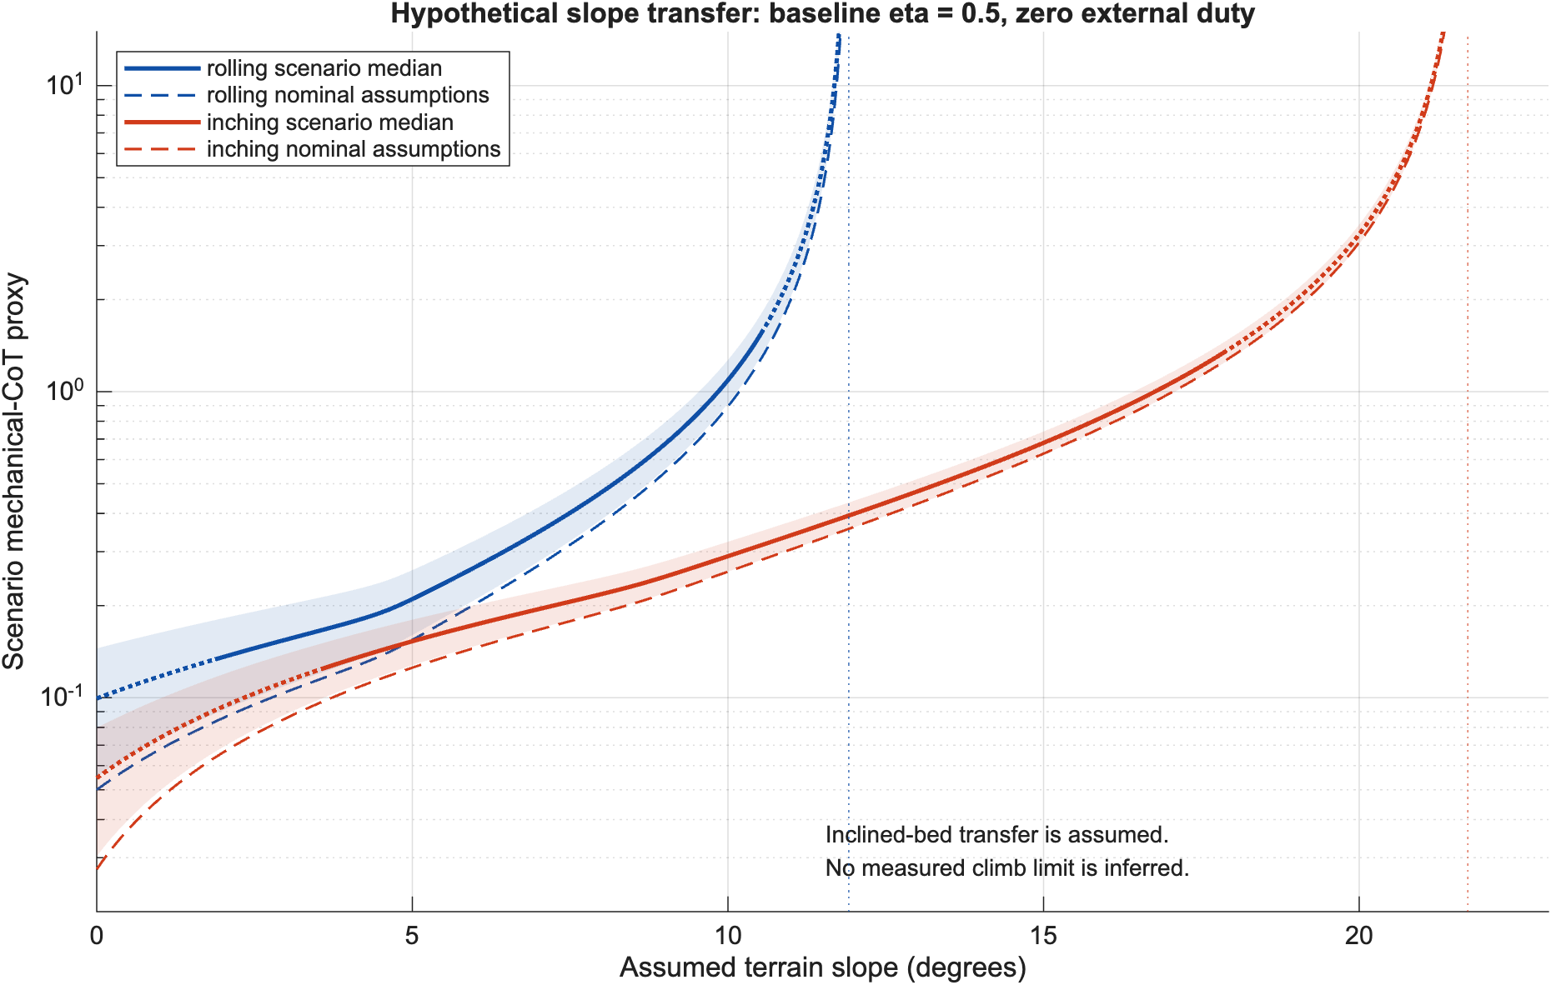
Scenario cost of transport versus slope angle.
Figure 6. Modeled CoT proxy versus slope at zero external duty. The original gravity-demand and resistance structure is retained. All slope predictions transfer a flat-bed closure under an assumed normal-load scaling; dotted sections additionally exceed source travel-reduction support. Vertical walls are mathematical extrapolations.
The extrapolated T = 1 slope walls are 11.9° for rolling and 21.7° for inchworming. These fixed-fit values are design-screening outputs, not measured climb limits or confidence intervals. The original slope formula assumes that flat-bed traction transfers after normal-load normalization. Inclined-bed data are therefore required to validate it.

3.4 Screw-propelled benchmark
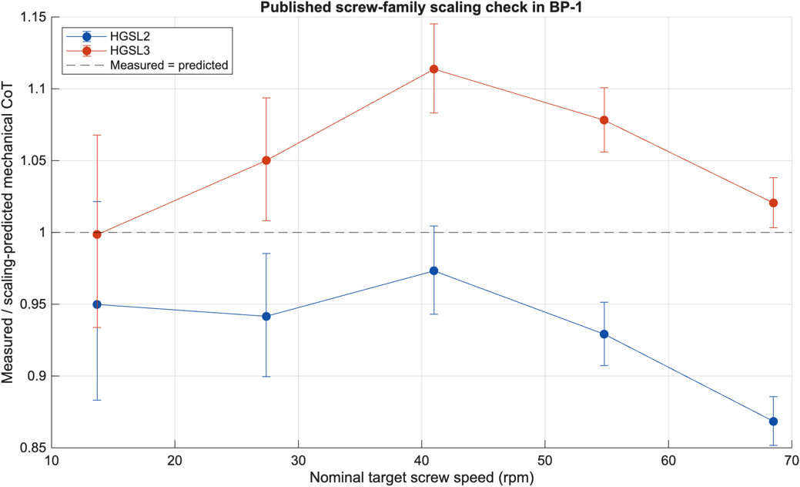
Mechanical CoT scaling check for the reconstructed helical prototype pairs.
Figure 7. Measured-to-predicted mechanical CoT ratios for HGSL2 and HGSL3 reconstructed from [20], Figure 4. The ratio uses paired power and velocity and cancels mass. Unity denotes agreement with the published scaling prediction. Points are published prototype means; error bars propagate graphical extraction bounds, not experimental confidence intervals.
Across ten paired observations, the published helical scaling predictions have pooled mean absolute percentage errors of 3.9% in shaft power, 5.3% in speed and 6.1% in CoT. This supports approximate scaling within the tested BP-1 family [20]. The main comparison uses the measured-to-predicted CoT ratio because the source parameter table omits mass-unit labels. Absolute CoT under a kilogram interpretation is retained only as a conditional supplemental calculation. Absolute CoT is not pooled across these prototypes to rank the wheel and helical modes.
The available evidence does not exclude a different result in terrain where wheels become immobile but helices continue moving. In that regime, a finite high CoT may be operationally preferable to zero mobility.

3.5 Robustness summary
The baseline and expanded resistance scenarios are reported separately. In both, the fitted traction advantage contributes to the modeled ordering, while the assumed resistance reduction and actuator surcharge determine the energy margin. Keeping the original η = 0.5 model does not establish that resistance energy is physically halved. The strongest remaining uncertainties are the duty-dependent power closures, gait-dependent losses and transfer between soils; the selected Monte Carlo percentiles do not include them all. At d = 0.10, expanding η to 0.5–1 gives a median paired reduction of 21.0% [10.5, 32.8] across the selected scenarios. Some expanded low-duty cases reverse the ordering; those low-duty inchworm predictions extend below the observed travel-reduction range.
The complementary whole-vehicle PN check gives held-out MAPE of 3.0% for pneumatic tires and 5.2% for rigid tires (Figure 8). All eight predictions are below the reconstructed observations; the mean held-out Q proxy drifts upward by 3.1% and 5.5%, respectively. These within-experiment checks use measured travel reduction and a separately calibrated Q0; they do not independently validate the mechanical duty curves in Figures 5–6.
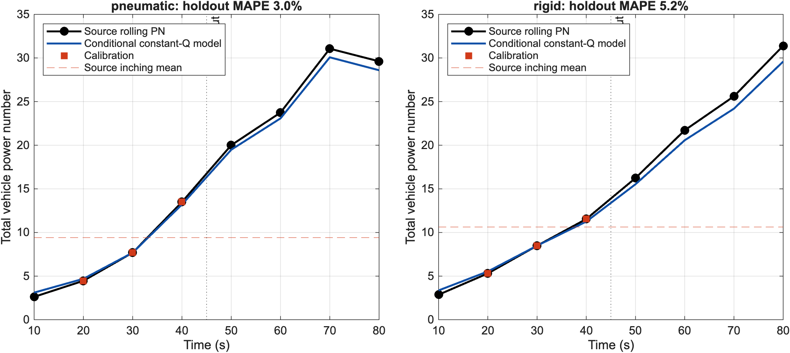
Figure 8. Complementary check against published whole-vehicle power-number curves [22]. Q0 is calibrated at 20–40 s and predicts later PN using observed travel reduction. This within-experiment check concerns a different energy boundary and does not validate the assumed mechanical duty closures in Figures 5–6.

4. Discussion

4.1 Interpretation of the wheel comparison
The central result is conditional but useful: for the tested platform, inchworming develops greater net traction at a given source-defined travel reduction than rolling. In the retained energy scenarios, CoT scales as the assumed normalized input power divided by 1 − T. Loss of forward progress can therefore amplify transport cost near a traction limit, but traction improvement by itself does not specify the consumed power.
The result does not imply that inchworming should be used continuously. Rolling avoids repeated chassis articulation and is likely faster on low-resistance terrain. Inchworming becomes attractive when rolling slip, drawbar demand, or slope approaches a threshold at which additional wheel speed mostly shears soil. The engineering question is therefore not “Which mode wins everywhere?” but “When should the rover switch modes?”

4.2 Hybrid mobility implication
A practical controller could use rolling as the default and trigger inchworming when one or more observable indicators exceed calibrated thresholds:
- sustained slip above a threshold over several wheel rotations;
- increasing motor current without proportional forward velocity;
- estimated drawbar duty approaching the empirically established rolling operating boundary;
- wheel sinkage or pitch/roll indicating a high-risk slope; or
- repeated failure of conventional traction-control actions.
The controller should include hysteresis so that noise does not cause rapid switching. It should also consider the energy and time required to enter, execute, and exit the gait. A mission-relevant optimization would minimize total energy to complete a traverse subject to immobilization risk and time constraints, not instantaneous CoT alone.

4.3 Interpretation of screw propulsion
The SPV benchmark must remain separate from the wheel scenarios. Helical motion produces a three-dimensional soil flow, and its scaling has been examined experimentally [20]. Energy efficiency and terrain accessibility are different objectives. A multi-objective comparison should include minimum traversable bearing strength, maximum sustainable drawbar pull, turning radius, disturbance to the terrain, mechanical complexity, sealing, wear, and fault tolerance. The available measurements do not isolate which of those factors causes an energy difference from wheels.
Accordingly, the present data support neither a universal SPV penalty nor a reason to discard screw propulsion. Its energy competitiveness requires a comparison with the same task, terrain and measurement boundary.

4.4 Mars relevance
Dimensionless scaling is valuable because it identifies conditions under which Earth tests can inform lower-gravity performance [14], [20], [21]. Its validity depends on matching the relevant Π groups and on retaining the same constitutive regime. Martian soils may contain cohesion, cemented crusts, broad particle-size distributions, angular grains, electrostatic effects, and rocks. If cohesion does not scale with gravity, its relative importance increases in low gravity and breaks the simple $ξ∝g$ assumption [21]. A credible Mars claim therefore requires tests across representative simulants and, ideally, reduced-gravity experiments or validated DEM/MBD simulations.

4.5 Threats to validity

Internal validity
Only eleven wheel markers were reconstructed, and digitization errors may be correlated. The two-term closure is flexible relative to this sample size, and no trial-level uncertainty is inferred from the markers. Motion resistance, its inchworm reduction, and the actuator surcharge remain selected model assumptions. Mathematical walls extend beyond observed support. The scenario bands hold traction fits fixed and therefore exclude fit and extrapolation uncertainty.

Construct validity
Mechanical CoT does not include the full electrical energy chain or mission overhead. A slower gait may have low mechanical CoT yet increase thermal, computing, and time-dependent energy use. Conversely, measured motor electrical power may include losses that are omitted from an ideal mechanical model. The conditional power-number check uses whole-vehicle input and cannot supply the missing mechanical-power calibration for the duty model.

External validity
The experiments use simulants under Earth laboratory conditions. GRC-1 and BP-1 are not interchangeable, and neither captures every Martian terrain state. Results cannot be generalized to cohesive dust, rock fields, crusted surfaces, or high-speed operation without validation.

Comparative validity
The SPV benchmark differs in medium, apparatus, geometry, and duty. Its uncertainty is not paired with the wheel model. It should remain a contextual benchmark until all three architectures are tested under a common protocol.

4.6 Required validation study
The next experiment should use a factorial, same-bed design. Each locomotion mode should be tested at matched supported mass, normalized geometry, speed group, and duty in at least two simulants and on multiple slopes. Repeated runs should randomize mode order and recondition the bed between trials. Measurements should include mechanical and electrical power, velocity, slip, sinkage, drawbar pull, actuator-cycle energy, and soil disturbance. A preregistered analysis should report effect sizes and uncertainty rather than only best-case curves.
A minimum comparison matrix would include duties of 0, 0.05, 0.10, 0.15, and values near each mode’s feasible boundary; slopes of 0°, 5°, 10°, 15°, and 20° where feasible; and at least three independent bed preparations per condition. SPV testing at nonzero duty is essential. These data would permit a hierarchical model that separates mode effects from simulant, slope, and repeated-bed variability.

5. Conclusions
Our work supports three conclusions.
First, the original two-term traction and duty-model structure remains useful for conditional comparison. The refitted multiplier is 1.888, and at duty 0.10 the baseline scenario median inchworm CoT proxy is 32.7% lower than rolling. This is a result of the fitted traction curve together with explicit resistance and power assumptions, rather than a directly measured energy saving. The extrapolated duty and slope walls do not establish physical operating limits.
Second, these are model-supported estimates, not direct Mars performance measurements. The small digitized dataset, assumed motion-resistance reduction, actuator-overhead range, and extrapolated mathematical walls limit numerical certainty. “Robust within the selected scenario ranges” is the correct interpretation; “proved for Martian terrain” is not.
Third, the SPV result is exploratory. The published helical predictions agree approximately with measured means within the tested family, but cross-study differences prevent a universal three-way ranking. Screw propulsion may still be valuable when terrain accessibility dominates energy efficiency.
The most defensible design recommendation is a hybrid rolling–inchworming rover: roll during low-demand travel, monitor slip and energy indicators, and activate inchworming when the rolling mode approaches a traction or slope threshold. A controlled same-bed experiment is required before deciding whether screw propulsion should be included as an additional extreme-terrain mode.

Data and Code Availability
The primary wheel and helical analyses use reconstructed experimental figures from Moreland et al. [7] and Thoesen et al. [20]; the complementary energy check uses Creager et al. [22]. The accompanying supplementary analysis package includes source-derived CSVs and provenance, MATLAB scripts, recorded scenario draws and solver settings, fitted results, figures, and execution logs. The original experimental time series are not claimed to be available. No repository DOI has yet been assigned.

Acknowledgements
The authors thank teaching assistants Jamall Brown and Amirmohammad Haddad, lead instructor Christopher Cheney, and SRA organizers Dr. Kim and Dr. Holden for their guidance and support.

Author Contributions
O.C. drafted the original abstract and introduction. Y.F., Y.L., and O.C. developed the methodology and simulation design. Y.L. analyzed the results. Y.F. drafted the original conclusion. All authors reviewed the original manuscript.

Generative AI and AI-Assisted Technologies Disclosure
The original project used Grammarly for language refinement and an AI assistant for MATLAB debugging, Monte Carlo workflow suggestions, and equation-format conversion. Codex assisted with manuscript editing, reference checks, consistency checks, and figure preparation. The authors retain responsibility for the scientific analysis, verification of cited sources, and final content.

References
[1] G. A. Landis and V. Lyons, “Robots and humans in planetary exploration: Working together?” NASA Glenn Research Center, Cleveland, OH, USA, NTRS Doc. 20020072847, 2002.
[2] B. L. Ehlmann et al., “The sustainability of habitability on terrestrial planets: Insights, questions, and needed measurements from Mars for understanding the evolution of Earth-like worlds,” Journal of Geophysical Research: Planets, vol. 121, no. 10, pp. 1927–1961, 2016.
[3] M. A. Rucker, “Mars surface power generation challenges and considerations,” NASA, White Paper, NTRS Doc. 20230015763, 2024.
[4] J. Guo, W. Li, H. Gao, L. Ding, T. Guo, B. Huang, and Z. Deng, “In-situ wheel sinkage estimation under high slip conditions for grouser-wheeled planetary rovers: Another immobility index,” Mechanism and Machine Theory, 2021.
[5] Z. Wang et al., “Wheels’ performance of Mars exploration rovers: Experimental study from the perspective of terramechanics and structural mechanics,” Journal of Terramechanics, vol. 92, pp. 23–42, 2020.
[6] H. Inotsume et al., “Evaluation of the reconfiguration effects of planetary rovers on their lateral traversing of sandy slopes,” in Proc. IEEE International Conference on Robotics and Automation, St. Paul, MN, USA, 2012.
[7] S. Moreland, K. Skonieczny, D. Wettergreen, V. Asnani, C. Creager, and H. Oravec, “Inching locomotion for planetary rover mobility,” in Proc. IEEE Aerospace Conference, Big Sky, MT, USA, 2011, doi: 10.1109/AERO.2011.5747265.
[8] D. Wettergreen et al., “Design and field experimentation of a prototype lunar prospector,” The International Journal of Robotics Research, vol. 29, no. 12, pp. 1550–1564, 2010.
[9] P. Bartlett, D. Wettergreen, and W. Whittaker, “Design of the Scarab rover for mobility and drilling in the lunar cold traps,” in Proc. International Symposium on Artificial Intelligence, Robotics and Automation in Space, Los Angeles, CA, USA, 2008.
[10] N. Patel, R. Slade, and J. Clemmet, “The ExoMars rover locomotion subsystem,” Journal of Terramechanics, vol. 47, no. 4, pp. 227–242, 2010.
[11] H. A. Oravec, X. Zeng, and V. M. Asnani, “Design and characterization of GRC-1: A soil for lunar terramechanics testing in Earth-ambient conditions,” Journal of Terramechanics, vol. 47, no. 6, pp. 361–377, 2010, doi: 10.1016/j.jterra.2010.04.006.
[12] A. Thoesen, Helically-Driven Dynamics in Granular Media. Ph.D. dissertation, Arizona State University, 2019.
[13] I. Townsend et al., “Mars ISRU pathfinder regolith autonomous operations—modeling and systems integration,” in Proc. AIAA SPACE and Astronautics Forum and Exposition, Orlando, FL, USA, 2017.
[14] J. Slonaker, D. C. Motley, Q. Zhang, S. Townsend, C. Senatore, K. Iagnemma, and K. Kamrin, “General scaling relations for locomotion in granular media,” Physical Review E, vol. 95, Art. no. 052901, 2017, doi: 10.1103/PhysRevE.95.052901.
[15] C. Li, T. Zhang, and D. I. Goldman, “A terradynamics of legged locomotion on granular media,” Science, vol. 339, no. 6126, pp. 1408–1412, 2013.
[16] S. Collins, A. Ruina, R. Tedrake, and M. Wisse, “Efficient bipedal robots based on passive-dynamic walkers,” Science, vol. 307, no. 5712, pp. 1082–1085, 2005.
[17] Z. Janosi and B. Hanamoto, “The analytical determination of drawbar pull as a function of slip for tracked vehicles in deformable soils,” in Proc. 1st International Conference on the Mechanics of Soil–Vehicle Systems, Turin, Italy, 1961.
[18] M. G. Bekker, Introduction to Terrain-Vehicle Systems. Ann Arbor, MI, USA: University of Michigan Press, 1969.
[19] J. Y. Wong, Theory of Ground Vehicles, 4th ed. Hoboken, NJ, USA: Wiley, 2008.
[20] A. Thoesen et al., “Granular scaling laws for helically driven dynamics,” Physical Review E, vol. 102, Art. no. 032902, 2020, doi: 10.1103/PhysRevE.102.032902.
[21] Q. Zhang et al., “Expanded scaling relations for locomotion in sloped or cohesive granular beds,” Physical Review Fluids, vol. 5, Art. no. 114301, 2020, doi: 10.1103/PhysRevFluids.5.114301.
[22] C. M. Creager, K. A. Johnson, M. Plant, S. J. Moreland, and K. Skonieczny, Push-Pull Locomotion for Vehicle Extrication, NASA/TM-2014-218431, December 2014. Available: https://ntrs.nasa.gov/citations/20150000897.

