AI ASSIGMENT

Code Structure:
- main.py: Executes the script to optimize hyperparameters for the Naïve Bayes and Logistic Regression algorithms.
- main_firstPart.py: Runs the classification models using the optimal hyperparameters identified, evaluating the performance of our Naïve Bayes and Logistic Regression implementations by printing precision tables.
- main_secondPart.py: Similar to main_firstPart.py, but applies the optimal hyperparameters to scikit-learn’s Naïve Bayes and Logistic Regression implementations, also outputting precision tables.
- Utils.py: Contains utility functions for vectorizing text reviews, essential for feature extraction.
- Kampiles.py: Implements learning curve computation to assess model performance over varying training set sizes.
- Kampiles_run.py: Executes learning curve calculations for both our implementations and scikit-learn’s algorithms, facilitating direct comparison.

First part:

Optimization Process for Logistic Regression Hyperparameters
- Feature Selection with Information Gain
  - We initially set n=20 and k=20 to accelerate the computation of information gain, which determines the most informative words in the dataset.
  - Since our goal was to find the most effective subset of features, we opted to calculate information gain for nearly all words to maximize the model’s efficiency.
- Tuning the Training Sample Size
  - We iterated over for m from 1000 to 10001 in increments of 1000, keeping the learning rate and regularization parameter fixed.
  - The highest accuracy was achieved at m=6000, which was selected as the optimal training sample size.
- Hyperparameter Grid Search
  - With m=6000 fixed, we performed a grid search over the learning rate and regularization parameter (λ):
    - LR varied from 0.001 to 0.1 in increments of 0.01.
    - λ varied from 0.001 to 0.1 in increments of 0.01.
  - The best-performing hyperparameters were identified as lr=0.011 and λ=0.001.
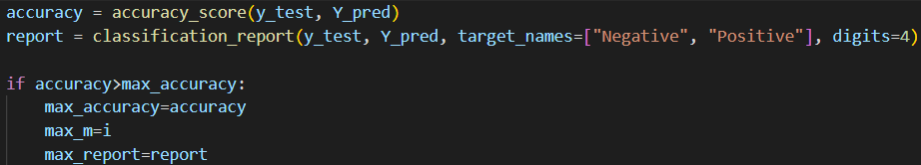
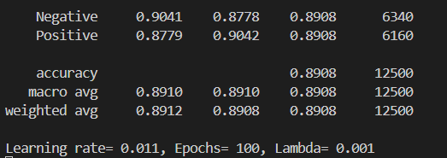
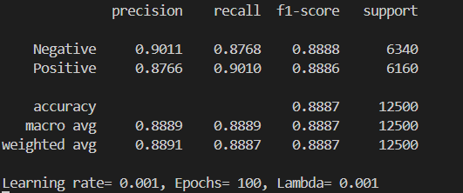
Logistic Regression, with Stochastic ascent and regulation

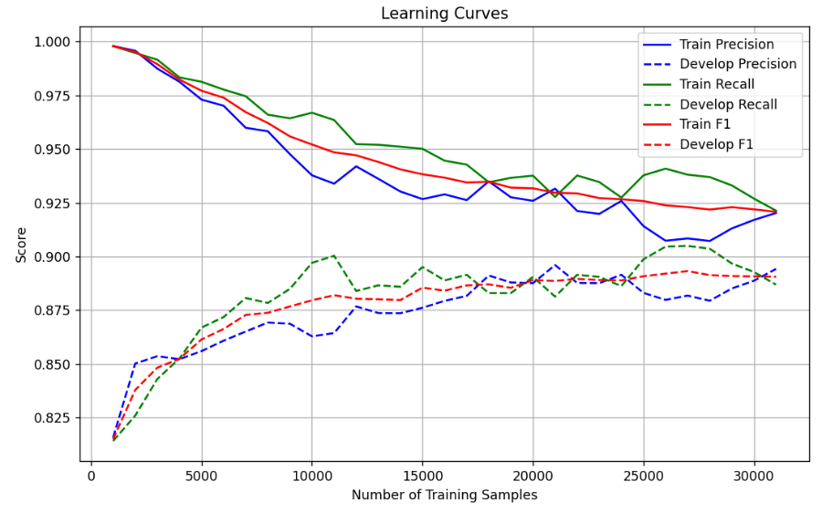

Optimization Process for Naïve Bayes Hyperparameters
- Feature Selection with Information Gain
  - We initially set n=20 and k=20 to accelerate the computation of information gain, which determines the most informative words in the dataset.
  - Since our goal was to find the most effective subset of features, we opted to calculate information gain for nearly all words to maximize the model’s efficiency.
- Tuning the Training Sample Size
  - We iterated over for m from 1000 to 10001 in increments of 1000, keeping the laplace parameter fixed.
  - The highest accuracy was achieved at m=6000, which was selected as the optimal training sample size.
- Hyperparameter Grid Search
  - With m=6000 fixed, we performed a grid search over the laplace parameter:
    - Laplace varied from 0.1 To 5.0 in incremeants of 0.1
  - The best-performing laplace parameter was identified as laplace=0.9.
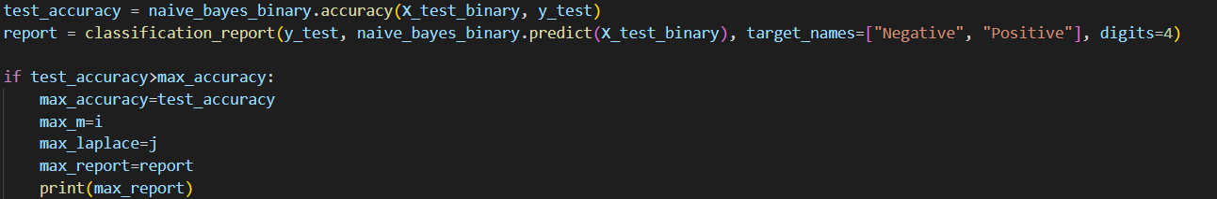
NAÏVE BAYES
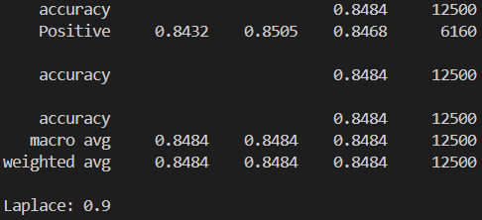
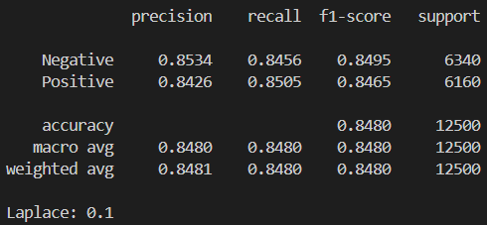

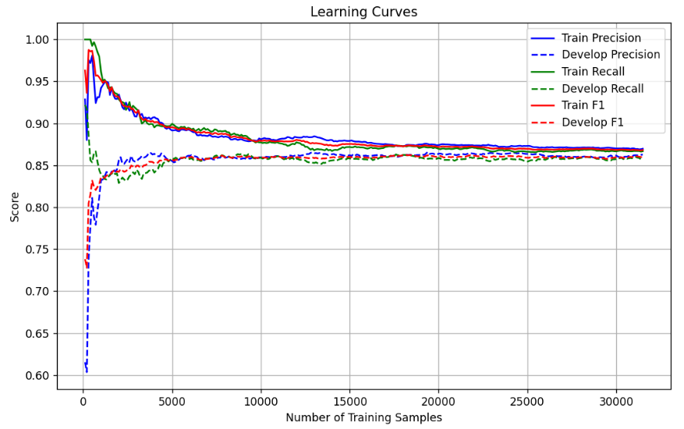

Second Part:

Logistic Regression using Scikit-Learn:
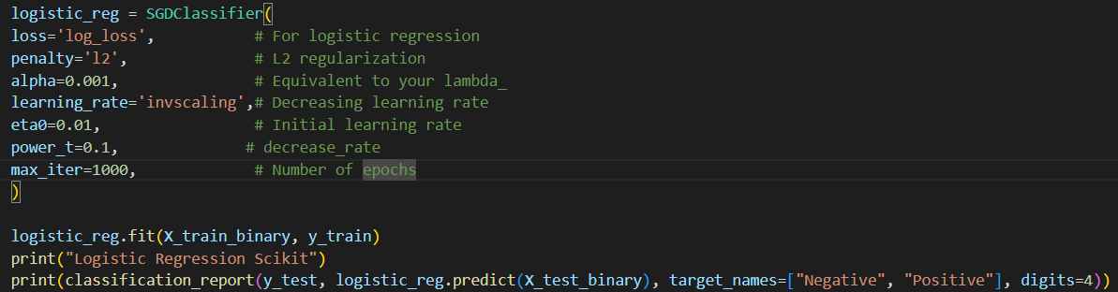

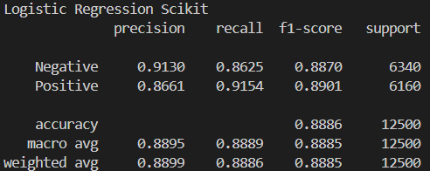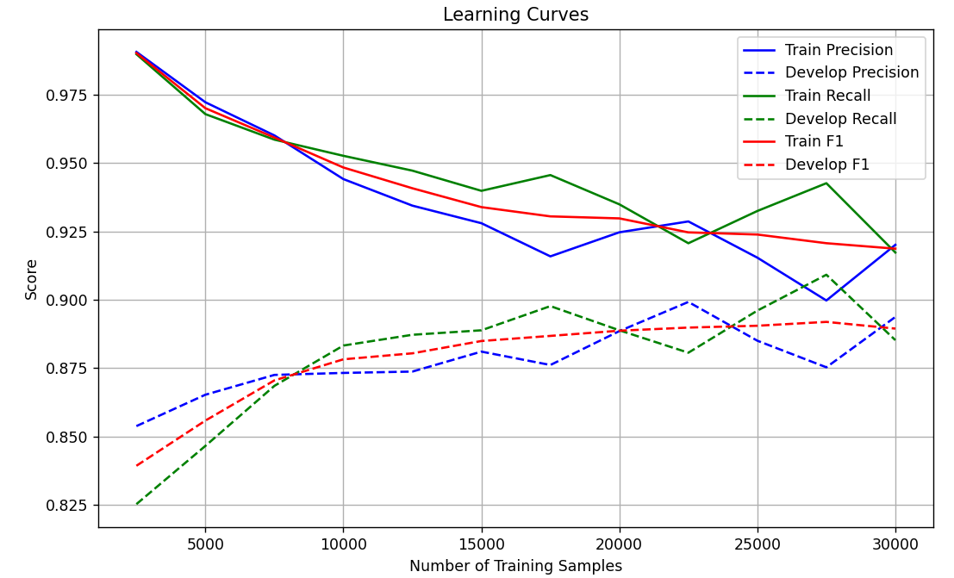

Naïve Bayes using Scikit-Learn:
