aBioinformatics, YYYY, 0–0
doi: 10.1093/bioinformatics/xxxxx
Advance Access Publication Date: DD Month YYYY
Journal Article

Journal Article
Barbac: A versatile tool for analysing DNA barcode sequences
Loukas Theodosiou^{1*}, Andrew D Farr² and Paul B Rainey^{1,2}
¹Department of Microbial Population Biology, Max Planck Institute for Evolutionary Biology, Plön, Germany, ²Laboratory of Biophysics and Evolution, CBI, ESPCI Paris, Université PSL, CNRS, Paris, France
*To whom correspondence should be addressed.
Associate Editor: XXXXXXX
Received on XXXXX; revised on XXXXX; accepted on XXXXX
Abstract
In recent years, evolutionary biologists have increasingly utilized DNA barcodes to track individual lineages within bacterial, yeast, and cancer cell populations, enabling fine-scale insights into the eco-evolutionary dynamics underlying biodiversity and microbial community function. A critical challenge in such studies is the precise quantification and accurate tracking of barcode lineages from amplicon sequencing data. Here, we introduce barbac, a novel computational pipeline designed explicitly to address this challenge. Unlike existing approaches, barbac uniquely provides the option to dynamically incorporate newly emerging, highly abundant barcodes into lineage structures throughout a time-course experiment, ensuring comprehensive representation of lineage diversity. At its core, barbac employs the Levenshtein distance metric to group sequences, effectively capturing not only mismatches but also insertions and deletions—an advantage over traditional Hamming-distance-based methods, which consider only mismatches. Furthermore, barbac utilizes a sophisticated graph-based model to assess indirect relationships among barcode variants, significantly enhancing clustering accuracy. The pipeline offers an end-to-end analytical solution, seamlessly processing raw FASTQ files and generating comprehensive time-resolved lineage visualizations. To promote accessibility, reproducibility, and adaptability, barbac includes customizable clustering parameters, interactive visualizations, and a user-friendly R Shiny interface deployable on local or remote servers. We benchmarked barbac using simulated data generated by the Barcosim simulation framework (https://github.com/loukesio/barcosim), demonstrating almost perfect clustering accuracy (99.4 %) even at sequencing error rates as high as 2%. Additionally, application of barbac to previously published experimental datasets revealed previously undetected fine-scale clonal dynamics and mutational patterns. Due to its computational efficiency and modular design, barbac is not limited to barcode lineage tracking but can be readily adapted for broader amplicon and metagenomic sequence analyses.

Contact: theodosiou@evolbio.mpg.de
Supplementary information: Supplementary data are available at Bioinformatics online.

1 Introduction

Cell barcoding is an increasingly valuable technique for tracking cell lineages in experimental systems. By inserting short, unique DNA barcode sequences into individual cells, researchers can trace the relationships and dynamics of clones across multiple generations (Ba et al., 2019; Blundell and Levy, 2014; Levy et al., 2015; Theodosiou et al., 2023; Geiler-Samerotte and Lang, 2023; Masuyama et al., 2019; Woodworth et al., 2017; VanHorn and Morris, 2021). When paired with time-series sampling, barcoding enables quantification of growth, mutation, and other eco-evolutionary characteristics of cell populations (Levy et al., 2015; Fasanello et al., 2020; Jasinska et al., 2020). However, realising the potential of cell barcoding requires overcoming computational challenges in extracting and analysing barcode sequence data generated by high-throughput sequencing. Raw sequences contain errors and must be accurately clustered to progenitor barcodes before connecting into cell lineage trees (Johnson et al., 2023).
To generate barcode sequencing data, barcodes are first integrated into target genomes using CRISPR-mediated insertion or transposon mutagenesis via helper plasmids (Borchert et al., 2022; Zhu et al., 2019; Theodosiou et al., 2023; Jasinska et al., 2020; Levy et al., 2015). Cells are then cultured over time, with population samples collected at specific intervals. Following DNA extraction and library preparation, high-throughput sequencing produces read data containing many copies of the barcode of each cell (Jasinska et al., 2020; Theodosiou et al., 2023; Vasquez et al., 2021). An ideal workflow would process these reads to identify barcode sequences, cluster similar sequences originating from a common progenitor, and connect barcodes into lineages across time in a time-sufficient manner.
Current computational approaches for lineage barcoding data typically address individual analytical steps rather than supporting end-to-end workflows. Considerable effort has been devoted to improving barcode error correction and clustering barcode families into lineages (Tavakolian et al., 2022). Nevertheless, important opportunities remain to advance lineage reconstruction over time and to increase the flexibility of clustering methods for diverse experimental contexts. Among existing tools, Bartender stands out by offering built-in functionality for longitudinal lineage tracking through the matching of barcode clusters across multiple time points (Zhao et al., 2018). Bartender applies a statistical clustering strategy based primarily on Hamming distances, allowing it to effectively distinguish true barcodes from sequencing and PCR artifacts. However, its reliance on identifying the most abundant barcodes at early sampling points, coupled with the absence of correction mechanisms for insertion or deletion (indel) errors, may limit its accuracy in more complex experimental settings.
Alternatively, Starcode utilizes an exact all-pairs search within a defined Levenshtein distance to cluster barcodes rapidly, accommodating insertion-deletion errors effectively. Starcode’s computational speed significantly surpasses other methods, but it relies on a fixed distance threshold without an explicit error model, creating potential trade-offs in clustering precision (Johnson et al., 2023; Zorita et al., 2015). Addressing some of these limitations, the more recent Shepherd algorithm incorporates a k-mer indexing scheme alongside a Bayesian model of sequencing error rates. Shepherd achieves high clustering precision, substantially reducing spurious lineage counts, yet its rigorous filtering approach can inadvertently exclude barcodes exhibiting unexpected sequence variations, and it imposes a greater computational burden (Tavakolian et al., 2022; Johnson et al., 2023).
Beyond barcode-specific solutions, general-purpose clustering tools such as CD-HIT (Fu et al., 2012) and DNAClust (Ghodsi et al., 2011), along with specialized error-correction pipelines, have also been applied . However, barcode-centric methods like Bartender, Starcode, and Shepherd consistently outperform these alternatives in accuracy when denoising and clustering barcode data (Johnson et al., 2023). Importantly, Bartender remains the only tool among these with built-in functionality for directly tracking lineages across time points, whereas other methods require supplementary post hoc analysis.
To address these gaps, we present barbac, an R package and accompanying Nextflow pipeline that provide a user-friendly and comprehensive solution for lineage barcoding analysis. barbac implements an end-to-end workflow that begins with raw FASTQ files, performs barcode extraction and error correction, and reconstructs lineage relationships over time. It supports a wide range of clustering algorithms based on both Hamming and Levenshtein distances, implemented in C++ for high performance, as well as additional algorithms available through the stringdist library. Unlike existing tools, barbac supports time-series lineage reconstruction not only by tracking abundant barcodes detected at early time points, but also by incorporating newly emerging, highly abundant barcodes that appear later and do not belong to existing clusters. At its core, barbac estimates sequencing error rates and uses these to guide the choice of an appropriate Levenshtein distance threshold for clustering, while a graph-based indexing scheme improves clustering precision by modeling relationships among barcode variants. Finally, to enhance reproducibility and scalability, barbac is available as a fully automated R pipeline, enabling easy integration into modern bioinformatics workflows.
To demonstrate utility of barbac we benchmarked performance using both a simulated dataset, generated by Barcosim (https://github.com/loukesio/barcosim) – a tool specialized for creating barcoded sequences with various error rates, simulated datasets from Johnson et al 2023 as well as empirical datasets.

2 Methods
The barbac package is designed as a modular, end-to-end workflow for processing barcode sequencing data from raw FASTQ files to interpretable lineage visualizations. Each function within the package corresponds to a specific step in the analysis pipeline, facilitating clarity, reproducibility, and ease of use. The pipeline integrates essential pre-processing steps such as quality control, read merging, and reference mapping via external tools, which are seamlessly wrapped in R functions. These are followed by barcode extraction, clustering, time series construction and visualization modules, implemented in R using ggplot2 (R Core Team, 2024; Wickham, 2009). Below, we describe the individual components of this workflow in the order that they are typically applied.
Raw paired-end or single-end sequencing data undergoes quality assessment through FastQC (Andrews, 2010), accessed via the run_fastqc() function. This step generates HTML reports for each sample, revealing sequence quality distributions, adapter content, and potential technical artifacts. Users provide input through a standardized sample table containing paths to forward and reverse read files, ensuring consistent data organization throughout the analysis.
Paired-end reads are subsequently merged using PEAR (Zhang et al., 2014) through run_pear_merge(). Output is partitioned into three categories: successfully assembled sequences, unassembled pairs, and discarded low-quality reads. This stratification permits downstream quality assessment and recovery of partial barcode information when complete assembly fails.
Merged sequences align to a reference barcode library using minimap2 (Li, 2018) via run_minimap2(). Resulting BAM files undergo statistical summarization through summarise_bam_stats(), producing tabulated metrics of alignment efficiency, coverage depth, and mapping quality. Additionally, the pipeline calculates batch-specific error rates by examining sequence fidelity within synthetic invariant sequences engineered into the barcode construct. For each mapped sequence, mismatches within these constant regions are quantified as a percentage, providing an empirical measure of combined PCR and sequencing error rates. These statistics inform decisions about data quality and potential technical issues requiring attention.
Barcode sequences are extracted from aligned BAM files using barbac_xtr(), which targets specific genomic coordinates within the reference alignment. The function employs GenomicRanges infrastructure (Lawrence et al., 2013) to parse alignments and extract sequences from user-defined positions. Extracted barcodes are counted, their lengths recorded, and results exported as comma-separated files. The accompanying barbac_xtr.stats() function generates diagnostic visualizations including length distributions, abundance profiles, and sequence entropy calculations, enabling rapid assessment of barcode diversity and potential amplification biases.
Sequence clustering via barbac_cluster() groups related barcodes into lineages based on sequence similarity. Users can select from multiple distance algorithms including Levenshtein (lv) and Hamming (hamming) distances implemented in C++ for optimal performance, or choose from additional metrics—Optimal String Alignment (osa), Damerau-Levenshtein (dl), Longest Common Substring (lcs), q-gram (qgram), cosine, Jaccard, Jaro-Winkler (jw), and Soundex, provided through the stringdist R package (van der Loo, 2014). The algorithm employs a union-find data structure, a tree-based method that maintains disjoint sets through path compression and union-by-rank operations, achieving near-constant time complexity for cluster assembly. This implementation processes typical datasets at rates of 100-1000 sequences per second when using C++ distance metrics. For each cluster, the algorithm identifies a central representative sequence (the barcode with highest total similarity to other members), records all member sequences, and aggregates their counts. The output data frame contains the central barcode, a concatenated list of cluster members, and summed abundance values. This systematic categorization enables quantitative analysis of lineage relationships and diversity within barcode populations, providing the foundation for downstream trajectory reconstruction and evolutionary dynamics assessment.
When analyzing time series barcode data, the barbac_ts() function provides comprehensive visualization and quantification of lineage dynamics. The function operates in two analytical modes controlled by the cluster_zero parameter. When set to TRUE, only lineages present at the initial time point are tracked, revealing persistence and extinction patterns of founding populations. When FALSE, all lineages appearing at any time point are included, capturing both founding and emergent populations throughout the experimental timeline. The function generates multiple outputs: stacked barplots displaying the temporal dynamics of barcode lineages across time points, where each colored band represents a distinct lineage with width proportional to its relative frequency; accompanying data tables containing absolute abundances and normalized frequencies for each lineage at each time point; and summary statistics quantifying diversity metrics and turnover rates. The highlight parameter enables selective emphasis by rendering specified lineages in color while fading others to gray, facilitating focus on lineages of particular biological interest. This feature proves particularly valuable when tracking specific mutations or engineered variants within complex populations. Color schemes are fully customizable through user-specified palettes or predefined options optimized for categorical data visualization, ensuring clear differentiation between lineages even in highly diverse populations.
The complete workflow executes through run_cli_pipeline(), which coordinates all processing steps while maintaining detailed logs for reproducibility. Environment configuration and tool availability are verified through configure_environment() and check_barbac_tools() functions before analysis begins. These functions automatically establish a Conda environment containing required external dependencies, FastQC, PEAR, minimap2, and samtools, ensuring consistent software versions across platforms. Output follows a standardized directory structure with quality reports, merged sequences, alignments, and statistical summaries organized in dedicated subdirectories.
Lastly, the clustering algorithm's performance was systematically evaluated using simulated datasets generated with controlled error rates, as well as empirical barcode sequencing datasets (see Results section 3.1)

3 Results
3.1 Benchmarking clustering accuracy on synthetic datasets
To evaluate the clustering performance of barbac under controlled conditions, we generated synthetic barcode libraries using BarcoSim. This simulator produces datasets with precisely defined error rates and known ground truth labels. We constructed datasets spanning per-base error rates from 0.01 to 0.30, covering the range from high-quality sequencing data to severely degraded samples. Each dataset contained 1,000 parent barcodes (25 bp) with 10–100 derivative sequences per parent. Derivative sequences were generated through independent substitutions at specified rates to mimic stochastic error accumulation.
We clustered these datasets using Levenshtein distance thresholds ranging from 1 to 5 mismatches. This design yielded 30 parameter combinations (6 error rates × 5 thresholds), each replicated to ensure stable estimates. We assessed clustering performance using three complementary metrics: Purity, Completeness, and the Clustering F1 Score. These measures quantify how well inferred clusters correspond to known parent labels, providing information on both cluster homogeneity and the distribution of parent sequences across clusters.
Purity is calculated for each cluster as the proportion of sequences belonging to the most frequent parent:

where p∈P represents the parent labels present in the cluster. Higher purity indicates that a cluster predominantly contains sequences from a single parent.
Completeness reflects the fraction of sequences from a given parent that are grouped into the cluster where that parent is most represented:

where c∈Cc are clusters containing sequences from the given parent. High completeness indicates that sequences from the same parent are not dispersed across multiple clusters.
The Clustering F1 Score provides a single, comprehensive measure of clustering quality by calculating the harmonic mean of Purity and Completeness:

This metric balances the trade-off between forming pure clusters and ensuring that sequences from the same parent are grouped together. A higher F1 Score indicates both high cluster homogeneity and good grouping performance.
Overall, barbac achieved perfect parent barcode recovery (100%) at error rates up to 0.10 across all distance thresholds tested (Figure 1A). At the highest error rate (0.15), recovery declined to 40% uniformly across thresholds, indicating a breakdown in the ability to distinguish true parents from highly degraded derivatives. Cluster purity remained at 100% across all error rates and thresholds (Figure 1B), demonstrating that barbac consistently groups sequences without mixing distinct parent lineages. The F1 Score showed strong performance at low to moderate error rates (Figure 1C). At error rates ≤0.05, F1 scores exceeded 0.95 for thresholds ≥2. Performance remained high (F1 ≥0.92) at error rate 0.10 with thresholds ≥3. At higher error rates (0.15), F1 scores decreased substantially, particularly at lower thresholds, reaching only 0.17 at threshold 1.
The number of clusters formed decreased with increasing distance threshold, as expected from more permissive grouping criteria (Figure 1D). At low error rates (0.01–0.02), cluster numbers remained close to the true number of parents (1,000) across all thresholds, converging to approximately 20–30 clusters at threshold 5. At higher error rates (0.10–0.15), the number of clusters was substantially elevated at restrictive thresholds, reflecting fragmentation of parent lineages into multiple clusters. At threshold 1 and error rate 0.15, over 450 clusters were formed, more than twice the number of true parents.
These results establish that barbac maintains high clustering accuracy at error rates typical of Illumina sequencing (≤0.10). Performance declines at higher error rates, particularly at restrictive thresholds that fragment true lineages or permissive thresholds that may merge distinct parents.
3.2 Benchmarking barbac on empirical data
We evaluated barbac on three empirical barcode datasets derived from experimental evolution studies (Levy et al. 2015; Johnson et al. 2019; Borchert et al. 2022). These datasets represent real-world sequencing conditions with naturally occurring errors, indels, and quality variation. For each dataset, we extracted barcode sequences using barbac and applied barbac with distance thresholds optimized based on the synthetic benchmarking results.
3.3 Comparison with established error-correction methods
To position barbac within the landscape of existing barcode error-correction tools, we benchmarked its performance against six published methods using the simulated dataset from Johnson et al. (2023). This dataset comprises 100,000 true barcodes (20 bp) with approximately 25 million reads, simulated with 0.4% per-base substitution errors and indel errors in homopolymer regions, resulting in 1,544,850 unique observed sequences.
We ran barbac with a Levenshtein distance threshold of 3, matching the parameters used for the published methods. Clustering required 392 minutes on a MacBook Air M1 (16 GB RAM), reflecting the computational cost of processing large-scale datasets with edit-distance calculations.

Table 2. Performance comparison of barcode error-correction methods on the Johnson et al. (2023) simulated dataset. R: Pearson correlation coefficient between log-transformed true and inferred abundances. WS: Wrong Sequences rate (fraction of barcodes assigned to incorrect clusters). FN: False Negative rate (true barcodes not recovered). FP: False Positive rate (spurious clusters not matching any true barcode).
Method | R | WS (%) | FN (%) | FP (%) | Clusters
Starcode | 1.00 | 0.33 | 0.04 | 0.03 | 99,581
Bartender | 1.00 | 2.74 | 0.08 | 0.75 | 100,257
Shepherd | 1.00 | 0.06 | 0.00 | 0.03 | 99,615
Deletion-Correct | 1.00 | 0.00 | 0.47 | 0.03 | 99,152
CD-Hit | 0.91 | 5.29 | 2.11 | 1.79 | —
DNAClust | 0.99 | 0.39 | 0.25 | 4.70 | —
barbac | 1.00 | 0.00 | 0.77 | 0.35 | 99,582

barbac achieved perfect correlation (R = 1.00) between true and inferred barcode abundances, matching the performance of all bespoke barcode clustering tools and substantially outperforming generic clustering methods (CD-Hit: R = 0.91; DNAClust: R = 0.99). Notably, barbac achieved a Wrong Sequences rate of 0%, indicating that every recovered barcode was assigned to its correct parent sequence. This matched Deletion-Correct and exceeded Starcode (0.33%), Bartender (2.74%), and Shepherd (0.06%).
The false negative rate (0.77%) was moderately higher than Shepherd (0.00%) and Starcode (0.04%), indicating that barbac did not recover approximately 770 low-abundance true barcodes. The false positive rate (0.35%) was higher than the best-performing methods (0.03%) but substantially lower than DNAClust (4.70%) and CD-Hit (1.79%). These spurious clusters likely represent error sequences that were processed before their true parent in the abundance-ranked clustering procedure.
A key advantage of barbac over Shepherd lies in its handling of insertion and deletion errors. Shepherd applies strict length filtering and corrects only single-base indels, which caused it to miss thousands of barcodes in empirical datasets from Levy et al. (2015), Johnson et al. (2019), and Borchert et al. (2022) (Johnson et al., 2023). In contrast, barbac employs Levenshtein distance, which naturally accommodates insertions and deletions of any size up to the specified threshold without requiring explicit length filtering. In our benchmark, barbac successfully clustered sequences ranging from 18 to 22 bp, demonstrating robustness to length variation.
4 Discussion
The analysis of lineage barcoding data depends critically on accurate error correction, clustering, and lineage reconstruction, yet existing computational approaches address these challenges only in part. Here, we developed barbac, an R package and Nextflow pipeline that provides an end-to-end framework for processing barcode sequencing data. barbac integrates barcode extraction, flexible clustering, and time-series lineage reconstruction within a single reproducible workflow.
Benchmarking on synthetic datasets demonstrated that barbac recovers parent barcodes with high accuracy at sequencing error rates typical of Illumina platforms (≤0.10). Across this range, clustering purity remained consistently high, indicating that the method effectively distinguishes true barcode sequences from error-derived variants. Performance declined at higher error rates, reflecting expected challenges in separating highly degraded sequences from their progenitors. These results establish practical operating ranges for the method and provide guidance for parameter selection under different sequencing conditions.
Evaluation on empirical datasets from experimental evolution studies confirmed that barbac performs reliably under realistic sequencing scenarios, which include heterogeneous error structures, indels, and variable quality. By supporting both Hamming- and Levenshtein-based clustering and allowing the incorporation of lineages emerging at later time points, barbac accommodates a range of experimental designs and barcode mutation dynamics. Several limitations should be noted. The accuracy of clustering depends on appropriate parameterization of distance thresholds, which in turn is influenced by sequencing quality. Although synthetic benchmarks provide useful guidance, empirical datasets may present additional sources of error not captured by the simulations. Furthermore, while barbac efficiently integrates barcode clustering with time-series reconstruction, it does not implement explicit probabilistic models of error, as in Shepherd, which may limit sensitivity in datasets with unusual error distributions.
Comparison with established error-correction methods revealed that barbac performs competitively with specialized barcode clustering tools. On the Johnson et al. (2023) simulated benchmark, barbac achieved perfect count correlation (R = 1.00) and zero wrong-sequence assignments, matching or exceeding the performance of Starcode, Bartender, Shepherd, and Deletion-Correct. While barbac exhibited slightly elevated false negative and false positive rates compared to the best-performing methods, these trade-offs may be offset by its more flexible handling of indel errors. Unlike Shepherd, which employs strict length filtering and corrects only single-base indels, barbac uses Levenshtein distance to accommodate insertions and deletions naturally. This design choice may prove advantageous for empirical datasets where indel errors are prevalent, as evidenced by Shepherd's failure to identify thousands of abnormal-length barcodes in published experimental datasets (Johnson et al., 2023). Furthermore, barbac does not implement explicit probabilistic error models as in Shepherd, which simplifies parameterization but may reduce sensitivity in datasets with unusual error distributions. Despite this limitation, the combination of high accuracy, flexible distance metrics, and seamless integration with time-series analysis makes barbac a practical choice for lineage barcoding studies.
In summary, barbac provides a practical solution for processing and analyzing barcode sequencing data. By combining modularity, speed, and flexible lineage reconstruction, it addresses several gaps in existing workflows. These capabilities should facilitate broader use of lineage barcoding in ecological and evolutionary studies where accurate reconstruction of population histories is essential.
Acknowledgements
We thank Carsten Fortmann-Grote for comments on the manuscript and code, and Thijs Jansen for discussions on software development.
Funding

References

Ba,A.N.N. et al. (2019) High-resolution lineage tracking reveals traveling wave of adaptation in laboratory yeast. Nature, 575, 494–499.
Blundell,J.R. and Levy,S.F. (2014) Beyond genome sequencing: Lineage tracking with barcodes to study the dynamics of evolution, infection, and cancer. Genomics, 104, 417–430.
Borchert,A.J. et al. (2022) Experimental and analytical approaches for improving the resolution of randomly barcoded transposon insertion sequencing (RB-TnSeq) studies. ACS Synth Biol, 11.
Fasanello,V.J. et al. (2020) High-throughput analysis of adaptation using barcoded strains of Saccharomyces cerevisiae. PeerJ, 8.
Fu,L. et al. (2012) CD-HIT: accelerated for clustering the next-generation sequencing data. Bioinformatics, 28, 3150–3152.
Geiler-Samerotte,K. and Lang,G.I. (2023) Best Practices in Microbial Experimental Evolution. J Mol Evol.
Ghodsi,M. et al. (2011) DNACLUST: accurate and efficient clustering of phylogenetic marker genes. BMC Bioinformatics, 12, 271.
Jasinska,W. et al. (2020) Chromosomal barcoding of E. coli populations reveals lineage diversity dynamics at high resolution. Nat Ecol Evol, 4, 437–452.
Johnson,M.S. et al. (2023) Best Practices in Designing, Sequencing, and Identifying Random DNA Barcodes. J Mol Evol, 91, 263–280.
Levy,S.F. et al. (2015) Quantitative evolutionary dynamics using high-resolution lineage tracking. Nature, 519, 181–6.
Masuyama,N. et al. (2019) DNA barcodes evolve for high-resolution cell lineage tracing. Curr Opin Chem Biol, 52.
R Core Team (2024) R: A language and environment for statistical computing.
Tavakolian,N. et al. (2022) Shepherd: accurate clustering for correcting DNA barcode errors. Bioinformatics, 38, 3710–3716.
Theodosiou,L. et al. (2023) Barcoding Populations of Pseudomonas fluorescens SBW25. J Mol Evol, 91, 254–262.
VanHorn,S. and Morris,S.A. (2021) Next-Generation Lineage Tracing and Fate Mapping to Interrogate Development. Dev Cell, 56.
Vasquez,K.S. et al. (2021) Quantifying rapid bacterial evolution and transmission within the mouse intestine. Cell Host & Microbe, 29, 1454-1468.e4.
Wickham,H. (2009) ggplot2: Elegant Graphics for Data Analysis New York.
Woodworth,M.B. et al. (2017) Building a lineage from single cells: genetic techniques for cell lineage tracking. Nat Rev Genet, 18.
Zhao,L. et al. (2018) Bartender: a fast and accurate clustering algorithm to count barcode reads. Bioinformatics, 34, 739–747.
Zhu,S. et al. (2019) Guide RNAs with embedded barcodes boost CRISPR-pooled screens. Genome Biol, 20.
Zorita,E. et al. (2015) Starcode: sequence clustering based on all-pairs search. Bioinformatics, 31, 1913–1919.

Figures

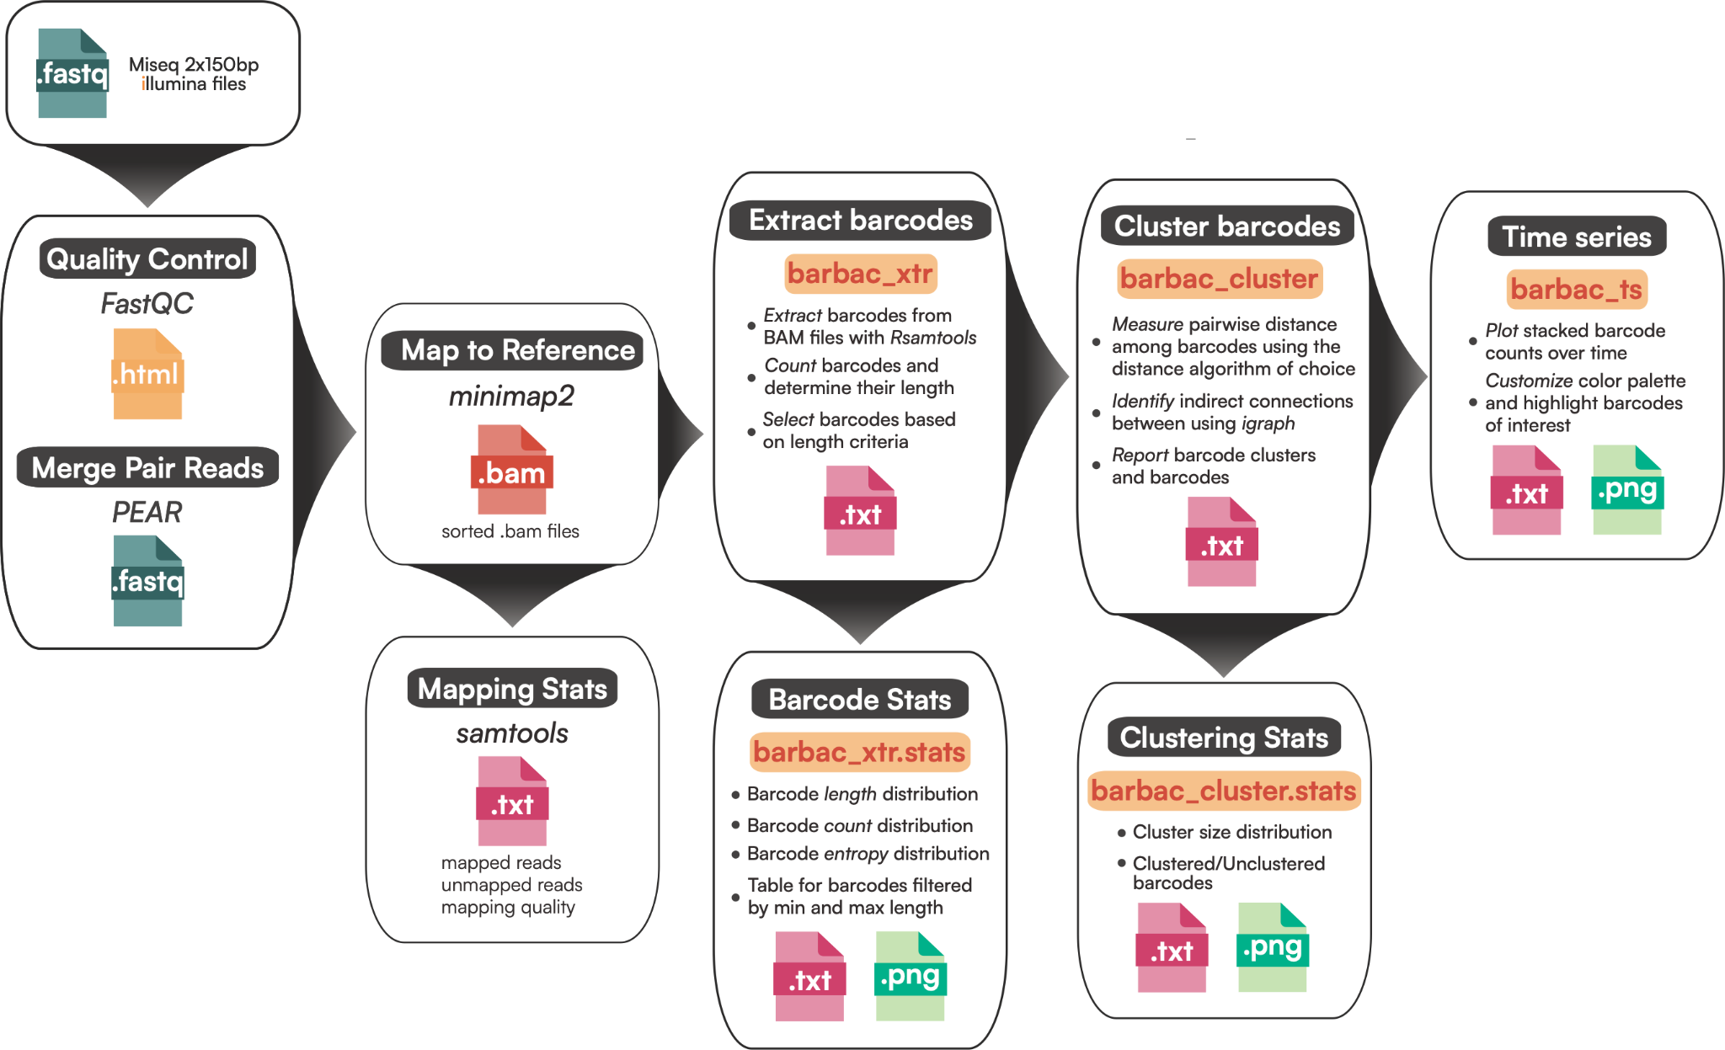

Figure X: The depicted pipeline provides an end-to-end workflow for barcode data analysis, with each box representing a distinct analytical function and file icons indicating the output type. Different file extensions are color-coded to aid identification: .fastq files (blue), .ht
ml reports (green), .bam files (red), .txt outputs (black), and .png images (orange). Arrows illustrate the flow and progression of data through the pipeline, demonstrating how the output from one function serves as input to the subsequent stage.

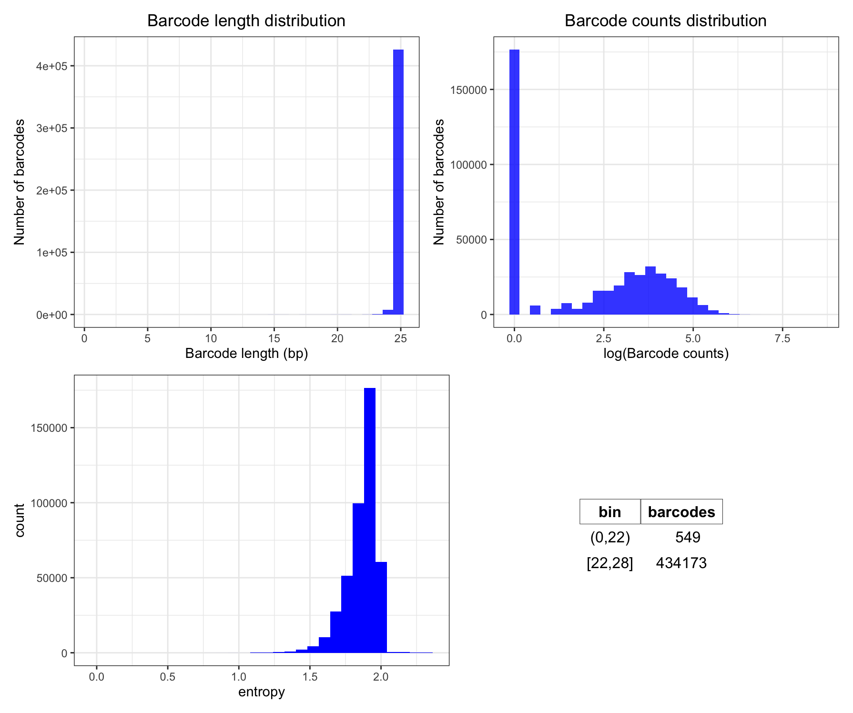
Figure X: A. Barcode length distribution: This histogram shows the distribution of barcode lengths in base pairs (bp). The x-axis represents the barcode length, and the y-axis represents the number of barcodes with a given length. B. Barcode counts distribution: This histogram displays the distribution of barcode counts on a logarithmic scale. The x-axis shows the log-transformed barcode counts, and the y-axis indicates the number of barcodes with specific counts. C. Entropy: The histogram portrays the Shannon entropy distribution of the barcodes. The x-axis represents the entropy values, and the y-axis illustrates the count of barcodes with each entropy value. D. Barcodes per bin: This table enumerates barcodes based on their lengths categorized into bins. The bin column shows the range of barcode lengths, and the barcodes column indicates the number of barcodes within each bin.

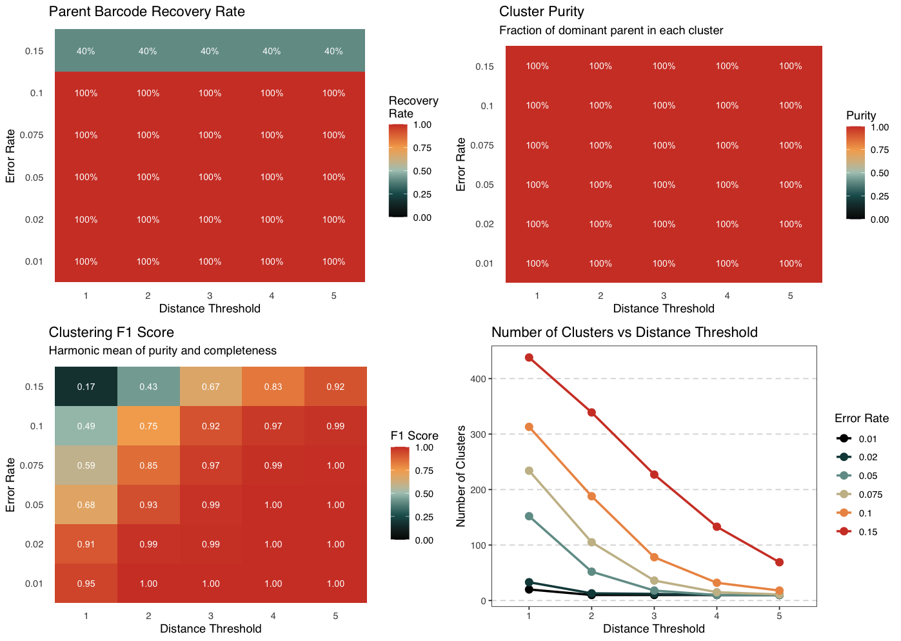
Figure X: Performance evaluation of the barcode clustering algorithm under varying simulation parameters. The algorithm's performance was tested across a range of simulated sequencing error rates (y-axis) and Levenshtein distance thresholds (x-axis). (Top Left) Heatmap of the Parent Barcode Recovery Rate, indicating the percentage of true parent sequences identified as cluster centroids. (Top Right) Heatmap of Cluster Purity, representing the average proportion of sequences within a cluster that originate from the dominant parent. (Bottom Left) Heatmap of the Clustering F1 Score, the harmonic mean of purity and completeness, which serves as a balanced measure of overall accuracy. (Bottom Right) Line plot showing the total number of clusters identified as a function of the distance threshold for each simulated error rate. The results show that a higher distance threshold is required to maintain optimal F1 scores as the sequencing error rate increases.
The expected number of sequencing errors per read can be estimated from the Phred quality score (Q-score), which quantifies the probability that a base is incorrectly called during sequencing. A Q-score of 30 (Q30) corresponds to a per-base error probability of 0.001, meaning that one error is expected in every 1,000 bases. In contrast, a Q-score of 20 (Q20) reflects a higher per-base error probability of 0.01, or one error in every 100 bases. Based on these error probabilities, a sequencing read of 150 base pairs is expected to contain approximately 0.15 errors under Q30 conditions and approximately 1.5 errors under Q20 conditions. In practical terms, Q30-quality data results in most reads being completely error-free, with only a small proportion containing a single erroneous base. In contrast, Q20-quality data leads to a majority of reads containing one or more errors. This distinction has important implications for downstream analyses, particularly in applications requiring high sequence accuracy such as variant calling, molecular barcode clustering, or the detection of low-frequency mutations. Even a modest increase in the per-base error rate can dramatically reduce the proportion of error-free reads, thereby impacting the sensitivity and reliability of these analyses.

The Parent Barcode Recovery Rate (top left) demonstrates ability of the algorithm to identify the original, error-free parent sequences as cluster centroids. At error rates of 0.1 or lower, the algorithm successfully recovers 100% of the parent barcodes. However, performance degrades at higher error rates, with recovery dropping to 60% at an error rate of 0.15 and as low as 0% at an error rate of 0.3. Concurrently, the Cluster Purity (top right) remains at or near 100% across almost all tested conditions. This indicates that even when the true parent is not identified as the centroid, the clusters formed are exceptionally homogeneous, rarely mixing sequences from different parental lineages.
The Clustering F1 Score (bottom left) provides the most comprehensive measure of performance by calculating the harmonic mean of purity and completeness. This panel reveals a critical relationship between the sequencing error rate and the optimal distance threshold. For low error rates (≤ 0.05), near-perfect F1 scores (≥ 0.99) are achieved with distance thresholds of 2 or 3. As the error rate increases, a larger distance threshold is required to correctly group the more divergent sequences. For example, at an error rate of 0.15, the optimal F1 score (0.89) is achieved with a distance threshold of 5. This highlights the algorithm's adaptability, though its effectiveness diminishes substantially at very high error rates (e.g., 0.3), where the F1 score remains low regardless of the parameters.
Finally, the Number of Clusters (bottom right) plot shows that, as expected, increasing the distance threshold reduces the number of final clusters by merging more distant sequences. At higher error rates, more unique sequences are generated, leading to a higher initial number of clusters that are progressively consolidated as the distance threshold increases. Together, these analyses demonstrate that our algorithm is robust and highly accurate for error rates up to 0.15, and the F1 score provides a reliable guide for selecting the optimal distance threshold based on the expected error profile of the sequencing data.

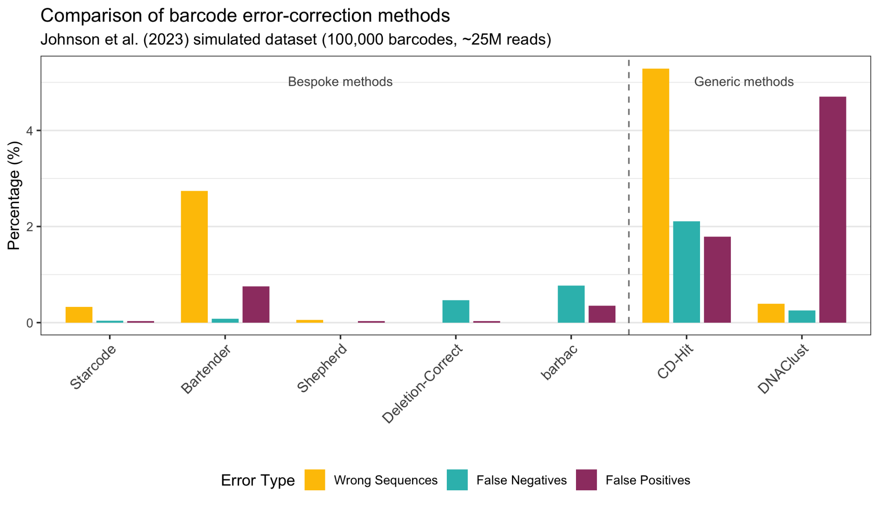
Figure X. Benchmark comparison of error-correction methods. Error rates for seven methods on the Johnson et al. (2023) simulated dataset (100,000 barcodes, ~25M reads). WS: wrong sequences; FN: false negatives; FP: false positives. Lower values indicate better performance. Dashed line separates bespoke barcode tools (left) from generic clustering methods (right). barbac achieved WS = 0%, FN = 0.77%, FP = 0.35%, with Pearson R = 1.00.

https://academic.oup.com/bioinformatics/pages/author-guidelines#section-17fgy g
Original papers: up to 7 pages, this is approx. 5000 words, not including figures,

