NBA and EuroLeague basketball, 2010/11–2025/26: a Bayesian replication and update
Loukas Theodosiou
2026-11-03
Abstract
Mandić and colleagues (2019) compared the NBA and the EuroLeague from 2000 to 2017 and concluded that the two leagues were becoming more alike. We re-implement their model in Stan, reproduce all 68 of their published estimates from their own data (largest difference 0.013), and extend the comparison to sixteen seasons (2010/11–2025/26), 24,874 games and 4,057,782 located shots. Bayesian mixed models with team- and opponent-season effects describe the leagues today; second-order random-walk trends, a shift model with a discrete lag and a “time gap” estimate describe how they changed; a matched design compares playoffs with the same teams’ regular seasons; and shrinkage style profiles place every team and player on its league’s path through time. Today the two leagues shoot equally well and take the same share of their shots from three (41.1% in both), but they differ in style: the NBA plays 10.4 more possessions per 40 minutes and the EuroLeague commits 7.5 more fouls per 100 possessions. Shot mix converged while pace diverged. On three-point shooting the EuroLeague moves with the NBA or a season behind it; on volume measures it resembles the NBA of three to five seasons ago. Houston (NBA) and Real Madrid (EuroLeague) played their leagues’ future most clearly. Code, models and figures are openly available.

Introduction
The NBA and the EuroLeague are the two strongest basketball competitions in the world, but they are played under different rules (a 48- against a 40-minute game, a 7.24 m against a 6.75 m three-point line, different defensive and foul rules) and by teams built in different ways. How the two leagues differ, and whether they are becoming alike, matters to coaches and scouts who move players between them and to analysts who compare their statistics.
Mandić et al. (2019) compared the leagues from 2000/01 to 2016/17 with a Bayesian model of season means and linear trends. They found that the NBA was moving towards the EuroLeague’s style, most clearly in three-point shooting, and that NBA playoff basketball looked more “European” than the NBA’s regular season. Since 2017 the three-point revolution has continued (Goldsberry, 2019), both leagues have changed rules (the 14-second shot-clock reset after an offensive rebound reached the NBA in 2018/19), and shot-location data have become available for both leagues, which allows comparisons the original box-score study could not make (Erčulj & Štrumbelj, 2015).
This paper replicates and extends that study. We ask four questions:
- RQ1. How do the two leagues differ today (2023/24–2025/26), in box scores and in where shots are taken and made?
- RQ2. How have they changed since 2010/11? Are they converging, and does one league follow the other?
- RQ3. How does play change in the playoffs, and do NBA playoffs look more like the EuroLeague?
- RQ4. Which teams and players embodied their league’s typical style, and which were ahead of their time?
The contributions are (i) a full replication of the 2019 model on the authors’ own data; (ii) an update to 2025/26 with models that separate team, opponent and season effects; (iii) new analyses of convergence, lead–lag and playoff change; and (iv) a probabilistic “time position” for every team and player. All code, models and figures are open.

Data
Box scores come from ESPN for the NBA, through the hoopR package (Gilani, 2021), and from the official EuroLeague API for the EuroLeague. Shot locations come from NBA Stats (through hoopR) and from the EuroLeague API. The main window is 2010/11–2025/26: 24,874 games and 4,057,782 field-goal attempts with court coordinates. Seasons from 2001/02 are used only for the lead–lag model. Seasons are labelled by their starting year in the code (2010 = 2010/11).
The metrics follow Mandić et al. (2019) exactly. Possessions are 2PA + 3PA + 0.5·FTA + TOV; counting statistics are per 100 possessions; the four factors (Kubatko et al., 2007; Oliver, 2004) are computed for each team and its opponent; free throws are counted per foul received; and rotation depth is the entropy of minutes played. We add possessions per 40 minutes (to put the 48- and 40-minute games on one scale), points per 100 possessions and the share of field-goal attempts taken from three.
Two scorekeeping systems. Rebounds and turnovers are summed over players in both leagues, because team rebounds and team turnovers are recorded differently. EuroLeague scorers place layups and dunks about 1.1 m from the hoop on average, so close-range EuroLeague shots appear as a ring rather than at the rim; the rim area is therefore defined as within 1.75 m. Shots are grouped into five zones: rim area (< 1.75 m), short mid-range (1.75–4.25 m), long mid-range (two-pointers beyond 4.25 m), corner three and above-the-break three, each with its own league’s court geometry.
Playoffs. NBA playoffs exclude the play-in. EuroLeague playoffs are the playoff series and the Final Four; the former Top 16 counts as regular season (the 2019 paper counted it as playoffs) and the 2025/26 play-in is dropped.

Methods
All models are Bayesian and fitted in Stan (Carpenter et al., 2017), directly or through brms (Bürkner, 2017). Every reported model passed the usual checks (R-hat ≤ 1.04, no or negligible divergent transitions). Figures were drawn with the ggbasket package (Theodosiou, 2026).
Replication (RQ2). The 2019 model describes each league and metric by game-level values $y_{ij}∼N\left(μ_{j},σ_{j}\right)$ in season $j$, with season means on a line, $μ_{j}∼N\left(μ+s t_{j},σ\right)$, and flat priors. Because games are independent and normal within a season, the season’s game count, mean and variance are sufficient statistics; we write the model on them, which gives the same posterior about a thousand times faster. Fitted to the authors’ published data (PLOS ONE S1 Data), it reproduces their Table 1 (Section 4.2).
Differences today (RQ1). Each metric is standardised and modelled at team-game level as $z∼N\left(β_{\text{league}}+u_{\text{team-season}}+v_{\text{opponent-season}},σ_{\text{league}}\right)$, with weakly informative priors ($N\left(0,1.5\right)$ on league effects, $N\left(0,1\right)$ on standard deviations). The league difference is reported in game-to-game standard deviations and on the original scale. Shot shares and accuracy by zone use binomial models with team-season effects; accuracy across the court uses a binomial model with a smooth two-dimensional tensor-product surface per league (Wood, 2017).
Trends and convergence (RQ2). Season means are modelled as a second-order random walk (RW2) (Rue & Held, 2005) plus season-specific shocks, ${\overset{‾}{y}}_{t}∼N\left(f_{t},\sqrt{se_{t}^{2}+τ^{2}}\right)$ with $f_{t}=2f_{t−1}−f_{t−2}+ω ε_{t}$. When $ω→0$ the trend is the straight line of the 2019 model. Because all terms are Gaussian, the curve is integrated out analytically and only $ω$ and $τ$ are sampled; curves are then drawn from their exact conditional distribution. The gap between the leagues’ curves, and the probability that it shrank, follow from the joint draws.
Lead–lag (RQ2). A shift model asks whether the EuroLeague’s trend equals the NBA’s shifted by $k$ seasons, ${\overset{‾}{y}}_{t}^{E}∼N\left(a+b f_{t−k},⋅\right)$, with $k∈\{−5,…,5\}$ marginalised out, so the posterior $P\left(k∣\text{data}\right)$ says how strongly each lag is supported. Probability that piles up at the edges of the window means that no lag fits well. A second, descriptive measure finds, for each posterior draw of the NBA curve, the season in which the NBA first reached the EuroLeague’s 2025/26 level (“time gap”).
Playoffs (RQ3). Only teams that reached the playoffs are used, each compared with its own regular season, with team- and opponent-season effects: $z∼N\left(β_{\text{league}}+γ_{\text{league}}⋅\text{playoff}+u+v,σ\right)$. For each metric we also compute the probability that the NBA’s playoff shift points towards the EuroLeague’s regular-season level.
Style profiles (RQ4). Each team-season is described by 14 numbers (pace, five-zone shot mix, free throws, assists, turnovers, offensive rebounds, blocks, steals, fouls and rotation depth) and each rotation player-season by 13, always compared with players of the same position. Profiles are conjugate posteriors (Dirichlet–multinomial for shot mix, gamma–Poisson for rates, normal for game means) with prior strength estimated by marginal likelihood (empirical Bayes), so small samples are shrunk towards the league–season average. A team’s time position is the season on its league’s path through style space that it is closest to; a team of 2012/13 closest to the league of 2016/17 is four seasons ahead. All features are put on one scale, the pooled within-season spread between teams (or players) of the same league, so that a difference of 1 means “as different as a typical pair of teams in the same season”. Distances are Euclidean on that scale and are computed for each of 400 posterior draws, which gives the credible intervals in Figures 12–14.
From models to figures. Every figure is drawn from saved posterior summaries:
- Figure 1 shows the league effects of the RQ1 box-score models; Figures 2–4 show the raw shot locations (Figure 2), the zone models (Figure 3) and the spatial accuracy model (Figure 4).
- Figure 5 compares the replicated 2019 model with the published Table 1.
- Figures 6–7 show the RW2 trends and the draw-by-draw difference between them; Figures 8–9 show the shift model and the time-gap calculation.
- Figures 10–11 show the matched playoff models and the “towards the EuroLeague” ratio.
- Figures 12–14 show the style-profile distances and time positions.
Each caption repeats what is plotted and how it was computed, and the code for every figure is in the scripts/ folder of each research question in the repository.

Results

How the leagues differ today (RQ1)
The two leagues now shoot alike (Figure 1). Three-point percentage (36.1% NBA, 36.1% EuroLeague), free-throw percentage, effective field-goal percentage and the share of shots taken from three (41.1% against 41.1%) are practically identical. They differ in style. The NBA plays faster (94.2 against 83.8 possessions per 40 minutes), blocks more and earns more free throws per foul (1.16 against 0.90). The EuroLeague fouls far more (24.3 against 16.8 per 100 possessions), turns the ball over more and rebounds more of its own misses.
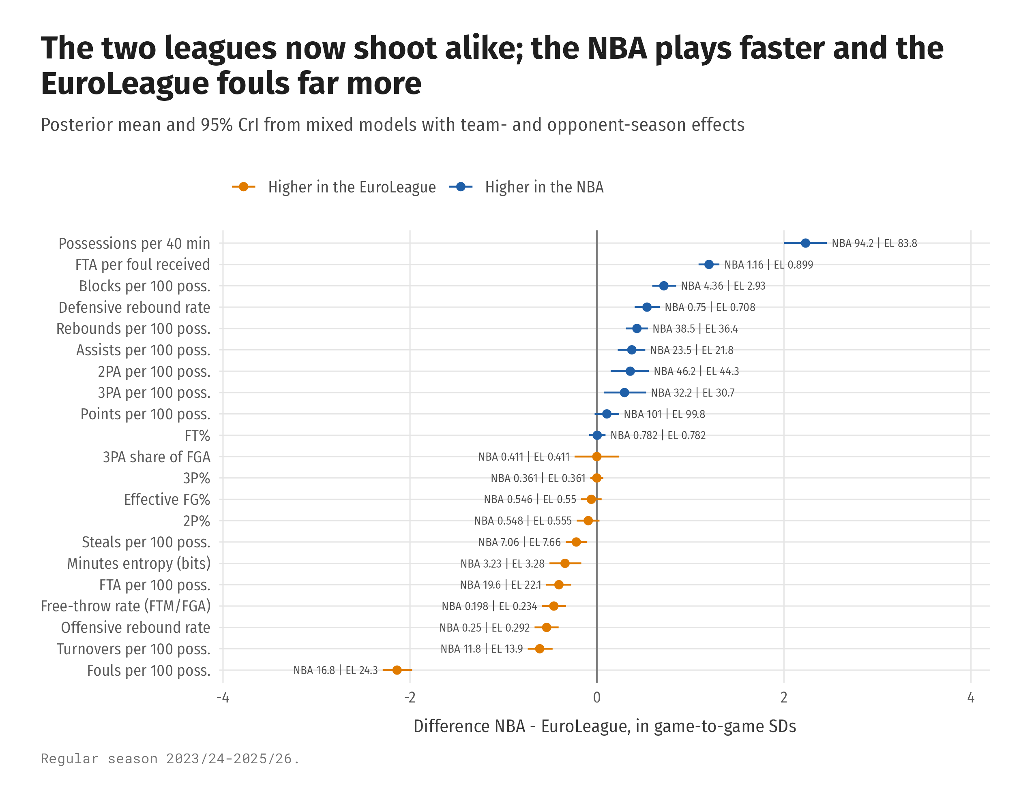
Figure 1: Box-score differences between the leagues, regular season 2023/24–2025/26. For each metric a Bayesian mixed model was fitted to every team-game (metric standardised; league effect plus team-season and opponent-season random effects; league-specific residual SD). Dots are the posterior mean of the league difference (NBA − EuroLeague) divided by the game-to-game SD, bars its 95% credible interval; the numbers are each league’s model-based mean on the original scale.
The equal three-point share hides different shot locations (Figure 2, Figure 3). 11% of NBA shots come from the corner against 4% in the EuroLeague, which instead takes more above-the-break threes (36% against 30%) and more short mid-range shots (21% against 16%). The rare EuroLeague corner three is worth more: 1.28 points per shot against 1.16 in the NBA. In both leagues threes are taken from just behind the league’s own line, and beyond 2.5 m accuracy is the same; EuroLeague accuracy falls off faster on the mid-range wings and far beyond the arc (Figure 4).
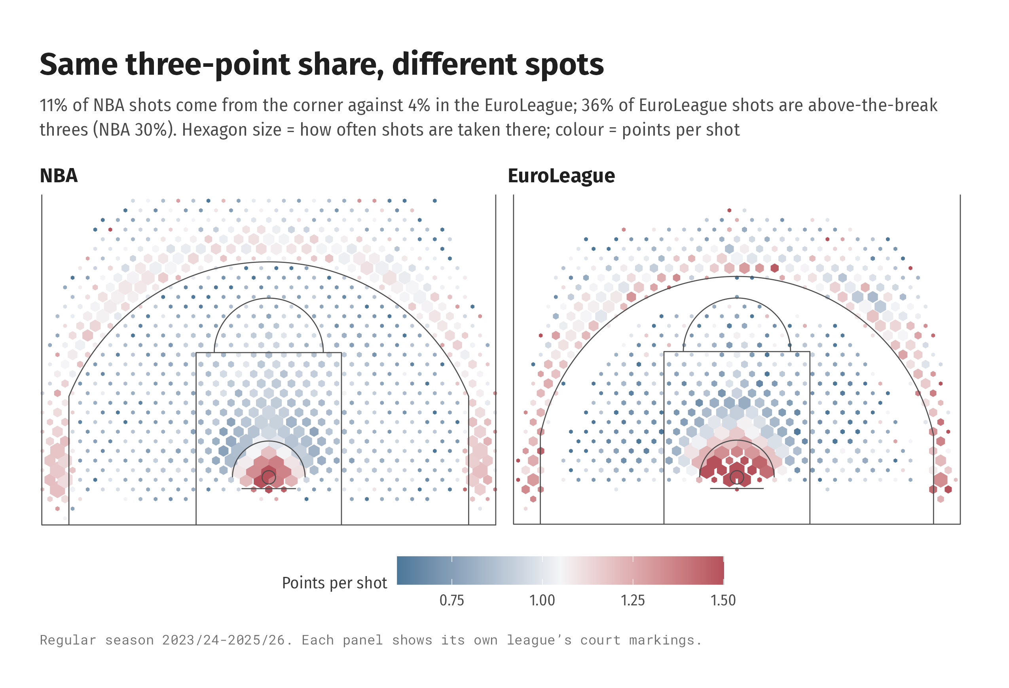
Figure 2: Shot charts, regular season 2023/24–2025/26. All located field-goal attempts of each league are binned into hexagons (30 across the court width, about 0.5 m). Hexagon area is proportional to the share of the league’s attempts taken there (capped at the 98th percentile so the rim does not dominate); colour is the observed points per attempt in the hexagon (2 or 3 × made). Hexagons with fewer than 15 attempts are not drawn.
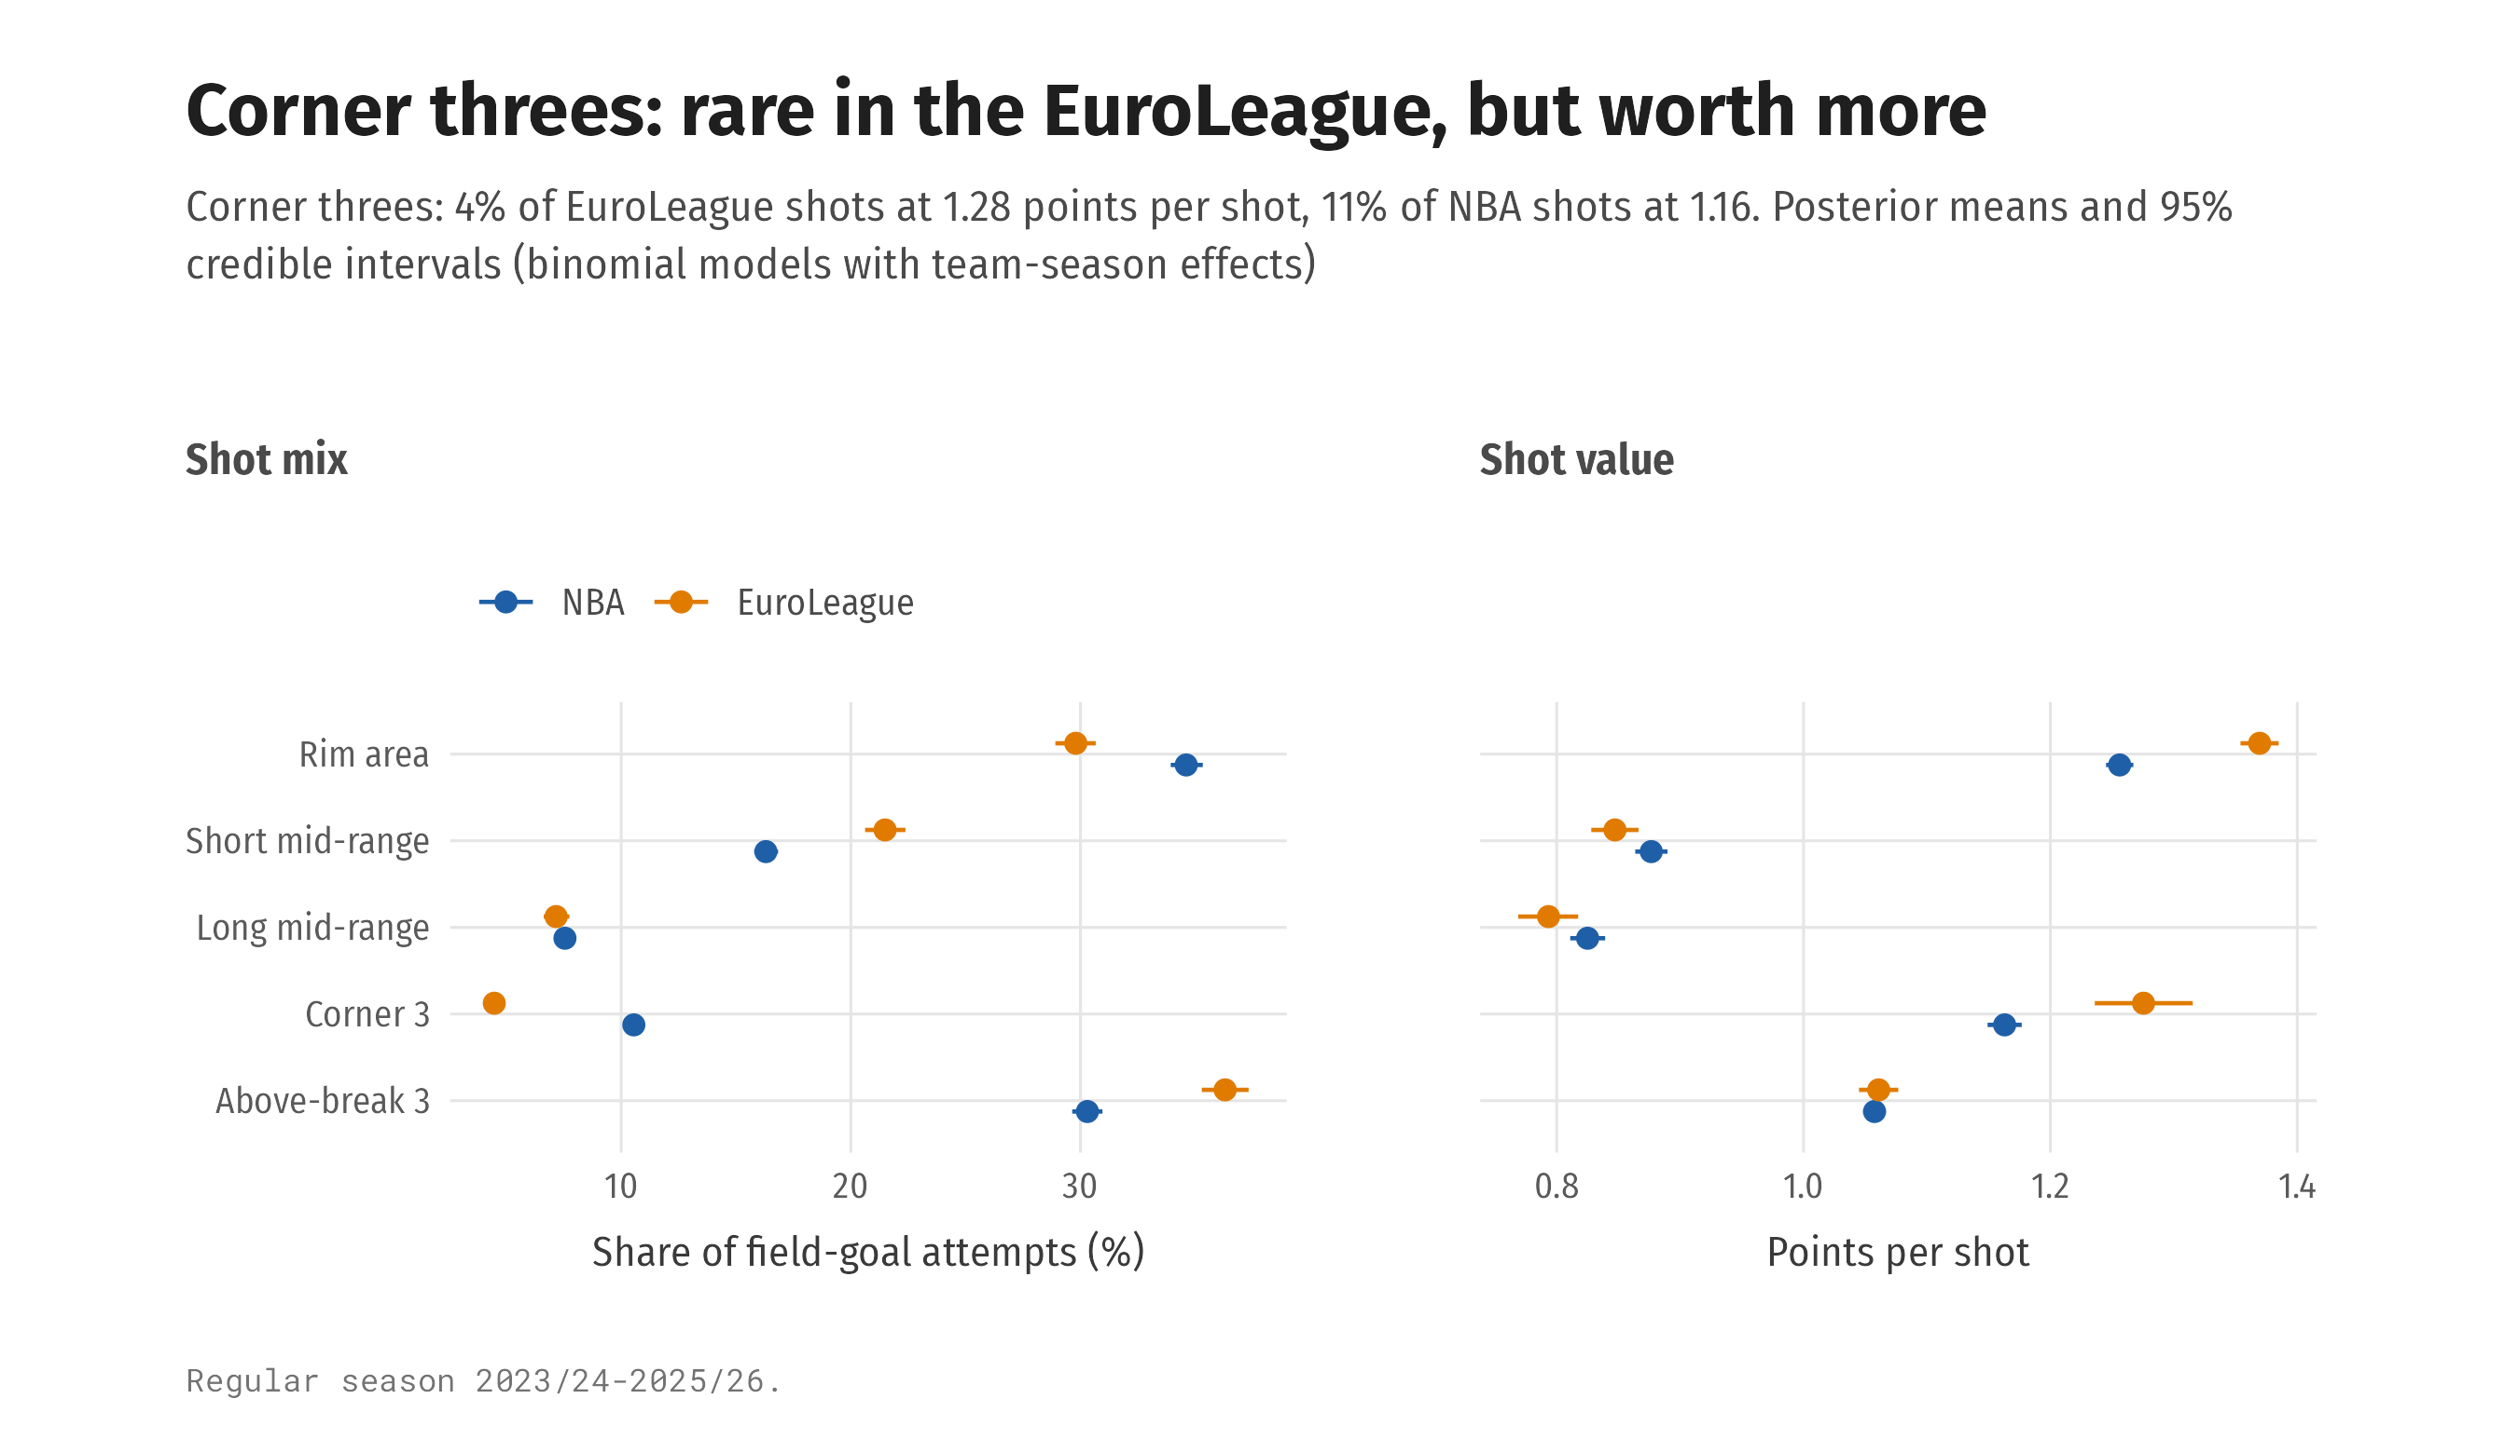
Figure 3: Shot share and value by zone for a typical team, regular season 2023/24–2025/26. Each attempt is assigned to one of five zones (Section 2). Left: share of attempts per zone from a binomial model (attempts in the zone out of all attempts; league effect plus team-season random effect). Right: points per shot = modelled make probability in the zone (binomial model of makes out of attempts, same structure) × the zone’s shot value. Dots are posterior means at the average team-season, bars 95% credible intervals.
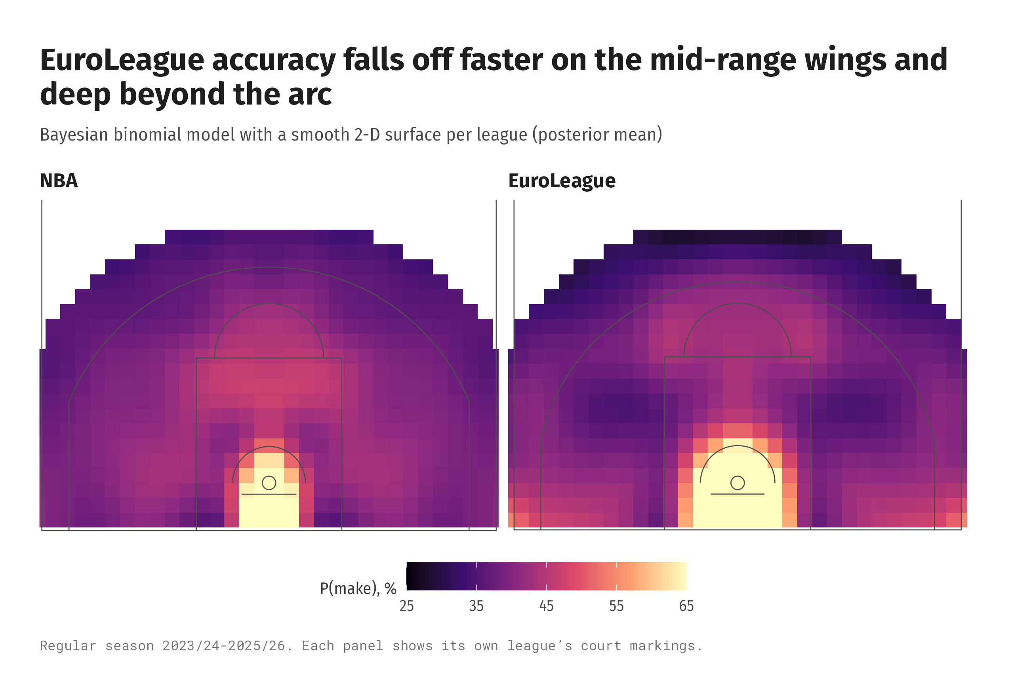
Figure 4: Modelled accuracy across the court, regular season 2023/24–2025/26. Shots are aggregated into 0.5 m × 0.5 m cells (left and right sides pooled), and a binomial model of makes out of attempts with a separate smooth two-dimensional tensor-product surface per league is fitted; the map shows the posterior mean make probability in each cell, mirrored back to both sides.

How the leagues changed, and who follows whom (RQ2)
Replication. Fitted to the 2019 paper’s own data, our implementation reproduces all 68 published estimates; the largest absolute difference is 0.013 (Figure 5).
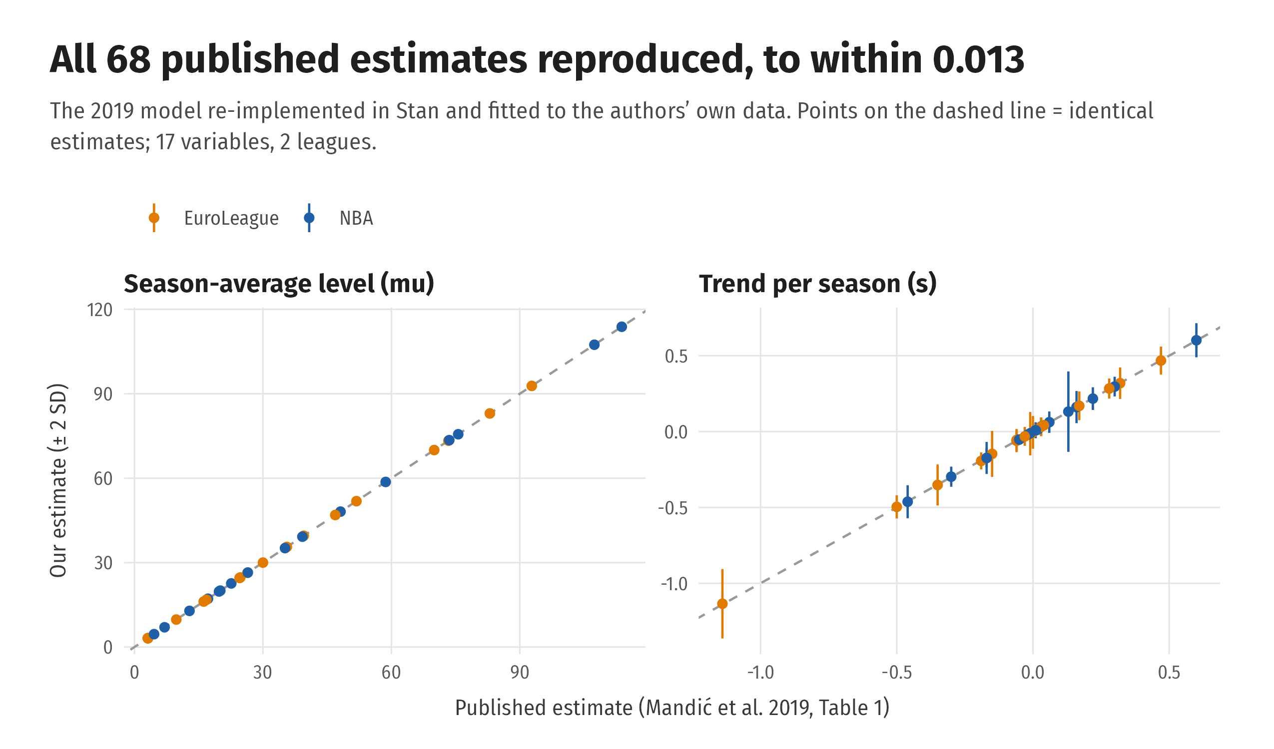
Figure 5: Replication of Mandić et al. (2019). Each point is one of the 68 published estimates (17 metrics × 2 leagues; level μ in the left panel, trend s in the right). The x-axis is the published value (their Table 1); the y-axis is our posterior mean from the same model fitted in Stan to the authors’ S1 data, with ± 2 posterior SD. Points on the dashed line are identical.
Trends. Since 2010/11 both leagues have moved in the same direction on most metrics (Figure 6). The NBA closed an 11-point gap in three-point share: the gap went from -10.7 to 0.1 percentage points (probability that it shrank 1.00). Pace went the other way: the gap grew from 6.7 to 9.6 possessions per 40 minutes (probability that it shrank 0.003). Free-throw rate and offensive rebounding also drifted apart (Figure 7).
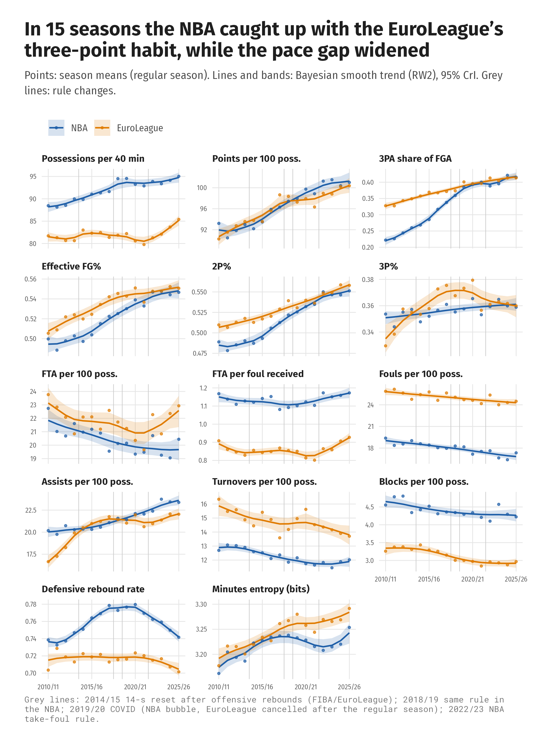
Figure 6: Trends, regular season 2010/11–2025/26. Points are the observed season means of team-game values. Lines and bands are the posterior mean and 95% credible band of a second-order random-walk (RW2) trend fitted separately to each league and metric, using the season means and their standard errors (Section 3). Grey vertical lines mark rule changes.
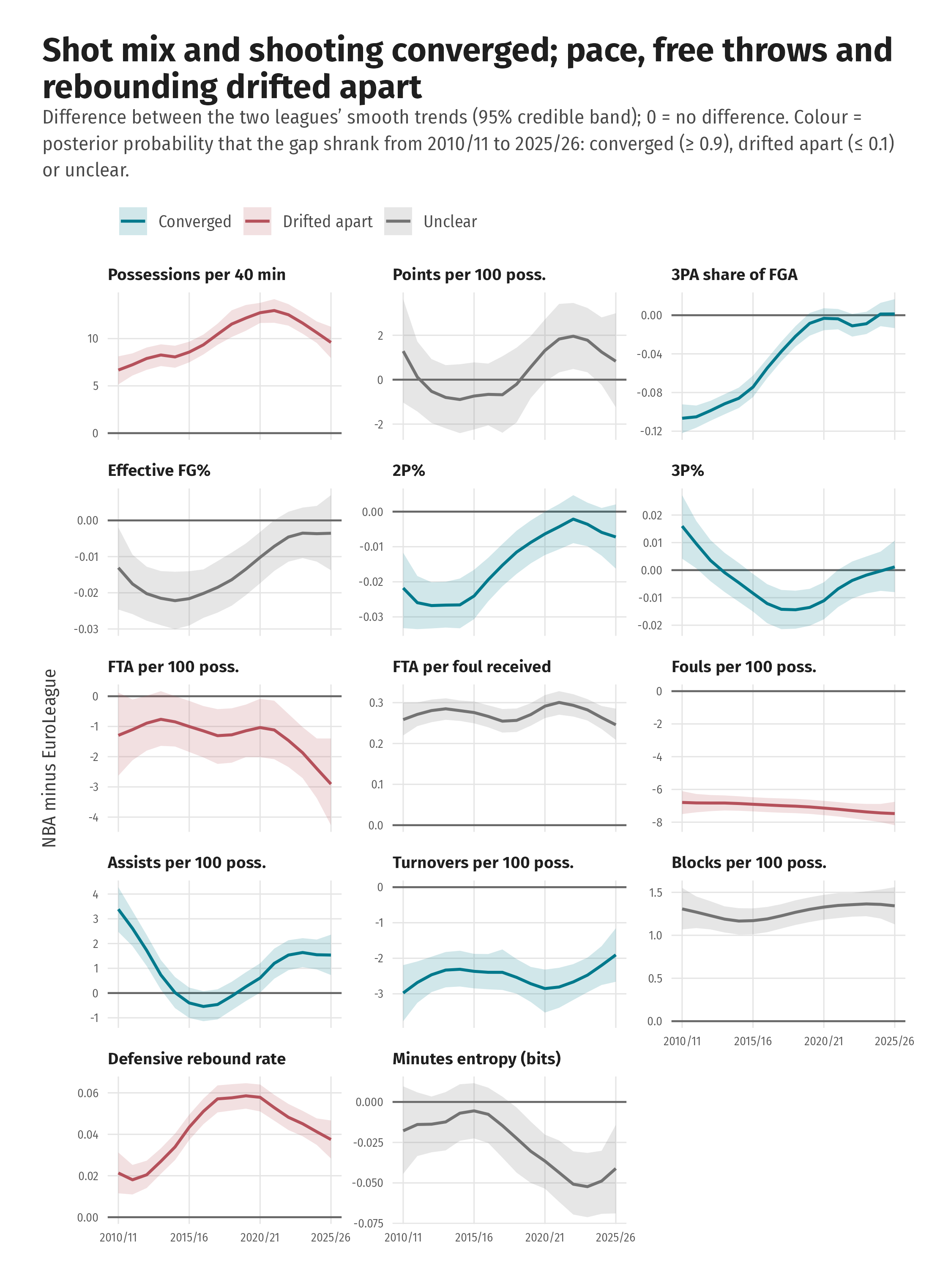
Figure 7: Gap between the leagues over time. For every posterior draw, the EuroLeague trend of Figure 6 is subtracted from the NBA trend season by season; lines and bands are the posterior mean and 95% credible band of that difference. The colour is the posterior probability that the absolute gap in 2025/26 is smaller than in 2010/11: converged (≥ 0.9), drifted apart (≤ 0.1) or unclear.
Lead–lag. For most metrics the shift model cannot say which league leads (Figure 8). The clearest signals concern three-point shooting: on three-point attempts per 100 possessions the leagues move in step (most probable lag 0, probability 0.50), and on the share of shots from three the EuroLeague is in step or one season behind (probability that it follows 0.65). On volume measures the EuroLeague of 2025/26 looks like the NBA of about 3 (points per 100 possessions), 4 (three-point attempts) and 5 (assists) seasons earlier (Figure 9).
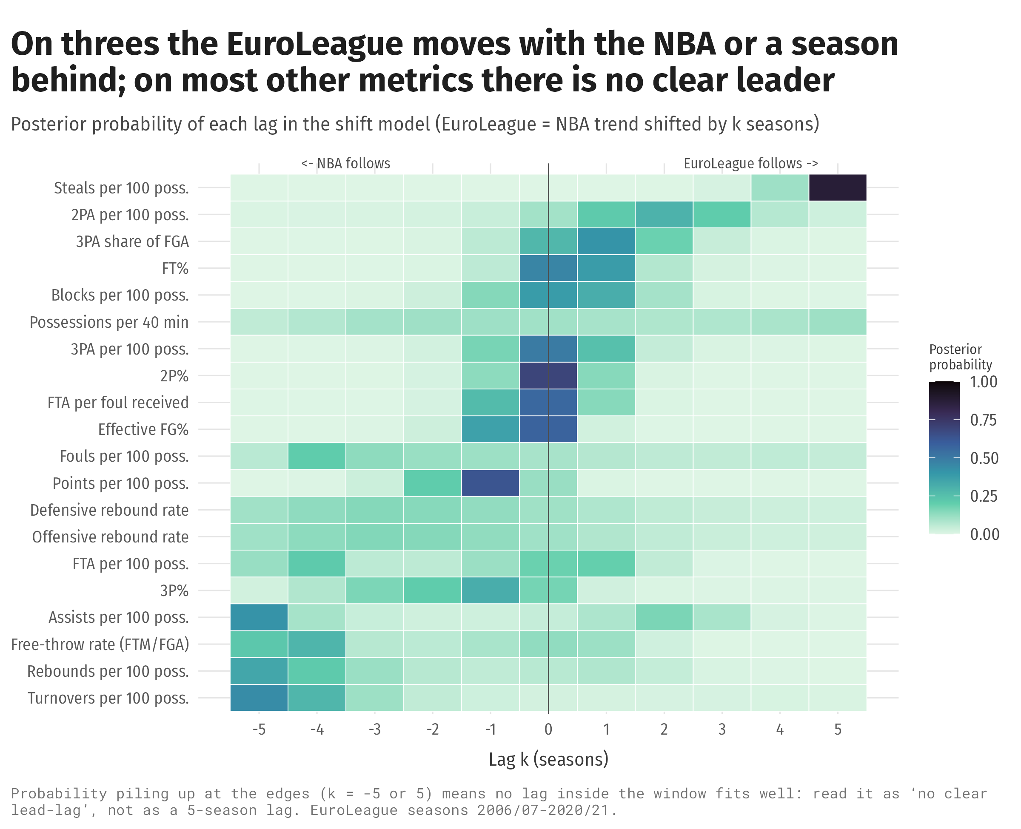
Figure 8: Lead–lag. For each metric, the shift model (Section 3) is fitted for lags k = −5 … 5 seasons with k marginalised out; each cell is the posterior probability P(k | data) that the EuroLeague’s season means follow the NBA’s smooth trend shifted by k seasons (k > 0: the EuroLeague follows). Probability piling up at k = ±5 means that no lag inside the window fits well.
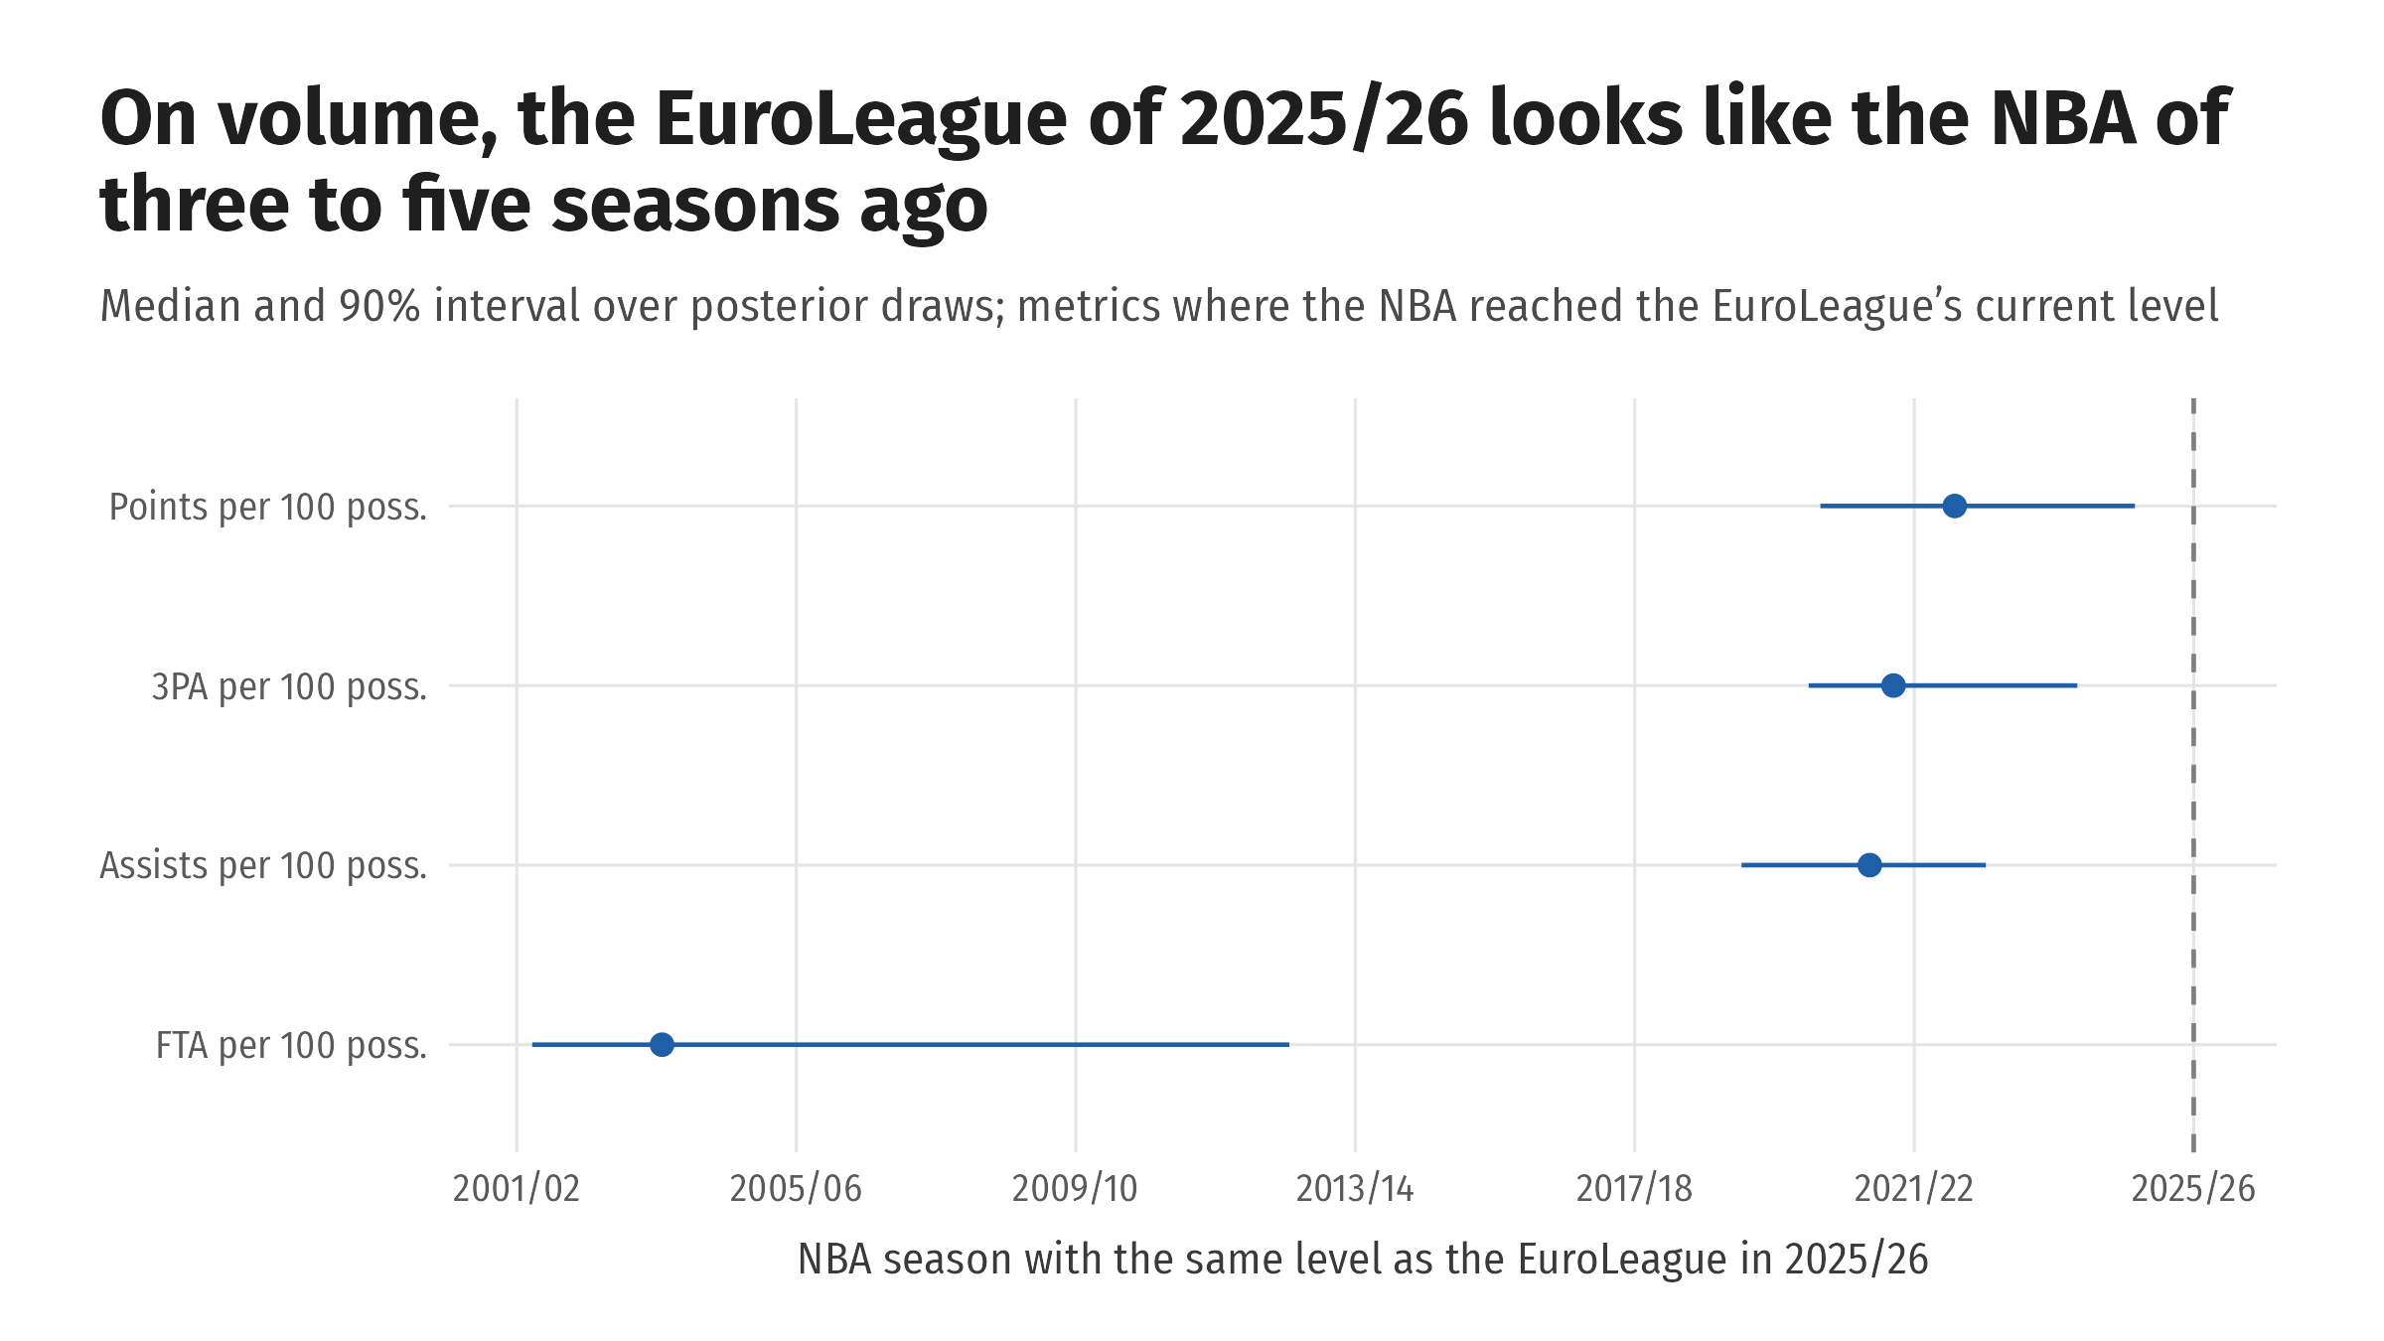
Figure 9: Time gap. For each posterior draw of the NBA’s RW2 trend (2001/02–2025/26), we find the first season in which the NBA reached the EuroLeague’s 2025/26 level of the metric; dots are the median season and bars the 90% interval over draws. Only metrics where the NBA reached that level in most draws are shown.

The playoffs (RQ3)
In the playoffs both leagues slow down, foul more, take more free throws and shoot worse (Figure 10). The NBA’s playoff shift points towards the EuroLeague’s regular-season level on 10 of 21 metrics, mostly pace, fouls and free throws, and away from it on 8, including every field-goal percentage (Figure 11). The 2019 claim that NBA playoff basketball “looks European” therefore holds for tempo and physicality but not for field-goal shooting. In shot selection, EuroLeague teams swap rim shots for above-the-break threes in the playoffs (-1.9 and +1.9 percentage points), while NBA teams move a little from the rim to the short mid-range.
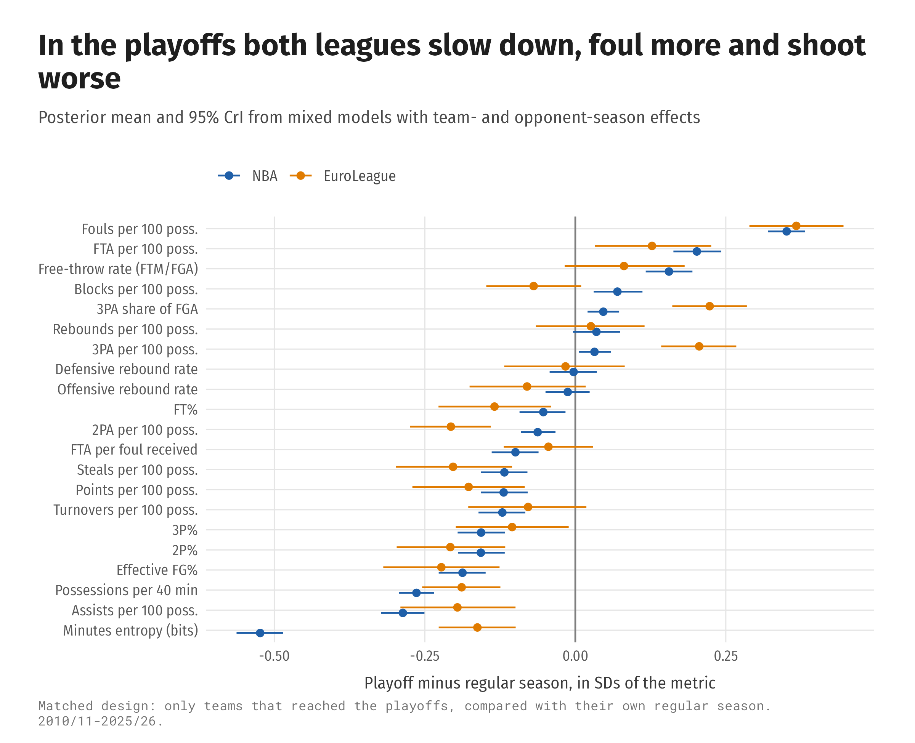
Figure 10: Playoff shifts, 2010/11–2025/26. Only teams that reached the playoffs are used. For each metric a mixed model of standardised team-game values with league, league × playoff, team-season and opponent-season effects is fitted; dots are the posterior mean playoff-minus-regular-season shift in each league (in game-to-game SDs), bars 95% credible intervals.
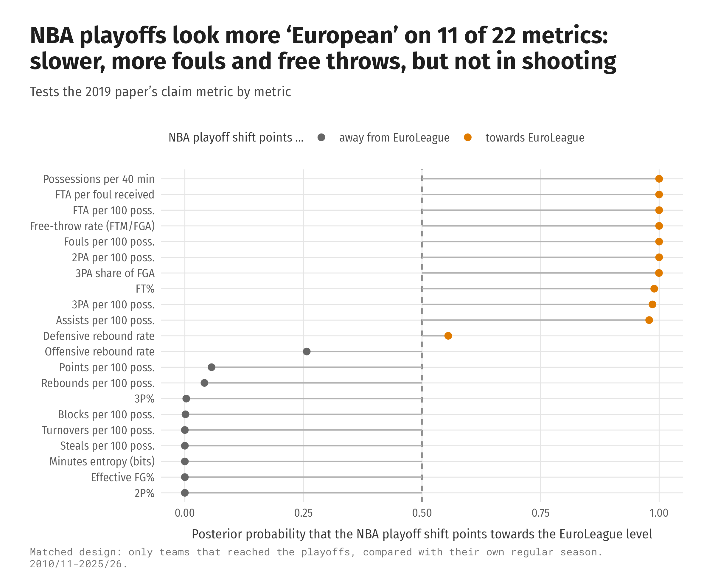
Figure 11: Does the NBA’s playoff shift point towards the EuroLeague? For each metric and posterior draw, the NBA’s playoff shift is divided by the regular-season gap (EuroLeague − NBA); a positive ratio means the playoffs move the NBA towards the EuroLeague, and 1 would close the gap. Shown are the posterior probability that the ratio is positive and its median.

Teams and players ahead of their time (RQ4)
The Houston Rockets were the NBA’s most different team in seven straight seasons (2013/14–2019/20): almost no long two-pointers, many corner threes and free throws (Figure 13). Their 2012/13 and 2016/17 teams sit about four seasons ahead of the league, which later moved their way (Figure 12). In the EuroLeague, Real Madrid of 2013/14–2017/18 played the league’s future: fast, assist-heavy, with few turnovers, almost no long two-pointers and many above-the-break threes. Teams behind their time include the 2022/23 Chicago Bulls, whose mid-range offence resembled an NBA team of about 2017/18, and Partizan 2022/23.
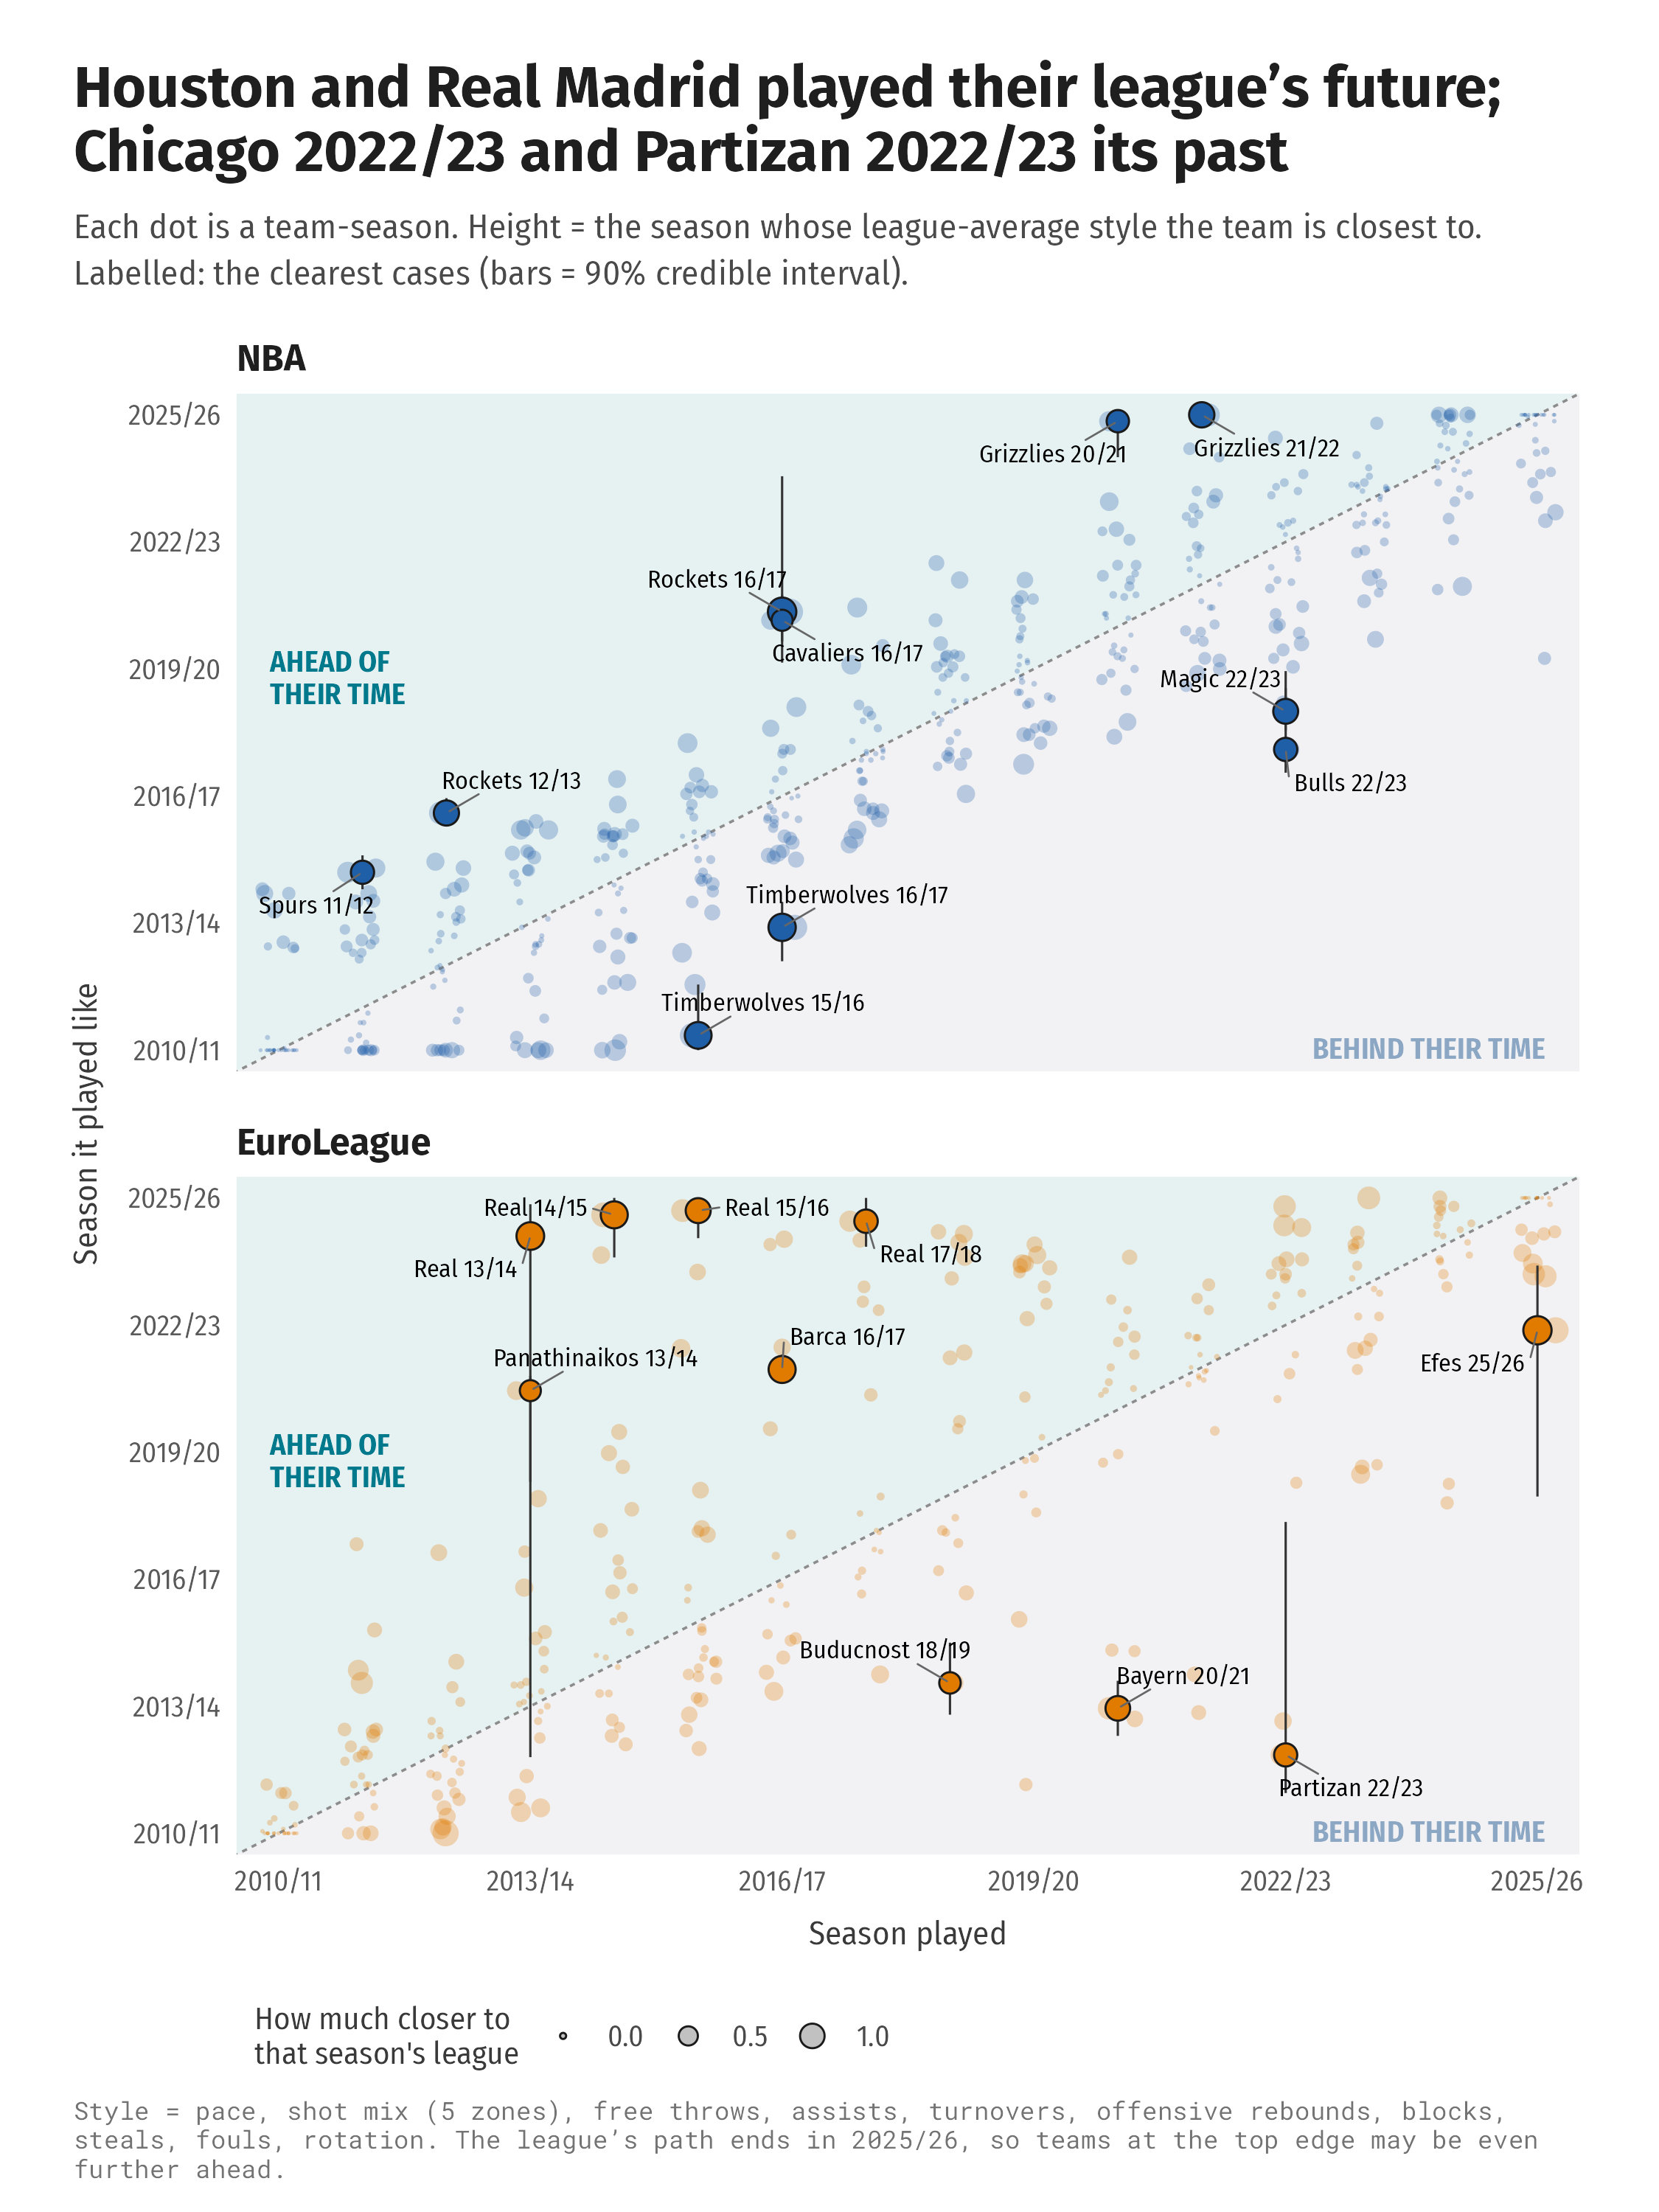
Figure 12: The time machine. Each team-season’s 14-number style profile (shrinkage posterior, 400 draws, each feature scaled by the pooled within-season spread between teams) is compared with its league’s average profile in every season (the league’s path); its time position is the season it is closest to (Euclidean distance), computed draw by draw. Dots: median time position; bars: 90% interval; dot size: how much closer that season is than the team’s own season. Above the diagonal = ahead of its time.
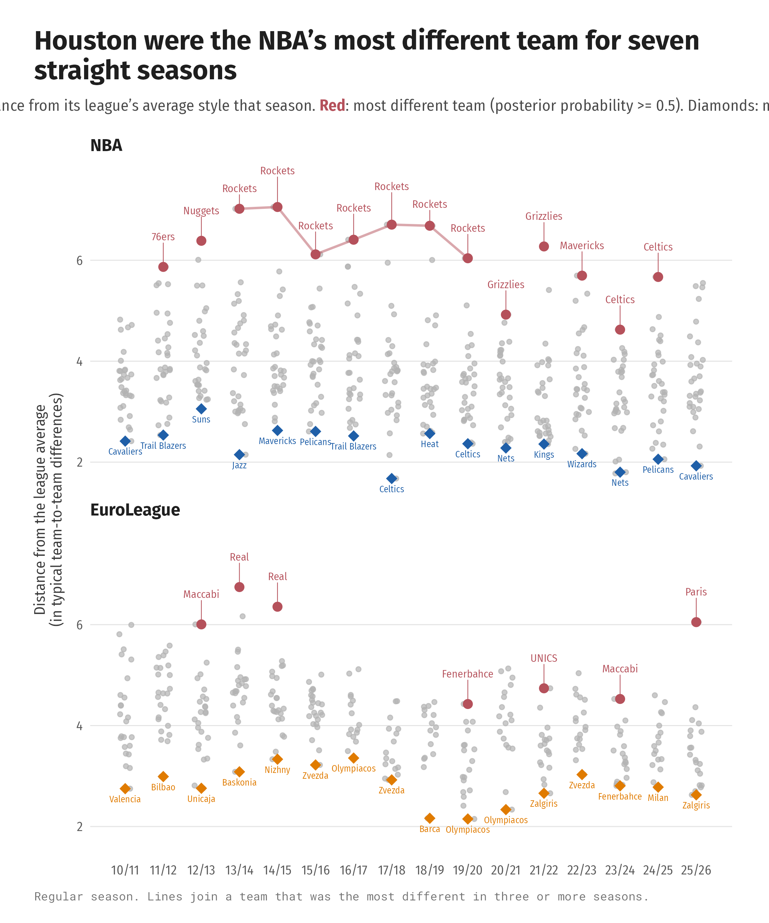
Figure 13: Typical and different teams. For each team-season and posterior draw, the Euclidean distance between its scaled style profile and the league-season average; dots are the posterior mean distance. Red marks the team that is furthest away in most draws (the most different team of the season); lines join teams that were the most different in three or more seasons.
Among players, Nikola Kalinić was the EuroLeague’s most typical player in six seasons. Brook Lopez is the clearest individual case of a player jumping ahead: from 14 three-point attempts in 2015/16 to 387 in 2016/17, moving from a 2010s centre to a centre of today in one summer, while his twin Robin stayed a 2010s centre (Figure 14). EuroLeague guards such as Juan Carlos Navarro, Miloš Teodosić, Sergio Llull and Vassilis Spanoulis sit ahead of their time for most of their careers.
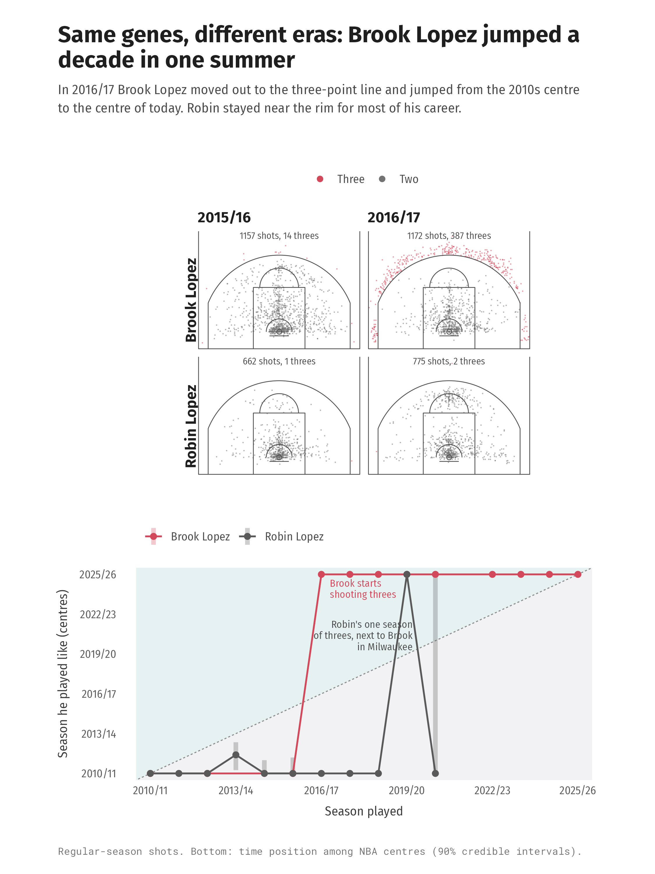
Figure 14: Brook and Robin Lopez. Top: every regular-season shot in 2015/16 and 2016/17 (red = three-point attempts). Bottom: each season’s time position among NBA centres, computed as for teams but with the 13-number player profile compared with the average centre of every season (median and 90% interval).

Discussion

Overview of the results
- RQ1, the leagues today (2023/24–2025/26). The NBA and the EuroLeague now shoot equally well and take the same share of their shots from three (41.1%). They differ in style: the NBA plays about ten more possessions per 40 minutes, blocks more and earns more free throws per foul; the EuroLeague commits about seven more fouls per 100 possessions, turns the ball over more and rebounds more of its own misses. The same three-point share comes from different spots: 11% of NBA shots are corner threes against 4% in the EuroLeague, where the rare corner three is worth more (1.28 against 1.16 points per shot).
- RQ2, change since 2010/11. The 2019 model was reproduced exactly (68 of 68 estimates, largest difference 0.013). Since 2010/11 the leagues converged in shot mix and shooting (the NBA closed an 11-point gap in three-point share) but drifted apart in pace, free throws and rebounding. On three-point shooting the EuroLeague moves with the NBA or a season behind; on volume measures it looks like the NBA of three to five seasons ago; for most other metrics no league clearly leads.
- RQ3, the playoffs. In both leagues playoff games are slower, more physical and lower in shooting accuracy. The NBA’s playoffs move towards the EuroLeague’s numbers on 11 of 22 metrics (tempo, fouls, free throws) but away from them on 8, including every field-goal percentage.
- RQ4, ahead of their time. Houston was the NBA’s most different team for seven straight seasons (2013/14–2019/20), and its 2012/13 and 2016/17 teams played about four seasons ahead of the league; Real Madrid of 2013/14–2017/18 played the style the EuroLeague later adopted; Chicago and Partizan in 2022/23 played an older one. Among players, Brook Lopez jumped about a decade in one season, and EuroLeague guards such as Navarro, Teodosić and Spanoulis were ahead of their time for most of their careers.

What is new in this study
Earlier comparisons of the two leagues have been cross-sectional or descriptive. Paulauskas et al. (2018) compared European players at one tournament (EuroBasket 2015) with discriminant analysis. Mandić et al. (2019) used league-season box scores from 2000/01 to 2016/17 with a straight-line trend per league and metric. Long-run NBA studies such as Zając et al. (2023) describe four decades of shooting in a single league, and Erčulj & Štrumbelj (2015) compared shot types across levels of competition. This study adds six things that none of them did:
- A replication before the update. We re-implemented the 2019 model and reproduced all 68 published estimates from the authors’ own data, so the update starts from a verified baseline.
- Where shots are taken and made. 4.1 million located attempts, compared zone by zone and across the whole court with each league’s own court geometry, instead of box-score totals alone.
- Team and opponent adjustment. League differences are estimated at game level with team-season and opponent-season effects, so they are not driven by a few extreme teams or schedules.
- Trends that can bend, with uncertainty. Second-order random walks replace straight lines, and every gap and convergence statement comes with a posterior probability.
- An explicit test of who follows whom. The shift model and the time-gap calculation turn the question into one the data can answer, or openly fail to answer.
- Teams and players placed in time. Shrinkage style profiles give every team and rotation player a time position with a credible interval, so cases such as Houston, Real Madrid or Brook Lopez are measured rather than told as anecdotes.
All code, Stan models, tables and figures are open, and the figures are drawn with a documented R package (Theodosiou, 2026), so the analysis can be rerun as new seasons are played.

The leagues are converging in skill, not in style
Sixteen seasons after the period studied by Mandić et al. (2019), the convergence they saw has continued for shooting, and the NBA closed its three-point-share gap by about 2019/20 (Figure 7). But convergence in shooting has not brought convergence in style. The pace gap widened until about 2020/21 and has narrowed only slightly since, and the foul, free-throw and rebounding gaps have grown. Even the equal three-point share is reached from different places (Figures 2–3).

Why the leagues differ
The remaining differences line up with the rules and with the players. Pace is measured per 40 minutes, so the longer NBA game alone does not explain it; the NBA’s defensive three-second rule and its slightly larger court may favour a faster, more spread-out game. The foul gap fits the different foul limits (six personal fouls in the NBA, five under FIBA rules), and the fact that the EuroLeague earns fewer free throws per foul suggests that more of its fouls are non-shooting, tactical fouls. The corner-three gap follows partly from court geometry: the FIBA corner three is only 11 cm shorter than the NBA’s (6.60 m against 6.71 m), while the arc above the break is 49 cm shorter (6.75 m against 7.24 m), so in the EuroLeague the above-the-break three is relatively easier. Because the rare EuroLeague corner three is worth more per attempt (1.28 points against 1.16 in the NBA), EuroLeague teams could probably take more of them. Players matter too: Paulauskas et al. (2018) found that European players in the NBA differ from EuroLeague players mainly in variables linked to body size (rebounds, blocks and fouls drawn), which matches the NBA’s lead in blocks and defensive rebounding here.

Who follows whom
The lead–lag results describe timing, not influence. Smooth trends over about 25 seasons can often be shifted a few seasons either way and still fit, so for most metrics the honest answer is that the data cannot tell which league leads. Where they can, the EuroLeague moves with the NBA or one season behind on three-point shooting, and on volume measures (points, three-point attempts and assists per 100 possessions) it resembles the NBA of three to five seasons ago. This refines the 2019 view that the NBA was becoming “more European”: the EuroLeague took a larger share of its shots from three first, but the NBA now takes more threes per possession, because it has more possessions and fewer turnovers. In the playoffs the NBA does move towards the EuroLeague in tempo, fouls and free throws, but not in field-goal shooting, so the 2019 claim holds only in part.

Practical implications
For scouting and player movement, shooting skill now translates directly between the leagues, while pace, physical contact and the share of possessions that end in fouls do not: a player moving from the EuroLeague to the NBA meets a faster game with fewer fouls and more free throws per foul. For EuroLeague coaches, the corner three is an under-used shot. For analysts, the scorekeeping differences documented here (rim shots recorded about a metre from the hoop, team rebounds and turnovers credited differently) must be handled before the two leagues’ shot or play-by-play data are compared.

Future work
Three extensions follow. Play-by-play data would allow possession-level comparisons of shot-clock use, transition play, home advantage and line-ups. A joint model of both leagues with shared trend components would test convergence directly. And models that follow the same players across both leagues would separate the effect of the league from the effect of who plays in it.

Limitations
Box scores and shot locations come from two scorekeeping systems: shots near the rim are recorded less precisely in the EuroLeague, and rebounds and turnovers are credited slightly differently. The EuroLeague’s format changed several times (Top 16 until 2015/16, a single round robin since 2016/17, a play-in since 2025/26), and the 2019/20 season was cancelled after the regular season. Lead–lag results describe timing only; shared causes such as analytics, rule changes and player movement could produce the same pattern. The RQ4 results depend on which features define style; a different list could name different teams or players, and the posterior probabilities show where the choice is close. NBA possessions per 40 minutes before 2010/11 use regulation length, which only affects the lead–lag model.

Data and code availability
All code, Stan models, result tables and figures are at https://github.com/loukesio/nba-vs-euroleague (MIT licence). The data are downloaded from public sources by the scripts in 00_data/scripts/ and remain subject to their providers’ terms. Figures were made with ggbasket (https://loukesio.github.io/ggbasket/).

References
Bürkner, P.-C. (2017). Brms: An R package for Bayesian multilevel models using Stan. Journal of Statistical Software, 80(1), 1–28. https://doi.org/10.18637/jss.v080.i01
Carpenter, B., Gelman, A., Hoffman, M. D., Lee, D., Goodrich, B., Betancourt, M., Brubaker, M., Guo, J., Li, P., & Riddell, A. (2017). Stan: A probabilistic programming language. Journal of Statistical Software, 76(1), 1–32. https://doi.org/10.18637/jss.v076.i01
Erčulj, F., & Štrumbelj, E. (2015). Basketball shot types and shot success in different levels of competitive basketball. PLOS ONE, 10(6), e0128885. https://doi.org/10.1371/journal.pone.0128885
Gilani, S. (2021). hoopR: Access men’s basketball play by play data. https://hoopr.sportsdataverse.org
Goldsberry, K. (2019). SprawlBall: A visual tour of the new era of the NBA. Houghton Mifflin Harcourt.
Kubatko, J., Oliver, D., Pelton, K., & Rosenbaum, D. T. (2007). A starting point for analyzing basketball statistics. Journal of Quantitative Analysis in Sports, 3(3). https://doi.org/10.2202/1559-0410.1070
Mandić, R., Jakovljević, S., Erčulj, F., & Štrumbelj, E. (2019). Trends in NBA and Euroleague basketball: Analysis and comparison of statistical data from 2000 to 2017. PLOS ONE, 14(10), e0223524. https://doi.org/10.1371/journal.pone.0223524
Oliver, D. (2004). Basketball on paper: Rules and tools for performance analysis. Potomac Books.
Paulauskas, R., Masiulis, N., Vaquera, A., Figueira, B., & Sampaio, J. (2018). Basketball game-related statistics that discriminate between European players competing in the NBA and in the Euroleague. Journal of Human Kinetics, 65(1), 225–233. https://doi.org/10.2478/hukin-2018-0030
Rue, H., & Held, L. (2005). Gaussian Markov random fields: Theory and applications. CRC Press.
Theodosiou, L. (2026). ggbasket: Learn from basketball games, NBA and EuroLeague. https://loukesio.github.io/ggbasket/
Wood, S. N. (2017). Generalized additive models: An introduction with R (2nd ed.). CRC Press.
Zając, T., Mikołajec, K., Chmura, P., Konefał, M., Krzysztofik, M., & Makar, P. (2023). Long-term trends in shooting performance in the NBA: An analysis of two- and three-point shooting across 40 consecutive seasons. International Journal of Environmental Research and Public Health, 20(3), 1924. https://doi.org/10.3390/ijerph20031924

