Luke Morrison
Brice Muniz
ECE 423 Final Project

Project Overview
Name | Spec | Slow | Typical | Fast | Extracted
Power Supply (V) | Vdd  Vcm | 2.25  1 | 2.5  1 | 2.75  1 | 2.5  1
Ext. Capacitors (pf) | CL  Cc  CFB | 3.9  1.3  1 | 3  1  1 | 2.1  0.7  1 | 3  1  1
OpAmp Cap (%) | - | 30 | 0 | -30 | 0
OpAmp Res (%) | - | 30 | 0 | -30 | 0
Temperature (C) | - | 100 | 27 | -40 | 27
Loop Gain (dB) | >70 | 71.084 | 71.602 | 71.768 | 71.54
Loop UGBW (MHz) | >80 | 88.873 | 129.76 | 207.48 | 78.86
Loop PM (Deg) | >60 | 59.63 | 57.44 | 52.85 | 62.27
CMFB PM (Deg) | >60 | 41.07 | 27.063 | 14.031 | 33.17
CM Accuracy (mV) | <+/- 50 | 32.8 | 10.7 | 49.2 | 32.9
Out Swing (Vpk-pk) | >2 | ~2.1 | ~2.1 | ~2.1 | ~2.1
Power (mW) | <10 | 9.34 | 8.24 | 10.58 | 9.34
NOTE: We didn't realize until we submitted our layout that we had followed an older version of our schematic. This is the reason why we do not pass Loop PM for the slow and typical case. We are aware we could pass these requirements by modifying the compensation caps

Very early into the design process, we decided to make every PMOS transistor in our schematic to be twice the size of their complementary NMOS transistors. We did this to make our cicuit more symmetrical from and NMOS/PMOS point of view given that PMOS transistors need to be bigger to achieve similar overdrive voltages. We could have made them even bigger with respect to NMOS transistors but decided against it because it would increase out parasitic capacitances. We also chose our 1x transistor sizing to be around W/L=80u/0.24u from our previous assignments.

Main amplifier
The topology of the amplifying circuit of our OpAmp is a two stage Telescopic topology. Before using this topology, we experimented with a folded cascode circuit. At first, the folded cascode seemed like it would be a very good option since it should have good output swing despite being a single stage design. We thought we could get high gain and high bandwidth while using very little power since there is no second stage. Eventually, after trying to tweak and optimize that OpAmp, we realized that both the phase margin and gain were too low. To solve this, we resorted to adding a second stage to the folded cascode topology. This worked well, but burned too much power, escially in the second stage. We had to sink a lot of current through the second stage to improve our phase margin. We eventually realized that folded cascode with a second stage also offered no real advantage compared to a telescopic OpAmp topology with a second stage. We were effectively trading phase margin for output swing on the first stage when using folded cascode, which was useless. For the telescopic design, we also chose to use a PMOS input because we didn't want the VGS of our second stage NMOS transistor to be across the current source.

Biasing Circuit
The biasing circuit was made as sturdy as possible to provide the best biasing voltages and current mirroring in the rest of the OpAmp. For example, in three of the biasing branches, we used two PMOS transistors to mirror the current over. This was done so that the overdrive voltage across the other transistors in the same branch would be lower, therefore creating more accurate mirroring (since current depends on both VGS and VDS). Furthermore, we decided against using any Sutch cascode topologies to create biasing voltages. The advantage of Sutch cascode is that you can create more than one biasing voltage on each branch at the cost of extra transistors. This reduces the power consumption since less current needs to be used. However, we found that Sutch Cascode seemed to create more biasing problems than the standard 1/4x transistor method for creating VT + 2∆. Therefore, we only used the 1/4x transistor method. If you notice in the schematics, these transistors are actually smaller than 1/4x to give extra saturation headroom. We found that this increased both our gain and bandwidth quite noticebly.

CMFB Circuit
Given our inexperience with common mode feedback circuits, we decided to use one of the two designs that were shown to us during class. At first, we used the circuit with resitors since it seemed to be Moon's favorite of the two. Later on, we decided to implement the second circuit as well so that we could compare them. We saw no difference in functionality, but the circuit without resistors used less transistors. Because of that, we used the circuit without resistors.
The only thing to keep in mind when using this circuit is that the VDS across the gain transistors in the CMFB circuit needs to be very high. This is because our output swing could be limited by this circuit if it is not biased properly.

Optimization
During the design process, we spent the bulk of our time tweaking various parameters to meet key specifications. For example, we started our design with all transistors at the smallest length, and then gradually increased the lengths to increase gain and bandwidth. The lengths of the gain transistors were kept at minimal for maximum gain. We routinely experimented with the current flowing through the second stage. If we increased it, we could trade off some gain to increase the phase margin and vice versa. Another big variable was the size of the biasing/common-mode transistors with respect to the main transistors. Making these transistors smaller saved us a lot of power. We also split the current source transistor in our main amplifier into two parallel transistors to reduce our CMFB gain, which in turn would reduce CMFB bandwidth and increase phase margin of the CMFB loop.

Specifications
For schematics see appendix A.

Simulation Results
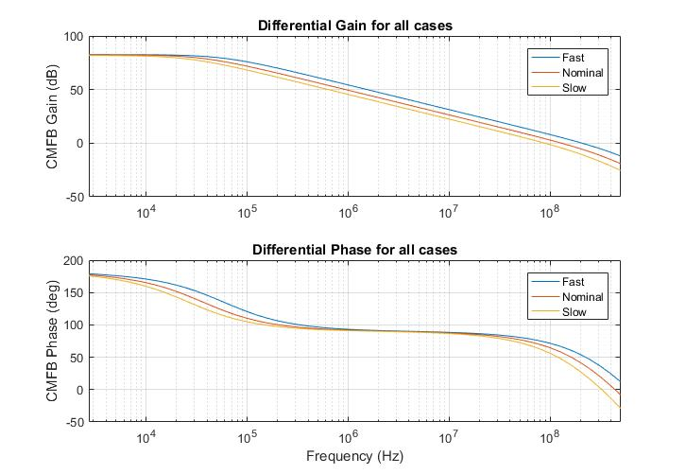
See appendix B for test bench schematics. Differential Loop Results

CMFB Loop Results
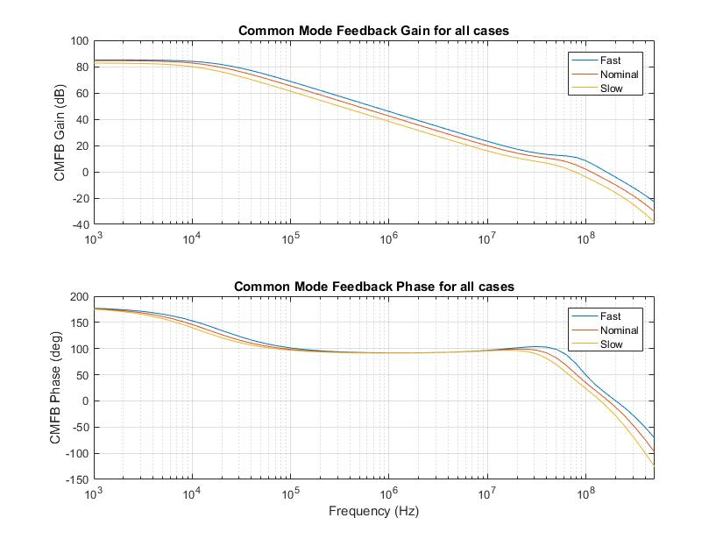
Output SwingAll measurements for output swing were made when the OpAmp was setup to measure CMFB.
We found that our results were different otherwise.
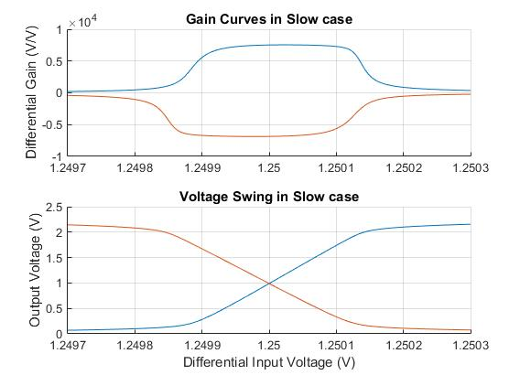

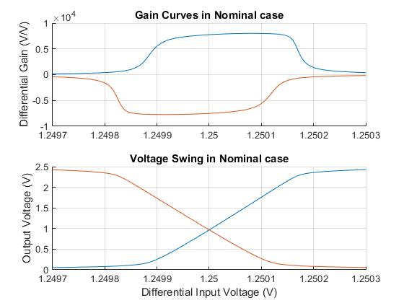
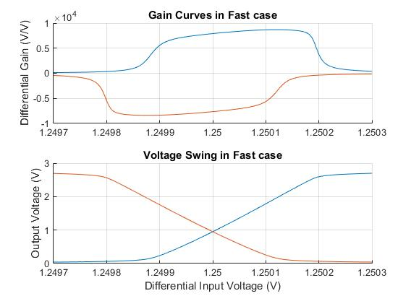
Power
Slow Mode
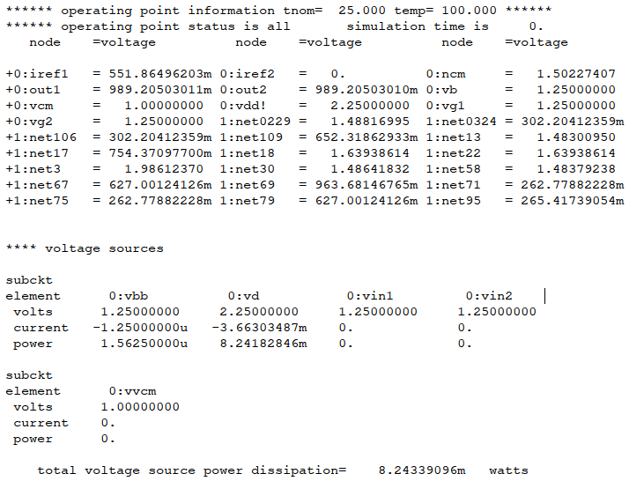

Typical Mode
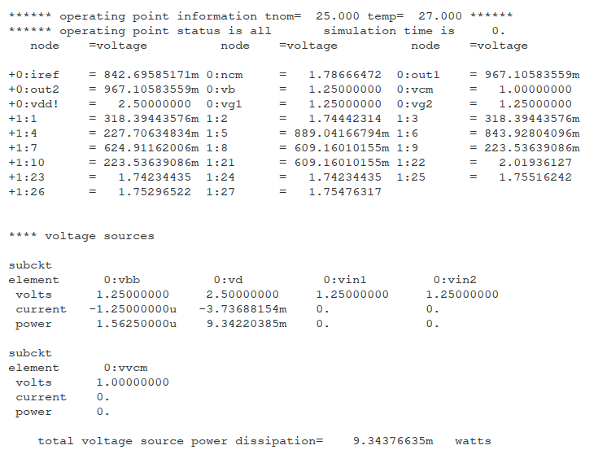

Fast Mode
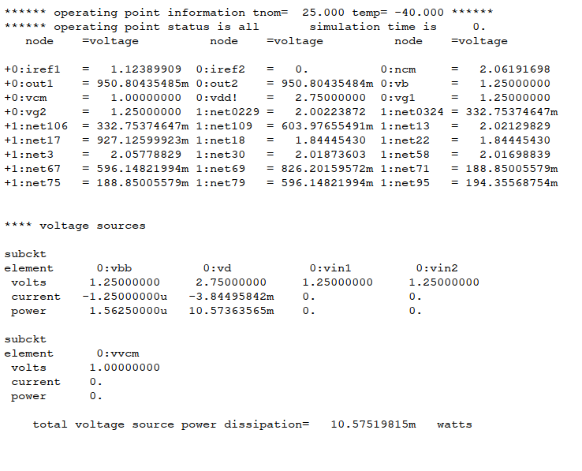
Layout

Design Process
The layout design process began with the Biasing and CMFB circuits as the Main stage was still undergoing slight alterations for optimization. The transistors of each stage were grouped together to avoid confusion in the layout process but each stage was placed very close to each other to minimize space requirements. The PMOS transistors were also given priority to be above the NMOS transistors as less trace material would be needed to connect the bulks to the voltage source plane. Each transistor was also placed close together but with enough spacing in between to allow for easy differentiation and space for traces to pass between them. It was decided to place this section of the layout between a ground plane, beneath, and a source voltage plane, above, which ultimately would result in a central source voltage pin and the majority of the layout being circled by a ground plane. Once the minimal alterations to the Main stage were completed the layout of that section began. In terms of the occupation of space, the PMOS transistors of the Main stage were vastly dominant. This reduced the pathing demands of connecting the bulks of every PMOS to the voltage source. The NMOS transistors were placed on the right side as it helped to optimize space and simplified pathing.
Later on, capacitors were placed as an afterthought as their space requirements were massive. An attempt to minimize pathing confusion was made by initially only using planes 1, 2, and 3 for transistor connections. However due to certain paths between transistors becoming full, in order to connect between the Main stage and Biasing and CMFB stages plane 4 was used. Also, due to the operation of Virtuoso, a single NMOS bulk was placed in the ground plane to connect all NMOS bulks to ground. Overall the layout design ended fairly compressed, however in retrospect there is still some room for improvement.

See appendix D for layout image.

Simulation Results
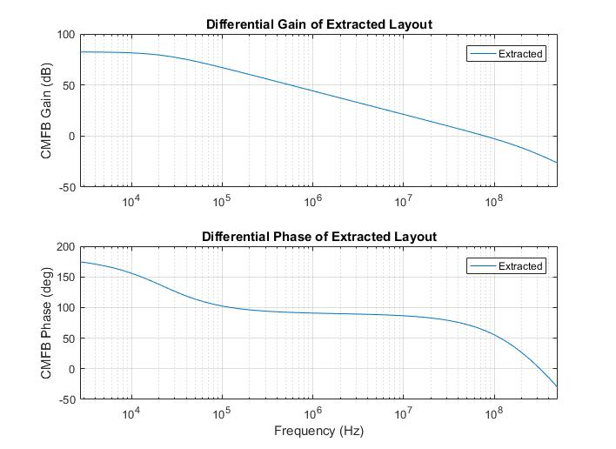
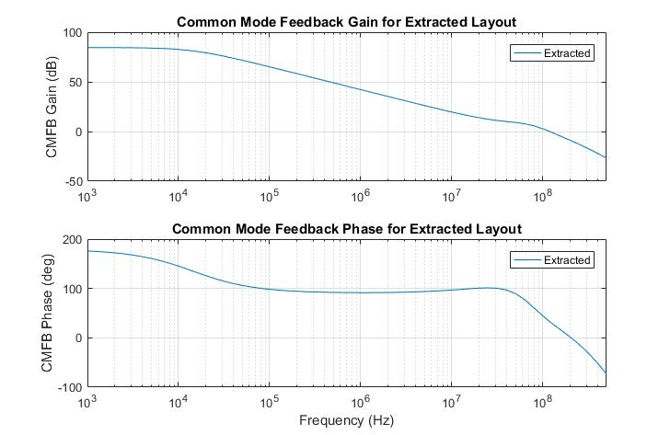
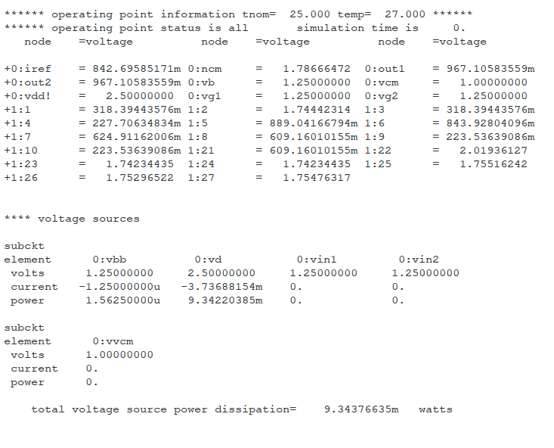
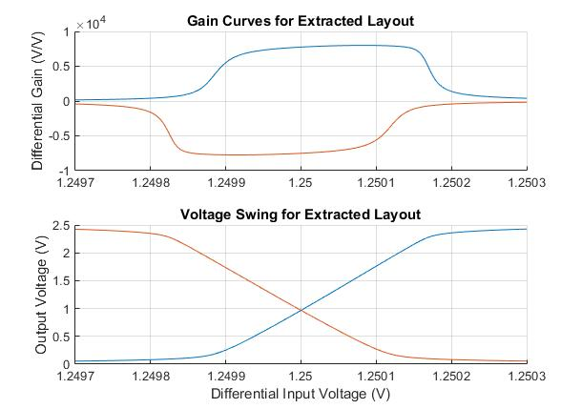
Conclusion
In conclusion, our OpAmp design is far from perfect. First, if we were to redo the project, we would triple check the performance of the schematic generated netlist before moving onto the layout. As we previously mentioned, we mistakenly based our layout on an older version of the schematic, which was not optimized appropriately. This caused us to fail phase margin requirements in the slow and typical case. Aside from that, we definitely could meet the specs better if we researched different topologies than the folded cascode and telescopic topologies. These are very basic and make it difficult to meet the requirements. Additionally, we had little experience in modifying some of the parameters such as transistor length, which makes our design rudimentary. Aside from our errors, we managed to meet more than half of the specifications. Overally the project was an excellent learning experience that taught us much about OpAmp design as well as how much more there is to learn.
Appendix A – Full size schematics

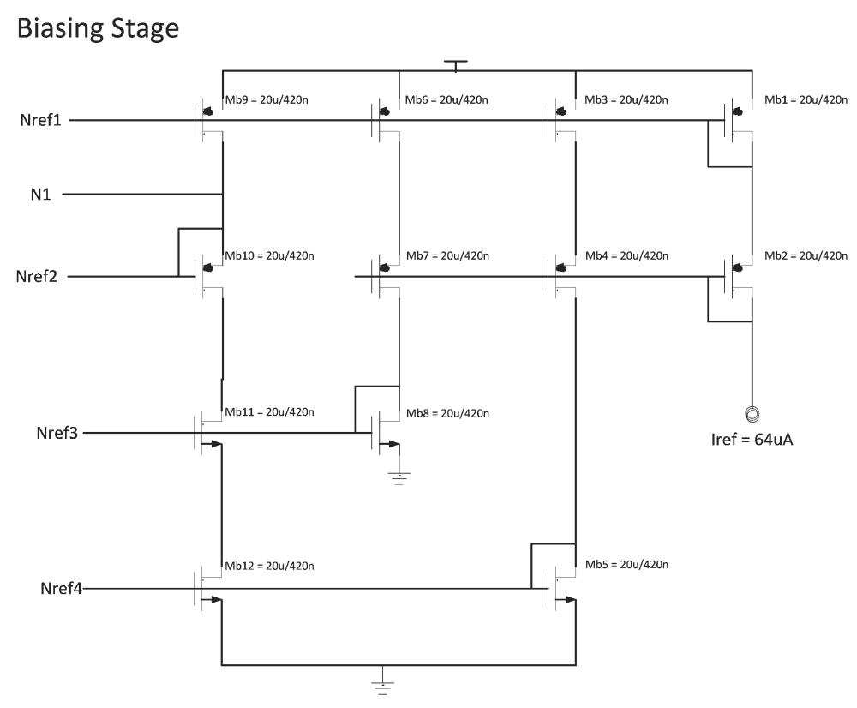

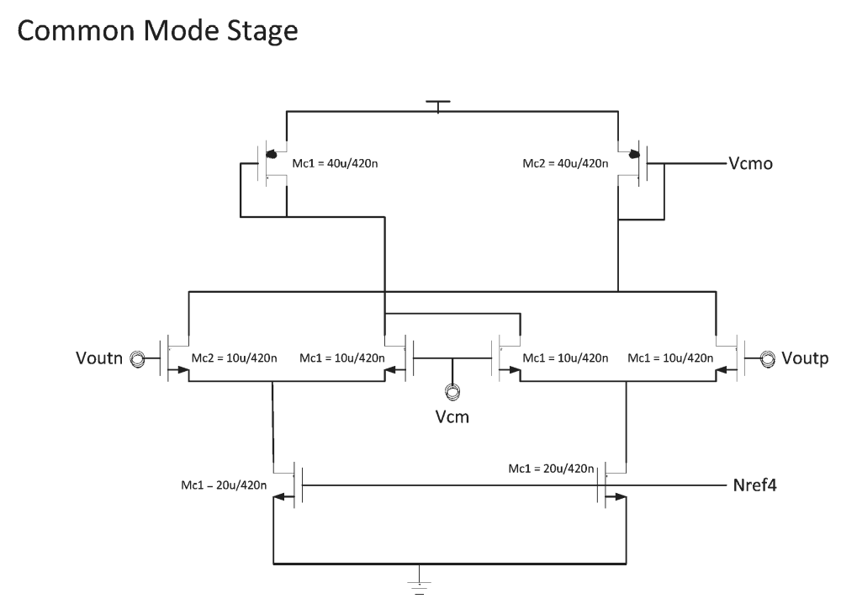

Appendix B – Test bench schematics
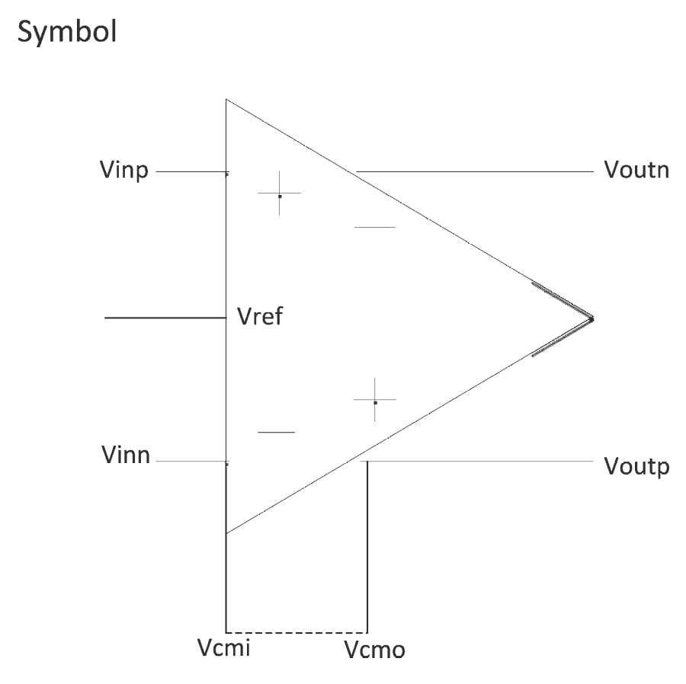
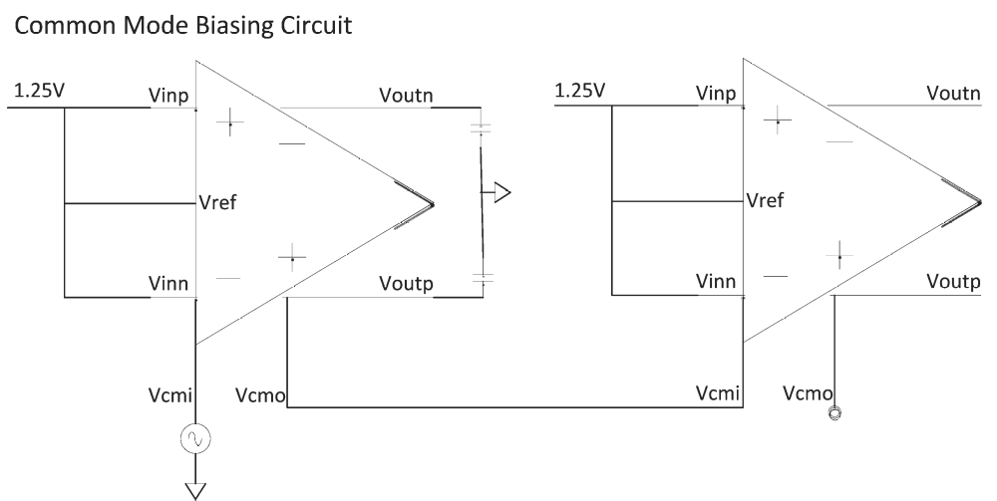
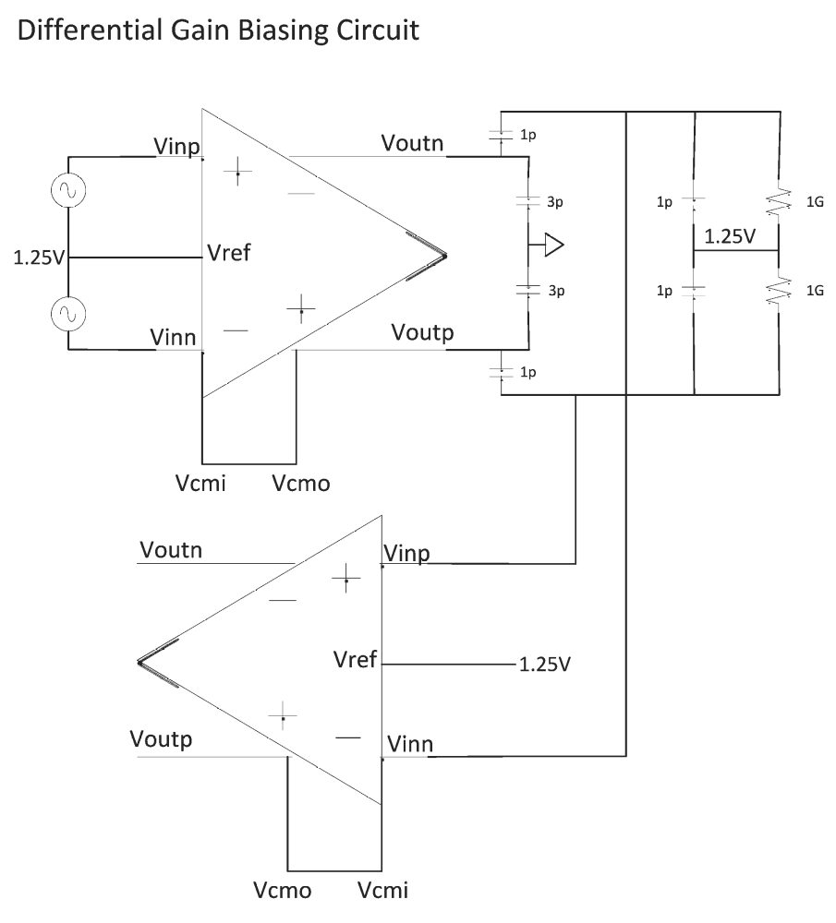

Appendix C – Test bench netlist

.title ECE423_Final_Project
.options post numdgt=8
*.inc tsmc25.net
.GLOBAL VDD!

.lib "/nfs/guille/u1/c/cdsmgr/cdsmgr/pdk/CDK1.4/local/models/hspice/public/publicModel/tsmc25dN" NMOS
.lib "/nfs/guille/u1/c/cdsmgr/cdsmgr/pdk/CDK1.4/local/models/hspice/public/publicModel/tsmc25dP" PMOS

.subckt opamp VIN1 VIN2 VOUT1 VOUT2 VCMI VCMO IREF VCM
C0 VOUT1 NET67 'var*1E-12' M=1.0
C2 VOUT1 0 'var*3E-12' M=1.0
C3 VOUT2 0 'var*3E-12' M=1.0
C1 VOUT2 NET79 'var*1E-12' M=1.0

***** COPY AND PASTE TRANSISTOR NETLIST HERE ****
.ends

** DEFAULT SETUP ******************************
Xop1 vg1 vg2 out1 out2 ncm ncm IREF VCM opamp
Cin1 vg1 0 1p
Cin2 vg1 0 1p
Clp1 vg1 out1 1p
Clp2 vg2 out2 1p
***********************************************

** CMFB EVALUATION SETUP **********************
*Vcmtest vt 0 DC=1.78666472 AC=1V
*Xop1 vg1 vg2 out1 out2 vt cmfb_out IREF VCM opamp
*Xop2 vb vb ot1 ot2 cmfb_out nf IREC VCM opamp
***********************************************

** DIFFERENTIAL GAIN SETUP ********************
*Xop1 vg1 vg2 out1 out2 ncm1 ncm1 IREF VCM opamp
*Xop2 vg1 vg2 ot1 ot2 ncm2 ncm2 IREF VCM opamp

*Cin1 n23 vb 1p
*Cin2 n24 vb 1p
*Rgig1 n23 vb 1g
*Rgig2 n24 vb 1g
*Clp1 n23 out1 1p
*Clp2 n24 out2 1p

*Cin3 n21 vb 1p
*Cin4 n22 vb 1p
*Rgig3 n21 vb 1g
*Rgig4 n22 vb 1g
*Clp3 n21 ot1 1p
*Clp4 n22 ot2 1p
**********************************************

** SOURCES **
Vin1 vg1 0 DC=1.25V AC=.5,180
Vin2 vg2 0 DC=1.25V AC=.5,0
VD VDD! 0 DC=2.5V

Vvcm VCM 0 DC 1V
Iiref IREF 0 64u

** SIMULATION **
.param var=1
.temp 27
.op
*.pz V(cmfb_out) Vcmtest
*.pz V(out2) Vin1
.ac dec 10 1e3 1e9
.dc Vin1 1.249 1.251 .000001
.end
Appendix D – Layout
