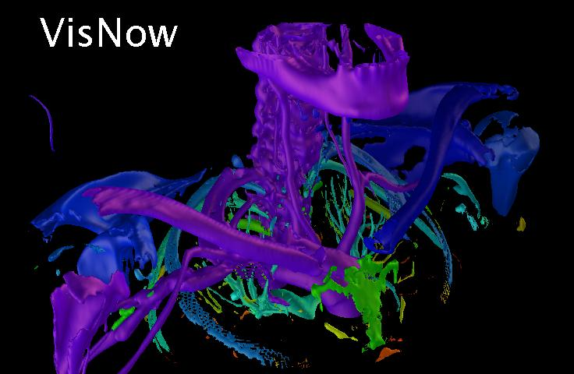
for Medical Image and Volume Analysis

VisNow – a modular, extensible, data driven visual analysis system

Library of modules:

data readers
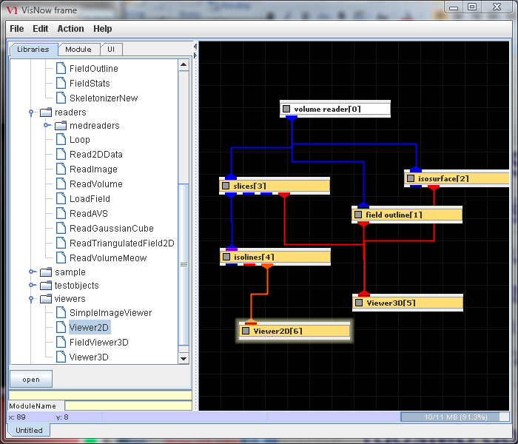
- medical data readers supporting standard image and volume data formats
- universal structured datafile reader
- easily extensible for specific needs

data processing filters
- from simple data cropping and downsizing
- to elaborate anisotropic denoisers, registration and semiautomatic segmentation modules

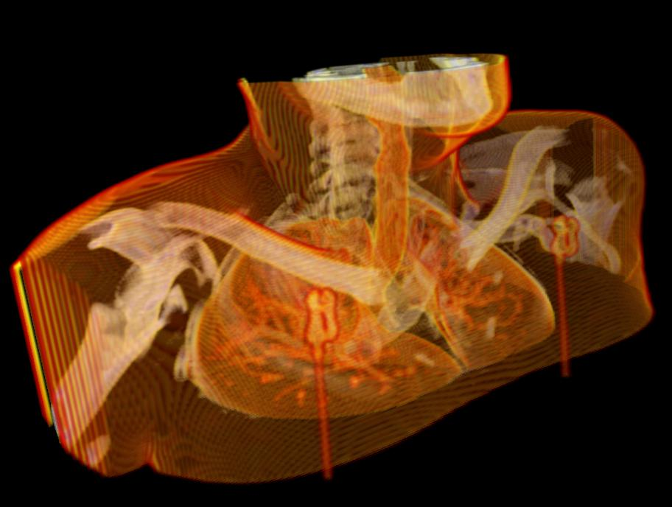
mappers
- volume slicing, isosurfacing, skeletonization

- fast volume rendering with elaborate data mapping capabilities

viewers
- user friendly control of obiect rendering, lighting and viewing
- image and movie output
- measurements in 3D

Modules brought to life and organized within a dataflow diagram (a network)

Intuitive, easy and consistent paradigm:
- A box – a living module
- A connection – the module downstream consumes data produced by a neighbor upstream

Simple, user friendly graphical interface
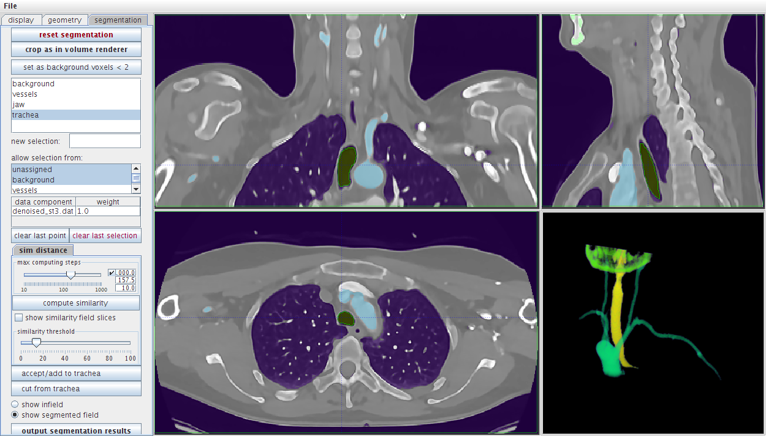
- Wizardlike interface for network building for easy orientation in tens and hundreds of available modules
- Defaults providing fast, informative visualization
- Fine tuning of data processing parameters, e.g. amount of denoising filtration or transparency map for volume rendering
- Intuitive graphical user interface for complicated tasks, e.g. segmentation of multiple objects

Advanced denoising of image and volume data
Nonlinear anisotropic denoiser
- Simple (2 – 3 controlling parameters)
- Fast (2 minutes for 512x512x200 volume)
- Efficient
- Preserving contour sharpness

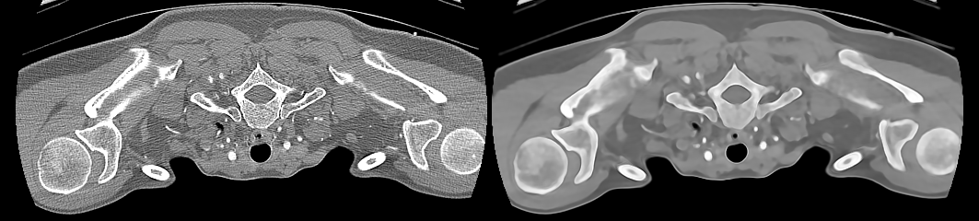
slice of original volume slice of denoised volume
- Radically simplifying and improving quality of segmentation

Integration of elaborate information extraction procedures

Example: Left ventricle kinematics from USG4D data
Starting point: a sequence of 8 frames from a USG3D examination:  noisy, hard to segment data  Step 1: Initial denoising by anisotropic filtration in space and time  Step 2: Nonrigid registration of all frames to frame 0  Step 3: Further noise reduction by averaging of registered values  Step 4: Ventricle segmentation and creation of a mesh of inner ventricle surface  Step 5: Reconstruction of mesh kinematics from registration fields | 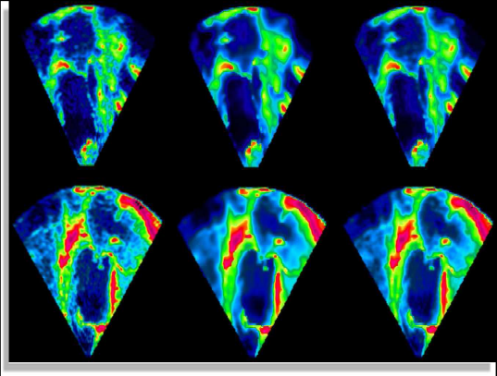  Original data after initial denoising
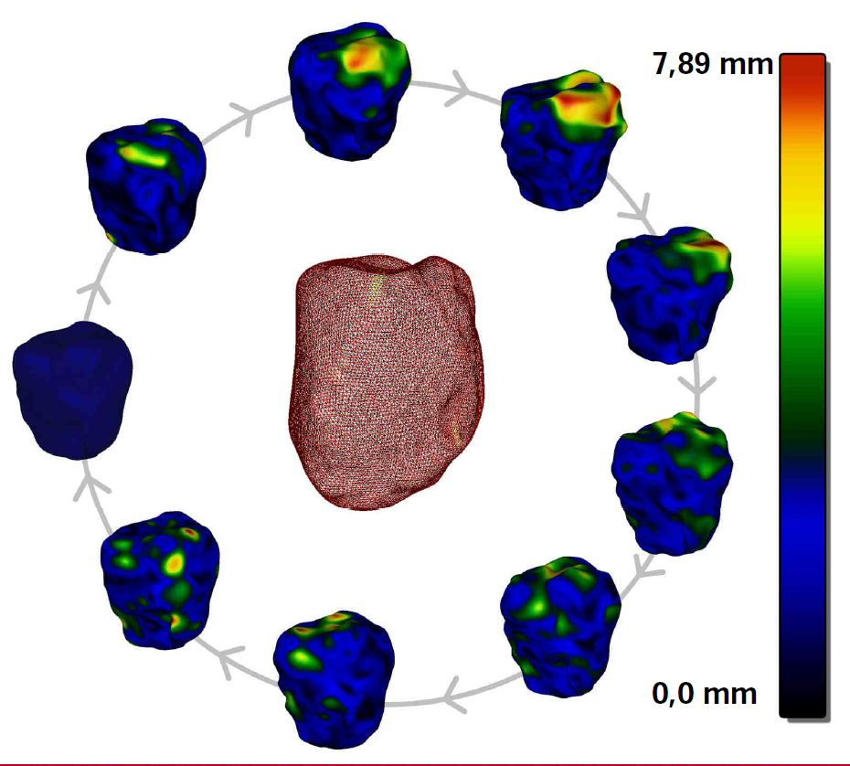  Results: mesh and point displacement | 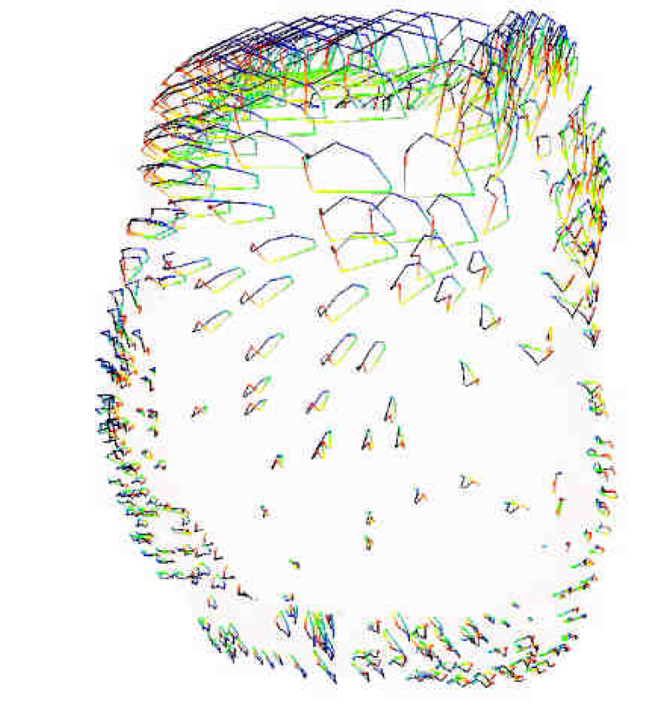  Results: point trajectories  during a single cycle

Example: MRI and EEG fusion
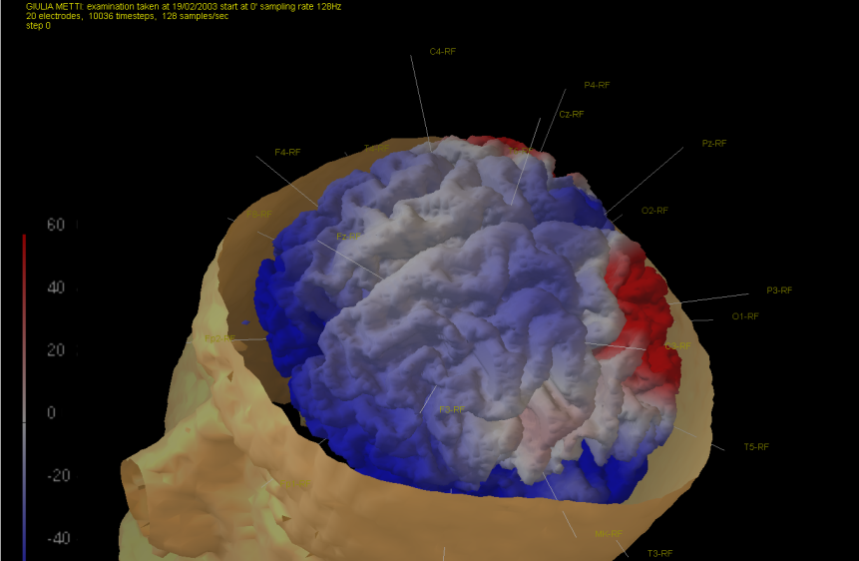
Anatomy from a MRI scan
EEG signal mapped to brain surface

Technical details

- Java/Java3D platform
- Available on Windows and Linux workstations
- Intended for open source release
- Generic framework allowing for creation of specialized applications
- User extendable
- Ready for distributed and parallel implementation

Developed in University of Warsaw, ICM

Team:
- Krzysztof S. Nowiński
- Bartosz Borucki
- Michał Chlebiej
- Michał Łyczek
- Hubert Orlik-Grzesik
Project page:
http://visnow.icm.edu.pl/

