**Assignment 1**

## Part 1. Source Code

//mul.cpp

#include "iostream"

using namespace std;

int main(){

cout <<"Please input two integers:"<< endl;

long long int a,b;

while(1) //https://www.cnblogs.com/tonglingliangyong/p/3908463.html

{

cin >> a >> b;

if (!cin)

{

cout <<"Please check your input type and try again: "<< endl;

cin.clear();

cin.sync();

}

else

{

cout << "The product is: "<< a*b << endl;

break;

}

}

return 0;

}

## Part 2. Result & Verification

Test case #1:

Please input two integers:

2 3

The product is: 6

Screen-short for case #1:

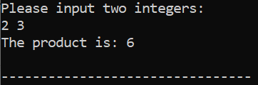

Test case #2:

Please input two integers:

ak2 dn32

Please check your input type and try again:

dk 214km

Please check your input type and try again:

23 27

The product is: 621

Screen-short for case #2:

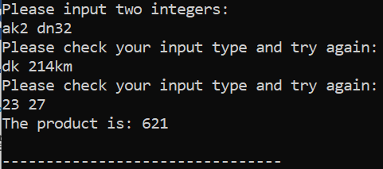

Test case #3:

Please input two integers:

123456789 1234567890

The product is: 152415787501905210

Screen-short for case #3:

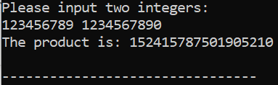

## Part 3. Difficulties & Solutions, or others

First of all, I did not notice a typo in the assignment sheet that says with inputs 2 and 3, the output of the program would be 3, which clearly is not the product of the two integers input. Thus I first implemented the max(a,b) function by including in the header <stdlib.h> to compare the inputs and output the larger one. It took only a closer look and several seconds to fix the code by changing the function to a*b, and deleting the header file #include <stdlib.h>.

The second major problem I encountered was to flag wrong types of input. I did a little research online and found several blog pages dealing with wrong input data types. I chose the most concise one using if-else statement, with (!cin) representing that the inputs’ data type does not match the data type assigned previously to the variables. In this case, a and b are both long long int, and when any of the input is not long long int, the program would note the user of this error.

It is quite obvious that the type int would not be large enough to store big numbers, given that its sized through 16 to 32 bits. To solve the third question raised in the assignment sheet, I went through the documentation website for C++ (<http://www.cplusplus.com/doc/tutorial/variables>), and found the type long long int, which supports 64 bits integers.

I also found on a blog page that different compilers showcase different levels of adaptation to 64-bit integers. (<https://blog.csdn.net/hanyonghuicn/article/details/5856324?utm_medium=distribute.pc_relevant.none-task-blog-BlogCommendFromMachineLearnPai2-5.channel_param&depth_1-utm_source=distribute.pc_relevant.none-task-blog-BlogCommendFromMachineLearnPai2-5.channel_param>)

Here is a graph from the page.

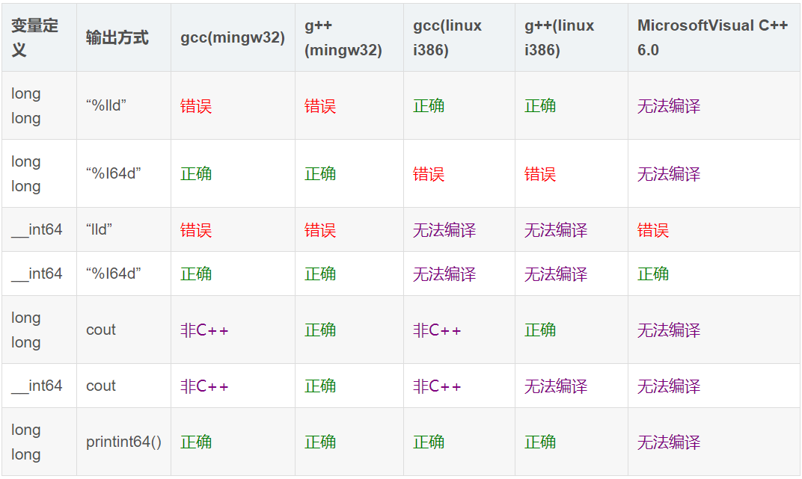

Additionally, inspired by the blog quoted in the code (<https://www.cnblogs.com/tonglingliangyong/p/3908463.html>), I added a while loop that prompt the user to keep inputting until the data type is correct and the product comes out.

P.S. I did a more complex version afterwards that prompts the user to determine in which way they want the result to come out. I still have questions about pointers and how to convert them, but I looked up online a bit and here is what I got. The code is attached below (only the highlighted part is changed).

//mul.cpp

#include "iostream"

#include "string.h"

#include "iomanip"

using namespace std;

int main(){

cout <<"Please input two integers:"<< endl;

long long int a,b;

while(1) //https://www.cnblogs.com/tonglingliangyong/p/3908463.html

{

cin >> a >> b;

if (!cin)

{

cout <<"Please check your input type and try again: "<< endl;

cin.clear();

cin.sync();

}

else

{// inspired by a friend, Weike Fang, who also takes this course

cout << "How would you like the result to be presented? A: scientific B: integer"<<endl;

//<http://www.cplusplus.com/forum/beginner/23342/>

char selection[1024];

cin.getline(selection,1024,'\n');

cin >> selection;

if (strcmp(selection, "A") == 0)

{

double c = (double) a*b;

cout.precision(5);

//http://www.cplusplus.com/reference/ios/scientific/

cout << "The product is: " <<std::scientific<< c << endl;

}

else if (strcmp(selection, "B") == 0)

{

cout << "The product is: "<< a*b << endl;

}

break;

}

}

return 0;