**PPT5**

T1

x = int(input())

if(x>10):

y=3*x-7

elif(x>=0&x<10):

y=x*x

else:

y=-x-5

print(y)

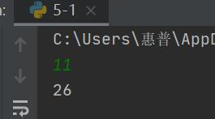

T2

x = int(input())

a = 1

for i in range(1, x+1):

a = a*i

print("product = %d" % float(a))

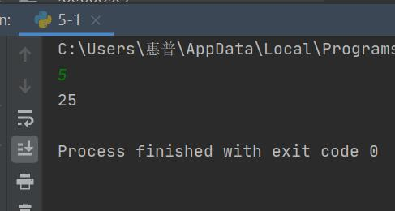

T3

for i in range(1,101):

if i % 2 == 1:

print(i)

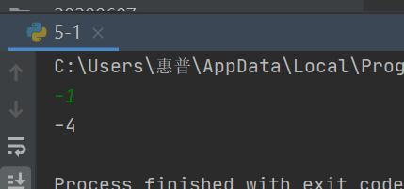

T4

import math

def is_prime(n):

if n == 1:

return False

for i in range(2, int(math.sqrt(n)) + 1):

if n % i == 0:

return False

return True

primes = []

for i in range(1, 101):

if is_prime(i) is True:

primes.append(i)

print('素数:{}\n素数和:{}'.format(primes, sum(primes)))



**PPT6**

T1

str = "我有100W人民币"

print(len(str))

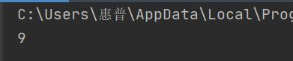

T2

str = "dasdfuweherfsadpjqpf213a234"

print(str.count("a"))

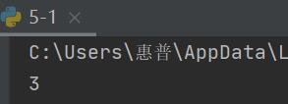

T3

str = "hHdhaDdaidHdsadDXqweDLJYYDdgayqrye"

print(str.swapcase())

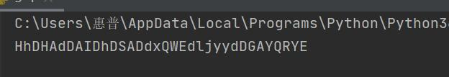

T4

str = "I like Python"

print(str.replace('Python','myself'))

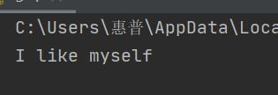

T5

str = "hk度扫werypqxvvaHKDShHdsK"

print(str.index("HK"))

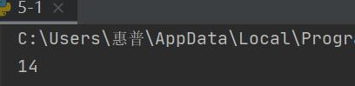

T6

str = "我爱你中国"

print(str[-2]+str[-1])

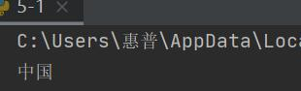

T7

str = "我爱你中国"

print(str[:-1])

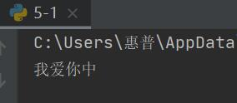

T8

import re

str = "我爱你中国，我不爱编程"

print(re.sub('不','',str))

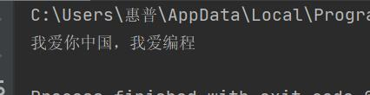

T9

str = "我爱你中国，我不爱编程"

print(str[0:str.rfind('，')])

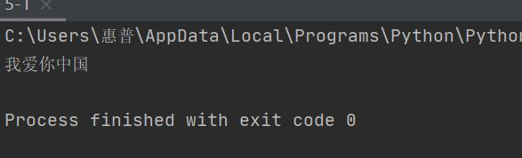

T10

import re

str = "123,231214,213ydsad,Zhong,多花点钱"

print(re.split(',',str))

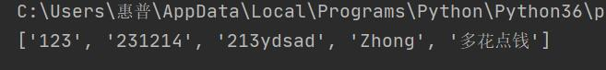

**PPT7**

T1

tup=("one","two","three","four")

print(len(tup))

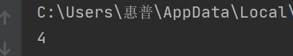

T2

tup1=("one","two","three","four")

tup2=("five","six","seven")

tup=(*tup1,*tup2)

print(tup)

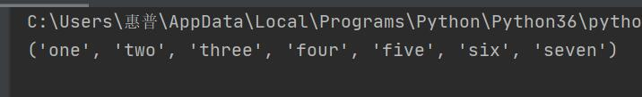

T3

tup=(1,4,56,7,9,9,2,324,657,980,423,1,2,1,5,0,8,1)

print(tup.count(1))

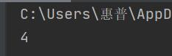

T4

tup=(1,4,56,7,9,9,2,324,657,980,423,1,2,1,5,0,8,1)

print(tup.index(980,0))



T5

tup=(1,4,56,7,9,9,2,324,657,980,423,1,2,1,5,0,8,1)

print(tup[1:])

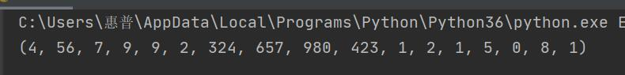

T6

tup=(1,4,56,7,9,9,2,324,657,980,423,1,2,1,5,0,8,1)

print(tup[-2],tup[-1])



T7

tup=(1,4,56,7,9,9,2,324,657,980,423,1,2,1,5,0,8,1)

print(tup[4:13])



**PPT8**

T1

list=[[1,2],[3,4],["a","b"]]

print(len(list))



T2

list1=[17,12,32,24,25]

list2=[16,71,28]

list=list1+list2

list.sort()

print(list)



T3

list=["a","c","c"]

list[1]="b"

print(list)

