流程控制

练习1.

import random

x=random.randint(-10,20)

print('x= ',x)

if x>10:

y=3\*x-7

elif x>=0&x<10:

y=x\*x

else:

y=-1\*x-5

print('y= ',y)

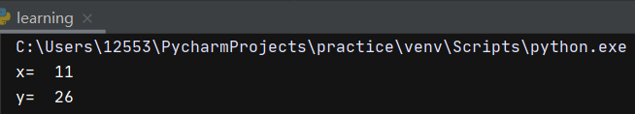

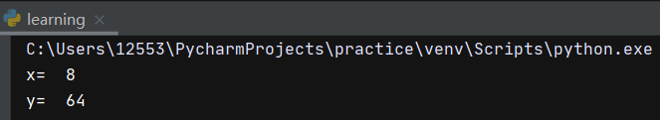

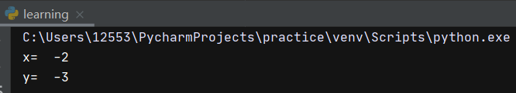

练习2

import random

n=random.randint(0,20)

print('n= ',n)

total=1

for i in range(1,n+1):

total=total\*i

print('n!= ',total)

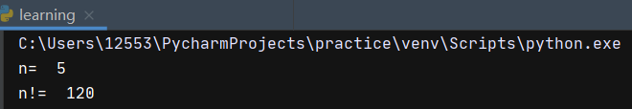

练习3

for x in range(1,101):

if x%2==1:

print(x)

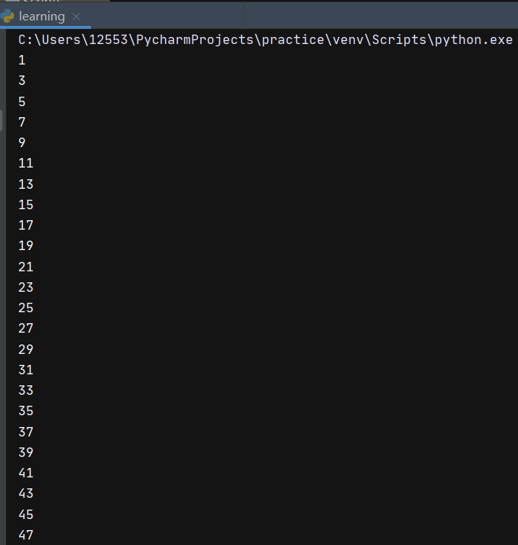

......

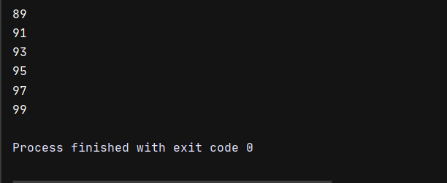

练习4

group=[]

for x in range(2,101):

for j in range(2,x):

if(x%j==0):

break

else:

group.append(x)

s=0

for x in group:

print(x)

s=s+x

print('sum= ',s)

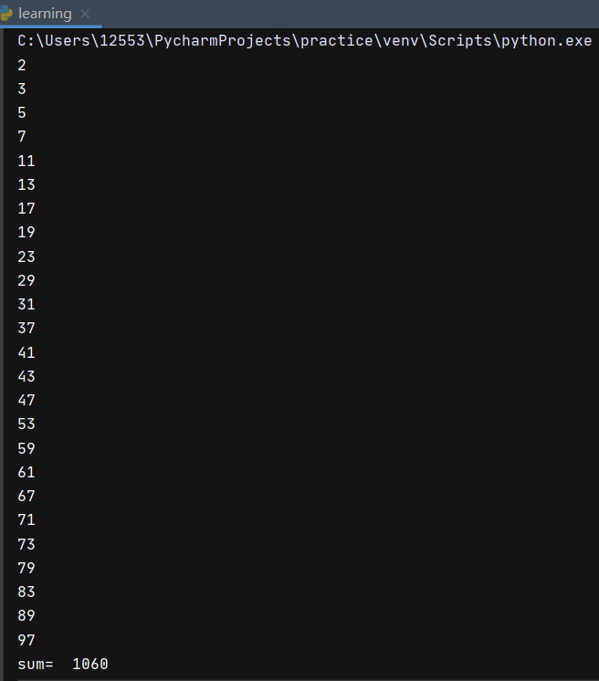

字符串

import string

Import re

#练习1

str='我有100w人民币'

print(len(str))

#练习2

str1='dasdfuweherfsadpjqpf213a234'

times=str1.count('a')

print(times)

#练习3

str2='hHdhaDdaidHdsadDXqweDLJYYDdgayqrye'

print(str2.swapcase())

#练习4

str3='I like Python'

print(str3.replace('Python','myself'))

#练习5

str4='hk度扫werypqxvvaHKDShHdsK'

print(str4.find('HK'))

#练习6 & 7

str5='我爱你中国'

print(str5[3:5])

print(str5[0:-1])

#练习8 & 9 & 10

str6='我爱你中国,我不爱编程'

print(re.sub('不','',str6))

print(str6.rstrip(','))

print(str6[0:str6.find(',')])

#练习11

str7='123,231214,213ydsad,Zhong,多花点钱'

print(str7.split(','))

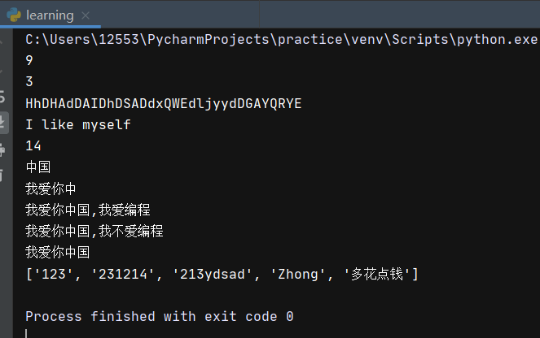

元组

#练习1

tup=("one","two","three","four")

print(len(tup))

#练习2

tup2=("five","six","seven")

print(tup+tup2)

#练习3~7

tup3=(1,4,56,7,9,9,2,324,657,980,423,1,2,1,5,0,8,1)

print(tup3.count(1))

print(tup3.index(980))

print(tup3[1:])

print(tup3[-2],tup3[-1])

print(tup3[4:12])

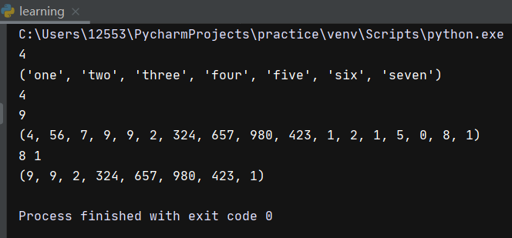

列表

#练习1

list=[[1,2],[3,4],['a','b']]

print(len(list))

#练习2

list1=[17,12,32,24,25]

list2=[16,71,28]

l=list1+list2

l.sort()

print(l)

#练习3

list3=['a','c','c']

list3[1]='b'

print(list3)

