x = int(input())  
if(x>10):  
 y=3*x-7  
elif(x>=0&x<10):  
 y=x*x  
else:  
 y=-x-5  
print(y)

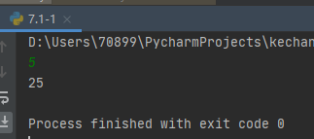

x = int(input())  
a = 1  
for i in range(1, x+1):  
 a = a*i  
print("product = %d" % float(a))

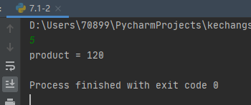

for i in range(1,101):  
 if i % 2 == 1:  
 print(i)

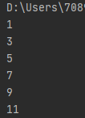

import math  
def is_prime(n):  
 if n == 1:  
 return False  
 for i in range(2, int(math.sqrt(n)) + 1):  
 if n % i == 0:  
 return False  
 return True  
primes = []  
for i in range(1, 101):  
 if is_prime(i) is True:  
 primes.append(i)  
print('素数:{}\n素数和:{}'.format(primes, sum(primes)))

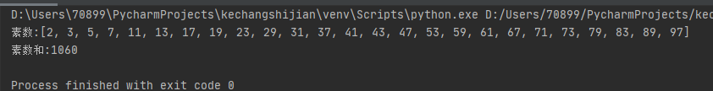

str = "我是猛男"  
print(len(str))

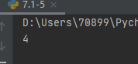

str = "djbfgd7d8sh9h30sbibibsdcnlad8ye7hisd"  
print(str.count("d"))

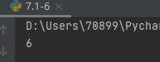

str = "hHdhaDdaidHdsadDXqweDLJYYDdgayqrye"  
print(str.swapcase())

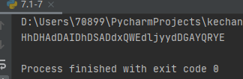

str = "I like Python"  
print(str.replace('Python','myself'))  
  
str = "hk度扫werypqxvvaHKDShHdsK"  
print(str.index("HK"))  
  
str = "我爱你中国"  
print(str[-2]+str[-1])  
  
str = "我爱你中国"  
print(str[:-1])  
  
import re  
str = "我爱你中国，我不爱编程"  
print(re.sub('不','',str))  
  
str = "我爱你中国，我不爱编程"  
print(str[0:str.rfind('，')])  
  
import re  
str = "123,231214,213ydsad,Zhong,多花点钱"  
print(re.split(',',str))  
  
  
tup=("one","two","three","four")  
print(len(tup))  
  
tup1=("one","two","three","four")  
tup2=("five","six","seven")  
tup=(*tup1,*tup2)  
print(tup)  
  
tup=(1,4,56,7,9,9,2,324,657,980,423,1,2,1,5,0,8,1)  
print(tup.count(1))  
  
tup=(1,4,56,7,9,9,2,324,657,980,423,1,2,1,5,0,8,1)  
print(tup.index(980,0))  
  
tup=(1,4,56,7,9,9,2,324,657,980,423,1,2,1,5,0,8,1)  
print(tup[1:])  
  
tup=(1,4,56,7,9,9,2,324,657,980,423,1,2,1,5,0,8,1)  
print(tup[-2],tup[-1])  
  
tup=(1,4,56,7,9,9,2,324,657,980,423,1,2,1,5,0,8,1)  
print(tup[4:13])  
  
list=[[1,2],[3,4],["a","b"]]  
print(len(list))  
  
list1=[17,12,32,24,25]  
list2=[16,71,28]  
list=list1+list2  
list.sort()  
print(list)  
  
list=["a","c","c"]  
list[1]="b"  
print(list)

