Project 1 – The Basics

CS 111

due September 11, 11:59pm

**Part 1 - Your Work Setup**

**1. (3pts) Provide the full version number of your installation of Python 3 (e.g., 3.11.3).**

3.11.1

**2. . (3pts) Provide a picture or screenshot of IDLE open on your computer (whether or not you plan on using IDLE for your IDE).**

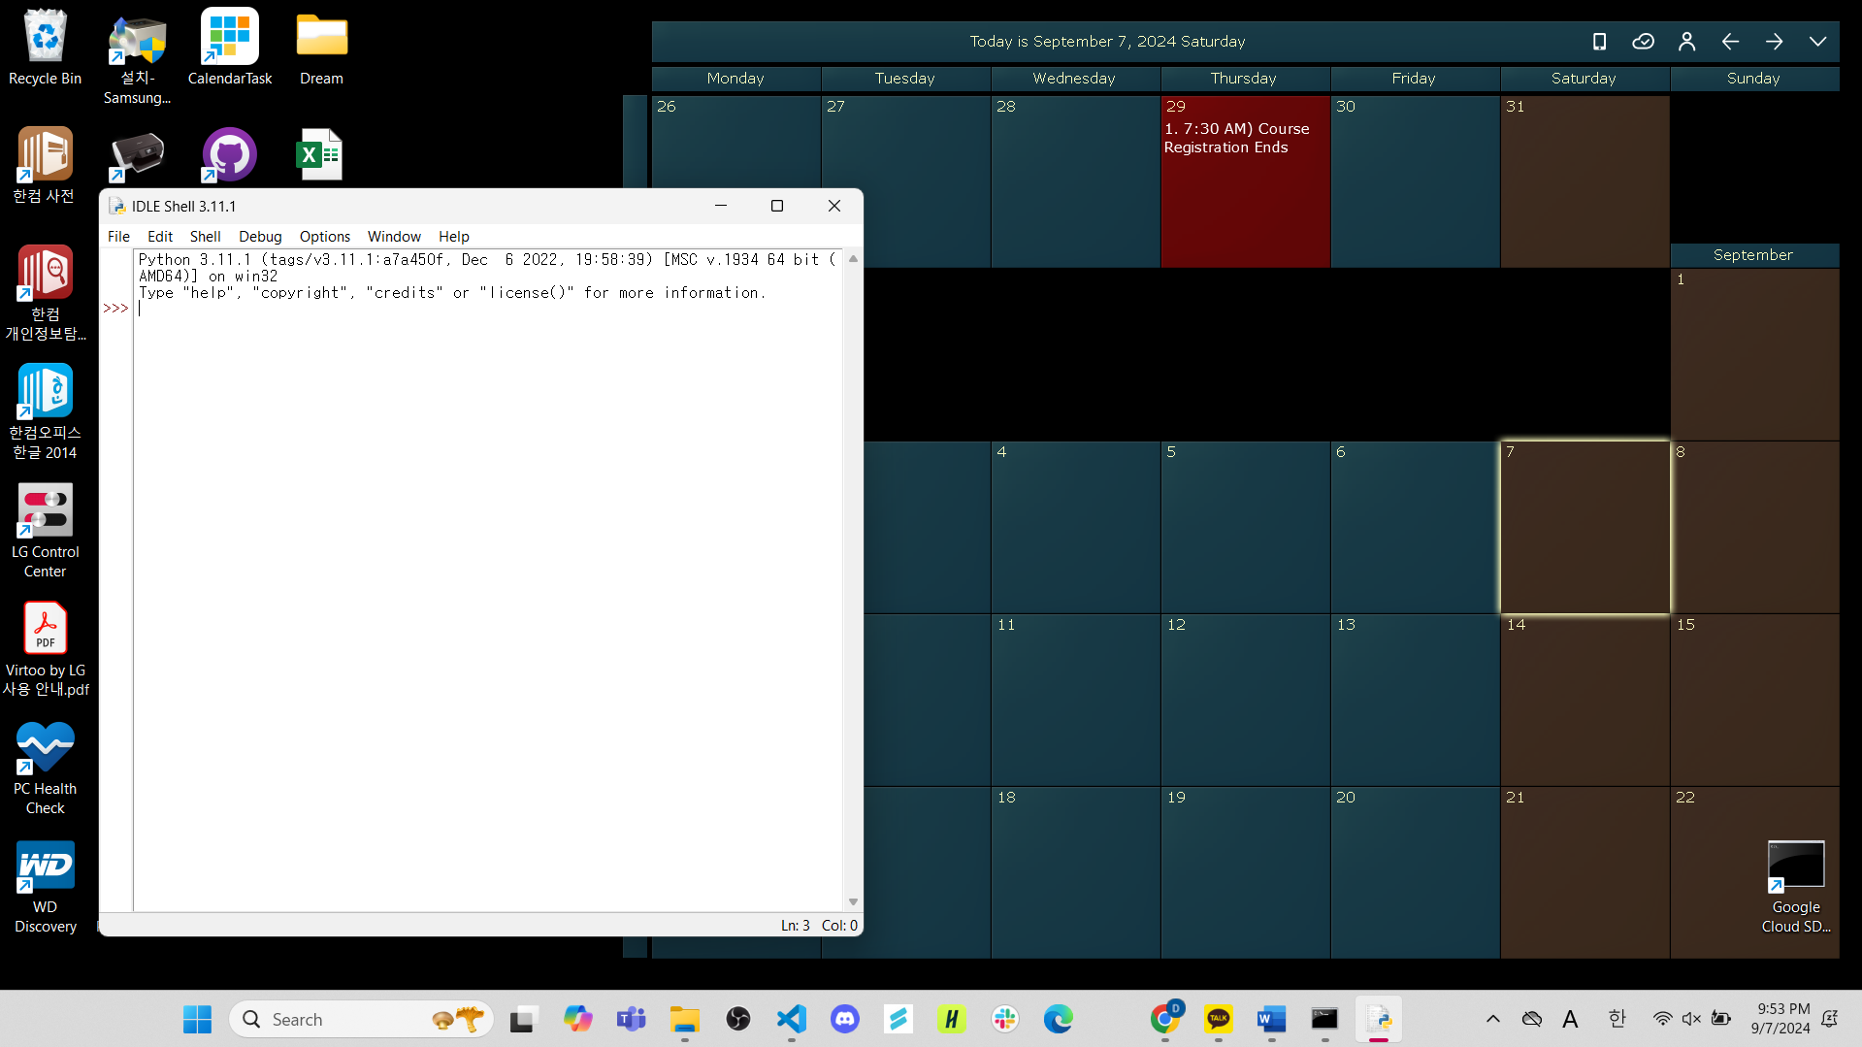

**Part 2 - A Program from the Ground Up**

**1. (9pts) Perform Polya’s first problem-solving step for your programming assignment by answering the following questions: ”What is the unknown? What are the data? What is the condition?”**

**What is the unknown?**

The unknown for this program is considered as the output of the program. So the unknown can be the very first answer that the user of the program inputted since the program would ask first which of the quantities is unknown. For example, if the user inputted “h” for the answer of the first question, then the unknown quantity is “h”.  
  
Also, the state of the landing safety can be the unknown for this program since the program outputs whether the spaceship is safe for the landing or not based on whether the thresholds are crossed or not.

**What are the data?**

The data for this program consists with 4 quantities. First, the moon’s gravitational acceleration, which is defines as g = −1.62 m/s^2, and second to fourth will be the quantities that the user inputted after defining the unknown quantity. For example, if the user defined the unknown quantity as “h”, $v$ the current velocity, $a$ the acceleration, and $t$ the time that the user inputted are all data.

**What is the condition?**

The condition is what makes the output correct. For this program, the acceleration should be the same or bigger than -49 m/s^2 and the landing impact velocity should be in between the boundary of -10 m/s and 0 m/s at the same time for a safe landing because the spaceship is in a situation for landing on a planet and according to the research, an average human can withstand -49 m/s^2 of acceleration, and the spaceship can withstand a landing impact velocity of -10 m/s.

Also, the value of the height and time should be same or bigger than 0

**2. (30pts) Create a functional decomposition diagram for the programming assignment. The diagram can be a picture of a hand-drawn diagram, or it can be made digitally. For each of the leaves in your diagram, provide pseudocode for the leaf’s functionality.**

**3. (10pts) Provide a test for an edge case of your program. Spend a sentence or so describing what edge case it tests.**

Test case 1: When the user inputs a number when it should be inputting the letter for the question asking which quantity is unknown.

Test case 2: When the user inputs a letter other than “h”, “t”, “v”, and “a” for the question asking which quantity is unknown.

Test case 3: When the user inputs a letter when it should be inputting the number for the question asking about the known quantity’s value.

Test case 4: When the user inputs data that are so big that the variables couldn’t store them.

**4. (25pts) Consider your program (with the functionality described in Section 2.2) and the overall problem it is trying to solve. Answer the following four tasks with roughly a paragraph each:**

**(a) (10pts) Suppose that a user always provides input of the correct type, so that, e.g., they respond to “What is h?” with a number and not a letter. Even then, the specifications provided in Section 2.2 are not perfect. What ways could your program crash, hang, give unexpected results, give unspecified behaviour, or otherwise go wrong? How could one protect against these issues?**

If the user inputs numbers that are so big that the variables couldn’t store them, it’s highly possible that the program would return unexpected behaviour. To protect from this issue, we can apply an if statement that makes the program return a message that tells that the input is too big if it exceeds the storage limit.

**(b) (5pts) Does your program fully solve the problem it is designed for? Are there details of the problem not taken into account?**

The user might accidentally make a typo while inputting the unknown quantity like inputting a letter other than “h”, “t”, “v”, “a” for the question asking which quantity is unknown. Currently, the program does not verifies whether the user inputted an appropriate letter for the unknown quantity nor does not return any error message to make the user check the input that was submitted if there are some typos.

Also, the value of the height and time should be same or bigger than 0 but the current program does not check whether the two values are same or bigger than 0.

**(c) (5pts) How user-friendly is your program? Is there more you could do to improve the user experience?**

Currently the program assumes that the user inputs the data based on m, m/s, and m/s^2. The program’s user experience could be improved by checking what measures that the user’s input data are based on and converting them into m, m/s, and m/s^2.

**(d) (5pts) Are there any ethical implications about your code? Could it be used to make the world a worse place?**

This code is simply dealing about the landing of the spaceship but there are possibilities that this code could be used for military applications such as missiles and military payloads. As the dynamics of the spaceship could be substituted to those aggressive weapons, if this program is used on purpose of malicious and offensive intent, the program could possibly contribute to armed conflicts and warfare making loss of lives and damages to this planet.

**Experience report**

This project took about 4 days to completely put all the necessary attribution text to this .pdf file. For coding the program it only took 2 days. The level of difficulty for this project was somewhere between easy and medium because the goal of this program was straightforward but during the process of coding the program, I had to figure out every single possible case that the user might input for the unknown quantity and create an appropriate subsequent process for calculating and judging if the spaceship is safe to land or not based on each possible unknown quantity cases.