Peer-graded Assignment: Contiki Hands-on
Course: Embedded Hardware and Operating System
Student: João Lourenço Souza Junior | Date: 2020-06-20

NOTE: The all tasks use: Instant Contiki 3.0 and Contiki 3.0

Task 1

Setup
The Task 1 setup contains eight (8) Sky mote types random positioned, follow the mote type information:
- Contiki source: contiki/examples/ipv6/sample-udp-rpl/broadcast-example.c
- Contiki firmware: contiki/examples/ipv6/sample-udp-rpl/broadcast-example.sky
- Compile commands: make broadcast-example.sky TARGET=sky

Parts of the system
The simulation is demonstrated in Figure 1, wherein the Network screen the green circle indicates the coverage region from mote with ID 4, conform show in the Mote output screen.
Figure 1: A screenshot demonstrating the running simulation executing Task 1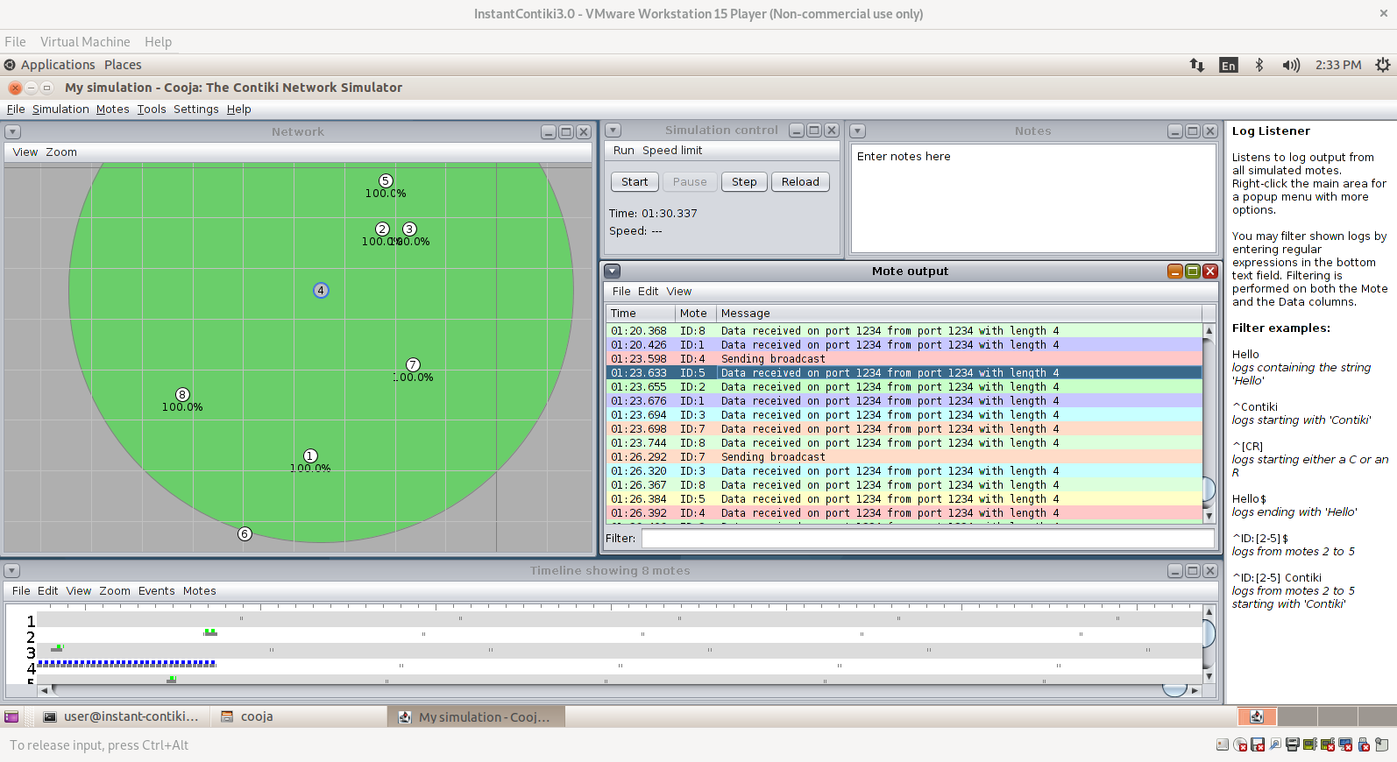

Task 2

Setup
The Task 2 setup contains six (6) Sky mote types random positioned, follow the mote type information:
- Contiki source: contiki/examples/ipv6/sample-udp-rpl/broadcast-example.c
- Contiki firmware: contiki/examples/ipv6/sample-udp-rpl/broadcast-example.sky
- Compile commands: make broadcast-example.sky TARGET=sky

Parts of the system
The simulation is demonstrated in Figure 2, wherein the Network screen the green circle indicates the coverage region from mote with ID 1, conform show in the Mote output screen. Different from Task 1, the motes in Task 2 are more disperse.

Figure 2: A screenshot demonstrating the running simulation executing Task 2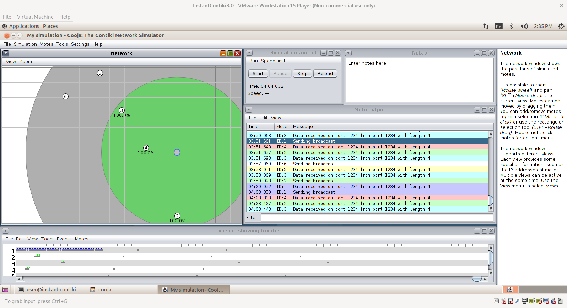

Task 3

Setup
The Task 3 setup contains six (6) Sky mote types random positioned, follow the mote type information:
- Contiki source: contiki/examples/rime/example-abc.c
- Contiki firmware: contiki/examples/rime/example-abc.sky
- Compile commands: make example-abc.sky TARGET=sky
The original source code (contiki/examples/rime/example-abc.c) was modify:
- Line 56: printf("MY COURSERA ABC message received '%s'\n", (char *)packetbuf_dataptr());
- Line 80: printf("MY COURSERA ABC sent\n");

Parts of the system
The simulation is demonstrated in Figure 3, wherein the Network screen the green circle indicates the coverage region from mote with ID 1, conform show in the Mote output screen.
Figure 3: A screenshot demonstrating the running simulation executing Task 3