Organisation Dynamics

Exercise 3 17 February 2005

Hand in: Exercise 1.1.3e & 1.3

Consider the following experimental setting. Separated by a transparent screen (a window, at position p0), at each of two positions p1 and p2 a piece of food can be placed. At some moment (with variable delay) the screen is raised, and the animal is free to go to any position. Within this experiment the animal is able to observe the positions of food, screen, and itself.

The four simple example traces in Table 1 for situations without cups illustrate a stimulus-response pattern of behaviour within the experimental setting.

time trace | time point 0 | time point 1 | time point 2 | time point 3 | time point 4 | time point 5
trace 1 | food at p2  screen | no food at p2 screen | food at p2  screen | food at p2  no screen | food at p2  no screen  goes to p2 | no food at p2  no screen
trace 2 | no food at p2  screen | no food at p2 screen | no food at p2  screen | food at p2  screen | food at p2  no screen | food at p2  no screen  goes to p2
trace 3 | no food  screen | no food  no screen | no food  no screen | food  no screen | food  no screen  goes to p2 | no food  no screen
trace 4 | food at p2  screen | no food at p2  no screen | food at p2  screen | food at p2  screen | food at p2  no screen | food at p2  no screen  goes to p2

Table 1 Example set of observed stimulus-response traces
Here the time points indicated are time points that show a different state, so no uniform time scale is assumed. The observed (animal) agent receives observation input on the availability of food (indicated by food), and of the limitation of its moving around due to the presence or absence of a screen in the experimental setting (indicated by screen). Depending on the circumstances it can decide to eat the food (indicated by the action eat). Assume that the traces depicted in Table 1 are observed. In this table, for example, the fact that at a certain point in time it is observed that there is food at p2 is simply denoted by food at p2, and goes to p2 denotes that the agent performs the action to go to p2. A regularity that can be observed in the above traces is the following:

Every time that the agent observes that there is food at p2, and no screen is present,
it will go to p2.
In semi-formal form, this property can be written as:

ESR1
at any point in time,
if the agent observes that food is present at position p2
and it observes that no screen is present,
then it will go to position p2

Although the above is an adequate external description of the behaviour in Table 1, this does not exclude to consider the possibility of a description from an internal perspective. For this example, internal mental concepts b1 and b2 (relating to food present and screen absent, respectively) can be assumed with the following dynamic properties:

ISR1
at any point in time,
if the agent observes that food is present at position p2
then internal state property b1 will hold

ISR2
at any point in time,
if the agent observes that no screen is present,
then internal state property b2 will hold

ISR3
at any point in time,
if internal state property b1 holds
and internal state property b2 holds,
then the agent will go to position p2

Notice that for cases that the observations are of a very short duration, for this description of internal dynamics to work, the phrases ‘b1 will hold’ and ‘b2 will hold’ either need to be defined by an exact time delay, or they need to persist sufficiently long, so that b1 and b2 occur at a common point in time. Notice that these properties together entail the external property ESR1.

  - Creating a simulation model on the basis of the "leads-to" simulation specification language
The goal of this exercise is to build a simulation model for the above story. In particular, we will formalise dynamic property ESR1. Let’s use the following three state properties to express the contents described in this property: observes_food_at_p2, observes_no_screen, and goes_to_p2. Notice that the first two are input state properties, and the last one is an output state property. In order to generate a working simulation model, we will have to do three important things:
- Specify the dynamic property (ESR1)
- Initialise the input state properties
- Specify the total duration of the simulation

1.1.1 Specifying the dynamic property
Let us start by introducing property ESR1 to the editor. In order to do this, execute the following steps:

- Download the software from http://www.few.vu.nl/~lourens/sim (ask the login and password of the teacher). A detailed installation instructions can be found at the same web site. The initial window will look like this:
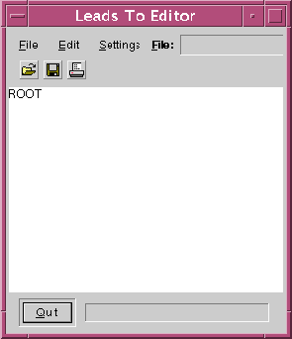
- Mouse over ROOT and click the right mouse button. A menu with nine entries will appear.
- While holding down the mouse button, point to the entry Leadsto. Release the mouse button. The following subtree will appear, representing a “leadsto” rule:

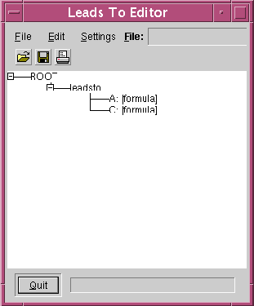
- The Leadsto node has two children A:[formula] (A for antecedent) and C:[formula] (C for consequent). First, we will change the C: node into an atom node: click the right mouse button on the node C:[formula]. Release when over Change atom. The node will now change into C:[atom].
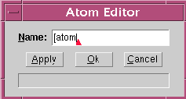
- Next, we are going to edit the atom. Right-click on this node and release when over Edit. A window with name "Atom editor" will appear:

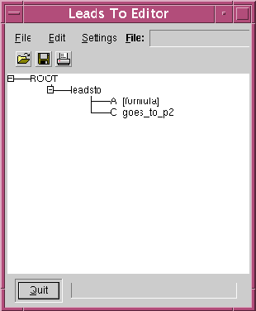
- Within this editor, we can replace the line "[atom]" by a specific identifier. In our case, replace it by the text goes_to_p2. Press button Ok. As a result, the main canvas now looks like this:

- Now, we have to change the antecedent. However, the antecedent consists of the conjunction of two state properties (see page 11: the two arrows leading from input to output are connected together). Therefore, change the A: node into an and node (by right-clicking on it and releasing when over Change and). A new subtree with two formulae appears.
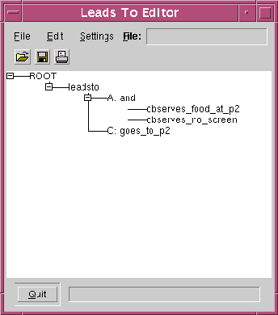
- Edit both formulae. First change them to atoms, and then change their names into resp. observes_food_at_p2 and observes_no_screen, in the same way as you did in step e) and f). The result looks like this:

- Next, we add the time parameters e, f, g and h: Right click on the leadsto node and select add delay. The node EFGH: efgh([time],[time],[time],[time]) appears.
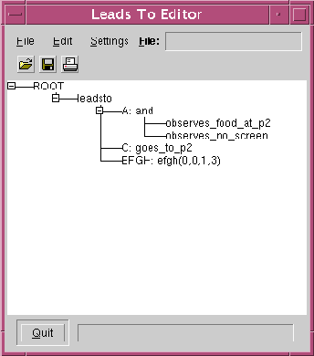
- Edit this node (right click on it and select Edit). Replace the [time] strings in such a way that the result is efgh(0,0,1,3). By doing this, we express that if the antecedent is true with duration 1.0, then the consequent will be true with duration 3.0, with a delay of duration 0.0. Finally, the main canvas will look as follows:

1.1.2 Initialising the input state properties
We have now succesfully entered dynamic property ESR1 into the editor. However, if we would start the simulation at this point, nothing would happen. The reason is that our property can only have some effect if the input state properties are true at certain time points. Thus, we have to initialise the input state properties (i.e. observes_food_at_p2 and observes_no_screen in our example). In order to do this, execute the following steps:

- Mouse again over ROOT and click the right mouse button. This time, release the right mouse button over the entry Interval. A subtree will appear, representing an interval rule with entries R for Range and F for Formula.
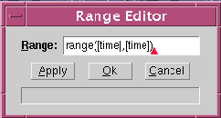
- To fill in the range, click right mouse button on the node "R: range([time],[time])". Release the button when over edit. A window with name "Range Editor" will appear:

- Edit the line "range([time],[time])". For the moment, let us assume that the input state properties are only true during the first time unit of the simulation. Thus, replace both times so that the result is "range(0,1)". Press button Ok. In the canvas you will see the change.
- Next edit the entry representing the formula, marked F [formula] by placing the mouse over that text, right click and release over entry Change atom. The node will be changed into F [atom]
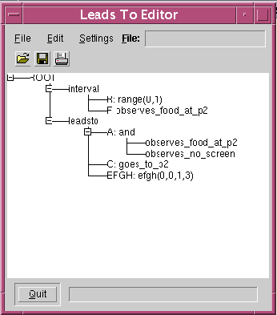
- Edit this atom by clicking the right mouse button on F [atom], and releasing when over entry Edit. Change the value in the "Atom Editor" window into observes_food_at_p2. Press button Ok. The result in the main canvas will look like this:

- To include the second input state property, repeat steps a) to e). Again, choose range(0,1), but this time, change the value in the text area into observes_no_screen. The result in the main canvas will look like this:
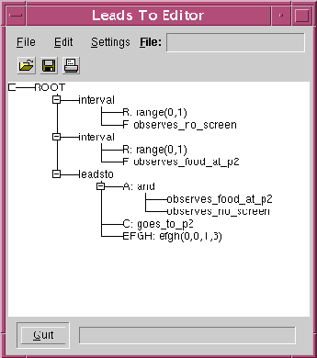

1.1.3 Specifying the total duration of the simulation
The last thing we need to do is specifying the total duration of the simulation. For example, let us assume that the simulation will last five time units. Execute the following steps:

- Mouse again over ROOT and click the right mouse button.A menu will appear.
- While holding down the mouse button, point to the entry End time. Release the mouse button. A node labeled "end_time([value])" will appear.
- At this place we can fill in the range: click the right mouse button on this node and release when over Edit. A window with name "Constant Editor for end_time" will appear:
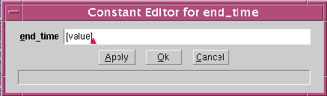

- Replace the line "[value]" by "5". Press button Ok. You have now succesfully specified your simulation model. If everything went well, the main canvas now looks like this:
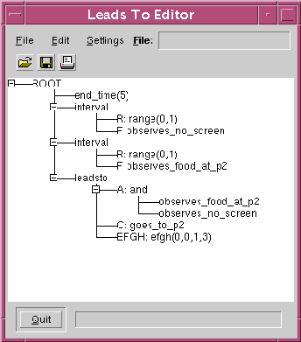
- To save the specification entered, click on the second icon below the File entry (looks like a floppy) and specify a file name (without extension), say ex1. When you are finished, hand in this file by e-mailing it to the teacher.

1.2 Running your "leads-to" specification with the "leads-to" simulation tool
In the second exercise you are going to run the specification you just created. In order to do this, execute the following steps:

- On Windows, double click the leadsto icon on your desktop. The initial window will look like this:
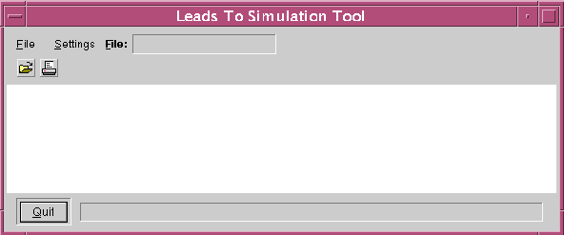
- To load (and immediately run) the file you just saved, click on the first icon below File (folder icon).
- A file chooser window will appear. Select the file you saved in the last step of the previous exercise, say ex1.
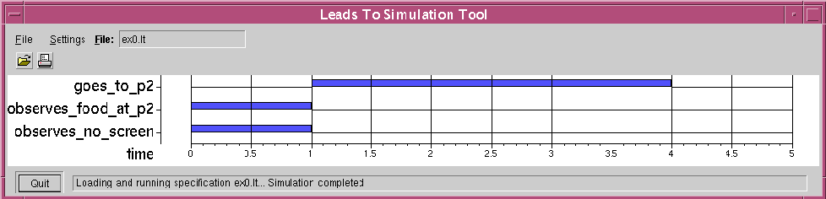
- If you did not make any mistakes, your specification will now be executed. The resulting trace will look like this:

- After quitting the Leads To Simulation Tool, you can change the name of the trace. By default, a generated trace is stored as file trace.tr. If you want to make sure that this trace is not overwritten by the next simulation, rename it to some other file, such as ex3.tr.

1.3 Making experimental modifications to your “leads-to” specification

Now that you have a working “leadsto” specification, try to experiment with the software by making some small modifications to your specification. In particular, execute the following steps:

- In the first place, see what happens if you choose different delay parameters. In order to do this, execute the lteditor again, and load your file by clicking on the folder icon. Now, mouse over the EFGH: efgh(0,0,1,3) node and click right mouse button. Edit the parameters by giving them some new values, e.g. efgh(1,1,1,3) or efgh(0,0,2,3). Do not forget to save your changes! Then go back to the leadsto simulation software, and re-load your modified file by clicking on the folder icon. Do you see any changes in behaviour? Can you explain these changes? Hand in your answers to these two questions for at least three different combinations of timing parameters. Hand in your answers by e-mail.
- Besides modifying the time parameters of the “leadsto” formula, you can also modify the time parameters of the input state properties (you initialised them in exercise 1.1.2, remember?). In order to do this, you have to give the “range(0,1)” nodes a new value, e.g. “range(0.5,2.5)”. Another possibility is to give both input state properties different time parameters. Experiment a bit with these time parameters, also in combination with the different efgh-parameters you used in a). Finally hand in a brief report by e-mail in which you explain your findings.
- In this final exercise you have to generate a complete new “leadsto” specification, in which you model the internal dynamics of stimulus-response behaviour. In order to obtain a correct specification, you have to formalise dynamic property ISR1, ISR2 and ISR3. You are free to choose you own time parameters. As soon as your specification works, hand in this file by e-mail. In addition, experiment a bit with different time parameters as you did in a) and b). Again, hand in a brief report of your findings by email.

