AGRITECH SUITE
One platform for the African farmer: diagnose, decide, sell.
________________________________________________________________________________________________

The idea
A farmer in Nigeria wakes up to find leaves turning brown. Nobody is coming to tell her what it is. The nearest extension officer serves thousands of other farmers and she has never met him. She guesses, sprays whatever the shop recommends, and hopes. Weeks later, whatever survives is sold at the farm gate to a middleman, at whatever price he names, because she has no idea what the crop is worth in Lagos and no way to reach anyone there.
AgriTech Suite is built for that morning. She photographs the leaf, and in seconds the app names the disease, explains what caused it, tells her what to do today and how to stop it next season. The same app tells her what to grow more of and what to abandon, based on her own farm's history. When she harvests, it shows her buyers who are looking for exactly what she has — and shows those buyers her produce, directly.
It is one platform doing six jobs that are currently scattered across six apps, most of which the average smallholder will never install: AI disease diagnosis for crops and livestock, personalised farm advisory, local agricultural news, a farmer-to-buyer marketplace, a community of peers, and a conversational AI expert that already knows her farm.

The problem this exists to solve
African agriculture is not short of effort. It is short of information reaching the person holding the hoe, and short of a fair route to market once the harvest is in. Three numbers explain the whole business case.
The number | What it means
1 extension officer per 2,500-10,000 farmers  (FAO recommends 1 per 1,000; some Nigerian states report 1 per 24,000) | Expert advice effectively never arrives. Most farmers will not meet an extension officer this season. When disease strikes, they guess.
N3.5-5 trillion lost in Nigeria in 2025  (30-40 million tonnes of food; up to 50% for tomatoes, onions, bananas) | Farmers do everything right in the field and still lose the value after harvest — to disease caught too late, and to having no buyer ready.
145 agritech companies in Nigeria — yet thin smallholder adoption | The tools exist but do not fit: single-purpose, priced for commercial farms, or requiring data and smartphones that rural users do not have.

These compound. Late diagnosis destroys the crop; no market access destroys the price of whatever survived. Fix one and you have helped a little. Fix both in the same place and the farmer's season changes.

Who it is for
Nigerian farmers and agricultural traders first, then West Africa and the wider continent. Nothing in the system is Nigeria-specific — crops, languages, currencies and news sources are all configurable. Every account is one of two roles, and that single choice shapes the entire experience.
Role | Who they are | What they get
Farmer (Producer) | Smallholders, mixed crop-and-livestock households, commercial growers, cooperatives. | Disease diagnosis, personalised advisory, ability to list produce, and a feed of buyers currently seeking what they grow.
Buyer (Consumer) | Market traders, aggregators, processors, restaurants, exporters, bulk households. | Ability to post buy requests, and a feed of produce offered directly by farmers, with location and price.

How it works
The most-used moment is the diagnosis. It was deliberately built so that it still returns a useful answer when the network is weak or absent — because that is exactly where farmers are standing when they need it.
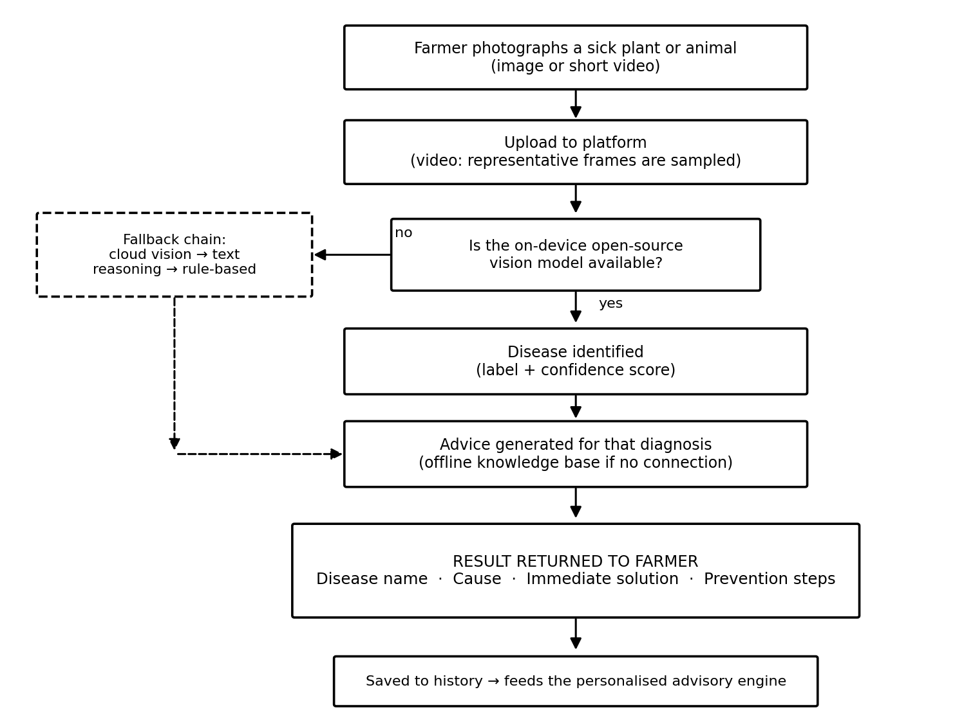
The diagnosis flow. If anything in the chain is unavailable, it falls back rather than failing.
The commercial engine is the marketplace, and it is two-sided by design. A farmer never has to understand listing categories — they post what they have, and the system publishes it as a sell offer. A buyer posts what they need and it becomes a buy request. Each side is then shown the other.
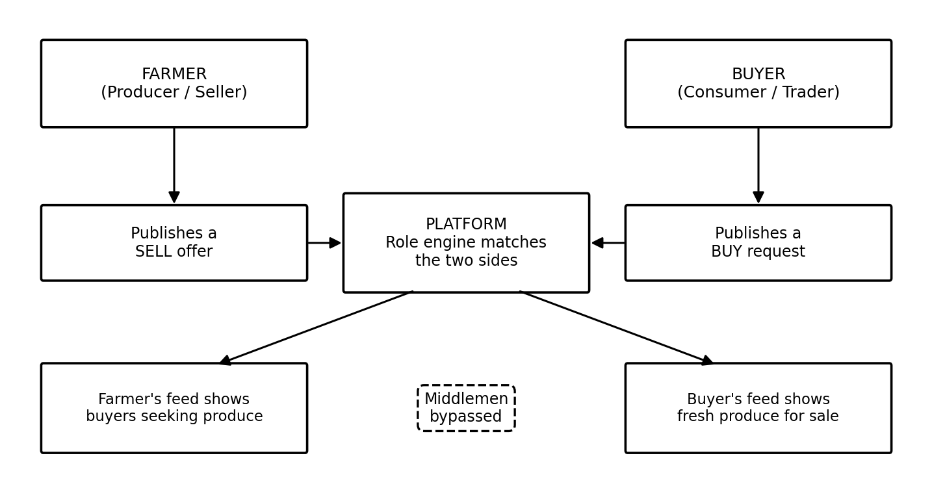
Producers and buyers are matched directly, cutting out the intermediary.

What makes it different
The market has good point solutions. PlantVillage Nuru diagnoses crop disease offline and does it well. Crop2Cash reaches feature-phone farmers with financial services. AFEX runs real commodity trading. Farmcrowdy and Thrive Agric bring financing. None of them assemble the whole picture for one farmer in one place.
 | Nuru | Plantix | Farmcrowdy | Thrive Agric | AFEX | Crop2Cash | AgriTech Suite
Plant diagnosis | Yes | Yes | No | Partial | No | No | Yes
Animal diagnosis | No | No | No | No | No | No | Yes
Per-farm advisory | Partial | No | No | Partial | No | No | Yes
Direct farmer-to-buyer market | No | No | Partial | Partial | Yes | No | Yes
AI assistant | No | No | No | No | No | No | Yes
Free to run (no paid AI per use) | Yes | No | n/a | n/a | n/a | n/a | Yes
Live in the field today | Yes | Yes | Yes | Yes | Yes | Yes | Not yet

Two honest conclusions. First, nobody else combines diagnosis, advisory and a direct marketplace so that the diagnosis informs what to plant and where to sell it — that gap is the business. Second, this project is the only one in that table not yet in the field. It is technically complete and unproven, and the plan reflects that.
The quiet advantage is technical but has a commercial consequence: the disease model is open-source and runs locally rather than calling a paid AI service. That means each diagnosis costs effectively nothing to serve. It is the difference between a tool a subsistence farmer can use freely forever and one that must be metered — and metering is precisely what prices out the farmers who need it most.

It has to work for the poorest farmer, not just the richest
Users will not be alike. Some will run hundreds of hectares from a laptop. Far more will have a shared phone, a weak signal, a prepaid balance measured in hundreds of naira, and limited reading confidence in English. A platform that only serves the first group is not an agricultural platform — it is a business tool for people who already have options.
So capability degrades with the user's means but never disappears. The core — diagnosis, advisory, news, community, AI assistant — is free permanently, and revenue never comes from access to knowledge. A planned USSD short-code and SMS layer will carry price alerts, buyer matching and advisory summaries to feature phones with no data bundle at all, and local languages (Hausa, Yoruba, Igbo, Pidgin) with voice answers will follow for users who cannot comfortably read English. Where the device cannot reach, a trusted local agent will — earning a commission, which turns inclusion itself into a livelihood.

How it makes money
One rule: the platform earns when the user earns, and not before. Charge a subsistence farmer for advice and they will abandon the app, and they would be right to. Take a small share of a sale they would not otherwise have made, and they will gladly pay it.
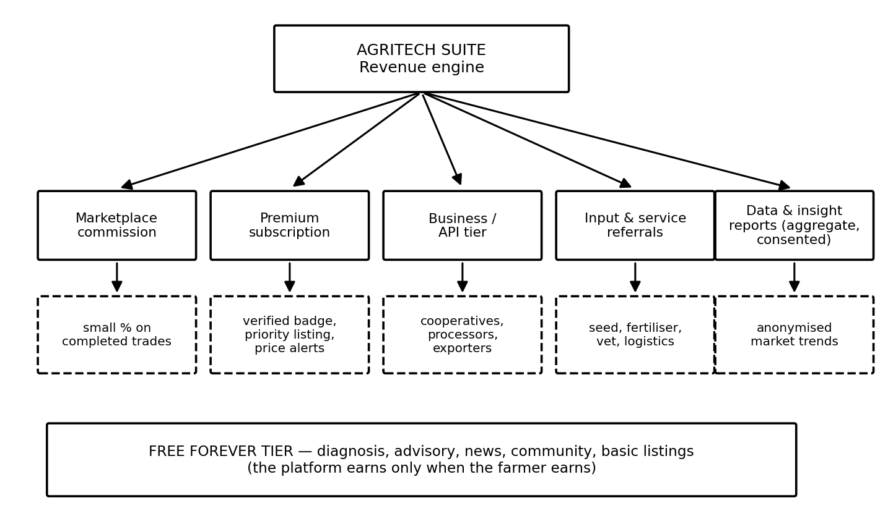
Revenue sits on top of a permanently free core.
Stream | Who pays | Why it works
Marketplace commission (primary) | Buyer or seller, on a completed trade | Perfectly aligned: no sale, no fee. Nothing is paid upfront and no behaviour has to change. This switches on first.
Premium subscription | Active traders, commercial farmers | Verified badge, priority listing, price alerts, better matching. Optional — never required for the core.
Business / API tier | Cooperatives, processors, exporters, NGOs | Bulk sourcing, analytics, integrations. These users have budgets and clear operational value.
Input & service referrals | Seed, fertiliser, veterinary, logistics providers | The diagnosis already identified the need; connecting it to a vetted supplier serves the farmer and monetises the moment.
Financing & insurance partnerships | Lenders, insurers | Verified sales history de-risks lending — and gives farmers a credit record they have never had.

The farmer's side of the ledger matters just as much: a better price by reaching buyers directly, less of the harvest lost to late diagnosis, money not wasted on the wrong chemical, planting what is actually in demand, and eventually a financial record that unlocks credit. The platform's revenue is a by-product of those gains, which is the only arrangement that survives contact with a farmer's budget.

Where it stands
The software is built and tested — not a prototype or a mock-up. The backend, the web application, the AI pipeline, the role system and the database all work, and an automated test suite covering every feature passes.
Built and working | Not yet done
Disease diagnosis for plants (38 classes) and livestock, from photo or video | Deployment to public hosting (Render for the backend, Vercel for the frontend)
Personalised advisory, agri-news, marketplace, community, streaming AI assistant | A field pilot with real farmers — accuracy in real conditions is not yet measured
Farmer/Buyer roles, sign-in (including Firebase), full database and web interface | USSD and SMS access, local languages, payments and escrow

The immediate next step is simply to put it online and get it in front of real farmers in one Nigerian state. The remaining work is about reach and evidence rather than construction: deploy it, measure the diagnosis honestly against expert assessment, then build the USSD layer that extends it to the feature-phone majority that no smartphone-only platform will ever serve.

Contact
Author | Flourish Olaiya — Full-Stack Software Engineer and AI Architect
Email | flourisholaiya@gmail.com
Portfolio | https://flourish-webpage.vercel.app/
Repository | github.com/lourish789/crispy-funicular

