**Super Space Armada**

*Art Style Guide*

Gateway Games

Version 1.0

**Team Roster**

|  |  |
| --- | --- |
| **Position** | **Name** |
| Producer | [Sean Randall](https://www.facebook.com/sean.p.randall?fref=grp_mmbr_list) |
| Creative Director | [Andrew Ehrlich](https://www.facebook.com/andrew.ehrlich.5?fref=grp_mmbr_list) |
| Technical Director | [Enrique Martinez](https://www.facebook.com/enrique.martinez.50?fref=grp_mmbr_list) |
| Art Director | Luis Rodriguez |
| Lead Designer | Ian Smith |
| Designer | [Zachary Gadzinski](https://www.facebook.com/zachary.gadzinski?fref=grp_mmbr_list) |
| Artist | [Seth Gose](https://www.facebook.com/seth.gose?fref=grp_mmbr_list) |
| Artist | [James Countryman](https://www.facebook.com/profile.php?id=100008472934842&fref=grp_mmbr_list) |
| Technical Artist | [Jonathan Hoang Nguyen](https://www.facebook.com/profile.php?id=594480628&fref=grp_mmbr_list) |

**Document Revision Table**

|  |  |  |  |
| --- | --- | --- | --- |
| **Version** | **Updates** | **Advocate** | **Date** |
| 1.0 | Initial Document | Gideon Shbeeb | 9/16/2015 |

# Table of Contents

(This should be auto generated and interactive)

Table of Contents

Aesthetic Summary

Game Art Overview

Technical Overview

Lighting

Colors

Map Colors:

Ship Race colors:

Human

Kratakos

Cephalons

Vultarii

Particle Colors:

Materials/Textures

Proportion/Scale

Fonts

Menu font:

Game fonts:

Credit font:

Asset List

Meshes

Textures + Materials

Animations

Particle Systems

Audio Assets

# Aesthetic Summary

(This section contains a description of the world and how it looks as an artist would perceive the representation. A discussion of materials, style, “feeling”, and theme live here.)

Super Space Armada will immerse you in a world of science fiction space battles. With alien races, unique ship designs, and a galactic starfield in which to play. The artistic style will have a realistic look and feel despite fictitious ship designs and arenas in space. The look will be accomplished using materials like blinn, anisotropic shaders and a variety of texturing maps including metal and roughness in order to take full advantage of PBR in Unreal engine.

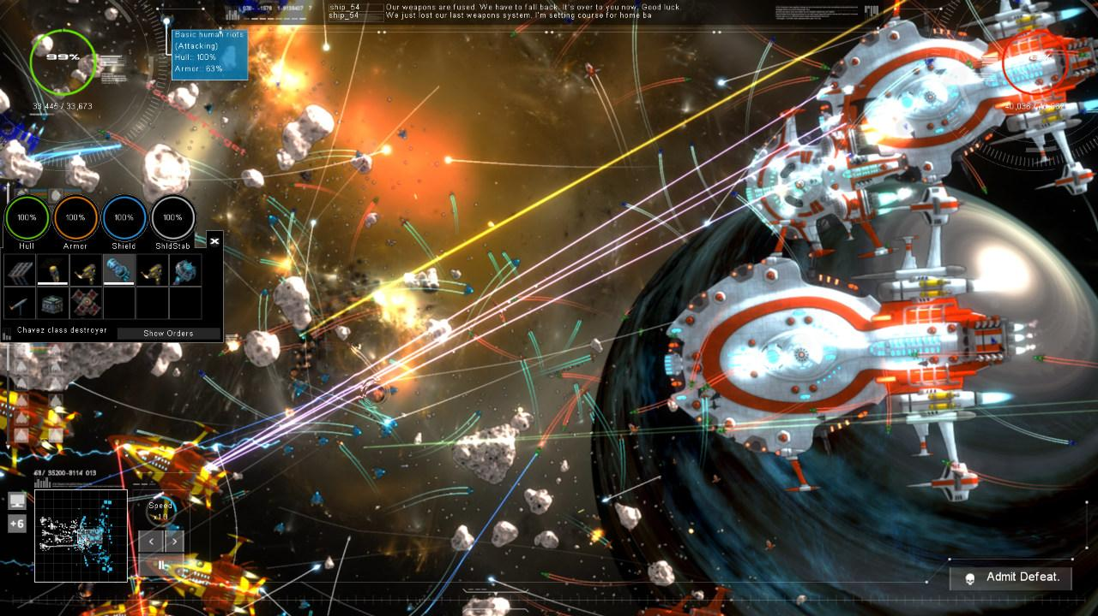

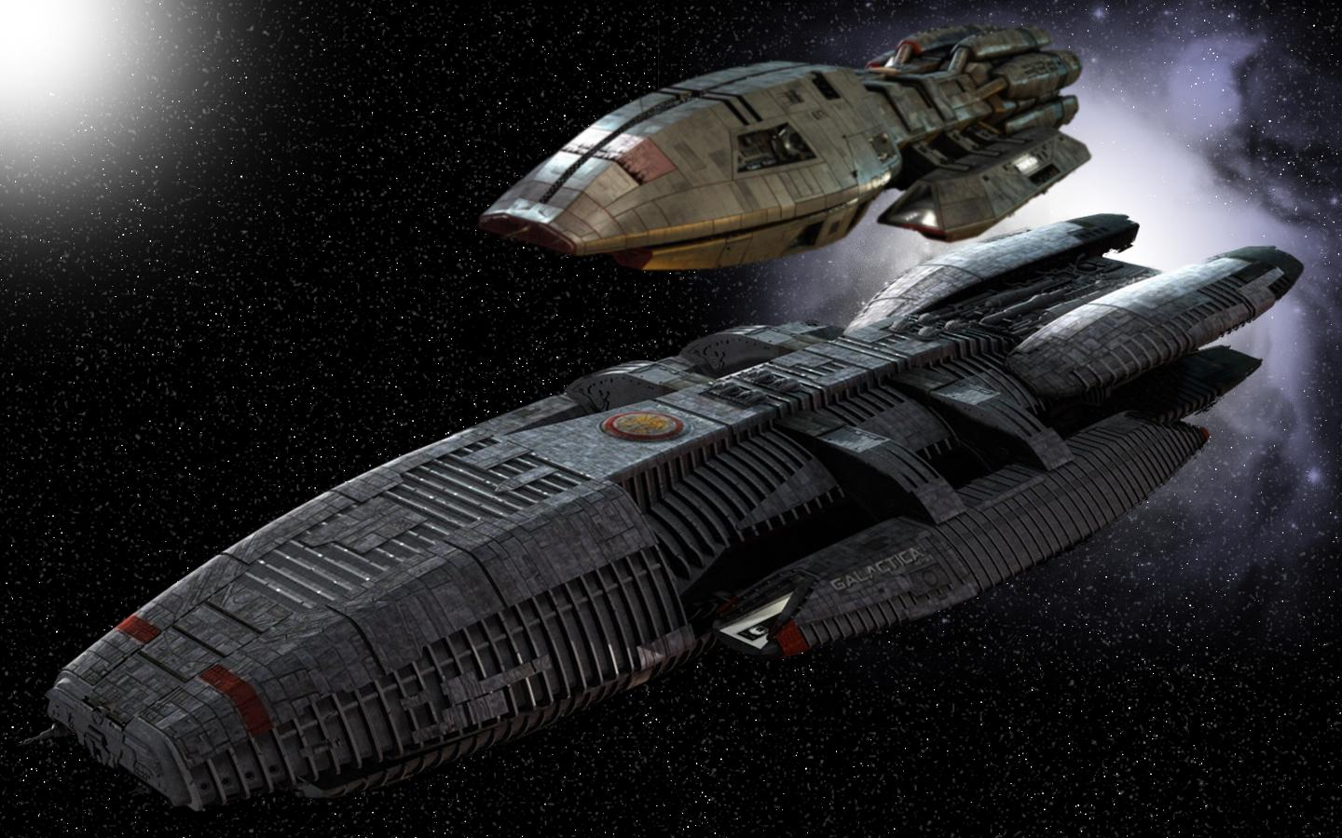

# Game Art Overview

(Describe the consistent elements of objects, architecture, characters, and key landmarks in the game world as they pertain to their visual and spatial relationships.)

The aesthetics will be created using PBR rendering for unique ship styles to each race. Each race will have their own distinct style of spaceships within the different classes such as fighter, capital ships, cruisers, and frigates. Humans will have sleek fighters but bulky bigger ships. Dragomir will have vicious alien looking ships through all their ship classes. Kratakos will be bulky ships through all ship classes with a focus on crystal looking designs for their ships. Cephalons will have very organic ship designs with aquatic inspiration. Vultarii ships will take hint from the avian species they are and have talon inspired ships with slim builds. The Hive will have ships based on insectoid hives.

# Technical Overview

## Lighting

(A discussion of lighting methods and values to be repeated for consistency and avoided for dissonance.)

Using Unreals lighting capabilities, dynamic lighting will be used to pop color and particle effects throughout the game world. Since Super Space Armada gameplay takes place in an arena style space map, it is imperative that important objects, ships, and areas of the map be well lit. The majority of lighting should feel like practical lights from objects in the environment such as the sun, reflection of light off of objects like moons or planets and of course any weapon attacks that would illuminate the play field in reality. The effects that occur during battle should be obvious and cue the player into whether or not they were hit.

## Colors

(Images and descriptions for color palettes throughout the game.)

The color palette will present battle worn ships that maintain some the of the original manufacturing luster. Each of the races will have varying ship design styles and will therefore have unique color palettes. The ships will use bright colored emissive maps to highlight, accent, and or convey active zones on the ships. The maps will be used to show a star strewn galaxy with colorful planets and dangers lurking at every corner.

### Map Colors:

Since the arena will be set in a wasteland the primary colors for the map will have a rustic influence, similar to this example:

For structures, props, such as crates or barrels, and other dieselpunk manufactured equipment it will have a very industrial visual:

### 

### Ship Race colors:

#### Human

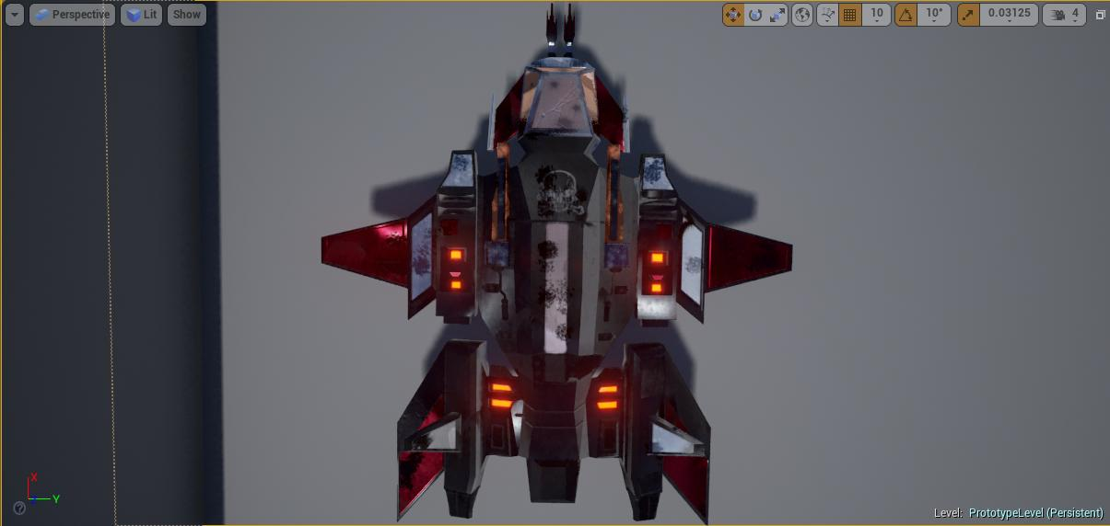

Human ships will have a gritty look. The idea is to build ships similar in style and feel that convey believable future tech and ship design. The colors will be metallic with painted areas and distinct insignia for identifiers among the human fleet.

#### Kratakos

#### 

#### 

Kratakos ships will be based of a crystal scheme. Being rock creatures, their tech stems from crystal power and crystal design. They will have runes etched into their ships as part of the design. Their color scheme can run the gamut of the spectrum but our primary palette will run from white, red, blue, to green.

#### Cephalons

#### 

Cephalon ships will have an organic and aquatic feel to them in their design. They will have bright blues, reds, yellows, and purples.

#### Vultarii

#### 

Vultarii ships will have a much more narrow design wit ships that are based around the concept of fast and agile. Their color scheme will range from greys, greens, and oranges.

**Dragomir**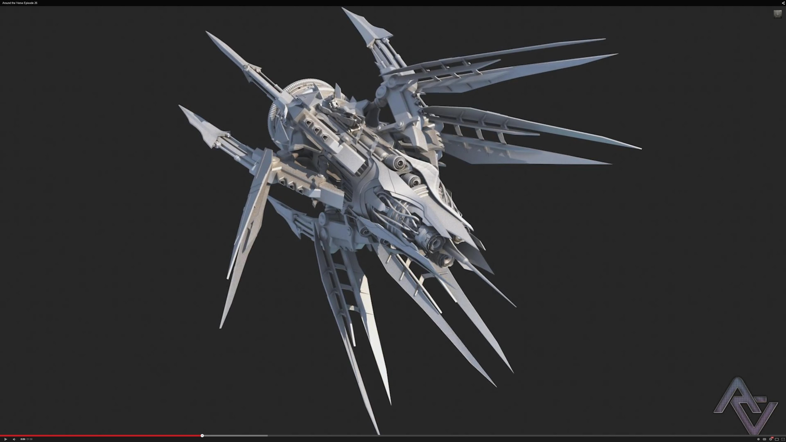

Dragomir are our reptilian race. Their ships will be aggressive and menacing in design. They will have aggressive colors with dark grey, red, black, and orange for their primary colors.

**The Hive**

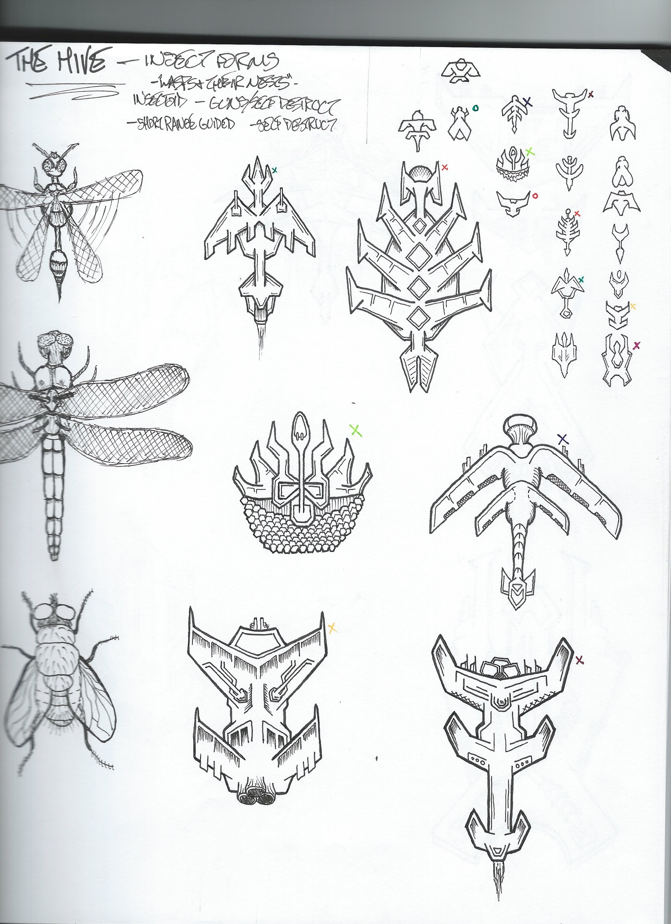

The Hive being our intergalactic insectoid race will have insectoid structured ships with some of design taking inspiration directly from members of their race. Their colors will range from brown, green, black, and yellow for primary colors.

### Particle Colors:

Particle colors will be bright in order for players to be able to distinctly see that when they fire their ships are shooting and hitting their targets. The brightest hues of blue, red, green, yellow, and orange.Here is a reference image:

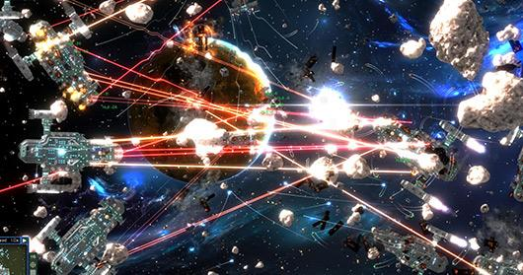

## Materials/Textures

(Discuss the resolution, density, and process for laying out a texture to be used in game.)

Texture sizes will be 2048x2048 all assets exempting especially small assets. We will downscale textures to appropriate sizes in order to maximize performance. Projectiles will be the exception not requiring full resolution. Texture files can be created as a .png for assets. Under no circumstances will a .jpg format be used. Important to note is UE4 does not allow light baking with overlapping UVs so no UV should have overlapping faces.

Materials for the project should be consistent for the object types, if it should be a reflective material it should reflect and materials should have normal maps as well. It is important to assign the material of the object inside Maya or Max so the fbx can be exported with both material and texture attached to save time. When using Substance Painter the materials will have to be attached to the texture images manually UE4 has a strong material editor and it is recommended to use the node system in the material to adjust the details of a material instead of working on the material settings in Maya or Max.

## Proportion/Scale

(A graphic and textual comparison of scale for all characters, architecture, assets, and cameras/lights in the game world.)

Unreal Units (also known as UU) are 16 units to 1 foot.

The chart below only represents their initial size.

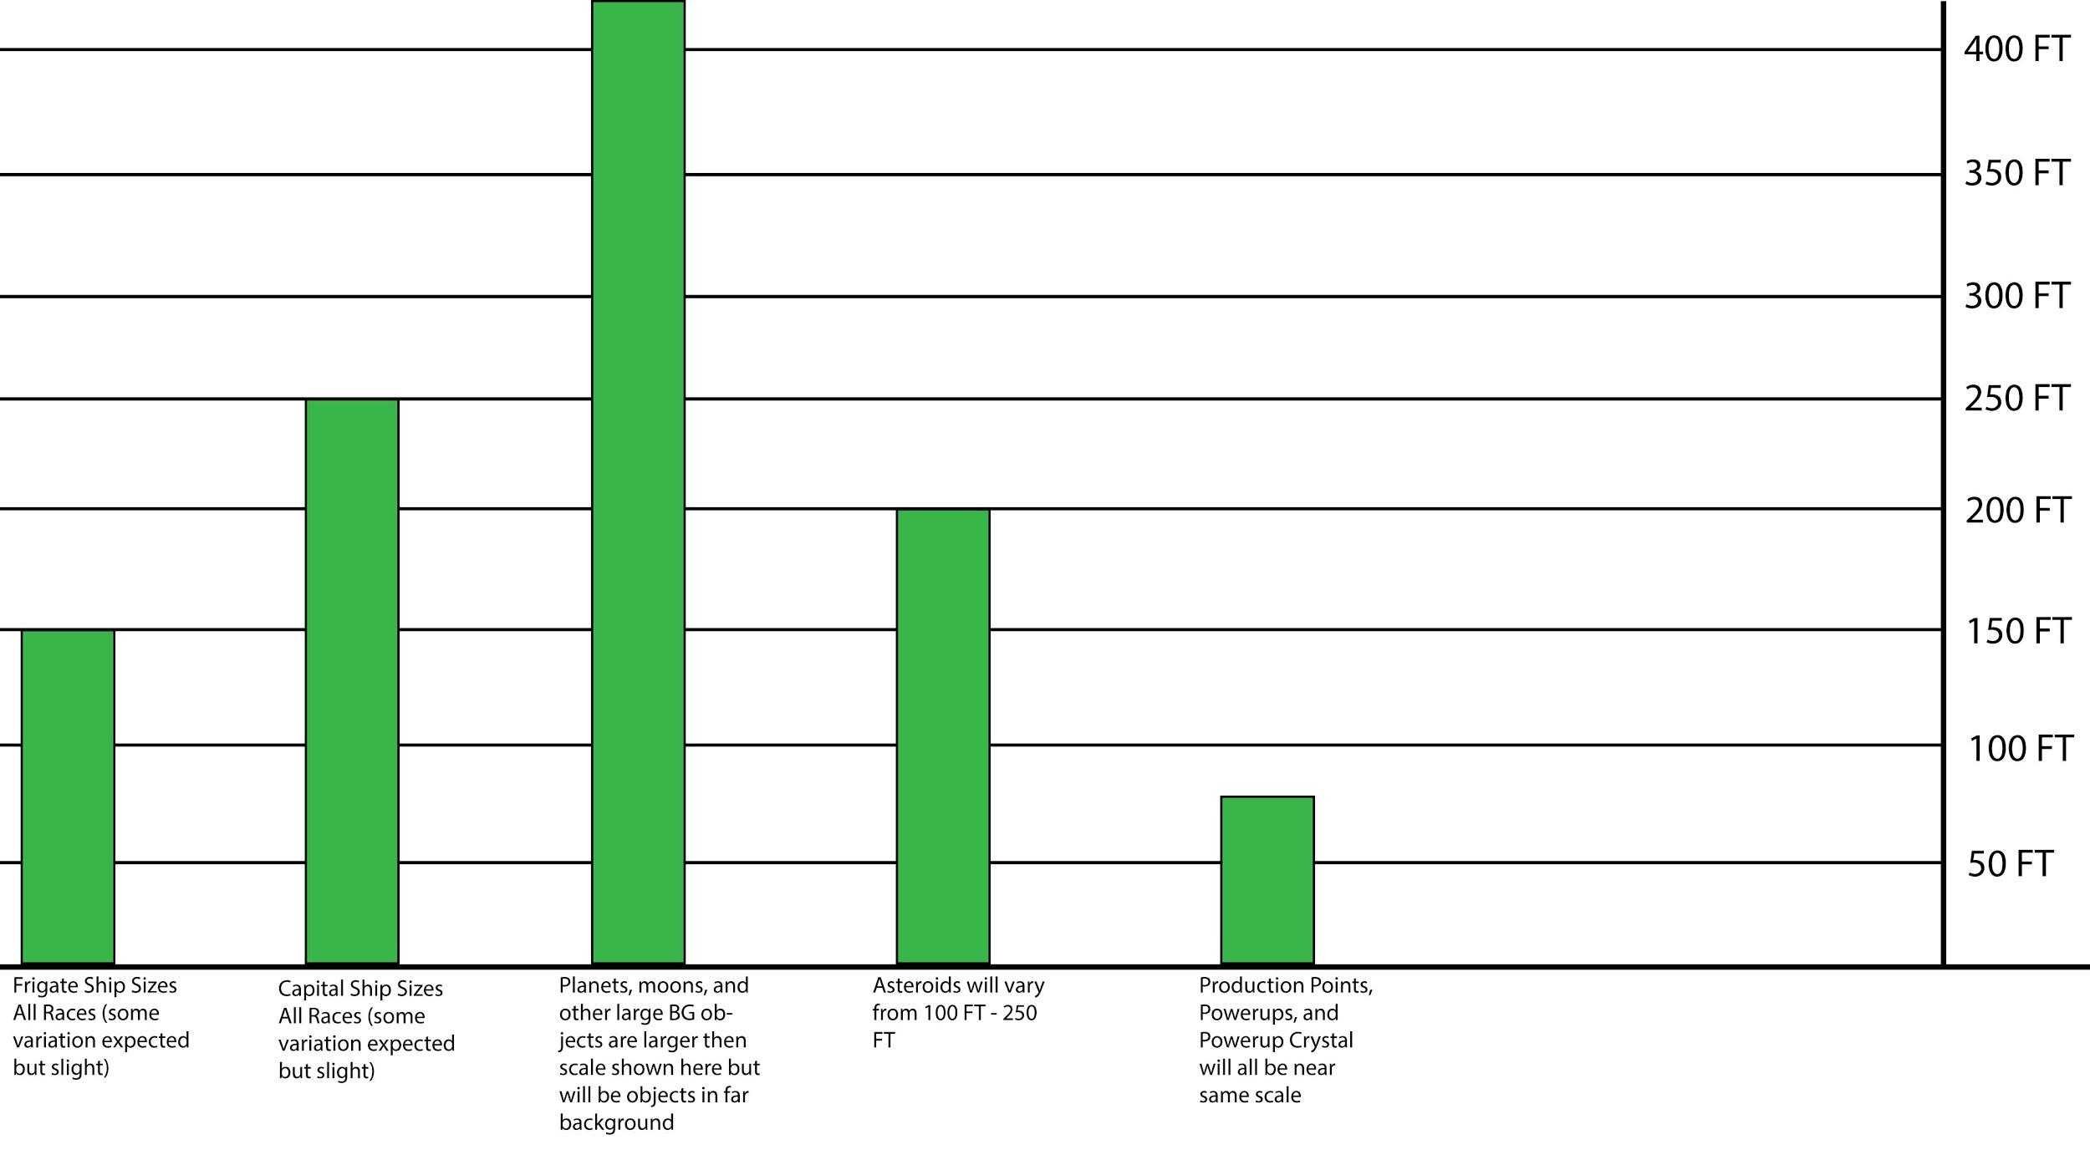

## Fonts

(A list and example of fonts used in game, as well as those used in the menu systems and credits.)

### Menu font:

Times New Roman

### Game fonts:

Syncopate

Georgia

### Credit font:

Arial Black

## Asset List

(A list of all assets that need to be created out of the engine and inside: Textures, Models, Animations, Particle Systems, Materials, etc.)

### 

### Meshes

|  |  |  |
| --- | --- | --- |
| Asset | Details | Tri-Count |
| Human Ship Frigate | Model | 3.7k |
| Human Ship Capital | Model | >3k |
| Dragomir Ship Frigate | Model | >3k |
| Dragomir Ship Capital | Model | >3k |
| Kratakos Ship Frigate | Model | >3k |
| Kratakos Ship Capital | Model | >3k |
| Cephalons Ship Frigate | Model | >3k |
| Cephalons Ship Capital | Model | >3k |
| Vultarii Ship Frigate | Model | >3k |
| Vultarii Ship Capital | Model | >3k |
| The Hive Ship Frigate | Model | >3k |
| The Hive Ship Capital | Model | >3k |
| Missiles | Model | 300 max |
| Asteriods | Model | 500 max |
| Crystal Shards | Model | 500 max |
| Planetoids | Model | 1000 max |
| PowerUp Crate | Model | 500 max |
| Health Crate | Model | 500 max |
| Production Points | Model | 1000 max |
| Galactic Backgrounds | Images |  |

### Textures + Materials

|  |  |  |
| --- | --- | --- |
| Asset | Details | Res. |
| Human Ship Frigate | Base Color, Normal, Metallic, Roughness, AO, Emissive | 2k x 2k |
| Human Ship Capital | Base Color, Normal, Metallic, Roughness, AO, Emissive | 2k x 2k |
| Dragomir Ship Frigate | Base Color, Normal, Metallic, Roughness, AO, Emissive | 2k x 2k |
| Dragomir Ship Capital | Base Color, Normal, Metallic, Roughness, AO, Emissive | 2k x 2k |
| Kratakos Ship Frigate | Base Color, Normal, Metallic, Roughness, AO, Emissive | 2k x 2k |
| Kratakos Ship Capital | Base Color, Normal, Metallic, Roughness, AO, Emissive | 2k x 2k |
| Cephalons Ship Frigate | Base Color, Normal, Metallic, Roughness, AO, Emissive | 2k x 2k |
| Cephalons Ship Capital | Base Color, Normal, Metallic, Roughness, AO, Emissive | 2k x 2k |
| Vultarii Ship Frigate | Base Color, Normal, Metallic, Roughness, AO, Emissive | 2k x 2k |
| Vultarii Ship Capital | Base Color, Normal, Metallic, Roughness, AO, Emissive | 2k x 2k |
| The Hive Ship Frigate | Base Color, Normal, Metallic, Roughness, AO, Emissive | 2k x 2k |
| The Hive Ship Capital | Base Color, Normal, Metallic, Roughness, AO, Emissive | 2k x 2k |
| Missiles | Base Color, Normal, Metallic, Roughness, AO, Emissive | 2k x 2k |
| Asteriods | Base Color, Normal, Metallic, Roughness, AO | 2k x 2k |
| Crystal Shards | Base Color, Normal, Metallic, Roughness, AO, Emissive | 2k x 2k |
| Planetoids | Base Color, Normal, Roughness, AO | 2k x 2k |
| PowerUp Crate | Base Color, Normal, Metallic, Roughness, AO, Emissive | 1k x 1k |
| Health Crate | Base Color, Normal, Metallic, Roughness, AO, Emissive | 1k x 1k |
| Production Points | Base Color, Normal, Metallic, Roughness, AO, Emissive | 1k x 1k |
| Galactic Backgrounds | Images |  |
|  |  |  |

### Animations

|  |  |
| --- | --- |
| Asset | Details |
| Production Points | Simple rotation of objects approx. 400 frames |
| Kratakos Planet | Cloud Rotation |
|  |  |
|  |  |
|  |  |
|  |  |
|  |  |
|  |  |
|  |  |
|  |  |
|  |  |
|  |  |

### Particle Systems

|  |  |
| --- | --- |
| Asset | Details |
| Propulsion | Human, Kratakos, Cephalons, Vultarii, Dragomir, The Hive |
| Propulsion Idle | Human, Kratakos, Cephalons, Vultarii, Dragomir, The Hive |
| Explosions | Human Death, Kratakos Death, Cephalons Death, Vultarii Death, Dragomir Death, The Hive Death  Human Missile Detonation, Vultarii Mine Detonation, The Hive Drone Detonation |
| Weapons and Misc. | Human Missile Thrust, Human Phasers, Kratakos Rail Cannon, Vultarii Machine Guns, Vultarii Mine Beacon, The Hive Self-Destruct, Cephalon Pulse Attack, Cephalon Teleport Effect |
|  |  |

### Audio Assets

|  |  |
| --- | --- |
| Asset | Details |
| Human Commander | .mp3 clips, dialogue to be completed by VAK |
| Dragomir Commander | .mp3 clips, dialogue to be completed by VAK |
| Kratokos Commander | .mp3 clips, dialogue to be completed by VAK |
| Vultaari Commander | .mp3 clips, dialogue to be completed by VAK |
| The Hive Commander | .mp3 clips, dialogue to be completed by VAK |
| Cephalon Commander | .mp3 clips, dialogue to be completed by VAK |
| Mercenary Commander | .mp3 clips, dialogue to be completed by VAK |
| General Combat Remarks | .mp3 clips, dialogue to be completed by VAK |
| User Interface Announcer | .mp3 clips, dialogue to be completed by VAK |
| Tutorial Mode Announcer | .mp3 clips, dialogue to be completed by VAK |
| Story Mode Announcer | .mp3 clips, dialogue to be completed by VAK |
| BGM | .mp3 clips, assorted music for menus, ship selection, the different maps, |
| Collision | For general collision with other objects, Attack hits |
| Weapon | Discharge sounds and detonation sounds |
| Ships | Engine sounds for movement |
| Maps | Ambient sounds for arenas |
| Menu (and associated sounds) | Selection, back, confirm, sounds for conveying menu selections have occurred |