CIS269
Quiz 4

Section I: Linked lists

- Create a structure that will accommodate both the operations of a stack and a queue. Using that structure, create the four functions that are needed. You will need to account for code size and efficiency.

#include<stdio.h>
#include<stdlib.h>

struct Llist
{
int data;
struct Llist *next, *prev;
};

typedef struct Llist List;

struct Grave
{
List *beg, *end;
};

typedef struct Grave StackQ;

int Empty(StackQ *sq)
{
return !sq->beg;
}

int Push(StackQ *sq, int data)
{
List *temp = (List *)malloc(sizeof(List));

if(!temp) return 0;
temp->data = data;
temp->next = sq->beg;
temp->prev = NULL;
if(sq->beg)
sq->beg->prev = temp;
else
sq->end = temp;
sq->beg = temp;
return 1;
}

int Pop(StackQ *sq, int *data)
{
List *temp;

if(Empty(sq)) return 0;

temp = sq->beg;
(*data) = temp->data;
sq->beg = temp->next;
if(sq->beg)
sq->beg->prev = NULL;
free(temp);
return 1;
}

int Enqueue(StackQ *sq, int data)
{
return Push(sq, data);
}

int Dequeue(StackQ *sq, int *data)
{
List *remnode;

if(Empty(sq)) return 0;
remnode = sq->end;
sq->end = remnode->prev;
if(!sq->end)
sq->beg = NULL;
else
sq->end->next = NULL;
(*data) = remnode->data;
free(remnode);
return 1;
}

int main()
{
StackQ sq;
int x, data;

sq.beg = sq.end = NULL;

for(x=0; x<20; x++)
Push(&sq, x);

for(x=0; x<10; x++)
{
Pop(&sq, &data);
printf("%3d", data);
}

printf("\n");
while(!Empty(&sq))
{
Dequeue(&sq, &data);
printf("%3d", data);
}

return 0;
}

- Write a function to recursively reverse a singly linked list.

#include<stdio.h>
#include<stdlib.h>

struct Llist
{
int data;
struct Llist *next;
};

typedef struct Llist List;

int AddToFront(List **head, int data)
{
List *temp=(List *)malloc(sizeof(List));
if(!temp) return 0;

temp->data = data;
temp->next = (*head);
(*head) = temp;
return 1;
}

void ShowList(List *head)
{
if(head)
{
printf("%d->", head->data);
ShowList(head->next);
}
}

void KillList(List *head)
{
if(head)
{
KillList(head->next);
free(head);
}
}

List *Reverse(List *ptr, List *prev)
{
if(!ptr)
return prev;
else
{
List *temp = Reverse(ptr->next, ptr);
ptr->next = prev;
return temp;
}
}

int main()
{
int x;
List *head = NULL;

for(x=0; x<10; x++)
{
AddToFront(&head, x);
}

ShowList(head);
printf("\n");

head = Reverse(head, NULL);

ShowList(head);
printf("\n");

KillList(head);
return 0;
}

Section II: Trees

- Show the tree after the following AVL operations.

Insert 4
Insert 9
Insert 12
Insert 10
Delete 4

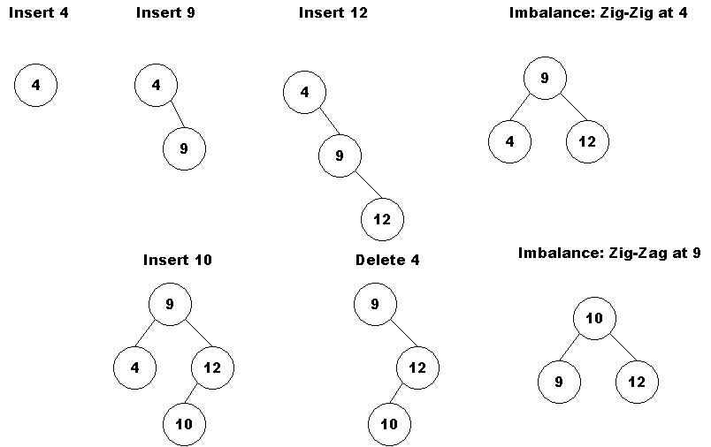

- Take the following tree and perform the following splay searches.

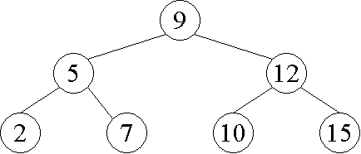

Find 7

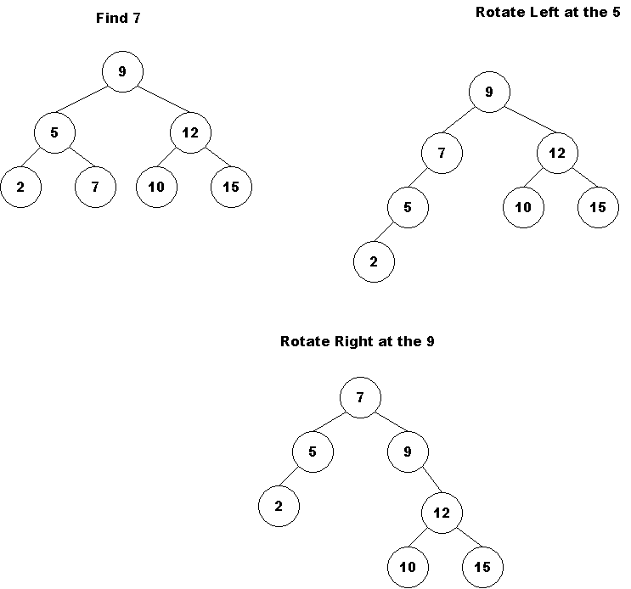

Find 15

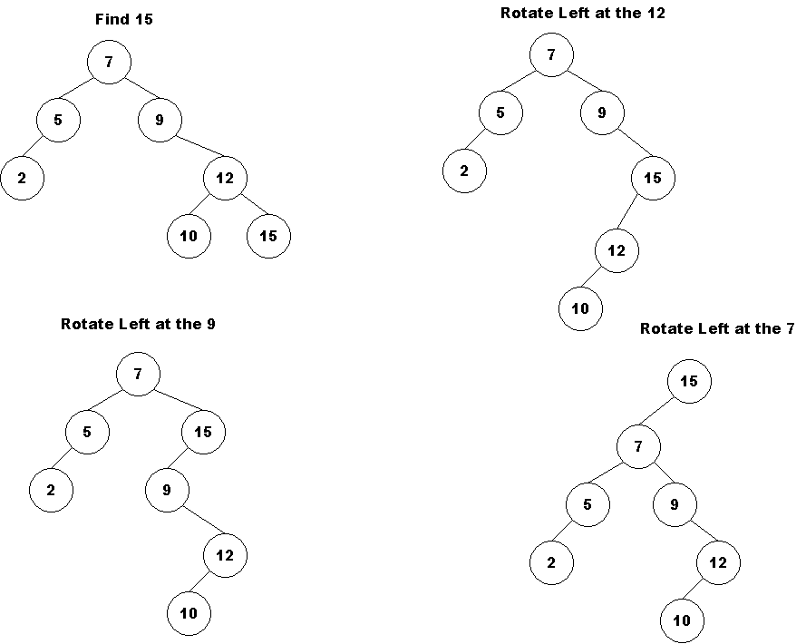

- Write a recursive function (you may add functionality) to remove only the leaves from a given BST.

#include<stdio.h>
#include<stdlib.h>
#include<time.h>

struct Tree
{
int data;
struct Tree *left, *right;
};

typedef struct Tree BST;

BST *Insert(BST *root, int data)
{
if(!root)
{
BST *temp = (BST *)malloc(sizeof(BST));
temp->data = data;
temp->left = temp->right = NULL;
return temp;
}

if(data < root->data)
{
root->left = Insert(root->left, data);
}
else
{
root->right = Insert(root->right, data);
}
return root;
}

BST *RemoveLeaves(BST *root)
{
if(!root) return NULL;

if(!root->left && !root->right )
{
free(root);
return NULL;
}

root->left = RemoveLeaves(root->left);
root->right = RemoveLeaves(root->right);
return root;
}

void KillTree(BST *root)
{
if(root)
{
KillTree(root->left);
KillTree(root->right);
free(root);
}
}

int main()
{
int x;
BST *root=NULL;

srand(time(NULL));
for(x=0; x<20; x++)
{
root = Insert(root, rand() % 100);
}

root = RemoveLeaves(root);
KillTree(root);

return 0;
}

- Write a function that accepts an array of key values (integer) that represent a post-order traversal of a BST. Return the tree that created that post-order traversal.

#include<stdio.h>
#include<stdlib.h>

struct Tree
{
int data;
struct Tree *left, *right;
};

typedef struct Tree BST;

BST *Insert(BST *root, int data)
{
if(!root)
{
BST *temp = (BST *)malloc(sizeof(BST));
temp->data = data;
temp->left = temp->right = NULL;
return temp;
}

if(data < root->data)
root->left = Insert(root->left, data);
else
root->right = Insert(root->right, data);
return root;
}

void KillTree(BST *root)
{
if(root)
{
KillTree(root->left);
KillTree(root->right);
free(root);
}
}

BST *GetTree(int *post, int nvals)
{
int x;
BST *root = NULL;

for(x=nvals-1; x>=0; x--)
{
root = Insert(root, post[x]);
}
return root;
}

int main()
{
BST *root=NULL;
int post[] = {4, 7, 9, 12, 15, 10};

root = GetTree(post, 6);
KillTree(root);

return 0;
}

