Version | Date | Description | Author
Inception (and Elaboration) Draft | 08/30/02 | First draft. Essentially refined to elaboration phase. Minor changes to be incorporated. | Lou Rosas

Introduction
This document is the repository of all WeatherCalculator Applicatoin requirements not captured in the Use Cases.

Functionality

Error Handling
Handle all errors in such a way to inform the user.

Start up Sequence
The application needs to be started up by the user before any user value action can take place.

Usability

Human Factors
All input and calculated data will be visible to the user.
- Text should be easily visible from a typical viewing distance from where a typical user would sit.
- Speed, ease and error free calculation is of paramount importance.
- Usage of the application needs to be intuitively obvious: there should be no “usage roadblocks” for the user.
- The user should see this application as nothing more a tool for the purpose of calculation and archiving valid weather data and therefore wants to perform both of the tasks with the utmost of ease.

Reliability

Recoverability
Unsaved data is to be periodically saved to a temporary file. Upon a system or application crash, this data should be available for the user to transfer to the primary weather data file. While this does not completely solve the problem of immediate saving upon the event of a system or application crash, it does (within reason) help recover data most recently calculated by the user.

Performance
As mentioned under Human Factors, the user wants complete weather data calculation quickly. Provided it is implemented, one potential bottleneck is external weather gathering electronic hardware, which would provide the data needed for the calculations. The goal is to achieve all weather calculations in less than 1 second 90% of the time, regardless to if the hardware is connected or not.

Supportability

Adaptability
No Major Issues

Configurability
Different customers are going to desire different aspects of the WeatherCaculator Application. Some prefer to use the application as a “one-time” use tool. Others will prefer to use the tool to manually input weather, calculate and save weather data periodically throughout a given time period. Others will prefer to use the application as an automated tool to periodically calculate and record weather data using weather collection instrumentation networked to a computer. This application will be somewhat configurable to satisfy the user’s needs. Customers possibly will desire the ability to view the calculated data in either analog or digital format, in addition with the ability to change units (metric, English or absolute).

Implementation Constraints
The WeatherCalculator application is to be implemented in Java, using Java Technologies and solutions (I.E. Networking). This will aid in porting the application, implementing it as a web applet and make development slightly easier.

Purchased Components
- When needed, weather collection equipment.

Free Open Source Components
In general, it is recommended maximizing the use of free Java technology on this project.
The following are suggested likely candidates:
- Java Swing AWT components for GUI.
- JDBC for Data Base Connectivity and storage.
- Java Networking Components
- Client-Server packages.

Interfaces

Noteworthy Hardware and interfaces
- Weather collection hardware is part of the tini components, which can be purchased from www.ibutton.com.
- The tini components have built in temperature and humidity sensors.
- The tini components have built in Ethernet capability: therefore the system can and should be networked via Ethernet.
- Ethernet network interface.

Software Interfaces
  - The tini has a built in Java Virtual Machine (JVM). Therefore, client-server communication using Java Technology would be a great advantage as well as the implementation of Remote Method Invocation (RMI).

Domain (Business) Rules

ID | Rule | Configurability | Source
Rule 1 | Heat Index depends upon a temperature over and Relative Humidity (Note: calculating the Heat Index is more accurate on temperatures over 78 °F). | Low | Physical Law
Rule 2 | Dewpoint depends upon Temperature and Relative Humidity. | Low | Physical Law
Rule 3 | Windchill depends upon temperature, relative humidity and windspeed. | Low | Physical Law

Domain Rules
None—freeware
Information in Domains of Interest
Weather data calculations are quite complex and involve large numerical values. These formulae often intertwine formulae from physical laws with formulae based on empirical knowledge.
Currently as stated previously, the WeatherCalculator application will calculate the heat index, Dewpoint and windchill under the appropriate conditions.
The associated formulae are as follows:

Heat Index:
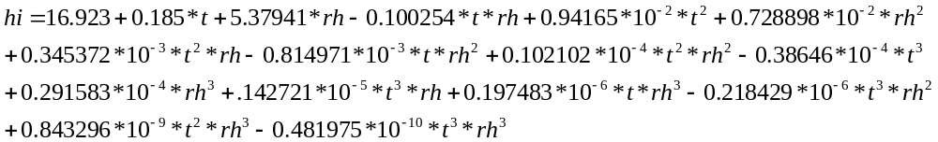

Where rh is the relative humidity, t is the temperature and hi is the Heat Index.

Windchill: There are two different formulas based on Metric, English or knots (for windspeed) in calculating the windchill:

Metric: Baseline: 33 °C, 1.8 m/s (windspeed).
Siple:

Court:

English: Baseline: 91.4 °F, 4 mph (windspeed).
Siple:

Court:

Roots: Baseline: 91.4 °F, 3.47 knots (windspeed).
Siple:
Court:

Where t is the temperature and ws is the windspeed.

Dewpoint:
There are two different formulae. One deals with the temperature in Kelvin and the other deals with the temperature in degrees Celsius.

Kelvin:
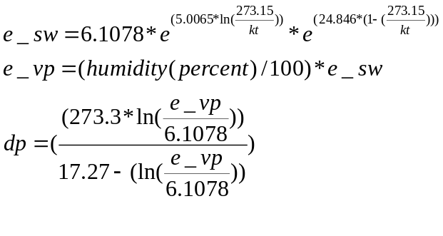

Where e_sw is the saturation vapor pressure, e_vp is the vapor pressure, kt is the Kelvin temperature and dp is the dewpoint.

Celsius:
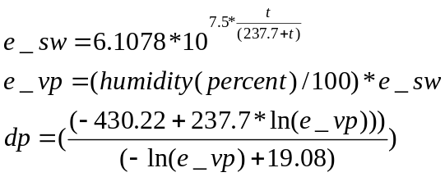

Where e_sw is the saturation vapor pressure, e_vp is the vapor pressure, t is the Celsius temperature and dp is the dewpoint.

In addition, it might be necessary to convert from °C to °F and vise-versa. The formulae are as follows:

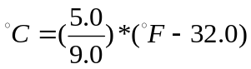

and

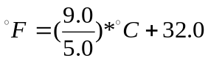

To convert to Kelvin, it is important to make sure the value is in units of °C and then add 273.15 to the value:
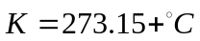

Then convert to °F if needed.

