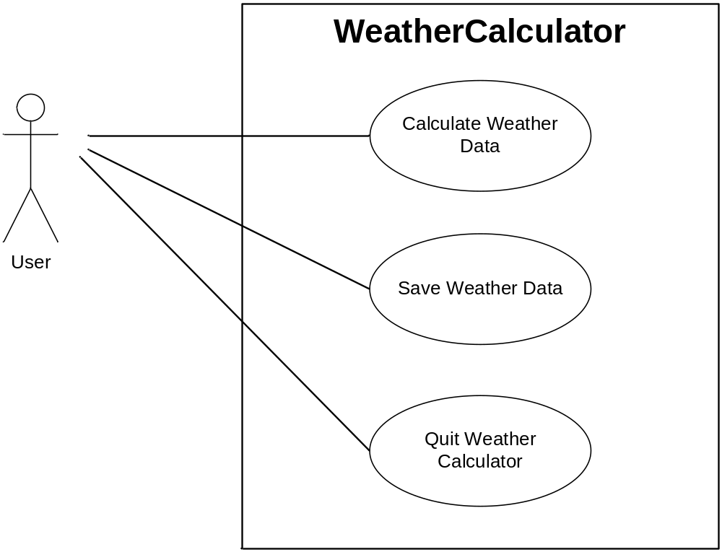

Figure 1: Use Case Diagram for the WeatherCalculator application

