Version | Date | Description | Author
Inception (and Elaboration) Draft | 08/26/02 | First draft. Essentially refined to elaboration phase. Minor changes to be incorporated. | Lou Rosas

Introduction
I envision a WeatherCalculator Application with the capability for the user to calculate, view and record selected weather data, with the flexibility to handle both human and electronic input.

Positioning

Business Opportunity
Current weather calculators exist on a primitive level (In web pages, limited capability to save and/or record data). These same weather calculators cannot work both on or offline, allowing both user and/or machine input. Current weather calculators cannot exist as both a stand-alone application and an applet, serving as an integral part of a web page.

Problem Statement
Current weather calculators are inflexible, incompatible sit application flexibility. This leads to problems in weather analysis, prediction and data collection that is suitable for both a standalone application as well as a web applet.

Product Position Statement
General users intent on calculating and saving selected weather data in both English and Metric units, using English, Metric and Absolute temperature scaling. This application should be accessed via the web as well as a stand-alone application.

Stakeholder Descriptions

Market Demographics
Limited web based weather oriented individuals and businesses interested in phenomenon observance and analysis.

Stakeholder Summary
Businesses that rely on weather could benefit from such an application as presented here.

User Summary
Users interested in weather analysis and observance, data collected from this application could benefit the user in areas such as: weather prediction, weather archiving, lawn maintenance (under what conditions should the plants and grass in a particular landscape receive water) and outdoor recreation. As well as benefiting the informed user as to the weather conditions existing outside. This information benefits the user in making informed weather related decisions.

Key High-level goals and problems of the Stakeholders

High-Level Goal | Priority | Problems and Concerns | Current Solutions
Quick weather data calculation | High | 1. Speed loss on a network.  2. Computer “Freeze”  3. Miscalculation, network loss of initial input data from external weather station. | Make sure network is running at adequate speed, might require a server.  Create effective, robust code.  No true solution to the problem.
Accurate, fast weather data archiving | High | - Cannot save data over a network.  - Cannot save data to media due to error.  - Data saved in wrong format. | - Make sure computer “sees” desired media to save to.  - Make sure media drive is accessible and in good working order.  - Correct save format, know and understand the correct format data will be saved in with respect to the type of data base (Microsoft, Oracle,…).

User-Level Goals
  - User: Calculate Weather Data, Save Weather Data.

User Environment
Windows 2000 with networking capability
Linux (preferably connected to a network)
Both systems should be running Java 2 version of the JDK and JRE.

Product Overview

Product Perspective
There are several places the WeatherCalculator Application could reside. The most sensible/practical will be located on stand-alone computers and/or web servers. This product will provide services to users and collaborate with weather data collection equipment as shown in Figure 1.

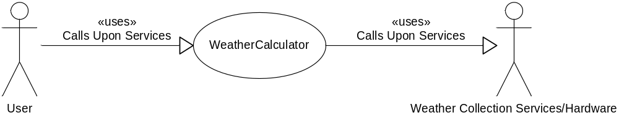

Figure 1: Weather Calculator System Context Diagram

Summary of Benefits
Supporting Features | Stakeholder Benefit
Functionality, the WeatherCalculator will provide all the common services from primitive weather data that needs to be calculated. This includes Dew Point, Heat Index, Wind-chill and so forth. The WeatherCalculator application will have the ability to save data for a select day on a periodic basis or on user demand. | Fast, reliable weather data calculation and archiving services.
Automated data requests from third party systems, using standard networking protocol. | Periodic, timely data available for weather data collection.

Assumptions and Dependencies
A possible system set up with the appropriate weather data collection hardware. Hardware that will indicate: temperature, humidity, wind speed and barometric pressure.
A system that can serve as a stand-alone application and allow user input; such a system would have the flexibility to be independent of external hardware. This would indicate the weather collection hardware would be optional.

Cost and Pricing
Development of the software is free. This software possibly distributed as freeware. Weather data collection hardware to be obtained via: www.ibutton.com for about $50. Weather data collection hardware for wind-speed and wind direction as well as barometric pressure: approximately $50.

Licensing and Installation
N/A (If needed, the GNU free public license).

Summary of System Features
  - Weather Data collection (User Oriented)
  - Weather Data archiving (User Oriented)
  - Weather Data calculation
  - Automated weather data collection, calculation and archiving
  - Automatic recording of system failures when external hardware components (if attached) fail.

Other Requirements and Constraints
Automated data collection depends on reliability of third party equipment, attempt will be made to contact local user if there is a failure in the collection network.

Performance
Goal is to achieve data collection accuracy of 100%, 100% of the time. This data collection is to be done in a timely fashion, suited to the periodic requests of the user or through automated data requests, calculations and archiving.

