Microbes have existed for many eons and with them, comes their innate ability to impact biogeochemical cycles, such as the nitrogen cycle, through the numerous metabolic pathways that exist on terrestrial and marine environments that can affect primary productivity in both a negative and positive fashion (1). Although microbes are unseen through the world given their microscopic size, they contribute to a significant portion of the world’s biomass due to their abundance in a wide variety of environments and their sheer abundance contributes to a significant portion of the global catalysis (2). Given that microbes drive many large-scale processes across the globe, it could be said that form some sort of “engine” that drives the Earth’s biogeochemical cycles and can therefore be affected by, and affect climate change (3). As humans have existed for a relatively short period of time in the history of the Earth (~300,000 years ago) (4) compared to microbes, it could be said that humans heavily rely on microbes, whereby the opposite cannot be said in the same light.

The nitrogen cycle is an essential part of the Earth’s processes, especially affecting that affect the biological landscape through processes put forth by microbes. Nitrogen fixation reduces the abundant N2 gas in the atmosphere into ammonium, a form that can be used by organisms for assimilation into biomass (1). This ammonium can be further oxidized by microbes to nitrite and finally nitrate, which can be used by phytoplankton to drive primary production, producing oxygen and biomass that can support marine food webs (1). Also, heterotrophic bacteria can remineralize This oxygenation of our atmosphere is essential for supporting the lives of us humans and since they partially contribute to, and also support the organisms that contribute 50% of the world’s primary productivity (2). However, as this is a cycle, there are also processes that go in the opposite direction where fixed nitrogen is lost as nitrogen gas (N2) or nitrous oxide (N2O), whether it be through denitrification or annamox performed by microbes (Canfield, 2010). As these processes usually happen in the absence of oxygen, they happen in zones in the ocean called Oxygen Minimum Zones or OMZs (5). This causes the nitrogen to be released into atmosphere again and nitrous oxide can be a greenhouse gas, potentially causing problems with climate change, which increases the CO­2 in the atmosphere and temperature, reducing the solubility of oxygen causing the increase of these OMZs and further exacerbating climate change in the process (6).

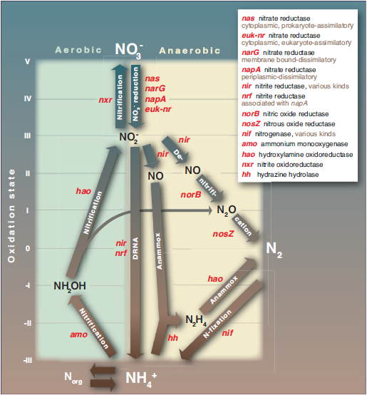

**Figure 1: the reactions and linkages of the nitrogen cycle and the metabolic genes involved (1).**

Microbial cells are microscopic in size and only contain a small amount of carbon in each cell, but they are very abundant around the Earth and the high number of cells contributes to turning these biogeochemical processes into large-scale ones. There are a wide variety of environments such as soil and the oceans that vary in microbial abundance largely due to differing conditions. Marine environments typically have around 1.5 x 1029 prokaryotic cells and typically contribute a little over 50% of the world’s primary productivity at 51 Pg of carbon per year, largely due to subsurface prokaryotes (2). Soil has almost double the number of cells at 2.6 x 1029, and they contribute to the break down of organic matter and recycling of nutrients for other organisms like plants to grow (2). Although the subsurface (both marine and subsurface) is hard to measure, it could be said that there is an order of magnitude greater than both marine and soil prokaryotes combined and these are generally anaerobic bacteria that live in the sediments under the sea or terrestrial surface and reduce inorganic to methane (CH4) or sulfate to hydrogen sulfide (H2S) (2). These pathways have evolved from several billion years ago when methanogenesis was common (7) and have been conserved over the years showing that microbes have been around for many years. With this many prokaryotic cells, it could be said that they contribute to a large portion of the world’s biomass and global biogeochemical catalysis.

Given that microbes have been on Earth at a time not too relatively long after it was formed (about 3.8 billion years ago) (7), this meant that microbes have been on t he Earth significantly longer than humans have. This meant that the metabolic pathways that microbes partake in that we see today have survived over these years have withstood the evolutionary pressures that arise along the way and have been refined through small perturbations, making them “guardians of metabolism” through the vertical and horizontal gene transfer (3). As humans have only been around for around ~300,000 years (4), a relatively very small amount of time on the geologic time scale, we have largely depended on microbes to previously shape the world we have lived him for so many years, including all the biogeochemical cycles and landscape that we take for granted through the control of electron flow (3). Although microbes do play a role in climate change, it largely depends on human activities that release large amounts of CO2 into the atmosphere and the cycling of microbes could mitigate it, but it takes time. This makes us dependent on microbes and microbes could continue living without us and could change the Earth even more over longer time scales.

Overall, microbes have a large impact on the biogeochemical cycles of the Earth due to their sheer abundances in the various environments that make up the Earth. They influence the nutrient availability for other organisms, including humans through their processes, like nitrogen cycling and the pathways that come with that, and photosynthesis with primary production producing oxygen for humans and animals. As we came not too long ago, but several billions and millions of years after microbes started appearing, they could easily live without us given that their metabolic pathways have survived over time, while we cannot live with them since we rely on their processes to shape the Earth like it is now. However, given our rate of technological advances, is there some way we could sharply reduce our reliance on microbes?

**References:**

1. Canfield DE, Glazer AN, Falkowski PG. 2010. The Evolution and Future of Earth’s Nitrogen Cycle. Science. 330(6001):192-196. [10.1126/science.1186120](http://dx.doi.org/10.1126/science.1186120)
2. Whitman WB, Coleman DC, Wiebe WJ. 1998. Prokaryotes: The unseen majority. Proc Natl Acad Sci USA. 95(12):6578-6583.
3. Falkowski PG, Fenchel T, Delong EF. 2008. The Microbial Engines That Drive Earth's Biogeochemical Cycles. Science. 320(5879):1034-1039. [10.1126/science.1153213](https://doi.org/10.1126/science.1153213)
4. Schlebusch CM, Malmstrom H, Gunter T, Sjodin P, Coutinho A, Edlund H, Munters AK, Vicente M, Steyn M, Sooyall H, Lombard M, Jakobsson, M. 2017. Southern African ancient genomes estimate modern human divergence to 350,000 to 260,000 years ago. Science. 358(6363):652. [10.1126/science.aao6266](http://dx.doi.org/10.1126/science.aao6266)
5. Lam P, Kuypers MMM. 2011. Microbial Nitrogen Cycling Processes in Oxygen Minimum Zones. Ann Rev Mar Sci. 3(1):317-345. [10.1146/annurev-marine-120709-142814](http://dx.doi.org/10.1146/annurev-marine-120709-142814)
6. Stramma L, Visbeck M, Brandt P, Tanhua T, Wallace D. 2009. Deoxygenation in the oxygen minimum zone of the eastern tropical North Atlantic. Geophys Res Lett. 36(20):L20607. [10.1029/2009GL039593](http://dx.doi.org/10.1029/2009GL039593)
7. Nisbet EG, Sleep NH. 2001. The habitat and nature of early life. Nature. 409(6823):1083-1091. [10.1038/35059210](http://dx.doi.org/10.1038/35059210)