Module 3 Microbial Species Concepts

Evidence worksheet_05 “Extensive mosaic structure”

Part 1: **Learning objectives:**

* Evaluate the concept of microbial species based on environmental surveys and cultivation studies.
* Explain the relationship between microdiversity, genomic diversity and metabolic potential
* Comment on the forces mediating divergence and cohesion in natural microbial communities

**General Questions:**

• *What were the main questions being asked?*

What are the differences between these three strains, beyond their 16S rRNA sequence?

• *What were the primary methodological approaches used?*

* Sanger sequencing was used to sequence the genomes (dye terminator chemistry) with 7X coverage
* Genome annotation using a web-based annotator called MAGPIE
  + Uses GLIMMER to look for and define ORFs
* Use BLAST to check predicted proteins for redundance

• *Summarize the main results or findings.*

* Backbone was acquired through vertical gene transfer
* Pathogenicity islands were acquired through horizontal gene transfer causes large variations between different strains
  + Absence of Type III secretion system in CFT073
  + Absence of phage/plasmid-encoded virulence genes common to strain O157:H7
* All three strains encode a pili similar to Salmonella Enterica, but vary in their genetic makeup that encode these fimbriae or pili
* CFT073 differs from MG1655 and EDL933 in its protein amino acid sequence by 53 to 81%

• *Do new questions arise from the results?*

* Does this large variance in pathogenicity islands apply to other bacteria that have pathogenic and non-pathogenic strains?
* Is using the 16S rRNA sequence sufficient for determining difference species given that only 39% of their proteins are similar?

• *Were there any specific challenges or advantages in understanding the paper (e.g. did the authors provide sufficient background information to understand experimental logic, were methods explained adequately, were any specific assumptions made, were conclusions justified based on the evidence, were the figures or tables useful and easy to understand)?*

* The background information is brief and does not give enough background for the reader to understand what is being looked at
* The methods section is very brief (2 paragraphs) and does not fully explain the techniques that they used
* Better explanation of the secretion systems would help in understanding how it is linked fimbriae/pili formation

Part 2: **Learning objectives:**

* Comment on the creative tension between gene loss, duplication and acquisition as it relates to microbial genome evolution
* Identify common molecular signatures used to infer genomic identity and cohesion
* Differentiate between mobile elements and different modes of gene transfer

Based on your reading and discussion notes, explain the meaning and content of the following figure derived from the comparative genomic analysis of three *E. coli* genomes by Welch et al. Remember that CFT073 is a uropathogenic strain and that EDL933 is an enterohemorrhagic strain. Explain how this study relates to your understanding of ecotype diversity. Provide a definition of ecotype in the context of the human body. Explain why certain subsets of genes in CFT073 provide adaptive traits under your ecological model and speculate on their mode of vertical descent or gene transfer.

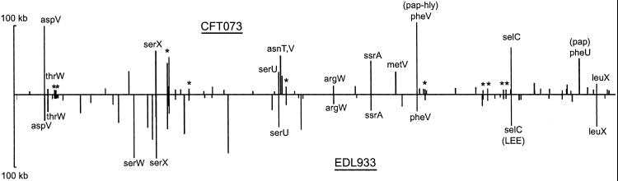

The X-axis denotes the position of islands along the genome, and the Y-axis denotes island size. In the context of the human body, ecotype is defined by the different strains of E. coli that have various adaptations to survive a different part of the human body, like having pili in uropathogenic bacteria. The additional islands shown determines additional sequences an organism has that allows it to survive