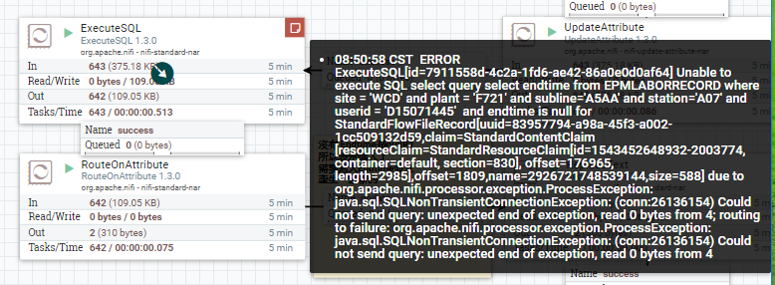

報錯信息， routing to failure:org.apache.nifi.processor.exception.ProcessorException:java.sql.SQLNonTrasactionConnectionException: Could not send query:unexpected end of exception,read 0 bytes from 4;

網絡上的解答：

We encountered the same problem recently, due to a combination of incorrect parameters. This error is caused by your web instance trying to use a connection that is no longer a valid one.

This can be resolved by making sure the following parameters are correct:

1. You have a validationQuery configured for your database connection. i.e. validationQuery="SELECT 1" in case of mariadb, in the server configuration.
2. You have the wait_timeout set to a reasonable value. 8 hours keepAlive seems a bit optimistic, we are now using wait_timeout=180
3. Make sure the validationInterval, which you can also set in the server configuration (server.xml in case of a tomcat setup), is set to a value that is lower than the wait_timeout value. I reduced the wait_timeout to 15s in one case, with the validationInterval value being higher than that, which caused the error to still appear at times. Now it is set to validationInterval=60, combined with the wait_timeout=180 which should catch any broken connections in time.

解決方式：

1.增大waittime；2.提高connection數量

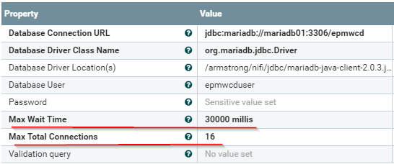

Cannot get a connection,pool error Timeout waiting for object

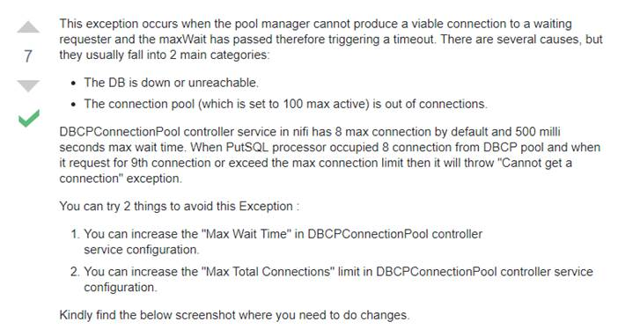

解決方式：

1.增大waittime；2.提高connection數量



錯誤

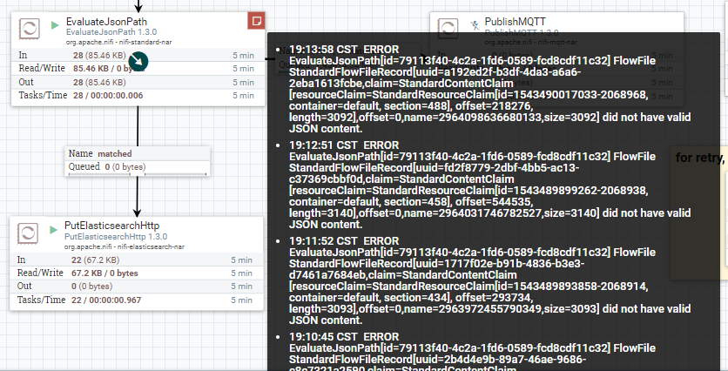

傳輸數據的JSON格式報錯

檢查傳輸數據的格式是否正確

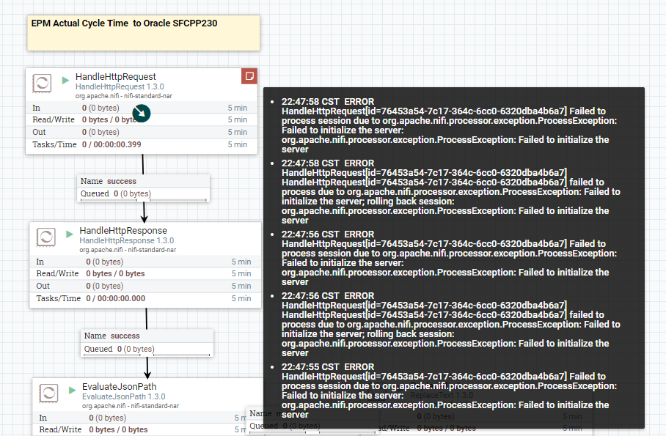

端口占用

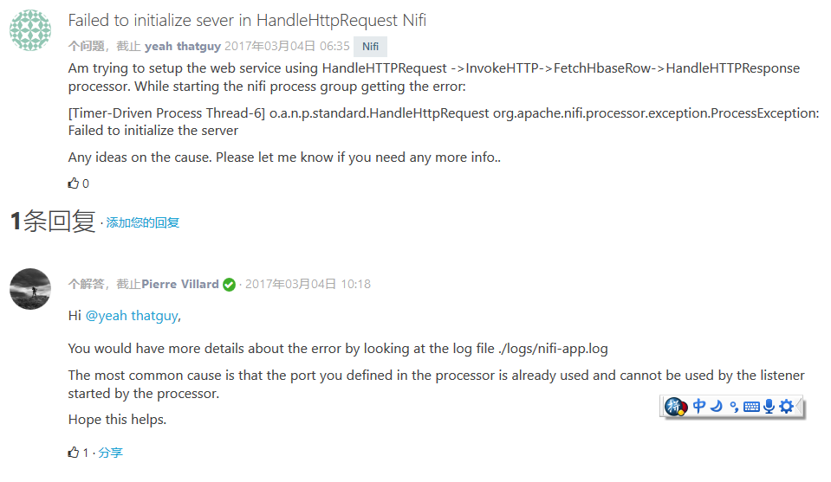

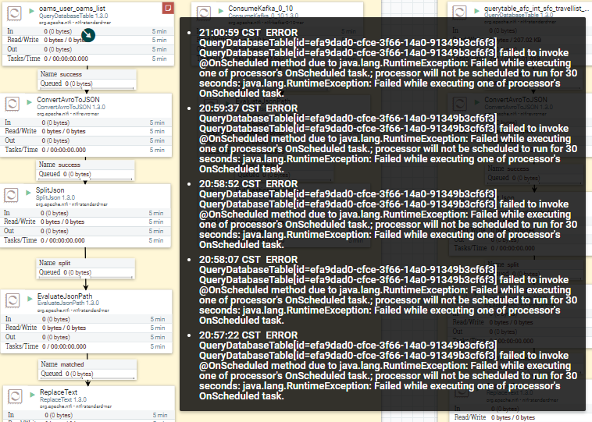

檢查連接數據庫的配置是否正確，賬號和密碼是否正確。

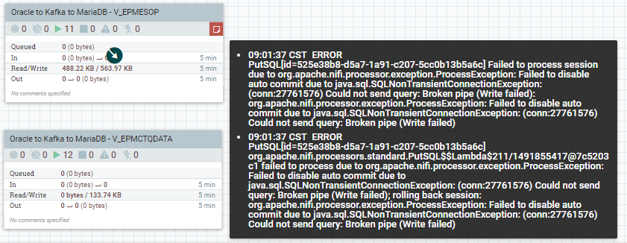

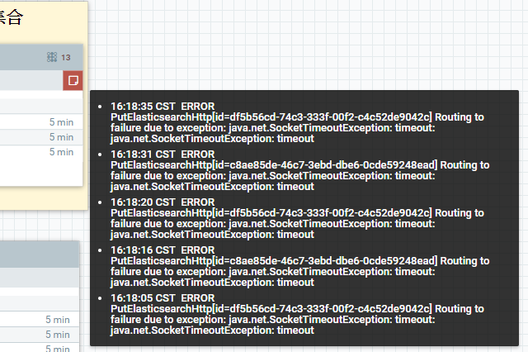

timeout，這個是ES故障，數據無法寫入。。

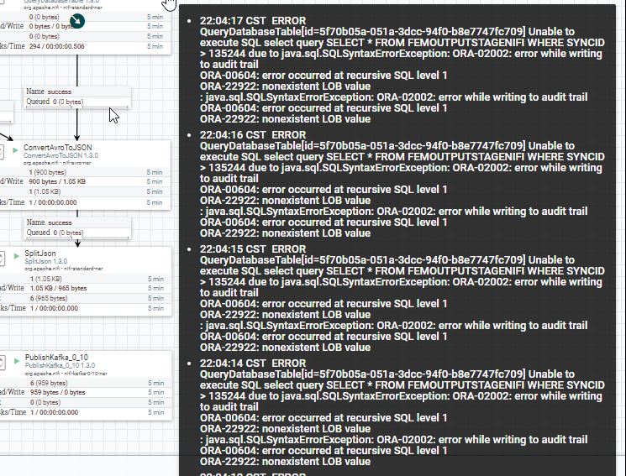

檢查oracle的相關設置，NONEXISTENT LOB value

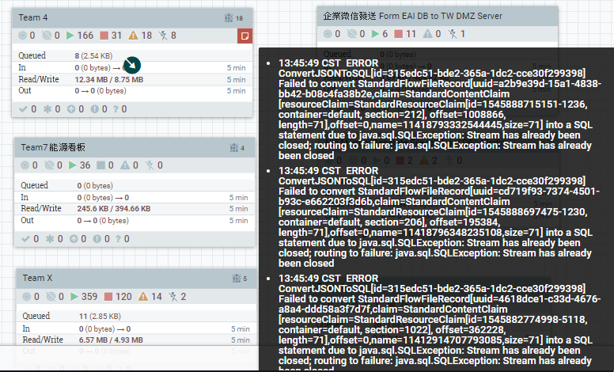

這個是由於之前的SQL寫入報錯，再一次打開該Processor，對面DB數據流已經被關閉。

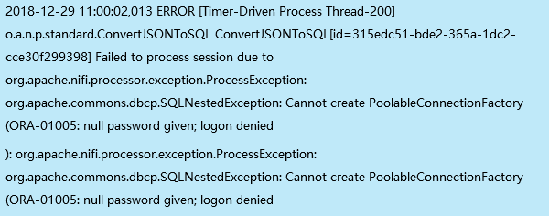

報錯為密碼為null值，把密碼再寫入一次。

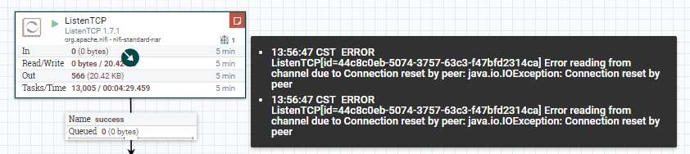

TCP連接異常斷開，上拋程式拋了null值或者並發數據量大，上拋函數加個鎖。

nifi executeSQL could not send query unexpect end of exception read 0 bytes from 4

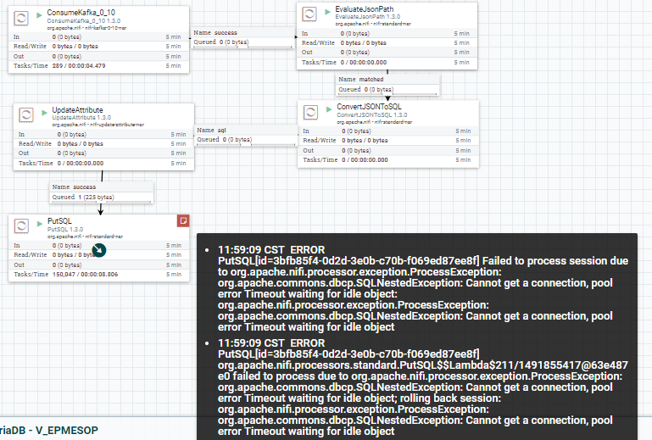

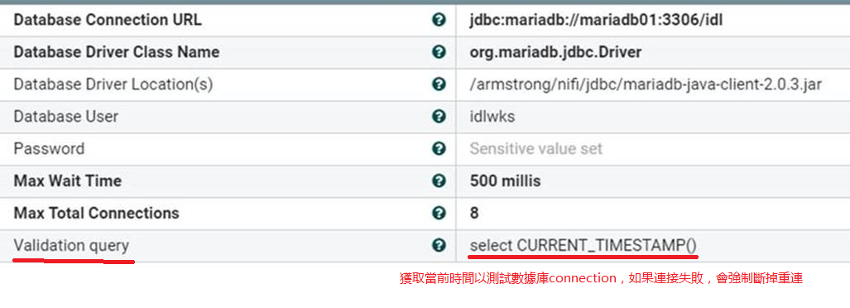

獲取當前時間測試數據庫的connection，如果連接失敗，會斷掉重連。

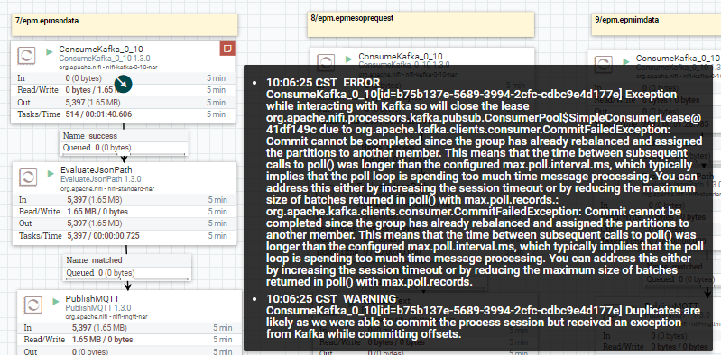

由於Kafka正在rebalance，重新指定分區，導致poll時間比設定的時間要長。

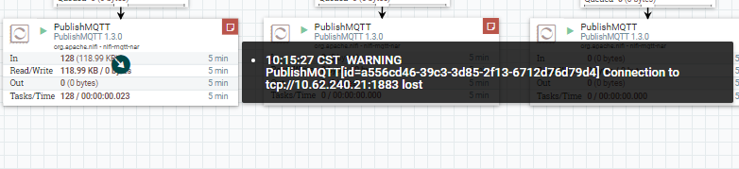

MQTT斷開連接，原因待排查。