Message for Nijmegen:
JIO MSX-DOS 2
Shared 2GB hard disk image between real MSX and openMSX
Hard disk image hosted on PC, served to MSX through joystick port 2 (115600 kbps).

Continue your game from openMSX to real MSX…
… and the opposite.

115600 kbps awesome communication routines by NYYRIKKI.
MSX-DOS 2 version by Louthrax and b3rendsh.

To do:
- Test NIIRYKKY latest routine.
- ...

How to build yourself an adapter cable:
- I'm currently using this adapter. It works well, but outputs 3.3V. I have the feeling it could work better on MSX 1 if outputing 5V. I ordered today this other model that can be configured to 3.3V or 5V, but which does not seem to have a crystal (I have not received yet). I'll see if I can find a 5V model with a crystal....
- DO NOT use non-TTL RS232 adapters. These might output +12/-12V that could kill you MSX !
- The wiring is the following:
  - MSX Joystick port 2 Pin 1 goes to adapter TX
  - MSX Joystick port 2 Pin 6 goes to adapter RX
  - MSX Joystick port 2 Pin 9 goes to adapter GND
  - MSX Joystick port 2 Pin 5 goes to adapter VCC
Joystick view:
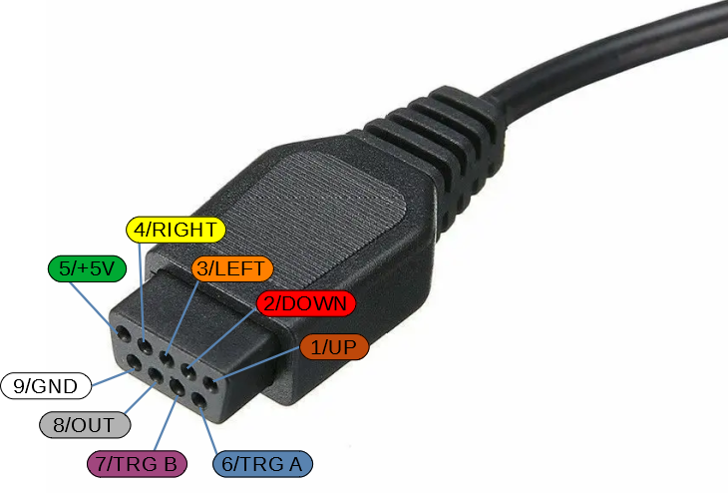
Port view:
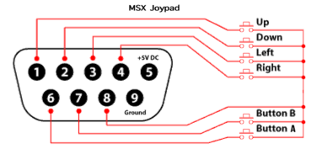
- I recommend using a short cable (10cm) between the adapter and the MSX for now, but you can have a long USB extension cable that goes to the PC (I'm using a 3m one here).

Current issues:
- Booting on a FAT16 partition does not work. I'm currently using 4 partitions (1st: 32MB FAT12, others: 2GB FAT16).
- turboR requires FAT16.COM to access FAT16 partitions.

- Casio PV-7 and National CF3000 are showing these kind of corruptions on reception:
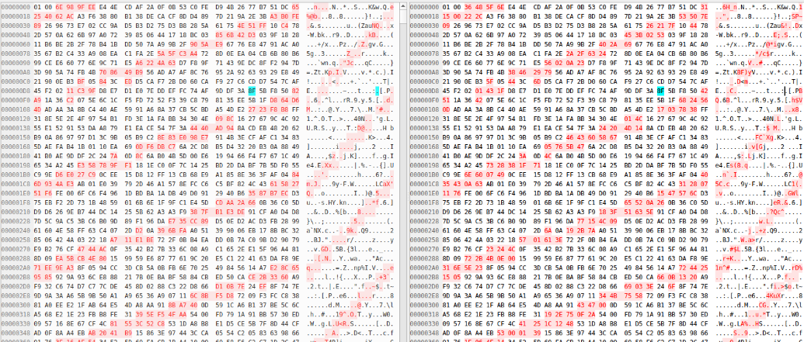
It works a bit better if I add a pull down resistor between MSX RX and GND, but there are still errors.

Parameters that could be obtained from the sever at boot time:
- Drive sounds ON / OFF
- CRC checks enabled or not
- Drive to boot
- Drives to disable
- Cartridge slots to disable
- …

Server GUI features:
- Handle different connections to several MSX at the same time (images could also be shared between MSX machines).
- Associating a MSX name to each TTY device (myVG8235, myTurboR, etc...), and select the image served for each.
- A "defrag-like" map of the disk could be shown with the sectors read (green) and written (red).
- Logs of the sectors access could be displayed for debugging purposes.
- Lock and Unlock functionality for each image.

Command line tools:
- USYNC.COM: Synchronizes local and remote repositories.
- UTIME.COM: Set the MSX RTC according to the server one.

Videos ideas:
- Create a Maze of Galious save state on openMSX with Game Master. Continue playing the game on real MSX !

Ubuntu instructions for server:
sudo apt install python3-serial
sudo usermod -aG dialout <username> # Reboot is required for change to take effect

Ubuntu instructions for z88dk:
sudo snap connect z88dk:removable-media

Technical notes:
- Here are some speed tests I did on my MSX machines
VG 8235 3554367 Hz
VG8020 3579200 Hz
HB-G900AP 3578959 Hz
HB-F700F 3579599 Hz
Toshiba HX-10 3579367 Hz
National CF-3000 3579405 Hz
Palcom PX-V60 3579431 Hz
Casio PV-7 3579431 Hz
turboR - Z80 3579617 Hz
- Uncompressing Aleste 2 disks (3x720KB) timings:
  - 3m30s on MFRSCC+SD
  - 8m40 on JIO
  - 9m9 on JIO BT

Setting the HC-05 to 115200 bauds:
- Default adapter password for BlueTooth connection is “1234”.
- Plug the HC-05 adapter in the "BlueTooth" plug
- Plug the FTDI FT232RL adapter in the "USB Cable" plug
- Keep the "AT" button of the HC-05 adapter pressed...
- ... and put the USB plug of the cable in a USB port
- HC-05 led should be blinking "slowly" (2s)
- Launch the "DSD TECH Wireless Tools" utility.
- Set UART to "COM9" (or whatever COMx), set Baud Rate to 38400 and click on "Open"
- You should now be able to set and query parameters for the HC-05
- You can set the good configuration for this project by sending this command (using the first tab):
AT+UART=115200,1,0

