Title: Wordgame
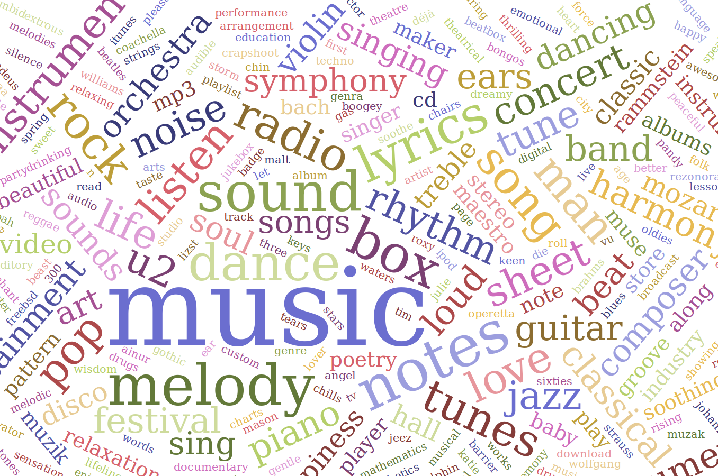
Description: 0.3M word-word associations scraped from 10 online messageboards.

Header:

This dataset was created to as part of an ongoing research on what information about the human mind could be possibly hidden in word-word associations. I will also create notebooks for feature extraction and machine learning. The WordGame project be found on my Github page.

### Inspiration

Here are a few questions you might try to answer with this dataset:
- How well can we classify word pairs as originating from a specific online community?
- What are the properties of the graph/network of word associations?
- What are frequently used words? Are there differences among communities?

### Data

The dataset contains 4 columns:

1) author – integer ID
2) word1
3) word2
3) source

For example: 6014,blue dress,gown,wrongplanet

When the data was scraped, in june 2017, most topics were still active, thus future rescraping will result in a bigger dataset.

