User Manual
UDP Server
Lourens Schep
Daniel Deveau

- Requirements

- Instructions

- Behind the Scene

Requirements

- A Machine with Java 6

Instructions

1) open up a terminal and navigate to the folder including the server/client files

2)Compile all the java code using javac *.java

3) Run the MainServer using “java MainServer”
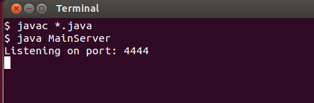

4) Then run the Client in a different terminal leaving the server running
by typing “java Client”
5) The Client will then ask for a Ip address which is the IP address that the Server is on which
you can find out by typing “ifconfig” in a terminal on the same machine as the server and look
for the Inet Address
If you have the Server Ip Address you can type that in when the client asks like this.
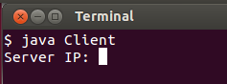

For Example with the Ip Address 192.168.10.10 and after you pressed enter you would get this.
Client: Server:
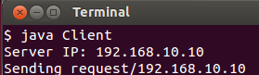
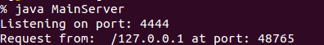

If it is the correct Ip Address you will get this (using localhost in this example).
You can jump to step 6.
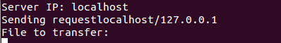

And if not you will get this (using 192.168.10.10 in this example), it will ask for the server Ip again incase it was wrong.
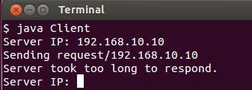

6)
The Client will ask the User (You) for a file, you would like from the Server which you can type in and hit enter, like so (filename being “nature.jpg” ).
Client: Server:
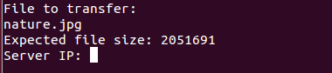
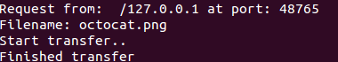

If there is no errors with the file it will show a little percentage thing for how far it is with its transfer
and display “Expected file size:” with the file size of the file requested.
Some of the errors that could show up.
Error: file doesn't exist.
- The file requested does not exist in the server directory.
Error: not a file
- The file requested is not a file.
Error: can't read from file.
- The file requested is can't be read.
Error: can't write to disk.
- The file requested is already on the client machine folder and will not overwrite it.
When either the file transfer is done or a error occurred it will go back to step 5 by asking for the
Ip Address of the Server.
Incase you would like to quit the client you can type “quit” anytime.

