Pregnency Diabetes data set

Pre-processing:

A number of files containing bacteria information for several patients which their bacteria was sequenced together, therefore each file held information specified according to a different sequencing run.

Each file had information about a particular group of bacteria that did not always overlap fully between the files, so when we performed a union to create a single final file holding all samples from all patients, for each sample the missing values for bacterial we did not have information of, the value 0 was assigned.

We wanted to check for homogeneity in the files, because it can be problematic In case there is a dependence between the examples in each file.

Therefore, we calculated the correlation of the samples against each other and found that there are no areas where there is a pattern that indicates dependence.
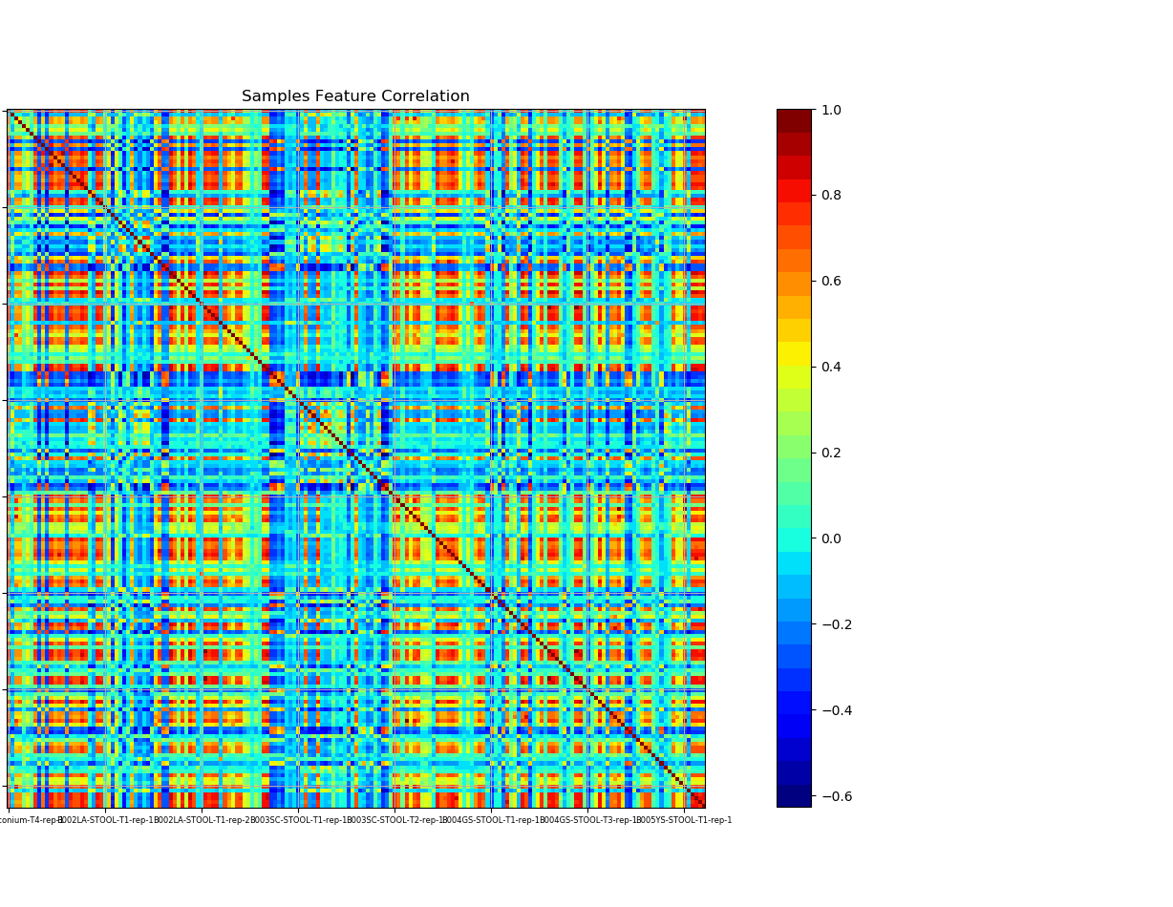

After finishing organizing the data files, we want through 3 stages-
In the first stage, we restricted the information for each type of microbiome given in the data set by only the first six levels to minimize the number of features.

In the second stage, we performed normalization using Z score, and log base 10 to obtain normalized values with an average of 0 and standard deviation 1.
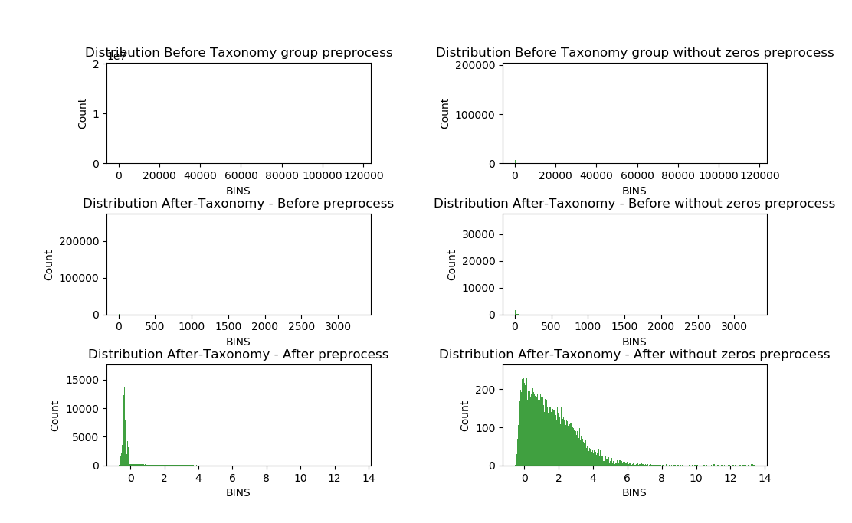
In the third stage, we performed PCA to lower the features dimensions to twenty.
We chose a value of 20 according to the accumulation of the eigenvalues variance.
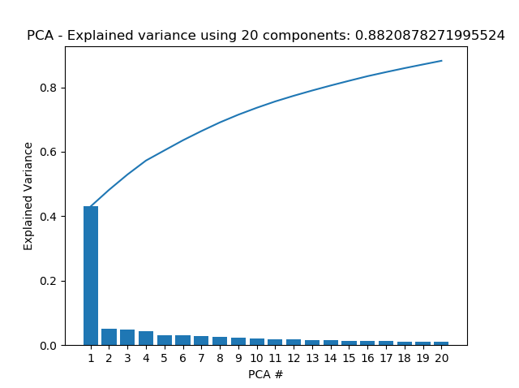
Towards component number 20, we have seen that the cumulative variance does not increase much as we proceed - so we stopped.

Correlation between bacteria between saliva and stool samples taken at the same conditions
Is there a correlation? Which bacteria have a strong link between them?

We extracted ‘saliva-stool’ samples pairs from each patient who had a saliva and stool samples taken in the same time.
We performed a calculation of RHO values according to Spearman correlation on the original data (before normalization).
Since there is about 12,000 types of bacteria for taxonomy level 6, we lowered it to taxonomy level 5 were we got only 181 types of bacteria.

We found that there are no areas where there is a pattern that indicates deep dependence, but a striped pattern was detected.
When one bacteria from saliva sample has a high correlation to a second bacteria from stool sample- it is expected to see a single red/blue hue.

The results are presented using a heat map.
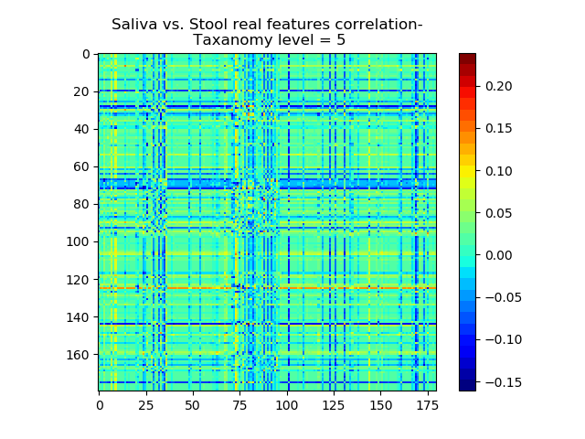
When we got a striped pattern, we understood that there is something suspicious in the data distribution, it makes no sense that a single bacteria affects all the other bacteria in such way.

After looking at the values of the samples created the most high correlated strips:
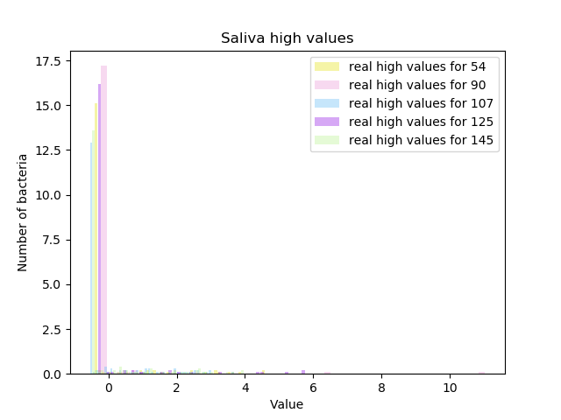
We hypothesize that this is due to samples who has for many bacteria values of 0. The examples that were sequenced together in the same run and originate in the same previous file, has many common 0 values that result from the ‘zero-padding’ we performed to create the final file. Those common zeros create a dependency.

Indeed, the control proved us right. When we performed the calculation of RHO values according to Spearman correlation on the mixed data, when the values were scrambled for each of the bacterium, a completely random map was obtained, without a striped pattern.

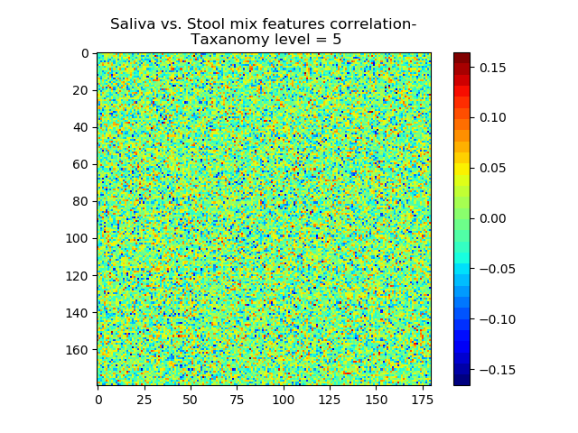

Linked bacteria between saliva and stool –
ADD IN THE FUTURE

Distinction between diabetic and healthy patients (the control group)
Is patient healthy or diabetic?

Something wrong.
For the mixed labels we would expect to see a more dense distribution around zero.
I still don’t understand what is causing the problem.

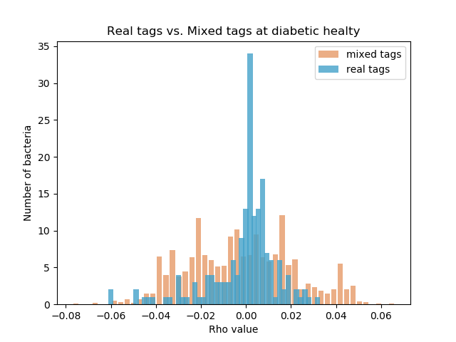

Significant bacteria –
ADD RESULTS AFTER FIGURING OUT WHATS WRONG !!

Dynamics in bacterial throughout trimesteres
Which bactrial changes together?

We calculated the differences between bacterial values between samples taken from the same women, from the same body part in following trimesters, 1-2, and 2-3.
After creating the differences we calculated self-correlation, finding bacteria that change together.
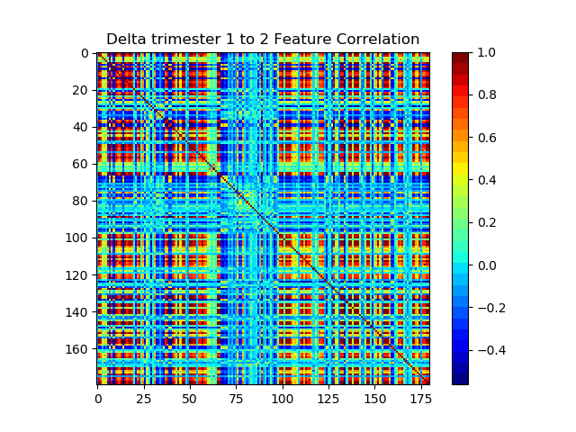
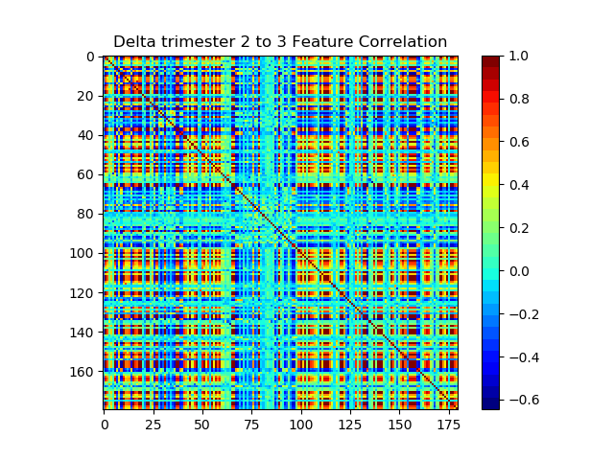

Significant bacteria –
ADD RESULTS

