The paper aims at understanding the specialties of coconut shell biomass, which is directly used for [thermochemical conversion](https://www.sciencedirect.com/topics/engineering/thermochemical-conversion) mainly for charcoal production via; chemical structure, energy potential, and morphological analysis. The biomass exhibits a high: density of 412 kg/m3, a calorific value of 19.4 MJ/kg, fixed carbon of 21.8%, a volatile matter of 70.8%, carbon of 40.1%, and low amount moisture of 5.6%, and ash of 1.8%. EDX and XRF analysis revealed a low amount of complex heavy metals, trace amounts of sulfur, and nitrogen, thus pre-treatment is not required before its utilization, ideal for thermochemical conversion. The coconut shell possesses amorphous and crystalline carbonaceous materials based on the XRD spectrum.

Based on the UN Environment Programme (UNEP) annual emissions gap report, in the past decade, the CO2 emissions from [deforestation](https://www.sciencedirect.com/topics/agricultural-and-biological-sciences/deforestation) rose to more than 55 gigatonnes equivalent to 1.5% per year on average [[2]](https://www.sciencedirect.com/science/article/pii/S2090447921002355" \l "b0010). To avoid disastrous consequences, scientists say it is necessary from now until 2030 that global emissions should be reduced by 7.6% per year. This makes the world’s environmental and energy security issues to explore for a cleaner energy source [[2]](https://www.sciencedirect.com/science/article/pii/S2090447921002355#b0010), [[3]](https://www.sciencedirect.com/science/article/pii/S2090447921002355" \l "b0015).

[Mappoji - The Process of Making Coconut Shell Charcoal: From Shells to Valuable Fuel](https://mappoji.com/news/the-process-of-making-coconut-shell-charcoal-from-shells-to-valuable-fuel)

[Production and characterization of coconut shell charcoal-based bio-briquettes as an alternative energy source for rural communities - ScienceDirect](https://www.sciencedirect.com/science/article/pii/S2405844024117483)

The increasing demand for sustainable energy solutions has driven interest in the utilization of agricultural residues, such as coconut shells, for bio-briquette production. This study investigates the impact of binder types (cassava and corn) and concentrations (5 wt%, 10 wt%, 15 wt%) on the properties of bio-briquettes made from dried coconut shells with two particle sizes (40 mesh and 60 mesh). The experimental evaluation focuses on several performance indicators, including density, shatter index, percentage moisture content (PMC), percentage volatile matter (PVM), percentage ash content (PAC), percentage fixed carbon (PFC), higher heating value (HHV), ignition time, burning time, and boiling time. The results indicate that briquettes with 10 % fine charcoal cassava binder achieved the highest density of 0.764 g/cm³ due to improved compaction. Briquettes with 15 % coarse charcoal corn binder demonstrated the highest shatter resistance at 96.99 %, reflecting their superior structural integrity. The highest PMC and PVM values were observed in briquettes with 15 % coarse charcoal cassava binder, at 8.13 % and 31.25 %, respectively. Conversely, the highest PAC was 16.34 % for 5 % coarse charcoal cassava binder. Briquettes with 10 % fine charcoal corn binder exhibited the highest PFC of 70.79 % and HHV of 31.51 MJ/kg. Boiling times ranged from 15 min 53 s to 36 min 35 s, with the shortest boiling time for briquettes with 10 % fine charcoal corn binder. The findings highlight the superior mechanical properties and energy performance of bio-briquettes with specific binder concentrations and particle sizes. This study demonstrates the potential of coconut shell bio-briquettes as a viable and sustainable energy source, offering economic and environmental benefits through the effective utilization of agricultural waste and reduction of carbon emissions.

Access to reliable and sustainable energy sources is crucial for societal development, yet remains a significant challenge in many rural areas, including Ghana. Recent reports indicate that the electricity supply in Ghana falls short of the targeted demand, particularly affecting rural communities [[1](https://www.sciencedirect.com/science/article/pii/S2405844024117483" \l "bib1)]. This energy gap compels approximately 73 % of Ghanaians to rely on traditional energy sources such as firewood and charcoal for cooking and heating [[29](https://www.sciencedirect.com/science/article/pii/S2405844024117483" \l "bib29)], contributing to environmental degradation, deforestation, and greenhouse gas emissions [[2](https://www.sciencedirect.com/science/article/pii/S2405844024117483" \l "bib2)]. Globally, about 41 % of households, equating to more than 2.8 billion individuals, depend on solid fuels like coal and biomass for their energy needs [[5](https://www.sciencedirect.com/science/article/pii/S2405844024117483" \l "bib5),[30](https://www.sciencedirect.com/science/article/pii/S2405844024117483" \l "bib30)].

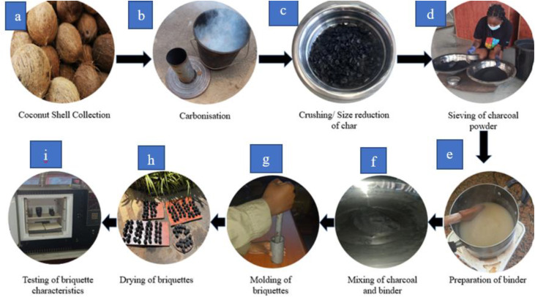

[Preparation of charcoal briquette from palm kernel shells: case study in Ghana: Heliyon](https://www.cell.com/heliyon/fulltext/S2405-8440(20)32109-5?_returnURL=https%3A%2F%2Flinkinghub.elsevier.com%2Fretrieve%2Fpii%2FS2405844020321095%3Fshowall%3Dtrue)

[Influence of Coconut Shell Properties on Charcoal Production](https://biochar.dudaone.com/influence-of-coconut-shell-properties-on-charcoal-production)