**计算智能 作业4**

2021年11月09日

**要求：**

1. 在文档中说明解题思路、方法实现、求解结果等，必要时需要对结果进行分析和讨论。
2. 将源代码作为附录粘贴于作业文档末尾，并同时作为提交的附件与作业文档一起放在压缩包内备查。
3. 独立完成，严禁抄袭。

**内容：**

1. 编写程序实现论文“一种多尺度协同变异的粒子群优化算法”（哈尔滨工程大学陶新民等,《软件学报》，2012年07期）的部分测试实验。

说明：

1. 至少编程实现传统PSO算法和论文所提出的MAEPSO算法。
2. 至少测试论文中的三个Benchmark函数。

3) 编程语言不限（推荐C/C++，需提交源代码和运行结果截图）。

解析：

传统PSO算法：

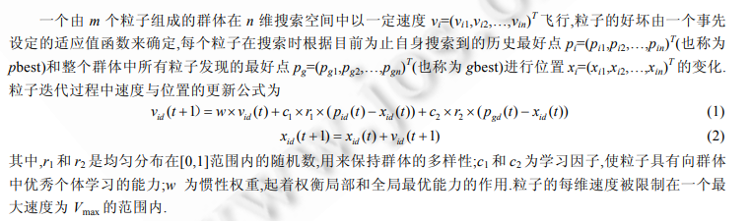

根据PPT的算法：

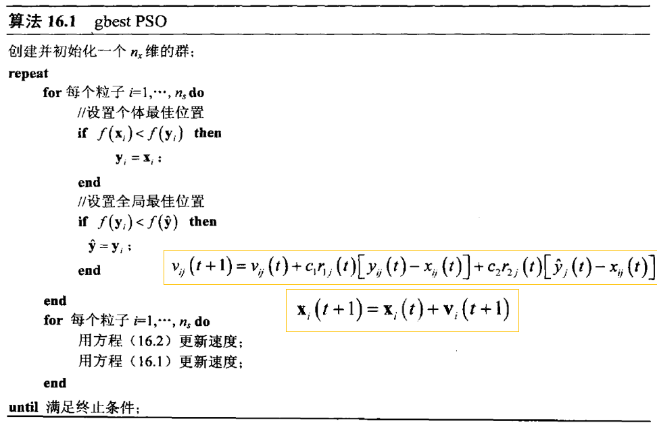

更新速度算法：

# 按照公式更新速度  
def update_speed(self, part):  
 for i in range(self.dim):  
 speed_value = self.W * part.get_speed()[i] + self.C1 * random.random() * (part.get_pbest()[i] - part.get_pos()[i]) \  
 + self.C2 * random.random() * (self.get_gbest()[i] - part.get_pos()[i])  
 if speed_value > self.maxSpeed:  
 speed_value = self.maxSpeed  
 elif speed_value < -self.maxSpeed:  
 speed_value = -self.maxSpeed  
 part.set_speed(i, speed_value)

在这里我们使用gbest PSO算法，每次更新的同时，根据fitness同时更新gbest和gbest

def update_pos(self, part):  
 for i in range(self.dim):  
 pos_value = part.get_pos()[i] + part.get_speed()[i]  
 part.set_pos(i, pos_value)  
 value = fitnessFunction(part.get_pos())  
 if value < part.get_fitness_value():  
 part.set_fitness_value(value)  
 for i in range(self.dim):  
 part.set_pbest(i, part.get_pos()[i])  
 if value < self.get_bestFitnessValue():  
 self.set_bestFitnessValue(value)  
 for i in range(self.dim):  
 self.set_gbest(i, part.get_pos()[i])

MAEPSO算法：

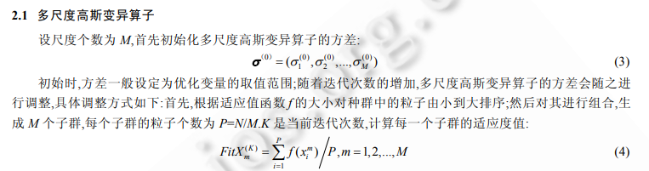

这里的关键之一是多尺度，即多个子群体。

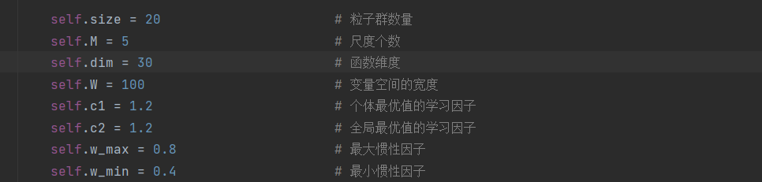

这里是适应度的计算

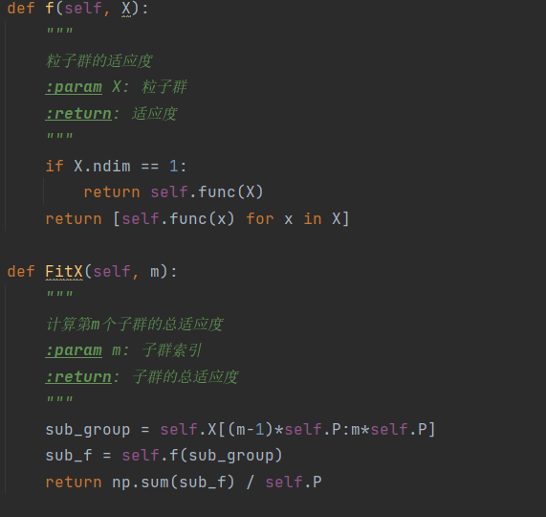

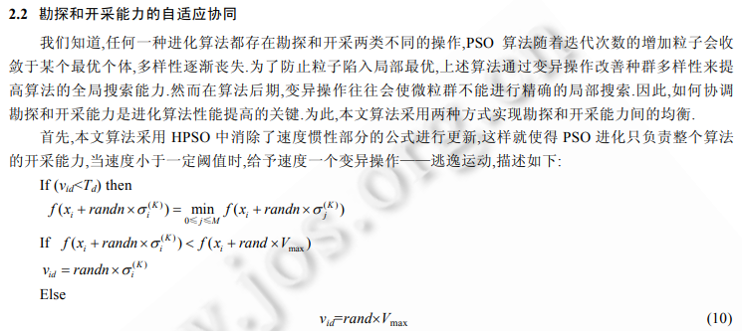

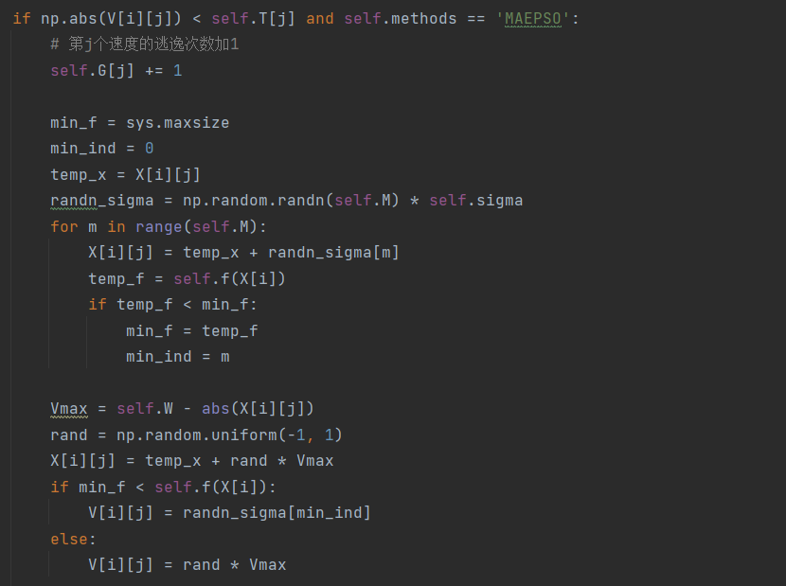

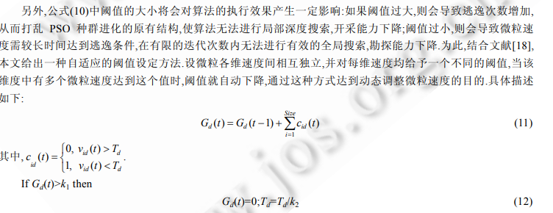

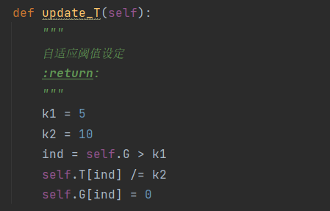

通过这些关键函数，将这两个算法实现之后，我们做以下对比：

在这里我们设定迭代范围为500、个体维度为30维、个体数目为20，

为了强调对比结果，我们只看400-500迭代时候的最优解

Tablet：

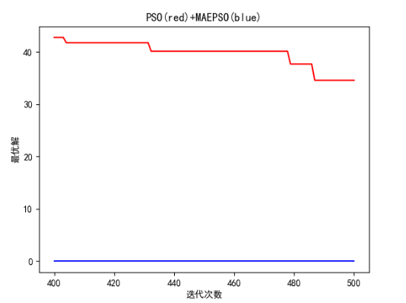

Quadratic：

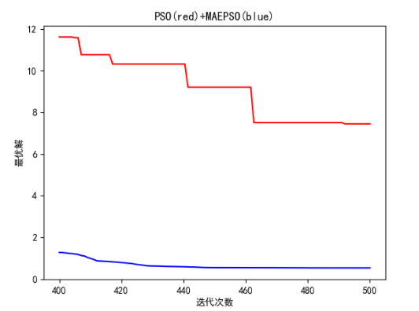

Rosenbrock：

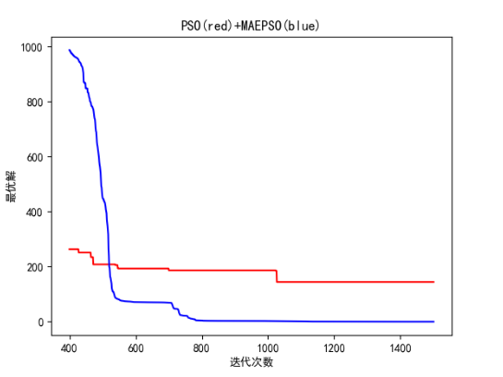

Griewank：

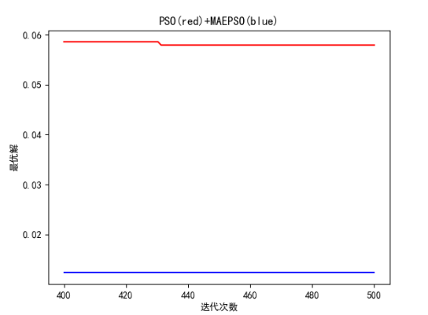

Rastrigin：

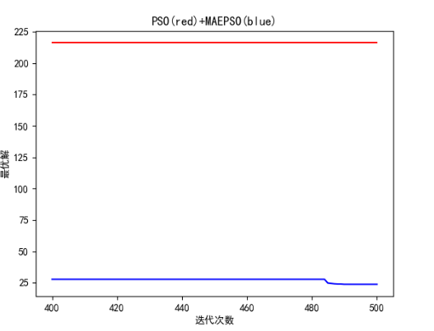

Schaffer：

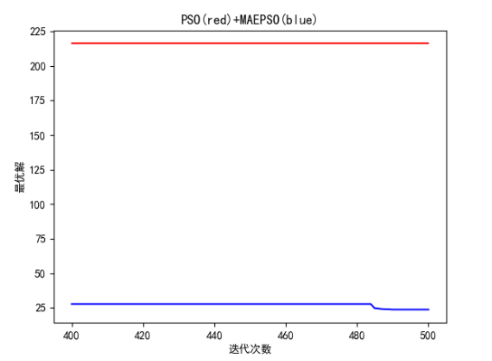

## 代码

import math  
  
  
def Tablet(X):  
 sum = 0  
 for i in range(1, len(X)):  
 sum = sum + X[i] ** 2  
 return sum + (X[0] ** 2) * 100000  
  
  
def Quadratic(X):  
 sum = 0  
 for i in range(0, len(X)):  
 tmp = 0  
 for j in range(0, i + 1):  
 tmp += X[j]  
 sum += tmp ** 2  
 return sum  
  
  
def Rosenbrock(X):  
 sum = 0  
 for i in range(0, len(X) - 1):  
 sum += 100 * (X[i + 1] - X[i] * X[i]) ** 2 + (X[i] - 1) ** 2  
 return sum  
  
  
def Griewank(X):  
 sum1 = 0  
 sum2 = 1  
 for i in range(0, len(X)):  
 sum1 += X[i] * X[i] / 4000  
 sum2 *= math.cos(X[i] / math.sqrt(i + 1))  
 return sum1 - sum2 + 1  
  
  
def Rastrigin(X):  
 sum = 0  
 for i in range(0, len(X)):  
 sum += (X[i] ** 2 - 10 * math.cos(2 * math.pi * X[i]) + 10)  
 return sum  
  
  
def Schaffer(X):  
 sum = 0  
 for i in range(0, len(X) - 1):  
 si = pow(X[i] ** 2 + X[i + 1] ** 2, 1 / 4)  
 sum += si * (math.sin(50 * pow(si, 1 / 10)) + 1.0)  
 return sum

import sys  
import numpy as np  
import matplotlib.pyplot as plt  
from benchmark_function import *  
  
class MAEPSO(object):  
 *"""  
 MAEPSO算法  
 陶新民, 刘福荣, 刘玉,等. 一种多尺度协同变异的粒子群优化算法[J]. 软件学报, 2012, 23(7):1805-1815.  
 """* def __init__(self, func=lambda x:np.sum(np.square(x), axis=1), methods='MAEPSO'):  
 *"""  
 算法参数设置* ***:param*** *func: 适应度函数  
 """* self.size = 20 # 粒子群数量  
 self.M = 5 # 尺度个数  
 self.dim = 30 # 函数维度  
 self.W = 100 # 变量空间的宽度  
 self.c1 = 1.2 # 个体最优值的学习因子  
 self.c2 = 1.2 # 全局最优值的学习因子  
 self.w_max = 0.8 # 最大惯性因子  
 self.w_min = 0.4 # 最小惯性因子  
 self.w = self.w_max # 惯性因子  
 self.P = (int)(self.size / self.M) # 每个子群的粒子个数  
 self.func = func # 适应度函数  
 self.methods = methods # 粒子群算法  
 self.bestFitnessList = []  
 self._init_PSO()  
  
 def _init_PSO(self):  
 *"""  
 位置、速度等变量初始化* ***:return****:  
 """* self.X = np.random.uniform(-self.W, self.W, (self.size, self.dim)) # 初始化粒子位置  
 self.pb = np.copy(self.X) # 个体最优位置  
 self.gb = self.X[np.argmin(self.f(self.X))] # 全局最优位置  
 self.V = np.random.uniform(-1, 1, (self.size, self.dim)) # 初始化粒子速度  
 self.T = np.ones(self.dim) * 0.5 # 速度的阈值  
 self.G = np.zeros(self.dim) # 速度的逃逸次数  
 self.sigma = np.ones(self.M) * 2 * self.W # M个尺度的高斯变异算子方差  
  
 def f(self, X):  
 *"""  
 粒子群的适应度* ***:param*** *X: 粒子群* ***:return****: 适应度  
 """* if X.ndim == 1:  
 return self.func(X)  
 return [self.func(x) for x in X]  
  
 def FitX(self, m):  
 *"""  
 计算第m个子群的总适应度* ***:param*** *m: 子群索引* ***:return****: 子群的总适应度  
 """* sub_group = self.X[(m-1)*self.P:m*self.P]  
 sub_f = self.f(sub_group)  
 return np.sum(sub_f) / self.P  
  
 def update_sigma(self):  
 *"""  
 更新所有高斯变异算子的方差* ***:return****:  
 """* FitXs = [self.FitX(m+1) for m in range(self.M)]  
 max_FitX = np.max(FitXs)  
 min_Fitx = np.min(FitXs)  
 total_FitX = np.sum(FitXs)  
  
 for i in range(self.M):  
 self.sigma[i] *= np.exp((self.M * FitXs[i] - total_FitX) / (max_FitX - min_Fitx + pow(10, -10)))  
  
 while self.sigma[i] > self.W / 4:  
 self.sigma[i] -= self.W / 4  
  
 def update_T(self):  
 *"""  
 自适应阈值设定* ***:return****:  
 """* k1 = 5  
 k2 = 10  
 ind = self.G > k1  
 self.T[ind] /= k2  
 self.G[ind] = 0  
  
 def update_VP(self, methods='MASPSO'):  
 *"""  
 更新粒子群的速度和位置* ***:return****:  
 """* V = self.V  
 X = self.X  
  
 for i in range(self.size):  
 for j in range(self.dim):  
  
 # 速度更新公式  
 V[i][j] = self.w * V[i][j] + \  
 self.c1 * np.random.rand() * (self.pb[i][j] - X[i][j]) + \  
 self.c2 * np.random.rand() * (self.gb[j] - X[i][j])  
  
 # 判断是否需要逃逸, 若满足逃逸条件，则进行逃逸  
 if np.abs(V[i][j]) < self.T[j] and self.methods == 'MAEPSO':  
 # 第j个速度的逃逸次数加1  
 self.G[j] += 1  
  
 min_f = sys.maxsize  
 min_ind = 0  
 temp_x = X[i][j]  
 randn_sigma = np.random.randn(self.M) * self.sigma  
 for m in range(self.M):  
 X[i][j] = temp_x + randn_sigma[m]  
 temp_f = self.f(X[i])  
 if temp_f < min_f:  
 min_f = temp_f  
 min_ind = m  
  
 Vmax = self.W - abs(X[i][j])  
 rand = np.random.uniform(-1, 1)  
 X[i][j] = temp_x + rand * Vmax  
 if min_f < self.f(X[i]):  
 V[i][j] = randn_sigma[min_ind]  
 else:  
 V[i][j] = rand * Vmax  
  
 X[i][j] = temp_x  
  
 # 更新粒子的位置  
 X[i][j] += V[i][j]  
 # 更新个体经历过的最优位置  
 if self.f(self.pb[i]) > self.f(X[i]):  
 self.pb[i] = X[i]  
 # 更新全局最优位置  
 if self.f(self.gb) > self.f(self.pb[i]):  
 self.gb = self.pb[i]  
  
 self.V = V  
 self.X = X  
  
 def evolve(self, steps=50, trials=1):  
 *"""  
 粒子群进化过程* ***:param*** *steps: 迭代次数* ***:param*** *trials: 实验次数* ***:return****:  
 """* w_max = self.w_max  
 w_min = self.w_min  
 results = np.array([])  
 print(self.func.__name__)  
 for t in range(trials):  
 self._init_PSO()  
 plt.figure()  
 fitness_iter = np.array([])  
 for s in range(steps):  
 self.update_VP()  
 self.update_sigma()  
 self.update_T()  
 # HPSO论文(3)，消除速度惯性部分的公式  
 self.w = w_max - (w_max - w_min) * s / steps  
  
 self.bestFitnessList.append(self.f(self.gb))  
 if self.f(self.gb) == 0:  
 print("finished")  
 break  
 fitness_iter = np.append(fitness_iter, self.f(self.gb))  
  
 res = self.f(self.gb)  
 results = np.append(results, res)  
 print("trial {}: final fitness: {}".format(t+1, res))  
  
 results = np.array(results)  
 print("min fitness: {}".format(np.min(results)))  
 print("median fitness: {}".format(np.median(results)))  
 print("varience fitness: {}".format(np.var(results)))  
 print("mean fitness: {}".format(np.mean(results)))  
 print("max fitness: {}".format(np.max(results)))  
 print("")  
 return self.bestFitnessList

import random  
  
import matplotlib.pyplot as plt  
  
from MAEPSO import *  
plt.rcParams['font.sans-serif'] = ['SimHei']  
  
  
iter_num = 1500 # 迭代次数  
  
  
class Particle:  
 def __init__(self, Vmax, maxSpeed, dim, func=lambda x:np.sum(np.square(x), axis=1)):  
 self.pos = [random.uniform(-Vmax, Vmax) for i in range(dim)] # 粒子的位置  
 self.speed = [random.uniform(-maxSpeed, maxSpeed) for i in range(dim)] # 粒子的速度  
 self.bestPos = [0.0 for i in range(dim)] # 粒子最好的位置  
 self.func = func  
 self.fitnessValue = self.func(self.pos) # 适应度函数值  
  
 def set_pos(self, i, value):  
 self.pos[i] = value  
  
 def get_pos(self):  
 return self.pos  
  
 def set_best_pos(self, i, value):  
 self.bestPos[i] = value  
  
 def get_best_pos(self):  
 return self.bestPos  
  
 def set_speed(self, i, value):  
 self.speed[i] = value  
  
 def get_speed(self):  
 return self.speed  
  
 def set_fitness_value(self, value):  
 self.fitnessValue = value  
  
 def get_fitness_value(self):  
 return self.fitnessValue  
  
  
class PSO:  
 def __init__(self, iter_num, func=lambda x:np.sum(np.square(x), axis=1), bestFitnessValue=float('Inf')):  
 self.C1 = 1.2  
 self.C2 = 1.2  
 self.W = 1  
 self.dim = 30 # 粒子的维度  
 self.n = 20 # 粒子个数  
 self.iter_num = iter_num # 迭代次数  
 self.Vmax = 10  
 self.maxSpeed = 0.5 # 粒子最大速度  
 self.bestFitnessValue = bestFitnessValue  
 self.bestPosition = [0.0 for i in range(self.dim)] # 种群最优位置  
 self.bestFitnessList = [] # 每次迭代最优适应值  
 self.func = func # 适应度函数  
  
 # 对种群进行初始化  
 self.ParticleList = [Particle(self.Vmax, self.maxSpeed, self.dim, self.func) for i in range(self.n)]  
  
 def set_bestFitnessValue(self, value):  
 self.bestFitnessValue = value  
  
 def get_bestFitnessValue(self):  
 return self.bestFitnessValue  
  
 def set_bestPosition(self, i, value):  
 self.bestPosition[i] = value  
  
 def get_bestPosition(self):  
 return self.bestPosition  
  
 # 按照公式更新速度  
 def update_speed(self, part):  
 for i in range(self.dim):  
 speed_value = self.W * part.get_speed()[i] + self.C1 * random.random() * (part.get_best_pos()[i] - part.get_pos()[i]) \  
 + self.C2 * random.random() * (self.get_bestPosition()[i] - part.get_pos()[i])  
 if speed_value > self.maxSpeed:  
 speed_value = self.maxSpeed  
 elif speed_value < -self.maxSpeed:  
 speed_value = -self.maxSpeed  
 part.set_speed(i, speed_value)  
  
 # 按照公式更新位置  
 def update_pos(self, part):  
 for i in range(self.dim):  
 pos_value = part.get_pos()[i] + part.get_speed()[i]  
 part.set_pos(i, pos_value)  
 value = self.func(part.get_pos())  
 if value < part.get_fitness_value():  
 part.set_fitness_value(value)  
 for i in range(self.dim):  
 part.set_best_pos(i, part.get_pos()[i])  
 if value < self.get_bestFitnessValue():  
 self.set_bestFitnessValue(value)  
 for i in range(self.dim):  
 self.set_bestPosition(i, part.get_pos()[i])  
  
 def update(self):  
 for i in range(self.iter_num):  
 for part in self.ParticleList:  
 self.update_speed(part) # 更新速度  
 self.update_pos(part) # 更新位置  
 self.bestFitnessList.append(self.get_bestFitnessValue()) # 每次迭代完把当前的最好适应度保存  
 return self.bestFitnessList  
  
  
if __name__ == "__main__":  
 pso1 = PSO(iter_num, func=Rosenbrock)  
 bestFitnessList1 = pso1.update()  
 pso2 = MAEPSO(func=Rosenbrock, methods='MAEPSO')  
 bestFitnessList2 = pso2.evolve(iter_num, 1)  
 x = np.linspace(400, iter_num, iter_num-400)  
 plt.figure()  
 plt.plot(x, bestFitnessList1[400:], c="r")  
 plt.plot(x, bestFitnessList2[400:], c="b")  
 plt.title("PSO(red)+MAEPSO(blue)")  
 plt.xlabel("迭代次数")  
 plt.ylabel("最优解")  
 plt.show()