1. 基于附件中的数据efit1.dat，复现文献中的两道例题（50%）。

Example 3.7

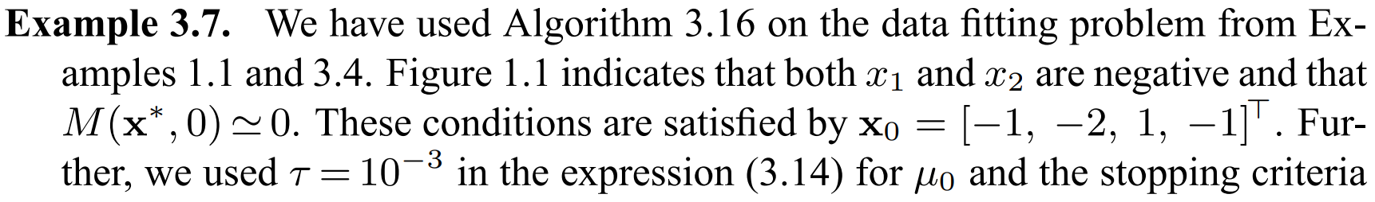 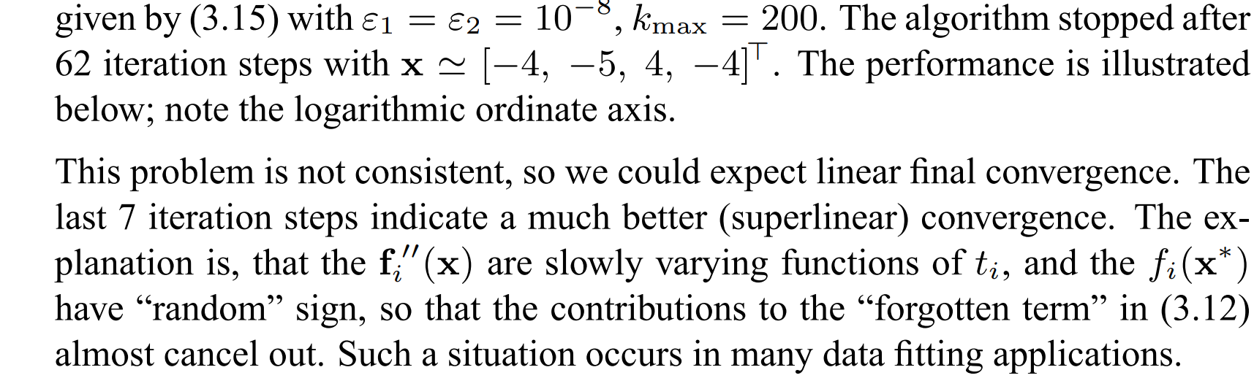

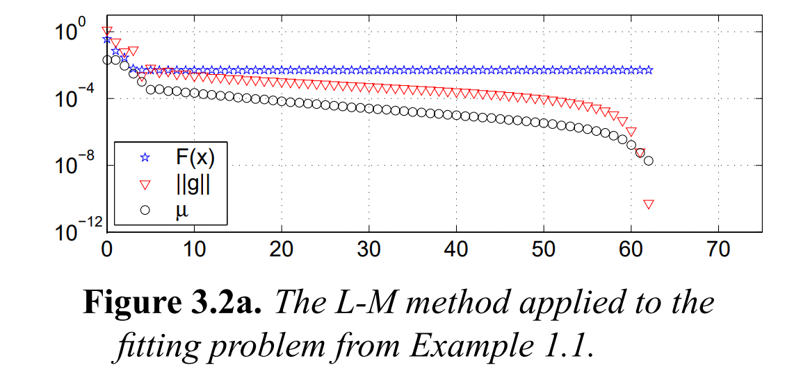

使用Levenberg-Marquardt算法拟合：

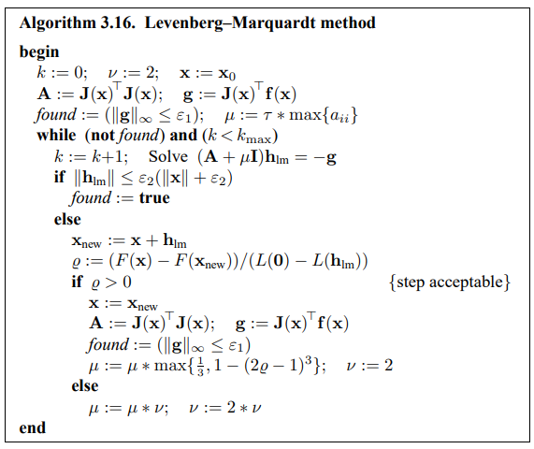

拟合结果与原论文中结果基本一致。

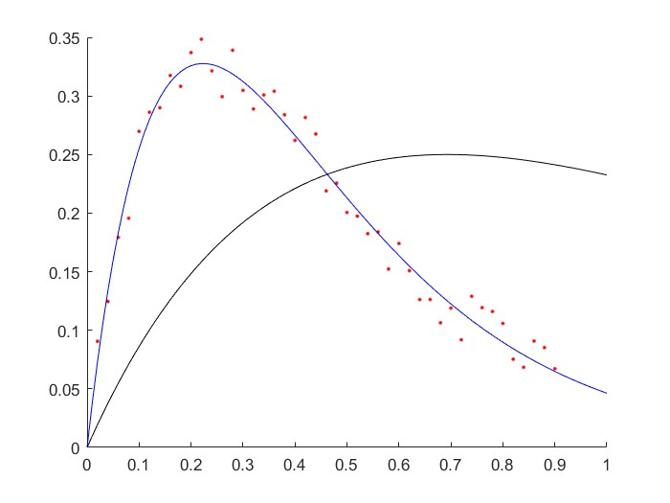

参数变化与3.2a基本一致。

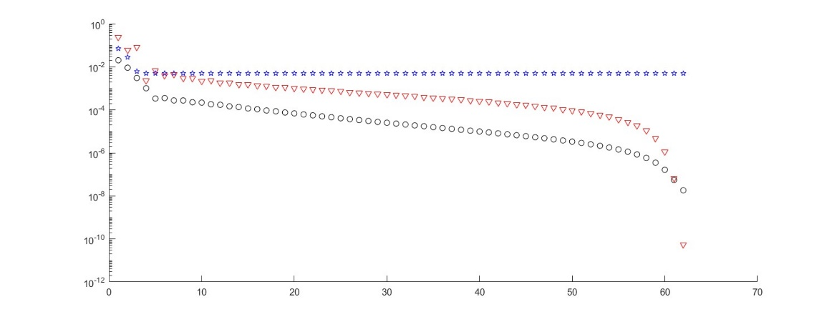

代码：

syms c1 c2 c3 c4 t y

data=importdata('efit1.dat');

t1=data.data(:,1);

y1=data.data(:,2);

epsilon=1e-8;

n=200;

disp('Example 3.7')

c0=[-1;-2;1;-1];

lambda=0.001;

c_root1=LevenbergMarquardt(t1,y1,c0,epsilon,epsilon,lambda,n)

function [ x ] = LevenbergMarquardt( t , y , x0 , epsilon_1 , epsilon_2 , tau , N )

%% Levenberg-Marquardt算法，进行高斯曲线拟合

% 输入变量为 t , y , x0 , epsilon_1 , epsilon_2 , tau , N

% t：自变量

% y：因变量

% x0：参数初始猜测值

% epsilon_1：迭代终止误差

% epsilon_2：迭代终止误差

% tau：倍率

% N：迭代最高次数

% 输出变量为 x

% x：迭代终止后参数的结果

Fx = [];

gg = [];

mul = [];

%% Objective function vector

fun = @(x) y-(x(3)*exp(x(1)*t)+x(4)*exp(x(2)*t)); % gauss type

% fun = @(x) log( abs( y - x(4) ) ) - log( abs( x(1) ) ) + ( ( t - x(2) ) / x(3) ).^2 / 2; % log type

%% Jacobi matrix for gauss function

Jacobi = @(x) [

-t*x(3).*exp(x(1)*t),...

-t*x(4).*exp(x(2)*t),...

-exp(x(1)*t),...

-exp(x(2)*t)

]; % gauss type

% Jacobi = @(x) -1 * [

% ones( length(t) , 1 ) / x(1) ,...

% ( x(2) - t ) / x(3)^2,...

% -( t - x(2) ).^2 / x(3)^3,...

% 1 ./ ( x(4) - y )

% ]; % log type

%%

count = 0;

v = 2;

x = x0;

Jmatrix = Jacobi( x );

A = Jmatrix' * Jmatrix;

g = Jmatrix' * fun( x );

found = ( norm( g , Inf ) < epsilon_1 );

mu = tau * max( diag( A ) );

while ~found && ( count < N )

count = count + 1;

h_lm = ( A + mu * diag( ones( 4 , 1 ) ) ) \ ( -g );

if ( norm( h_lm ) <= ( epsilon_2 * ( norm( x ) + epsilon_2 ) ) )

found = 1;

else

x_new = x + h_lm;

gain_radio = ( fun( x )' * fun( x ) - fun( x_new )' * fun( x_new ) ) / 2 /...

( 0.5 * h_lm' * ( mu * h_lm - g ) );

if gain_radio > 0

x = x_new;

Jmatrix = Jacobi( x );

A = Jmatrix' * Jmatrix;

g = Jmatrix' * fun( x );

found = ( norm( g , Inf ) <= epsilon_1 );

gg = [gg norm(g,Inf)];

mul = [mul mu];

tmp = 0.5*fun(x)'*fun(x);

Fx = [Fx tmp];

mu = mu * max( [ 1/3 , 1 - ( 2 * gain_radio - 1 )^3 ] );

v = 2;

else

mu = mu * v;

v = 2 * v;

end

end

end

figure(1);

hold on;

plot(t,y,'r.');

ax = 0:0.01:1;

plot(ax,x(3)*exp(x(1)*ax)+x(4)*exp(x(2)*ax),'b');

plot(ax,x0(3)*exp(x0(1)*ax)+x0(4)*exp(x0(2)*ax),'k');

hold off;

figure(2);

hold on;

plot(1:1:count,Fx,'bp')

plot(1:1:count,gg,'rv')

plot(1:1:count,mul,'ko')

hold off;

end

Example 3.11

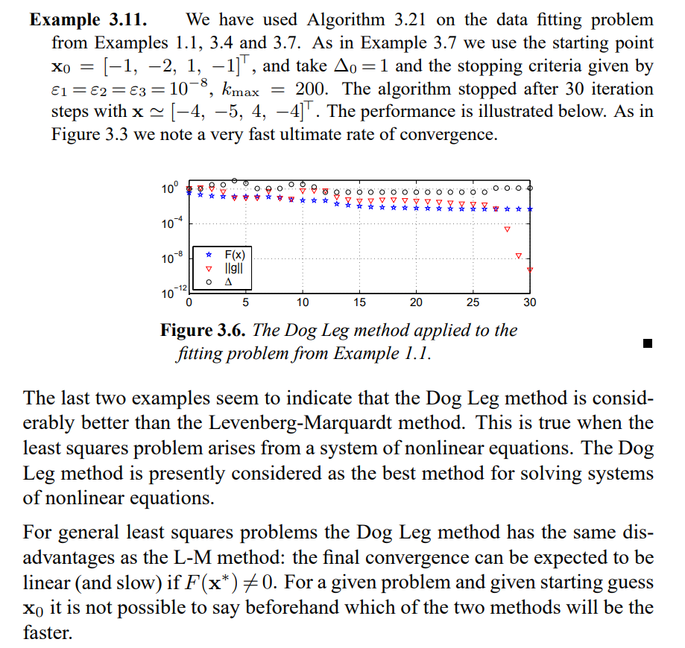

使用Dog Leg Method拟合：

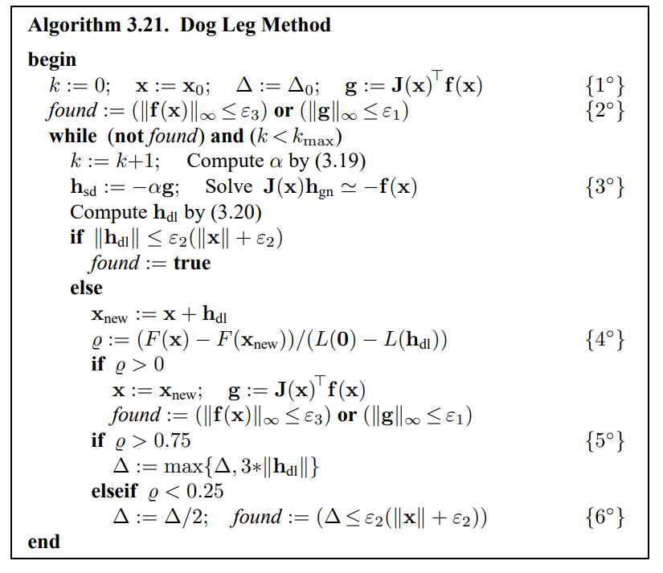

拟合结果与原论文中结果基本一致。

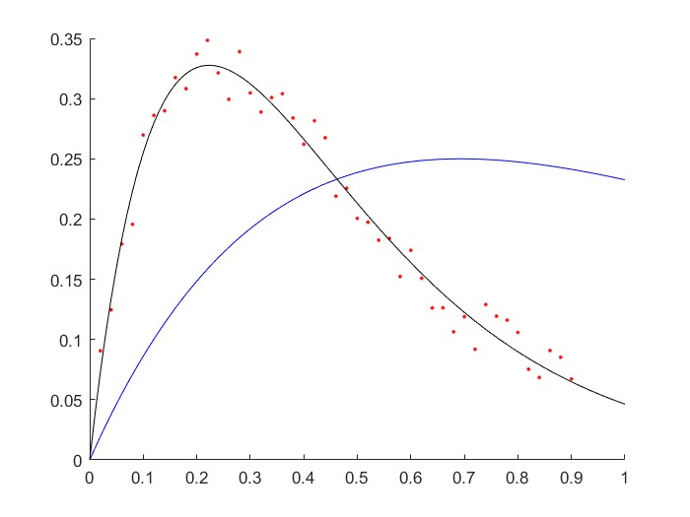

参数变化与3.6基本一致。

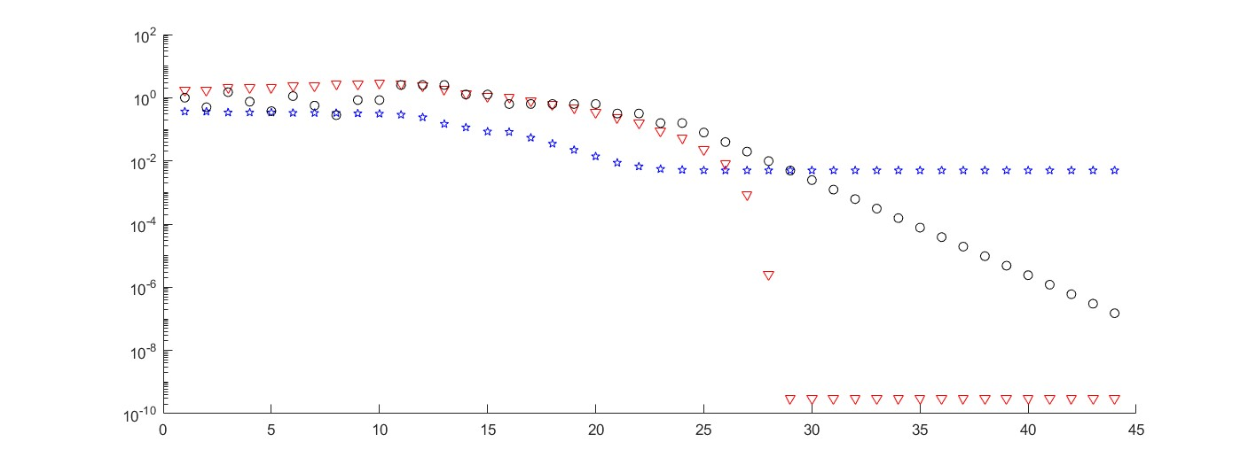

代码：

M=100;

data=importdata('efit1.dat');

t_data=data.data(:,1)';

y_data=data.data(:,2)';

x0=[-1 -2 1 -1];

k_max=200;

epsilon_1=1.0e-8;

epsilon_2=1.0e-8;

epsilon_3=1.0e-8;

delta=1;

disp('Example 3.11');

fit_result=powells_dog_leg_sinus(t_data, y_data, x0, k_max, epsilon_1, epsilon_2, epsilon_3, delta)

function [x_new] = powells_dog_leg_sinus(t_data, y_data, x0, k_max, epsilon_1, epsilon_2, epsilon_3, delta)

M=length(t_data(1,:));

k=0;

x=x0;

F_x_list = [];

g_norm_list = [];

delta_list = [];

% Jacobian matrix

J=zeros(M,4);

J(:,1)= -t_data*x(3).*exp(x(1)*t_data);

J(:,2)= -t_data*x(4).*exp(x(2)*t_data);

J(:,3)= -exp(x(1)*t_data);

J(:,4)= -exp(x(2)*t_data);

% calculate f

f=zeros(1,M);

f=y_data-(x(3)*exp(x(1)*t_data)+x(4)*exp(x(2)*t_data));

% calculate g

g=transpose(J(:,:))*transpose(f(1,:));

% calculate norm f

f_norm=sqrt(sum(f(1,:).*f(1,:)));

% calculate norm g

g_norm=sqrt(sum(g(:,1).*g(:,1)));

% calculate boolean variable found

found_bool=(f_norm <= epsilon_3) | (g_norm <= epsilon_1);

% main loop

while ((~found_bool) && (k < k_max))

% increase iteration variable k

k=k+1;

% Jacobian matrix

J=zeros(M,4);

% caclulate derivation according to amplitude

% fill first column of Jacobian matrix

J(:,1)= -t_data*x(3).*exp(x(1)*t_data);

J(:,2)= -t_data*x(4).*exp(x(2)*t_data);

J(:,3)= -exp(x(1)*t_data);

J(:,4)= -exp(x(2)*t_data);

% calculate f

f=zeros(1,M);

f=y_data-(x(3)*exp(x(1)*t_data)+x(4)*exp(x(2)*t_data));

% calculate g

g=transpose(J(:,:))*transpose(f(1,:));

% calculate norm g

g_norm=sqrt(sum(g(:,1).*g(:,1)));

% calculate J(x)*g(x)

Jg=J(:,:)*g(:,1);

% calculate norm Jg

Jg_norm=sqrt(sum(Jg(:,1).*Jg(:,1)));

% calculate alpha

alpha=g_norm^2/Jg_norm^2;

% calculate h_sd

h_sd=(-1.0)*alpha*g(:,1);

h_sd=transpose(h_sd);

% calculate h_gn

A=transpose(J(:,:))*J(:,:);

B=transpose(J(:,:))*transpose(f(1,:));

h_gn=(-1.0)*transpose(B)*inv(A);

% calculate h_dl

% calculate norm h_gn

h_gn_norm=sqrt(sum(h_gn(1,:).*h_gn(1,:)));

% calculate norm alpha*h_sd

alpha_h_sd=alpha*h_sd(1,:);

alpha_h_sd_norm=sqrt(sum(alpha_h_sd(1,:).*alpha_h_sd(1,:)));

% calculate norm h_sd

h_sd_norm=sqrt(sum(h_sd(1,:).*h_sd(1,:)));

% caclulate h_dl

if (h_gn_norm <= delta)

h_dl=h_gn(1,:);

elseif (alpha_h_sd_norm >= delta)

h_dl=(delta/h_sd_norm)*h_sd(1,:);

else

beta=sym('beta');

h_dl=alpha*h_sd(1,:)+beta*(h_gn(1,:)-alpha*h_sd(1,:));

h_dl_norm=sqrt(sum(h_dl(1,:).*h_dl(1,:)));

eqn=(h_dl_norm == delta);

beta_result=solve(eqn, beta, 'Real', true);

beta_result=double(beta_result);

clear beta;

h_dl=alpha*h_sd(1,:)+beta_result(2,1)*(h_gn(1,:)-alpha*h_sd(1,:));

end

% calculate norm h_dl

h_dl_norm=sqrt(sum(h_dl(1,:).*h_dl(1,:)));

% calculate norm x

x_norm=sqrt(sum(x(1,:).*x(1,:)));

delta_list = [delta_list delta];

g_norm_list = [g_norm_list g_norm];

if (h_dl_norm <= epsilon_2*(x_norm+epsilon_2))

found_bool=1;

else

x_new=x(1,:)+h_dl(1,:);

% calculate F(x)

% caclulate function f

f=zeros(1,M);

f=y_data-(x(3)*exp(x(1)*t_data)+x(4)*exp(x(2)*t_data));

F_x=0.5*sum(f(1,:).*f(1,:));

F_x_list = [F_x_list F_x];

% calculate F(x_new)

f=zeros(1,M);

f=y_data-(x_new(3)*exp(x_new(1)*t_data)+x_new(4)*exp(x_new(2)*t_data));

F_x_new=0.5*sum(f(1,:).*f(1,:));

% ro denominator

ro_denominator=0.5*h_dl(1,:)*(alpha*transpose(h_dl(1,:))-g(:,1));

% calculate ro - gain ratio

ro=(F_x-F_x_new)/ro_denominator;

if (ro > 0)

x=x_new(1,:);

% Jacobian matrix

J=zeros(M,4);

% caclulate derivation according to amplitude

% fill first column of Jacobian matrix

J(:,1)= -t_data*x(3).*exp(x(1)*t_data);

J(:,2)= -t_data*x(4).*exp(x(2)*t_data);

J(:,3)= -exp(x(1)*t_data);

J(:,4)= -exp(x(2)*t_data);

% calculate f

f=zeros(1,M);

f=y_data-(x(3)*exp(x(1)*t_data)+x(4)*exp(x(2)*t_data));

% calculate norm f

f_norm=sqrt(sum(f(1,:).*f(1,:)));

% calculate g

g=transpose(J(:,:))*transpose(f(1,:));

% calculate norm g

g_norm=sqrt(sum(g(:,1).*g(:,1)));

% cacluate boolean variable found

found_bool=(f_norm <= epsilon_3) | (g_norm <= epsilon_1);

end

if (ro > 0.75)

% calculate norm h_dl

h_dl_norm=sqrt(sum(h_dl(1,:).*h_dl(1,:)));

% calculate new delta

delta=max([delta 3*h_dl_norm]);

elseif (ro < 0.25)

% calculate new delta

delta=delta/2;

% calculate norm x

x_norm=sqrt(sum(x(1,:).*x(1,:)));

% calculate boolean variable found

found_bool=(delta <= epsilon_2*(x_norm+epsilon_2));

end

end

end

figure(1);

hold on;

plot(t_data,y_data,'r.');

ax = 0:0.01:1;

plot(ax,x0(3)*exp(x0(1)*ax)+x0(4)*exp(x0(2)*ax),'b');

plot(ax,x_new(3)*exp(x_new(1)*ax)+x_new(4)*exp(x_new(2)*ax),'k');

hold off;

figure(2);

hold on;

plot(1:1:k,F_x_list,'bp')

plot(1:1:k,g_norm_list,'rv')

plot(1:1:k,delta_list,'ko')

hold off;

end