多数据库源配置

- 以北汽项目模块baicpre-mobile-service为例配置
文件: 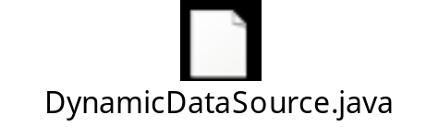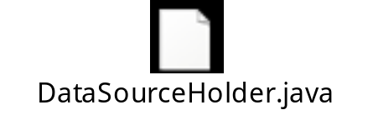
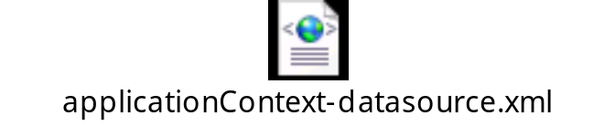
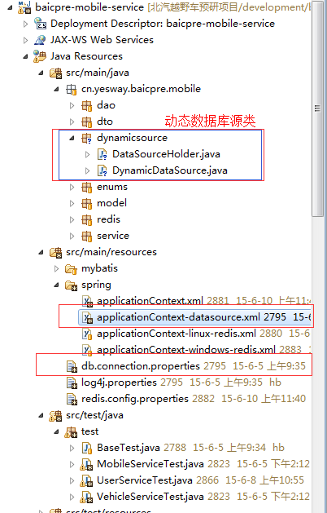
- applicationContext-datasource.xml配置:
<!-- 读写库 -->
<bean id="masterDataSource" class="com.mchange.v2.c3p0.ComboPooledDataSource">
<property name="driverClass" value="${yconnect.jdbc.driver}" />
<property name="jdbcUrl" value="${yconnect.jdbc.url}" />
<property name="user" value="${yconnect.jdbc.username}" />
<property name="password" value="${yconnect.jdbc.password}" />
<property name="initialPoolSize" value="${yconnect.connection_pools.initial_pool_size}" />
<property name="minPoolSize" value="${yconnect.connection_pools.min_pool_size}" />
<property name="maxPoolSize" value="${yconnect.connection_pools.max_pool_size}" />
<property name="maxIdleTime" value="${yconnect.connection_pools.max_idle_time}" />
<property name="acquireIncrement" value="${yconnect.connection_pools.acquire_increment}" />
<property name="checkoutTimeout" value="${yconnect.connection_pools.checkout_timeout}" />
</bean>

<!-- slave1 只读库 -->
<bean id="slaveDataSource" class="com.mchange.v2.c3p0.ComboPooledDataSource">
<property name="driverClass" value="${slave.driver}" />
<property name="jdbcUrl" value="${slave.url}" />
<property name="user" value="${slave.username}" />
<property name="password" value="${slave.password}" />
<property name="initialPoolSize" value="${yconnect.connection_pools.initial_pool_size}" />
<property name="minPoolSize" value="${yconnect.connection_pools.min_pool_size}" />
<property name="maxPoolSize" value="${yconnect.connection_pools.max_pool_size}" />
<property name="maxIdleTime" value="${yconnect.connection_pools.max_idle_time}" />
<property name="acquireIncrement" value="${yconnect.connection_pools.acquire_increment}" />
<property name="checkoutTimeout" value="${yconnect.connection_pools.checkout_timeout}" />
</bean>

<!-- slave2 只读库 -->
<bean id="slaveDataSource2" class="com.mchange.v2.c3p0.ComboPooledDataSource">
<property name="driverClass" value="${slave2.driver}" />
<property name="jdbcUrl" value="${slave2.url}" />
<property name="user" value="${slave2.username}" />
<property name="password" value="${slave2.password}" />
<property name="initialPoolSize" value="${yconnect.connection_pools.initial_pool_size}" />
<property name="minPoolSize" value="${yconnect.connection_pools.min_pool_size}" />
<property name="maxPoolSize" value="${yconnect.connection_pools.max_pool_size}" />
<property name="maxIdleTime" value="${yconnect.connection_pools.max_idle_time}" />
<property name="acquireIncrement" value="${yconnect.connection_pools.acquire_increment}" />
<property name="checkoutTimeout" value="${yconnect.connection_pools.checkout_timeout}" />
</bean>

<!-- 动态数据源 -->
<bean id="dynamicDataSource" class="cn.yesway.baicpre.mobile.dynamicsource.DynamicDataSource">
<!-- 初始化读库配置 -->
<constructor-arg index="0" name="dataSourceHolder" ref="dataSourceHolder" />

<!-- 默认写库为数据库源 -->
<property name="defaultTargetDataSource" ref="masterDataSource"></property>

<!-- 添加目标数据源 -->
<property name="targetDataSources">
<map>
<entry key="master" value-ref="masterDataSource" />
<entry key="slave1" value-ref="slaveDataSource" />
<entry key="slave2" value-ref="slaveDataSource2" />
</map>
</property>
</bean>

<!-- 读库配置 同上targetDataSources的map中salve库的key须一致,配置list集合只为多个读库随机选取一个-->
<bean id="dataSourceHolder" class="cn.yesway.baicpre.mobile.dynamicsource.DataSourceHolder">
<constructor-arg index="0" name="slaves">
<list>
<value>slave1</value>
<value>slave2</value>
</list>
</constructor-arg>
</bean>

<!-- 开启事务注解驱动 -->
<tx:annotation-driven />

<!-- 事务管理器 -->
<bean id="transactionManager" class="org.springframework.jdbc.datasource.DataSourceTransactionManager">
<property name="dataSource" ref="dynamicDataSource" />
</bean>

<!-- 创建SqlSessionFactory，同时指定数据源 -->
<bean id="sqlSessionFactory" class="org.mybatis.spring.SqlSessionFactoryBean">
<property name="dataSource" ref="dynamicDataSource" />
<!--<property name="configLocation" value="classpath:mybatis-setting.xml"/> -->
<property name="mapperLocations" value="classpath:mybatis/*Mapper.xml" />
</bean>

<!-- spring mybatis整合且扫描dao层自动注入 -->
<bean class="org.mybatis.spring.mapper.MapperScannerConfigurer">
<property name="basePackage" value="cn.yesway.baicpre.mobile.dao" />
<property name="sqlSessionFactoryBeanName" value="sqlSessionFactory" />
</bean>

</beans>

- DataSourceHolder类
package cn.yesway.baicpre.mobile.dynamicsource;

import java.util.List;
import java.util.Random;

/**
* 读库数据库设置(默认是读写库)
*
* @version : Ver 1.0
* @author : <a href="mailto:358911056@qq.com">hubo</a>
* @date : 2015-7-3 下午3:38:30
*/
public class DataSourceHolder {

private static List<String> slaves; // 读库key集合

private final static ThreadLocal<String> dbcontext = new ThreadLocal<String>();

@SuppressWarnings("static-access")
public DataSourceHolder(List<String> slaves) {
this.slaves = slaves;
}

/**
* 获取数据库源的key
*
* @author : <a href="mailto:358911056@qq.com">hubo</a> 2015-7-6 下午4:48:59
* @return
*/
public String getDBSourceType() {
return dbcontext.get();
}

/**
* 随机获取读库的 key
*
* @author : <a href="mailto:358911056@qq.com">hubo</a> 2015-7-6 下午3:05:12
*/
public static void userReadDB() {
String key = ""; // 从库节点的key
int size = slaves.size();
if (size > 0) {
int index = getRandomNumber(0, size - 1);
key = slaves.get(index);
}
dbcontext.set(key);
}

/**
* 生成[min,max]区间中的随机数
*
* @param min
* @param max
* @return
*/
private static int getRandomNumber(int min, int max) {
Random rand = new Random();
int tmp = Math.abs(rand.nextInt());
return tmp % (max - min + 1) + min;
}
}

- DynamicDataSource类
package cn.yesway.baicpre.mobile.dynamicsource;

import org.springframework.jdbc.datasource.lookup.AbstractRoutingDataSource;

/**
* 动态数据源
*
* @version : Ver 1.0
* @author : <a href="mailto:358911056@qq.com">hubo</a>
* @date : 2015-7-3 下午3:16:32
*/
public class DynamicDataSource extends AbstractRoutingDataSource {

private DataSourceHolder dataSourceHolder;

public DynamicDataSource(DataSourceHolder dataSourceHolder) {
this.dataSourceHolder = dataSourceHolder;
}

@Override
protected Object determineCurrentLookupKey() {
return dataSourceHolder.getDBSourceType();
}
}

applicationContext.xml配置加载
<!-- 引入配置文件,读取db.connection.properties文件等 -->
<context:property-placeholder location="classpath*:/*.properties" ignore-resource-not-found="true" ignore-unresolvable="true" />

<!-- 加载数据库源>
<import resource="classpath*:/spring/applicationContext-datasource.xml" />

</beans>

- db.connection.properties数据库属性配置文件
#------------ JDBC Connection config------------
################读写库存####
yconnect.jdbc.driver=com.microsoft.sqlserver.jdbc.SQLServerDriver
yconnect.jdbc.url=jdbc:sqlserver://10.1.11.165:1433;databaseName=Baicpre_Platform
yconnect.jdbc.username=sa
yconnect.jdbc.password=Asdf1234
################读库1 ##
slave.driver=com.microsoft.sqlserver.jdbc.SQLServerDriver
slave.url=jdbc:sqlserver://10.1.11.165:1433;databaseName=Baicpre_Platform_slave
slave.username=sa
slave.password=Asdf1234

################读库2 ##
slave2.driver=com.microsoft.sqlserver.jdbc.SQLServerDriver
slave2.url=jdbc:sqlserver://10.1.11.165:1433;databaseName=Baicpre_Platform_slave2
slave2.username=sa
slave2.password=Asdf1234

yconnect.connection_pools.initial_pool_size=5
yconnect.connection_pools.min_pool_size=5
yconnect.connection_pools.max_pool_size=100
yconnect.connection_pools.max_idle_time=600
yconnect.connection_pools.acquire_increment=5
yconnect.connection_pools.checkout_timeout=60000

- 测试:
@RunWith(SpringJUnit4ClassRunner.class)
@ContextConfiguration(locations = { "/META-INF/spring/test-applicationContext.xml" })
public class VehicleServiceTest extends BaseTest{
@Autowired
private VehicleService vehicleService;
@Test public void getVehicleTest() {
/**
* 手动调用此DataSourceHolder.userReadDB();
* 表示当前与数据库交互是从读库随机应用一个源load数据
* 注释或者不手动调用此方法则默认以读写库也就是主库做数据库源
*/
DataSourceHolder.userReadDB();
VehicleVo vo = vehicleService.getVehicle("bbbb");
print(vo);
}

