

Table of Contents

Summary 1

Login 2

Time Sheet Approval 3

Time Sheets 4

Incidents 6

Job Postings 7

# Summary

‘Tempus Workforce Management’ is a web-based application that allows you to

* Request temp workers from the MSP by submitting ‘Job Postings’
* Review the distribution of the job postings and candidates, who are placed to your job orders
* Reject any specific placement
* Monitor the temp employees’ attendance
* Approve/Reject time sheets
* Submit incident reports with supporting attachments

# Login

Go to <https://gc-employment.com/login>

You will be redirected to following page.

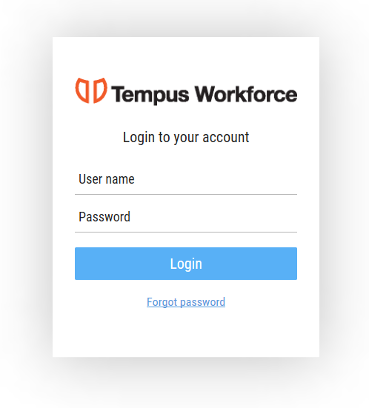

Use your credential to login.

You will be redirected to the Dashboard.

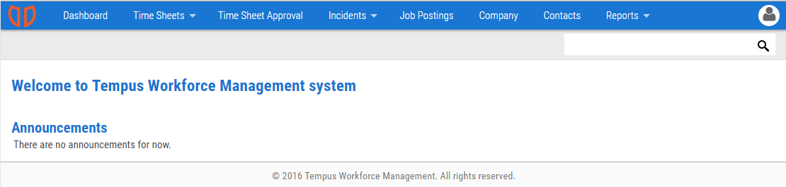

# Time Sheet Approval

To approve employees’ time, select *Time Sheet Approval* from main menu. By default, the time sheets for the current week will be loaded. You can change the *Week Start Date* on top of the page to load data for previous weeks.

To approve all records, click on *Approve all*.

To approve a subset of the timesheets, either click on the approve button in each row, or selected multiple rows (by clicking on the check box next to employee’s name) and then click on *Approve Selected* button.

To reject a record select *reject* button of corresponding record you want to reject.

To adjust a record, click on the *Edit* button and enter the adjustment value (in minutes) and the reason of adjustment.

You can also export these records to excel and PDF.

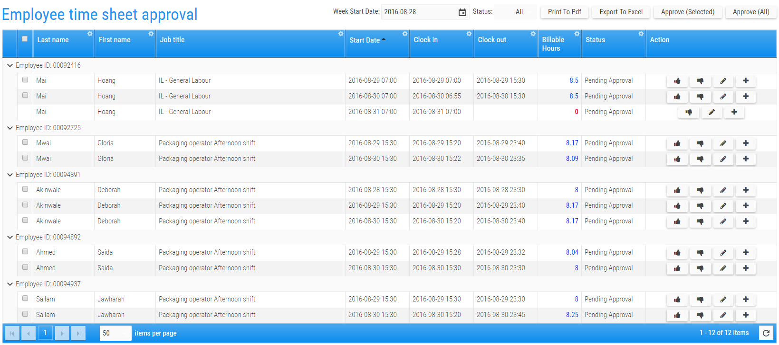

# Time Sheets

We track employees’ attendance based on their punches on our punch clocks. There are several pages in the system that allows you to review the employees’ attendance. You can review ‘Daily time sheets’ and ‘Time sheet history’ by selecting options under time sheets menu.

Daily Time Sheets

In this page, you will see the raw punches for each employee on a daily basis (Clock in and Clock out). Under the ‘Total Hours’ you’ll see the total hours that the employee has worked. The value in this column is color-coded:

* Red: Records that have a problem. For example the punch-in is missing.
* Green: Records that have been manually adjusted.
* Blue: Records that have no issues and have not been adjusted.

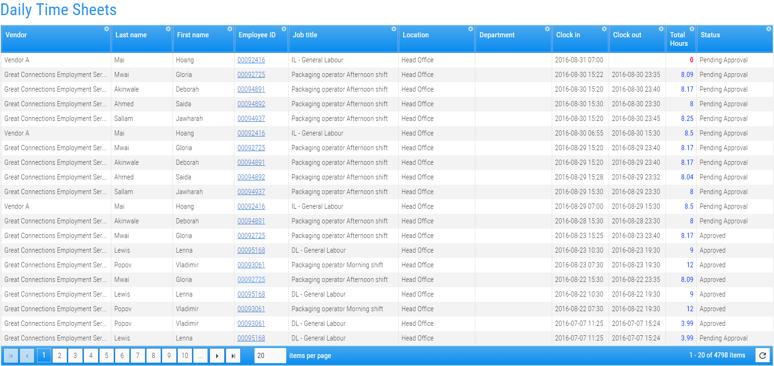

Time Sheet History

This page represents a weekly view of approved hours for the selected date range. After selecting the values in ‘From’ and ‘to’ boxes, click on *Load* button to retrieve the data.

To export the data, you should select the rows first. Clicking on the check box in the grid’s header has the same effect as clicking on the check box in every displayed row.

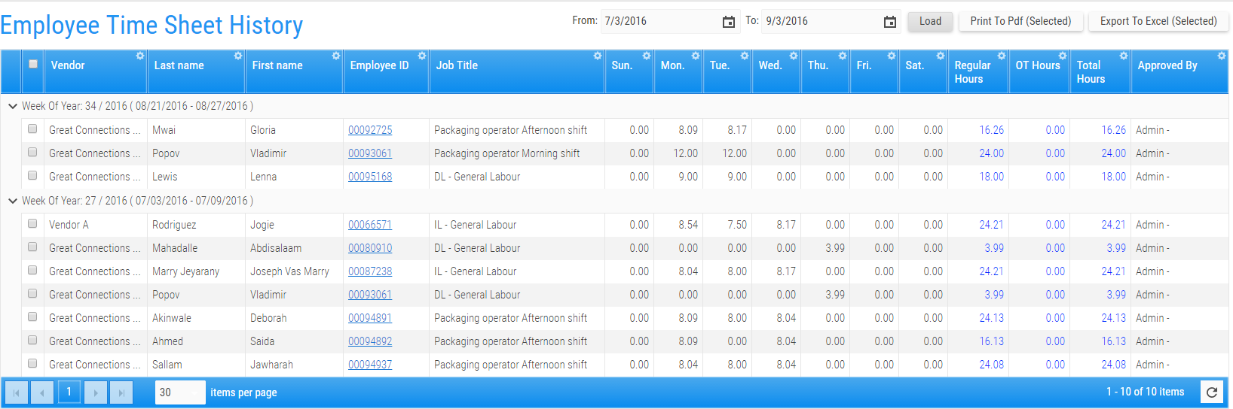

Incidents

You can report workplace incidents using the system and submit the related documents to us by selecting *Incident History* under *Incident* menu.

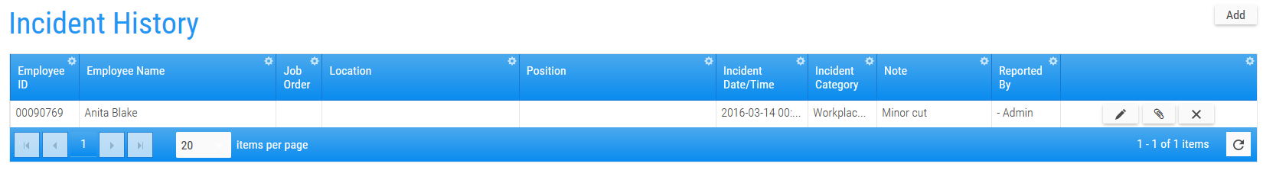

To report a new incident click on Add button above the grid.When you save the inceident an email is sent to the recruiter about the new reported incident.

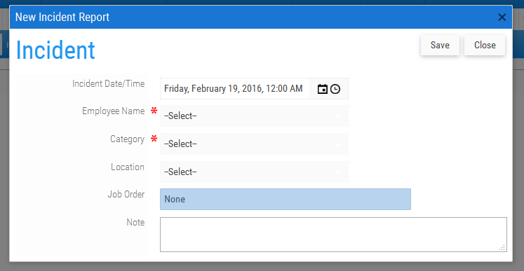

To add documents to the new reported incident you can select *attachment* icon from the grid and upload the documents.

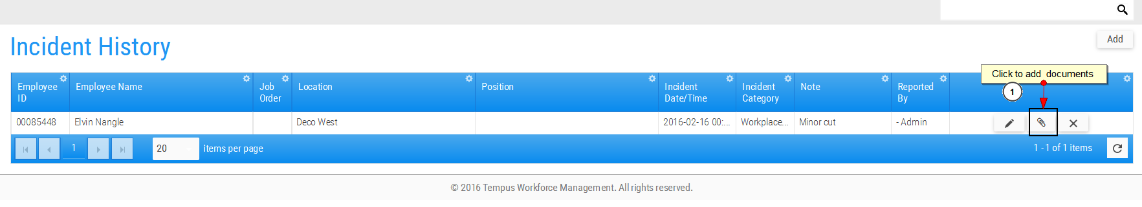

# Job Postings

To request temporary employees, you can submit a ‘Job Posting’, which will be processed by our recruiters. You can see all your job postings in this page. Every Job Posting will create at least one job order.

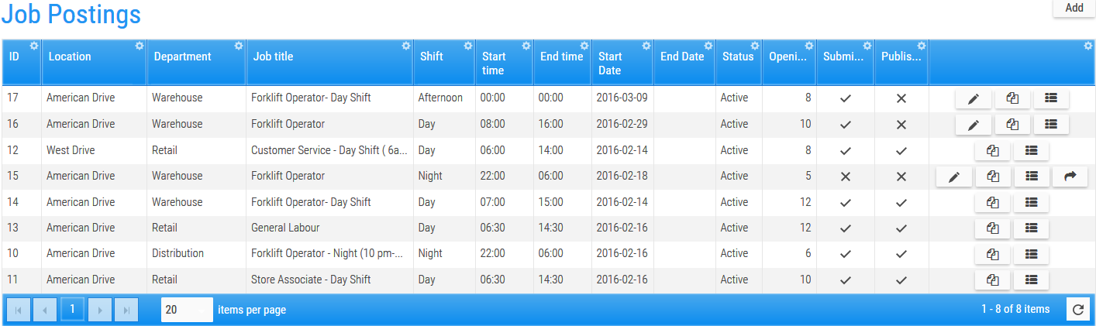

To create a new *job posting* click on *Add* button at top right corner above the grid, or select an existing job posting in the grid and click on ‘*Copy*’.

You will be redirected to the job posting’s edit page.

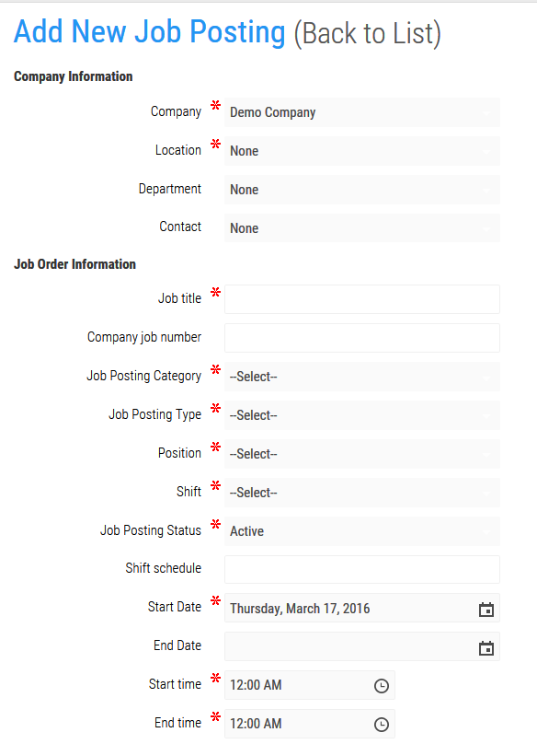

Enter details for job posting under *Company Information* and *Job Order Information* sections. After filling the required information click on ‘*Save*’. Once you save the *Job Posting* it will be added in the grid but it will not be submitted.

To submit a *Job posting* to MSP click on *submit* button in the grid corresponding to the record you want to submit. Once you submit the record, MSP will be notified with email regarding your job posting and MSP can start assigning open positions to different vendors.

After assigning open positions to vendors MSP will *publish* the job posting. Once the job posting is published by the MSP, you will not be able to make any change in the job posting.

You can view job posting details by clicking on the details link in the grid

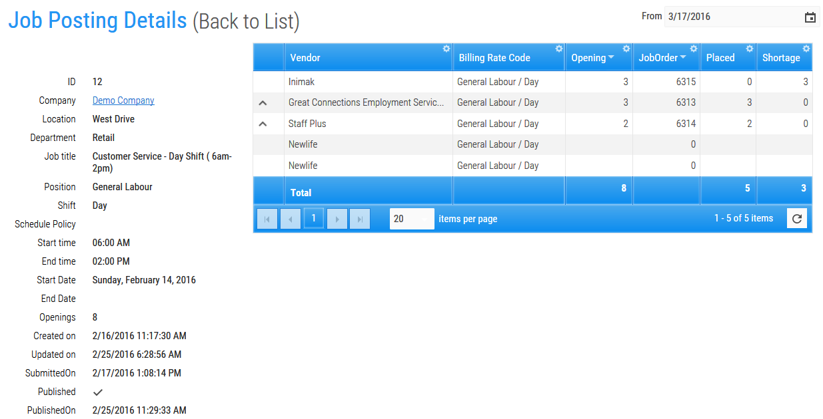

You can also see candidates placed by different vendors by clicking on the arrow icon in front of specific Vendor.

To *reject* any candidate you can click on *reject* button for corresponding candidate as displayed in the above screen.