VIETNAM GENERAL CONFEDERATION OF LABOUR
TON DUC THANG UNIVERSITY
FACULTY OF INFORMATION TECHNOLOGY



FINAL REPORT

SOFTWARE ENGINEER
TOPIC: MINI FOOTBALL FIELD
MANAGEMENT SOFTWARE

Instructor: GV NGUYEN NGOC PHIEN Executor: NGUYEN QUANG HUY - 520H0140 NGUYEN TRAN NHAT AN - 523H0115
TRAN QUANG ANH – 523H0003

HO CHI MINH CITY, YEAR 2025
VIETNAM GENERAL CONFEDERATION OF LABOUR
TON DUC THANG UNIVERSITY
FACULTY OF INFORMATION TECHNOLOGY

FINAL REPORT

SOFTWARE ENGINEER
TOPIC: MINI FOOTBALL FIELD
MANAGEMENT SOFTWARE

Instructor: GV NGUYEN NGOC PHIEN Executor: NGUYEN QUANG HUY - 520H0140 NGUYEN TRAN NHAT AN - 523H0115
TRAN QUANG ANH – 523H0003

HO CHI MINH CITY, YEAR 2025

ACKNOWLEDGMENT

We would like to express our appreciation to Ton Duc Thang University, the Faculty of Information Technology, the Division of Computer Science, and every lecturer and professor in the faculty for creating a positive and excellent environment for us to thrive and succeed. We are especially grateful for the immense effort of M.S. NGUYEN NGOC PHIEN . In conclusion, we cherish the opportunities and experiences that have been provided to us, and we are proud to be students at Ton Duc Thang University.

Ho Chi Minh City, day 15 month 5 year 2025
Author

NGUYEN TRAN NHAT AN

NGUYEN QUANG HUY

TRAN QUANG ANH

DECLARATION OF AUTHORSHIP

We hereby declare that this report was carried out by myself under the guidance and supervision of M.S. NGUYEN NGOC PHIEN; and that the work and the results contained in it are original and have not been submitted anywhere for any previous purposes. The data and figures presented in this thesis are for analysis, comments, and evaluations from various resources by my own work and have been duly acknowledged in the reference part.
In addition, other comments, reviews and data used by other authors, and organizations have been acknowledged, and explicitly cited.
I will take full responsibility for any fraud detected in my report. Ton Duc Thang University is unrelated to any copyright infringement caused on my work (if any).

Ho Chi Minh City, day 15 month 5 year 2025
Author

NGUYEN TRAN NHAT AN

NGUYEN QUANG HUY

TRAN QUANG ANH

TEACHER'S CONFIRMATION AND ASSESSMENT SECTION
The confirmation part of the instructor

Ho Chi Minh City, day 15 month 5 year 2025
Author

NGUYEN TRAN NHAT AN

NGUYEN QUANG HUY

TRAN QUANG ANH

The evaluation part of the teacher marks the exam

Ho Chi Minh City, day 15 month 5 year 2025
Author

NGUYEN TRAN NHAT AN

NGUYEN QUANG HUY

TRAN QUANG ANH

TABLE OF CONTENTS
LIST OF IMAGES v
LIST OF TABLES vi
CHAPTER 1. INTRODUCTION 1
1.1. Reasons to choose this topic 1
1.2. Requirement Engineering 1
1.2.1. Functional Requirement 1
1.2.2. Non-Functional Requirement 1
1.2.2.1. Performance Requirement 1
1.2.2.2. Safety Requirement 1
1.2.2.3. Confidentiality Requirement 1
1.2.2.4. Software quality attributes 1
1.3. Business process 1
1.4. Fact survey 1
CHAPTER 2. SPECIFIC DESCRIPTION 1
2.1. System specification 1
2.2. Target audience 1
2.3. Range 1
2.4. Possibility 1
2.5. Actors in the system 1
2.6. Use cases in the system 1
2.7. System function 1
CHAPTER 3. DETAILED DESIGN 1
3.1. General Use case diagram 1
3.2. Use case diagram 1
3.2.1. Register account Use case 1
3.2.2. Login Use case 1
3.2.3. Logout Use case 1
3.2.4. Manage Profile Use case 1
3.2.5. Send support request Use case 1
3.2.6. Search fields Use case 1
3.2.7. Cancel and Reschedule Use case 1
3.2.8. Sending Mail 1
3.2.9. Confirm and Reject Booking Use case 1
3.2.10. Manage Field Use case 1
3.3. Use case specification 1
3.3.1. Register account Use case 1
3.3.2. Login Use case 1
3.3.3. Logout Use case 1
3.3.4. Manage Profile Use case 1
3.3.5. Send support request Use case 1
3.3.6. Search fields Use case 1
3.3.7. Cancel and Reschedule Use case 1
3.3.8. Sending Mail 1
3.3.9. Confirm and Reject Booking Use case 1
3.3.10. Manage Field Use case 1
3.4. Activity diagram 1
3.4.1. Register account Use case 1
3.4.2. Login Use case 1
3.4.3. Logout Use case 1
3.4.4. Manage Profile Use case 1
3.4.5. Send support request Use case 1
3.4.6. Search fields Use case 1
3.4.7. Cancel and Reschedule Use case 1
3.4.8. Sending Mail 1
3.4.9. Confirm and Reject Booking Use case 1
3.4.10. Manage Field Use case 1
3.5. Sequence diagram 1
3.5.1. Register account Use case 1
3.5.2. Login Use case 1
3.5.3. Logout Use case 1
3.5.4. Manage Profile Use case 1
3.5.5. Send support request Use case 1
3.5.6. Search fields Use case 1
3.5.7. Cancel and Reschedule Use case 1
3.5.8. Sending Mail 1
3.5.9. Confirm and Reject Booking Use case 1
3.5.10. Manage Field Use case 1
3.6. Class diagram 1
3.7. Entity relationship 1
CHAPTER 4. ACTUAL PROCESS 1
4.1. Software development life cycle model 1
4.1.1. Introduction to Agile/Scrum model 1
4.1.2. Advantages 1
4.1.3. Defect 1
4.1.4. Reason for choosing model 1
4.2. Architecture use 1
CHAPTER 5. DEMO CODE 1
5.1. User interface 1
5.2. Admin interface 1
CHAPTER 6. TEST CASE AND UNIT TEST 1
REFERENCES 1

LIST OF IMAGES

Image 1. General Use Case Diagram
1

LIST OF TABLES

Table 2.1.1. Functional Requirements of Login Use Case 1

CHAPTER 1. INTRODUCTION
1.1. Reasons for Choosing the Topic
1.1.1. Rising Demand for Digital Convenience
Today’s customers expect instantaneous, 24/7 access to services. A dedicated online platform allows players to browse, select and reserve time slots without having to call or visit in person.
By automating availability checks and confirmations, the system reduces manual work for both customers and staff, increasing overall satisfaction and loyalty.
1.1.2. Operational Efficiency for Facility Owners
Manual scheduling and paper-based booking processes are time-consuming and prone to errors (double bookings, missed payments, etc.). Implementing a centralized system streamlines front-desk operations and minimizes human mistakes.
Administrators gain real-time visibility into field usage, revenues, and customer demands, enabling informed decisions on pricing, staffing, and maintenance schedules.
1.1.3. Enhanced Customer Engagement and Revenue Opportunities
Integrating optional services (referee booking, equipment rental, on-site refreshments) directly into the booking flow not only improves user experience, but also opens new streams of ancillary revenue for facility operators.
Automated notification (confirmation emails, SMS reminders) and feedback collection (ratings, reviews) build stronger customer relationships and provide data for continuous service improvement.
1.2. Requirement engineering
1.2.1. Functional requirement
1.2.1.1. Admin roles:
- Manage football field schedules and availability.
- Handle customer bookings and approve or reject reservations.
- Confirm payments (deposit or full).
- Respond to customer support requests.
- Manage system users and field data.
- View and export revenue statistics.
1.2.1.2. Customer roles
- Register and log in to the system.
- Search and book available fields by date and time.
- Cancel or reschedule bookings.
- Submit support requests or inquiries.
- Check in to use the field.
1.2.2. Non-Functional requirement
1.2.2.1. Performance requirements
- Fast response time (under 1 second for up to 1000 users).
- Real-time updates of field availability and booking status.
- Seamless service selection and booking process through the website.
1.2.2.2. Safety requirements
- Automatic system backups and data recovery mechanisms.
- Protection against connection failures, cyberattacks, or hardware damage.
1.2.2.3. Confidentiality
- Role-based access control (admin vs. customer).
- Independent permissions for view, add, edit, and delete operations.
- Restrict access to sensitive data like financial transactions.
1.2.2.4. Software quality attributes
- Web-based platform, accessible from desktop and mobile browsers.
- Easy to maintain, extend, and upgrade after deployment.
- Ensures key quality attributes:
+ Reliability, Maintainability, Interoperability.
+ Portability, Reusability, Security, Testability.
- Potential for reuse in managing other types of sports facility bookings.
- High level of data accuracy and system robustness.
1.3. Business process
Customers can book football fields online and choose to pay either via domestic bank transfer, e-wallet, or pay on-site. Customers are allowed to browse available fields and services without logging in. However, to make a booking, users are required to have an account. To create an account, users must register through the system.
To place a booking, the user selects a field and time slot, adds any optional services (e.g., referee, drinks, ball rental), and proceeds to payment. After the payment is completed successfully, the system receives and processes the booking.
Customers can then track the status of their booking through the Booking Status or Order View feature within the system
1.4. Fact survey
Interviewer | Interviewees | Interviewee’s role | Question | Answer
Nguyen Tran Nhat An | Nguyen Quang Huy | User | Hello, in your opinion, what is the most important feature of an online football field booking system? | Hi, from my experience booking football fields online, I think the most important feature is the ability to check available slots in real-time and make quick reservations without needing to call or go directly to the field.
Nguyen Tran Nhat An | Tran Quang Anh | User | What do you think is one of the disadvantages of current football field booking websites or apps? | In my opinion, one big disadvantage is that if the internet connection is unstable or unavailable, we can't access the booking system at all. This can be inconvenient when we urgently need to reserve a time slot.
Nguyen Quang Huy | Nguyen Tran Nhat An | Developer | As a developer, what is one of the challenges when building a football field management system? | One challenge is ensuring data consistency and security. For example, multiple users might try to book the same time slot at once, so the system needs to handle concurrency and avoid double bookings.
Tran Quang Anh | Nguyen Quang Huy | Admin | What do you think is one of the advantages of managing a football field through software? | One key advantage is that it helps reduce paperwork and human errors. It also makes it easier to manage schedules, view bookings, and track payments—all in one place and in real-time.

Table 1.4.1. Actual interview table
CHAPTER 2. SPECIFIC DESCRIPTION
1.1. System context
The system “Mini Football Field Booking Management Software” includes two main roles: Customer and Admin.
Customer side: Users who wish to book a football field must first create an account by registering on the system. After logging in, customers can browse available fields, select a suitable date and time, add extra services (e.g., ball rental, referee services), and make payments via e-wallets or cash-on-delivery (COD). After using the service, they can rate and leave feedback on the field and service quality.
Admin side: The administrator is responsible for managing field information, extra services, user accounts, and booking records. After a customer places a booking and completes payment, the admin must verify the request, confirm the payment, and coordinate the handover of the field. Admins also handle customer support, feedback moderation, and revenue reports for the business.
1.2. Target audience
This system targets mini football field owners and managers, as well as small-to-medium enterprises (SMEs) operating in sports rental services. The software aims to help them automate booking management, save time and resources, and expand their operations effectively.
1.3. Scope
The system is designed to deliver:
+ High-level security for user data and transactions.
+ Scalability and multilingual support.
+ Suitability for various types of fields (5-a-side, 7-a-side, indoor fields, etc.).
+ Deployment capability for multiple locations nationwide.
1.4. Feasibility
Technical Feasibility: The system built with NODEJS - a modern web technologies, with client-server or cloud-based architecture. The design allows for easy scaling and future integration with mobile platforms.
Financial Feasibility: This project is suitable for business owners and investors seeking to modernize their operations, attract more customers, and potentially expand through franchising or domestic investment.
1.5. Actors in the system
No. | Actor | Describe
1 | Admin | As the system administrator, manages customer accounts, field availability, bookings, extra services, payments, and handles support and revenue reports
2 | Member Customer | As a registered user, can log in, book fields, manage personal bookings.

Table 1.5.1. Actual interview table

1.6. Use cases in the system
No. | Use case name | Describe
UC-1 | Register Account | User provides email, password and personal details to create a new account; system sends a confirmation email.
UC-2 | Login | User (or admin) submits credentials to authenticate and gain access to protected features.
UC-3 | Logout | Authenticated user ends their session and is returned to the public (unauthenticated) view.
UC-5 | Manage Profile | Authenticated user views and updates their personal information (name, contact, password, etc.).
UC-6 | Search fields | Authenticated user searches for available football fields by date, time, location or other filters.
UC-7 | View schedule | Authenticated user or admin views the booking calendar/schedule for one or more fields.
UC-8 | Booking | Authenticated user selects a field, time slot and optional services, then submits a reservation request.
UC-9 | Cancel/Reschedule | Authenticated user cancels an existing booking or selects a new slot to reschedule their reservation.
UC-10 | Sending Mail | System automatically sends notification emails (registration confirmation, booking updates, etc.).
UC-11 | Confirm/Reject Booking | Admin reviews incoming booking requests and either confirms or rejects them; triggers notification.
UC-12 | Manage Fields | Admin adds, edits or removes field records and configures their availability (hours, slots, etc.).

Table 1.6.1. Use case in the system table

1.7. System functions
No. | Function name | Describe
1 | Register | Collects user details (email, password, personal info), creates a new account in “Unverified” state and triggers verification email.
2 | Verify | Validates the user’s verification token (from email/SMS) and transitions account to “Verified” status.
3 | Login | Authenticates user credentials, establishes a session or issues an access token for protected operations.
4 | Update user profile | Allows the authenticated user to modify personal information (name, password, contact details).
5 | Logout | Invalidates the user’s session or token, ending their authenticated session and returning to public view.
6 | Search fields | Returns a filtered list of available football fields based on date, time, location, and other criteria.
7 | Cancel/Reschedule | Enables a user to cancel an existing booking or choose a new slot to reschedule their reservation.
8 | Send support request | Accepts and records customer inquiries or issue reports, routing them to admin/support staff.
9 | Booking | Creates a new reservation for a selected field and time slot, applies optional services, and records payment intent.
10 | Create fields | Allows an admin to add new field records, specifying name, location, available hours, and pricing.
11 | Update fields | Permits an admin to edit existing field information, including schedule, pricing, and descriptive details.
12 | Delete fields | Enables an admin to remove field records from the system, after verifying no active bookings conflict.
13 | Get revenue statistic | Aggregates and returns financial reports (daily, weekly, monthly), including booking fees and service revenues.
14 | Confirm/Reject  Booking | Lets an admin approve or deny pending booking requests and triggers notification to the user.
15 | Send Verify/Confirm  Mail | System function to dispatch verification and confirmation emails (account activation, booking updates, cancellations).

Table 1.7.1. Function in the system table
CHAPTER 3. DETAILED DESIGN
3.1. General use case diagram
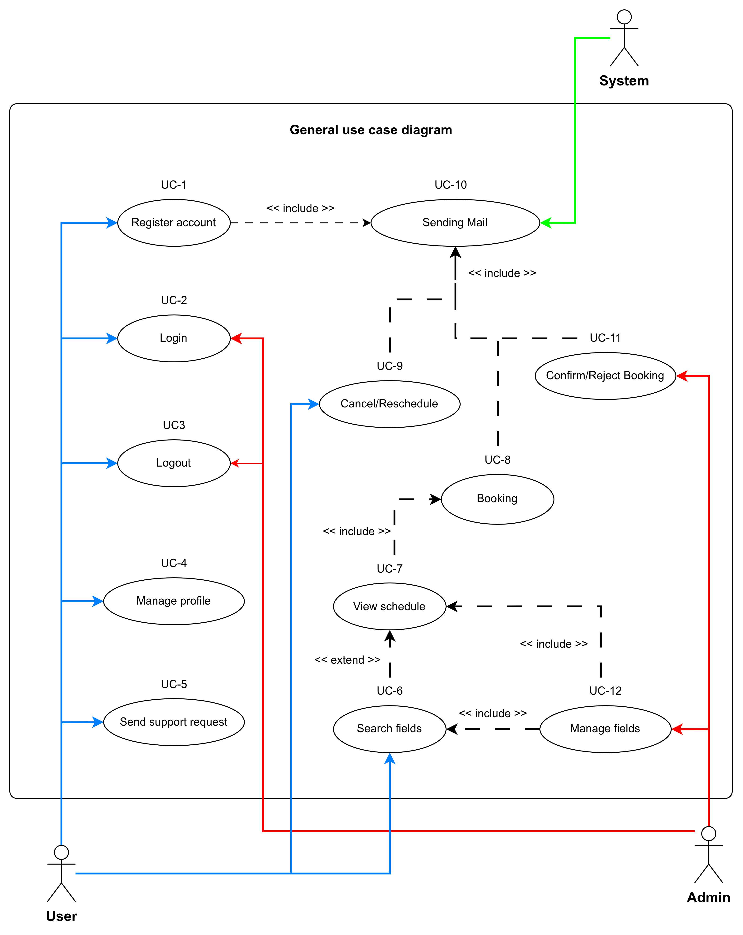

Image 3.1.1. General use case diagram
3.2. Use case diagram
3.2.1. Register account use case 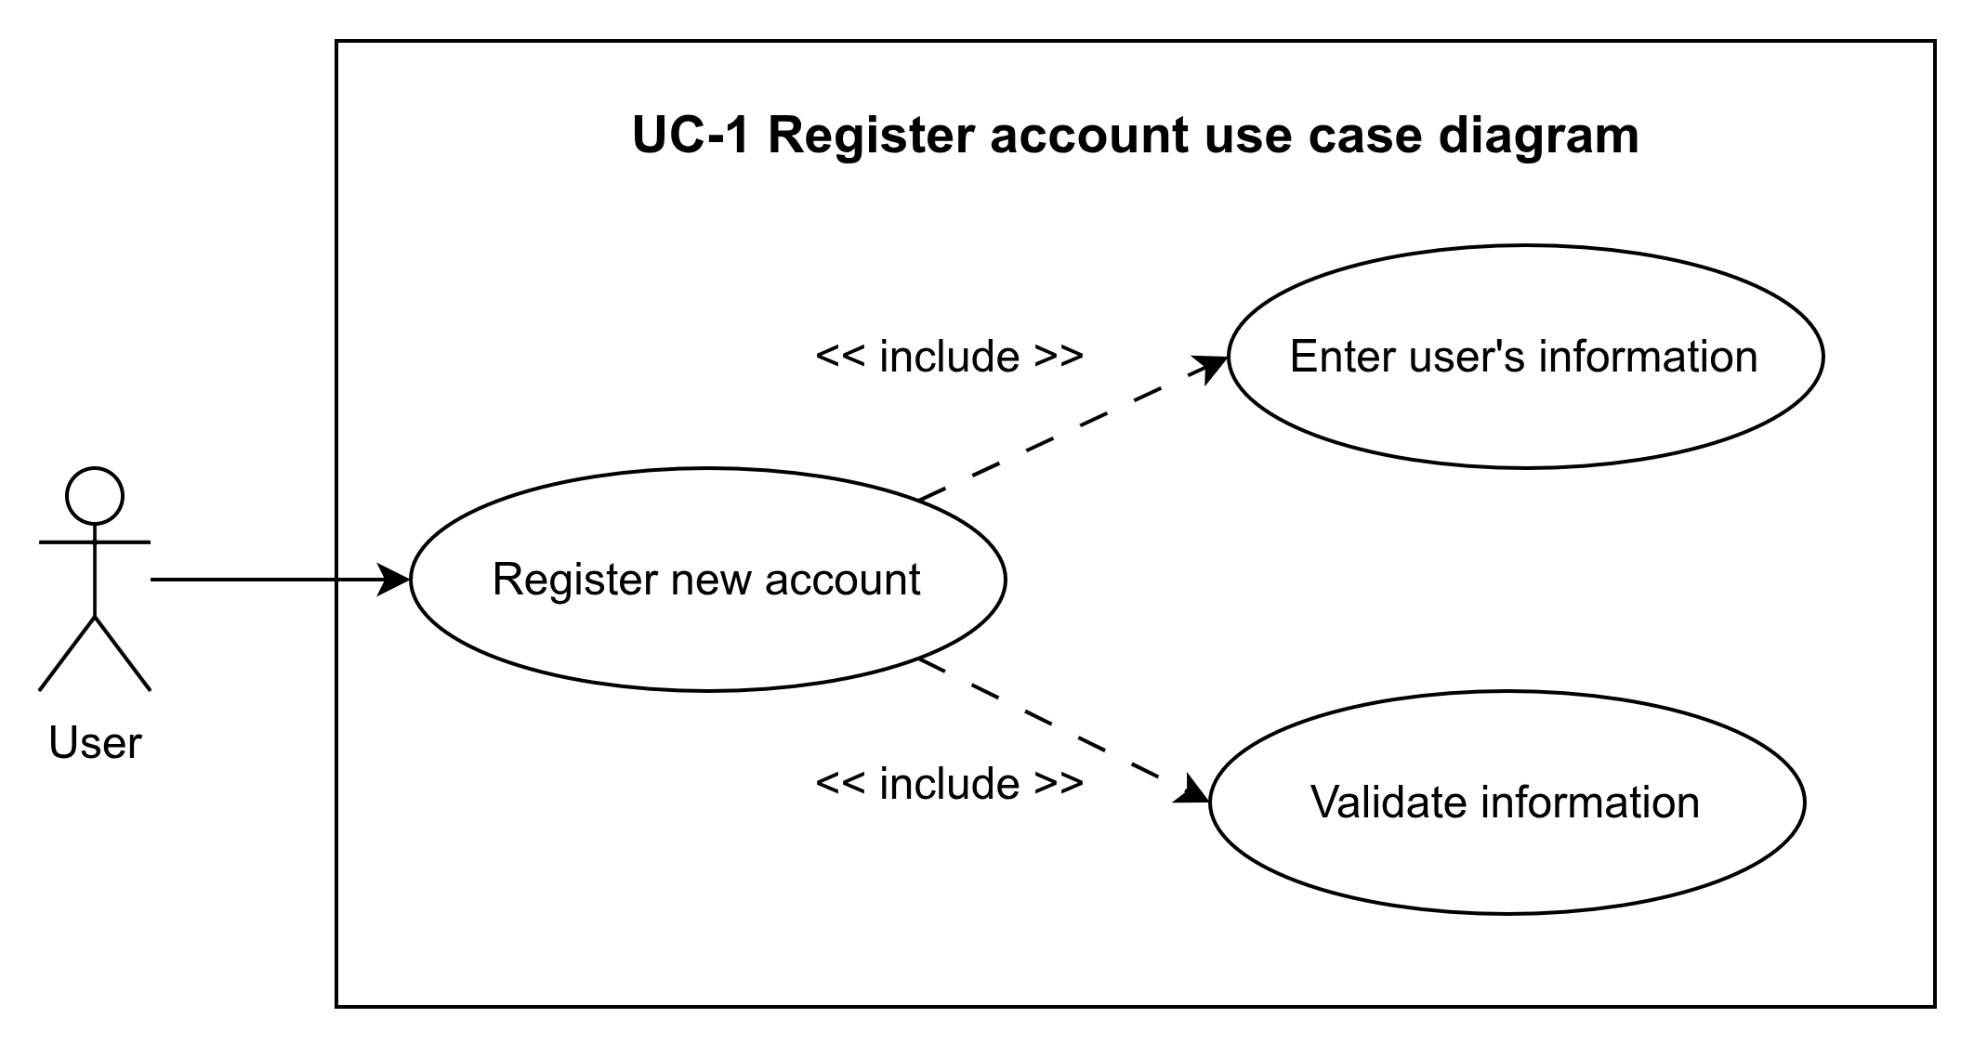
Image 3.2.1.1. use case diagram
3.2.2. Login use case
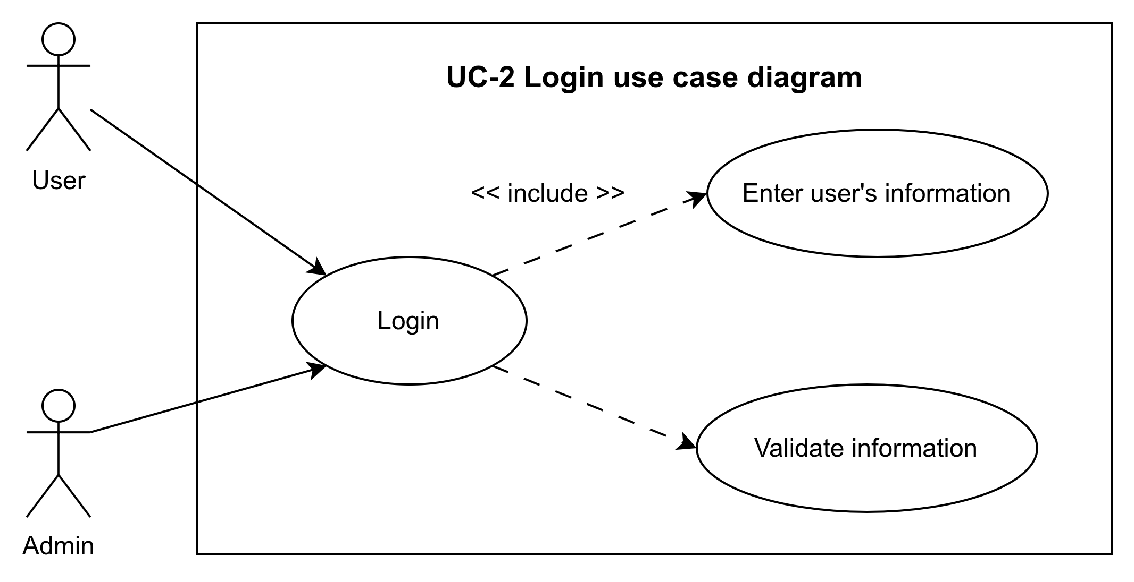
Image 3.2.2.1. use case diagram
3.2.3. Logout Use case
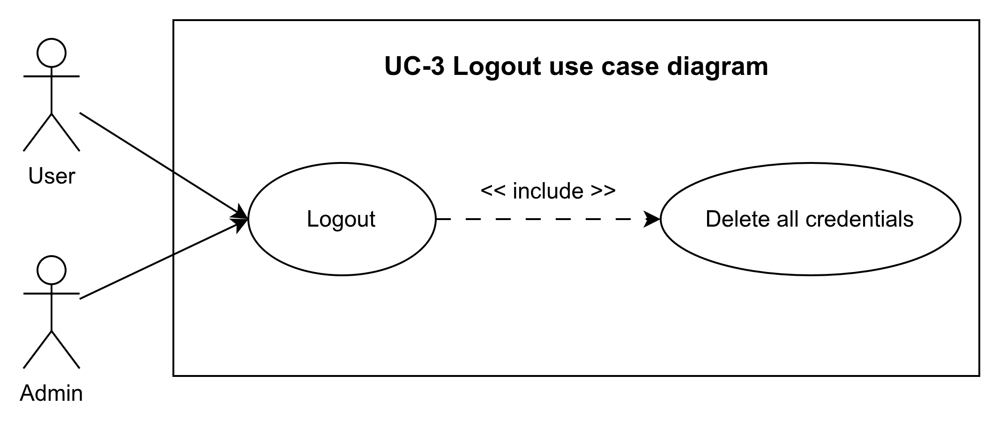
Image 3.2.3.1. use case diagram

3.2.4. Manage Profile Use case
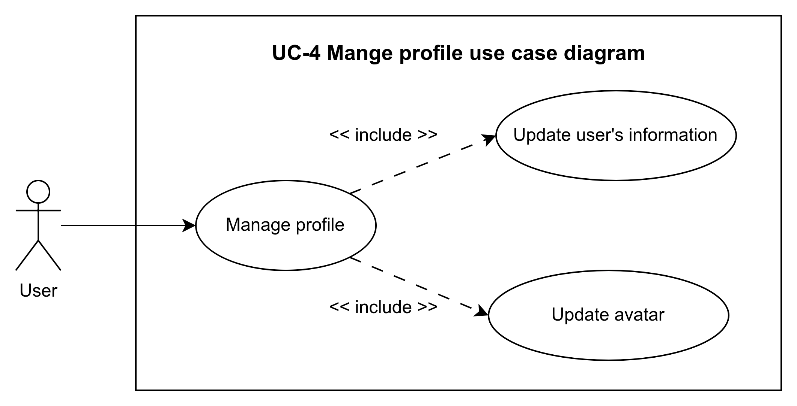
Image 3.2.4.1. use case diagram
3.2.5. Send support request Use case
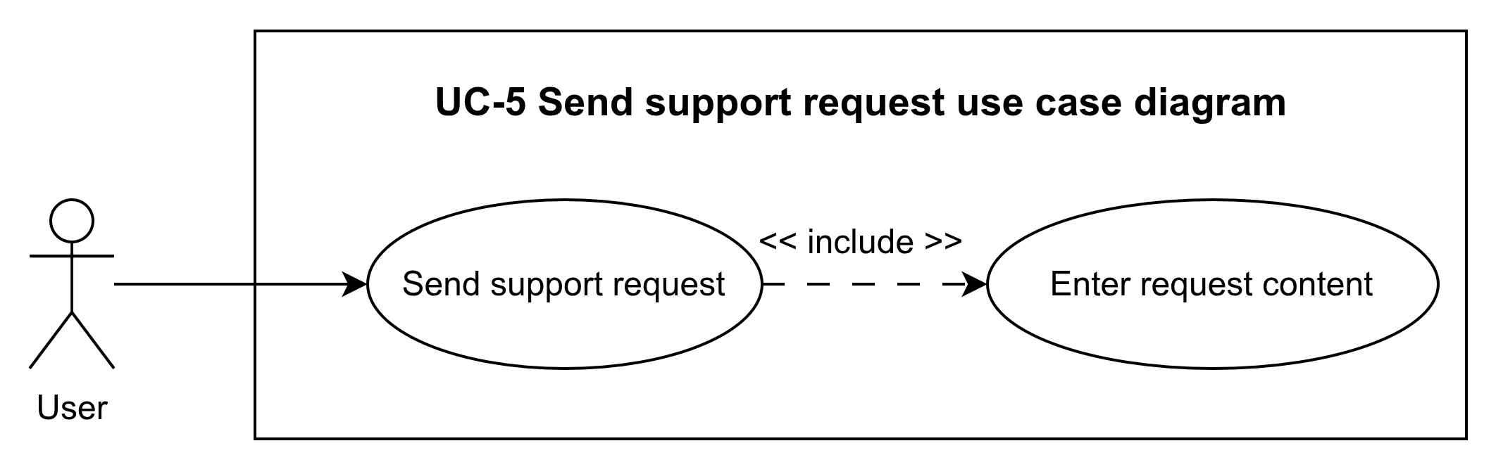
Image 3.2.5.1. use case diagram
3.2.6. Search fields Use case
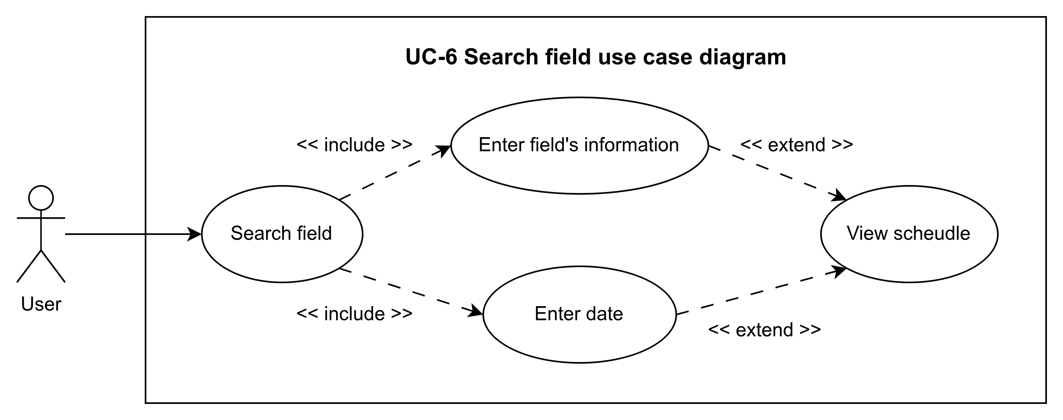
Image 3.2.6.1. use case diagram

3.2.7. Cancel and Reschedule Use case
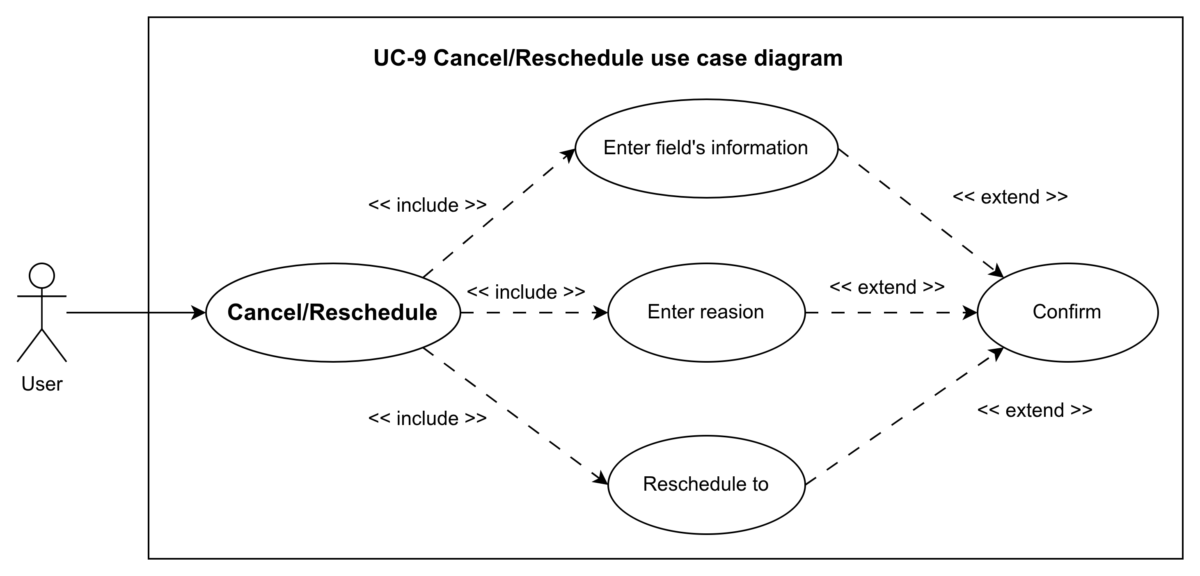
Image 3.2.7.1. use case diagram
3.2.8. Sending Mail
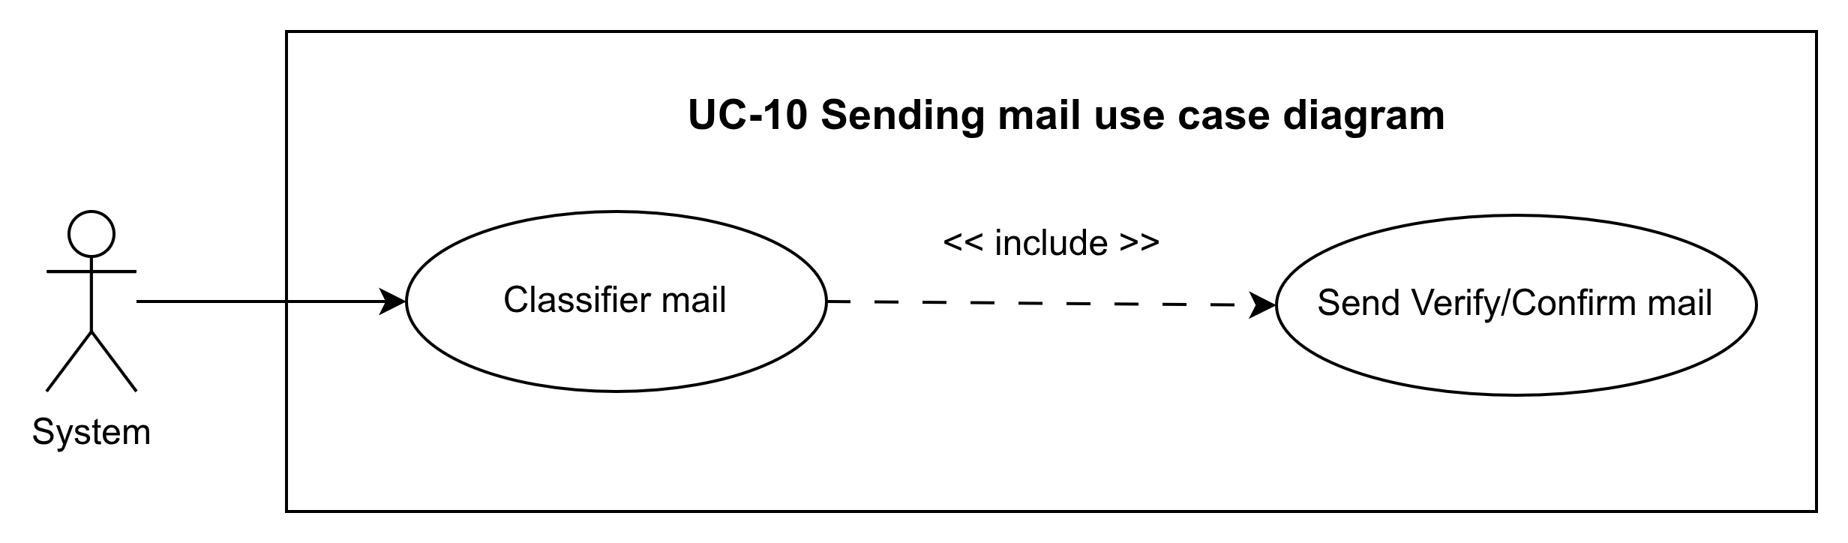
Image 3.2.8.1. use case diagram
3.2.9. Confirm and Reject Booking Use case
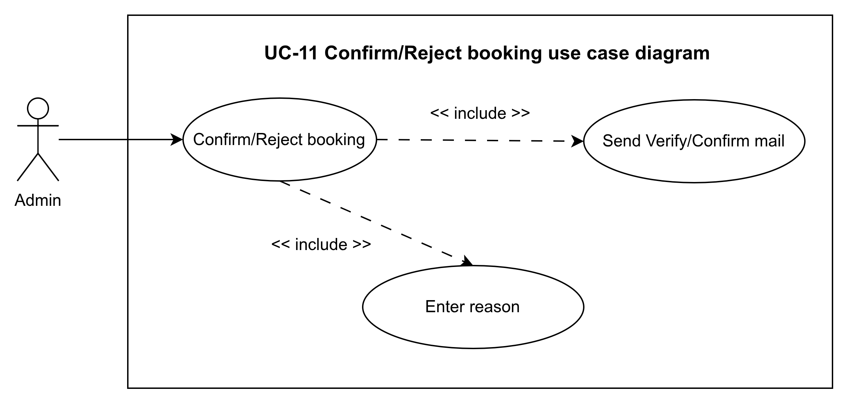
Image 3.2.9.1. use case diagram

3.2.10. Manage Field Use case
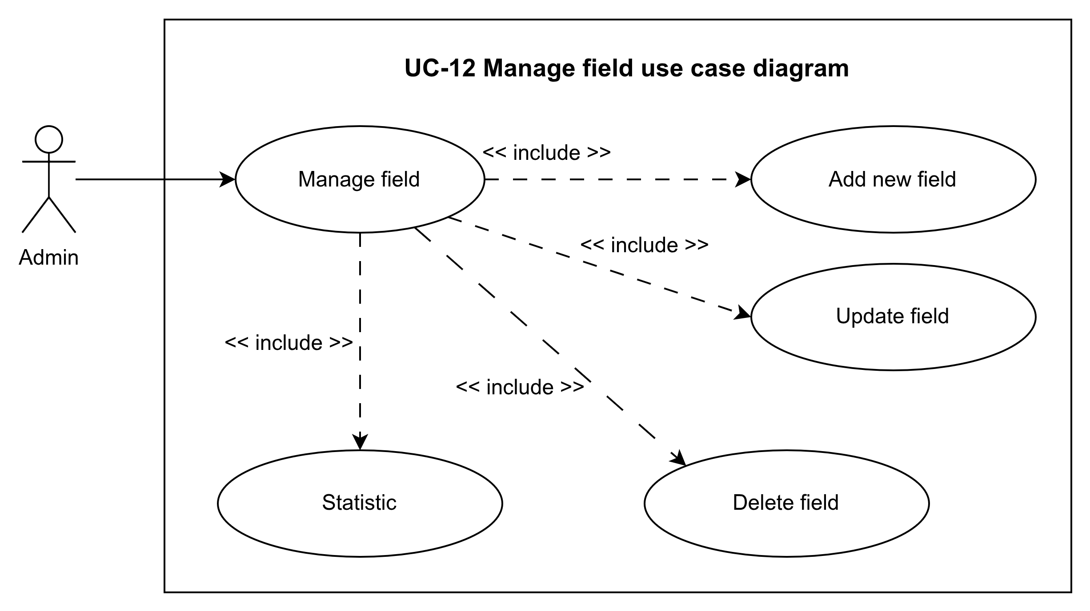
Image 3.2.10.1. use case diagram

3.3. Use case specification
3.3.1. Use case register account
Use Case Name | Register account
Scenario | A new user provides their details to create an account; the system records the user in an unverified state and sends a verification email.
Triggering event | User clicks “Sign Up” or “Register” on the public landing page.
Brief description | This use case allows a visitor to create a new customer account by submitting required personal information. After validation, the system stores the account as “Unverified,” generates a verification token, and sends a confirmation email with a link or code.
Actors | - Primary: User (prospective customer)  - Supporting: System (automated mailer)
Related use cases | - Includes:Send Confirmation Mail (UC-10)  - Extends: None  - Precedes: Verify Account (UC-2)
Stakeholders | - Prospective Customer: wants a quick, error-free registration process.  - Business / Operator: needs accurate user data and must ensure only verified accounts can book.  - System Administrator: monitors account creation volumes and handles any verification failures.
Preconditions | - User is on the public registration page.  - System’s email service is configured and operational.
Post conditions | - A new user record is created with status = "Unverified."  - A verification token is generated and stored.  - A confirmation email is sent.
Flow of activities(Actor) | 1. User navigates to the registration form.  2. User enters personal information.  3. User clicks "Register."
Flow of activities(System) | 1. Receive and validate input.  2. Check for existing email.  3. Create user record (Unverified).  4. Generate verification token.  5. Call Send Confirmation Mail (UC-10).  6. Display success message.
Exception conditions | - Missing/invalid input: return to form with errors.  - Email already registered: show "Email in use" message.  - Token generation failure: show error and abort.  - Email service unavailable: log and inform user to contact support.

Table 3.3.1.1. Use case register account specification

3.3.2. Login use case
Use Case Name | Login
Scenario | Registered user logs into the system using credentials.
Triggering event | User clicks "Login" after entering email and password.
Brief description | Authenticates credentials and establishes an authenticated session or issues an access token.
Actors | - Primary: User  - Supporting: System
Related use cases | - Preconditions for: Manage Profile, Search Fields, Booking, etc.
Stakeholders | - User  - System Administrator
Preconditions | - User account status = "Verified."
Post conditions | - User session is active.  - Access token/session cookie issued.
Flow of activities(Actor) | 1. User navigates to login page.  2. User enters credentials.  3. User clicks "Login."
Flow of activities(System) | 1. Receive credentials.  2. Validate email format and password.  3. Authenticate against database.  4. Issue session cookie or token.  5. Redirect to authorized area.
Exception conditions | - Invalid credentials: show "Invalid email or password."  - Account unverified: prompt to verify email.  - Account locked: inform user.

Table 3.3.2.1. Use case Login specification

3.3.3. Logout Use case
Use Case Name | Logout
Scenario | Authenticated user logs out of the system.
Triggering event | User clicks "Logout."
Brief description | Terminates the user session and returns to the public view.
Actors | - Primary: User  - Supporting: System
Related use cases | - Includes:  - Extends:  - Precedes:
Stakeholders | - User
Preconditions | - User is currently authenticated.
Post conditions | - Session is invalidated.  - User is redirected to the home page.
Flow of activities(Actor) | 1. User clicks "Logout."
Flow of activities(System) | 1. Invalidate session/token.  2. Redirect to public landing page.
Exception conditions | - Session invalidation error: log and still redirect.

Table 3.3.3.1. Use case log out specification
3.3.4. Manage Profile Use case
Use Case Name | Manage Profile
Scenario | Authenticated user views and updates personal profile.
Triggering event | User selects "Manage Profile" from the account menu.
Brief description | Allows editing of personal details such as name, contact, and password.
Actors | - Primary: User  - Supporting: System
Related use cases | - Preconditions: Login
Stakeholders | - User  - Business
Preconditions | - User is authenticated.
Post conditions | - Profile information is updated in the database.
Flow of activities(Actor) | 1. Navigate to profile page.  2. Update fields.  3. Click "Save."
Flow of activities(System) | 1. Validate inputs.  2. Update database record.  3. Confirm success to user.
Exception conditions | - Validation errors: return with messages.  - Database update failure: show error.

Table 3.3.4.1. Use case Manage profile specification
3.3.5. Send support request Use case
Use Case Name | Send support request
Scenario | An authenticated user submits a help or inquiry message to the system’s support team.
Triggering event | User clicks “Send Support Request” or “Help” after composing their message on the support page.
Brief description | This use case allows a user to describe an issue or ask a question. The system validates the request, records it in the support queue, and notifies the support staff (and optionally the user) that the request has been logged.
Actors | - Primary: User  - Supporting: System, Support Team (via dashboard or ticketing system)
Related use cases | - Preconditions: Login (UC-3), Manage Profile (UC-4)
Stakeholders | - End user: Needs timely help or answers.  - Support team: Needs clear, structured requests to resolve issues efficiently.  - Business Owner: Cares about customer satisfaction and SLA metrics.
Preconditions | 1. User is registered, verified, and currently authenticated.  2. Support subsystem (ticket queue) is online.
Post conditions | - A support ticket is created with a unique ID, timestamp, and status = “Open.”  - Support staff are notified (e.g. via dashboard alert or email).  - An acknowledgment is sent to the user (optional email or on-screen message).
Flow of activities(Actor) | 1. User navigates to “Support” or “Help” page.  2. User enters:  - Subject or category  - Detailed description of the issue/request  - (Optional) Attachments or screenshots  3. User clicks “Submit Request.”
Flow of activities(System) | 1. Validate user session.  2. Validate submitted fields (subject not empty, description length).  3. Create a new support ticket record in the database (status = “Open”).  4. Assign or queue the ticket for the support team.  5. Send on-screen confirmation to the user:  > “Your request (Ticket #1234) has been received. Our support team will contact you shortly.”  6. (Optional) Trigger **Send Confirmation Mail** to user with ticket details.  7. (Optional) Trigger internal notification to support staff.
Exception conditions | - Invalid Input:  • Missing subject or description → return to form with error message.  - Attachment Error:  • Upload fails (size/type) → inform user and allow retry without losing text.  - Database Failure:  • Unable to save ticket → show “System error, please try again later” and log error.  - Notification Failure:  • If email or internal alert fails, ticket remains created; system logs failure for retry.

Table 3.3.5.1. Use case Send support request specification
3.3.6. Search fields Use case
Use Case Name | Search Fields
Scenario | Authenticated user searches for available fields.
Triggering event | User enters criteria and clicks "Search."
Brief description | Filters fields by date, time, location, and returns availability list.
Actors | - Primary: User  - Supporting: System
Related use cases | - Preconditions: Login
Stakeholders | - User
Preconditions | - User is authenticated.
Post conditions | - List of matching fields is displayed.
Flow of activities(Actor) | 1. Enter search filters.  2. Click "Search."
Flow of activities(System) | 1. Receive criteria.  2. Query database.  3. Return results.
Exception conditions | - No results found: show appropriate message.  - System error: show generic error.

Table 3.3.6.1. Use case Search fields specification
3.3.7. Cancel and Reschedule Use case
Use Case Name | Cancel/Reschedule
Scenario | User cancels or reschedules an existing booking.
Triggering event | User selects a booking and clicks "Cancel" or "Reschedule."
Brief description | Allows modification or cancellation of pending or confirmed bookings.
Actors | - Primary: User  - Supporting: System
Related use cases | - Preconditions: Login  - Includes: Send Confirmation Mail (UC-10)
Stakeholders | - User  - Admin
Preconditions | - User has an existing booking.
Post conditions | - Booking status updated.  - Confirmation email sent.
Flow of activities(Actor) | 1. Navigate to bookings.  2. Choose booking.  3. Select Cancel or Reschedule.  4. If rescheduling, pick new slot.  5. Confirm action.
Flow of activities(System) | 1. Validate user session.  2. Check booking eligibility.  3. Update booking record.  4. Call Send Confirmation Mail.  5. Notify Admin if needed.
Exception conditions | - Booking not found: show error.  - Slot unavailable (for reschedule): prompt new slot.  - System error: show generic error.

Table 3.3.7.1. Use case Cancel and Reschedule specification
3.3.8. Sending Mail Use Case
Use Case Name | Sending Mail
Scenario | System sends automated emails for various events.
Triggering event | Completion of UC-1, UC-8, UC-9, or UC-11.
Brief description | Handles email generation and dispatch for confirmations and notifications.
Actors | - System  - Email Service
Related use cases | - Included by: Register, Booking, Cancel/Reschedule, Confirm/Reject
Stakeholders | - User  - Admin
Preconditions | - Valid recipient and template available.
Post conditions | - Email queued or sent.  - Log entry created.
Flow of activities(Actor) | NONE
Flow of activities(System) | 1. Load template.  2. Populate variables.  3. Send via Email Service.  4. Log result.
Exception conditions | - Invalid recipient: skip.  - Template missing: log error.  - Service failure: retry or alert.

Table 3.3.8.1. Use case Sending Mail specification

3.3.9. Confirm and Reject Booking Use case
Use Case Name | Confirm/Reject Booking
Scenario | Admin reviews and either confirms or rejects bookings.
Triggering event | Admin opens pending bookings list.
Brief description | Allows admin to approve or deny booking requests.
Actors | - Primary: Admin  - Supporting: System
Related use cases | - Preconditions: Login  - Includes: Send Confirmation Mail (UC-10)
Stakeholders | - Admin  - User
Preconditions | - Booking status updated.  - Notification sent to user.
Post conditions | - Booking status updated.  - Notification sent to user.
Flow of activities(Actor) | 1. Navigate to pending bookings.  2. Select a booking.  3. Click Confirm or Reject.
Flow of activities(System) | 1. Validate admin session.  2. Update booking status.  3. Call Send Confirmation Mail.  4. Log action.
Exception conditions | - Booking no longer pending: show error.  - System error: show generic error.

Table 3.3.9.1. Use case Confirm and Reject Booking specification

3.3.10. Manage Field Use case
Use Case Name | Manage Fields
Scenario | Admin manages field records and availability settings.
Triggering event | Admin selects "Manage Fields" in the admin dashboard.
Brief description | Enables CRUD operations on field entities and their schedules.
Actors | - Primary: Admin  - Supporting: System
Related use cases | - Preconditions: Login
Stakeholders | - Admin  - Business
Preconditions | - Admin is authenticated.
Post conditions | - Field data updated in the system.
Flow of activities(Actor) | 1. Navigate to Manage Fields.  2. Choose to Create, Update, or Delete.  3. Enter or modify field details.  4. Save changes.
Flow of activities(System) | 1. Validate admin session and input.  2. Perform database operation.  3. Confirm success to admin.
Exception conditions | - Missing/invalid data: return with errors.  - Conflict with active bookings: prevent deletion.  - System error: show generic error.

Table 3.3.10.1. Use case Manage Field specification

3.4. Sequence diagram
3.4.1. Register account use case
Image 3.4.1.1. Sequence diagram of Register account use case
3.4.2. Login use case
Image 3.4.2.1. Sequence diagram of Login use case
3.4.3. Logout use case
Image 3.4.3.1. Sequence diagram of Logout use case
3.4.4. Manage profile use case
Image 3.4.4.1. Sequence diagram of Manage profile use case
3.4.5. Send support request use case
Image 3.4.5.1. Sequence diagram of Send support request use case
3.4.6. Search fields use case
Image 3.4.6.1. Sequence diagram of Search field use case
3.4.7. Cancel and reschedule use case
Image 3.4.7.1. Sequence diagram of Cancel and reschedule use case
3.4.8. Sending mail use case
Image 3.4.8.1. Sequence diagram of Sending mail use case
3.4.9. Confirm and Reject Booking use case
Image 3.4.9.1. Sequence diagram of Confirm and Reject booking use case
3.4.10. Manage fields use case
Image 3.4.10.1. Sequence diagram of Manage fields use case
3.5. Sequence diagram
3.5.1. Register account use case
Image 3.5.1.1. Activity diagram of Register account use case
3.5.2. Login use case
Image 3.5.2.1. Activity diagram of Login use case
3.5.3. Logout use case
Image 3.5.3.1. Activity diagram of Logout use case
3.5.4. Manage profile use case
Image 3.5.4.1. Activity diagram of Manage profile use case
3.5.5. Send support request use case
Image 3.5.5.1. Activity diagram of Send support request use case
3.5.6. Search fields use case
Image 3.5.6.1. Activity diagram of Search field use case
3.5.7. Cancel and reschedule use case
Image 3.5.7.1. Activity diagram of Cancel and reschedule use case
3.5.8. Sending mail use case
Image 3.5.8.1. Activity diagram of Sending mail use case
3.5.9. Confirm and Reject Booking use case
Image 3.5.9.1. Activity diagram of Confirm and Reject booking use case
3.5.10. Manage fields use case
Image 3.5.10.1. Activity diagram of Manage fields use case
3.6. Class diagram
Image 3.6.1. Class diagram
3.7. Entity relational diagram
Image 3.7.1. Entity relational diagram
CHAPTER 4. ACTUAL PROCESS
4.1. Software development life cycle model
4.1.1. Introduction to Agile/Scrum model
4.1.2. Advantages
4.1.3. Defect
4.1.4. Reason for choosing model
4.2. Architecture use
CHAPTER 5. DEMO CODE
5.1 User interface
5.2 Admin interface
CHAPTER 6. TEST CASE AND UNIT TEST

