**实验题目1**：获取键盘事件，分别用[W,S,A,D]来控制示例中的矩阵点上下左右移动。

**代码及运行：**

import pygame  
import sys  
from pygame.locals import *  
pygame.init() # 初试化pygame  
  
white_colour = pygame.Color(255, 255, 255) # 白色  
black_colour = pygame.Color(0, 0, 0) # 黑色  
game_surface = pygame.display.set_mode((600, 400)) # 设置pygame游戏框大小  
pygame.display.set_caption("贪吃蛇") # 设置游戏标题  
  
def main():  
 head_position = [100, 100] # 蛇的初试位置  
 while True:  
 game_surface.fill(black_colour) # 背景填充为黑色  
 pygame.draw.rect(game_surface, white_colour, Rect(head_position[0], head_position[1], 20, 20)) # 在[100, 100]处画20*20的矩形  
 for event in pygame.event.get():  
 if event.type == pygame.QUIT: # 如果是退出键则退出游戏  
 sys.exit()  
 elif event.type == pygame.KEYDOWN and event.key == 27: # 按esc键退出游戏  
 sys.exit()  
 elif event.type == pygame.KEYDOWN and event.key == 119:  
 head_position[1] = head_position[1] - 20  
 elif event.type == pygame.KEYDOWN and event.key == 115:  
 head_position[1] = head_position[1] + 20  
 elif event.type == pygame.KEYDOWN and event.key == 100:  
 head_position[0] = head_position[0] + 20  
 elif event.type == pygame.KEYDOWN and event.key == 97:  
 head_position[0] = head_position[0] - 20  
 pygame.display.update()  
  
main()

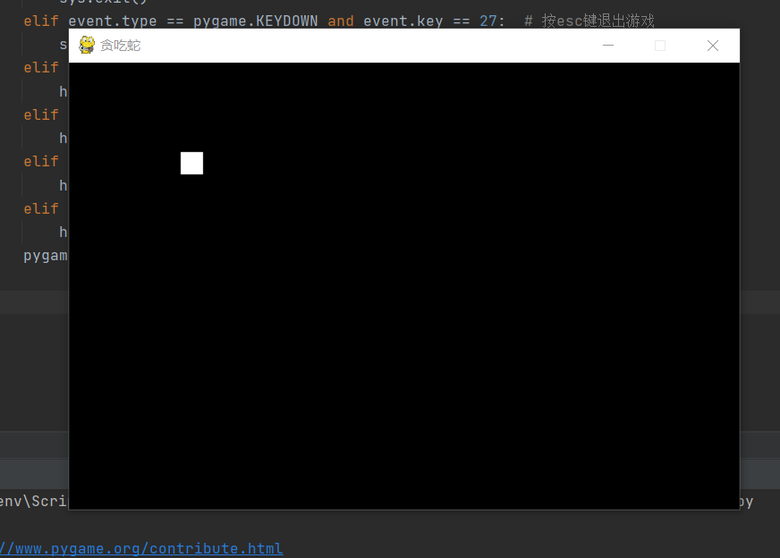

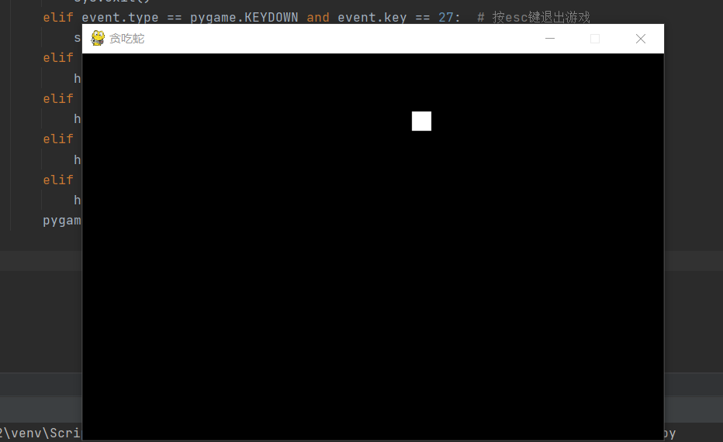

**实验题目2**：添加边界死亡条件。

**代码及运行：**

# 这是一个pygame的最小开发框架  
import pygame  
import sys  
from pygame.locals import *  
pygame.init() # 初试化pygame  
  
white_colour = pygame.Color(255, 255, 255) # 白色  
black_colour = pygame.Color(0, 0, 0) # 黑色  
game_surface = pygame.display.set_mode((600, 400)) # 设置pygame游戏框大小  
pygame.display.set_caption("贪吃蛇") # 设置游戏标题  
  
def main():  
 head_position = [100, 100] # 蛇的初试位置  
 while True:  
 game_surface.fill(black_colour) # 背景填充为黑色  
 pygame.draw.rect(game_surface, white_colour, Rect(head_position[0], head_position[1], 20, 20)) # 在[100, 100]处画20*20的矩形  
 for event in pygame.event.get():  
 if event.type == pygame.QUIT: # 如果是退出键则退出游戏  
 sys.exit()  
 elif event.type == pygame.KEYDOWN and event.key == 27: # 按esc键退出游戏  
 sys.exit()  
 elif event.type == pygame.KEYDOWN and event.key == 119:  
 head_position[1] = head_position[1] - 20  
 elif event.type == pygame.KEYDOWN and event.key == 115:  
 head_position[1] = head_position[1] + 20  
 elif event.type == pygame.KEYDOWN and event.key == 100:  
 head_position[0] = head_position[0] + 20  
 elif event.type == pygame.KEYDOWN and event.key == 97:  
 head_position[0] = head_position[0] - 20  
 #w,a,s,d键移动  
 # elif event.type == pygame.KEYDOWN:  
 # print("您的按键键值是：", event.key)  
 elif head_position[0]<0 or head_position[0]>590:  
 print('game over')  
 sys.exit()  
 elif head_position[1] < 0 or head_position[1] > 390:  
 print('game over')  
 sys.exit()  
 # 增加死亡判断功能  
  
 pygame.display.update()  
  
main()

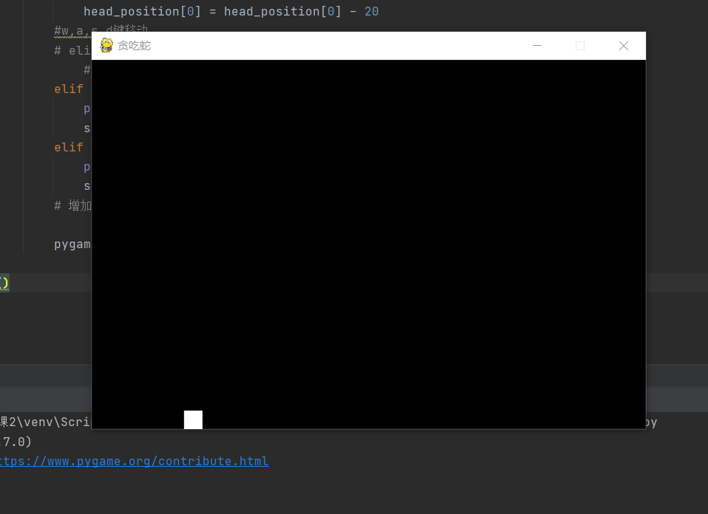

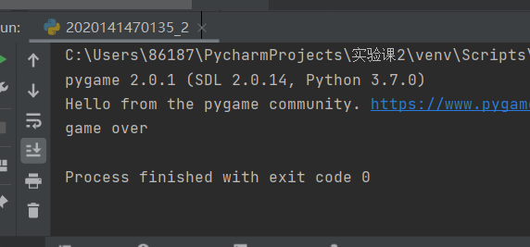

显示死亡