IBM Server Test Synopsis

Aims
The aims of the tests run at IBM were threefold:
- To test the limits of the server’s ability to handle large volumes of concurrent players
- To test the server’s load balancing capabilities with more cells and entities than ever done previously
- To verify that server load scales roughly linearly with respect to the number of entities

Test Procedures and Hardware
The large scale tests were carried out at the IBM Deep Computing facility in Poughkeepsie, NY. We uploaded our server and tools to the facility via a VPN connection, running and monitoring the tests via remote SSH (secure shell) sessions. We installed our various logging applications on the IBM servers to log the test results to disk, which we downloaded to our machines for analysis after the tests were complete. Because of the scale of the tests, the volume of data being logged (which was often gigabytes per test) prevented it being streamed to Sydney in real-time for live analysis.
In all tests, the machines used were dual 3.0GHz Xeons with 3GB of RAM and gigabit ethernet running Redhat Enterprise Linux 3. The cluster machines were connected via high capacity switches. These are basically pretty standard high-end server machines.
For the first two tests, we had 96 machines, 16 of which were Hyper-Threading enabled, and we usually used 80 for running the server and 16 for running bots.
For the third and final test, we had 128 machines, 22 of which were HT enabled, and we used 107 machines for running the server and 21 for bots and logging.

Handling of Large Volumes of Concurrent Players
This test was performed on the first IBM test cluster by adding bots to a 40km x 40km square region of a single space. We were able to achieve a total of 100,000 concurrently connected clients, as shown in the Space Viewer display in Figure 1 below:

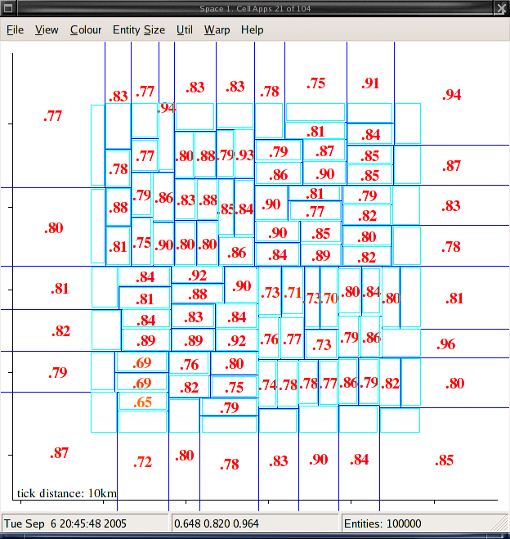
Figure 1. Space Viewer showing 100,000 concurrent clients
Briefly, Space Viewer is our tool that allows us to see a summary of the cell and entity distribution across a single space in the game world. The dark blue lines represent the cell extents (i.e. the area of the world each cell is responsible for) and within each cell, the light blue rectangle indicates the actual extents of the entities located within that cell. This is the only practical way of representing entity positions when dealing with tens of thousands of entities; it is not practical to log and display this volume of entity positions. The number in each cell indicates that cell’s load, between 0 and 1. The colour of that number is a visual aid to quickly ascertain load, where 0 is green and 1 is red, with blue, yellow, then orange in between.
The server was maintained at this level for an hour with no significant loss of clients by disconnection. Using this particular layout of entities, the 80 machines running the server are handling approximately 1250 entities each, or 625 per CPU. As far as we know, no other game engine has ever handled this volume of simultaneously connected clients in a single shard, let alone a single continuous Cartesian space.

Load Balancing Demonstration
To test the load balancing capabilities of the server, a large number of clients was connected to the server, and then their distributions were shifted from one pattern to another (e.g. square, 8 pointed star, randomly scattered “villages”). The server is expected to allocate cells and move their boundaries such that the load across all cell machines is as equal as possible. This feature of the server’s allows it to cope with shifts in load distribution over time, moving in extra cells to cope with increases in load, and retiring cells to conserve CPU and power usage when they are not needed. This also means that administrators can add or remove machines from a BigWorld cluster at will, and the server will always make the best use of the resources available to it.
As some of the movement patterns used concentrated more entities into particular locations, the average load they generate differs from pattern to pattern (more dense distributions require more updates per client, as each client can see a larger number of entities).
These are the results from the 8 pointed star test. Initially, we have 30000 clients distributed evenly across a 40km x 40km space:
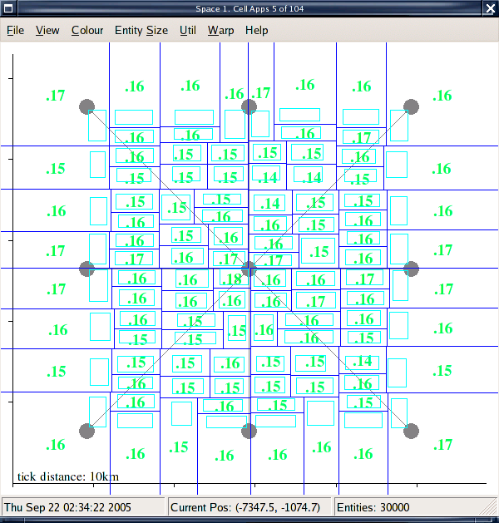
Figure 2. 30000 entities distributed evenly across a 40km x 40km region
The clients begin walking to one of the points on the star, and the load increases as the clients begin bunching up around the points of the star and its centre. The important thing to notice here is that even with a shifting entity distribution (and cell layout), the minimum and maximum loads differ from the average load by less than 5%:
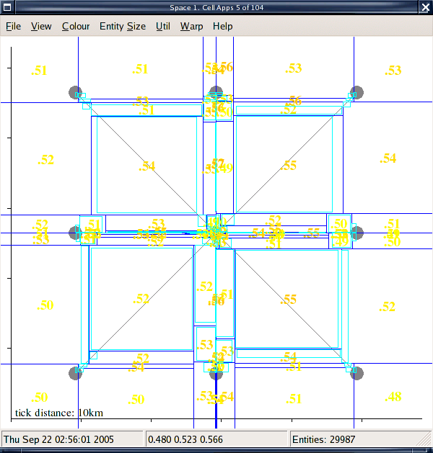
Figure 3. The 30000 entities are now crowded at 9 locations
As the clients begin walking the paths between the points of the star and the centre, the density decreases and the distribution shifts back towards the centre, however the load still stays balanced to within ±5% of average load:
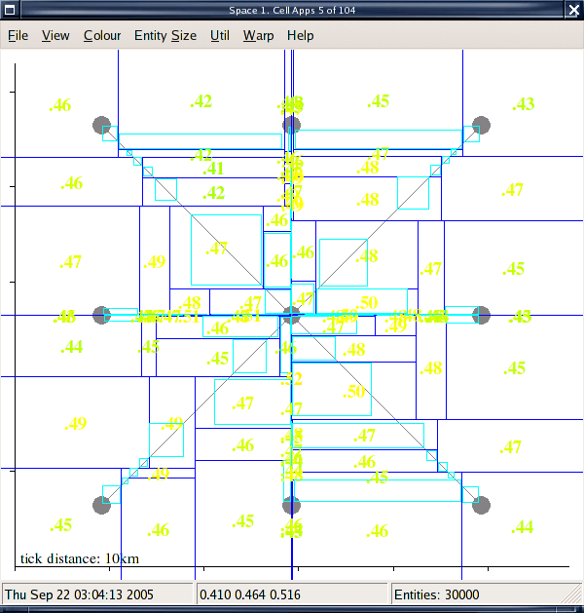
Figure 4. Clients begin traversing the paths from the points to the centre
Tests with other movement patterns produced greatly varying average loads (due to great variation in average density) however all tests showed that the server distributed load evenly over the available cellapps.

Scalability
An important feature of the BigWorld server is that load scales roughly linearly with respect to number of entities. More specifically, for all other variables such as AI, frequency of activity etc held constant, increasing the number of entities (clients and NPCs) should produce a linearly proportionate increase in overall server load. This is important because it means that a BigWorld server has no “glass ceiling” for performance, where the amount of extra hardware required to progressively increase the entity capacity of the server would become prohibitive. Simply put, with a BigWorld server, if you want to double the number of entities, you should expect to double the amount of hardware in the cluster; BigWorld will expand as much as the customer base requires for a predictable cost.
The following results are taken from the 2nd (128 machine) IBM cluster. In each test, the effect of different server settings is examined, but the important thing to note is that as entities are added to the server, the load grows linearly. In each test, the desired cell load was set to 20%, and in each set of results we see:
- Average load (green) held constant while number of active cells (purple) increases linearly, then
- Number of active cells held constant (i.e. all cellapps are now active) while average load increases linearly.
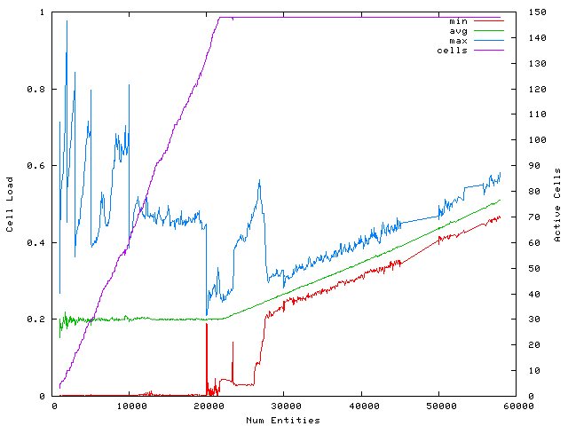
Figure 5. Graph of cell load and active cells vs. number of entities for Test 2

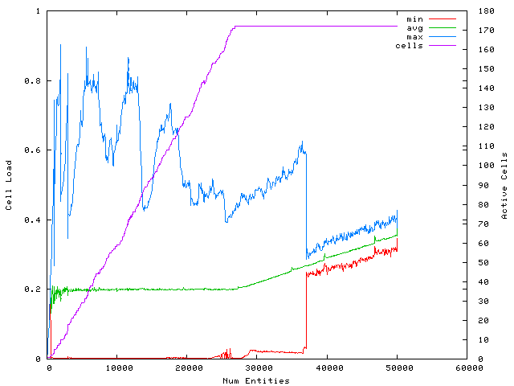
Figure 6. Graph of cell load and active cells vs. number of entities for Test 3
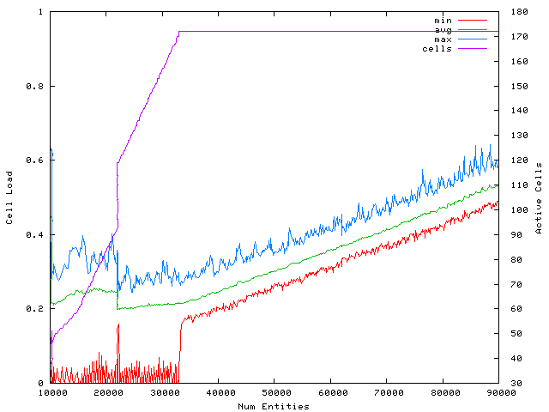
Figure 7. Graph of cell load and active cells vs. number of entities for Test 4
In Figure 7, the apparent “instant” jump in number of active cells around 20000 entities is only so relative to number of entities; at this point in the test we stopped adding entities briefly, which gave the server time to bring in more cells to drop the average load to 0.2. This explains the multiple data points when number of entities is 20000.
These results demonstrate that the BigWorld server does indeed scale linearly and therefore also that any BigWorld based game would be free to expand as much as its customer base demanded.

Conclusions
The tests demonstrate convincingly that the main features of the BigWorld server operate effectively under the high capacities it is intended for. In particular, evidence that the server scales linearly with entity counts is reassuring for us as developers and our clients, as the ability to scale with customer demand is important for any MMOG company.
Possible future work that was highlighted by the tests includes:
- Refining our server output logging mechanism which at present is based on simple text files, since generating raw text output for this volume of machines and processes is not practical.
- Possibly alter the load balancing algorithm to not require alternating horizontal/vertical splits and to allow re-balancing of the BSP, to try to avoid the “thin cells” cell distribution that can be caused by entities walking in east-west or north-south lines en masse (see Figure 3 for an example of this)
- It would be useful to run tests with both simple NPCs and virtual clients connected to try to approximate the rough costs of NPCs relative to clients, disregarding additional costs related to complex AI. This would also help with the profiling of API calls such as pathing, which could lead to optimisations where appropriate.
- We are now pursuing a re-factoring of our server tools into a single web interface, which will help alleviate some of the cross-platform issues we experience in developing the server tools for both Windows and Linux, and will make them more accessible from a remote-management perspective, both for ourselves in test situations like this and for server administrators for our customer’s games.
- We will need to provide more sophisticated cluster management tools for file distribution, shell access and other common admin tasks when operating a large server cluster such as this. IBM had their own suite of tools to do this (dcp, dsh etc), but since there is no standard solution available for this, we will need to provide our own.

