Project Report

Qualification Name | Professional Diploma in Data Science
Module Name | WSQ -Machine Learning Algorithms and Methods (SF)

Student name |  | As | sessor name
TOH KENG LENG |  | TOH
Date issued | Completion date |  | Submitted on
110325 | 190325 |  | 190325
Project title | Classification, regression, clustering and sentiment analysis using Azure Machine Learning

Learner declaration
I certify that the work submitted for this assignment is my own and research sources are fully acknowledged.

190325

Student signature: Date:

1. Project Background 3
2. Project Objective 3
3. Project Specifications 7
4. Project Tasks 8
4A. Activity 1 8
4B Activity 2 46
4C Activity 3 53
4D. Activity 4 67
Lab14 85

Document Version History

Version Number | Effective Date of release |  | Details | Author
1.0 | 15 Nov 2024 | Initial Creation |  | Ismayil Siyad

1. Project Background

<Explain the Project in your own words in 15 – 20 lines>
In this Modular Project at ABC Tech Solutions, I will engage in the full lifecycle of creating and managing data tasks using Azure's cloud-based resources. The primary goal is to explore and utilize Azure's data storage and machine learning tools, from setting up a secure data environment to automating model creation and evaluation. I will execute tasks that involve preprocessing data, and leveraging pipelines for both classification and regression. I will use pipelines to cluster the data and perform sentiment analysis on the text data and classify the sentiments.

2. Project Objective

<List down the top 5 objectives of the project>
Perform the following activities:
Activity 1: Regression Model for Sleep Hours Prediction
Objective: Develop a regression model to predict Sleep_Hours using the student performance dataset.
- Tasks:
  - Create Azure ML Workspace:
    - Create a new Azure Machine Learning workspace.
  - Create Compute Resources:
    - Set up a compute cluster within the workspace.
  - Register Dataset:
    - Register the student performance dataset as a tabular data asset in Azure ML Studio.
  - Create and Run Regression Model Pipeline:
    - Build and execute the regression pipeline as described below.
  - Evaluate Model Performance:
    - Document model performance using the evaluation metrics. • Label Column: Sleep_Hours
- Pipeline Steps:
  - Import Dataset: Begin with the student performance dataset by importing it into the Azure ML Designer.
  - Clean Missing Data: Use the "Clean Missing Data" module to handle missing values in the dataset, selecting strategies to remove entire row with missing values on all columns.
  - Normalize Data: Apply the "Normalize Data" with Z-Score algorithm on numerical datasets to scale numerical features, which helps the model handle features with different scales effectively.
  - Edit Metadata: Use the "Edit Metadata" module to ensure that all categorical columns are correctly flagged.
  - Convert to Indicator Values: Implement the "Convert to Indicator Values" (onehot encoding) module to transform categorical features into numerical format suitable for machine learning models.
  - Split Data: Use the "Split Data" module to divide the dataset into training (80%) and testing (20%) sets to validate the model's performance.
  - Train Models:
    - Neural Network Regression: Add the "Neural Network Regression" module to capture complex relationships between input features and the target variable.
    - Boosted Decision Tree Regression: Include the "Boosted Decision Tree Regression" module to handle non-linear relationships and interactions between features.
  - Tune Hyperparameters: For both models, use the "Tune Model Hyperparameters" module to optimize the model settings for better performance and configure with label column.
  - Score Model: Use the "Score Model" module to apply the trained models to the test dataset and generate predictions.
  - Evaluate Model: Connect the scored outputs to the "Evaluate Model" module to compare the performance of both models using metrics like Mean Absolute Error (MAE) and Root Mean Squared Error (RMSE).
Activity 2: Binary Classification for Learning Disability Prediction
Objective: Develop a binary classification model to predict Learning_Disability using the student performance dataset.
- Tasks:
  - Create Azure ML Workspace:
    - Create a new Azure Machine Learning workspace.
  - Create Compute Resources:
    - Set up a compute cluster.
  - Register Dataset:
    - Register the student performance dataset as Tabular data asset.
  - Create and Run Classification Model Pipeline:
    - Execute the pipeline as described below. • Label Column: Learning_Disability
- Pipeline Steps:
  - Import Dataset: Start with importing the student performance dataset into Azure ML Designer.
  - Clean Missing Data: Utilize the "Clean Missing Data" module to address missing values with appropriate strategies.
  - Normalize Data: Use the "Normalize Data" module to standardize numerical features.
  - Edit Metadata: Adjust column data types using the "Edit Metadata" module to differentiate between numerical and categorical features.
  - Convert to Indicator Values: Apply the "Convert to Indicator Values" module for one-hot encoding of categorical variables.
  - Split Data: Employ the "Split Data" module to create training (80%) and testing (20%) datasets.
  - Train Models:
    - Two-Class Boosted Decision Tree: Add the "Two-Class Boosted Decision Tree" module to handle binary classification with feature interactions.
    - Two-Class Neural Network: Integrate the "Two-Class Neural Network" module for non-linear classification tasks.
  - Tune Hyperparameters: Use the "Tune Model Hyperparameters" module to optimize both models.
  - Score Model: Apply the "Score Model" module to generate predictions on the test set.
  - Evaluate Model: Use the "Evaluate Model" module to compare the models, focusing on Accuracy, Precision, Recall, and F1 Score.
  - Evaluate Model Performance:
    - Analyze model results using classification metrics.
Activity 3: Clustering of Student Performance Data
Objective: Cluster the student performance data based on all available features to identify patterns among students.
- Tasks:
  - Create Azure ML Workspace:
    - Set up a new Azure Machine Learning workspace.
  - Create Compute Resources:
    - Set up a compute instance and compute cluster.
  - Register Dataset:
    - Register the student performance dataset.
  - Create and Run Clustering Model Pipeline:
    - Build and run the clustering pipeline as outlined.
  - Evaluate Clustering Results:
    - Document the cluster characteristics and patterns found.
- Pipeline Steps:
  - Import Dataset: Load the student performance dataset into Azure ML Designer.
  - Clean Missing Data: Use the "Clean Missing Data" module to handle missing entries.
  - Normalize Data: Apply "Normalize Data" to adjust numerical features to a common scale.
  - Edit Metadata: Use "Edit Metadata" to correct feature types.
  - Convert to Indicator Values: Use one-hot encoding via "Convert to Indicator Values" to handle categorical data.
  - Train Clustering Model:
    - K-Means Clustering: Add the "K-Means Clustering" module to group students into clusters.
  - Assign Data to Clusters: Use the "Assign Data to Clusters" module to label each student with a cluster ID.
  - Evaluate Clustering: Use the "Evaluate Model" module to assess cluster quality and interpret results.
Activity 4: Sentiment Analysis on Sentiment Data
Objective: Perform sentiment analysis on the provided text data to classify the sentiments.
- Tasks:
  - Create Azure ML Workspace:
    - Set up a new Azure Machine Learning workspace to host and run the pipeline.
  - Create Compute Resources:
    - Set up a compute instance and compute cluster within the Azure ML workspace to execute the pipeline.
  - Register Dataset:
    - Register the sentiment dataset as a tabular data asset in Azure ML Studio.
  - Create and Run Sentiment Analysis Pipeline:
    - Construct the pipeline in Azure ML Designer following the described steps.
  - Evaluate Sentiment Analysis Results:
    - Document the evaluation results and provide insights from the performance metrics. • Label Column: sentiment
- Pipeline Steps:
  - Import Dataset: Load the sentiment dataset into Azure ML Designer.
  - Preprocess Text:
    - Use the "Preprocess Text" module to clean the text data. This step involves removing stop words, punctuation, and performing other standard text preprocessing techniques to prepare the data for feature extraction.
- Split Data:
  - Use the "Split Data" module to divide the dataset into training and testing sets, with a split ratio of 50% for training and 50% for testing. This ensures that both the training and testing datasets are sufficiently large and balanced.
- Extract N-Gram Features:
      - First N-Gram Extraction:
      - Use the "Extract N-Gram Features from Text" module with specific configurations:
      - Text Column: The column used is the preprocessed text column named Preprocessed selected_text.
      - Vocabulary Mode: Set to "Create" to generate vocabulary from the training data.
      - N-Grams Size: Set to 2, capturing both unigrams and bigrams.
      - Weighting Function: Use "TF-IDF Weight" to weigh the ngrams based on term frequency and inverse document frequency.
      - Minimum Word Length: Set to 3, excluding very short words that may not carry significant meaning.
      - Maximum Word Length: Set to 25 to limit the length of ngrams.
      - Minimum N-Gram Document Absolute Frequency: Set to 5, ensuring that only n-grams that appear in at least 5 documents are included.
      - Maximum N-Gram Document Ratio: Set to 1, allowing all frequent n-grams to be considered.
      - Normalize N-Gram Feature Vectors: Enabled to normalize the feature vectors.
      - Second N-Gram Extraction:
      - Another "Extract N-Gram Features from Text" module is used with the vocabulary mode set to "ReadOnly". This reuses the vocabulary generated from the training dataset to extract features from the test dataset, ensuring consistent feature extraction across both sets.
- Select Columns in Dataset:
  - Use the "Select Columns in Dataset" module to exclude the original text columns (selected_text and Preprocessed selected_text), keeping only the extracted n-gram features for training the model.
- Train Model:
    - Multiclass Logistic Regression:
    - Add the "Multiclass Logistic Regression" module to perform the sentiment classification based on the extracted n-gram features.
    - Use the "Train Model" module to train the logistic regression model using the training dataset.
- Score Model:
▪ Apply the "Score Model" module to evaluate the trained model on the test dataset, generating predicted labels and probabilities.
- Evaluate Model:
▪ Use the "Evaluate Model" module to assess the performance of the sentiment analysis model. Key metrics include accuracy, precision, recall, and confusion matrix, which provide insights into the classification performance.

3. Project Specifications

<List and give brief of the technical tools used in the project >
< Explain approaches to execute the project>
Creating pipelines via virtual lab cannot create many components in pipeline. It takes longer time to process in 1.5 hour. We have to create parts by parts and configure and submit to jobs. After that we add on features. Those components that have already been submitted to jobs will be skipped by the system, Azure ML Studio. Unless you use your own personal account, there is no such worries. You have free account to use that costs US$200. However, whatever you perform tasks there are addon costs. These costs are charged monthly. However the previous components that are already configured and submitted to job will not reflect in flat lists of jobs. If you submit to job and job fails, you correct the errors and resubmit to job using existing experiment name. the new pipeline that is corrected and submitted to job successfully will not appear in flat list of jobs. It will only show failed pipeline job. You have to change to tree and select the new successful pipeline.

4. Project Tasks

4A. Activity 1

Please include screenshots and explanations in the provided space below.
- Screenshots of the Azure ML Workspace, and compute cluster.
- Screenshots of the regression pipeline setup and results.
- Performance evaluation results.

Azure ML Workspace

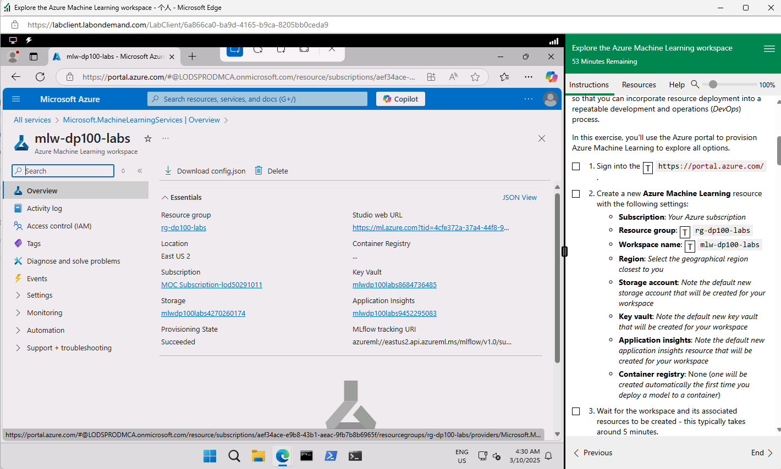

compute cluster

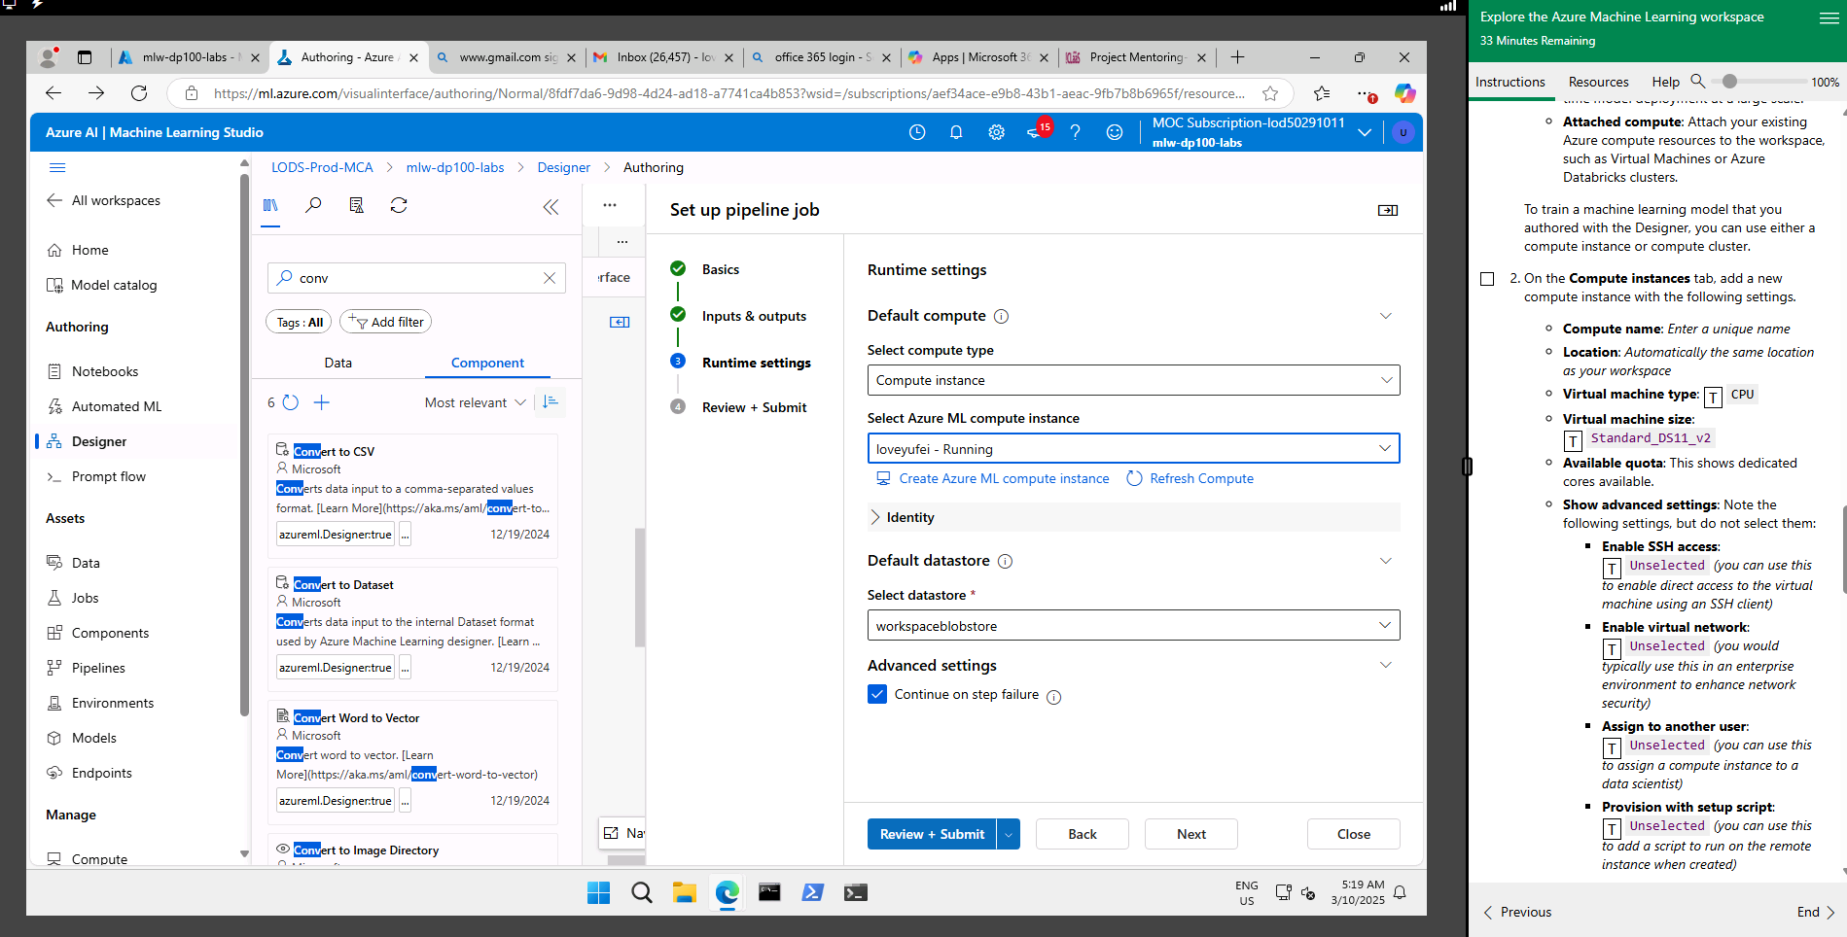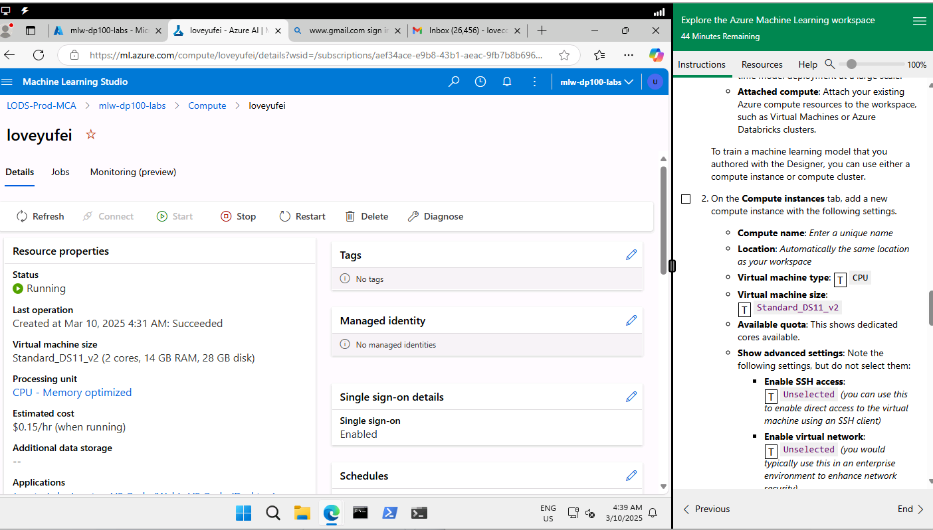

Screenshots of the regression pipeline setup and results

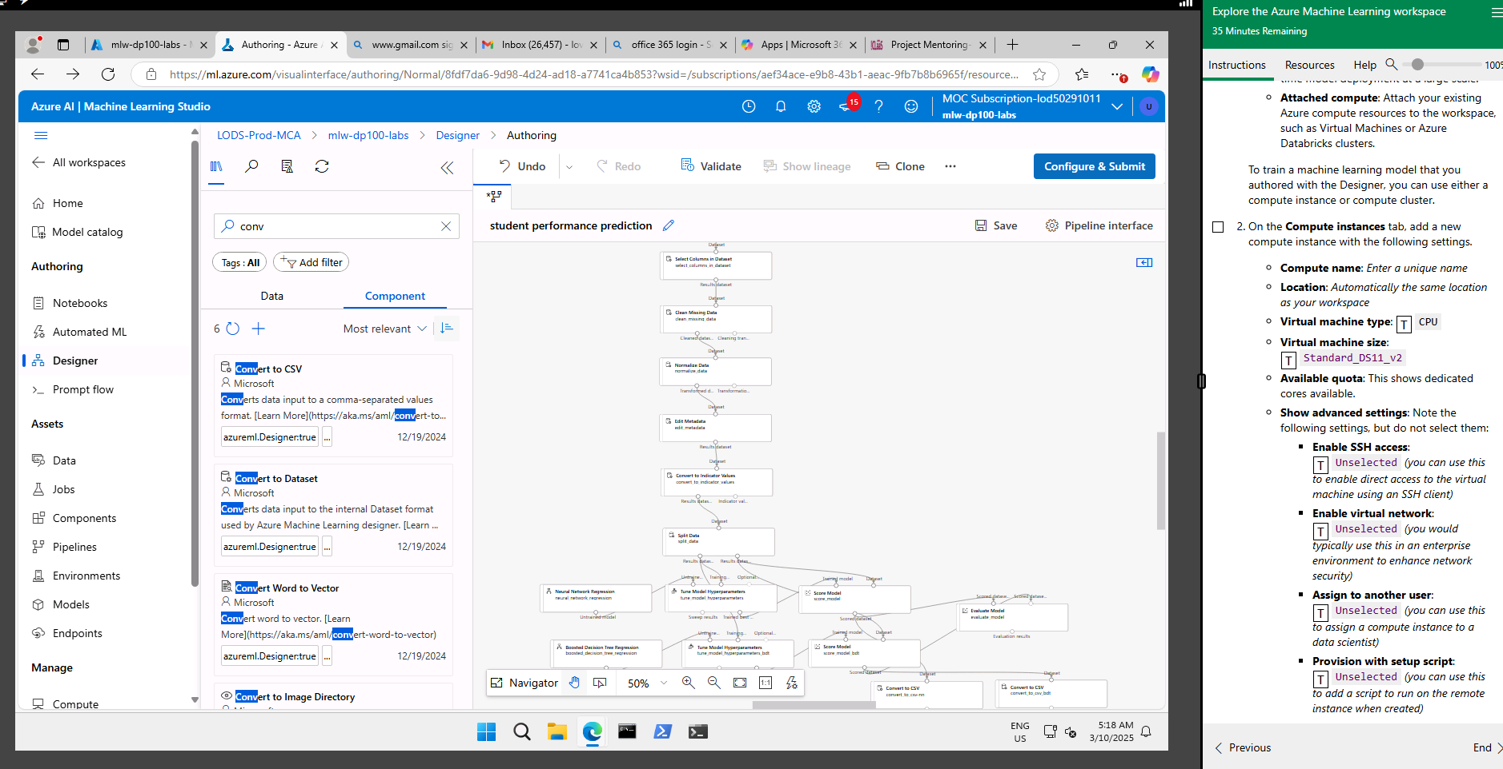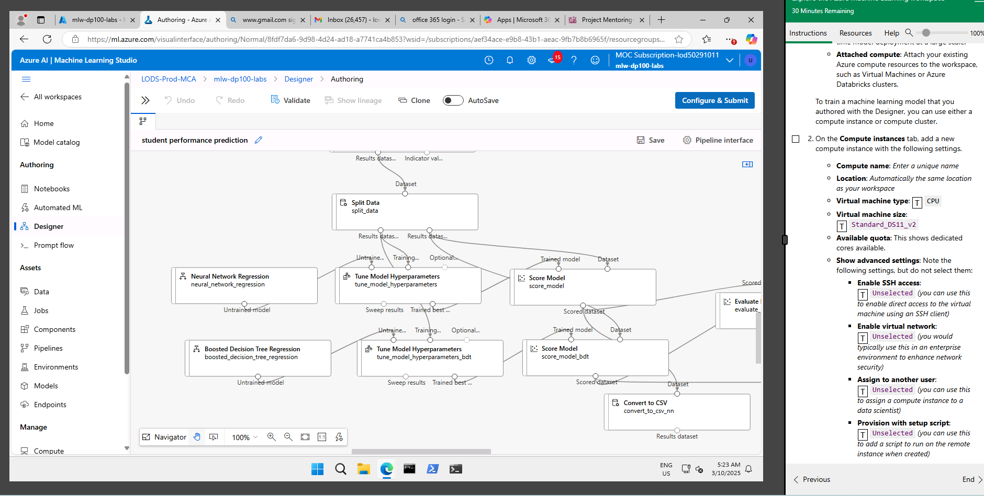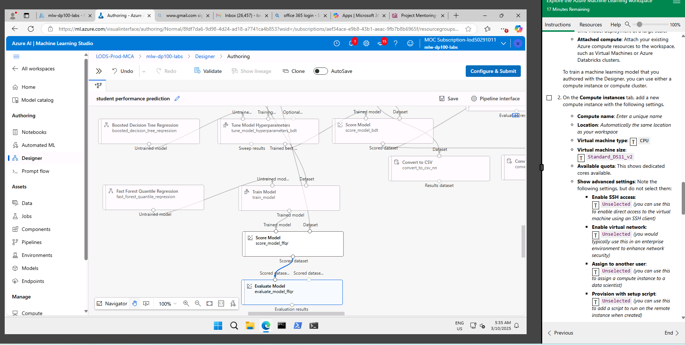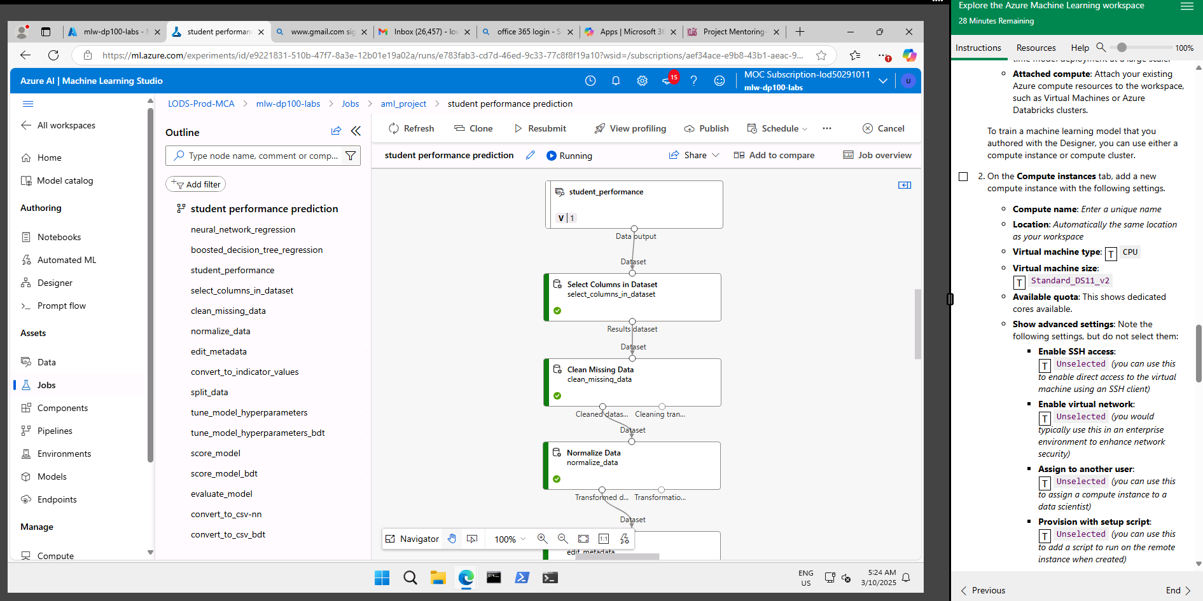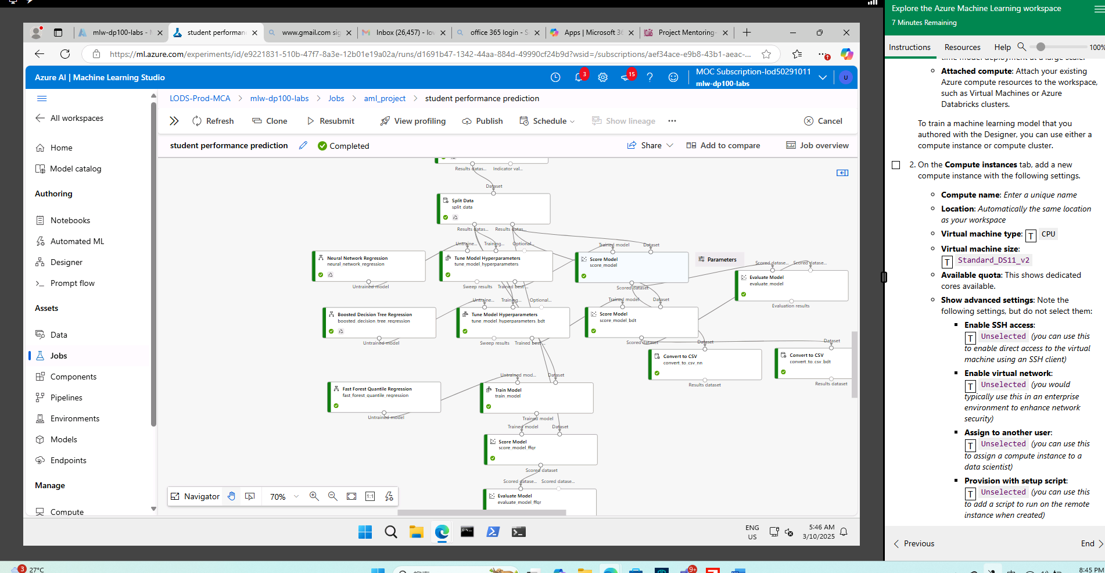

Performance evaluation results

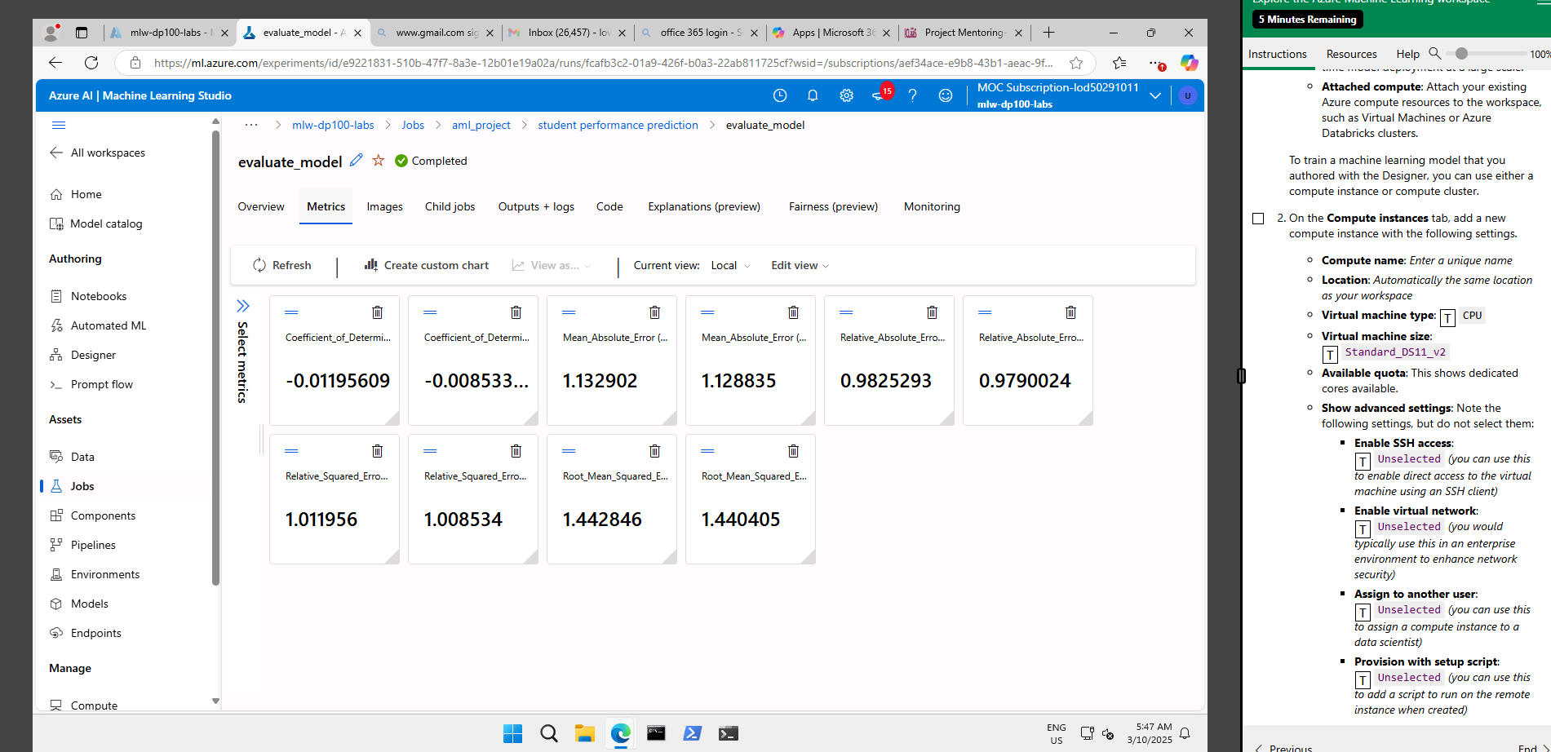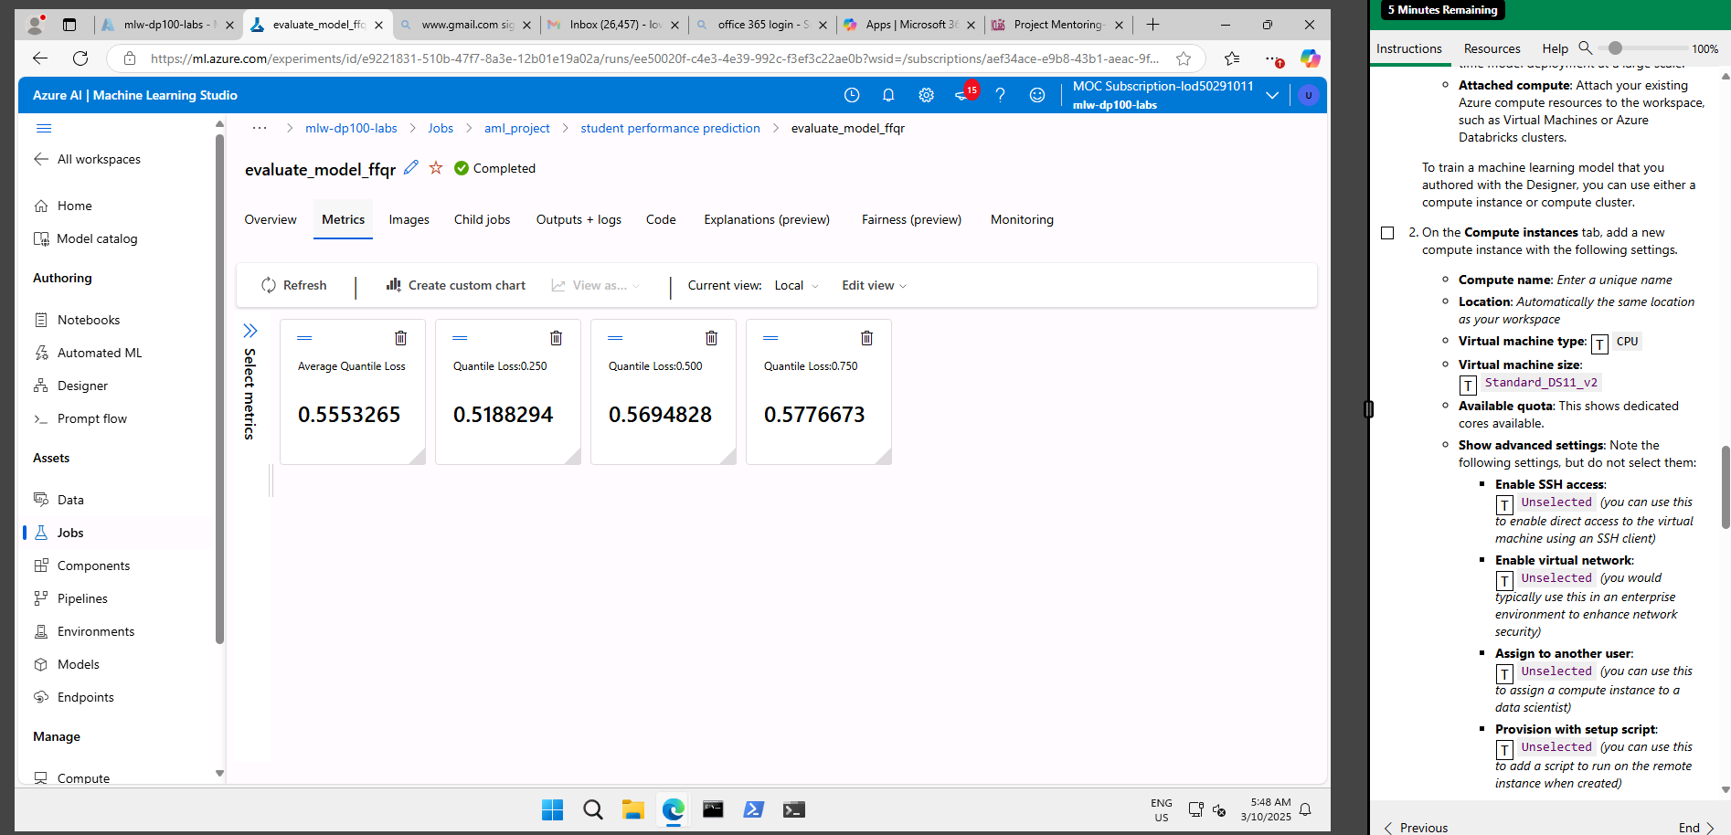

R^2score is more towards 0, positive value for boosted decision regression tree.
Left: neural network
Right: boosted decision tree

Re run pipelines with below parameters
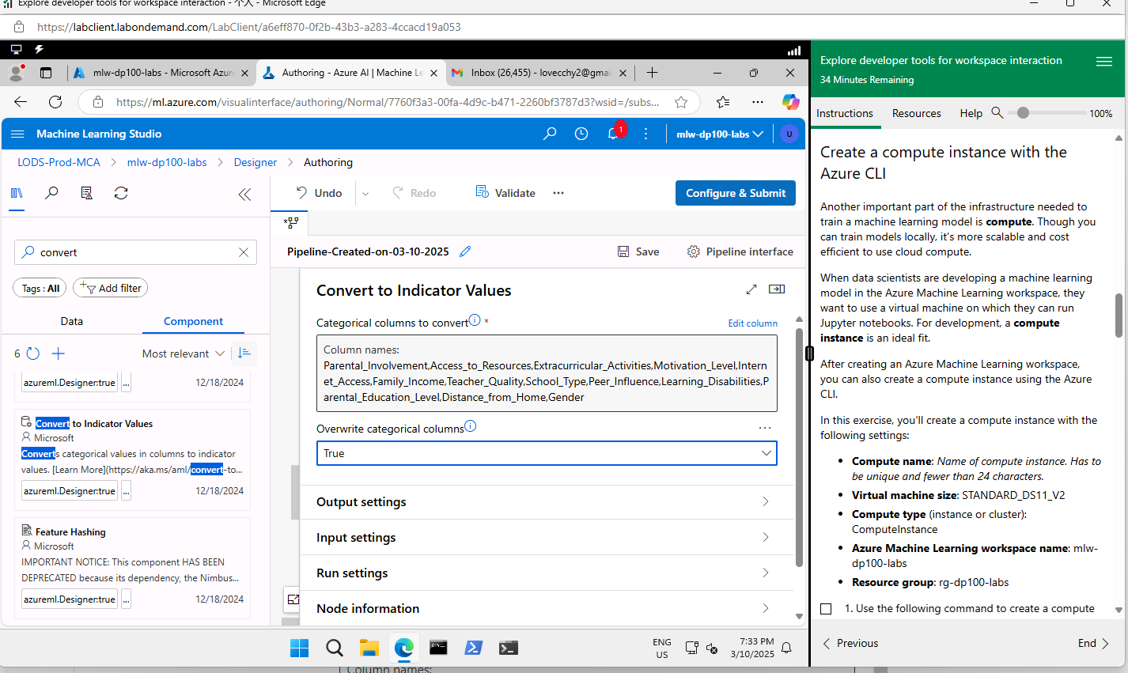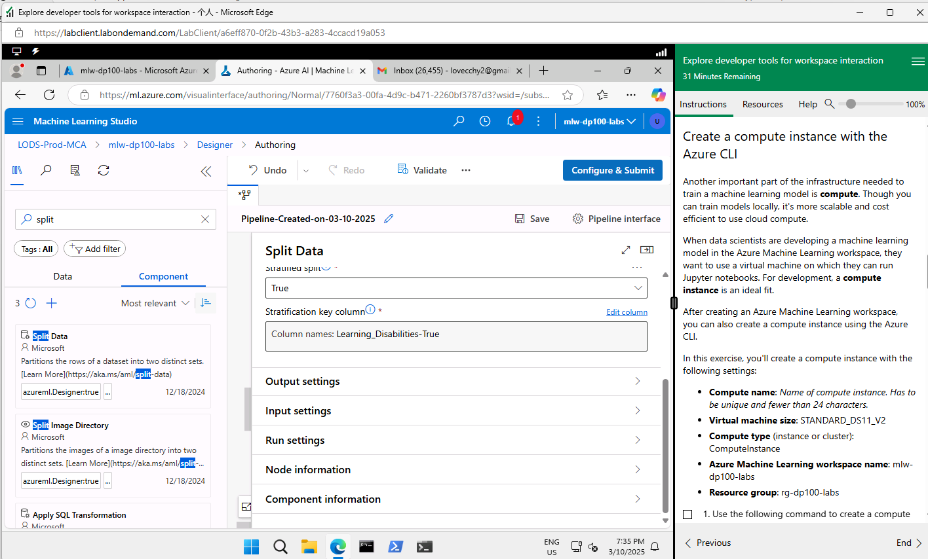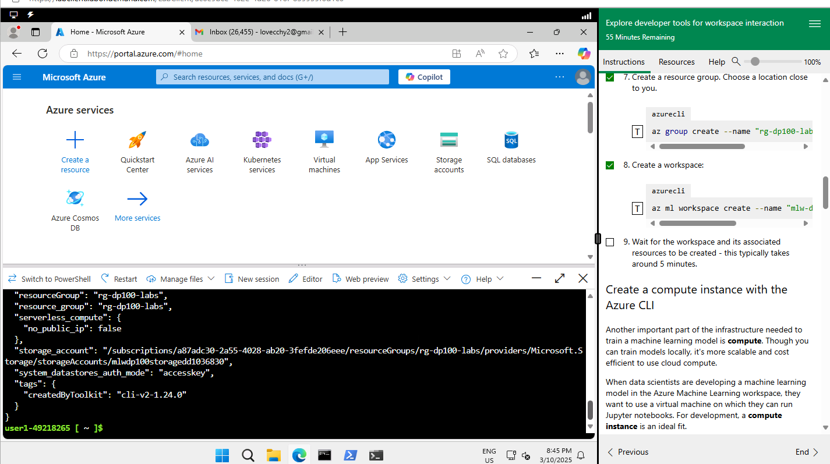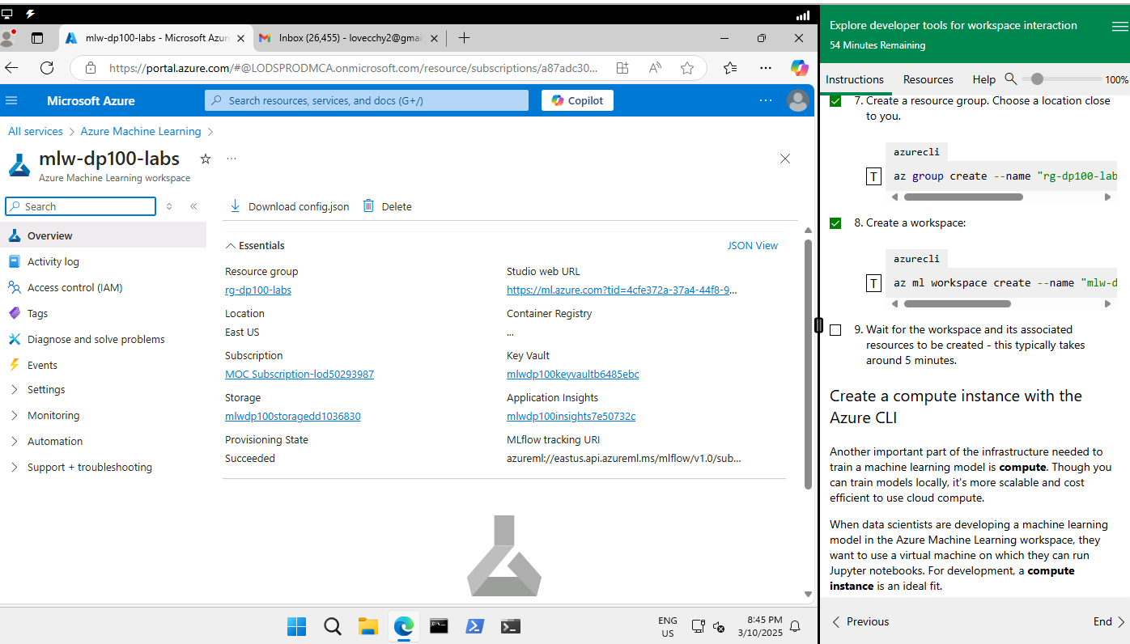

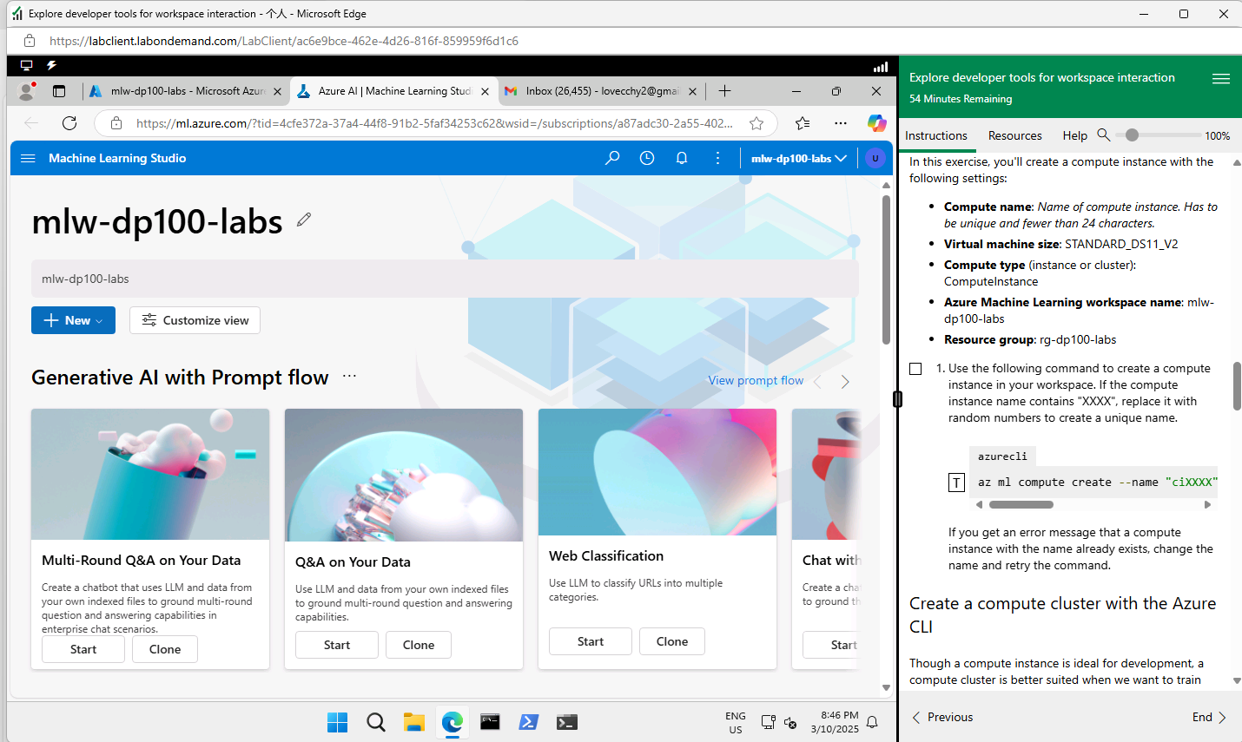

For compute instances, use navigation method. Because it is tedious to key in the whole command in azure cloudshell -> bash.
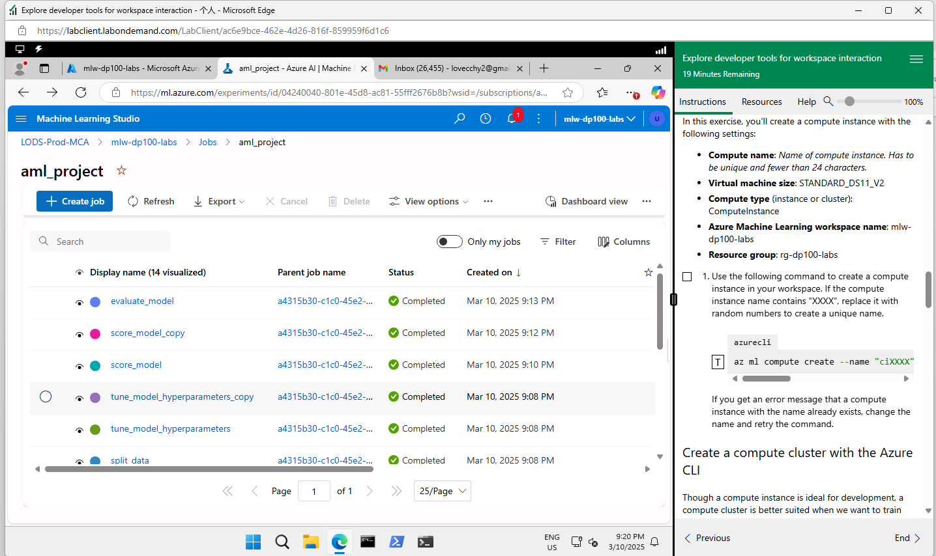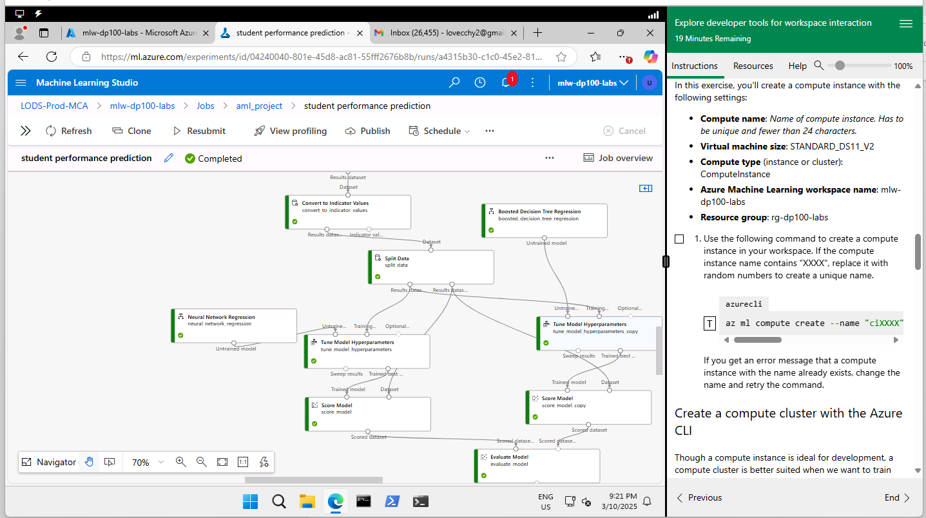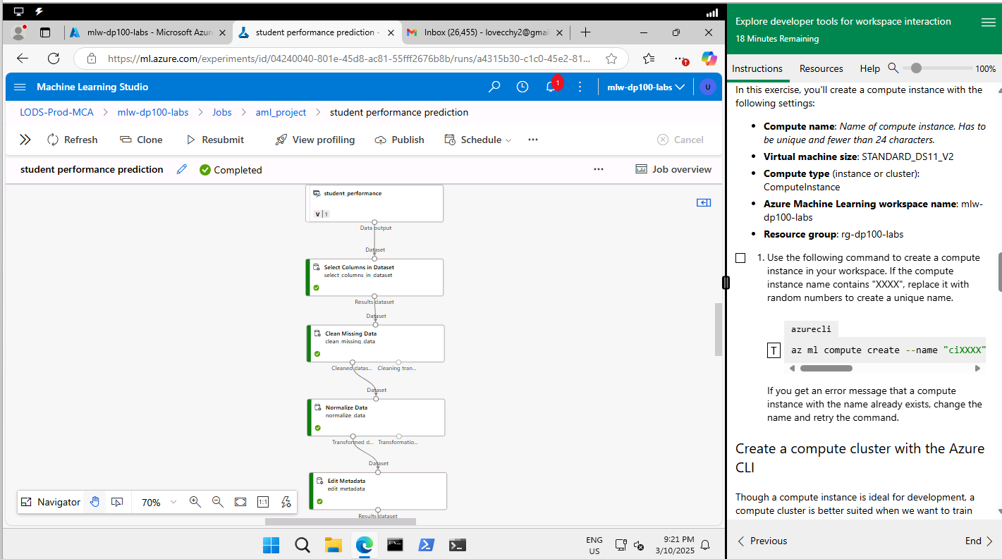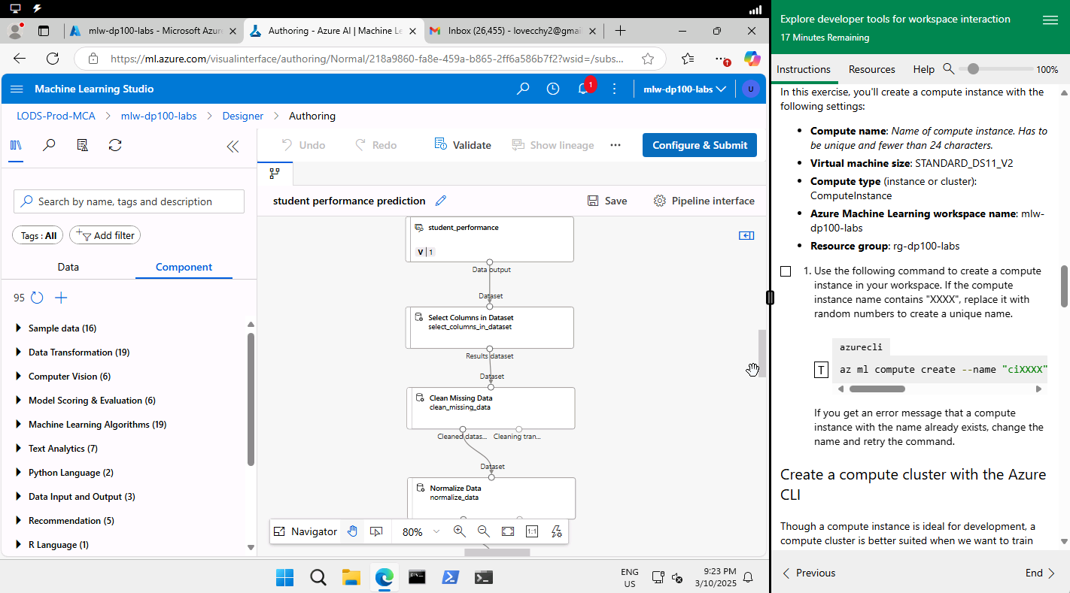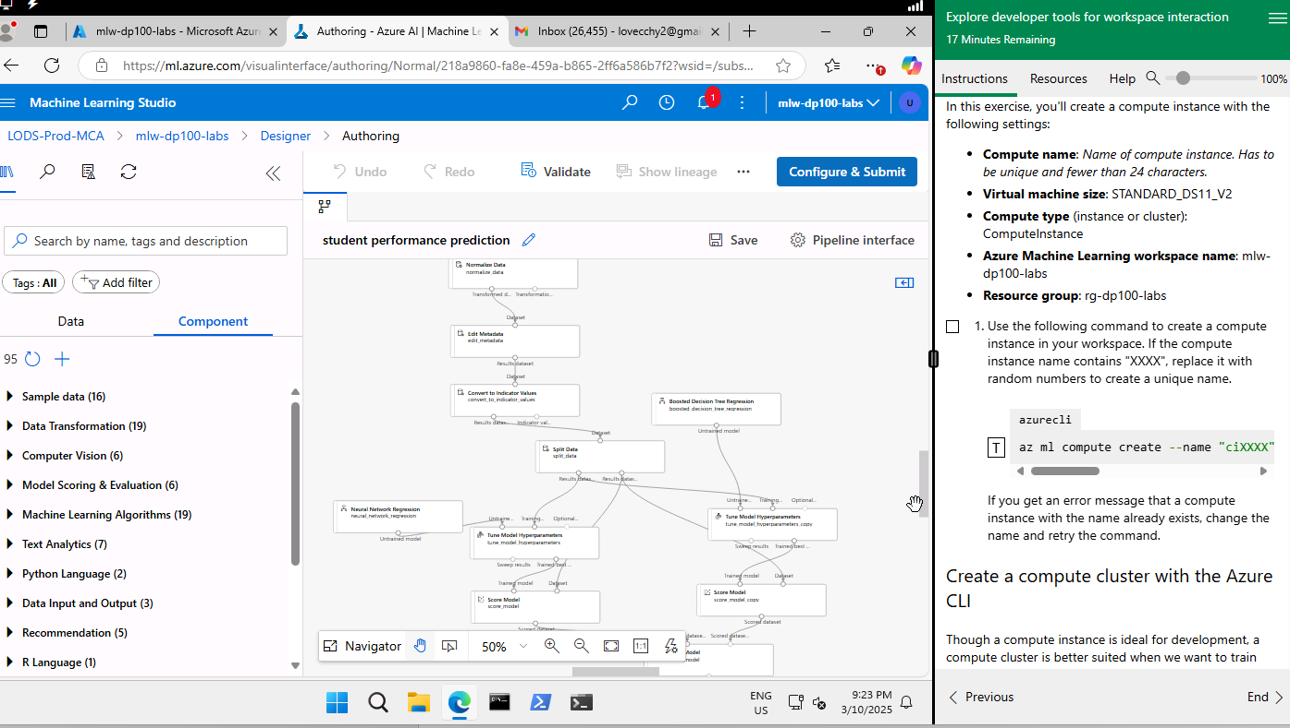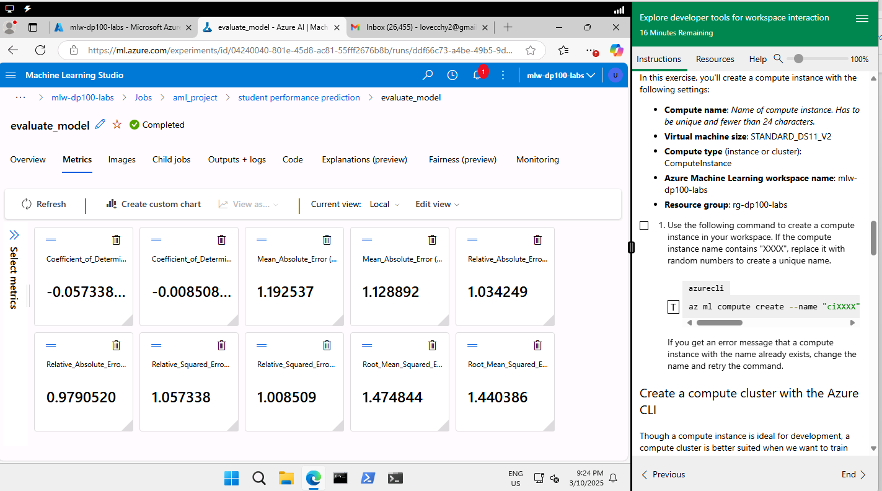

Left: Neural network regression
Right: Boosted Decision tree regression
Under convert to indicator values component - overwrite categorical columns – false and under split component – True - stratified column – Learning_Disabilities.
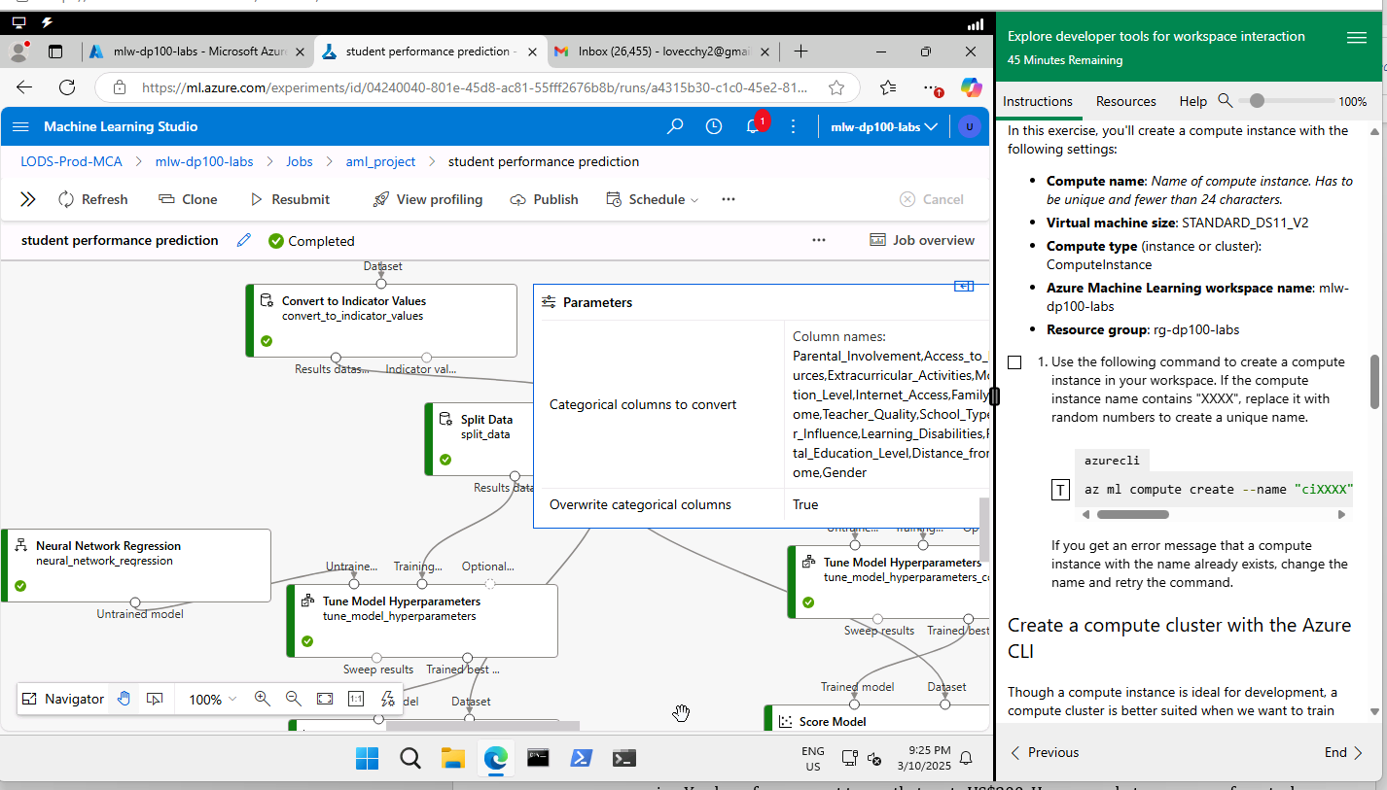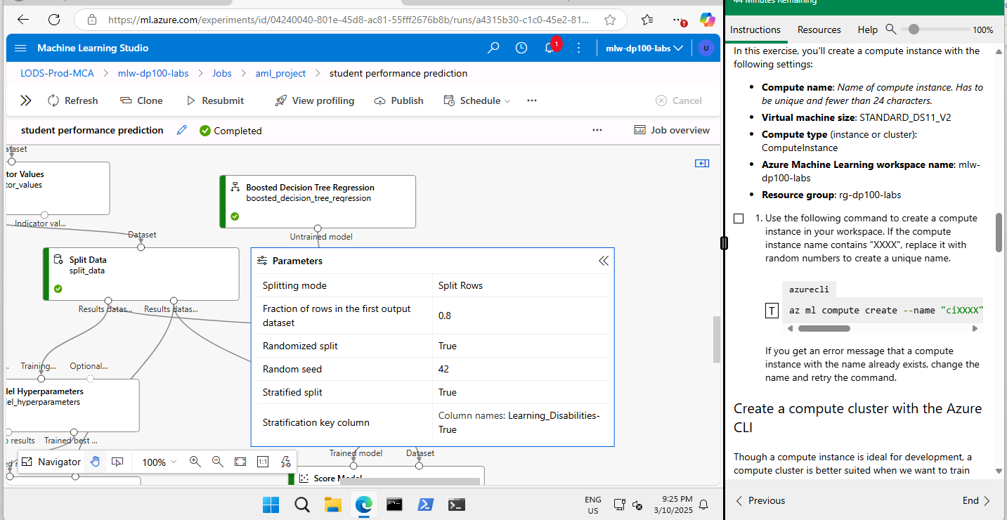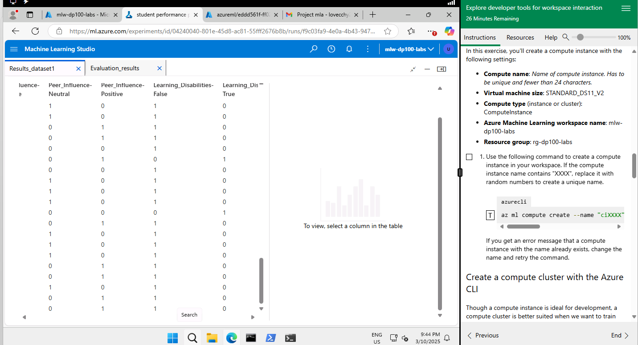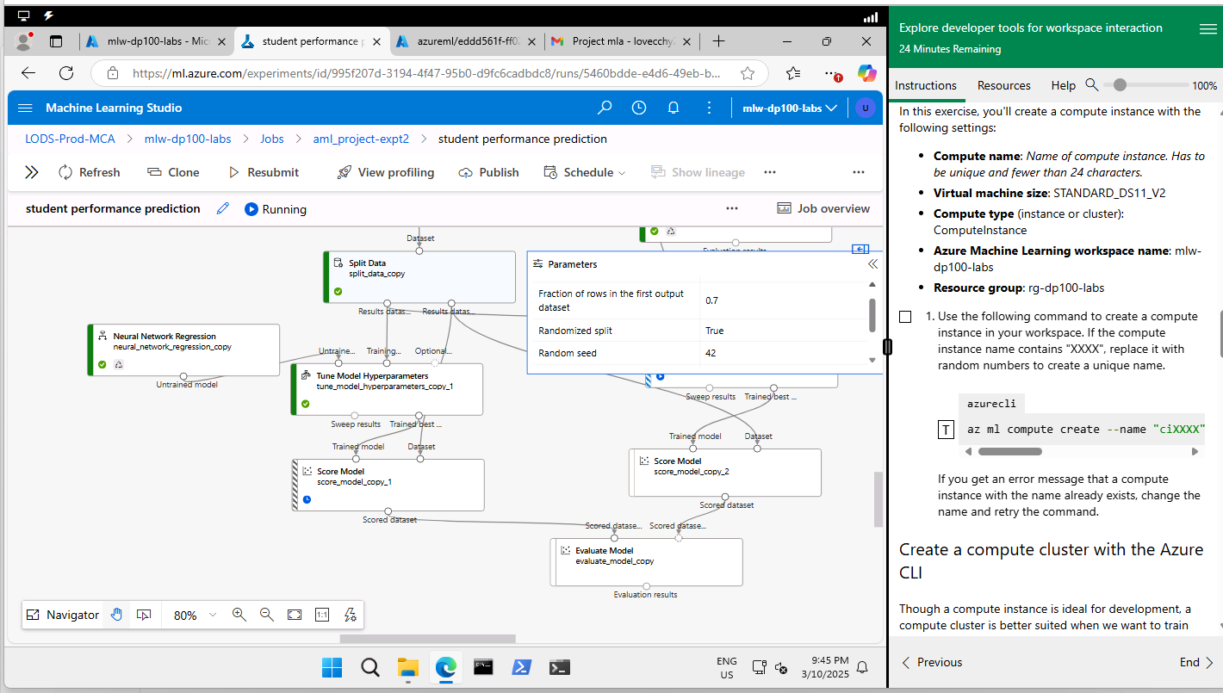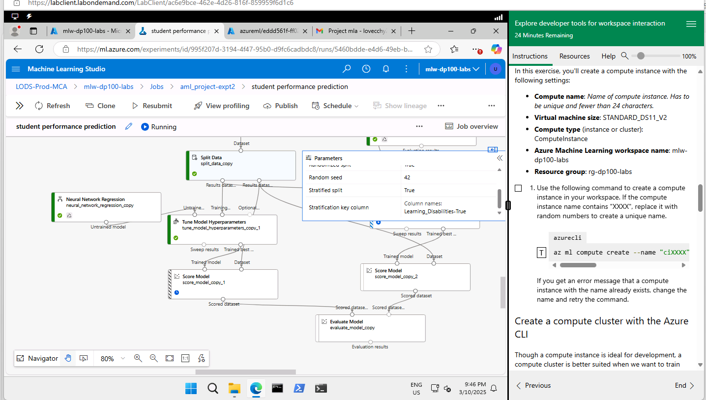
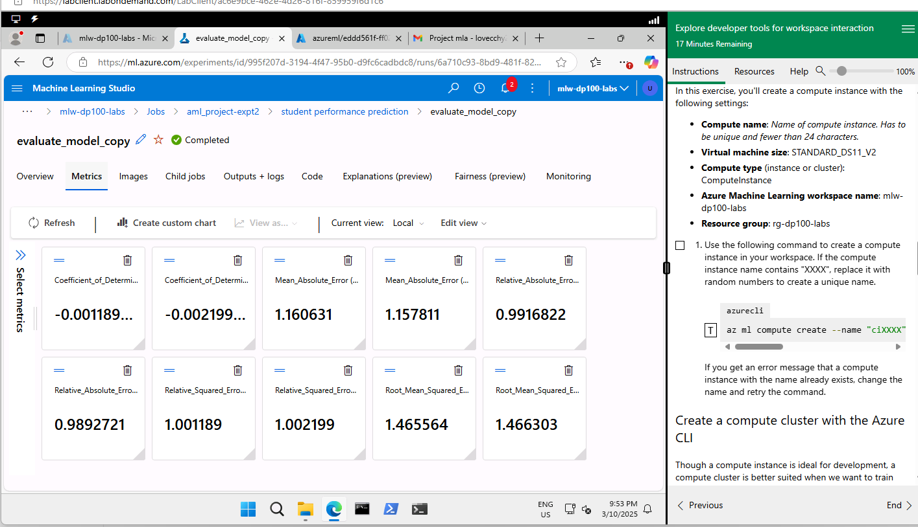

Split： 70%
Left: Neural Network regression
Right: Boosted Decision tree regression
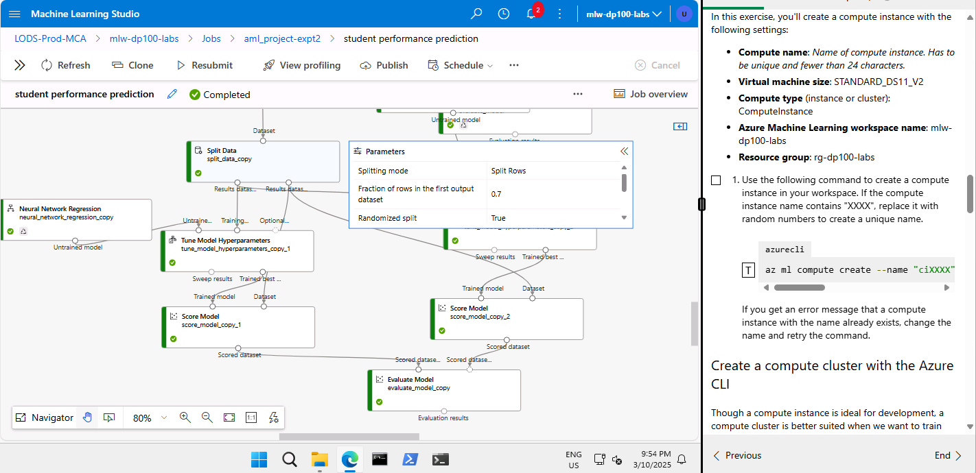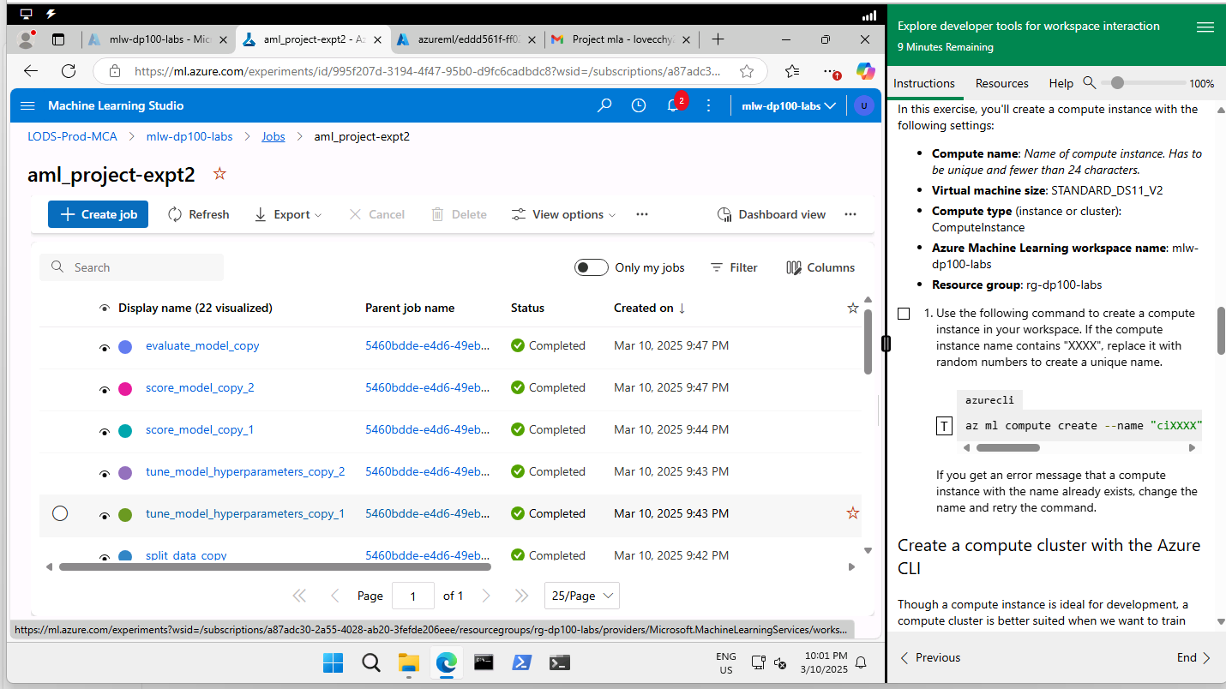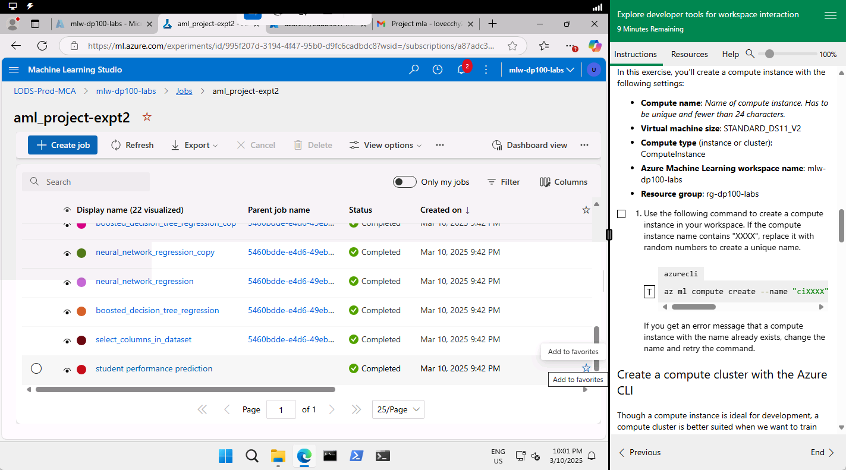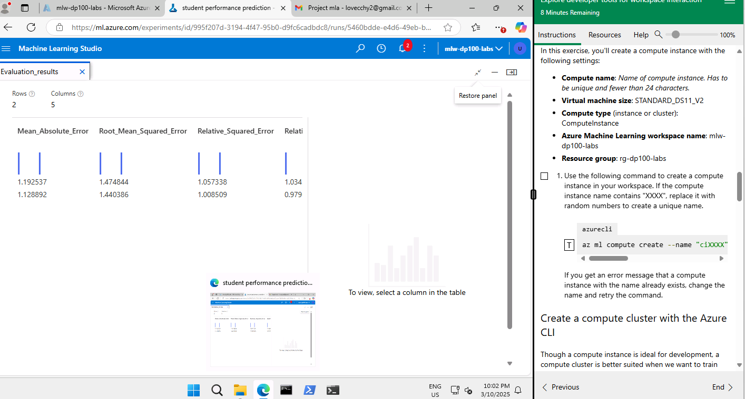

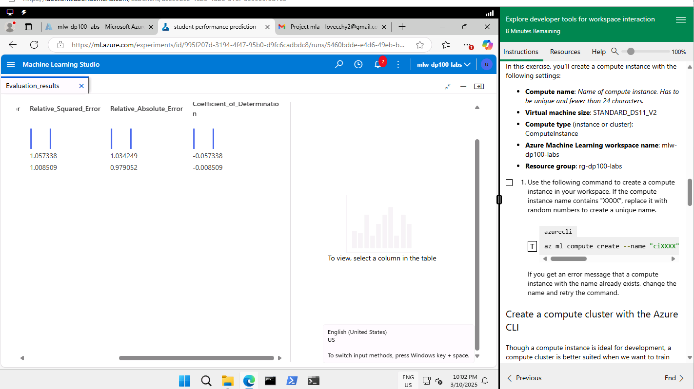
Split: 80%
Rerun pipeline
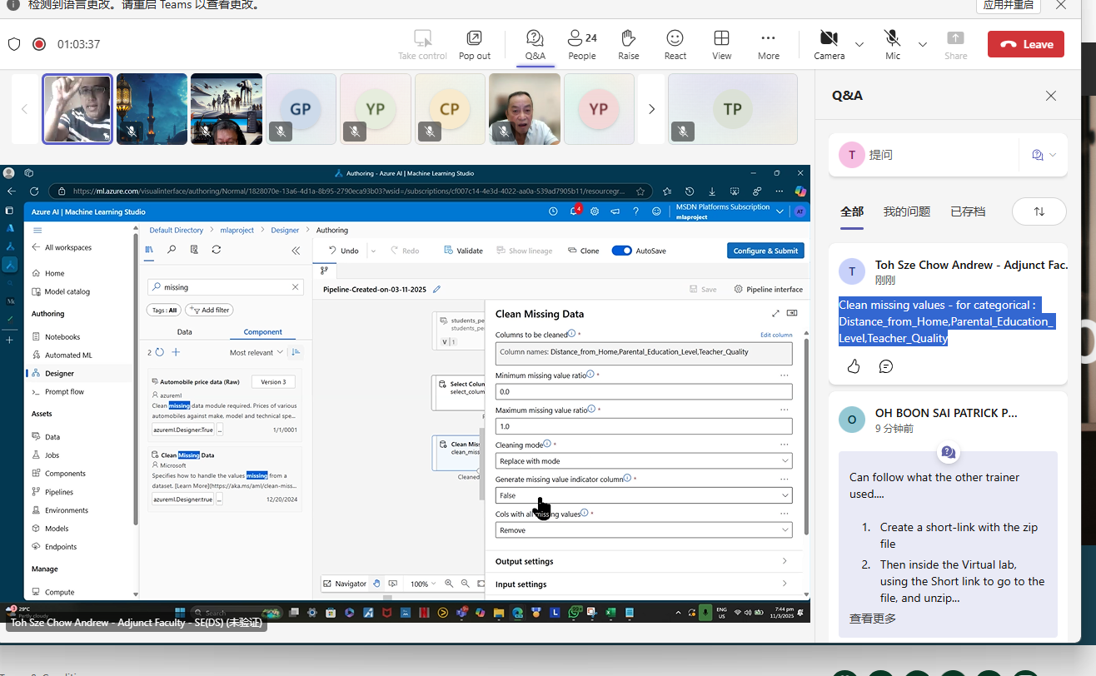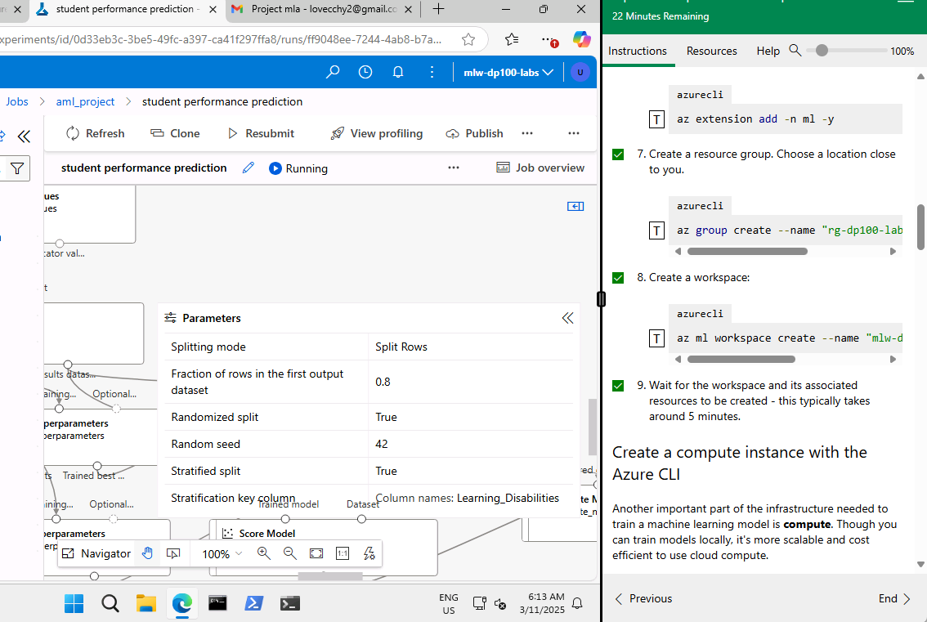
When overwrite categorical columns is true in convert to indicator values component and Learning_Disabilities without -True, component fails. Overwrite categorical columns is false and Learning_Disabilties -> component processes successfully.
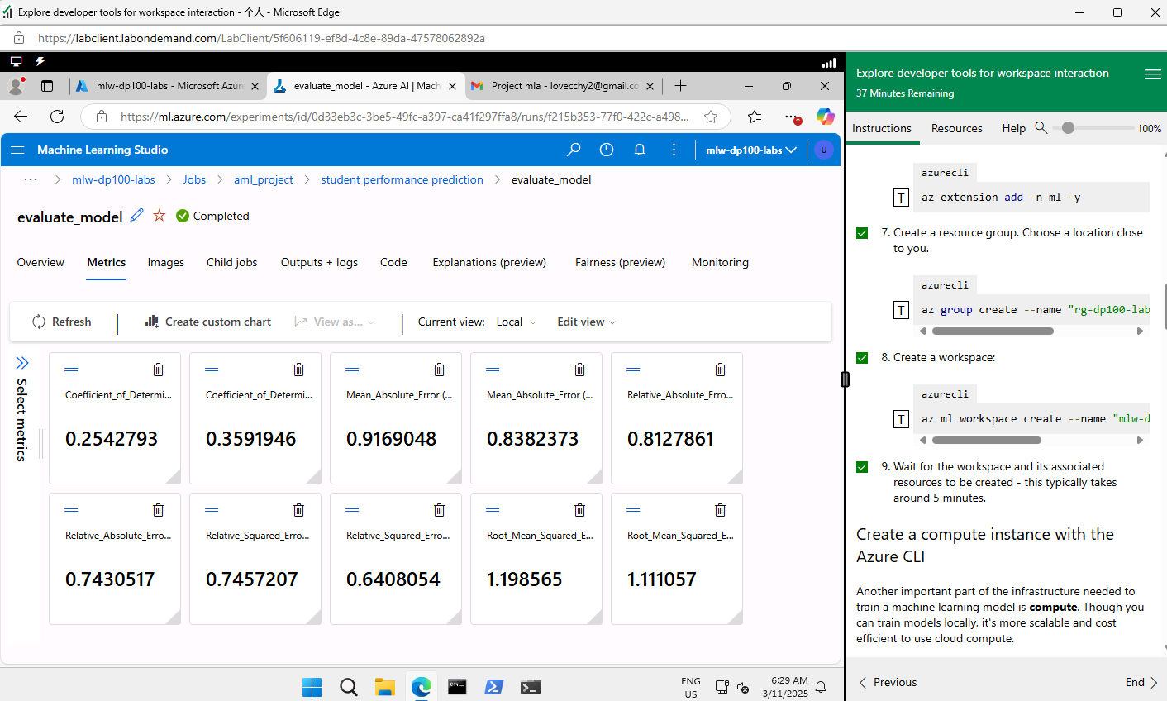
Neural network algorithm explains 25% of its data whereas Boosted decision tree regression algorithm explains 36% of its data. Boosted decision tree regression algorithm has lower rmse and mae.
Left: neural network
Right: boosted decision tree

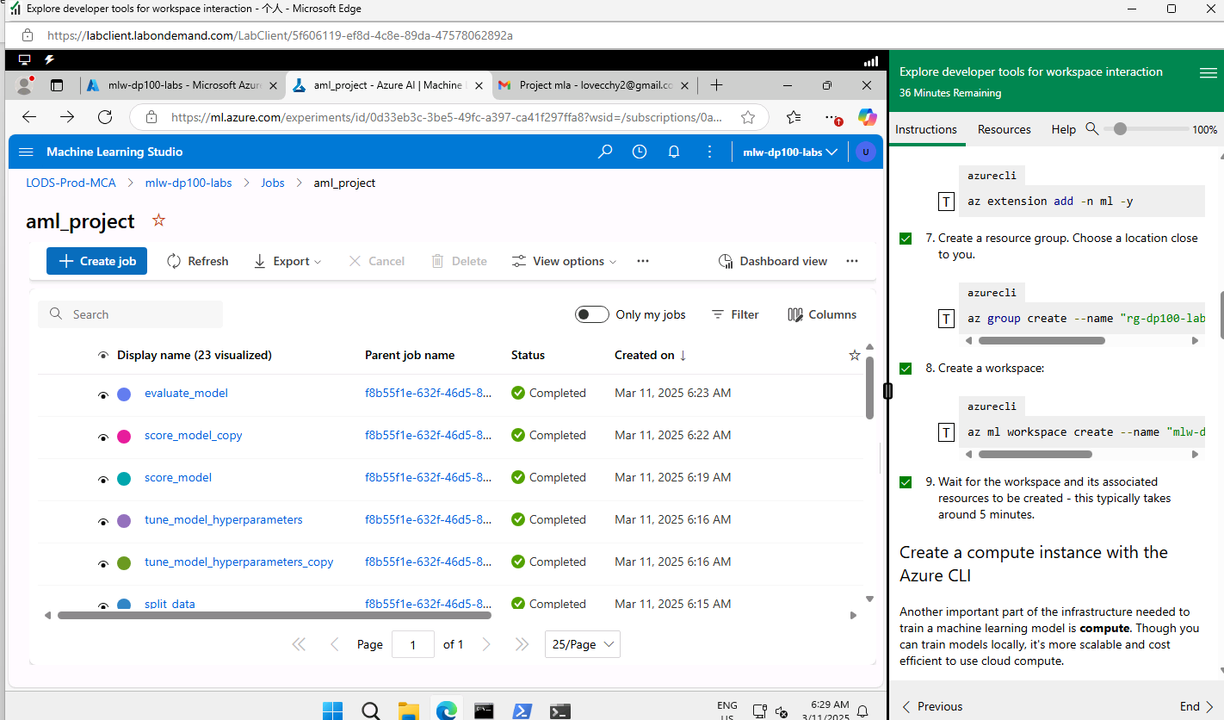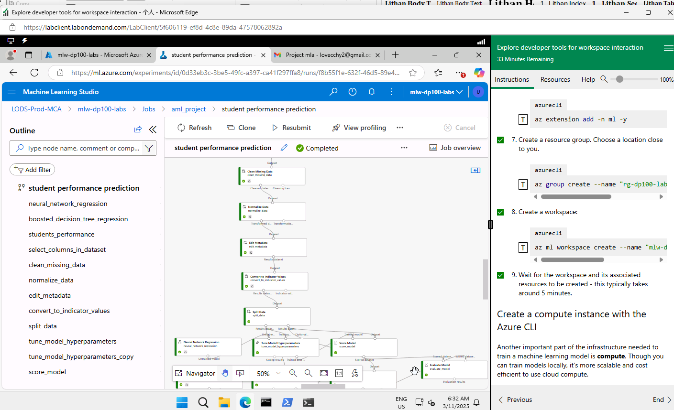

Another method
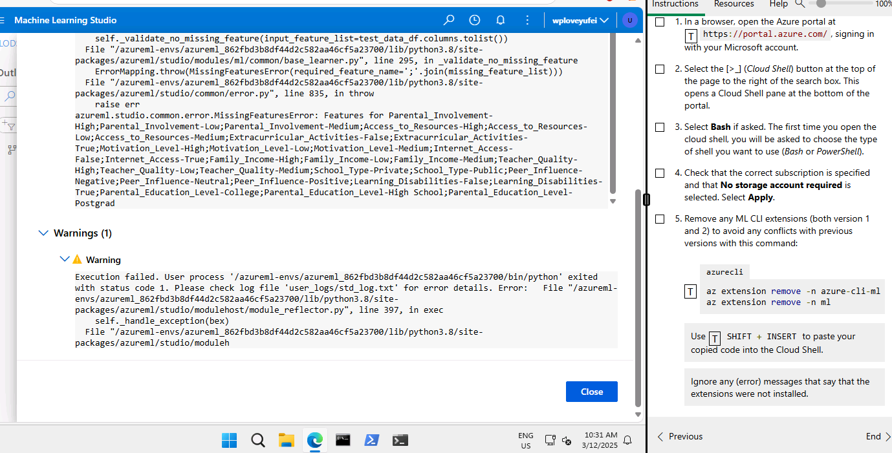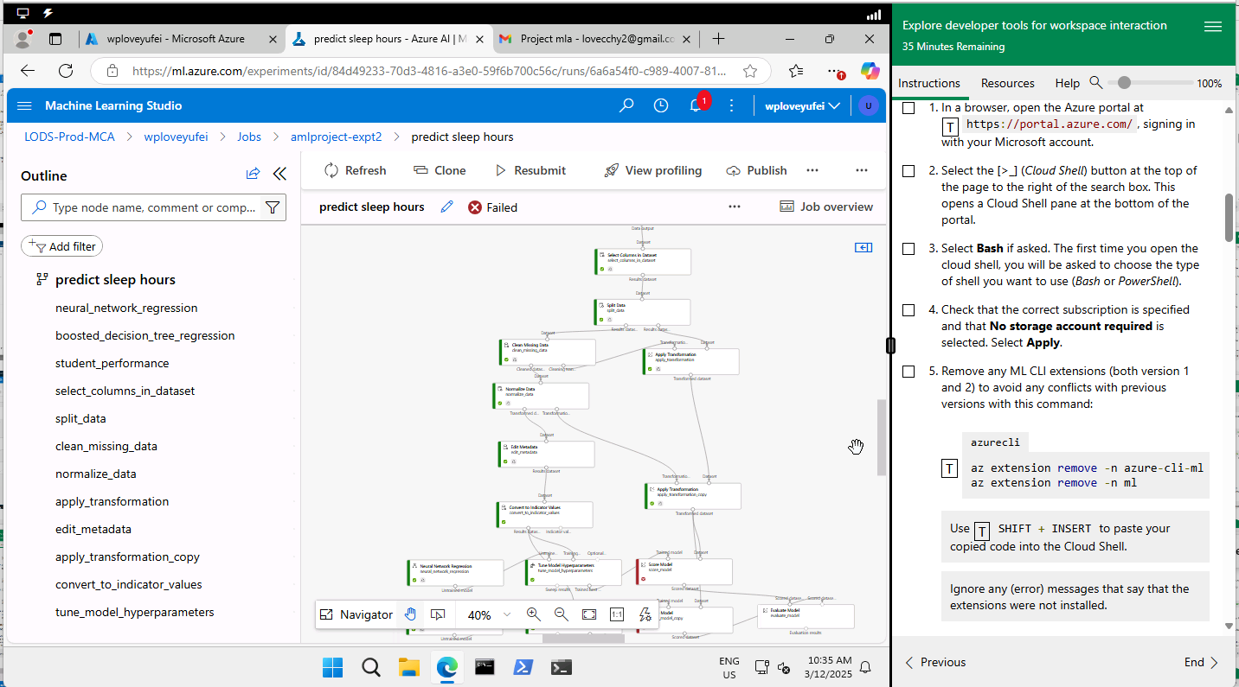
Score component fails. This includes one hot encoding. The error indicates missing features errors.
The failure of the "score model" component in your Azure Machine Learning pipeline could be due to several reasons. Here are some common issues to check:
- Incorrect Input Data: Ensure that the data being fed into the "score model" component is correctly formatted and matches the expected schema.
- Missing Values: Check for any missing values in the input data. Missing values can cause the scoring process to fail.
- Incompatible Data Types: Verify that the data types of the input features are compatible with the model being used for scoring.
- Model Issues: There might be issues with the trained model itself. Ensure that the model has been properly trained and validated.
- Pipeline Configuration: Make sure that all preceding steps in the pipeline are correctly configured and executed without errors.
When using the "Apply Transformation" component in your pipeline, non-numerical columns could be causing the error. Here's how you can address this:
- Ensure Consistent Preprocessing: Make sure that any transformations applied during training (e.g., one-hot encoding, normalization) are also applied during scoring.
- Check Feature Alignment: Confirm that the features in your transformation match those expected by the model. Non-numerical columns should be transformed appropriately (e.g., using one-hot encoding or label encoding).
- Verify Training and Scoring Data Consistency: The data used for scoring should have the same schema and preprocessing steps as the training data.
Looking at your data, it includes various columns, both numerical and non-numerical, such as "Gender" and "School_ty." To avoid errors when using the "Apply Transformation" component, follow these steps to ensure everything aligns properly:
1. Data Preprocessing:
- Handle Missing Values: Use Azure's "Clean Missing Data" component to remove or impute missing values.
- Convert Categorical Data: Transform non-numerical columns like "Gender," "School_ty," etc., into numerical values. You can use one-hot encoding or label encoding to achieve this.
2. Ensure Consistent Transformation:
- Align Training and Scoring Data: Make sure that the transformations applied during training are also applied during scoring. The schema should match exactly.
- Standardize and Normalize Data: Apply standardization or normalization if the model requires it.
3. Pipeline Configuration:
- Check Component Configuration: Review the settings of the "Apply Transformation" component to ensure it matches the model's expectations.
- Review Error Logs: Look at the logs to get specific details about the error. This can give you clues on what might be wrong.
Example Workflow:
- Preprocess Data: Clean missing data and encode categorical variables.
- Train Model: Ensure the model is trained with the preprocessed data.
- Save Transformation: Save the transformation logic used during training.
- Apply Transformation: Use the saved transformation on the scoring dataset.
- Score Model: Finally, score the model using the transformed data.
- Maybe convert to indicator values has to connect to apply transformation instead of from normalize component. Maybe that is why the score component does not recognize non-numerical columns. -> this suggestion is verified to be correct.

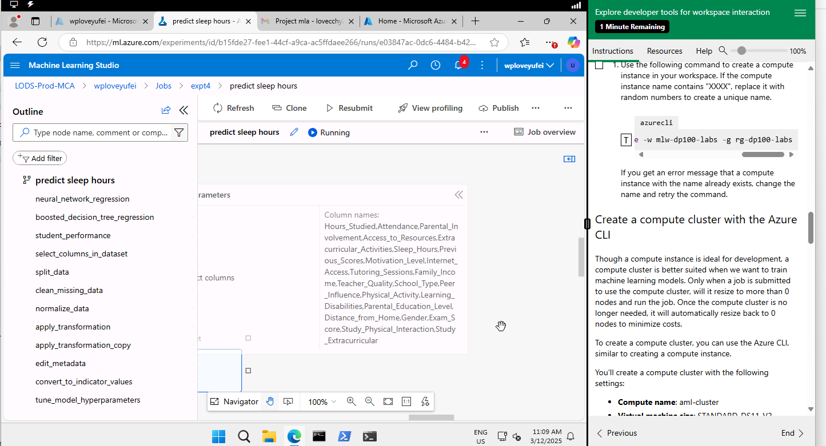
Select columns in dataset component
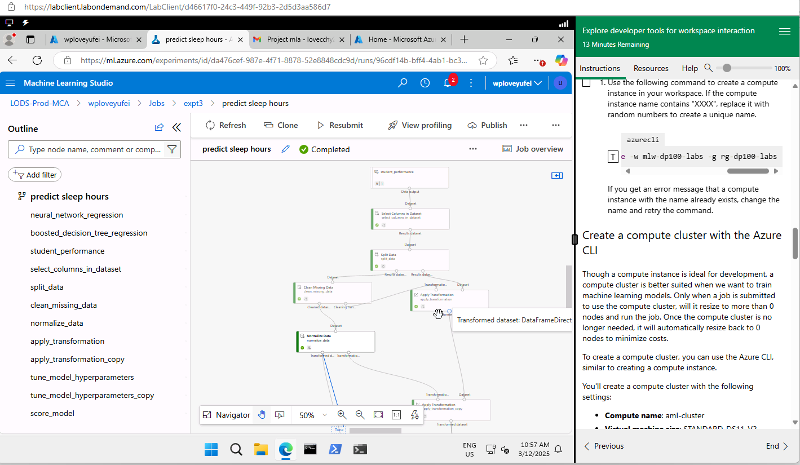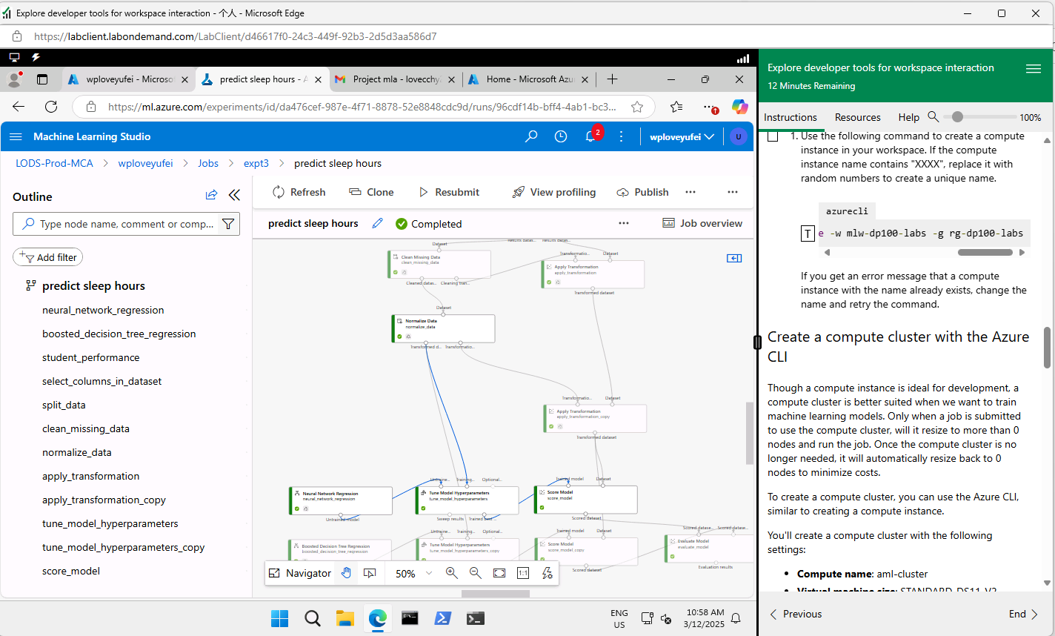
I remove one hot encoding and it works. This model learns training data based on numerical columns and ignores the non-numerical columns.
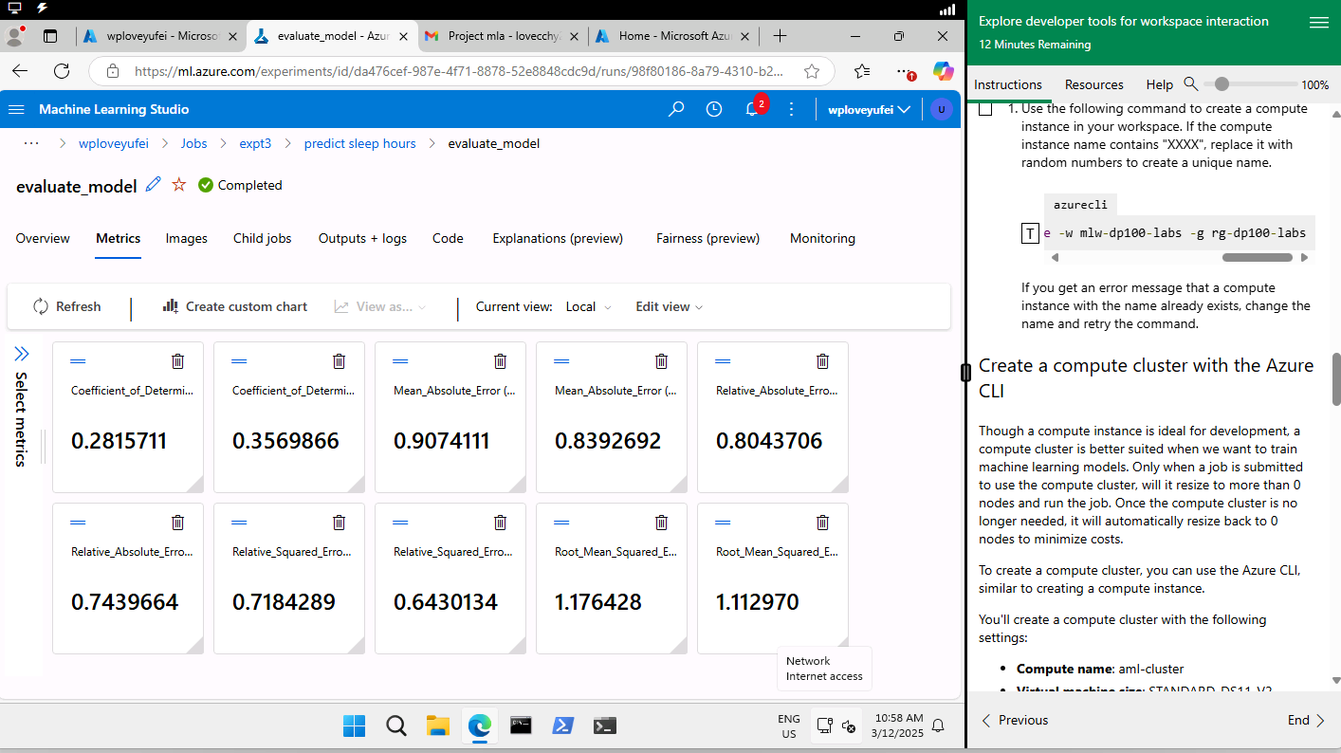
This model learns slightly less than the above screenshot with one hot encoding. The rmse is slightly higher than the above screenshot with one hot encoding.
Left: neural network
Right: boosted decision tree
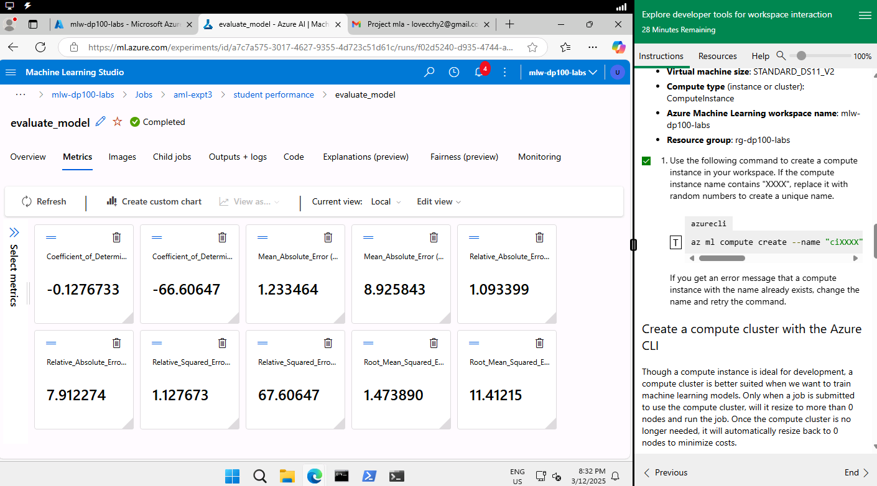
Left: boosted decision tree
Right: neural network
The rmse error is higher for the neural network algorithm.

It seems like you're working with some regression model evaluations! An R² score (or coefficient of determination) measures how well the regression predictions approximate the real data points.
A score closer to 1 indicates a model that predicts well, while a score closer to 0 indicates that the model's predictions are barely better than a simple mean of the target values. A negative R² score, like -0.128 or -66.606, suggests that the model is performing worse than the mean of the target values. This means that the model is making very poor predictions. For this method using apply transformation for test data, the result is horrible. It enables the model to predict based on real data. This solves data leakage problem.
It sounds like you're tackling data preprocessing in a detailed way. Here’s what might be happening:
- Data Splitting: You first split your dataset into training and test sets before any data cleaning. This ensures that the model is evaluated on data it hasn’t seen before, making the evaluation more robust.
- Data Cleaning: You clean the training data, which could involve handling missing values, removing duplicates, or correcting inconsistencies.
- Apply Transformation Component: The test data is connected to an "apply transformation" component. This likely means you're applying the same transformations (like scaling, normalization, or encoding) that you applied to the training data to maintain consistency and avoid data leakage.
Using this approach ensures that your model is trained and tested on data that has undergone the same preprocessing steps. It's essential for maintaining the integrity of your model evaluation.
I see that you're following a solid preprocessing pipeline by ensuring the same transformations are applied to both the training and test data. However, the negative R² scores indicate there's still an issue with the model's performance.
Let's dive a bit deeper into some potential causes and solutions:
- Feature Engineering:
  - Check Feature Importance: For the boosted decision tree, examine the feature importance scores. Some features might be irrelevant or even detrimental to the model's performance.
  - Interaction Terms: Create interaction terms or polynomial features if you suspect non-linear relationships in your data.
- Hyperparameter Tuning:
  - Use tools like grid search or random search to optimize the hyperparameters for both models. Common parameters for the boosted decision tree include the learning rate, number of estimators, and max depth. For neural networks, consider tuning the number of layers, number of neurons per layer, activation functions, and learning rate.
- Model Validation:
  - Ensure that cross-validation is used to get a more robust estimate of the model's performance. Sometimes, a single train-test split might not be representative of the data distribution.
- Data Quality:
  - Double-check for any data quality issues. Ensure that there are no data leaks between training and test sets, and that the data is correctly preprocessed (e.g., no missing values or outliers left unhandled).
Algorithm Choice:
- Consider trying different algorithms. Sometimes, the data may suit a different type of model better. For example, you could try a Random Forest, SVM, or simpler linear regression.
https://d.docs.live.net/3a0718dfa98eb90f/DataScience/WSQ%20Machine%20Learning%20Algorithms%20and%20Methods/Project/transformeddata.csv
我认为最后两列有很多空数。I think there are many missing data in last 2 columns. This affects the performance of the model. You can refer to the above link for the transformed dataset. If you train the model successfully and when it comes to real data, the model may fail. In this method we try to train the model to handle unseen data and use the same preprocessing steps to predict.
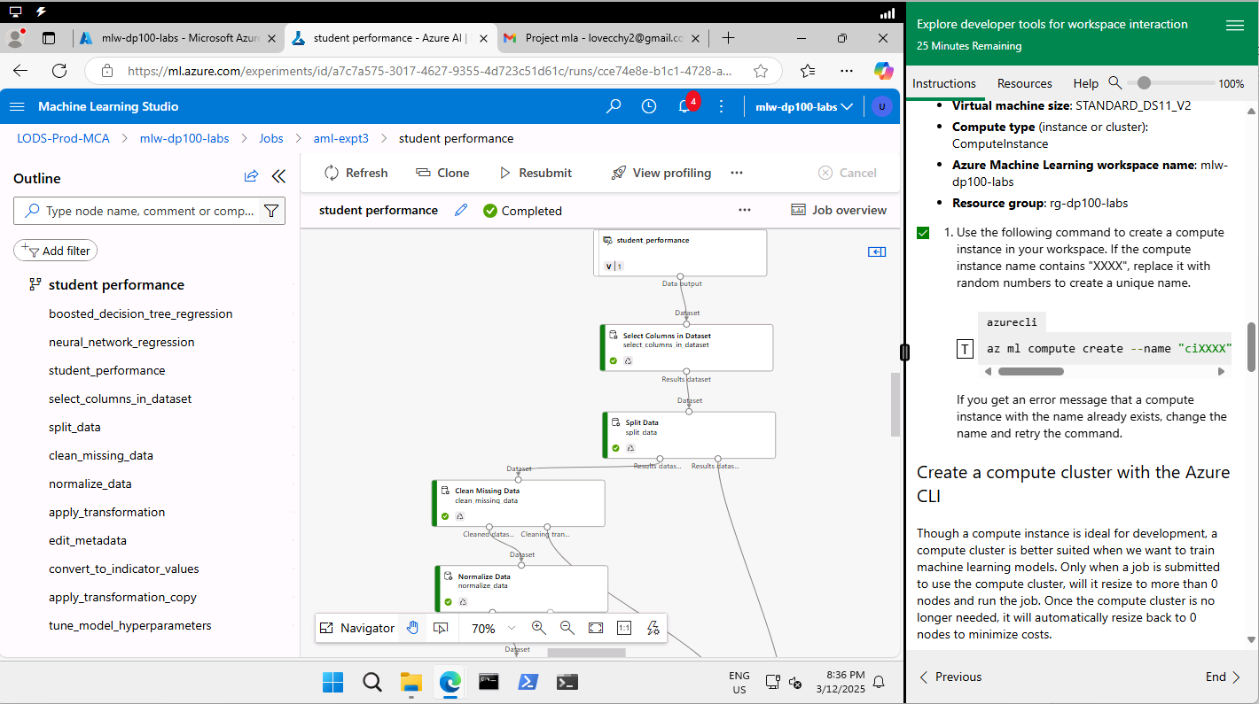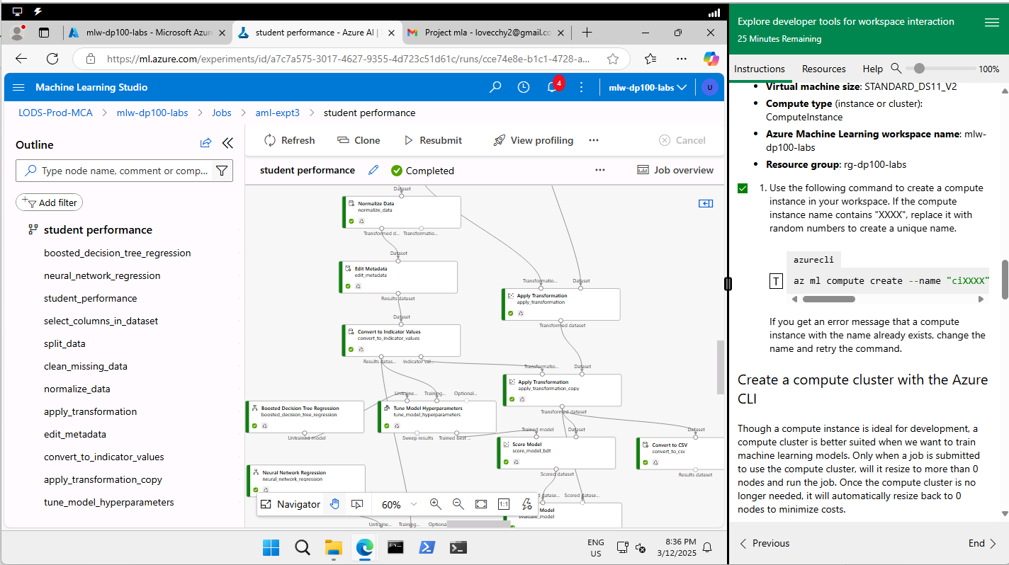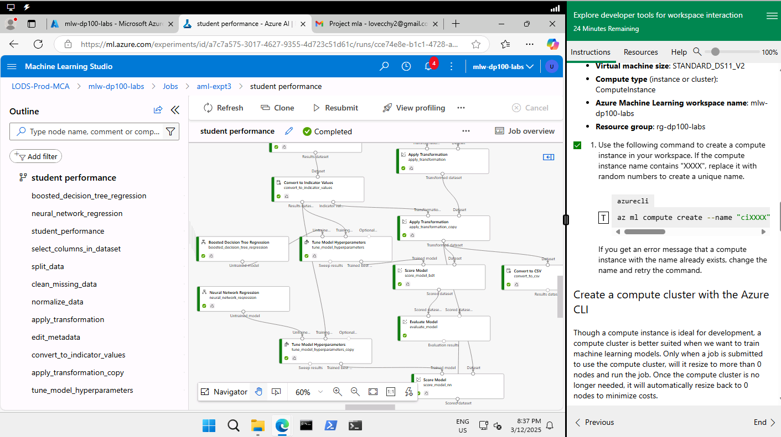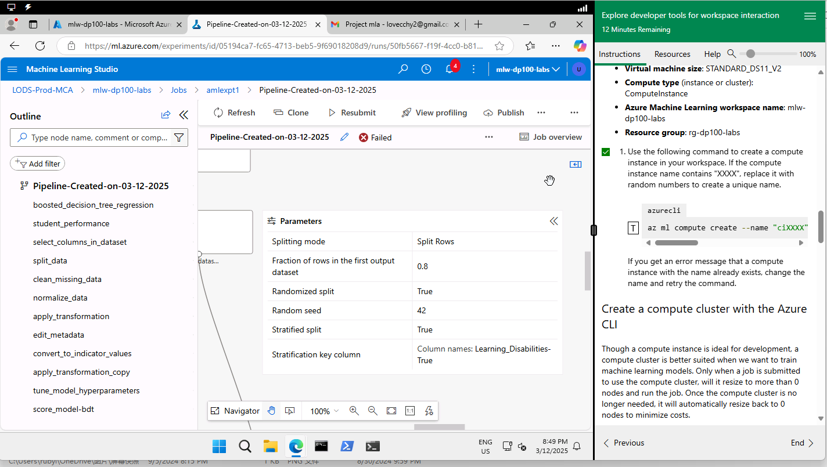
Data -> select columns in dataset -> split -> clean missing data -> normalize data -> edit metadata -> convert to indicator values
stratification key column should be Learning_Disabilities. Remove – True because there is no such column in dataset.
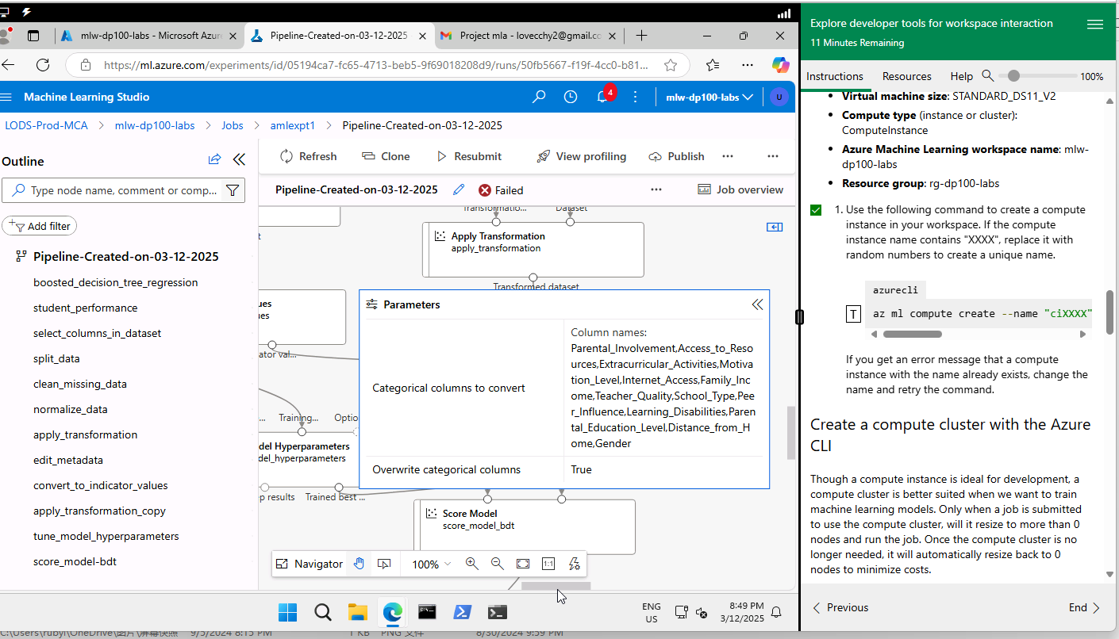
in convert to indicator values, overwrite categorical columns should set to False.
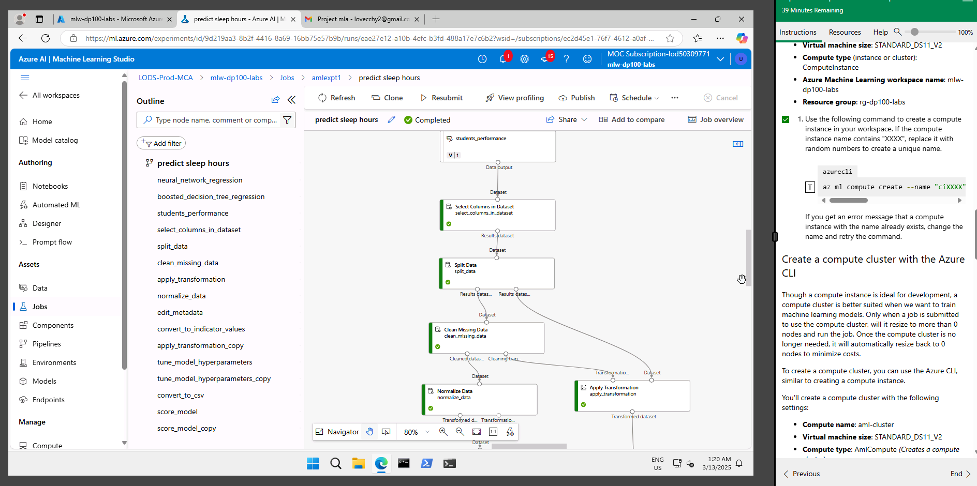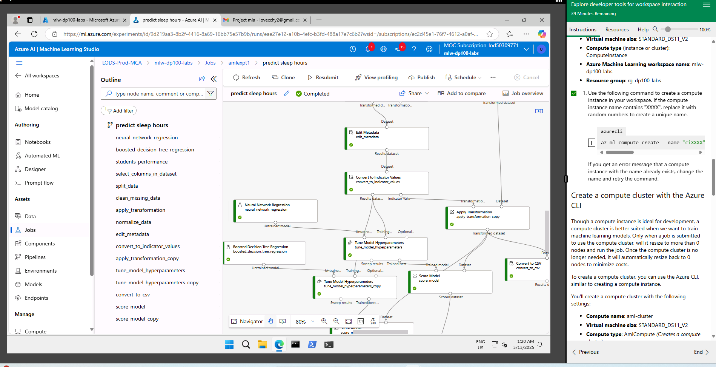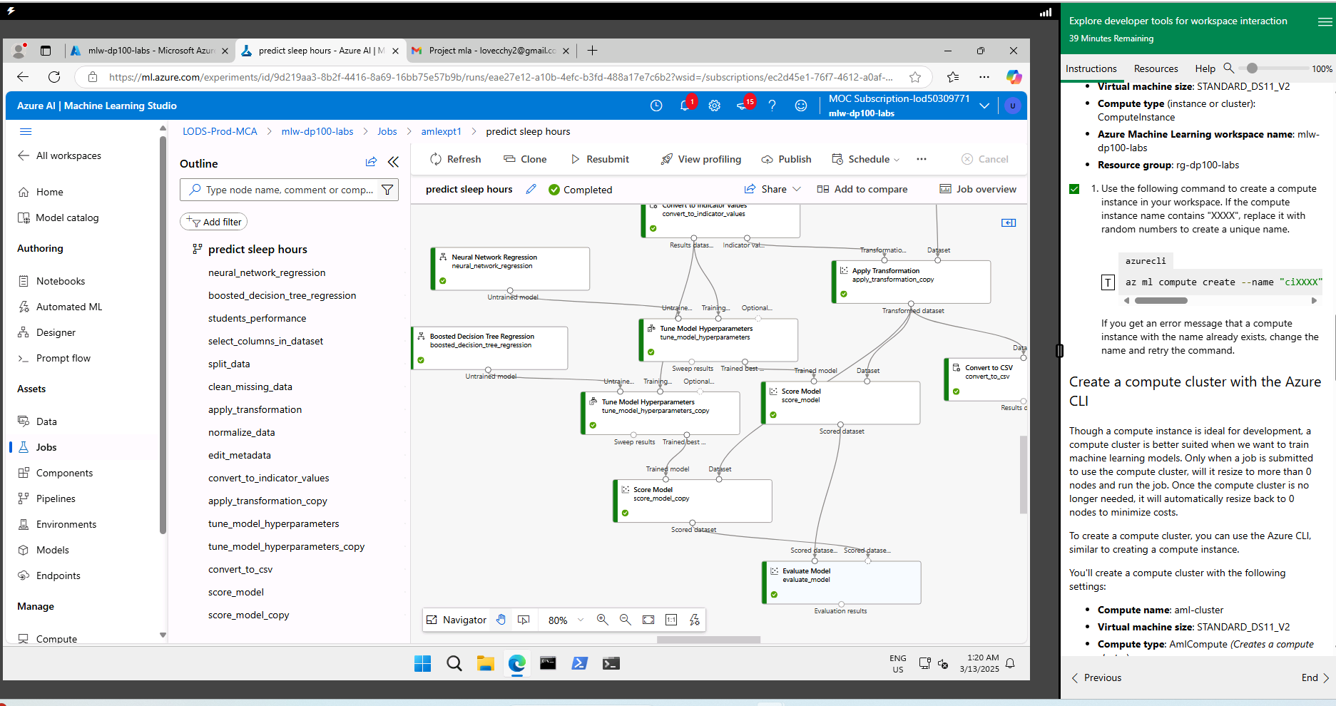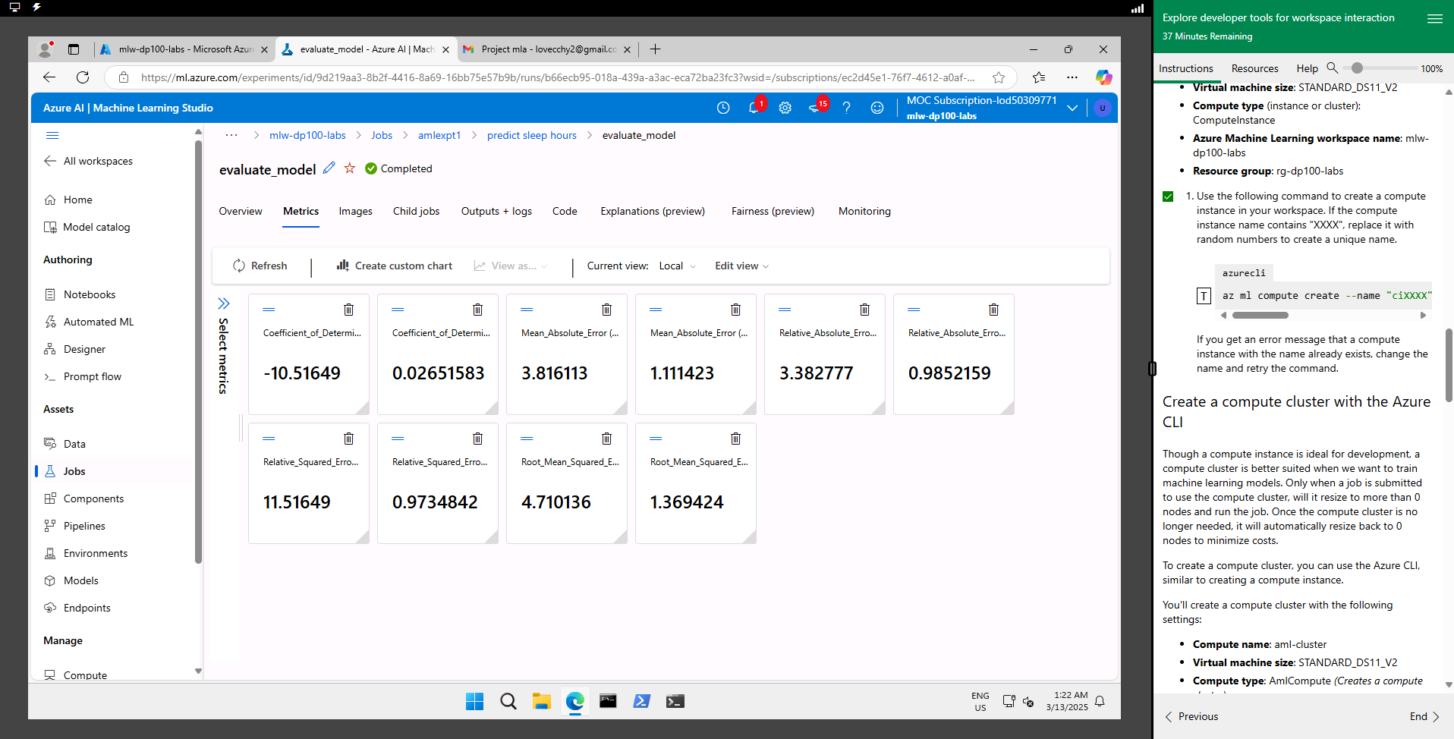
Left: neural network
Right boosted decision tree
Ah, the elusive R-squared score. It represents the proportion of the variance in the dependent variable that's predictable from the independent variables. So, an R-squared score of 0.0265 means that only about 2.65% of the variation in your data is explained by your model. In other words, your model isn't doing a great job of capturing the relationship between the variables. This could mean your model might need refinement or maybe a different approach altogether.
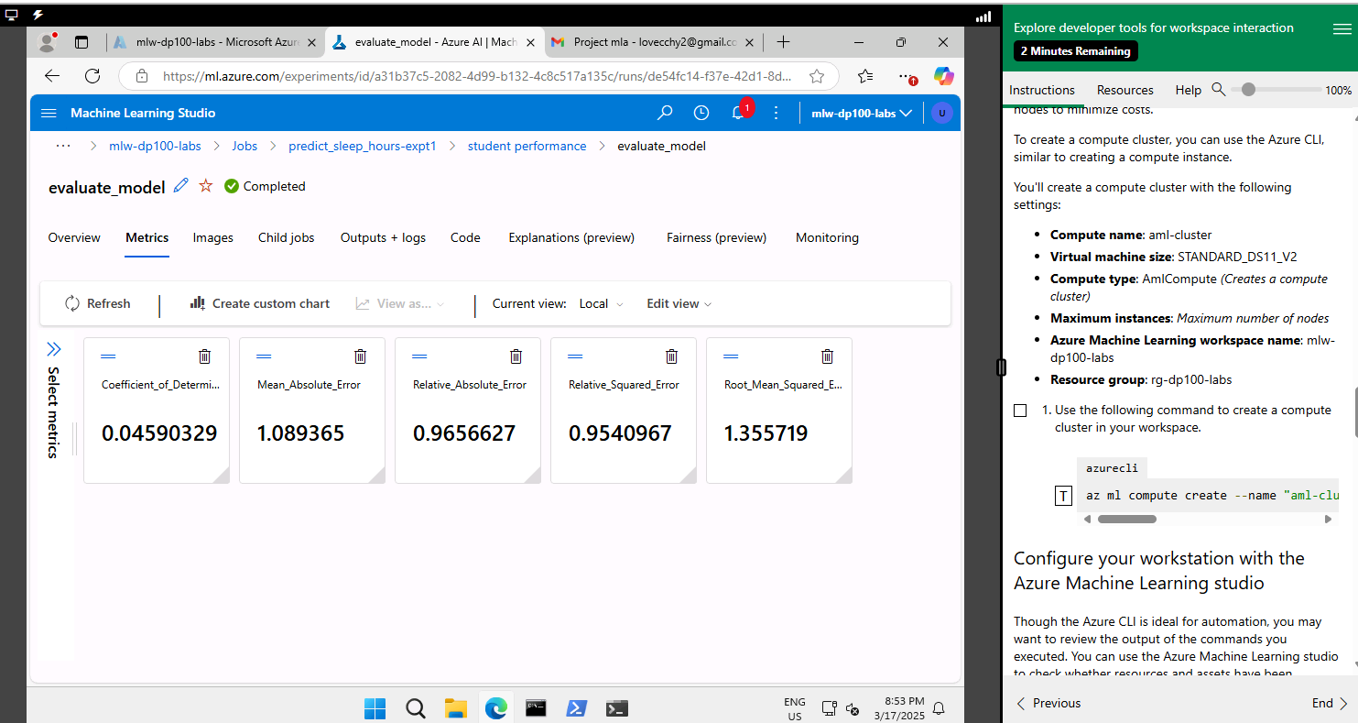
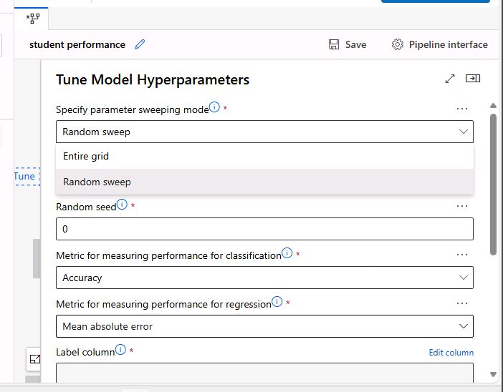
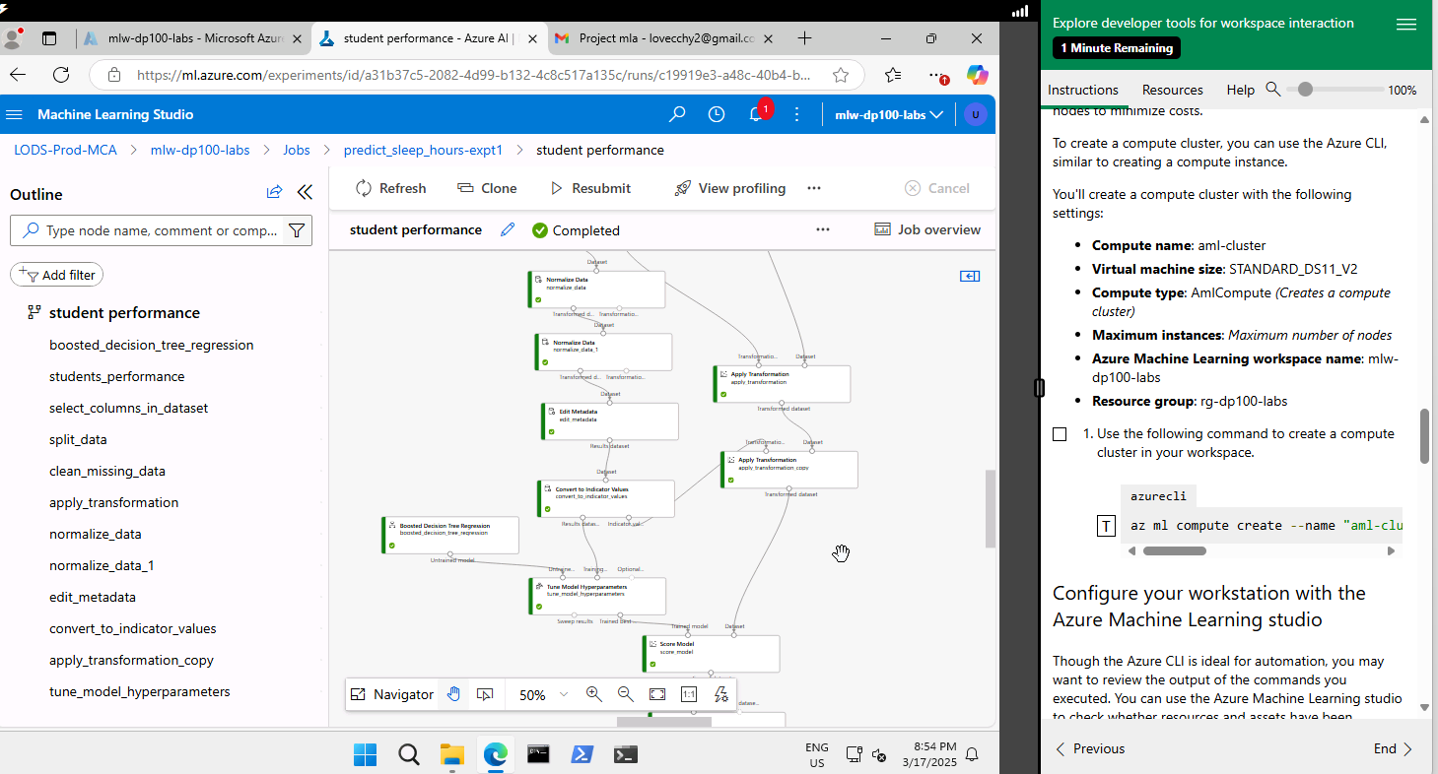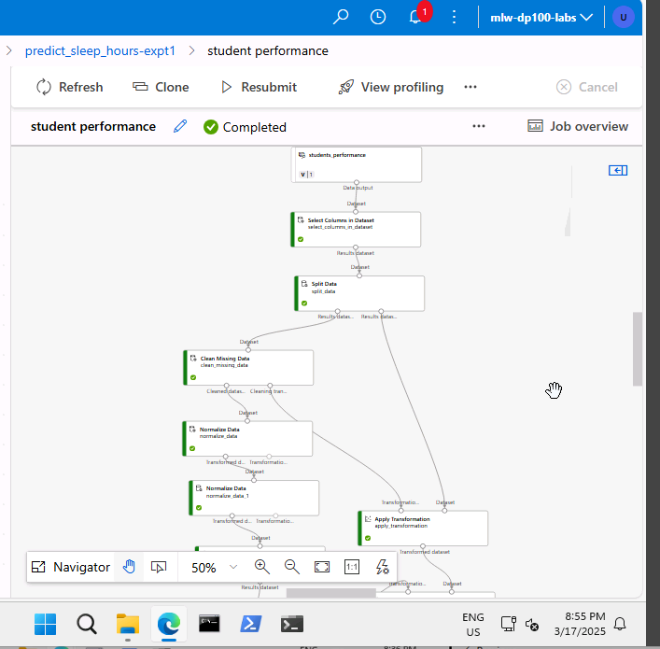
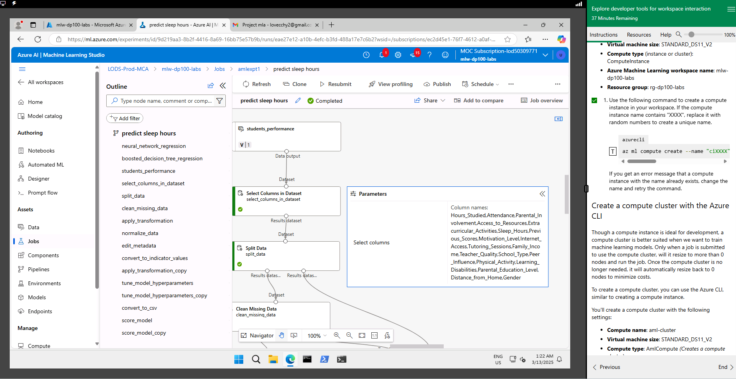
The last 2 numerical columns with missing data are removed.
https://d.docs.live.net/3a0718dfa98eb90f/DataScience/WSQ%20Machine%20Learning%20Algorithms%20and%20Methods/Project/transformeddata2.csv
Using Python
Support Vector Machine Regression Results:
Mean Absolute Error (MAE): 1.2324624468353238
Root Mean Squared Error (RMSE): 1.5155401308967231
R² Score: -0.06469196776508301
Neural Network Regression Results:
Mean Absolute Error (MAE): 1.4193025522228868
Root Mean Squared Error (RMSE): 1.763669321303925
r2 score : -0.4418610732396524

Boosted Decision Tree Regression Results:
Mean Absolute Error (MAE): 1.1862776845597163
Root Mean Squared Error (RMSE): 1.4846392721430262
r2 score : -0.021717859840715503
Hours_Studied Attendance Parental_Involvement Access_to_Resources \
0 23.0 84.0 Low High
1 19.0 64.0 Low Medium
2 24.0 98.0 Medium Medium
3 29.0 89.0 Low Medium
4 19.0 92.0 Medium Medium

Extracurricular_Activities Sleep_Hours Previous_Scores Motivation_Level \
0 No 7.0 73.0 Low
1 No 8.0 59.0 Low
2 Yes 7.0 91.0 Medium
3 Yes 8.0 98.0 Medium
4 Yes 6.0 65.0 Medium

Internet_Access Tutoring_Sessions ... Learning_Disabilities \
0 Yes 0 ... No
1 Yes 2 ... No
2 Yes 2 ... No
3 Yes 1 ... No
4 Yes 3 ... No

Parental_Education_Level Distance_from_Home Gender Exam_Score \
0 High School Near Male 67.0
1 College Moderate Female 61.0
2 Postgraduate Near Male 74.0
3 High School Moderate Male 71.0
4 College Near Female 70.0

Study_Physical_Interaction Study_Extracurricular Distance_to_Center_0 \
0 69.0 0.0 2.715926
1 76.0 0.0 3.413547
2 96.0 24.0 4.361727
3 116.0 29.0 5.142484
4 76.0 19.0 3.866492

Distance_to_Center_1 Distance_to_Center_2
0 3.684692 3.657864
1 4.044766 4.235032
2 2.884506 3.956122
3 3.203543 4.776561
4 3.083820 3.421554

[5 rows x 25 columns]
Constrained Exam_Score: 6.641633968014014

4B Activity 2

Please include screenshots and explanations in the provided space below.
- Screenshots of the classification pipeline setup and results.
- Performance evaluation results.

Screenshots of the classification pipeline setup and results.

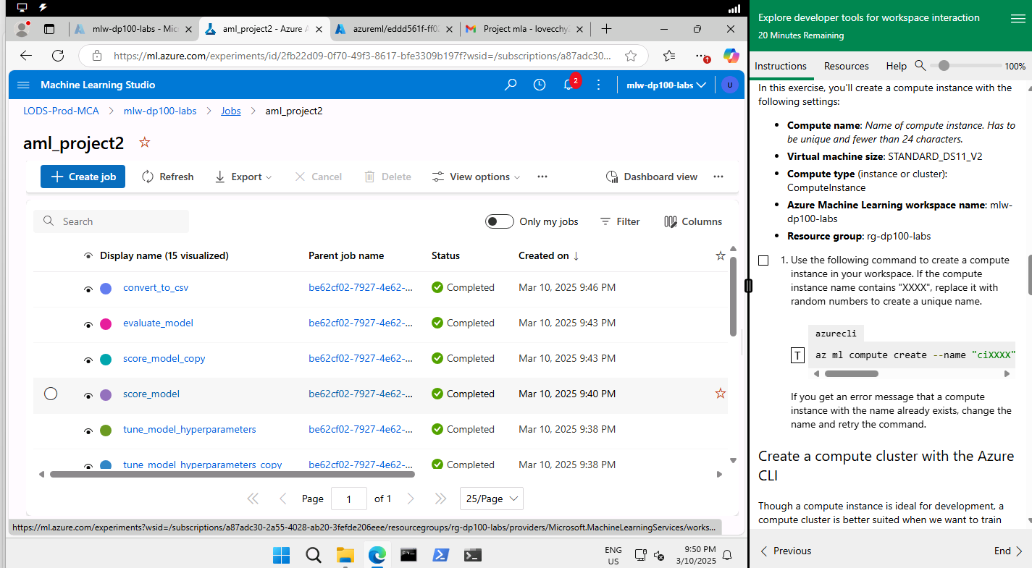
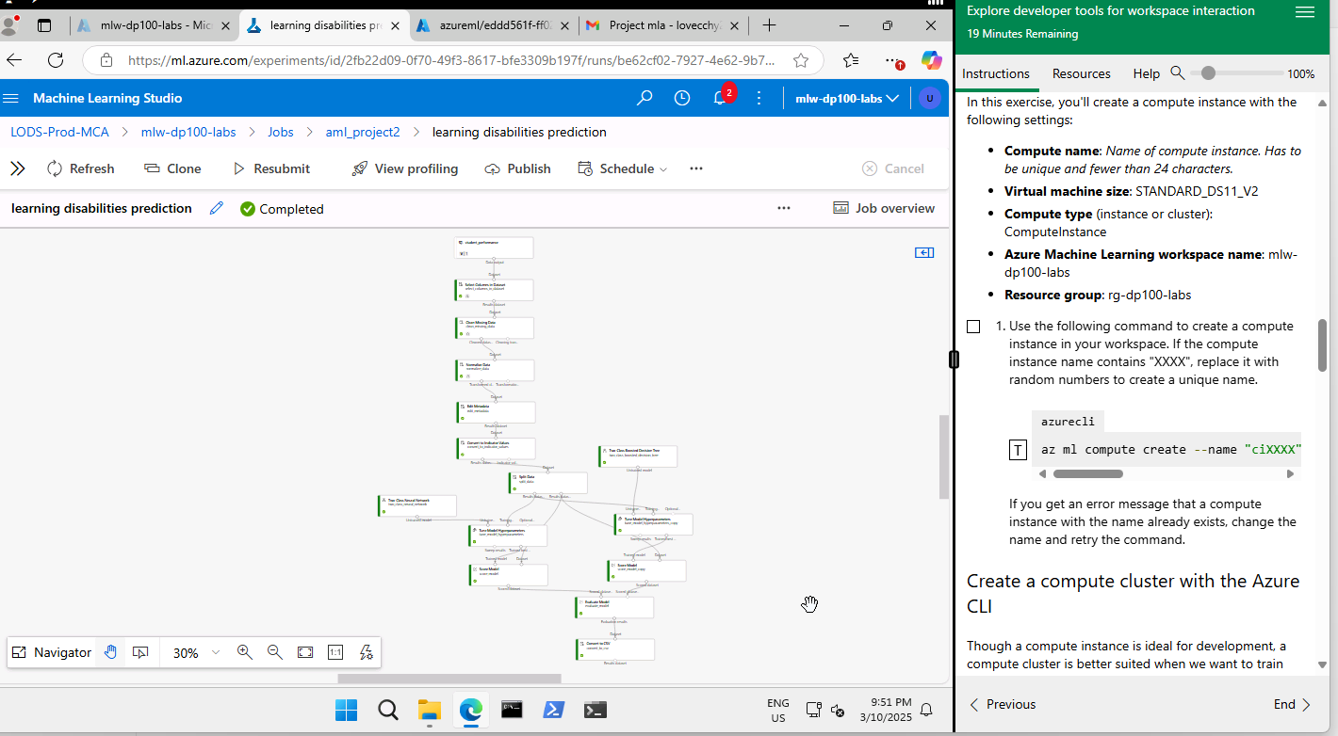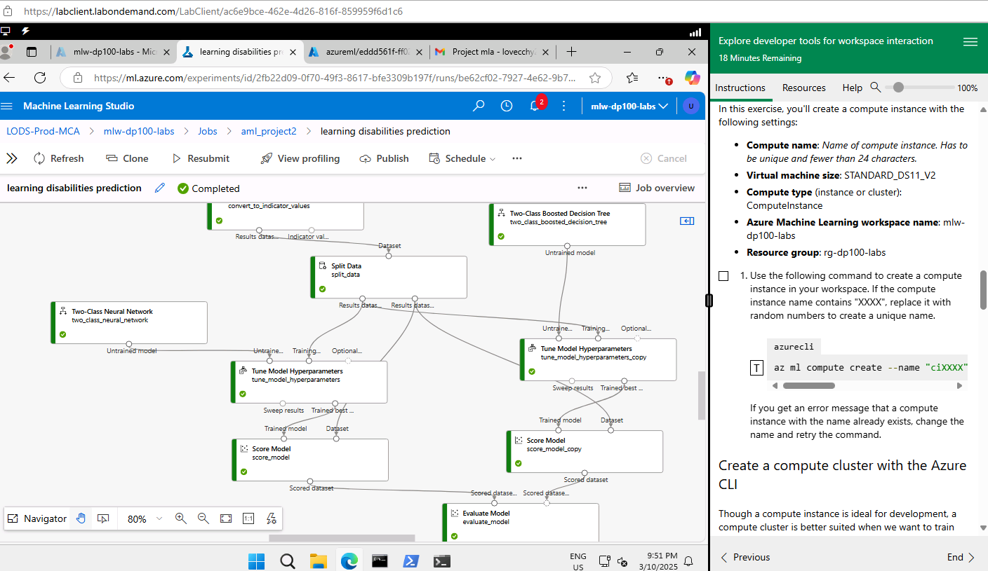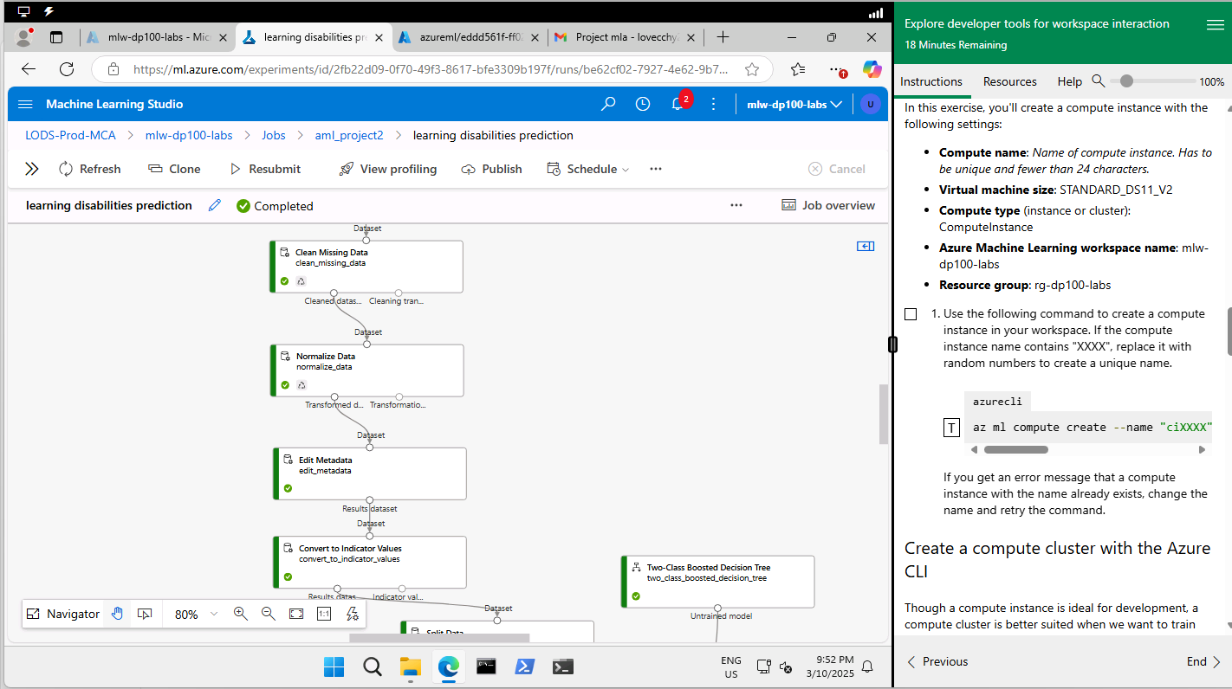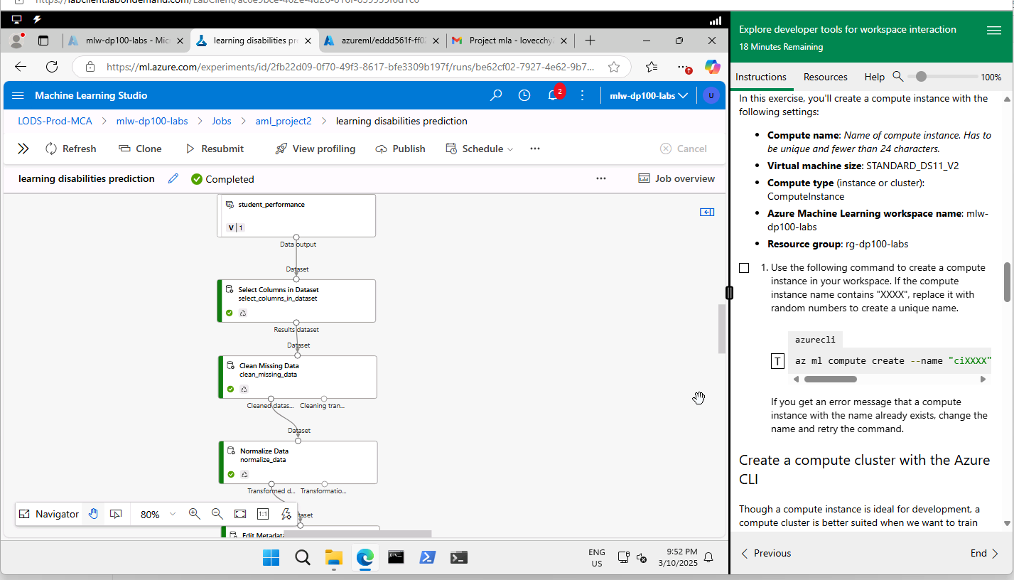

Performance evaluation results

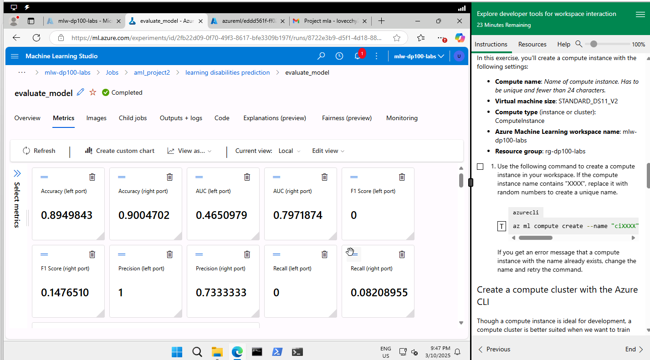

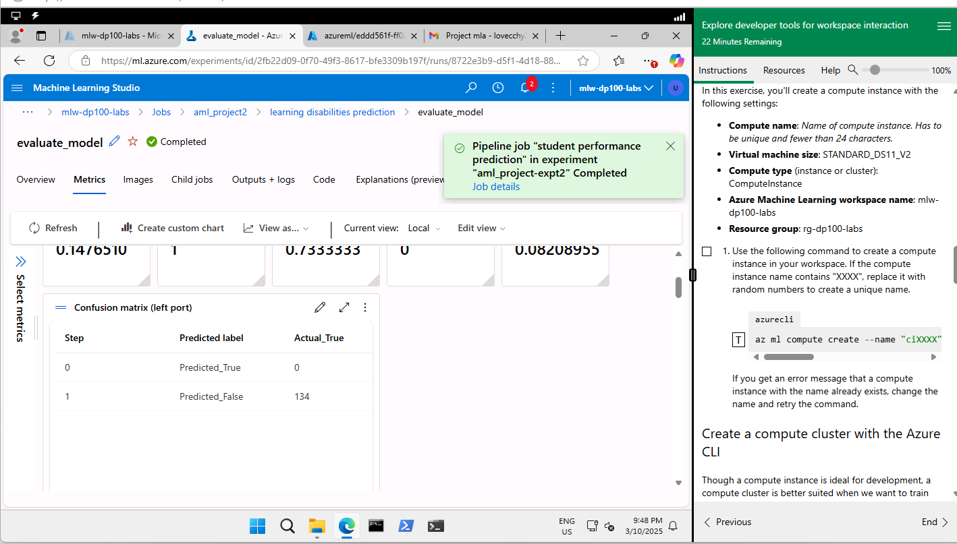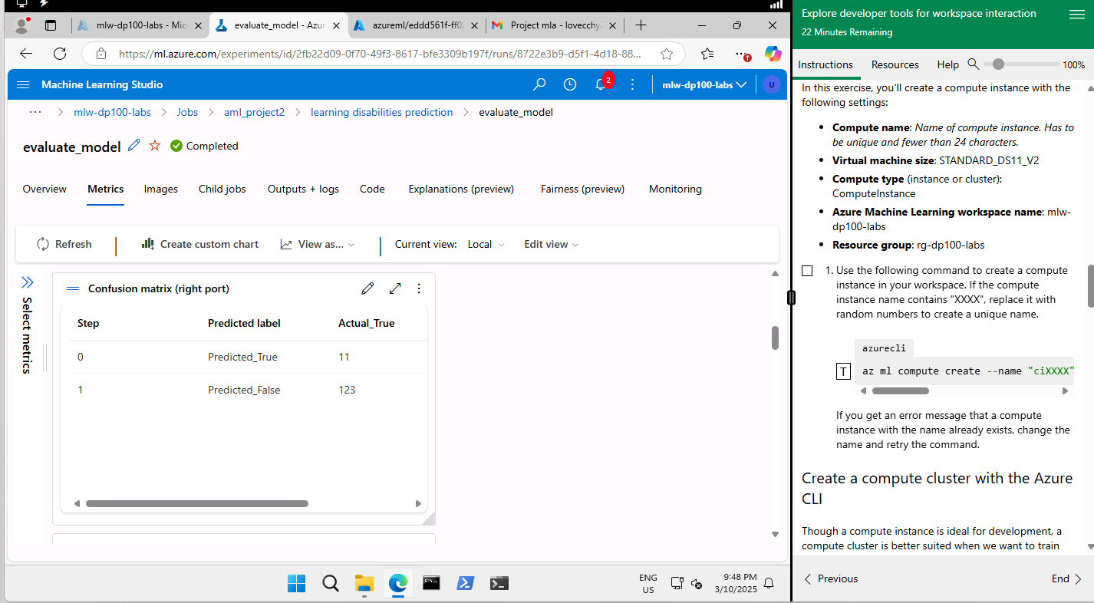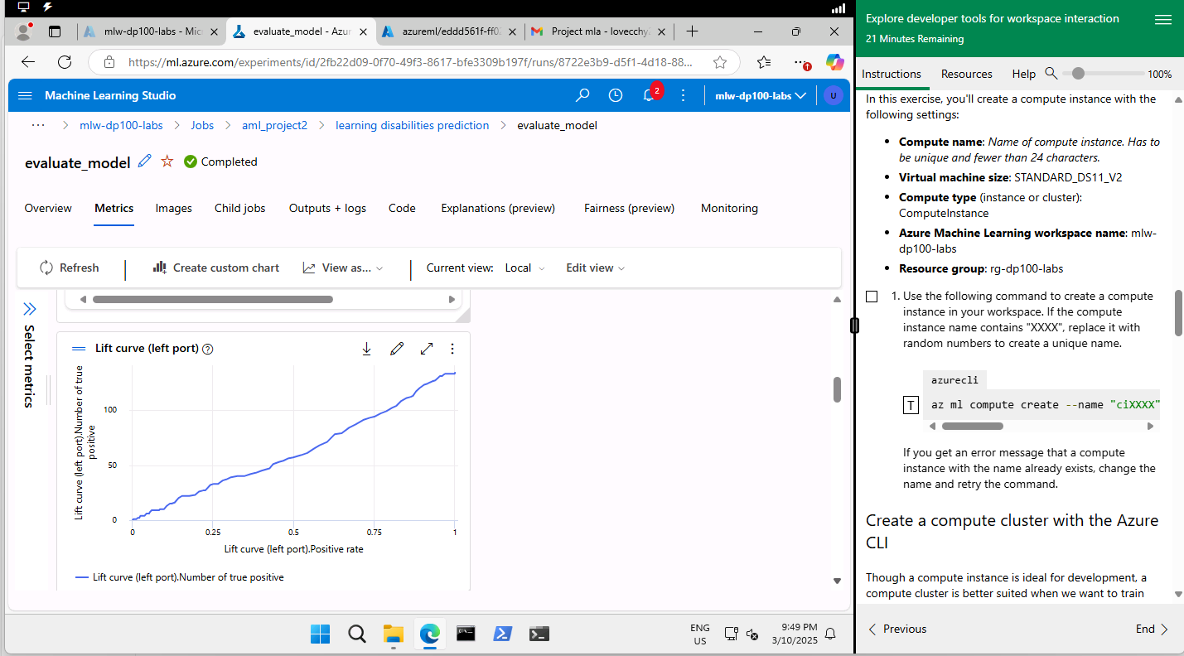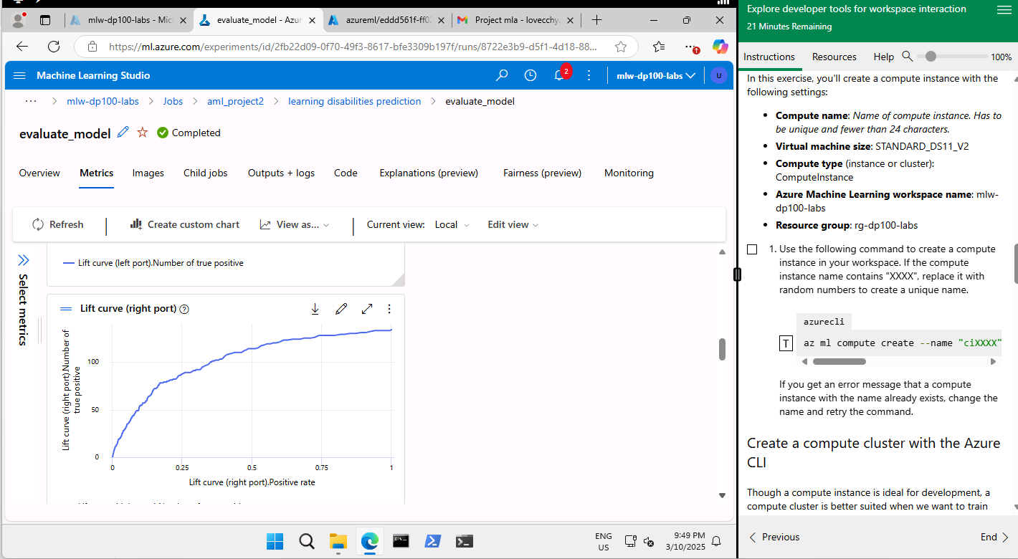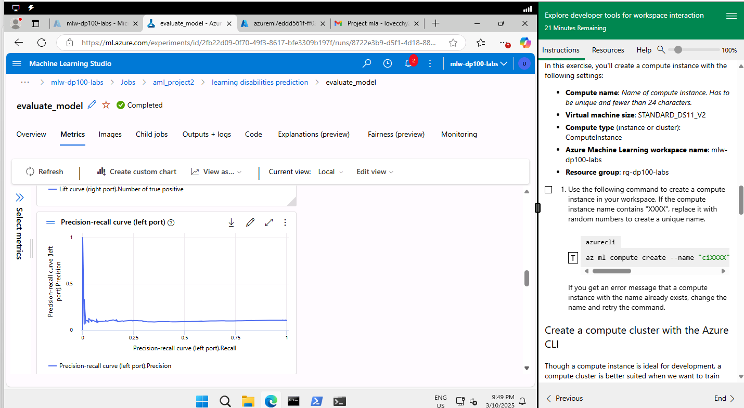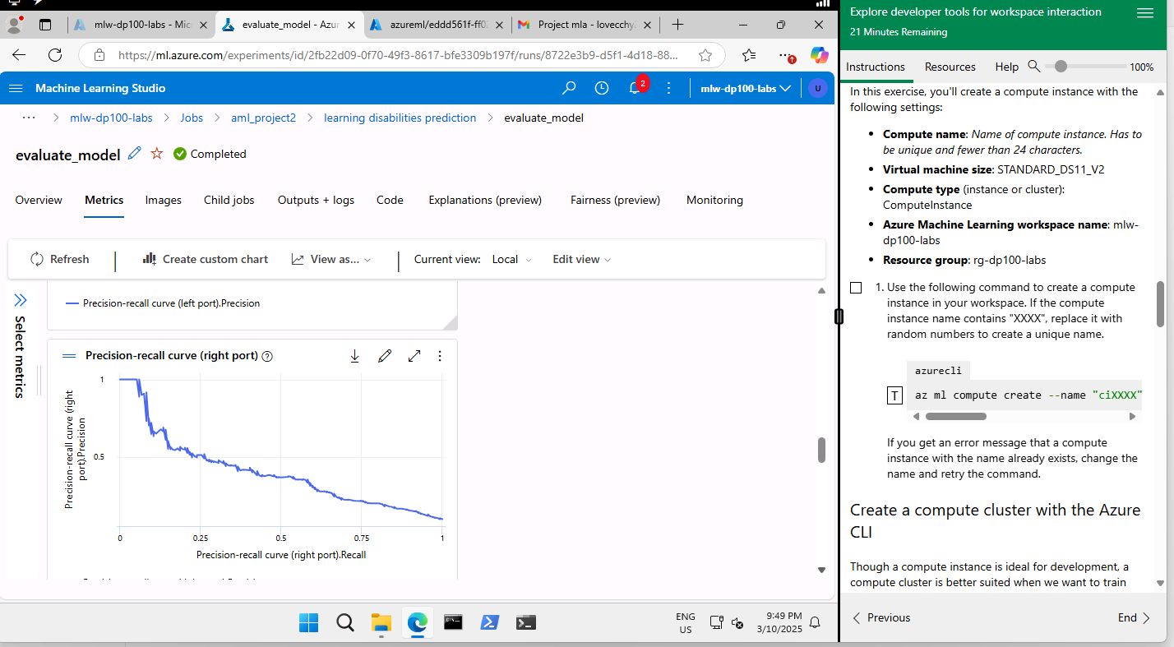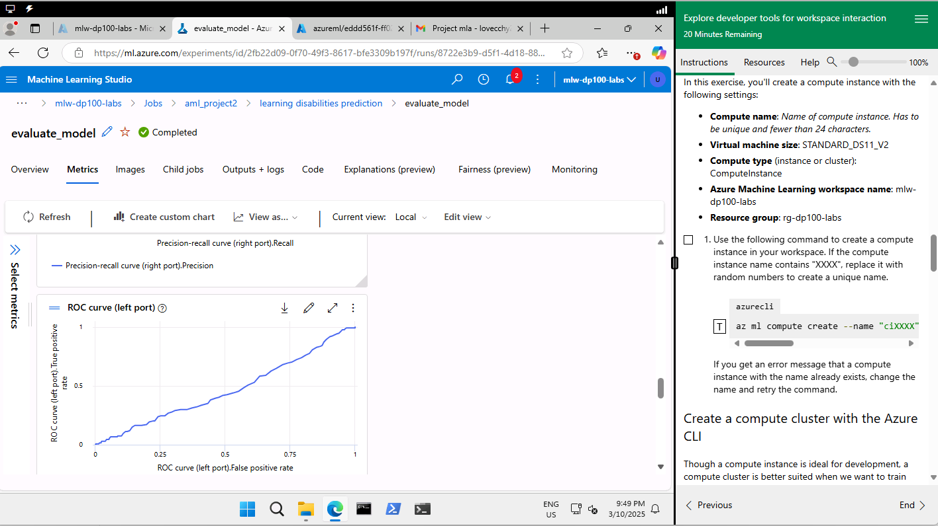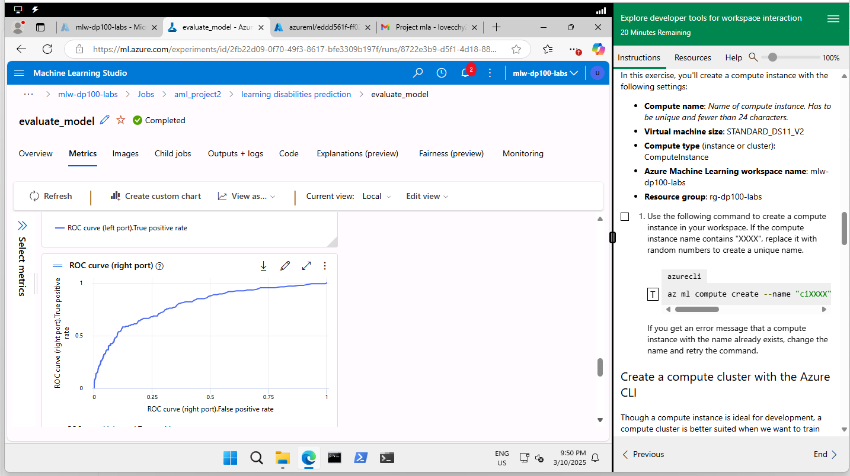

4C Activity 3

Please include screenshots and explanations in the provided space below.
- Screenshots of the clustering pipeline setup and results.
- Cluster analysis evaluation results.
Screenshots of the clustering pipeline setup and results

- 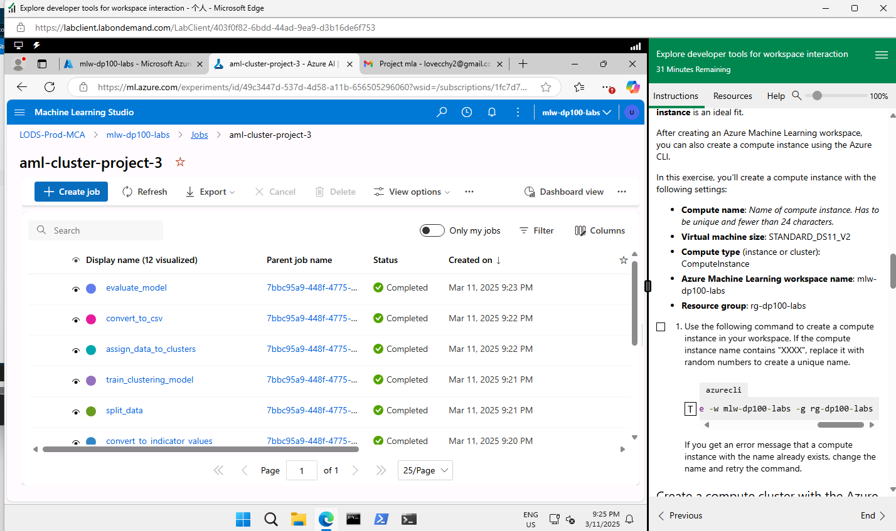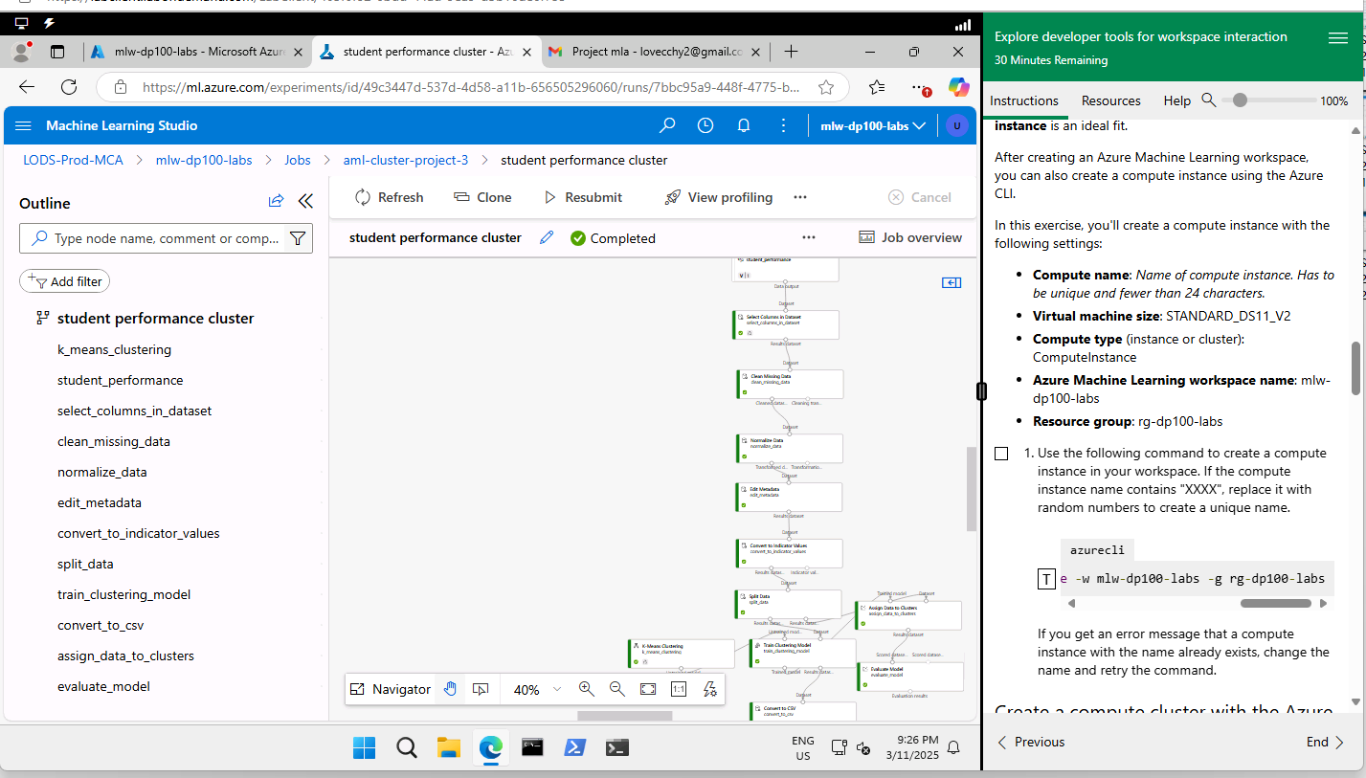

Cluster analysis evaluation results

Using Python
- Study_Physical_Interaction Study_Extracurricular Distance_to_Center_0 \
- 0 69.0 0.0 2.715926
- 1 76.0 0.0 3.413547
- 2 96.0 24.0 4.361727
- 3 116.0 29.0 5.142484
- 4 76.0 19.0 3.866492

- Distance_to_Center_1 Distance_to_Center_2
- 0 3.684692 3.657864
- 1 4.044766 4.235032
- 2 2.884506 3.956122
- 3 3.203543 4.776561
- 4 3.083820 3.421554
https://d.docs.live.net/3a0718dfa98eb90f/DataScience/WSQ%20Machine%20Learning%20Algorithms%20and%20Methods/Project/clusterdata.csv
Assignments | DistancesToClusterCenter no.0 | DistancesToClusterCenter no.1 | DistancesToClusterCenter no.2
2 | 4.819719609 | 4.389647527 | 4.040038974
2 | 3.781269035 | 4.251343874 | 3.288470169
0 | 3.532677149 | 4.053488416 | 4.209227673
0 | 3.557440182 | 4.071990899 | 4.201330478
0 | 3.132151184 | 3.742054322 | 3.827911432
0 | 3.340044498 | 3.885746219 | 4.021968067
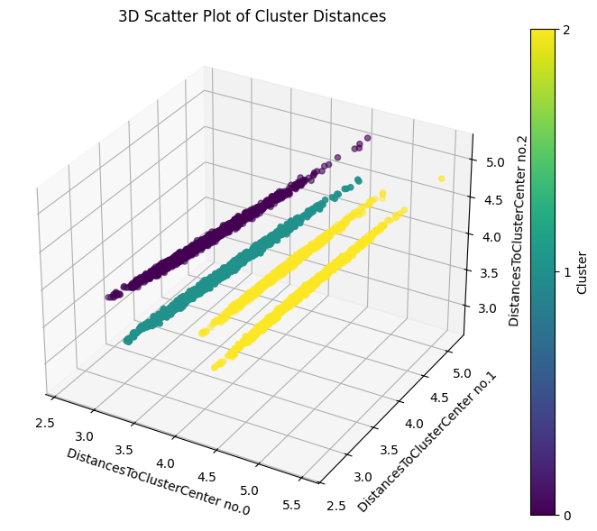

The clusters are based on 80% training data.
2 3.781269035 4.251343874 3.288470169
3.288 is distance to cluster 2. 3.781 is distance to cluster 0 and 4.251 is distance to cluster 1. This data point is nearer to cluster 2. Therefore this data point is assigned to cluster 2.
Let's break it down and evaluate the information provided:
### Overview:
The data contains:
- **Assignments**: Indicates the cluster to which each data point belongs (e.g., 2 or 0).
- **DistancesToClusterCenter no.0**, **DistancesToClusterCenter no.1**, and **DistancesToClusterCenter no.2**: Represent distances of each data point to the corresponding cluster centers.
### Observations:
1. **Cluster Assignments**:
- Data points 1 and 2 are assigned to cluster 2.
- Data points 3 and 4 are assigned to cluster 0.
2. **Distance Patterns**:
- For data points assigned to cluster 2 (row 1 & 2), the distances to "cluster center 2" are smaller compared to distances to the other centers.
- For data points assigned to cluster 0 (row 3 & 4), the distances to "cluster center 0" are generally smaller.
### Evaluation:
- The data appears to reflect a clustering structure where each point is assigned to the cluster with the closest center (based on its smallest distance). This is a common pattern in clustering algorithms like K-Means.

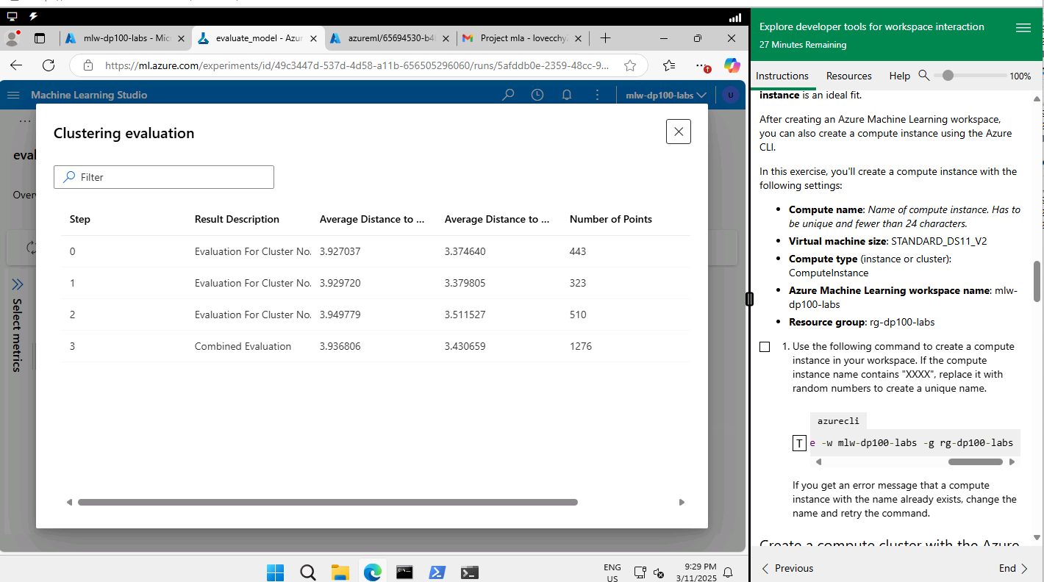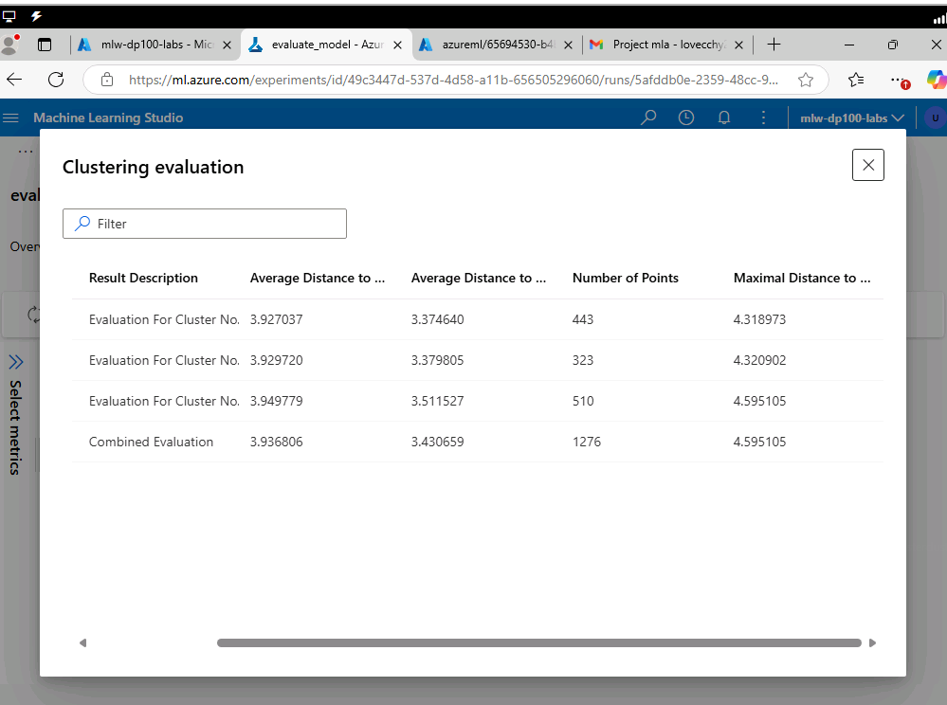
Cluster No.0
Cluster No.1
Cluster No.2
Another method
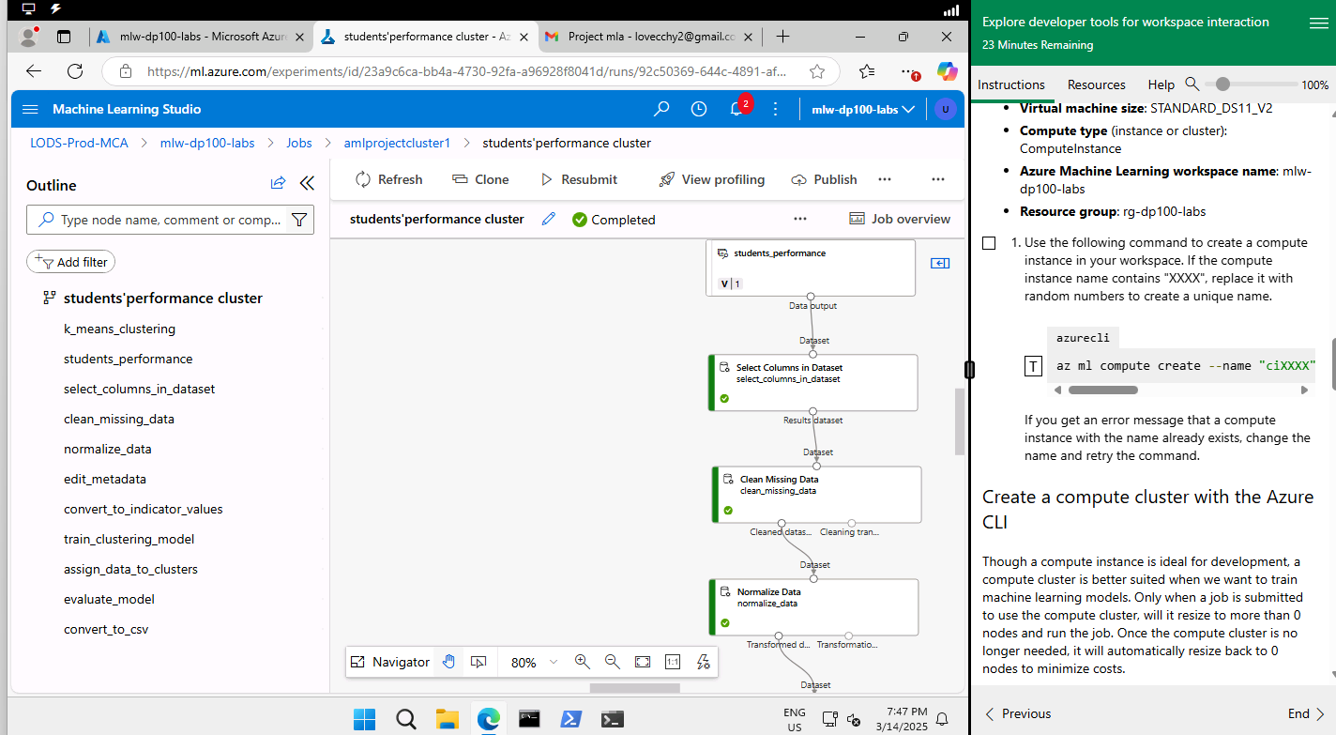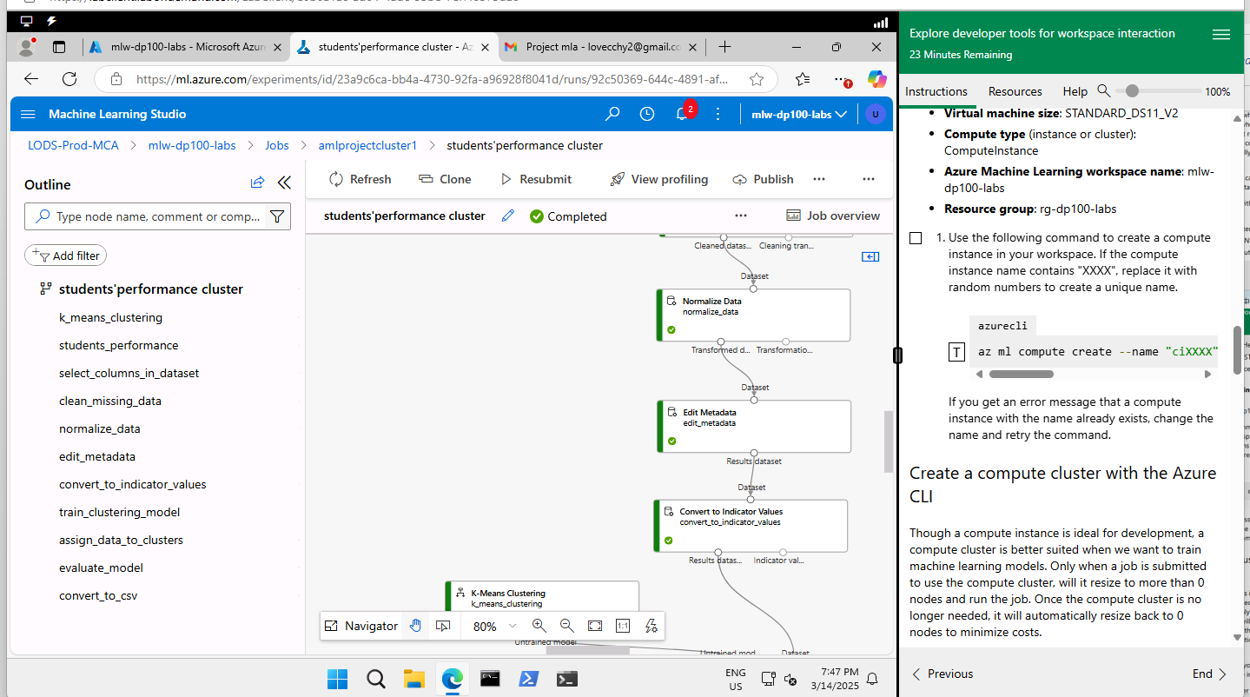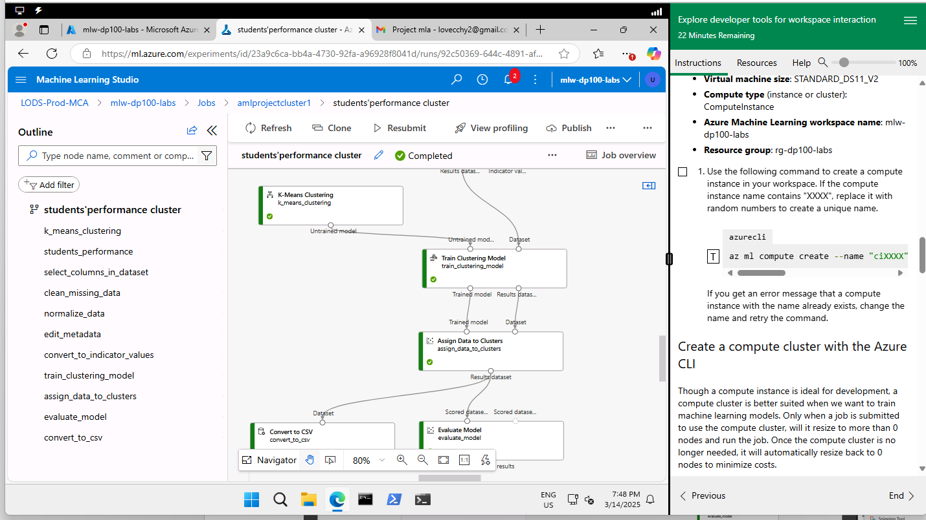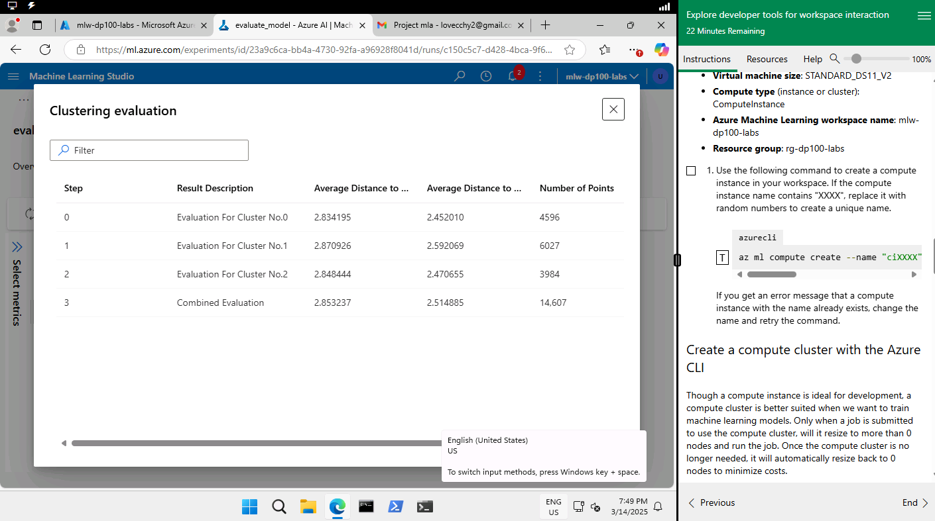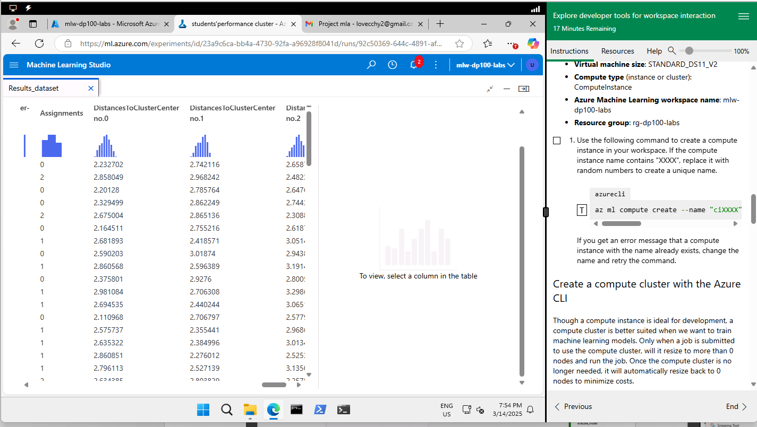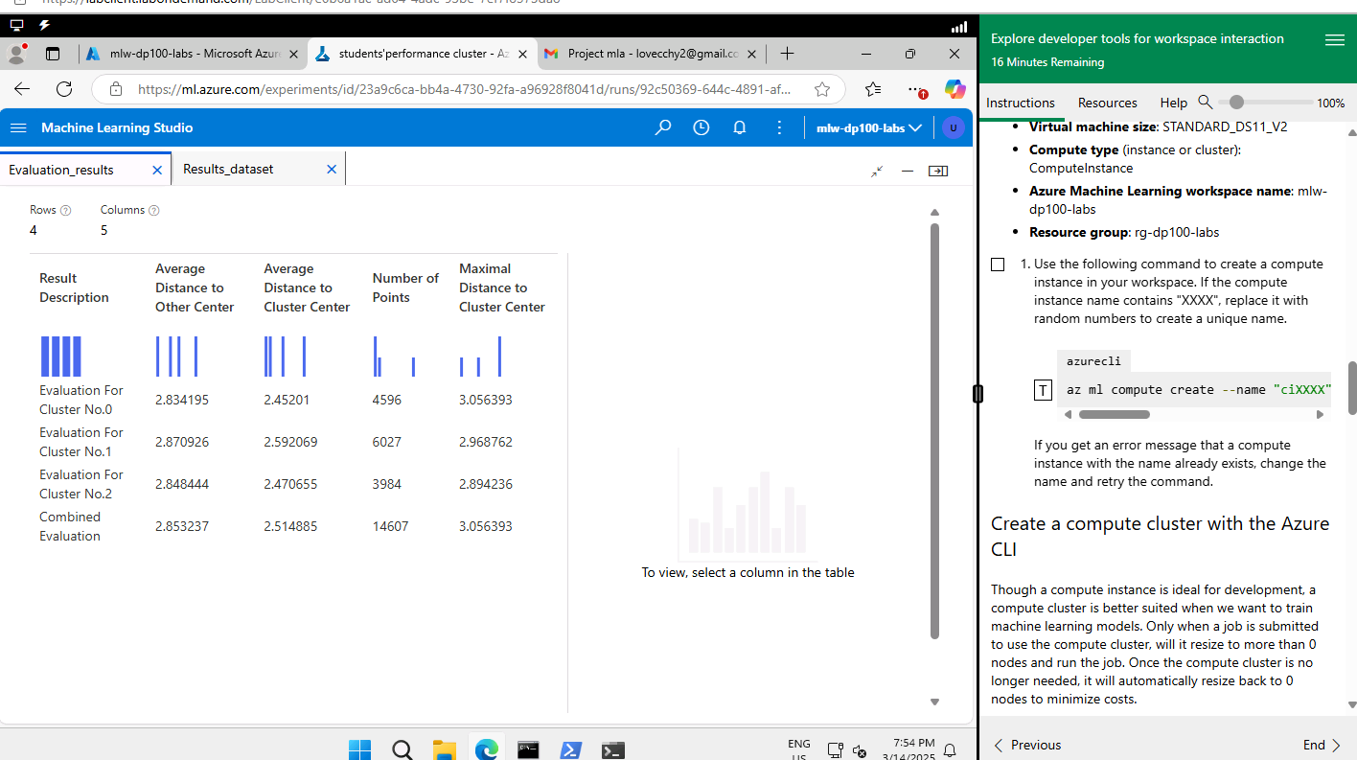

https://d.docs.live.net/3a0718dfa98eb90f/DataScience/WSQ%20Machine%20Learning%20Algorithms%20and%20Methods/Project/截图/clusterdata.csv

The evaluation for cluster 0, based on the provided metrics, can be interpreted as follows:
- Average Distance to Other Centers: 2.834195 — This represents how far, on average, the data points in cluster 0 are from the centroids of the other clusters. A lower value indicates that this cluster is relatively close to other clusters, which could imply potential overlap.
- Average Distance to Cluster Center: 2.45201 — This measures the average distance of the points within cluster 0 to its own centroid. A lower value suggests that the points are tightly grouped, indicating a well-defined cluster.
- Number of Points: 4596 — This shows the size of cluster 0, meaning it contains 4596 data points.
- Maximal Distance to Cluster Center: 3.056393 — This is the farthest distance from the centroid to any point in cluster 0. A relatively low value compared to the average distances would suggest the absence of significant outliers.
From this, cluster 0 appears to be reasonably compact and moderately close to other clusters. However, if you're conducting clustering analysis, it might be worth considering whether the clusters are well-separated (e.g., looking at the ratio of intra-cluster to inter-cluster distances).

Assignments | DistancesToClusterCenter no.0 | DistancesToClusterCenter no.1 | DistancesToClusterCenter no.2
0 | 2.232702 | 2.742116 | 2.65877
2 | 2.858049 | 2.968242 | 2.482349
0 | 2.20128 | 2.785764 | 2.647675
0 | 2.329499 | 2.862249 | 2.74433
2 | 2.675004 | 2.865136 | 2.308841
0 | 2.164511 | 2.755216 | 2.618715

There are 6 data points above. Each data is displayed based on distances to cluster center 0, 1 and 2. The smallest value indicates closer to that cluster center. 2.482349 is assigned to cluster 2 and 2.232702 is assigned to cluster 0. The distance between the 2 data points is 2.482349-2.232702=0.249647. Another data point 2.20128 that is assigned to cluster 0. Another data point 2.308841 is assigned to cluster 2.
Distance between cluster 2 and 0 as shown above
2.482349-2.232702=0.249647
2.308841-2.20128=0.107261
2.329499-2.308841=0.020658
2.308841-2.164511=0.14433
These data points with the distance between cluster 2 and 0 of 0.020658 are very close.
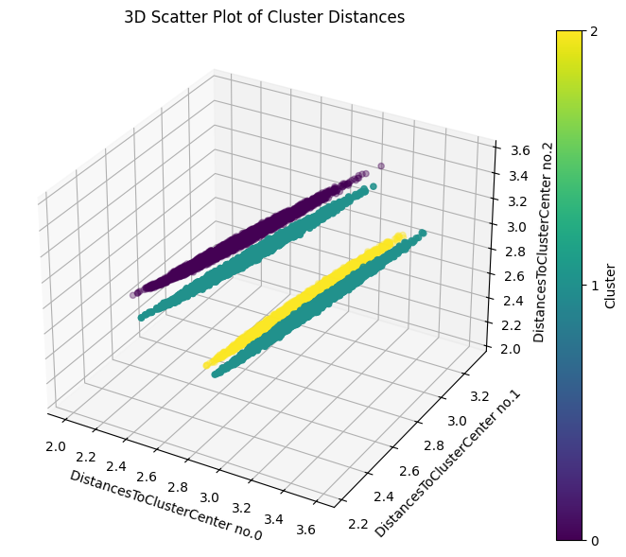
These cluster data are full training data and no. of centroids = 3.

https://d.docs.live.net/3a0718dfa98eb90f/DataScience/WSQ%20Machine%20Learning%20Algorithms%20and%20Methods/Project/clusterdatak5.csv
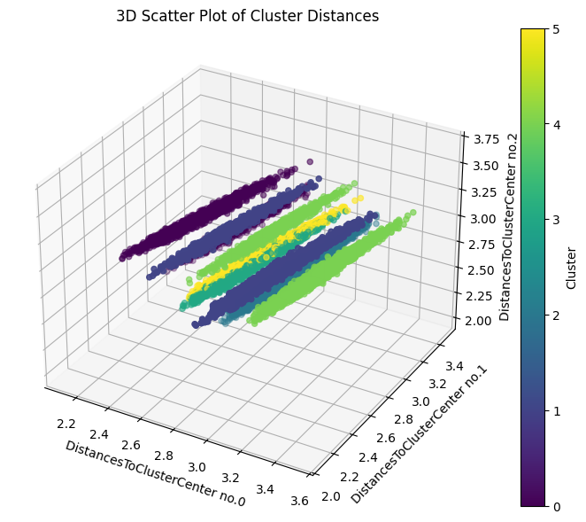
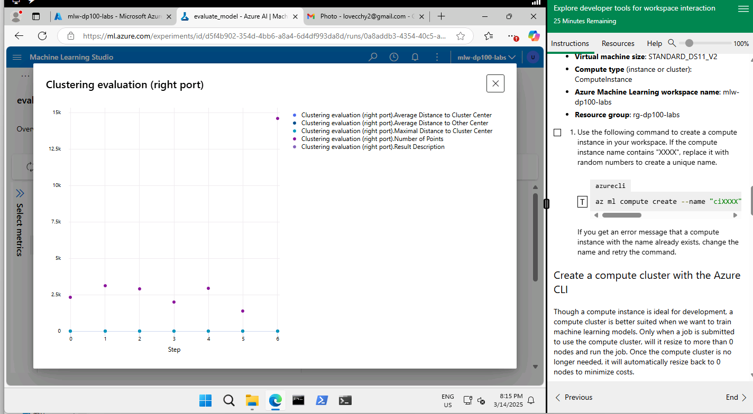

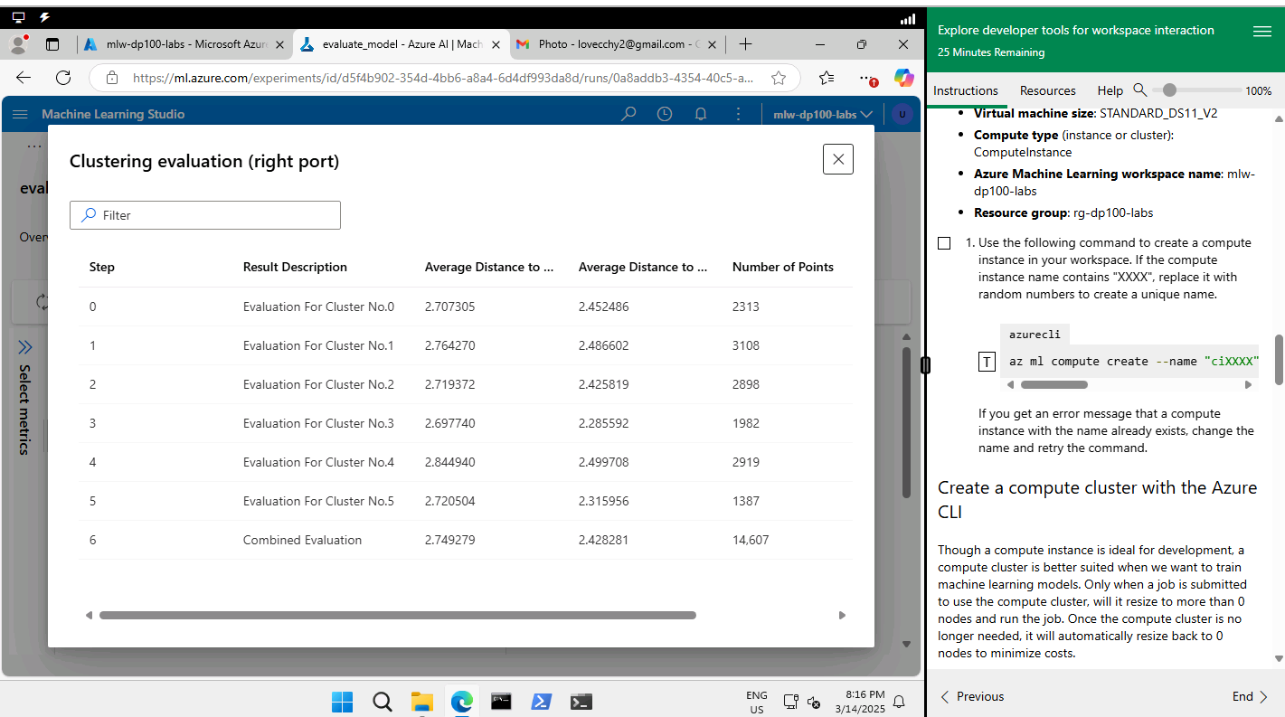
The evaluation for cluster 0, based on the provided metrics, can be interpreted as follows:
From the provided data:
Average Distance to Cluster Center: 2.452486
The maximal distance is generally around 1.25–1.5 times the average distance, depending on the density and spread of the cluster.
If we assume a reasonable spread and use a multiplier of 1.25 to 1.5, we can estimate:
Maximal Distance to Cluster Center ≈
2.452486
×
1.25
to
2.452486
×
1.5
Maximal Distance ≈ 3.07 to 3.68
Based on this calculation, the maximal distance could range between 3.07 and 3.68. However, this is an approximation.
Given the provided information, here’s a more detailed evaluation based on the metrics:
Provided Metrics:
Average Distance to Other Centers: 2.707305
Average Distance to Cluster Center: 2.452486
Number of Points: 2313
Maximal Distance to Cluster Center: Not provided (we estimated it in the range of 3.07 to 3.68 earlier).
Evaluation:
Cluster Compactness:
The Average Distance to Cluster Center (2.452486) is relatively close to the Estimated Maximal Distance (3.07–3.68). This suggests that most points in the cluster are fairly close to the centroid, with only a few outliers extending farther away.
The compactness of this cluster indicates a well-defined grouping of data points.
Cluster Size:
The Number of Points in the cluster is 2313. This is a reasonable size for a cluster, but its evaluation also depends on the overall dataset size. If this cluster is much larger or smaller than others, it might indicate an imbalance.
Separation from Other Clusters:
The Average Distance to Other Centers (2.707305) is only slightly larger than the Average Distance to Cluster Center (2.452486). This relatively small gap suggests the clusters may not be well-separated. This could potentially mean overlap between clusters, which might require further evaluation of your clustering algorithm.
Estimated Maximal Distance:
Based on our earlier estimate of Maximal Distance to Cluster Center (3.07–3.68), it aligns with expectations given the average distances. If the actual maximal distance falls within or close to this range, it confirms consistency in the data distribution within the cluster.
Conclusion:
While this cluster appears compact and reasonably cohesive, the relatively small gap between the Average Distance to Cluster Center and the Average Distance to Other Centers raises questions about separation from other clusters. It may be worth visualizing this cluster alongside others or calculating additional metrics (e.g., silhouette score, Dunn index) to better understand its distinctness and quality.
Cluster 0 - 2.707305 2.834195

Cluster 1 - 2.76427 2.870926

Cluster 2 - 2.719372 2.848444

Cluster 3 - 2.69774
Cluster 4 - 2.84494
Cluster 5 - 2.720504
The above are the distances between clusters from no. of centroids = 6 and no. of centroids = 3.
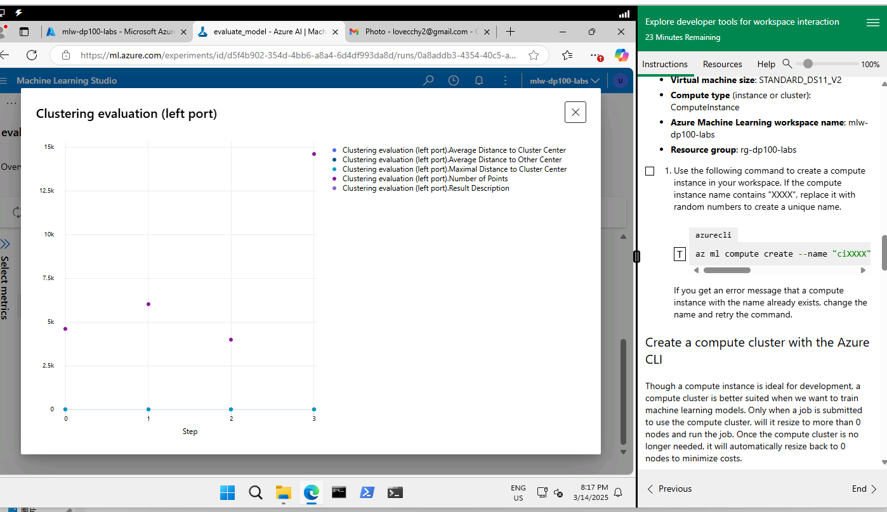

These cluster data are full training data and no. of centroids = 6.

4D. Activity 4

Please include screenshots and explanations in the provided space below.
- Screenshots of the sentiment analysis pipeline setup and results.
- Sentiment analysis evaluation results.
Screenshots of the sentiment analysis pipeline setup and results.

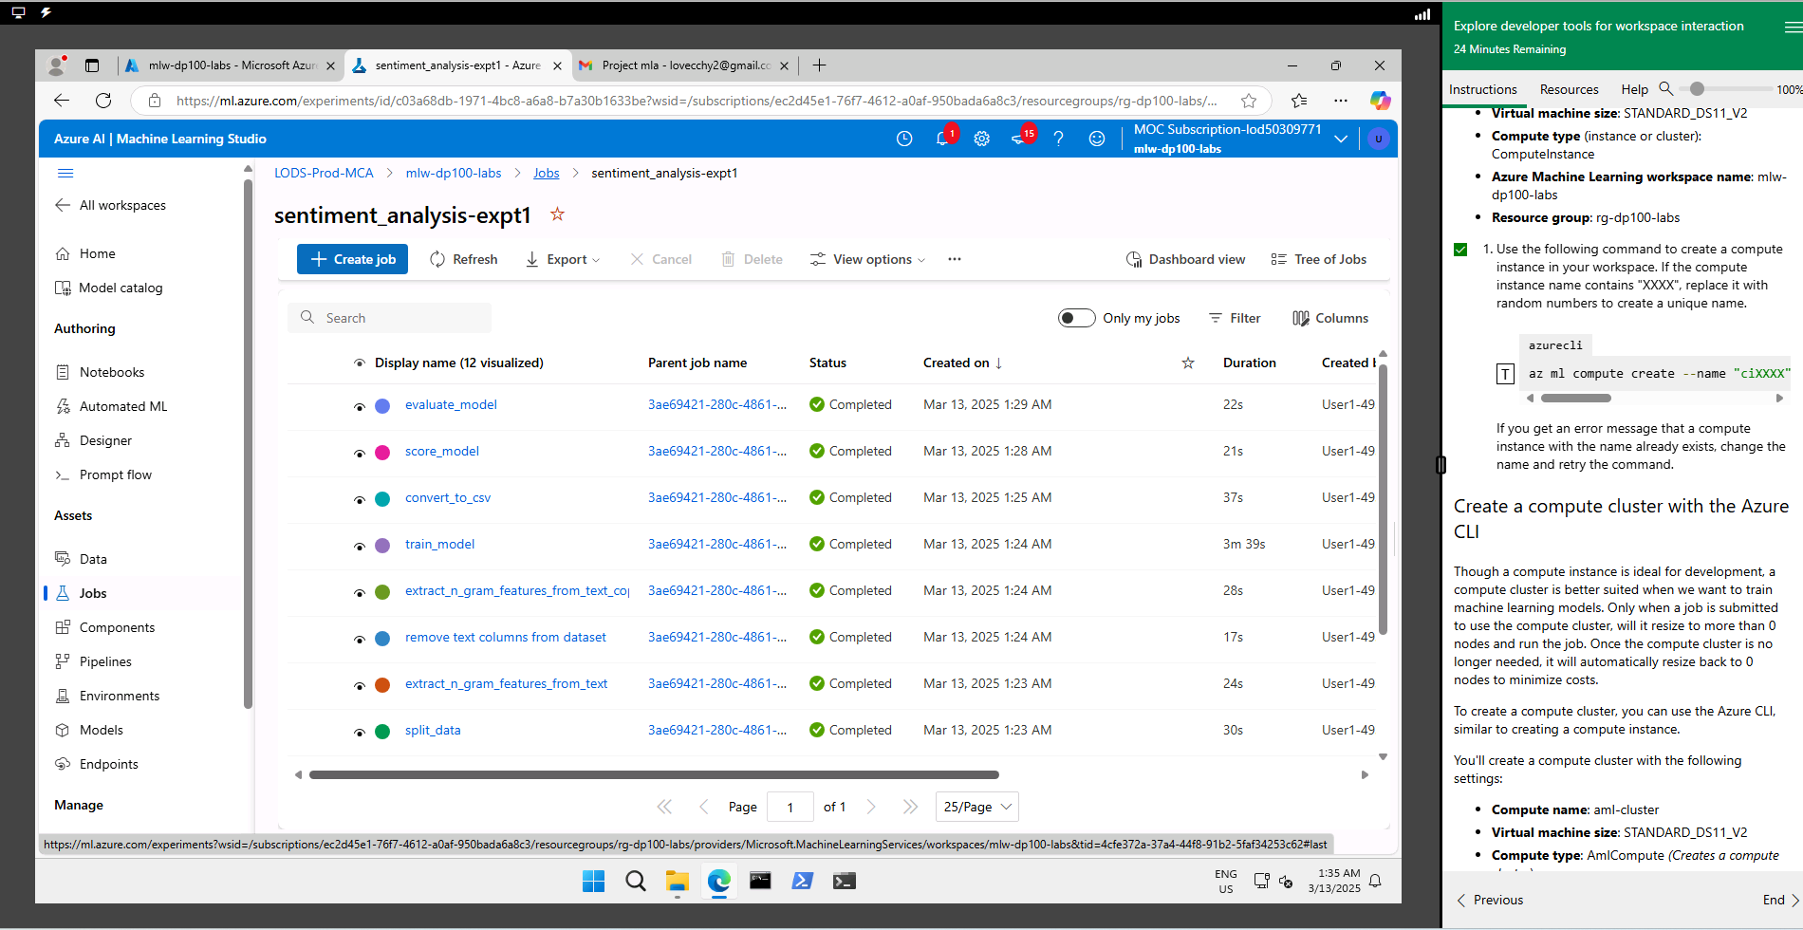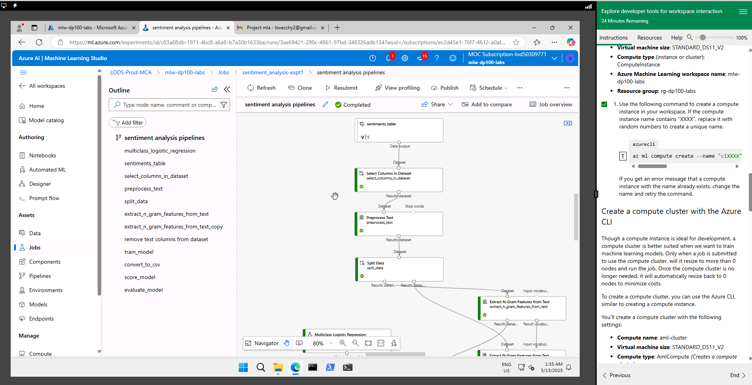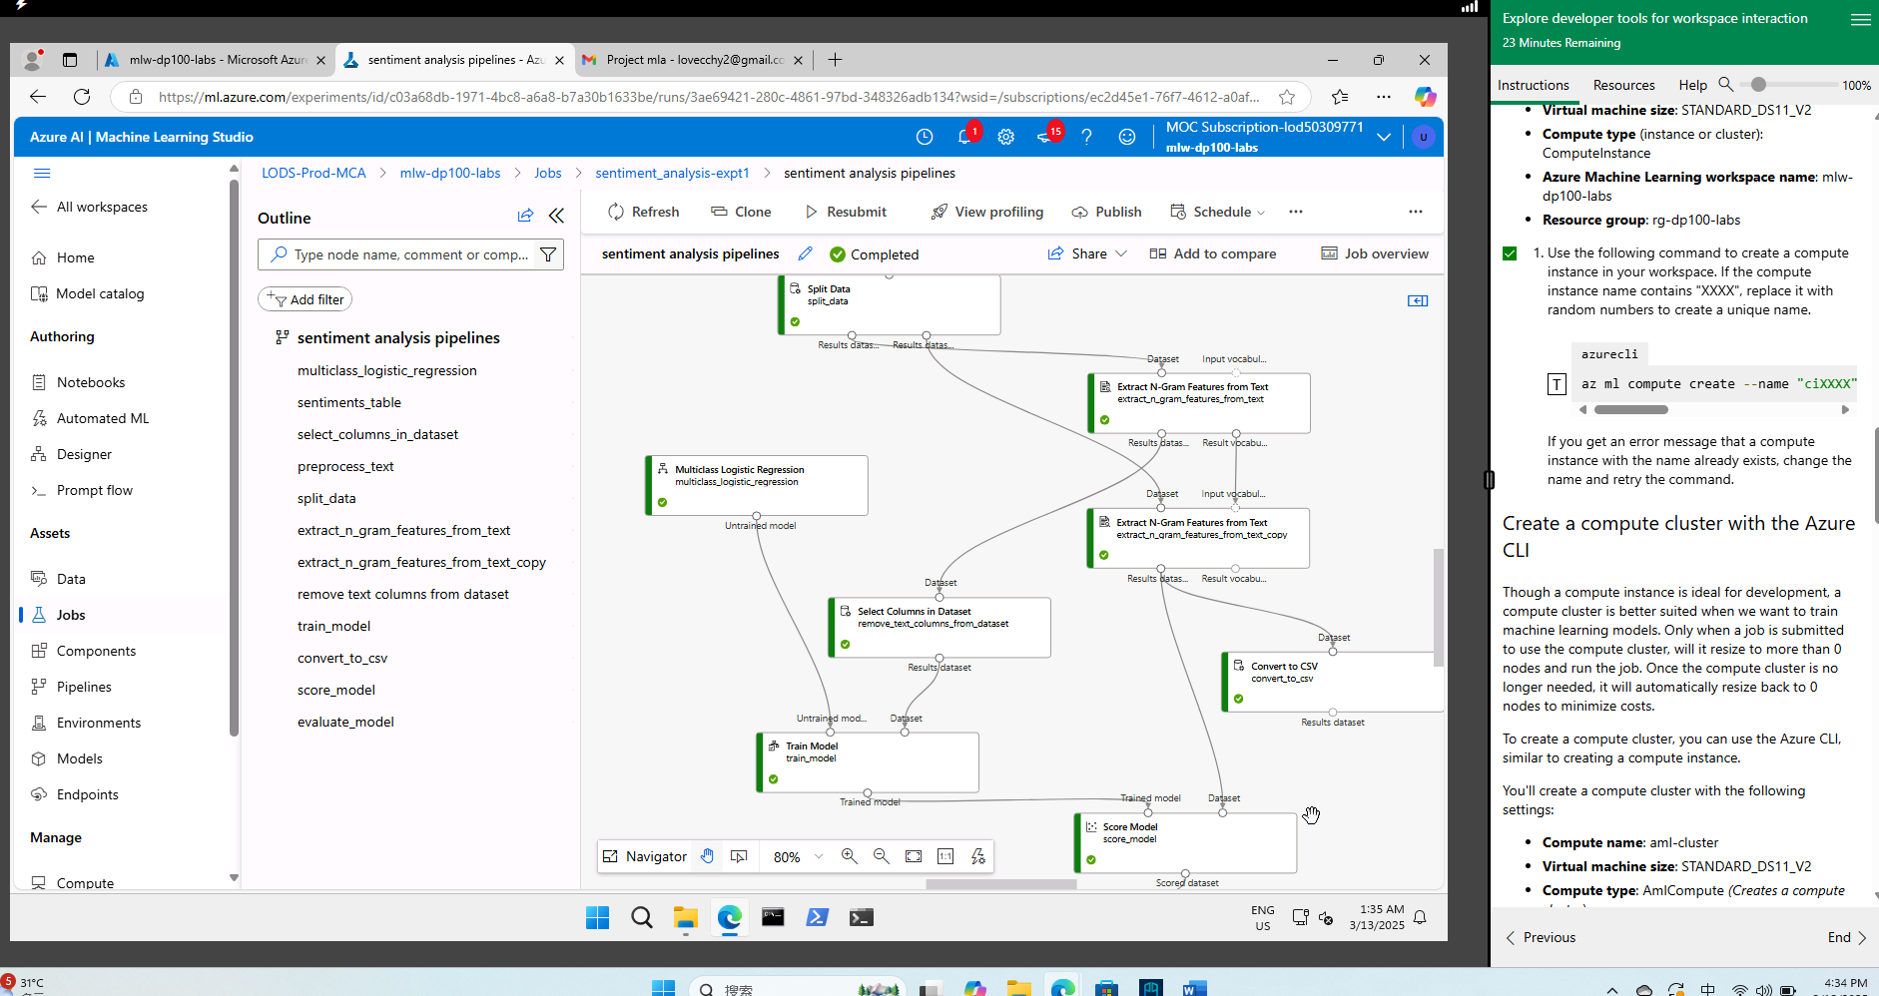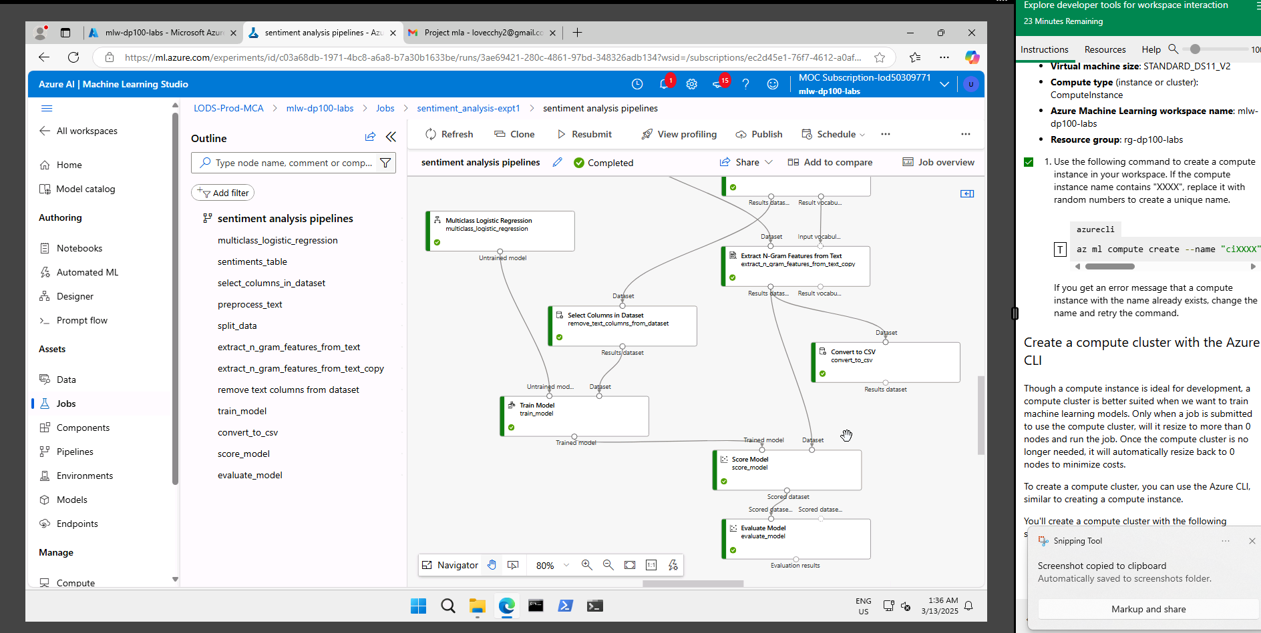
Sentiment analysis evaluation results
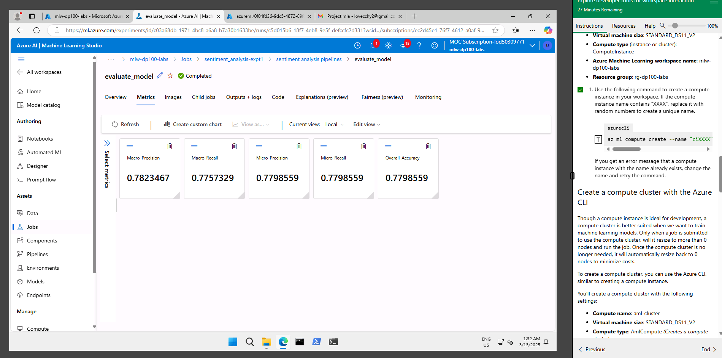
https://d.docs.live.net/3a0718dfa98eb90f/DataScience/WSQ%20Machine%20Learning%20Algorithms%20and%20Methods/Project/sentimentanalysisdata.csv -> output from ngram
https://d.docs.live.net/3a0718dfa98eb90f/DataScience/WSQ%20Machine%20Learning%20Algorithms%20and%20Methods/dataset_ml/dataset_ml/text_data.csv -> source dataset
Evaluation of Model Performance Metrics:
1. Macro Precision: 0.7823467
- Macro precision is the average precision across all classes, treating each class equally regardless of size.
- A precision of 0.7823467 indicates that, on average, the model is correctly identifying 78.2% of the true positives across all classes, but it does not consider class imbalance.
2. Macro Recall: 0.7757329
- Macro recall is the average recall across all classes, also treating each class equally.
- A recall of 0.7757329 means that, on average, 77.5% of the actual positives are being identified across all classes. This is good but suggests there may be slight room for improvement in capturing all true positives for some classes.
3. Micro Precision and Recall: 0.7798559
- Micro precision and micro recall are calculated globally across all classes by aggregating the contributions of all true positives, false positives, and false negatives.
- Since both micro precision and recall are equal (0.7798559), it suggests that the model's overall balance between precision and recall is good. The model identifies approximately 77.9% of the total positives across all classes.
4. Overall Accuracy: 0.7798559
- Accuracy is the ratio of the total number of correct predictions (true positives and true negatives) to the total number of predictions.
- An accuracy of 0.7798559 reflects that the model correctly predicted 77.9% of the samples. This aligns with the micro metrics, indicating consistent performance.
Summary:
- The performance metrics are quite balanced, with both macro and micro precision, recall, and accuracy hovering around 77-78%.
- The slightly lower macro recall compared to macro precision suggests that certain classes might have slightly fewer true positives identified, potentially due to class imbalance.
- For further improvement:
  - Address Class Imbalance: If class sizes vary significantly, consider techniques like oversampling/undersampling or class-weight adjustments during training.
  - Analyze Misclassifications: Examine confusion matrices to identify which classes are being misclassified and why.
  - Fine-tune the Model: Experiment with hyperparameters, feature selection, or more advanced algorithms.
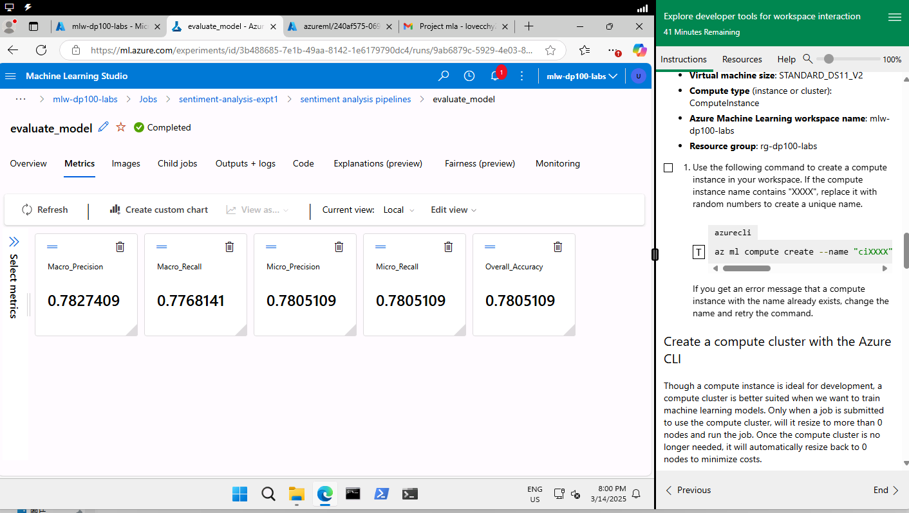
Precision = TP /TP+FP
Recall = TP/TP+FN
High recall means fewer missed cases. Recall answers the question: "Of all the actual instances of a certain class, how many did the model correctly identify?"
It measures how sensitive the model is to capturing all true positives.

High precision means fewer false alarms. Precision answers the question: "Of all the instances the model predicted as a certain class, how many were actually correct?"
It measures how reliable the model's positive predictions are.
Example
Imagine you're detecting "positive" sentiment in tweets:
- If the model predicts "positive" for 100 tweets, and 80 are truly positive, precision is 80%.
- If there are 120 positive tweets in total, and the model identifies 80 of them, recall is 66.7%.
Which one matters more depends on your use case. If you're prioritizing correctness, choose precision

F1-score = 2× precision × recall ÷(precision +recall)
2×0.81×0.78÷(0.81+0.78)=0.795
It is a number between 0 and 1. It is calculated based on precision and recall. The F1 score is a metric that combines both precision and recall into a single value, providing a balanced measure of a model's performance, especially useful when you want to consider both false positives and false negatives.
In the context of multiclass logistic regression for sentiment analysis, the choice of the primary metric depends on your specific goals. Here's a breakdown of your metrics:
- Macro Precision and Macro Recall: These metrics treat all classes equally, regardless of their frequency. They are particularly useful if you want balanced performance across all sentiment classes, especially when dealing with imbalanced datasets. If misclassification in minority classes is critical, Macro Recall might be the focus.
- Micro Precision, Micro Recall, and Accuracy: These metrics take into account class frequencies, giving more weight to the majority classes. Accuracy is a good choice if your dataset is balanced or if your priority is overall correctness rather than performance on individual classes.
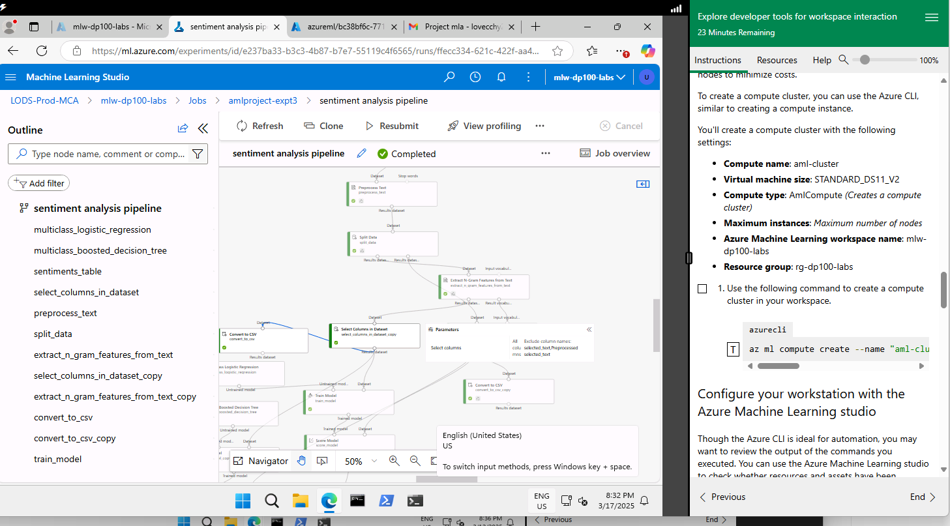
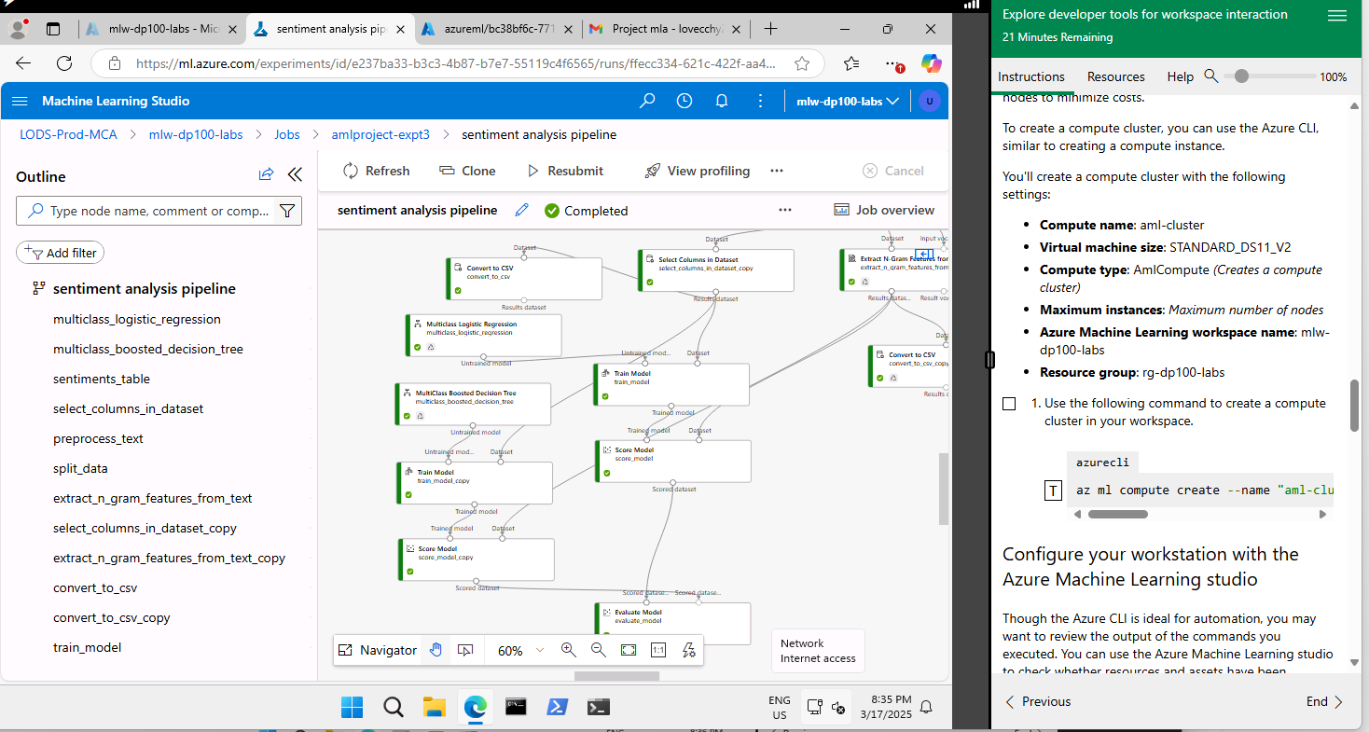

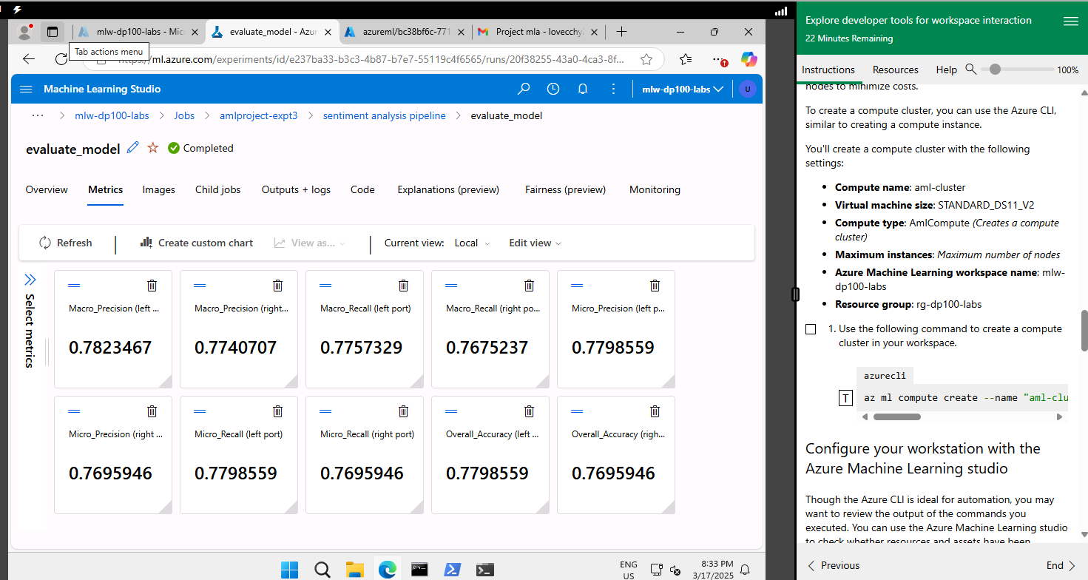

Left: multiclass logistic regression
Right: multiclass boosted decision tree regression

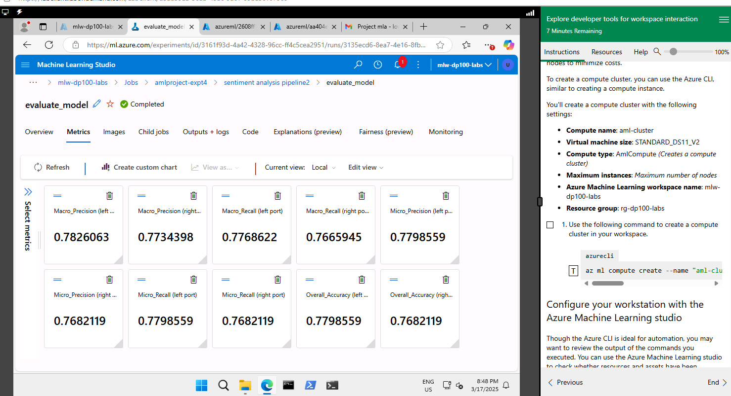
Left: multiclass logistic regression
Right: multiclass boosted decision tree regression for https://d.docs.live.net/3a0718dfa98eb90f/DataScience/WSQ%20Machine%20Learning%20Algorithms%20and%20Methods/dataset_ml/dataset_ml/text_data2.csv with additional of 1 row data input
Multiclass boosted decision tree regression’s metrics are bit lower.
https://d.docs.live.net/3a0718dfa98eb90f/DataScience/WSQ%20Machine%20Learning%20Algorithms%20and%20Methods/Project/afterscid2.csv
1st select columns in dataset component
selected_text, sentiment
2nd select columns in dataset component
It takes in from output of ngram that receives the training data. Configure as all columns exclude selected_text,Preprocessed selected_text. It means the dataset is left with sentiment and additional columns processed by ngram.

Using Python
Upload widget is only available when the cell has been executed in the current browser session. Please rerun this cell to enable.
Saving text_data.csv to text_data (3).csv
Top N-grams:
N-gram Count
63999 in the 822
50438 going to 740
131600 to be 545
45568 for the 525
132127 to go 509
56085 have to 494
133142 to the 481
95205 on the 458
93024 of the 414
141247 want to 389
/usr/local/lib/python3.11/dist-packages/sklearn/linear_model/_logistic.py:1247: FutureWarning: 'multi_class' was deprecated in version 1.5 and will be removed in 1.7. From then on, it will always use 'multinomial'. Leave it to its default value to avoid this warning.
warnings.warn(
precision recall f1-score support

negative 0.82 0.80 0.81 1562
neutral 0.81 0.88 0.84 2230
positive 0.90 0.81 0.86 1705

accuracy 0.84 5497
macro avg 0.84 0.83 0.83 5497
weighted avg 0.84 0.84 0.84 5497

Text: I love yufei very much but yufei does not love me. => Sentiment: positive
Text: I love yufei very much but yufei hurts me. => Sentiment: negative

N-gram Count
63999 in the 822

1 I`d have responded, if I were going
2 Sooo SAD I will miss you here in San Diego!!!
3 my boss is bullying me...
4 what interview! leave me alone
5 Sons of ****, why couldn`t they put them on the releases we already bought
6 http://www.dothebouncy.com/smf - some shameless plugging for the best Rangers forum on earth
7 2am feedings for the baby are fun when he is all smiles and coos
8 Soooo high
9 Both of you
10 Journey!? Wow... u just became cooler. hehe... (is that possible!?)
11 as much as i love to be hopeful, i reckon the chances are minimal =P i`m never gonna get my cake and stuff
12 I really really like the song Love Story by Taylor Swift
13 My Sharpie is running DANGERously low on ink
14 i want to go to music tonight but i lost my voice.

Consider 14 sentences,
Your dataset appears to be a collection of text samples that could have been used to generate the n-gram frequencies from your earlier table. Let me help connect this:
- 63999 ("in the"): Indicates the total number of times the n-gram "in the" appears across the entire dataset.
- 822 ("in the"): Represents the number of unique contexts (e.g., sentences, tweets, or documents) where "in the" is found.
If we apply this to your provided examples:
- Sentence 7: "2am feedings for the baby are fun when he is all smiles and coos" contains "in the" once.
- Sentence 14: "I want to go to music tonight but I lost my voice." contains none.
- Sentence 12: I really really like the song Love Story by Taylor Swift
Contains “in the” once
- Sentence 11: as much as i love to be hopeful, i reckon the chances are minimal =P i`m never gonna get my cake and stuff
Contains “in the” once
- Sentence 6: http://www.dothebouncy.com/smf - some shameless plugging for the best Rangers forum on earth
Contains “in the” once
- Sentence 2: Sooo SAD I will miss you here in San Diego!!!
Contains “in the” once
- Sentence 5: Sons of ****, why couldn`t they put them on the releases we already bought
Contains “in the” once

Even if "in the" were to appear multiple times within a single sentence or document, it would count once for the 822 but increase the 63999 value with every occurrence.
Based on above example,
822 - contains 6 nos of “in the”.
63999 - contains 6 nos of “in the” too. “in the” appears once in 1 sentence.

Here’s a breakdown of the evaluation:

### **1. Key Observations from Classification Report**
- **Accuracy:** The overall accuracy is **84%**, which is strong for text classification tasks.
- **Precision, Recall, F1-Score:**
- **Negative Sentiment:** Precision (82%), Recall (80%), F1-score (81%)—shows good balance for this class.
- **Neutral Sentiment:** The highest Recall (88%), indicating the model is strong at identifying neutral text.
- **Positive Sentiment:** Precision is high (90%), but Recall is slightly lower (81%). This suggests the model predicts positive sentiment accurately when identified, but it might miss some positive samples.

### **2. Predictions for New Text**
Your test sentences:
1. "I love yufei very much but yufei does not love me." → **Positive Sentiment**
- This might feel counterintuitive since it conveys heartbreak. However, the positive word "love" likely influences the model’s prediction.
2. "I love yufei very much but yufei hurts me." → **Negative Sentiment**
- The word "hurts" dominates the sentiment here, leading to a correct classification.

### **3. Suggestions for Improvement**
- **Expand Training Data:** Include a wider variety of emotionally complex texts to help the model capture subtleties.
- **Adjust Class Imbalance:** The dataset may have imbalances between sentiment classes. Techniques like oversampling or weighted loss functions could help.
- **Feature Engineering:** Add custom features such as sentiment scores from tools like `TextBlob` or `VADER` as additional model inputs.

The metrics for precision, recall and f1-score are higher than using Azure Machine Learning Studio.

Coding

import pandas as pd
from google.colab import files
from textblob import TextBlob
from sklearn.feature_extraction.text import CountVectorizer
# Load the CSV file
uploaded = files.upload() # File upload prompt in Google Colab
# Try reading the file with an alternative encoding
data = pd.read_csv('text_data.csv', encoding='latin1') # or 'ISO-8859-1', 'cp1252'
# Clean and prepare the text data
text_data = data['text'].dropna().astype(str).tolist() # Remove NaN values and ensure all values are strings
# Generate n-grams (e.g., bigrams or trigrams)
n = 2 # Define n for n-grams (2 for bigrams, 3 for trigrams, etc.)
vectorizer = CountVectorizer(ngram_range=(n, n)) # Adjust n-gram range
ngrams = vectorizer.fit_transform(text_data) # Fit and transform the text data
# Extract n-gram features and their counts
ngram_features = vectorizer.get_feature_names_out() # Extract the n-grams
ngram_counts = ngrams.toarray().sum(axis=0) # Sum up counts of each n-gram
ngram_data = list(zip(ngram_features, ngram_counts)) # Combine n-grams with their counts
# Convert to a DataFrame for better visualization
ngram_df = pd.DataFrame(ngram_data, columns=["N-gram", "Count"]).sort_values(by="Count", ascending=False)
# Display top n-grams
print("Top N-grams:")
print(ngram_df.head(10)) # Display the top 10 n-grams
# Handle missing values in 'selected_text' column
data['selected_text'] = data['selected_text'].fillna('') # Replace NaN with an empty string
# Alternatively, drop rows with NaN values:
# data = data.dropna(subset=['selected_text'])
from sklearn.feature_extraction.text import TfidfVectorizer
vectorizer2 = TfidfVectorizer()
X = vectorizer2.fit_transform(data['selected_text']) # Convert text to numerical data
y = data['sentiment'] # Labels
from sklearn.linear_model import LogisticRegression
from sklearn.model_selection import train_test_split
from sklearn.metrics import classification_report
# Split the data into training and testing sets
X_train, X_test, y_train, y_test = train_test_split(X, y, test_size=0.2, random_state=42)
# Train the Logistic Regression model
model = LogisticRegression(multi_class='multinomial', solver='lbfgs', max_iter=1000)
model.fit(X_train, y_train)
# Predict on test data
y_pred = model.predict(X_test)
# Evaluate the model
print(classification_report(y_test, y_pred))
new_text = ["I love yufei very much but yufei does not love me."]
new_X = vectorizer2.transform(new_text) # Vectorize the new text
predictions = model.predict(new_X)
for text, pred in zip(new_text, predictions):
print(f"Text: {text} => Sentiment: {pred}")
new_text2 = ["I love yufei very much but yufei hurts me."]
new_X2 = vectorizer2.transform(new_text2) # Vectorize the new text
predictions = model.predict(new_X2)
for text, pred in zip(new_text2, predictions):
print(f"Text: {text} => Sentiment: {pred}")

https://d.docs.live.net/3a0718dfa98eb90f/DataScience/WSQ%20Machine%20Learning%20Algorithms%20and%20Methods/dataset_ml/dataset_ml/text_data2.csv - > source dataset
Additional of 1 row for this dataset
https://d.docs.live.net/3a0718dfa98eb90f/DataScience/WSQ%20Machine%20Learning%20Algorithms%20and%20Methods/Project/sentimentanalysisdata2.csv
Evaluation of Updated Model Performance Metrics:
1. Macro Precision: 0.7827409
- This represents the average precision across all classes, treating each class equally. A precision of 78.27% indicates that the model is effective at minimizing false positives for all classes.
2. Macro Recall: 0.7768141
- This is the average recall across all classes, treating each class equally. A recall of 77.68% shows that the model identifies most true positives on average, but there might still be room to improve recall for specific classes.
3. Micro Precision and Recall: 0.77805109
- Both micro precision and micro recall are calculated globally across all classes. They account for the contributions of all true positives, false positives, and false negatives.
- A score of 77.81% for both indicates that the model has balanced performance when aggregating all classes, with an overall good trade-off between precision and recall.
4. Overall Accuracy: 0.77805109
- The model has an accuracy of 77.81%, meaning it predicts the correct class for approximately 78% of all samples. This aligns closely with the micro metrics, which is expected in a balanced dataset.
Observations:
- The metrics are slightly lower compared to the previous set, where the micro and macro precision/recall values were around 0.7798559 and macro precision was 0.7823467. This slight decline could indicate changes in the dataset or model adjustments affecting class separability.
- The difference between macro and micro metrics is minimal, suggesting that the dataset is relatively balanced and there aren't significant disparities between class sizes.
- An overall accuracy and precision/recall balance of ~78% is a solid starting point, though further fine-tuning might still improve performance.
Recommendations for Improvement:
- Analyze Class-Specific Performance: Inspect a confusion matrix to identify specific classes with lower precision or recall and investigate why misclassifications occur.
- Data Enhancements:
  - Balance the dataset if there's class imbalance (e.g., oversampling minority classes).
  - Add more representative samples for underperforming classes.
- Feature Engineering: Introduce or refine features to better separate classes.
- Model Optimization: Experiment with hyperparameters or try advanced algorithms to improve separability.
- Preprocessed selected_text.[-pron-_soo] 0.538752
It seems you're referring to a preprocessed version of selected_text with a score of 0.538752. This value might represent a derived metric, such as sentiment polarity, confidence score, or another measure.
For example:
If it's sentiment polarity, the value suggests a moderately positive sentiment leaning toward the positive side.
If it's a model confidence score, it indicates how certain the model is about its prediction for this particular text.
Jars was gonna be my answer | neutral | jars -pron- answer
amazing. | positive | amazing
Selected text neutral was,gonna,be,my are removed and pron is added.
Selected text positive full stop is removed.
Using python
• text_data2.csv(text/csv) - 4642772 bytes, last modified: 2025/3/16 - 100% done
Saving text_data2.csv to text_data2 (12).csv
textID text \
0 cb774db0d1 I`d have responded, if I were going
1 549e992a42 I love yufei but I am on one-sided love.
2 549e992a42 Sooo SAD I will miss you here in San Diego!!!
3 088c60f138 my boss is bullying me...
4 9642c003ef what interview! leave me alone

selected_text sentiment Time of Tweet \
0 I`d have responded, if I were going neutral morning
1 I love yufei but I am on one-sided love. negative morning
2 Sooo SAD negative noon
3 bullying me negative night
4 leave me alone negative morning

Age of User Country Population -2020 Land Area (Km?) Density (P/Km?)
0 0-20 Afghanistan 38928346 652860.0 60
1 46 Singapore 6900000 27400.0 105
2 21-30 Albania 2877797 27400.0 105
3 31-45 Algeria 43851044 2381740.0 18
4 46-60 Andorra 77265 470.0 164
['cb774db0d1' '549e992a42' '088c60f138' ... 'f67aae2310' 'ed167662a5'
'6f7127d9d7']
Empty DataFrame
Columns: [textID, text, selected_text, sentiment, Time of Tweet, Age of User, Country, Population -2020, Land Area (Km?), Density (P/Km?)]
Index: []
Top N-grams:
N-gram Count
63982 in the 822
50426 going to 740
131553 to be 545
45563 for the 525
132080 to go 509
56073 have to 494
133095 to the 481
95171 on the 458
92991 of the 415
141198 want to 389
/usr/local/lib/python3.11/dist-packages/sklearn/linear_model/_logistic.py:1247: FutureWarning: 'multi_class' was deprecated in version 1.5 and will be removed in 1.7. From then on, it will always use 'multinomial'. Leave it to its default value to avoid this warning.
warnings.warn(
precision recall f1-score support

negative 0.81 0.78 0.80 1568
neutral 0.79 0.89 0.84 2233
positive 0.90 0.80 0.85 1696

accuracy 0.83 5497
macro avg 0.84 0.82 0.83 5497
weighted avg 0.83 0.83 0.83 5497

Text: I love yufei very much but i am in one-sided love. => Sentiment: positive

Text: I love yufei very much but i am in one-sided love.
Sentiment Polarity: 0.42

Sentiment polarity refers to a numerical representation of the sentiment expressed in a piece of text. It typically ranges from -1 (strongly negative) to 1 (strongly positive). In your case, a sentiment polarity of 0.42 suggests a moderately positive sentiment—leaning toward favorable or upbeat, but not strongly so.
For example, the text "I love Yufei very much but I am in one-sided love" captures a complex mix of emotions—while "love" conveys positivity, the "one-sided" aspect introduces a touch of melancholy, tempering the overall sentiment.
It seems you are still experiencing issues with your DataFrame output not reflecting the data as expected. Since the snippet indicates some rows like '549e992a42' with different occurrences, while the filtered DataFrame is empty, let's revisit potential causes and resolution steps.
Likely Causes:
- Data Duplication or Overwriting: The textID column might have non-unique entries where one overwrites the other, causing confusion.
- Formatting Variations: Hidden whitespace, capitalization, or formatting differences may lead to mismatches when filtering.
- Preprocessing Errors: If any cleaning steps (e.g., deduplication, invalid value filtering) are applied before querying, they might remove or alter matching rows.
- Query Issue: If the filter criteria for textID (e.g., 550e995a42) do not match exactly, it results in an empty DataFrame.
- However when reading the csv via mobile browser, there is no issue.
Saving text_data2.csv to text_data2.csv
textID text \
0 cb774db0d1 I`d have responded, if I were going
1 550e995a42 I love yufei but I am in one-sided love.
2 549e992a42 Sooo SAD I will miss you here in San Diego!!!
3 088c60f138 my boss is bullying me...
4 9642c003ef what interview! leave me alone

selected_text sentiment Time of Tweet \
0 I`d have responded, if I were going neutral morning
1 I love yufei but I am in one-sided love. negative morning
2 Sooo SAD negative noon
3 bullying me negative night
4 leave me alone negative morning

Age of User Country Population -2020 Land Area (Km?) Density (P/Km?)
0 0-20 Afghanistan 38928346 652860.0 60
1 46 Singapore 6900000 27400.0 105
2 21-30 Albania 2877797 27400.0 105
3 31-45 Algeria 43851044 2381740.0 18
4 46-60 Andorra 77265 470.0 164
['cb774db0d1' '550e995a42' '549e992a42' ... 'f67aae2310' 'ed167662a5'
'6f7127d9d7']
textID text \
1 550e995a42 I love yufei but I am in one-sided love.
selected_text sentiment Time of Tweet \
1 I love yufei but I am in one-sided love. negative morning

Age of User Country Population -2020 Land Area (Km?) Density (P/Km?)
1 46 Singapore 6900000 27400.0 105
Top N-grams:
N-gram Count
63982 in the 822
50426 going to 740
131553 to be 545
45563 for the 525
132080 to go 509
56073 have to 494
133095 to the 481
95171 on the 458
92991 of the 415
141198 want to 389
/usr/local/lib/python3.11/dist-packages/sklearn/linear_model/_logistic.py:1247: FutureWarning: 'multi_class' was deprecated in version 1.5 and will be removed in 1.7. From then on, it will always use 'multinomial'. Leave it to its default value to avoid this warning.
warnings.warn(
precision recall f1-score support

negative 0.81 0.78 0.79 1568
neutral 0.79 0.88 0.84 2233
positive 0.90 0.80 0.85 1696

accuracy 0.83 5497
macro avg 0.84 0.82 0.83 5497
weighted avg 0.83 0.83 0.83 5497

Text: I love yufei very much but yufei makes me cry. => Sentiment: negative

Text: I love yufei very much but yufei makes me cry.
Sentiment Polarity: 0.38
It seems like you're exploring sentiment analysis here! Based on the text provided, the sentiment is mixed—expressing love but also sadness, which could explain why it might be evaluated as somewhat negative. The sentiment polarity of 0.38 indicates a slightly positive inclination overall, as values usually range from -1 (very negative) to +1 (very positive).

Coding
import pandas as pd
from google.colab import files
from textblob import TextBlob
from sklearn.feature_extraction.text import CountVectorizer
# Load the CSV file
uploaded = files.upload() # File upload prompt in Google Colab
data = pd.read_csv('text_data2.csv')
# Adjust settings to show all rows and columns
pd.set_option('display.max_rows', None) # Show all rows
pd.set_option('display.max_columns', None) # Show all columns
# Your DataFrame
print(data.head())
# Load the CSV again for comparison
raw_data = pd.read_csv('text_data2.csv')
print(raw_data['textID'].unique())
raw_data['textID'] = raw_data['textID'].str.strip()
print(raw_data[raw_data['textID'] == '550e995a42'])
# Clean and prepare the text data
text_data = data['text'].dropna().astype(str).tolist() # Remove NaN values and ensure all values are strings
# Generate n-grams (e.g., bigrams or trigrams)
n = 2 # Define n for n-grams (2 for bigrams, 3 for trigrams, etc.)
vectorizer = CountVectorizer(ngram_range=(n, n)) # Adjust n-gram range
ngrams = vectorizer.fit_transform(text_data) # Fit and transform the text data
# Extract n-gram features and their counts
ngram_features = vectorizer.get_feature_names_out() # Extract the n-grams
ngram_counts = ngrams.toarray().sum(axis=0) # Sum up counts of each n-gram
ngram_data = list(zip(ngram_features, ngram_counts)) # Combine n-grams with their counts
# Convert to a DataFrame for better visualization
ngram_df = pd.DataFrame(ngram_data, columns=["N-gram", "Count"]).sort_values(by="Count", ascending=False)
# Display top n-grams
print("Top N-grams:")
print(ngram_df.head(10)) # Display the top 10 n-grams
# Handle missing values in 'selected_text' column
data['selected_text'] = data['selected_text'].fillna('') # Replace NaN with an empty string
# Alternatively, drop rows with NaN values:
# data = data.dropna(subset=['selected_text'])
from sklearn.feature_extraction.text import TfidfVectorizer
vectorizer2 = TfidfVectorizer()
X = vectorizer2.fit_transform(data['selected_text']) # Convert text to numerical data
y = data['sentiment'] # Labels
from sklearn.linear_model import LogisticRegression
from sklearn.model_selection import train_test_split
from sklearn.metrics import classification_report
# Split the data into training and testing sets
X_train, X_test, y_train, y_test = train_test_split(X, y, test_size=0.2, random_state=42)
# Train the Logistic Regression model
model = LogisticRegression(multi_class='multinomial', solver='lbfgs', max_iter=1000)
model.fit(X_train, y_train)
# Predict on test data
y_pred = model.predict(X_test)
# Evaluate the model
print(classification_report(y_test, y_pred))
new_text = ["I love yufei very much but i am in one-sided love."]
new_X = vectorizer2.transform(new_text) # Vectorize the new text
predictions = model.predict(new_X)
for text, pred in zip(new_text, predictions):
print(f"Text: {text} => Sentiment: {pred}")
analysis = TextBlob(text)
print(f"\nText: {text}")
print(f"Sentiment Polarity: {analysis.sentiment.polarity}")
The difference in precision and recall between Python and Azure Machine Learning Studio for multi-class regression could stem from several factors:
1. **Algorithm Implementation**: Python libraries like scikit-learn or TensorFlow often allow fine-tuning of hyperparameters and algorithms, which might not be as customizable in Azure Machine Learning Studio's visual interface.
2. **Data Preprocessing**: Python gives you full control over data preprocessing steps, such as normalization, feature selection, and handling missing values. Azure Machine Learning Studio might apply default preprocessing steps that could affect model performance.
3. **Evaluation Metrics**: The way precision and recall are calculated might differ slightly between the two platforms. For example, averaging methods (macro, micro, or weighted) for multi-class classification can impact the results.
4. **Model Training**: Python allows for more granular control over the training process, such as learning rate adjustments, batch sizes, and stopping criteria, which can lead to better-optimized models.
5. **Resource Allocation**: Azure Machine Learning Studio relies on cloud resources, and the performance might vary depending on the allocated compute power and configuration.

Lab14
Perform using visual studio code
File ~\AppData\Local\Packages\PythonSoftwareFoundation.Python.3.11_qbz5n2kfra8p0\LocalCache\local-packages\Python311\site-packages\urllib3\connection.py:198, in HTTPConnection._new_conn(self)
197 try:
--> 198 sock = connection.create_connection(
199 (self._dns_host, self.port),
200 self.timeout,
201 source_address=self.source_address,
202 socket_options=self.socket_options,
203 )
204 except socket.gaierror as e:
File ~\AppData\Local\Packages\PythonSoftwareFoundation.Python.3.11_qbz5n2kfra8p0\LocalCache\local-packages\Python311\site-packages\urllib3\util\connection.py:60, in create_connection(address, timeout, source_address, socket_options)
58 raise LocationParseError(f"'{host}', label empty or too long") from None
---> 60 for res in socket.getaddrinfo(host, port, family, socket.SOCK_STREAM):
61 af, socktype, proto, canonname, sa = res

File C:\Program Files\WindowsApps\PythonSoftwareFoundation.Python.3.11_3.11.1264.0_x64__qbz5n2kfra8p0\Lib\socket.py:962, in getaddrinfo(host, port, family, type, proto, flags)
961 addrlist = []
--> 962 for res in _socket.getaddrinfo(host, port, family, type, proto, flags):
963 af, socktype, proto, canonname, sa = res
gaierror: [Errno 11001] getaddrinfo failed
The above exception was the direct cause of the following exception:
--> 700 raise ConnectionError(e, request=request)
702 except ClosedPoolError as e:
703 raise ConnectionError(e, request=request)
ConnectionError: HTTPSConnectionPool(host='management.azure.comyour%20resource%20id', port=443): Max retries exceeded with url: /providers/microsoft.insights/metrics?api-version=2018-01-01&metricnames=TokenTransaction&timespan=2025-03-16T20:19:19.826967Z/2025-03-16T20:49:19.826967Z&$filter=ModelDeploymentName%20eq%20'gpt-4o'%20or%20ModelDeploymentName%20eq%20'gpt-4o-mini' (Caused by NameResolutionError("<urllib3.connection.HTTPSConnection object at 0x000001C99352D290>: Failed to resolve 'management.azure.comyour%20resource%20id' ([Errno 11001] getaddrinfo failed)"))
Output is truncated. View as a scrollable element or open in a text editor. Adjust cell output settings...
The last code
import requests
from datetime import datetime, timedelta
import matplotlib.pyplot as plt

# Define the resource ID and the metric name
resource_id = "rg-AIFoundary"
metric_name = "TokenTransaction"
model_deployment_names = ["gpt-4o", "gpt-4o-mini"]

# Calculate the timespan for the last 30 minutes
end_time = datetime.now()
start_time = end_time - timedelta(minutes=30) # Feel free to change timedelta to (hours=1), if necessary
timespan = f"{start_time.isoformat()}Z/{end_time.isoformat()}Z"

# Create the filter condition for multiple model deployment names
filter_condition = " or ".join([f"ModelDeploymentName eq '{name}'" for name in model_deployment_names])

# Define the API endpoint with timespan and filter condition
url = f"https://ai.azure.com/managementCenter/project/connections?wsid=/subscriptions/d13836eb-8559-4af7-af71-4ffc9302215d/resourcegroups/rg-AIFoundary/providers/Microsoft.MachineLearningServices/workspaces/ai-project-ymhongirg3cpk&tid=4cfe372a-37a4-44f8-91b2-5faf34253c62"

# Set the headers
headers = {
"Authorization": f"Bearer {access_token}",
"Content-Type": "application/json"
}
# Make the request
response = requests.get(url, headers=headers)

# Check the response
if response.status_code == 200:
data = response.json()

# Extract time series data for each model deployment name
time_series_data = {}
for value in data['value']:
for timeseries in value['timeseries']:
model_name = timeseries['metadatavalues'][0]['value']
if model_name not in time_series_data:
time_series_data[model_name] = []
for data_point in timeseries['data']:
time_series_data[model_name].append((data_point['timeStamp'], data_point['total']))

# Plot the metrics over the timespan for each model deployment name
plt.figure(figsize=(12, 6))
for model_name, series in time_series_data.items():
timestamps, values = zip(*series)
plt.plot(timestamps, values, label=model_name)

plt.xlabel('Timestamp')
plt.ylabel('Processed Inference Tokens')
plt.title('Processed Inference Tokens Usage Over Time')
plt.legend()
plt.xticks(rotation=45)
plt.tight_layout()
plt.show()
else:
print("Failed to retrieve metrics:", response.status_code, response.text)
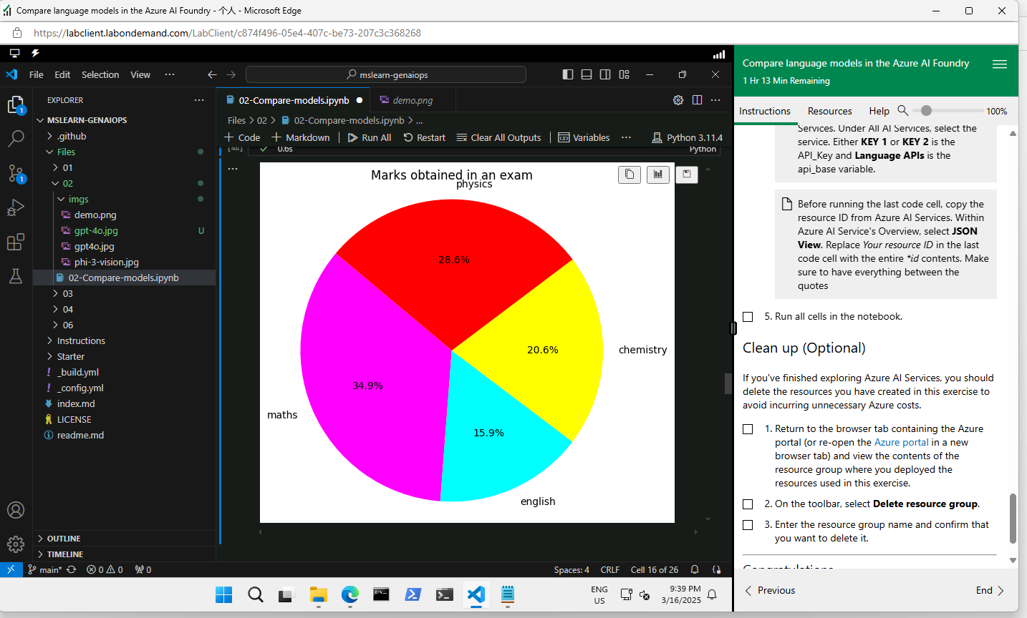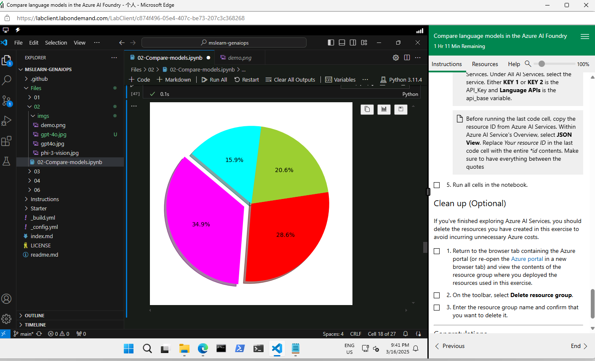
https://d.docs.live.net/3a0718dfa98eb90f/DataScience/WSQ%20Machine%20Learning%20Algorithms%20and%20Methods/Project/azureai-1.txt
Perform using azure AI Foundry website
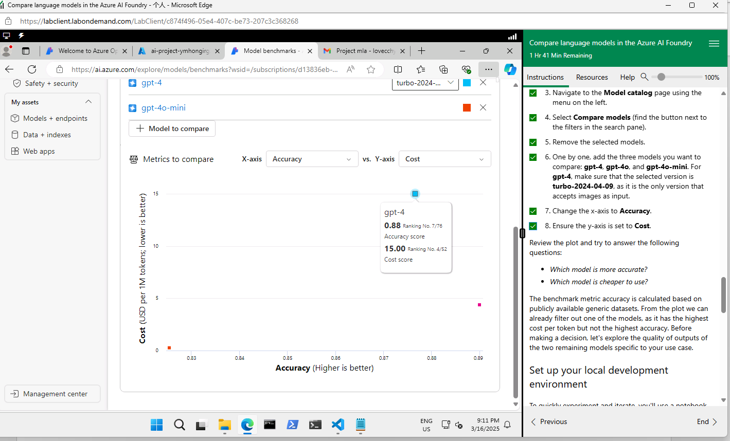
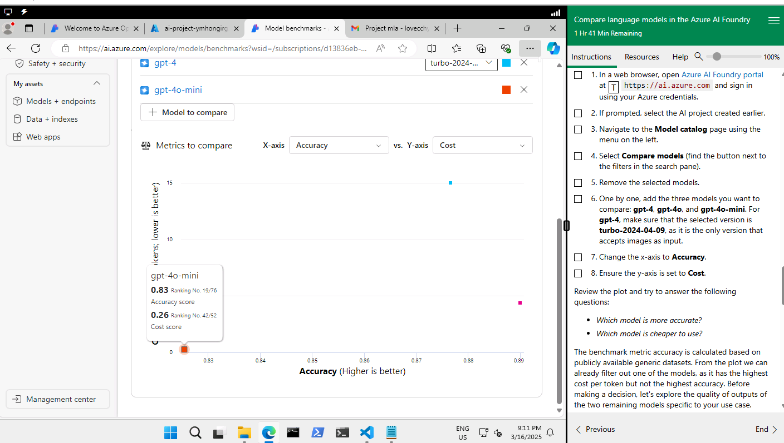
gpt-4o-mini is the cheapest and its accuracy is 0.83. It is just slightly lower than gpt-4 and gpt-4o.
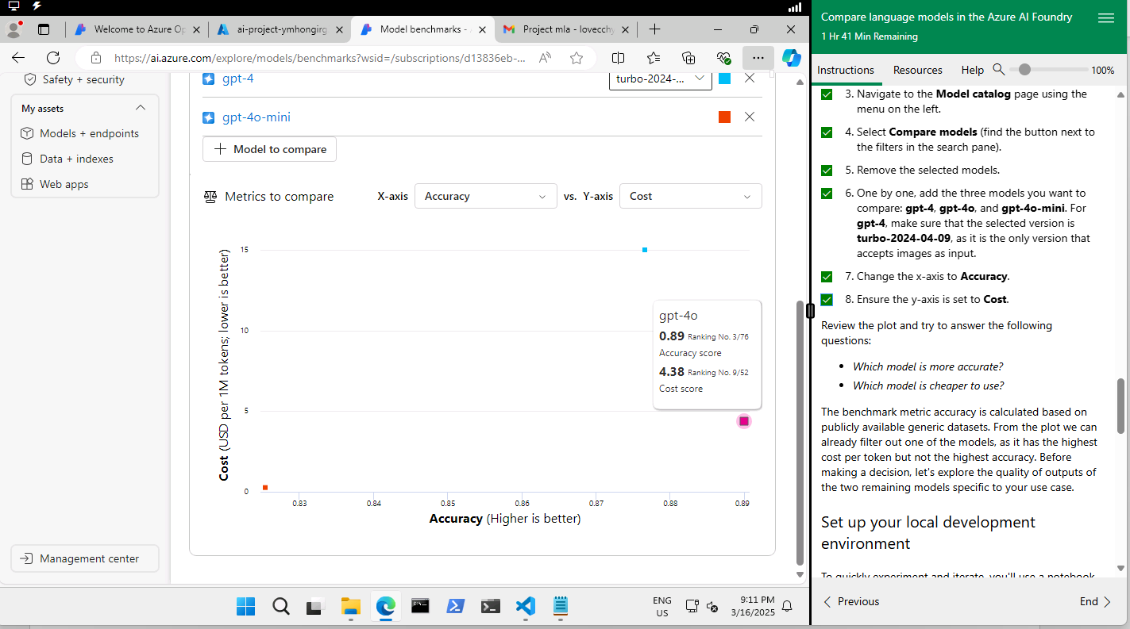
gpt-4o is more accurate and it costs USD$4.38 per 1M tokens.

gpt-4 is more expensive.
Project

