**MINISTRY OF EDUCATION AND TRAINING**

**HUNG YEN UNIVERSITY OF TECHNOLOGY AND EDUCATION**



**FINAL PROJECT**

**WEB APPLICATION**

**WEB APPLICATION DEVELOPMENT FOR E-COMMERCE PLATFORM MANAGEMENT**

MAJOR: COMPUTER SCIENCE

STUDENT: **VU QUANG PHUC**

CLASS: **124221KS**

SUPERVISOR: **Ph.D VU XUAN THANG**

**HUNG YEN – 2025**

**COMMENTS**

**Comments from supervisor:**

**SUPERVISOR**

**(**Signature and Full Name)

**Vu Xuan Thang**

COMMITMENT

I solemnly declare that the project for the Advanced Python Programming course, titled “Applying machine learning on diagnosing and analyzing Azheimer's Disease Data” is the result of my independent work.

All references and sources used in the project are appropriately cited in the References section. The findings and analyses presented in the project are entirely my own.

I accept full accountability for any discrepancies or violations of this declaration, as per the regulations of the faculty and the university.

*Hung Yen,................. ......., ...........*

Student

ACKNOWLEDGEMENT

Completing this project, “Applying machine learning on diagnosing and analyzing Azheimer's Disease Data” has been a challenging yet rewarding journey, and it would not have been possible without the invaluable guidance and support I have received along the way

First and foremost, I would like to express my deepest gratitude to the Department of Computer Science, Faculty of Information Technology – Hung Yen University of Technical Education. The resources, academic environment, and opportunities provided by the department have been instrumental in enabling me to carry out this project. I feel incredibly fortunate to have been part of a program that prioritizes academic excellence and hands-on learning.

I owe a special debt of gratitude to my mentor, Ph.D Nguyen Van Quyet, whose dedication, patience, and expertise have been a cornerstone of my progress. His thoughtful feedback and encouragement throughout the process not only enhanced the quality of this project but also deepened my understanding of advanced Python programming and data analysis. His ability to inspire confidence while challenging me to push my boundaries has left a lasting impact on my learning journey.

I would also like to thank all the faculty members of Hung Yen University of Technical Education. Their dedication to teaching and their tireless efforts to impart knowledge have equipped me with a strong foundation in computer science. The skills and insights I gained during their lectures and practical sessions have proven invaluable in overcoming the obstacles encountered in this project.

I acknowledge that, despite my best efforts, there may still be areas for improvement in this work. I warmly welcome constructive criticism and feedback from my professors, as I believe that every critique is an opportunity for growth.

Thank you for your encouragement and support throughout this journey

**TABLE OF CONTENTS**

COMMITMENT 1

ACKNOWLEDGEMENT 2

GLOSSARY OF TERMS 4

LIST OF TABLES 5

LIST OF FIGURES 6

CHAPTER 1: GENERAL INTRODUCTION 7

1.1 7

1.2 Problem 7

1.3 Problem 7

1.4 Problem 7

Dataset overview 8

CHAPTER 2: THEORICAL BACKGROUND 10

2.1 f 10

2.2 Problemfdfdfd 10

CHAPTER 3: SYSTEM ANALYSIS AND DESIGN 11

3.1 Problemfdfdfd 11

CHAPTER 4: WEBSITE IMPLEMENTATION 13

4.1 Problemfdfdfd 13

CONCLUSION 15

REFERENCES 16

GLOSSARY OF TERMS

|  |  |  |  |
| --- | --- | --- | --- |
| Index | Term | Full form | Meaning |
| 1 | MVC | Model View Control |  |
| ………. | ………. | ………. | ………. |
|  |  |  |  |
|  |  |  |  |
|  |  |  |  |
|  |  |  |  |
|  |  |  |  |
|  |  |  |  |
|  |  |  |  |

LIST OF TABLES

Table 4.1 13

LIST OF FIGURES

Figure 1.1 8

Figure 1.2 9

Figure 1.3 9

Figure 1.4 9

Figure 2.1 10

Figure 3.1 11

Figure 3.2 11

Figure 4.1 13

Figure 4.2 13

Figure 4.3 13

Figure 4.4 14

# GENERAL INTRODUCTION

## 

## Problem

## Problem

## Problem

Alzheimer's disease is a progressive neurodegenerative disorder that severely impacts memory, thinking, and behavior, and it is the most common cause of dementia. Currently, there are approximately 55 million people worldwide living with various forms of dementia, with Alzheimer’s accounting for 60-70% of these cases. The number of individuals affected is projected to triple by 2050. In Vietnam, around 500,000 people are currently diagnosed with Alzheimer's, and this number is expected to rise rapidly due to the aging population.

Machine learning (ML) is opening up numerous opportunities for diagnosing Alzheimer’s through medical imaging analysis (MRI, PET), early predictions using biological data, behavioral and linguistic analysis, as well as supporting treatment and patient management. However, the implementation of such technologies in Vietnam faces challenges, including the lack of high-quality data and limited healthcare infrastructure. To fully harness the potential of machine learning in this field, close collaboration among stakeholders is essential to enhance diagnostic and treatment efficacy while improving the quality of life for patients and their families.

Machine learning offers remarkable advancements over traditional Alzheimer’s diagnostic methods. It enables the early detection of subtle signs of brain damage, processes large volumes of complex data (e.g., imaging, biological, genetic), and automates diagnostic workflows, saving time and reducing errors. Additionally, ML facilitates personalized treatment plans tailored to the unique characteristics of each patient and utilizes unconventional data sources such as speech patterns and behavior.

Favorable conditions, such as the abundance of medical data, robust computational technologies, and growing interest from the scientific community, provide a strong foundation for the practical application of machine learning in Alzheimer’s diagnosis and treatment. These advancements hold the promise of significantly enhancing the efficiency and accuracy of diagnosing and managing Alzheimer’s disease, paving the way for improved patient care and outcomes.

## Dataset overview

* Dataset link in Kaggle: [*Alzheimer's Desease Dataset | Kaggle*](https://www.kaggle.com/datasets/rabieelkharoua/alzheimers-disease-dataset/data)

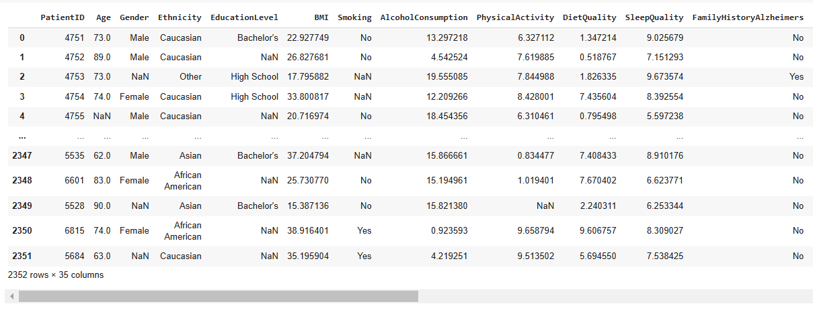

Figure .

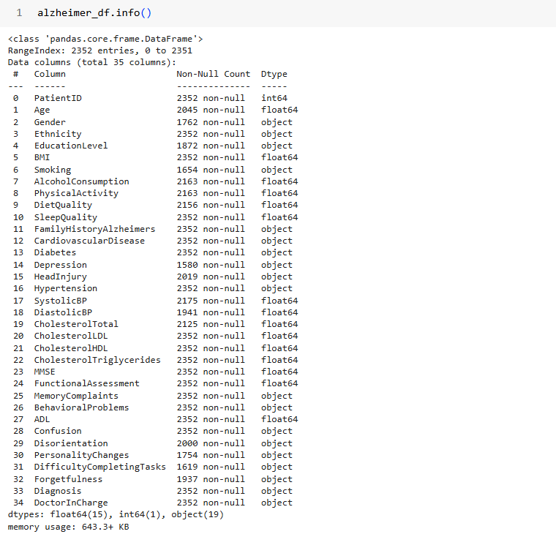

Figure .

Figure .

Figure .

# THEORICAL BACKGROUND



## f

## Problemfdfdfd



Figure .

# SYSTEM ANALYSIS AND DESIGN



## Problemfdfdfd

**3.1 LOvecrush LOvecrush LOvecrush LOvecrush**

Pandas is a robust open-source library in Python widely used for data manipulation and analysis, especially in data science and machine learning. Its name originates from "Panel Data," highlighting its ability to handle multidimensional datasets. Pandas offers two primary data structures:

* DataFrame: A two-dimensional, tabular data structure with labeled rows and columns, akin to a spreadsheet or database table.
* Series: A one-dimensional array, similar to a single column in a DataFrame.



Figure .

**Key Features:**

1. Handles data from various sources like CSV, Excel, SQL, and JSON.
2. Provides advanced methods for sorting, filtering, grouping, merging, and summarizing data.
3. Supports time-series data manipulation and handling of missing values.
4. Seamlessly integrates with libraries such as NumPy, Matplotlib, and Scikit-learn, making it an essential tool for data preprocessing and analysis.

**Advantages of Using Pandas**

1. Ease of Use: Simple syntax and extensive documentation make it beginner-friendly.
2. Optimized for Large Data: Built on NumPy, it efficiently handles large datasets.
3. Visualization Capabilities: Offers basic plotting tools and integrates with advanced libraries for visualization.
4. Data Management: Facilitates efficient and error-free data handling for projects demanding high accuracy.

**Application to Alzheimer’s Dataset Analysis**

* Pandas’ features are particularly well-suited for working with complex medical datasets, such as those related to Alzheimer’s disease. Key advantages include:



Figure .

1. **Data Management**

# WEBSITE IMPLEMENTATION



## Problemfdfdfd



Figure .

Table .

|  |  |  |  |
| --- | --- | --- | --- |
|  |  |  |  |
|  |  |  |  |
|  |  |  |  |

First, le general overview of the dataset including some basic 

Figure .

Table .

|  |  |  |  |
| --- | --- | --- | --- |
|  |  |  |  |
|  |  |  |  |
|  |  |  |  |

CONCLUSION

1. **Achievements:**

* The project has significantly improved the early detection and prediction of **Weaknesses:**
* Data Limitations: The quality and availability of data remain a challenge,
* populations or regions, leading to concerns about their generalizability.

1. **Future Enhancement:**

* Data Enhancement: Efforts should be made to acquire and integrate diverse datasets, including genetic data, biomarkers, and longitudinal studies, to improve

REFERENCES

|  |  |
| --- | --- |
| [1] | Dataset link: *https://www.kaggle.com/datasets/rabieelkharoua/alzheimers-disease-dataset/data* |
| [2] | Documents and slides of mentor Nguyen Van Quye |
| [3] | Documents and slides of mentor Nguyen Van Quyet |
| [3] | Documents and slides of mentor Nguyen Van Quyet |
| [3] | Documents and slides of mentor Nguyen Van Quyet |
| [3] | Documents and slides of mentor Nguyen Van Quyet |
| [3] | Documents and slides of mentor Nguyen Van Quyet |
| [3] | Documents and slides of mentor Nguyen Van Quyet |
| [3] | Documents and slides of mentor Nguyen Van Quyet |
| [3] | Documents and slides of mentor Nguyen Van Quyet |
| [3] | Documents and slides of mentor Nguyen Van Quyet |
| [3] | Documents and slides of mentor Nguyen Van Quyet |
| [3] | Documents and slides of mentor Nguyen Van Quyet |
| [3] | Documents and slides of mentor Nguyen Van Quyet |
| [3] | Documents and slides of mentor Nguyen Van Quyet |