**MINISTRY OF EDUCATION AND TRAINING**

**HUNGYEN UNIVERSITY OF TECHNOLOGY AND EDUCATION**



**FINAL PROJECT**

**ENGLISH FOR IT**

**THE FUTURE OF IT**

MAJOR: DATA SCIENCE

STUDENT: **VU QUANG PHUC**

CLASS: **124221KS**

SUPERVISOR: **Ph.D LE TRUNG HIEU**

**HUNG YEN – 2025**

**COMMENT**

**Comment from supervisor:**

**MENTOR**

**Le Trung Hieu**

# COMMITMENT

I solemnly declare that the project for the Advanced Python Programming course, titled “The future of IT” is the result of my independent work.

All references and sources used in the project are appropriately cited in the References section. The findings and analyses presented in the project are entirely my own.

I accept full accountability for any discrepancies or violations of this declaration, as per the regulations of the faculty and the university.

*Hung Yen,..................,.....,......*

Student

# ACKNOWLEDGEMENT

Completing this project, “The future of IT” has been a challenging yet rewarding journey, and it would not have been possible without the invaluable guidance and support I have received along the way

First and foremost, I would like to express my deepest gratitude to the Department of Computer Science, Faculty of Information Technology – Hung Yen University of Technical Education. The resources, academic environment, and opportunities provided by the department have been instrumental in enabling me to carry out this project. I feel incredibly fortunate to have been part of a program that prioritizes academic excellence and hands-on learning.

I owe a special debt of gratitude to my mentor, Ph.D Le Trung Hieu, whose dedication, patience, and expertise have been a cornerstone of my progress. His thoughtful feedback and encouragement throughout the process not only enhanced the quality of this project but also deepened my understanding of advanced Python programming and data analysis. His ability to inspire confidence while challenging me to push my boundaries has left a lasting impact on my learning journey.

I would also like to thank all the faculty members of Hung Yen University of Technical Education. Their dedication to teaching and their tireless efforts to impart knowledge have equipped me with a strong foundation in computer science. The skills and insights I gained during their lectures and practical sessions have proven invaluable in overcoming the obstacles encountered in this project.

I acknowledge that, despite my best efforts, there may still be areas for improvement in this work. I warmly welcome constructive criticism and feedback from my professors, as I believe that every critique is an opportunity for growth.

Thank you for your encouragement and support throughout this journey

# TABLE OF CONTENTS

COMMITMENT 1

ACKNOWLEDGEMENT 2

TABLE OF CONTENTS 3

CHAPTER 1: INTELLIGENT TECHNOLOGY 5

1.1 What’s Intelligent Technology? 5

1.2 Core of Intelligent Technology? 6

1.3 What’s Artificial Intelligent? 7

1.4 What’s the history of AI? 11

1.5 What’s Machine Learning? 13

1.6 What’s Deep Learning? 15

1.7 What’s Generative AI? 16

1.8 What’s Artificial General Intelligent? 18

1.9 The Rise of the Metaverse 20

1.10 The impact of AI 22

1.11 The Rise and Danger of AI 24

1.12 AI in Enterprise & Business 27

1.13 AI in Recuitment 29

1.14 Artificial Intelligent Market Size 31

CHAPTER 2: THE FUTURE OF IT 33

2.1 How will AI impact the future? 33

2.2 Automation & Robotics 34

2.3 Blockchain & Web3 36

2.4 Quantum Computing 38

2.5 Cybersecurity & Data Privacy 40

2.6 Cloud Computing & Edge Computing 42

2.7 Internet of Things (IoT) & Edge Computing 45

2.8 Augmented Reality (AR) and Virtual Reality (VR) 47

2.9 5G & Edge Computing 47

2.10 Semiconductor 50

2.11 Biotechnology 52

2.12 Digital Transformation 53

CONCLUSION 56

REFERENCES 57

# CHAPTER 1: INTELLIGENT TECHNOLOGY

## What’s Intelligent Technology?

In today’s fast-paced technological landscape, the term **“Intelligent Technology”** has become increasingly prominent, appearing in industry reports, expert analyses, and everyday conversations. But what does this term truly encompass?

At its essence, Intelligent Technology refers to systems and devices that demonstrate traits commonly associated with human intelligence. This includes capabilities such as understanding, learning, problem-solving, and decision-making—allowing machines to move beyond simple computation and engage in more complex cognitive tasks.

At the heart of Intelligent Technology lies **Artificial Intelligence (AI)** and its subset, **Machine Learning (ML)**. AI is the broader discipline focused on enabling machines to perform tasks requiring intelligence, while ML specifically empowers computers to learn and improve autonomously from data. These technologies facilitate advanced functions such as natural language processing, pattern recognition, and data-driven decision-making.

Beyond abstract computations, Intelligent Technology is increasingly embodied in **AI agents**—autonomous software systems that make decisions and take actions with minimal human intervention. Picture virtual assistants that not only execute commands but also anticipate needs, manage schedules, and optimize resources. In parallel, **Embodied AI** underscores the importance of physical interaction with the real world, emphasizing robotics as a crucial platform for developing intelligent, real-world applications.

The impact of Intelligent Technology is vast, revolutionizing industries such as:

* **Healthcare**: AI is improving diagnostics, personalizing treatments, and reducing costs.
* **Finance**: Intelligent systems enhance fraud detection, risk assessment, and financial advising.
* **Manufacturing**: AI optimizes production, predicts mechanical failures, and assists with design.
* **Energy**: AI enhances efficiency, reduces carbon emissions, and strengthens cybersecurity.
* **Transportation**: Autonomous vehicles rely on AI for navigation, object detection, and decision-making.
* **Cybersecurity**: AI-driven solutions are vital in combating evolving digital threats.
* **Customer Experience**: AI enables hyper-personalized interactions and engagement.

Cloud computing further amplifies Intelligent Technology, providing scalable infrastructure for AI-powered applications. While most current systems fall under **Narrow AI (Weak AI)**—designed for specific tasks—ongoing advancements in reasoning and neural networks fuel discussions about **Artificial General Intelligence (AGI)**, a future AI model with human-like cognitive abilities across diverse domains. Though AGI remains a long-term goal, its potential raises both excitement and ethical considerations.

Ultimately, **Intelligent Technology is more than just a trend—it represents a paradigm shift in how machines interact with the world**. As AI and ML continue to evolve, they offer groundbreaking opportunities while presenting new challenges that demand responsible innovation. Staying informed about these advancements is essential for individuals, businesses, and society to harness their benefits effectively.

## Core of Intelligent Technology?

At the foundation of every technological breakthrough is Information Technology (IT), which has evolved far beyond traditional computers and networks. Today, IT encompasses cloud computing, artificial intelligence, cybersecurity, blockchain, big data analytics, and next-generation networks, all geared towards innovation, automation, and connectivity.

Modern IT not only powers global business operations, secure financial transactions, real-time healthcare monitoring, and smart city infrastructure but also supports highly complex systems capable of autonomous decision-making, self-learning, and predictive analytics. Central to this evolution is the integration of advanced algorithms—particularly in Artificial Intelligence (AI) and Machine Learning (ML). AI serves as the broad field dedicated to endowing machines with human-like capabilities, while ML enables systems to learn from data and improve over time. Within ML, Deep Learning further refines these capabilities by modeling intricate data patterns.

The intelligent use of data is critical: advanced systems can analyze vast datasets to detect trends, identify anomalies, and predict future outcomes, which is essential for applications ranging from fraud detection to strategic business forecasting. Automation is another key element, as intelligent technology now powers autonomous systems such as self-driving vehicles and robotic manufacturing, reducing human error and boosting efficiency.

Additionally, the emergence of AI agents—systems that autonomously make decisions and take actions to achieve specific goals—demonstrates how Intelligent Technology can simulate complex human reasoning processes, even with incomplete information. The concept of Embodied AI further emphasizes the importance of physical interaction, with robotics serving as a crucial platform for integrating digital intelligence into real-world applications. Moreover, the advancement of specialized hardware, including GPUs, TPUs, and neuromorphic architectures, has been instrumental in accelerating AI workloads and fostering a closer synergy between software and hardware.

The core of Intelligent Technology is its seamless combination of advanced algorithms, data-driven learning, robust reasoning, and automation, all integrated with physical systems. This synergy not only replicates tasks traditionally requiring human intelligence but also transforms entire sectors by driving efficiency, innovation, and connectivity.

## What’s Artificial Intelligent?

*“AI is here to stay. To outcompete in the future, organizations and individuals alike need to get familiar fast.* *Artificial intelligence is a machine’s ability to perform some cognitive functions we usually associate with human minds.”*

*- McKinsey -*

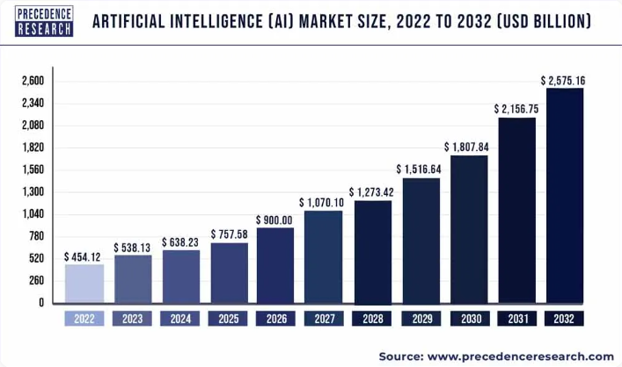

AI has already changed how we work and communicate. Today, about 32.9% businesses already use it, applying AI in data analysis and customer support.

However, this shift has its challenges. By 2025, many jobs may be replaced (such as those in transportation and manual labor). But there's still hope, with hundreds of new jobs expected in AI development and data science. Still, there are concerns about intelligent robots replacing a large portion of the global workforce by 2030. Consequently, this shows the need to carefully balance AI's advantages and potential drawbacks

One of the foundational pillars in this endeavor is **Machine Learning (ML)**. Instead of explicitly programming every single step a machine should take, ML allows systems to learn from data. Think of it like teaching a child – you don't give them a rule for every possible situation, but rather expose them to examples, and they learn to generalize. This ability to learn and improve over time without constant direct programming is a powerful force driving intelligent technology forward. And as source notes, the influence of **AI and ML** on our lives is only set to expand in the coming years.

Now, for a machine to be truly intelligent, it needs to go beyond just identifying patterns in data. It needs to **reason**. This involves the ability to take existing information and derive new, logical conclusions. It's the process of understanding "why" and "how," not just "what." For example, in AI systems, **reasoning** can be used to make informed decisions or to understand complex scenarios. Source even highlights a broad agreement in the AI research community on the value and essential nature of focusing on human-level and domain-specific reasoning abilities.

Furthermore, the digital age has ushered in an unprecedented deluge of information. Intelligent technologies thrive in this environment because they possess the capacity for **data analysis** and **pattern recognition**. They can sift through mountains of data, identify subtle trends that humans might miss, and extract valuable insights.

A significant outcome of these intelligent capabilities is **automation**. AI and related technologies are increasingly being used to automate both routine and complex tasks across various sectors [previously]. Imagine factories where AI-powered "humanoid" robots work alongside humans, capable of handling processes like picking and sorting items. This push for automation promises increased efficiency and productivity.

Looking towards the future, the concept of **AI Agents** is gaining prominence. These aren't just passive programs; they are systems designed to make decisions and take actions autonomously to achieve specific goals. Source points out the growing interest in integrating **Large Language Models (LLMs)** into multi-agent systems for collaborative problem-solving and distributed decision-making. However, it also highlights challenges like aligning LLMs with specific system needs and ensuring interpretability and security.

Interestingly, some researchers are exploring the importance of **Embodiment and Interaction with the Physical World**. **Embodied AI** posits that true intelligence emerges through the ongoing interaction of a physical body with a real environment. Think of robots that don't just process data in a server room but can perceive, understand, and interact with the physical world around them. Source explains that an embodied agent can learn, test, and revise causal models of the world through interaction, going beyond the correlational models learned by passive agents.

The relentless progress in AI also demands powerful tools. This is where **advanced hardware** comes into play. The development of specialized processors like GPUs is crucial for handling the complex computations required by modern AI algorithms. Source notes the increasing prominence of AI architecture co-creation, where hardware and software are designed in tandem to optimize performance.

Finally, in our increasingly interconnected world, **connectivity and integration** are vital. The **Internet of Things (IoT)** generates vast amounts of data, and **edge computing**, which processes data closer to its source, allows for faster, more responsive intelligent systems. Imagine a voice-controlled intelligent assistant connected to every aspect of your life, managing your meal plans and ordering groceries as needed.

However, it's crucial to understand that the journey of intelligent technology isn't without its complexities and debates. There's a significant discussion around the **perception versus the reality of AI capabilities**. Many believe that current perceptions are often overblown and driven by hype, which can hinder research by misdirecting efforts. This highlights the ongoing need for the AI community to educate the public about the true capabilities and limitations of AI.

In essence, the core of Intelligent Technology is a dynamic and evolving landscape where **AI and ML algorithms learn from data, enabling systems to reason, analyze, and automate tasks**. This is increasingly manifested through intelligent agents interacting with the physical world via advanced hardware and seamless connectivity. It's a journey marked by both immense potential and crucial considerations around ethical development and realistic expectations. Just as previous technological revolutions reshaped society, the ongoing advancements in intelligent technology promise to redefine our future in profound and multifaceted ways.

## What’s the history of AI?

The term “*artificial intelligence*” was coined in 1956 by computer scientist John McCarthy for a workshop at Dartmouth. But he wasn’t the first to write about the concepts we now describe as AI. Alan Turing introduced the concept of the “imitation game” in a 1950 paper. That’s the test of a machine’s ability to exhibit intelligent behavior, now known as the “Turing test.” He believed researchers should focus on areas that don’t require too much sensing and action, things like games and language translation. Research communities dedicated to concepts like computer vision, natural language understanding, and neural networks are, in many cases, several decades old.

MIT physicist Rodney Brooks shared details on the four previous stages of AI:

*“Symbolic AI (1956). Symbolic AI is also known as classical AI, or even GOFAI (good old-fashioned AI). The key concept here is the use of symbols and logical reasoning to solve problems. For example, we know a German shepherd is a dog, which is a mammal; all mammals are warm-blooded; therefore, a German shepherd should be warm-blooded.”*

The main problem with symbolic AI is that humans still need to manually encode their knowledge of the world into the symbolic AI system, rather than allowing it to observe and encode relationships on its own. As a result, symbolic AI systems struggle with situations involving real-world complexity. They also lack the ability to learn from large amounts of data.

* **Symbolic AI** was the dominant paradigm of AI research until the late 1980s.
* **Neural networks** (1954, 1969, 1986, 2012). Neural networks are the technology behind the recent explosive growth of gen AI. Loosely modeling the ways neurons interact in the human brain, neural networks ingest data and process it through multiple iterations that learn increasingly complex features of the data. The neural network can then make determinations about the data, learn whether a determination is correct, and use what it has learned to make determinations about new data. For example, once it “learns” what an object looks like, it can recognize the object in a new image.

**Neural networks** were first proposed in 1943 in an academic paper by neurophysiologist Warren McCulloch and logician Walter Pitts. Decades later, in 1969, two MIT researchers mathematically demonstrated that neural networks could perform only very basic tasks. In 1986, there was another reversal, when computer scientist and cognitive psychologist Geoffrey Hinton and colleagues solved the neural network problem presented by the MIT researchers. In the 1990s, computer scientist Yann LeCun made major advancements in neural networks’ use in computer vision, while Jürgen Schmidhuber advanced the application of recurrent neural networks as used in language processing.

**In 2012**, Hinton and two of his students highlighted the power of deep learning. They applied Hinton’s algorithm to neural networks with many more layers than was typical, sparking a new focus on deep neural networks. These have been the main AI approaches of recent years.

**Traditional robotics** (1968). During the first few decades of AI, researchers built robots to advance research. Some robots were mobile, moving around on wheels, while others were fixed, with articulated arms. Robots used the earliest attempts at computer vision to identify and navigate through their environments or to understand the geometry of objects and maneuver them. This could include moving around blocks of various shapes and colors. Most of these robots, just like the ones that have been used in factories for decades, rely on highly controlled environments with thoroughly scripted behaviors that they perform repeatedly. They have not contributed significantly to the advancement of AI itself.

But traditional robotics did have significant impact in one area, through a process called “simultaneous localization and mapping” (SLAM). SLAM algorithms helped contribute to self-driving cars and are used in consumer products like vacuum cleaning robots and quadcopter drones. Today, this work has evolved into behavior-based robotics, also referred to as haptic technology because it responds to human touch.

## What’s Machine Learning?

Machine learning is a form of artificial intelligence that can adapt to a wide range of inputs, including large sets of historical data, synthesized data, or human inputs. (Some machine learning algorithms are specialized in training themselves to detect patterns; [this is called deep learning](https://www.mckinsey.com/featured-insights/mckinsey-explainers/what-is-deep-learning). ) These algorithms can detect patterns and learn how to make predictions and recommendations by processing data, rather than by receiving explicit programming instruction. Some algorithms can also adapt in response to new data and experiences to improve over time.

It achieves this through the use of *algorithms that can identify patterns, comprehend natural language, make informed decisions, and continuously enhance their performance* as they are exposed to more data This capability makes ML a transformative force across a wide spectrum of industries, including healthcare, finance, and manufacturing.

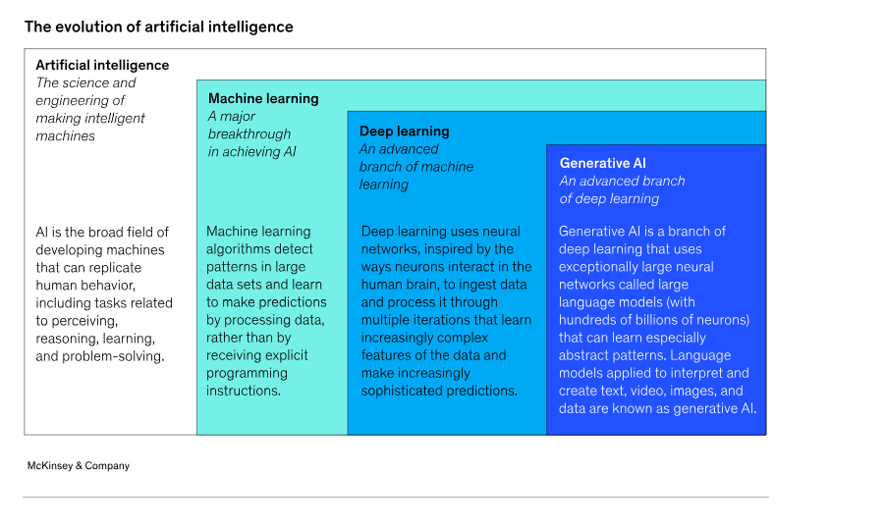

The sources further elaborate on the significance and future trajectory of AI, with machine learning being a fundamental component driving many of these advancements. For instance, the **"Future of IT Report 2023"** implicitly highlights the importance of ML in the context of the **IT Competitiveness Index**, which assesses a country's standing based on factors like talent and IT infrastructure. The development and application of sophisticated algorithms, a core aspect of ML, are crucial for maintaining competitiveness in the global IT landscape.

The sources also discuss specific areas where ML, often in the form of **deep learning**, is making significant strides. The report on the **"Future of AI: Trends, Impacts, and Predictions"** notes that AI, which now is classified as **Narrow AI or Weak AI**, can perform specific jobs, giving examples like self-driving automobiles and voice recognition. These technologies heavily rely on machine learning algorithms to process sensory data and make real-time decisions. The report further posits that the future of artificial intelligence lies in establishing **strong AI**, which is believed will eventually be able to outperform humans in all cognitive tasks. While this refers to the broader goal of AGI (as we discussed), the stepping stones involve advancements in machine learning capabilities.

The **"Future of AI" report** also touches upon the impact of AI and, by extension, machine learning on various sectors. In **finance**, AI algorithms are being employed in the management of equity funds, capable of considering a large number of variables to determine the optimal approach to handle funds, potentially outperforming human supervisors. In the **military and cybersecurity**, AI-assisted technologies are creating autonomous weapon systems and improving mission efficacy. However, the report also raises concerns about the explainability of AI algorithms, especially as deep neural networks become more complex. This highlights a critical aspect of machine learning – the need for **interpretable AI** to understand how models arrive at their decisions.

## What’s Deep Learning?

*“The volume and complexity of data that is now being generated, too vast for humans to process and apply efficiently, has increased the potential of machine learning, as well as the need for it.”*

*- McKinsey -*

Deep learning is a more advanced version of machine learning that is particularly adept at processing a wider range of data resources (text as well as unstructured data including images), requires even less human intervention, and can often produce more accurate results than traditional machine learning. Deep learning uses neural networks—based on the [ways neurons interact in the human brain](https://www.mckinsey.com/featured-insights/artificial-intelligence/notes-from-the-ai-frontier-applications-and-value-of-deep-learning)—to ingest data and process it through multiple neuron layers that recognize increasingly complex features of the data. For example, an early layer might recognize something as being in a specific shape; building on this knowledge, a later layer might be able to identify the shape as a stop sign. Similar to machine learning, deep learning uses iteration to self-correct and improve its prediction capabilities. For example, once it “learns” what a stop sign looks like, it can recognize a stop sign in a new image.

Key aspects of deep learning include:

* **Neural Networks:** It utilizes complex neural network architectures with many layers.
* **Hierarchical Feature Learning:** The network learns features at different levels of abstraction, with lower layers identifying simple features and higher layers combining them to represent more complex concepts.
* **Data-Driven:** Like other machine learning methods, deep learning relies on large amounts of data to train these networks.
* **Powerful Capabilities:** This approach has led to significant breakthroughs in various fields, including image recognition, natural language processing, and other complex tasks.

In essence, deep learning is a sophisticated form of machine learning that leverages deep neural networks to automatically extract intricate patterns from large datasets, leading to more powerful AI systems.

## What’s Generative AI?

*“Generative artificial intelligence (AI) describes algorithms (such as ChatGPT) that can be used to create new content, including audio, code, images, text, simulations, and videos. Recent breakthroughs in the field have the potential to drastically change the way we approach content creation.”*

*- Mckinsey -*

**Generative AI** refers to a category of **artificial intelligence algorithms**, such as **ChatGPT,** that are designed to create new content, including audio, code, images, text, simulations, and videos. These algorithms learn the underlying patterns and structures from vast amounts of existing data and then use this knowledge to generate novel, original outputs that can resemble the data they were trained on. Recent breakthroughs in this field have the potential to drastically change the way we approach content creation across various domains.

Before the rise of generative AI, factuality in AI systems was primarily a concern when systems were trained on bad data, leading to the "garbage in, garbage out" problem. However, generative AI, particularly large language models (LLMs), employs reconstructive memory, where they rebuild memories as needed based on distributed information rather than retrieving from a fixed store. Early generative LLMs gained attention for their ability to produce coherent but entirely imaginary stories.

The emergence of LLMs from 2020 onwards has significantly increased interest in the capabilities of generative AI. These models can be integrated into autonomous agent frameworks, leading to the concept of **Agentic AI**, aiming to leverage their generative capabilities to enhance interaction, creativity, and real-time decision-making. For instance, LLMs can be used as part of a workflow to automate routine tasks.

**Generative AI is impacting numerous industries:**

* **Media:** Generative AI tools are being explored for tasks like writing news narratives from structured data (e.g., sports statistics, financial results), assisting in creative processes in filmmaking, gaming, and advertising, and even generating personalized news recommendations. However, this raises questions about job displacement in editing, copywriting, and traditional journalism roles.
* **Scientific Discovery:** Generative AI is being used to accelerate materials discovery by scanning millions of material combinations. It can also direct automated chemistry laboratories.
* **Energy:** AI tools, including generative AI, are being used to monitor methane emissions, optimize energy systems, and potentially create new low-carbon footprint energy systems.
* **Healthcare:** AI, including generative models, has roles in post-treatment monitoring, routine information gathering via chatbots, and analysis of patient information.
* Despite its potential, generative AI faces significant challenges and raises concerns
* **Factuality and Hallucinations:** Generative AI technology remains prone to generating inaccurate or false information, referred to as "hallucinations". This can be exacerbated by the use of outdated or biased training data.
* **Misinformation and Deepfakes:** AI tools can be used maliciously to create deepfake videos and manipulate public opinion.
* **Job Displacement:** The automation capabilities of generative AI raise concerns about potential job losses in various sectors, particularly those involving repetitive tasks or content creation.
* **Ethical Considerations:** The use of generative AI brings up questions related to authorship, copyright protection, and intellectual property ownership of AI-generated content. This may lead to the emergence of new roles like ethics managers.

As generative AI continues to evolve, there is a trend towards developing smaller and more efficient models. The future may also see the rise of "AI hallucination insurance" as these models become more integrated into organizations. Ultimately, while generative AI presents powerful capabilities and opportunities, navigating its challenges and ensuring responsible development and deployment are crucial.

## What’s Artificial General Intelligent?

The term “artificial general intelligence” **(AGI)** was coined to describe AI systems that possess capabilities comparable to those of a human. In theory, AGI could someday replicate human-like cognitive abilities including reasoning, problem-solving, perception, learning, and language comprehension. But let’s not get ahead of ourselves: the key word here is “someday.” Most researchers and academics believe we are decades away from realizing AGI; some even predict we won’t see AGI this century, or ever. Rodney Brooks, an MIT roboticist and cofounder of iRobot, doesn’t believe AGI will arrive until the year 2300.

The timing of AGI’s emergence may be uncertain. But when it does emerge—and it likely will—it’s going to be a very big deal, in every aspect of our lives. Executives should begin working to understand the path to machines achieving human-level intelligence now and making the transition to a more automated world.

**Artificial General Intelligence (AGI)** represents a long-standing and ambitious goal within the field of Artificial Intelligence. Often referred to as **"human-level AI" or "strong AI"**, AGI is a **theoretical type of AI system that possesses intellectual capabilities comparable to those of a human across a broad range of cognitive tasks**. Unlike the current state of AI, which is largely characterized by **"narrow AI" or "weak AI"** capable of excelling at specific tasks, AGI aims to achieve a more general and adaptable form of intelligence. The aspiration is to create machines that can understand, learn, and apply knowledge across diverse domains with a proficiency similar to or exceeding human cognitive abilities.

The pursuit of AGI has been central to the AI enterprise since its inception. The very proposal for the Dartmouth workshop in 1955, which is considered the birth of AI as a field, conjectured that "every aspect of learning or any other feature of intelligence can in principle be so precisely described that a machine can be made to simulate it". Early AI pioneers envisioned creating machines that could use language, form abstractions and concepts, solve problems now reserved for humans, and even improve themselves. Predictions from the time, such as Herbert Simon's in 1957 that machines would eventually handle the same range of problems as the human mind, illustrate the early ambition towards achieving general intelligence.

However, for many decades, AI research primarily focused on specific methodologies and components of intelligence, such as reasoning and problem-solving, often without much consideration for their integration into general-purpose systems. While progress was made in narrow applications, the vision of generally intelligent systems functioning in the real world remained largely unfulfilled. This led to a resurgence of interest in pursuing "human-level" intelligence in the early 2000s, coinciding with the emergence of the term **Artificial General Intelligence (AGI)**. This term was embraced by a new generation of researchers who sought to move beyond the increasing focus on narrow, albeit valuable, AI applications and return to the field's original grand ambitions.

While the fundamental goal of AGI—AI that can match or exceed human cognitive abilities across a broad range of tasks—echoed the initial ambitions of the field, the explicit use of the term AGI served as a renewed and ambitious call to action for many within and outside the AI research community

Despite the enduring interest in AGI, it is important to note that **AGI is not a formally defined concept, nor is there any universally agreed-upon test for its achievement**. Some suggest that AGI will be recognizable when it is achieved, or that it will naturally emerge from the right set of AI principles and mechanisms. Others propose that AGI could be defined by reaching a certain threshold of capabilities and generality. However, a contrasting viewpoint argues that intelligence is better understood as existing within a continuous, multidimensional space, making a singular definition or test problematic. Critics also contend that aiming to "match or exceed human cognitive abilities" might not necessarily lead to the most beneficial AI tools for humanity, suggesting that more narrowly focused tools might be more practical and valuable.

## The Rise of the Metaverse

The **rise of the metaverse** is a significant trend in the evolution of online interaction, aiming to create *immersive digital environments that blend the physical and virtual worlds*. This vision is powered by technologies such as **Virtual Reality (VR), Augmented Reality (AR), Mixed Reality (MR),** blockchain for managing digital assets, and Artificial Intelligence (AI) for enabling intelligent interactions within these virtual spaces.

Here are some key aspects of the metaverse discussed in the sources:

* **Definition:** The metaverse represents the next evolution of online interaction, striving to create immersive digital environments that merge the physical and virtual realms.
* **Enabling Technologies:** Several technologies are crucial for the development of the metaverse, including VR, AR, MR, blockchain for managing digital assets, and AI for intelligent interactions. The widespread use of **8K resolution headsets for Virtual Reality is expected to cause a seismic shift in the VR landscape by 2030**, promising astounding clarity and realism that will further blur the line between the virtual and real worlds.
* **Applications:** The applications of metaverse technologies are diverse, spanning **gaming, healthcare, e-commerce, tourism, education, and enterprise collaboration**. **AR and VR** are already being employed in the entertainment sector to provide more immersive and captivating experiences and in healthcare to enhance patient care and speed up medical research. For instance, AR allows surgeons to superimpose digital images onto the patient's body for a more accurate view, and VR is used to train medical personnel in a secure setting. Education, industry, and retail are also utilizing AR and VR, and their expansion is anticipated.
* **Market Growth:** The metaverse market is projected to experience “*exponential growth, reaching a staggering $1334.18 billion by 2029,”* indicating substantial opportunities for professionals in this domain.
  + **Metaverse Architects:** Responsible for designing and creating the virtual spaces and environments.
  + **3D Designers and Animators:** Create the virtual assets, models, and animations that populate these worlds.
  + **AR/VR Software Engineers:** Develop the software programs and infrastructure that power the metaverse platforms.
  + **Metaverse Security Specialists:** Crucial for ensuring the safety and security of these virtual worlds, protecting user data and digital assets.
  + **Metaverse Content Creators:** Develop and produce the interactive experiences within the metaverse.
  + **Metaverse Event Managers:** Plan and manage virtual events and experiences.
  + **Metaverse Product Managers:** Oversee the development and launch of metaverse-related products and services.
  + **Metaverse User Experience (UX) Designers:** Focus on creating intuitive and engaging user experiences within these immersive digital environments.
* **Convergence of Technologies:** The metaverse relies on a synergistic combination of VR/AR technologies, blockchain for digital asset management, and AI for intelligent interactions. Artificial intelligence is playing a crucial role in creating more realistic and engaging experiences within the metaverse.
* **Challenges and Opportunities:** The metaverse presents unique challenges and opportunities related to digital identity, virtual economies, and social interactions, requiring IT professionals who can effectively navigate these new frontiers.

The metaverse is envisioned as a future iteration of the internet, characterized by immersive and interconnected virtual experiences. Its development is driven by advancements in VR, AR, blockchain, and AI, leading to a wide array of potential applications and the emergence of new IT roles focused on building, managing, and securing these virtual environments. The projected market growth underscores the significant potential of the metaverse to transform various aspects of our lives and the IT industry.

## The impact of AI

* ***Job Disruption***

Business automation has naturally led to fears over job losses. In fact, employees believe almost one-third of their tasks could be performed by AI. Although AI has made gains in the workplace, it’s had an unequal impact on different industries and professions. For example, manual jobs like secretaries are at risk of being automated, but the demand for other jobs like machine learning specialists and information security analysts has risen.

Workers in more skilled or creative positions are more likely to have their jobs augmented by AI, rather than be replaced. Whether forcing employees to learn new tools or taking over their roles, AI is set to spur upskilling efforts at both the individual and company level.

*“One of the absolute prerequisites for AI to be successful in many [areas] is that we invest tremendously in education to retrain people for new jobs*,” said Klara Nahrstedt, a computer science professor at the University of Illinois at Urbana–Champaign and director of the school’s Coordinated Science Laboratory.

* ***Data Privacy Issues***

Companies require large volumes of data to train the models that power generative AI tools, and this process has come under intense scrutiny. Concerns over companies collecting consumers’ personal data have led the FTC to open an investigation into whether OpenAI has negatively impacted consumers through its data collection methods after the company potentially violated European data protection laws.

In response, the Biden-Harris administration developed an AI Bill of Rights that lists data privacy as one of its core principles. Although this legislation doesn’t carry much legal weight, it reflects the growing push to prioritize data privacy and compel AI companies to be more transparent and cautious about how they compile training data.

* ***Increased Regulation***

AI could shift the perspective on certain legal questions, depending on how generative AI lawsuits unfold in 2024. For example, the issue of intellectual property has come to the forefront in light of copyright lawsuits filed against OpenAI by writers, musicians and companies like The New York Times. These lawsuits affect how the U.S. legal system interprets what is private and public property, and a loss could spell major setbacks for OpenAI and its competitors.

Ethical issues that have surfaced in connection to generative AI have placed more pressure on the U.S. government to take a stronger stance. The Biden-Harris administration has maintained its moderate position with its latest executive order, creating rough guidelines around data privacy, civil liberties, responsible AI and other aspects of AI. However, the government could lean toward stricter regulations, depending on changes in the political climate.

At the same time, AI could be seen as a key culprit in climate change. The energy and resources required to create and maintain AI models could raise carbon emissions by as much as 80 percent, dealing a devastating blow to any sustainability efforts within tech. Even if AI is applied to climate-conscious technology, the costs of building and training models could leave society in a worse environmental situation than before.

* ***Accelerated Speed of Innovation***

In an essay about the future potential of AI, Anthropic CEO Dario Amodei hypothesizes that powerful AI technology could speed up research in the biological sciences as much as tenfold, bringing about a phenomenon he coins “the compressed 21st century,” in which 50 to 100 years of innovation might happen in the span of five to 10 years. This theory builds on the idea that truly revolutionary discoveries are made at a rate of maybe once per year, with the core limitation being a shortage of talented researchers. By increasing the cognitive power devoted to developing hypotheses and testing them out, Amodei suggests, we might close the time gap between important discoveries like the 25-year delay between CRISPR’s discovery in the ‘80s and its application to gene editing.

## The Rise and Danger of AI

* ***Job Losses***

Between 2023 and 2028, 44 percent of workers’ skills will be disrupted. Not all workers will be affected equally — women are more likely than men to be exposed to AI in their jobs. Combine this with the fact that there is a gaping AI skills gap between men and women, and women seem much more susceptible to losing their jobs. If companies don’t have steps in place to upskill their workforces, the proliferation of AI could result in higher unemployment and decreased opportunities for those of marginalized backgrounds to break into tech.

* ***Human Biases***

The reputation of AI has been tainted with a habit of reflecting the biases of the people who train the algorithmic models. For example, facial recognition technology has been known to favor lighter-skinned individuals, discriminating against people of color with darker complexions. If researchers aren’t careful in rooting out these biases early on, AI tools could reinforce these biases in the minds of users and perpetuate social inequalities.

* ***Deepfakes and Misinformation***

The spread of deepfakes threatens to blur the lines between fiction and reality, leading the general public to question what’s real and what isn’t. And if people are unable to identify deepfakes, the impact of misinformation could be dangerous to individuals and entire countries alike. Deepfakes have been used to promote political propaganda, commit financial fraud and place students in compromising positions, among other use cases.

* ***Data Privacy***

Training AI models on public data increases the chances of data security breaches that could expose consumers’ personal information. Companies contribute to these risks by adding their own data as well. A 2024 Cisco survey found that 48 percent of businesses have entered non-public company information into generative AI tools and 69 percent are worried these tools could damage their intellectual property and legal rights. A single breach could expose the information of millions of consumers and leave organizations vulnerable as a result.

* ***Automated Weapons***

The use of AI in automated weapons poses a major threat to countries and their general populations. While automated weapons systems are already deadly, they also fail to discriminate between soldiers and civilians. Letting artificial intelligence fall into the wrong hands could lead to irresponsible use and the deployment of weapons that put larger groups of people at risk.

* ***Superior Intelligence***

Nightmare scenarios depict what’s known as the technological singularity, where superintelligent machines take over and permanently alter human existence through enslavement or eradication. Even if AI systems never reach this level, they can become more complex to the point where it’s difficult to determine how AI makes decisions at times. This can lead to a lack of transparency around how to fix algorithms when mistakes or unintended behaviors occur.

“I don’t think the methods we use currently in these areas will lead to machines that decide to kill us,” said Marc Gyongyosi, founder of Onetrack.AI. “I think that maybe five or 10 years from now, I’ll have to reevaluate that statement because we’ll have different methods available and different ways to go about these things.”

* ***Emotional and sociological impacts***

People anthropomorphize AI, forming emotional attachments and complex social dynamics, as seen with the ELIZA Effect6 and other AI companions. Over the next decade, these relationships might become more profound, raising psychological and ethical questions. Society must promote healthy interactions with increasingly human-like machines and help individuals discern genuine human interactions from AI-driven ones.

* ***Running out of data***

As AI-generated content dominates the internet—estimated to comprise around 50% of online material—the availability of human-generated data decreases. Researchers predict that by 2026, public data for training large AI models might run out. To address this, the AI community is exploring synthetic data generation and novel data sources, such as IoT devices and simulations, to diversify AI training inputs. These strategies are essential for sustaining AI advancements and ensuring that models remain capable in an increasingly data-saturated digital landscape.

As AI continues to progress and the focus shifts toward more cost-efficient models that enable tailored solutions for individuals and enterprises, trust and security must remain paramount.

**IBM’s watsonx.ai™** is a portfolio of AI products for developing, deploying and managing AI solutions that align with the current trends toward safer, more accessible and versatile AI tools.

**Watsonx.ai** integrates advanced AI capabilities with the flexibility needed to support businesses across industries, helping ensure they harness the power of AI for real impact and not just to be on trend. By prioritizing user-friendliness and efficiency, watsonx.ai is poised to become an indispensable asset for those looking to use AI in the decade ahead.

## AI in Enterprise & Business

* *About 42% of enterprise-scale companies surveyed (> 1,000 employees) report having actively deployed AI in their business.*
* *An additional 40% are currently exploring or experimenting with AI but have not deployed their models.*
* *However, 59% of those companies surveyed already exploring or deploying AI say they have accelerated their rollout or investments in the technology.*
* *The top barriers preventing deployment include limited AI skills and expertise (33%), too much data complexity (25%), and ethical concerns (23%).*

ARMONK, N.Y., January 10, 2024/ - New research commissioned by IBM (NYSE: IBM) found that about 42% of enterprise-scale organizations (over 1,000 employees) surveyed have AI actively in use in their businesses. Early adopters are leading the way, with 59% of responding enterprises already working with AI intending to accelerate and increase investment in the technology. Ongoing challenges for AI adoption in enterprises remain, including hiring employees with the right skillsets, data complexity, and ethical concerns continue to inhibit businesses from adopting AI technologies into their operations.

“We’re seeing that the early adopters who overcame barriers to deploy AI are making further investments, proving to me that they are already experiencing the benefits from AI. More accessible AI tools, the drive for automation of key processes, and increasing amounts of AI embedded into off-the-shelf business applications are top factors driving the expansion of AI at the enterprise level,” said Rob Thomas, Senior Vice President, IBM Software. “We see organizations leveraging AI for use cases where I believe the technology can most quickly have a profound impact like IT automation, digital labor, and customer care. For the 40% of companies surveyed stuck in the sandbox, I am confident 2024 will be the year of tackling and overcoming barriers to entry like the skills gap and data complexity.”

Highlights from the “IBM Global AI Adoption Index 2023,” conducted by Morning Consult on behalf of IBM, include:

Over the last several years, AI adoption has remained steady at large organizations surveyed

*“Today, 42% of IT professionals at large organizations report that they have actively deployed AI while an additional 40% are actively exploring using the technology.”*

Additionally, 38% of IT professionals at enterprises report that their company is actively implementing generative AI and another 42% are exploring it.

Organizations in India (59%), the UAE (58%), Singapore (53%), and China (50%) are leading the way in active use of AI, compared with lagging markets like Spain (28%), Australia (29%), and France (26%).

Companies within the financial services industry are most likely to be using AI, with about half of IT professionals within that industry reporting their company has actively deployed AI. 37% of IT professionals within the telecommunications industry state that their company is also deploying AI.

Easier to use AI tools and the need to reduce costs and automate processes are driving AI adoption among surveyed companies:

Advances in AI tools that make them more accessible (45%), the need to reduce costs and automate key processes (42%), and the increasing amount of AI embedded into standard off the shelf business applications (37%) are the top factors driving AI adoption.

For IT professionals, the two most important changes to AI in recent years are solutions that are easier to deploy (43%) and the increased prevalence of data, AI, and automation skills (42%).

The AI use cases driving adoption for surveyed companies currently exploring or deploying AI are not limited, but cut across many key areas of business operations:

* Automation of IT processes (33%)
* Security and threat detection (26%)
* AI monitoring or governance (25%)
* Business analytics or intelligence (24%)
* Automating processing, understanding, and flow of documents (24%)
* Automating customer or employee self-service answers & actions (23%)
* Automation of business processes (22%)
* Automation of network processes (22%)

## AI in Recuitment

As we move further into the 2020s, the recruitment landscape is rapidly evolving to meet the challenges of a fast-paced digital world. The demand for IT talent is soaring, especially in emerging fields such as artificial intelligence, blockchain technology, and data science. This surge is not just a fleeting trend, it reflects a fundamental shift in how businesses operate and compete. Companies are now tasked with refining their recruitment strategies to attract and retain the right talent in an increasingly competitive market. In this article, we will explore the key recruitment trends and the future of work in Vietnam IT industry in 2025, emphasizing the factors driving the demand for IT talent and the innovative strategies companies employ to meet this demand.

The rise of AI, Blockchain, and Data Science

The rapid advancement of technology has fundamentally transformed industries and reshaped the workforce. As digitalization permeates every sector, the need for skilled IT professionals has skyrocketed, reshaping the future of work in Vietnam IT industry. According to the Vietnam IT Salary Guide 2025 by JT1, approximately 97 million new roles could emerge that are more adapted to the new division of labor between humans, machines, and algorithms. This emphasizes the growing importance of IT skills and reinforces the urgent need for companies to prioritize recruitment in these fields.

Among the various segments of IT, three fields stand out for their explosive growth:

**Artificial intelligence:** Professionals with expertise in machine learning, natural language processing, and robotics are becoming more and more in demand as AI continues to improve corporate processes through automation and data analysis. Businesses are looking for bright people who can create AI-powered solutions that enhance customer satisfaction and operational effectiveness. With collaborations with international tech behemoths like NVIDIA, Google, and AWS propelling advances in generative AI, Vietnam's National AI Strategy (2021) seeks to establish the nation as a major force in AI innovation by 2030.

**Blockchain technology:** Blockchain has become a game-changing technology in several sectors with the emergence of cryptocurrencies and decentralized finance. Businesses are searching for business analysts and blockchain developers who can use blockchain solutions in industries including banking, healthcare, and supply chain management. The number of blockchain businesses in Vietnam is also rising, which is increasing the need for qualified experts in this area.

**Data science:** The need for data scientists who can sort through enormous volumes of data to extract useful insights has increased due to the emergence of big data. The need for expertise in statistics, data visualization, and data mining is increasing as a result of businesses depending on data scientists to assist and guide their initiatives. By 2024, Vietnam's digital economy is predicted to have grown by 20% a year to reach $36 billion, which would increase the need for data science specialists.

As we look towards 2025, the transformation of the recruitment landscape is clear. The surging demand for IT talent, particularly in areas like AI, blockchain, and data science, is reshaping how organizations attract and retain skilled professionals. Companies that embrace innovative recruitment strategies including building strong employer brands, focusing on diversity and inclusion, offering flexible work options, investing in upskilling initiatives to prepare for the future of work in Vietnam IT industry, and adopting advanced recruitment technologies will be better positioned to navigate the competitive talent market.

## Artificial Intelligent Market Size

The global artificial intelligence (AI) market size is calculated at USD 757.58 billion in 2025 and is forecasted to reach around USD 3,680.47 billion by 2034, accelerating at a CAGR of 19.20% from 2025 to 2034. The North America artificial intelligence (AI) market size surpassed USD 235.63 billion in 2024 and is expanding at a CAGR of 19.22% during the forecast period. The market sizing and forecasts are revenue-based (USD Million/Billion), with 2024 as the base year.

The rapid penetration of digital technologies and the internet has significantly contributed to the growth of the global artificial intelligence market in the past few years. The heavy investments by the tech giants in research and development are continuously fueling technological advancements in various industries. The burgeoning demand for artificial technology among the various end-use verticals such as automotive, healthcare, banking & finance, manufacturing, food and beverages, logistics, and retail is expected to significantly drive the growth of the global artificial intelligence market in the forthcoming years. Technological innovations have been always an important part of the majority of industries.

The rising popularity of various life-saving [medical devices](https://www.precedenceresearch.com/medical-devices-market) and the self-driving feature in the new [electric vehicles](https://www.precedenceresearch.com/electric-vehicle-market) is significantly boosting the growth of the AI market across the globe. The shifting focus of the globe towards the digitalization is positively impacting the market growth. The top global tech giants such as Google, Microsoft, IBM, Amazon, and Apple are increasing their investments in the upgradation and development of various applications of AI. The rising efforts of the tech giants towards improving the access to the AI is expected to foster the growth of the global AI market during the forecast period.

Favorable government initiatives are expected to impose a positive impact on industry growth. The establishment of subcommittees on [machine learning](https://www.precedenceresearch.com/machine-learning-market) and AI within the federal government has drawn the traction towards the AI industry. In 2020, The Government of India increased the spend for Digital India to $477 million to boost AI, IoT, big data, [cyber security](https://www.precedenceresearch.com/cyber-security-market), machine learning and robotics. The artificial intelligence market is expected to witness significant growth in the BFSI sector on account of data mining applications as there is an increase in the adoption of artificial intelligence solutions in data analytics, fraud detection, cybersecurity, and database systems.

End-use industries have started integrating artificial intelligence into their business processes to streamline their operations. The artificial intelligence technology is gaining momentum as it assists enduser organizations to become more efficient and result oriented. The growing adoption of artificial intelligence is encouraging new entrants to venture into the AI marketplace by offering niche applicationspecific products and solutions. Furthermore, companies are also taking several strategic initiatives in industry consolidations to gain competitive advantages.love

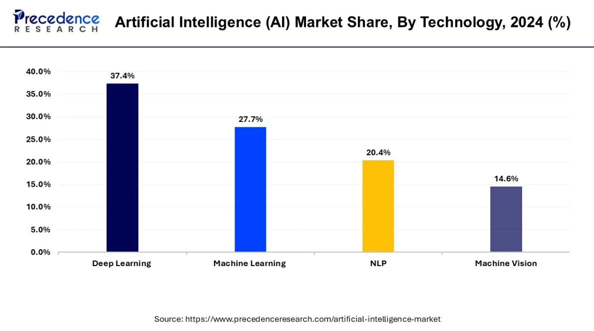

The huge share of the machine learning in the total investments in AI technology is fueling its adoption in various applications such as hypothesis generation, clustering, altering, tagging, clustering, filtering, visualization, and navigation promotes the development of the cognitive solutions. The rising deployment of the on-premises hardware and cloud computing platforms for handling and storing huge volumes of data has significantly contributed to the rise of the data analytics platforms. The rising investments by the top tech giants in the innovation and research are expected to fuel the growth of the AI market in the upcoming future.

# CHAPTER 2: THE FUTURE OF IT



## How will AI impact the future?

**Speed of life.** The most obvious change that many people will feel across society is an increase in the tempo of engagements with large institutions. Any organization that engages regularly with large numbers of users -- businesses, government units, nonprofits -- will be compelled to implement AI in the decision-making processes and in their public- and consumer-facing activities. AI will allow these organizations to make most of the decisions much more quickly. As a result, we will all feel life speeding up.

**Broad efficiency gains**. Business enterprises will almost certainly be compelled to integrate and exploit generative AI to improve efficacy, profitability and, most immediately, efficiency. Corporations' duty to increase shareholder value and fear of falling behind competitors that integrate and deploy AI more aggressively will make for a virtually irresistible imperative: Fully embrace AI or see your investors turn bearish as peers pull ahead.

**End of privacy**. Society will also see its ethical commitments tested by powerful AI systems, especially privacy. AI systems will likely become much more knowledgeable about each of us than we are about ourselves. Our commitment to protecting privacy has already been severely tested by emerging technologies over the last 50 years. As the cost of peering deeply into our personal data drops and more powerful algorithms capable of assessing massive amounts of data become more widespread, we will probably find that it was a technological barrier more than an ethical commitment that led society to enshrine privacy.

**Thicket of AI law**. We can also expect the regulatory environment to become much trickier for organizations using AI. Presently all across the planet, governments at every level, local to national to transnational, are seeking to regulate the deployment of AI. In the U.S. alone, we can expect an AI law thicket as city, state and federal government units draft, implement and begin to enforce new AI laws. And the European Union will almost certainly implement its long-awaited AI regulation within the next six to 12 business quarters. The legal complexity of doing business will grow considerably in the next five years as a result. The European Union AI ACT, the world’s first major AI regulatory scheme, cleared a final vote in the spring of 2024, and many observers imagine it will set a standard for clear and effective legal enforcement. But large multinationals are working hard to water down its secure carve-outs and otherwise defang the regulation. In effect, considerable uncertainty defines the AI regulatory arena on both sides of the Atlantic and will probably continue to do so far at least several more years.

**Human-AI teaming**. Much of society will expect businesses and government to use AI as an augmentation of human intelligence and expertise, or as a partner, to one or more humans working toward a goal, as opposed to using it to displace human workers. One of the effects of artificial intelligence having been born as an idea in century-old science fiction tales is that the tropes of the genre, chief among them dramatic depictions of artificial intelligence as an existential threat to humans, are buried deep in our collective psyche. Human-AI teaming, or keeping humans in any process that is being substantially influenced by artificial intelligence, will be key to managing the resultant fear of AI that permeates society.

## Automation & Robotics

Artificial Intelligence (AI) and automation continue to dominate the IT sector, transforming how businesses operate across industries. AI is no longer just a futuristic concept; it is being implemented in various real-world applications, from customer service chatbots to predictive analytics and robotic process automation (RPA). Companies are increasingly investing in AI and automation to streamline operations, reduce costs, and enhance decision-making processes. However, this rapid adoption also raises concerns about job displacement and the need for upskilling the workforce to adapt to new roles.

* **Vingroup**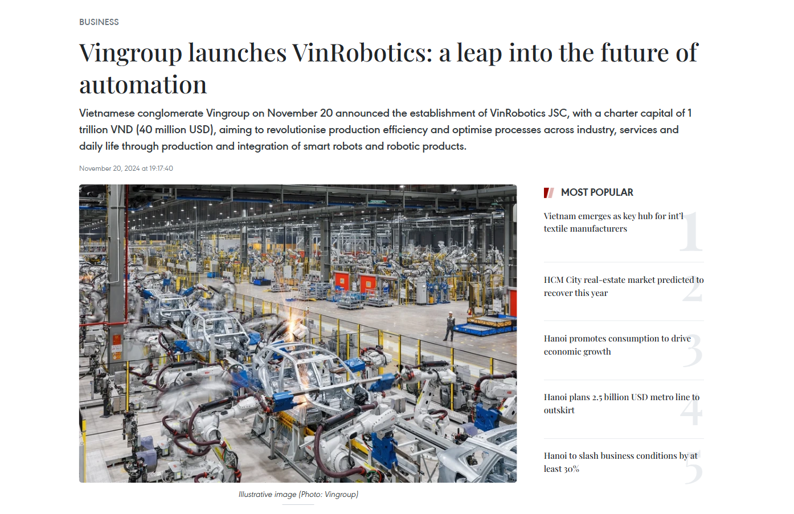

**Hanoi (VNA)** – Vietnamese conglomerate Vingroup on November 20 announced the establishment of VinRobotics JSC, with a charter capital of 1 trillion VND (40 million USD), aiming to revolutionise production efficiency and optimise processes across industry, services and daily life through production and integration of smart robots and robotic products.

According to a resolution recently approved by its Board of Directors, Vingroup holds a majority stake of 51% in VinRobotics. Pham Nhat Vuong contributes 39%, while his sons Pham Nhat Quan Anh and Pham Nhat Minh Hoang each own 5%. The position of General Director is held by Ngo Quoc Hung.

VinRobotics specialises in research, development and transfer of advanced technologies, particularly in automation, industrial robotics, and artificial intelligence (AI). Its goal is to become a leading entity in providing advanced smart products and hi-tech solutions, not just within the Vingroup ecosystem but also other businesses in key economic and industrial sectors across Vietnam and the broader region.

Vingroup is already a pioneer in Vietnam’s automotive industry with its flagship electric vehicle brand VinFast. The group has also made significant strides in AI and big data technologies through its brands VinBigdata, VinAI, and VinBrain.

## Blockchain & Web3

Blockchain technology is a super-secure digital ledger. Instead of the records being kept at one central location, they are kept in a chain of connected computers or nodes working together. Each block in the chain contains a list of transactions, and they're all linked with a unique code. Once a block is filled, it's sealed, and a new one starts.

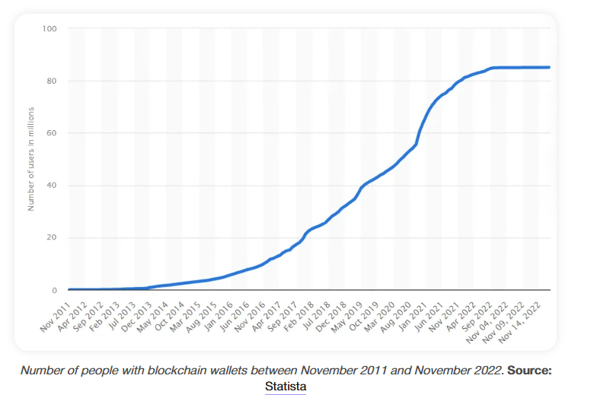

The internet is undergoing a significant evolution towards Web3, a decentralized iteration built upon blockchain technology 27. This new paradigm aims to shift power back to users by granting them ownership of their data and digital assets. Key enabling technologies include blockchain and cryptography, fostering transparency and security 3. Web3 is designed to facilitate direct interactions between users without the need for intermediaries, creating new transactional and ownership models that bridge the physical and virtual worlds 30. This fundamental shift in internet architecture and ownership necessitates a new set of skills and roles focused on building and managing decentralized systems.

The adoption of decentralized applications (dApps) is on the rise, with increasing activity in areas such as NFT collecting, decentralized finance (DeFi), and blockchain-based gaming 28. This growth is fueling a strong demand for professionals skilled in blockchain development, smart contracts, and related areas 37. The Web3 job market is currently experiencing a boom, with high demand for roles like Blockchain Developers and Smart Contract Developers, particularly those proficient in Solidity and Rust programming 37.

Several emerging IT roles are associated with Web3. Blockchain Developers are responsible for building the infrastructure for decentralized systems and developing dApps 37. Smart Contract Developers focus on writing and deploying smart contracts on platforms like Ethereum 37. Web3 Security Engineers are crucial for ensuring the security of smart contracts and decentralized systems, requiring expertise in cryptography and threat modeling 37. DeFi Specialists develop and manage decentralized financial products, needing skills in smart contract development and financial modeling 37. NFT Developers/Specialists work with non-fungible tokens, understanding their marketplaces and intellectual property rights 37. DAO Specialists focus on the development and governance of Decentralized Autonomous Organizations 28. Lastly, Web3 Product Managers oversee the development and launch of blockchain-based products, requiring a blend of technical and user-centric understanding 37. Security is a paramount concern in the Web3 space, given the financial sensitivity of many applications, leading to a particularly high demand for security-focused roles.

In the future, blockchain is going to change various sectors. One application is in [blockchain voting](https://www.f4p.ai/glossary/what-is-blockchain-voting) systems, where blockchain ensures secure, transparent, and tamper-resistant elections. It'll also help with things like tracking money, keeping medical records secure, and even making sure products are genuine. Imagine it like a super-powered digital notepad that everyone can see but no one can change.

However, there will also be challenges such as the need for making this technology work fast while many people are using it at once. Also, security issues may also appear since hackers might try to break in and steal information or mess with the records. According to [Glair](https://glair.ai/post/challenges-in-the-adoption-of-blockchain-and-how-to-solve-them), scalability issues, poor governance, and lack of compatibility are other problems blockchain may face.

## Quantum Computing

Quantum computing represents a significant paradigm shift in computational power, with ongoing advancements pointing towards transformative applications across various industries 3. Breakthroughs include processors with increasingly high qubit counts and enhanced qubit stability 15. The potential applications are vast, ranging from revolutionizing cryptography by both breaking current encryption standards and developing quantum-resistant methods, to accelerating drug discovery and materials science through molecular simulations 13. Quantum computing also holds promise for advancements in finance, logistics, and artificial intelligence 14. While general-purpose quantum computing is still considered experimental, annealing quantum computing is already demonstrating practical results in solving complex optimization problems 22.

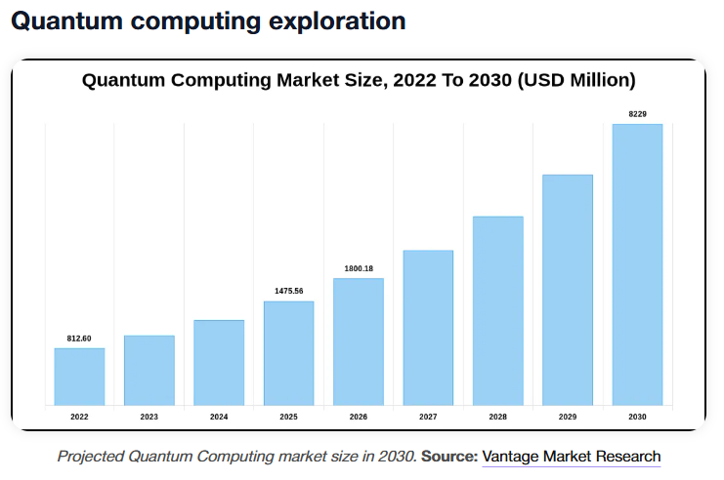

The demand for expertise in this nascent field is steadily growing. The role of Quantum Computing Engineer is identified as a top trending job for 2025, indicating an increasing recognition of the need for professionals with these skills 13. Notably, a significant skills gap exists in quantum computing, with the demand for qualified candidates currently exceeding the supply 23. This shortage is acknowledged by both governments and businesses, prompting investments in educational and training initiatives.

Given these advancements and the existing skills gap, several emerging IT roles in quantum computing are anticipated. Quantum Algorithm Developers will be crucial for designing and implementing quantum algorithms tailored to specific problem domains. Quantum Hardware Engineers will focus on the development, fabrication, and upkeep of quantum computing hardware. Quantum Software Engineers will build the necessary software tools and platforms to program and access quantum computers. Quantum Application Specialists will apply quantum computing to specific industries, such as finance (Quantum Finance Analyst) and healthcare (Quantum Drug Discovery Scientist). Quantum Cryptographers will be essential for developing and implementing quantum-resistant cryptographic algorithms. Finally, Quantum Computing Researchers will continue to advance the fundamental science and engineering of this transformative technology. The inherently interdisciplinary nature of quantum computing will necessitate professionals with backgrounds spanning physics, computer science, mathematics, and engineering, along with domain-specific knowledge for application-focused roles.

To explain it in the simplest of ways, quantum computing is like having a supercomputer on steroids. It can solve many complex problems at lightning speed, which regular computers can only dream of.

This technology is about to shake up everything we know about computing power. According to Vantage Market Research, the global quantum computing market is set to [skyrocket](https://www.vantagemarketresearch.com/industry-report/quantum-computing-market-2163).

Most of the data that computers around the world collect today is not analyzed – just because there is too much data. A quantum computer will be able to handle this problem. There will be a lot of opportunities: from optimizing pipeline systems to inventing new [drugs](https://www.drugdiscoverytrends.com/quantum-computing-drug-discovery/). This technology is only developing now and will be used for doing the things we now can’t even imagine.

Quantum computing, though still in its early stages, holds the potential to solve complex problems that are currently beyond the capabilities of classical computers.

Key points:

* Unprecedented processing power: Quantum computers will process information at speeds unattainable by classical computers, opening new possibilities for research and innovation.
* Complex problem solving: Industries such as healthcare, finance, and logistics will benefit from quantum computing’s ability to solve complex optimization and simulation problems.
* Investment in research: Continued investment in quantum computing research will accelerate its development and practical application in various fields.

## Cybersecurity & Data Privacy

As technology advances, the need for robust cybersecurity measures becomes increasingly critical. With the proliferation of connected devices and the increasing amount of data being generated, protecting sensitive information will be paramount. Future IT trends will focus on enhancing cybersecurity frameworks, implementing advanced encryption methods, and ensuring data privacy to safeguard individuals and organizations from cyber threats.

The landscape of cybersecurity is characterized by a continuous escalation of cyber threats, including malware, ransomware, social engineering attacks, and advanced persistent threats (APTs) 3. The financial implications of these threats are substantial, with global cybercrime damages projected to reach $10.5 trillion annually by 2025, underscoring the critical importance of robust cybersecurity measures and data protection strategies 75. Data breaches can result in significant financial losses, damage to reputation, and legal repercussions 80. Consequently, cybersecurity and data privacy will remain paramount concerns for organizations, driving a sustained demand for skilled professionals in these fields. The increasing sophistication of cyber threats necessitates proactive and adaptive security strategies.

Emerging technologies like artificial intelligence and quantum computing are significantly impacting the cybersecurity landscape 3. AI presents a dual-edged sword, enhancing the capabilities of cybercriminals while also providing powerful tools for threat detection, incident response, and proactive security measures 3. Quantum computing, with its potential to break current encryption methods, necessitates the development and implementation of quantum-resistant cryptography (post-quantum cryptography or PQC) 3. These technological advancements mean that IT professionals need to be proficient in leveraging AI for security purposes and prepared for the potential threats posed by quantum computing.

Several emerging IT roles are focused on addressing these evolving cybersecurity and data privacy challenges. AI-Powered Security Specialists develop and implement AI-driven systems for threat detection and response 13. Quantum Cryptographers research, develop, and implement quantum-resistant cryptographic algorithms 5. Data Privacy Officers (DPOs) / Data Privacy Specialists ensure compliance with data protection laws and regulations, safeguard sensitive information, and manage privacy risks 13. Threat Intelligence Analysts proactively identify and analyze emerging cyber threats and vulnerabilities. Security Automation Engineers automate security tasks and processes. Zero-Trust Architects design and implement security architectures based on the zero-trust model 19. Finally, Cybersecurity Incident Responders manage and mitigate the impact of security incidents and data breaches 80. The increasing complexity of the threat landscape and the evolving regulatory environment will lead to greater specialization within the cybersecurity and data privacy fields.

Cybersecurity and Data Privacy are growing concerns as more and more of our personal and business activities are conducted online. Cyberattacks are becoming increasingly sophisticated and can have serious consequences, including the theft of sensitive information and financial loss.

To address these threats, organizations must implement strong cybersecurity measures, including firewalls, encryption, and multi-factor verification.

Protecting the privacy of personal data is becoming increasingly important. Companies are collecting and storing large amounts of data about their customers. This has led to a greater emphasis on protecting valuable and sensitive information.

As cyber threats become more sophisticated, cybersecurity and data privacy will remain top priorities for businesses. Future trends will focus on advanced security measures and regulatory compliance.

Key points:

* Advanced threat detection: AI and ML will enhance threat detection and response, identifying and mitigating cyber threats in real-time.
* Data privacy regulations: Compliance with data privacy regulations, such as GDPR and CCPA, will be crucial as governments impose stricter controls on data handling.
* Zero Trust architecture: Implementing Zero Trust security models will ensure that all access requests are verified and authenticated, regardless of their origin.

## Cloud Computing & Edge Computing

Cloud computing means using the Internet to store data instead of your computer's hard drive. The technology can help you save money – you don’t need to buy and maintain lots of hardware anymore. For example, instead of having their own servers, a company can use cloud services like Amazon Web Services or Microsoft Azure. They only pay for what they use and don't have to worry about upgrading or fixing servers. It's also more efficient because they can easily scale up or down depending on their needs. However, sometimes there can be challenges like security issues or downtime if the internet goes down.

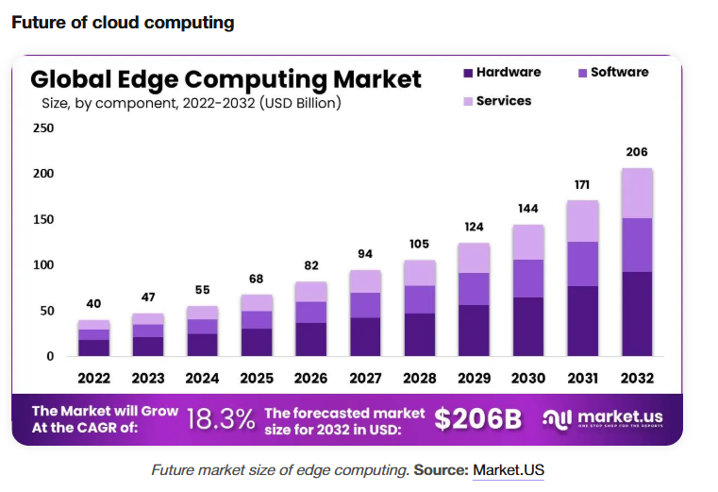

Cloud computing has already transformed the way businesses store, process, and access data. In the future, cloud computing will become more decentralized, with the rise of edge computing. Edge computing brings computing closer to the source of data generation, reducing latency and improving real-time processing capabilities. This will be particularly crucial in industries such as autonomous vehicles, healthcare, and smart cities.

Cloud Computing is another trend that is changing the way we use technology. It refers to the delivery of computing services that include servers, storage, databases, networking, software, and analytics over the internet.

Cloud computing allows companies to access powerful resources without investing in and managing their own equipment. This eliminates the need for them to maintain their own infrastructure.

This, in turn, makes it easier and more economical for organizations to store, manage, and analyze vast amounts of data.

The future of computing is moving swiftly towards the cloud, with 80% of businesses aiming to transition by 2025, according to Gartner. Hybrid cloud and edge computing lead this evolution.

With the growth of data and cybersecurity threats, end-to-end security solutions are becoming an important area of cloud technology development. The introduction of artificial intelligence (AI) and machine learning (MOD) for data analysis provides better detection and prevention of cyber attacks. In addition, data encryption and access control technologies are being developed to ensure reliable information protection.

Also, there is a growing interest in developing quantum computing resources and providing them in the form of cloud services. This opens up new perspectives for solving complex problems in the field of science, finance and research.

Cloud computing will continue to dominate the IT landscape, with hybrid cloud solutions offering the flexibility to leverage both public and private cloud environments.

Key points:

* Scalability and flexibility: Cloud computing will provide scalable resources that can be adjusted based on demand, ensuring optimal performance.
* Hybrid cloud adoption: Businesses will adopt hybrid cloud solutions to balance the benefits of public and private clouds, optimizing cost and control.
* Cloud-native applications: Developing cloud-native applications will enable businesses to fully exploit the benefits of cloud infrastructure, including improved resilience and scalability.

## Internet of Things (IoT) & Edge Computing

*“Edge computing is a fantastic complement to cloud computing for data that is best stored locally, accessed quickly, and analyzed with low latency.”*

*- Intel -*

Internet of Things (IoT) means that physical devises (such as refrigerators or lights) are connected to the internet, allowing users to control them remotely.

The IoT market has recently seen substantial growth. For people, IoT simplifies daily routine. For businesses, it helps track assets like delivery trucks and monitor machinery. The future of IoT looks promising, and it seems that soon we will see it in almost every area of our lives.

The Internet of Things (IoT) has connected millions of new devices to each other and the cloud. Now, thanks to the latest high-performance, low-power processors, analytics and AI are coming out of the cloud and directly to these endpoints. With the addition of edge computing, IoT has become truly intelligent.

For example, smart cameras equipped with vision processing units (VPUs) can analyze video feeds in real time to “see” what’s happening at a busy event venue, on a factory floor, or at a traffic intersection. An edge server in a retail store can perform advanced analytics on customer data while keeping it on location, complying with data locality requirements. Edge computing is a fantastic complement to cloud computing for data that is best stored locally, accessed quickly, and analyzed with low latency.

Intel offers a wide portfolio of edge computing technologies designed to support high-performance, cost-effective solutions. Our ecosystem of partners makes deployments more efficient with proven and prevalidated solutions designed especially for IoT.

In 2020, Intel put the best of our IoT technologies to work with a smart building blueprint for our design and development center in Petach Tikva, Israel. Our goal was to create a state-of-the-art office space that was user-friendly, operationally efficient, and cost efficient. The resulting blueprint includes systems for smart parking, smart lockers, smart lighting, and digital touch signs throughout the building to help with wayfinding, dining options, and more. When choosing technologies, we selected several Intel® IoT Market Ready Solutions (Intel® IMRS) designed for smart buildings and visual communications. With this model, we realized a lower CapEx through a single integration platform, consolidated cloud licensing through a single supplier, and better economics with off-the-shelf solutions.

Edge computing and IoT are transforming how data is processed and utilized, bringing computation closer to the data source and enabling real-time analytics.

Key points:

* Real-time processing: Edge computing allows for real-time data processing at the source, reducing latency and improving response times.
* IoT integration: The proliferation of IoT devices will generate vast amounts of data, which edge computing can analyze locally for faster insights and actions.
* Enhanced connectivity: IoT and edge computing will create more interconnected systems, improving automation and operational efficiency across industries.
* The Internet of Things has already transformed the way we interact with everyday objects. In the future, IoT will continue to expand, with billions of interconnected devices communicating and sharing data. This connectivity will lead to smarter homes, cities, and industries, optimizing resource utilization, improving safety, and creating more efficient systems.

## Augmented Reality (AR) and Virtual Reality (VR)

AR and VR technologies are set to revolutionize how we interact with digital content and our physical surroundings. From immersive gaming experiences to virtual meetings and training simulations, AR and VR will find applications in various sectors, including education, healthcare, and entertainment. As these technologies become more advanced and affordable, they will become mainstream, reshaping our daily lives.

Emerging technologies such as Virtual Reality and Augmented Reality are transforming our interactions with the environment. VR involves the creation of a simulated environment that can be experienced by users in a fully immersive way.

Augmented Reality (AR) is a technology that combines digital information with the physical world. This enables people to interact with virtual objects in a more natural manner.

These technologies are being used in a wide range of applications, from gaming and entertainment to education and training.

In the future, virtual reality (VR) and augmented reality (AR) could transform our world experience. They would let us interact with virtual environments and objects in novel and creative ways.

## 5G & Edge Computing

5G is the new mobile communication technology, improving data speeds with minimal delay and high security. It is transforming industries like healthcare and smart cities, making everything faster, smoother, and future-ready. For example, 5G enables quick and secure medical data sharing for remote surgeries and telemedicine in healthcare. For smart cities, it enhances connectivity for efficient traffic management, smart utilities, and real-time data exchange, making urban living more sustainable and responsive.

Before, we had 1G with analog phones. Then came 2G, bringing text messages and more efficiency. 3G came later, giving us faster Internet on mobiles. 4G made things even speedier and more reliable, paving the way for remarkable technologies like IoT. Now, 5G is the star, super-fast at 10Gbps, low delay (significant for businesses as things can be done without delays), super secure, and able to handle many devices. It is very prominent in industries like virtual reality, healthcare, and smart cities. It is just like upgrading from a bicycle to a supersonic jet – that's how 5G has changed the game, making everything faster, smoother, and ready for the future.

A new era of innovation and convenience is expected to begin with the introduction of 5G technology, which represents a revolutionary leap in connectivity. With speeds up to 100 times faster than its predecessor, 5G is ready to open a world of opportunities and enable game-changing services and applications. Real-time communication between autonomous vehicles will make them safer and more efficient, while smart cities will use data-driven insights to improve efficiency, security, and sustainability. As 5G enables continuous connectivity and real-time response, it has an impact on a variety of industries, including healthcare, manufacturing, and entertainment. This lays the groundwork for a future that is more connected and technologically advanced.

5G and Edge Computing are two trends that are set to transform the way we use the internet. 5G is the fifth generation of mobile networks and promises to deliver faster and more reliable internet connectivity.

Edge computing refers to the processing of data closer to the source of the data, rather than in a centralized location. This reduces latency and improves the performance of applications and services.

5G and edge computing are enabling the development of new technologies, such as autonomous vehicles and augmented reality. They are also making it possible to connect more devices and sensors to the internet.

This is a major advancement compared to what was previously possible.

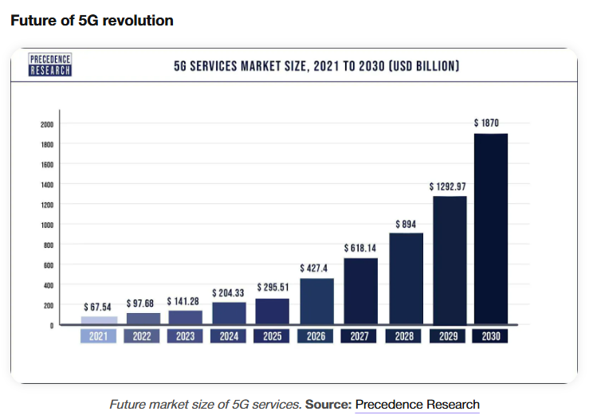

5G is going to be used in various areas. For example, it is going to enable quick and secure medical data sharing for remote surgeries and telemedicine in healthcare. It will also enhance connectivity for efficient traffic management and smart utilities in smart cities. Cloud Gaming will utilise 5G's ultra-low latency and high speeds. There will be no need for expensive computers; people can stream games on low-end devices via high-speed internet.

In the industrial sector, 5G could unlock possibilities in [blockchain voting](https://www.f4p.ai/glossary/what-is-blockchain-voting), remote diagnostics, and surgery. According to [STL Tech](https://stl.tech/blog/5g-stats-and-its-use-cases/), physical stores might become obsolete and could be replaced by online purchases delivered via drones. While the future with 5G holds promises, potential challenges include the need for robust infrastructure and addressing privacy and security concerns.

## Semiconductor

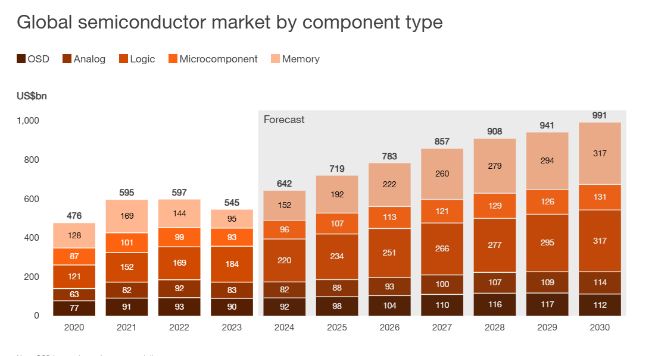

After overcoming supply chain disruptions caused by the covid-19 pandemic, and weathering a downturn in 2023, the semiconductor industry is on track for robust long-term growth, according to PwC’s State of the Semiconductor Industry report. Driven in part by AI and IOT technologies, automotive applications such as autonomous vehicles, and a massive demand for real-time data processing, the global semiconductor market is forecast to exceed US$1 trillion by the end of the decade.

Players in the chip industry have made strides in securing so-called supply-chain sovereignty, partly by investing in local production, but the semiconductor ecosystem as a whole remains a global one, with ongoing dependence on transnational supply and distribution networks. In an era of escalating trade tensions and regional conflict, tech companies seeking to seize this growth opportunity will need to take concrete steps to build resilience against geopolitical risks. The PwC report suggests starting with four moves:

**Diversify manufacturing and sourcing**. Leading players are adopting multi-fab and multi-sourcing strategies to minimise operational and supply chain disruptions. By diversifying their production sites and suppliers, companies can eliminate choke points and reduce the risk that geopolitical events will affect their operations.

**Develop an enhanced risk outlook**. Insulating against geopolitical uncertainty starts with clearly identifying, assessing and mitigating the risks to which semiconductor components—including modules and subcomponents—are exposed throughout their life cycle. But assessment and mitigation are only as effective as the criteria on which such actions are based. Make sure your organisation’s risk outlook is far-reaching, encompassing export restrictions, imminent regulatory shifts, and political and societal instability in countries where the company operates or intends to.

**Respond nimbly to product-localisation pressures.** Moves by governments to fully or partially localise chip production present a special challenge. Though some companies may be able to meet that challenge reactively, by adjusting their products only when necessary, other companies will need to develop a proactive strategy. That can include regionally differentiated products or using drop-in replacements for individual semiconductors to meet local requirements.

**Strengthen the talent pipeline.** Localisation pressures aren’t just a production issue. According to a [**recent studyOpens in a new window**](https://www.strategyand.pwc.com/de/en/industries/telecommunication-media-and-technology/bridging-the-talent-gap.html) by Strategy&, PwC’s global strategy consultancy, Europe’s semiconductor sector alone will need around 350,000 more professionals by 2030 to achieve the regional target set by the European Union of a 20% global market share. In the EU and beyond, players in the industry are going to have to build significant talent resources to meet soaring local demand spurred by such pressures. Doing so will require a robust talent pipeline tailored to highly specific skills and competencies.

Meaningful action in these four areas will be essential for companies in the semiconductor industry to innovate, compete and thrive.

## Biotechnology

*‘We will have life-changing, game-changing drugs ... getting to the right patient at the right time’*

*- Mckinsey –*

Many diseases today don’t have a cure. One reason is that drug discovery is difficult: finding and developing an effective medicine is a yearslong and very expensive process. But maybe it doesn’t have to be. Experts say AI—if properly integrated into scientists’ research—could revolutionize drug discovery, making it possible for more patients to get the treatments they need.

AI will be embedded into everyday research

The AI-driven drug discovery industry continues to grow, fueled by new entrants in the market, significant capital investment, and technology maturation. We’ve identified more than 250 companies working in the industry. More than half of them are based in the United States, but key hubs are emerging in Western Europe and Southeast Asia as well. The best of these companies will fully integrate AI into research workflows, as the exhibit shows. By putting AI at the center of the research engine, companies can transform research at scale—and bring about dramatic improvements in patient outcomes.

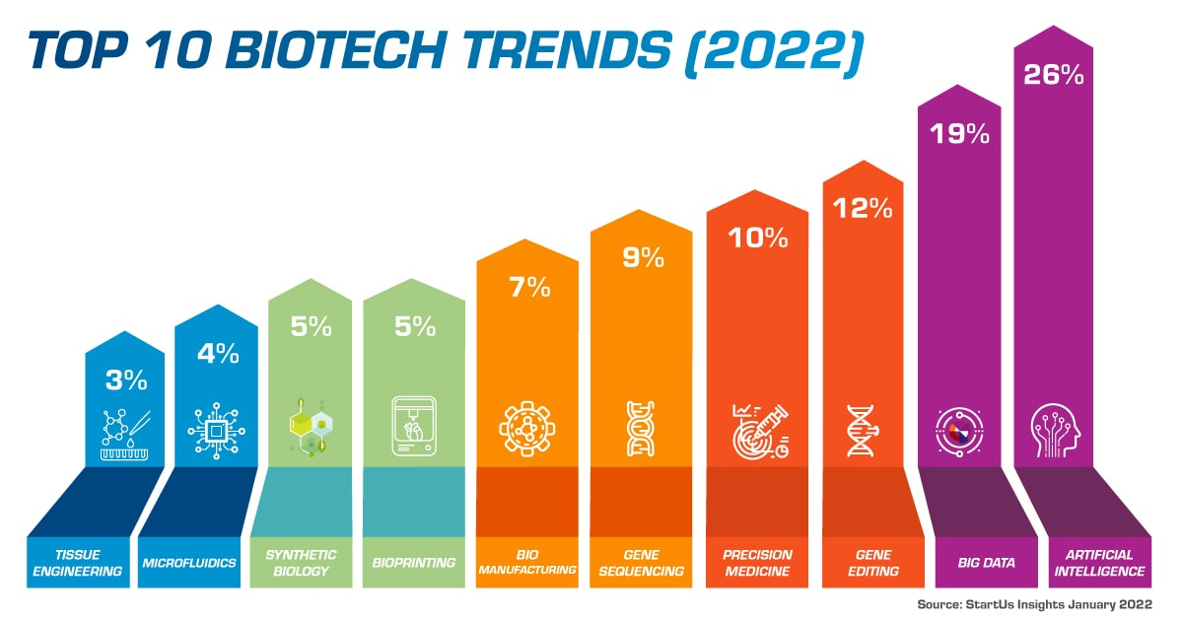

## Digital Transformation

HÀ NỘI —Entering 2025, Việt Nam is gearing up to accomplish important goals in its digital transformation journey for economic development.

At the third meeting of the National Committee for Digital Transformation, Prime Minister Phạm Minh Chính described digital transformation as an inevitable trend and an objective requirement to keep pace with developed nations, and a top priority for rapid and sustainable development.

The Government, along with various ministries and agencies, has focused on building a legal framework and policies to improve the digital landscape. Key documents include the master plan on information and communication infrastructure, the national data strategy, the semiconductor industry development strategy, human resources development for the semiconductor industry, and the framework for Việt Nam’s digital infrastructure.

In 2024, Việt Nam made remarkable strides with the rapid launch of the national population database, ensuring seamless data connection across eighteen ministries and sixty-three localities. This facilitated over 1.3 billion queries and more than 537 million data synchronisation actions by September 2024. Additionally, over twenty million electronic ID cards were issued, eight million accounts were registered for accessing the online public service portal, and more than fourteen million citizen records were integrated into the electronic health book.

According to the United Nations' e-government survey released in September 2024, Việt Nam climbed to 71th place out of 193 countries and territories, up 15 places compared to 2022. This achievement underscored Việt Nam's success in meeting its e-government goals for 2024.

As of October, over 82.4 per cent of households were using fiber optic internet, up 3.3 per cent year on year, surpassing the 80 per cent target set for 2025. Additionally, more than 87 per cent of the population used smartphones.

A major milestone in 2024 was the launch of the largest and most modern data centre by telecom provider Viettel Group. This high-security data centre, equipped with advanced technology, will be crucial in safeguarding national data sovereignty and personal data in Việt Nam.

Parallel to these development steps, Vietnamese technology companies are investing heavily in mastering key technologies of the digital age, including semiconductors, artificial intelligence (AI), and 5G chipsets.

By the end of 2024, Việt Nam's achievements in digital transformation across the pillars of digital government, digital economy, and digital society laid a solid foundation for the country's ongoing digital journey, as outlined in the 13th National Party Congress’s Resolution. — VNS

AI and the Future of Work

If you are wondering about how will artificial intelligence change the future, then do know that robots are probably not coming for your employment, at least not yet, so you can put some of your worries to rest?

Given how artificial intelligence has been presented in the media, particularly in some of our favorite science fiction films, it is obvious that the development of this technology has raised concerns about the possibility that humans could one day become redundant in the workplace. After all, many jobs formerly carried out by human hands have been mechanized as technology has improved. It makes sense to worry that the development of clever computers may spell the beginning of the end for employment as we know it. But don’t! Jobs will still be out there for you all. That’s the basic answer to what is the future of AI.

Be a Part of Future of AI

Yes, that's right! If you wish to be a part of AI in the furute, now is the time to enroll in our top-performing programs, and land yourself your dream job. Explore our comprehensive comparison of our top AI programs to make an informed decision that propels your career forward in the exciting field of Artificial Intelligence. Discover the details, features, and benefits of each program, and find the perfect fit that aligns with your goals and aspirations.

Finally, digital transformation is the most important trend that is shaping the future of Information Technology (IT) in several ways.

Digital transformation is driving the development of new technologies and products. These changes are impacting how we live and work.

Advances in artificial intelligence, the Internet of Things (IoT), and cloud computing are creating opportunities for businesses. They can automate processes, gather and analyze data in real-time, and deliver new products and services to customers. These possibilities were discussed earlier.

Digital transformation is improving efficiency and reducing costs for businesses. By automating manual processes and leveraging data-driven insights, organizations can streamline operations and make more informed decisions.

Improved operational efficiency and reduced costs lead to benefits for customers. These include lower prices and higher quality products and services.

Digital transformation is transforming the customer experience. By leveraging digital technologies, organizations can offer personalized and engaging experiences that meet the changing needs of their customers.

Companies can offer new and innovative products and services and also provide customers with convenient ways to interact with them. This ensures a seamless experience.

Finally, digital transformation is also having a significant impact on the workforce. The integration of digital technologies into the workplace is creating new job opportunities and changing the skill set required of employees.

Organizations must invest in training and development to equip their workforce with the skills necessary to succeed in the digital age. This investment will ensure their success.

Businesses are increasingly turning to digital transformation. This trend will have a significant impact on the future of IT, and on our lives and work.

# CONCLUSION

1. **The future of IT**

The IT industry or particularly AI will never stop and keep evoluting day by day. This is not just happening to AI but all sub field of it, such as AI, machine learning, deep learning, Generative AI, Quantum computing and so on,

After doing my own research about the future of IT. I realize there’s a lot of things out there I do not know or perhap even acknowledge. The field itself is continually evolving at a rapid race, I just wonder how can we evaluate the market growth rate at real time and choose for ourself the best option to move and pursue.

I also thanks to this “English for IT course” that help me do this research I couldn’t do it myself if it was not a requirement to pass the final test.

And I also aware of living in this era of AI was a bless for me, It helps me a lot in my learning journey, Especially having access to one of the biggest global research statistic ever, How could this be real if I was in back 10 years ago.

Doing this research get me the overview of the market size, realzing how small I’m.

Last but not least, keep positive mind, and evolve with the era of AI.

# REFERENCES

|  |  |
| --- | --- |
| [1] | https://www.mckinsey.com/featured-insights/mckinsey-explainers/whats-the-future-of-ai |
| [2] | https://www.linkedin.com/pulse/future-services-trends-watch-2025-htic-global-lukae/ |
| [3] | https://www.intel.com/content/www/us/en/business/resources/future-of-it.html |
| [4] | https://www.techtarget.com/searchenterpriseai/tip/The-future-of-AI-What-to-expect-in-the-next-5-years |
| [5] | https://www.simplilearn.com/future-of-artificial-intelligence-article |
| [6] | https://builtin.com/artificial-intelligence/artificial-intelligence-future |
| [7] | https://globalbusinessoutlook.com/magazine/technology-magazine/the-future-of-google-search/ |
| [8] | https://medium.com/@burchcourtney505/the-future-of-information-technology-trends-and-predictions-59f29133f39d |
| [9] | https://medium.com/@amitaknkpt/the-future-of-it-roles-an-in-depth-analysis-of-emerging-trends-8aac1af564a9 |
| [10] | https://www.ibm.com/think/insights/artificial-intelligence-future |
| [11] | https://www.jt1.vn/single-post/future-of-work-in-vietnam-it-industry-navigating-the-rising-demand-for-it-talent |
| [12] | https://www.cyncly.com/fr/blog/the-future-of-it/ |
| [13] | https://kpmg.com/xx/en/what-we-do/services/advisory/consulting/technology-consulting/the-future-of-it.html |
| [14] | https://solowise.com/blog/future-of-it |
| [15] | https://www.newmanbs.co.uk/what-is-the-future-of-it-services-and-how-will-it-evolve/ |
| [16] | https://www.lucentinnovation.com/blogs/it-insights/10-predictions-for-the-future-of-it-industry |
| [17] | https://cobait.com/blogs/future-of-information-technology |
| [18] | https://www.quora.com/What-is-the-future-of-IT-technology |