ASSIGNMENT 2

TASK 1 :- Make 5 partitions in your pendrive.
STEPS :- # sudo mount ( check the mounted device)
# sudo fdisk -l (to identify my device)
# sudo fdisk /dev/sdb (to make partitions)
First partition – n -> p -> 1 -> enter -> +10M (sdb1)
Second partition - n -> p -> 2 -> enter -> +10M (sdb2)
Third partition - n -> p -> 3 -> enter -> +10M (sdb3)
Extended part - n -> e -> enter -> +7G (sdb4)
Fourth partition - n -> enter -> +50M (sdb5)
Fifth partition - n -> enter -> +50M (sdb6)
w -> (saves the partition on disk)
# partprobe (save to the kernel)

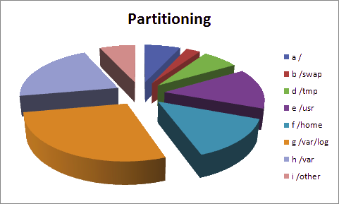

TASK 2 :- Mount those partition.
STEPS :- # cd /
# sudo mkdir mnt1 mnt2 mnt3 mnt4 mnt5 (made the mount points)
# sudo mkfs.ext4 /dev/sdb1 (giving file system to 1st partition)
# sudo mkfs.ext4 /dev/sdb2 (giving file system to 2ndpartition)
# sudo mkfs.ext4 /dev/sdb3 (giving file system to 3rdpartition)
# sudo mkfs.ext4 /dev/sdb5 (giving file system to 4thpartition)
# sudo mkfs.ext4 /dev/sdb6 (giving file system to 5thpartition)
# sudo mount /dev/sdb1 /mnt1
# sudo mount /dev/sdb2 /mnt2
# sudo mount /dev/sdb3 /mnt3
# sudo mount /dev/sdb5 /mnt4
# sudo mount /dev/sdb6 /mnt5

TASK 3 :- Validate the same by making files in the above and unmount the same and check if you still see the contents.
Steps :- # cd /mnt1
# sudo touch test1
# cd /mnt2
# sudo touch test2
# cd /mnt3
# touch test3
# cd /mnt4
# touch test5
# cd /mnt5
# touch test6
# sudo umount /dev/sdb1
# sudo umount /dev/sdb2
# sudo umount /dev/sdb3
# sudo umount /dev/sdb5
# sudo umount /dev/sdb6

TASK 4 :- Delete all the partitions and make a single partition.
Steps :- First delete all partitions properly.
# sudo fdisk /dev/
First partition -> d -> 1
Second partition -> d -> 2
Third partition -> d -> 3
Extended partition -> d -> 4
Fourth partition -> d -> 5
Fifth partition -> d -> 6
Save changes -> w
# sudo parted -a opt /dev/sdb mkpart primary ext4 0% 100%
(Created a single partition with whole disk space)

TASK 5 :- Make it a lvm partition -> physical vol -> vol_grp - > logical_vol1.
Steps :- # sudo lvmdiskscan (scans free disk for lvm partition)
# sudo pvcreate /dev/sdb (physical vol created)
# sudo pvscan (scans and shows the physical_vol)

output :-
PV /dev/sdb lvm2 [7.23 GiB]
Total: 1 [7.23 GiB] / in use: 0 [0 ] / in no VG: 1 [7.23 GiB]

# sudo vgcreate vol_grp /dev/sdb
# sudo vgdisplay

output:-
--- Volume group ---
VG Name vol_grp
System ID
Format lvm2
Metadata Areas 1
Metadata Sequence No 1
VG Access read/write
VG Status resizable
MAX LV 0
Cur LV 0
Open LV 0
Max PV 0
Cur PV 1
Act PV 1
VG Size 7.23 GiB
PE Size 4.00 MiB
Total PE 1850
Alloc PE / Size 0 / 0
Free PE / Size 1850 / 7.23 GiB
VG UUID KfqNo2-vlQ6-6bQ4-0UpP-72Pv-LjaY-UooGX2

# sudo lvcreate -l 256 -n logical_vol1 vol_grp
(logical_vol1 created by giving the value in form of extent 256 extent=1gb)
# sudo lvdisplay
output:-
--- Logical volume ---
LV Path /dev/vol_grp/logical_vol1
LV Name logical_vol1
VG Name vol_grp
LV UUID NCDTob-ssYC-0vo7-yOKv-ni9r-Aotf-a88oWg
LV Write Access read/write
LV Creation host, time dell-Inspiron-3542, 2018-05-22 16:23:44 +0530
LV Status available
# open 0
LV Size 1.00 GiB
Current LE 256
Segments 1
Allocation inherit
Read ahead sectors auto
- currently set to 256
Block device 253:0

TASK 6 :- Extend the size to 1.5G and then reduce it to 500M.
Steps :- # sudo lvextend -l384 /dev/vol_grp/logical_vol1
(we did it by giving 384 extent but we could also given +128 extent)
# sudo lvdisplay
output:-
--- Logical volume ---
LV Path /dev/vol_grp/logical_vol1
LV Name logical_vol1
VG Name vol_grp
LV UUID NCDTob-ssYC-0vo7-yOKv-ni9r-Aotf-a88oWg
LV Write Access read/write
LV Creation host, time dell-Inspiron-3542, 2018-05-22 16:23:44 +0530
LV Status available
# open 0
LV Size 1.50 GiB
Current LE 384
Segments 1
Allocation inherit
Read ahead sectors auto
- currently set to 256
Block device 253:0
# sudo lvreduce -L 500M /dev/vol_grp/logical_vol1
# sudo lvdisplay

output:-
--- Logical volume ---
LV Path /dev/vol_grp/logical_vol1
LV Name logical_vol1
VG Name vol_grp
LV UUID NCDTob-ssYC-0vo7-yOKv-ni9r-Aotf-a88oWg
LV Write Access read/write
LV Creation host, time dell-Inspiron-3542, 2018-05-22 16:23:44 +0530
LV Status available
# open 0
LV Size 500.00 MiB
Current LE 125
Segments 1
Allocation inherit
Read ahead sectors auto
- currently set to 256
Block device 253:0

# sudo resize2fs

TASK 7 :- LVM.
Theory :-

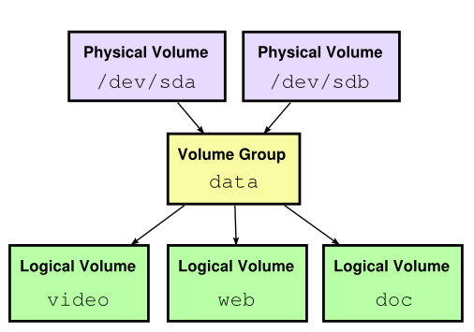

1. For adding a new PV we have to use fdisk to create the LVM partition.
=> To Create new partition Press n.
- Choose primary partition use p.
- Choose which number of partition to be selected to create the primary partition.
- Press 1 if any other disk available.
- Change the type using t.
- Type 8e to change the partition type to Linux LVM.
- Use p to print the create partition ( here we have not used the option).
- Press w to write the changes.
Restart the system once completed.
2. Ways to create the logical volumes.
=> We can create a logical volume either by giving the size directly or also with the help of extent. 1 extent = 4 MiB.
256 extent = 1024 GiB
3. What is LVM? Why we need it?
=> LVM is used for the following purposes:
- Creating single logical volumes of multiple physical volumes or entire hard disks, allowing for dynamic volume resizing.
- Managing large hard disk farms by allowing disks to be added and replaced without downtime or service disruption.
- On small systems (like a desktop), instead of having to estimate at installation time how big a partition might need to be, LVM allows filesystems to be easily resized as needed.
- Performing consistent backups by taking snapshots of the logical volumes.
- Encrypting multiple physical partitions with one password.
LVM can be considered as a thin software layer on top of the hard disks and partitions, which creates an abstraction of continuity and ease-of-use for managing hard drive replacement, repartitioning and backup.

TASK 7 :- Shell tasks given by RAJAT_VATS.
1. #!/bin/bash
char=”2”
#abc=echo -n $char|wc -c
if [$char -gt “9” ] && [$char -it “100”]
then
echo “double digit”
else
if [ $char -it “10” ]
then
echo “its single digit”
else
echo “invalid code”
fi

