Survey: Natural Language Processing Techniques

Loveena Stephen
Department of Computer Science
Lakehead University
ON, Canada
lstephe1@lakeheadu.ca

Abstract—This paper introduces the field of Natural Language Processing and the broad categories the various Natural Language Processing Techniques are classified into. In the second section, it explains four of these techniques, namely Pattern Matching, Syntactically Driven Parsing, Semantic Grammar and Case-Frame Instantiation. The third section attempts to draw a comparison between the fur afore-mentioned techniques. The fourth and final section concludes with the author's opinion on which of these techniques produces best results.
Keywords—natural language processing; techniques; pattern matching; syntactically driven parsing; semantic grammar; case-frame instantiation.

Introduction
Natural Language Processing (NLP) is the area of Artificial Intelligence that deals with making human languages understandable to a machine, enabling the machine to grasp information, analyze and respond to it in a way that is appropriate and acceptable by human standards. The research in NLP mainly focuses on understanding how human beings understand and use language to communicate so that similar approaches can be developed to make machines process human languages and be able to communicate with human beings and act accordingly. NLP is a cross-disciplinary field that overlaps Computer Science, Linguistics and Psychology to name a few.
Although NLP is a term generally used for the analysis of natural languages, an effort to make a machine understand natural language; it also, implicitly, includes the synthesis of natural languages i.e. a machine being able to respond back in a linguistic language. So NLP can be split into two sub-divisions: Natural Language Understanding and Natural Language Generation. Most research till date has focused on the analysis of languages. A few reasons have been recorded to this effect. One being natural language generation is easier than analysis and hence not an important area of focus. Another one is, it is difficult to build theories around the processing of an input that is left to imagination or the random choice of an entity like a machine.
In this paper, we will try to understand and compare 4 common approaches to Natural Language Analysis: Pattern Matching, Syntactically Driven Parsing, Semantic Grammars, Case Frame Instantiation.

Techniques in natural language processing
The research on Natural Language Analysis Techniques has been extensive. Some classify the techniques as classical (aka symbolic or rationalist) and empirical(aka statistic) approaches. Symbolic approach is based on a pre-written set of rules that attempts to emulate different language phenomena which is then used by the machine to interpret and understand a language. A statistical approach uses machine learning algorithms to learn the language from training data and build rules itself which it later uses to interpret new text. Some others classify them based on techniques oriented around processing of syntax, semantics or pragmatics. In light of that approach, the syntax oriented approaches are the oldest and most common, followed by the emerging approaches that are semantics oriented. However, a considerable research still needs to be done in the area of techniques based on pragmatics.

Pattern Matching
Pattern Matching is probably the simplest technique. In simple words, it is a list of rules that relate a pattern of word(s) to and interpretation. Hence it does not rely on understanding the most basic component and building up an interpretation by combining lower level units but rather takes the input as a whole and maps it directly to an interpretation. Some more

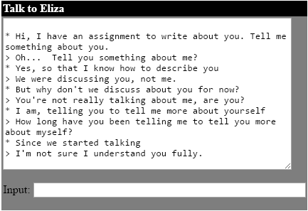
Dialogues with * is human and > is Eliza
Courtesy: http://psych.fullerton.edu/mbirnbaum/psych101/Eliza.htm

Fig. 1 Real-Time Conversation with Eliza

complex versions of this technique might take into consideration semantic elements therefore becoming a little more constructive. But the underlying idea still is to map a pattern to a corresponding interpretation there by enabling a basic and simple understanding.
One of the first systems to use pattern matching technique for NLP is ELIZA by Wizenbaum (Fig.1). The overall idea behind the working of the system is quite simple: the input is read and scanned for a keyword. When a pattern (i.e. keyword) match is found, it will go to that corresponding rule and respond with one of the interpretations attached to that pattern. Fig. 2 illustrates an example.

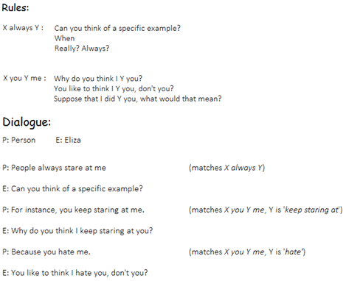

Fig. 2 Working of Eliza

The system does include a ranking of keywords to resolve conflict between multiple pattern matches in the same input. The ranking takes precedence over the order of appearance of keywords while reading from left to right. Also, the system considers a comma as a delimiter. Consequently, if a keyword has already been found before a comma, everything after the comma is discarded. And if a keyword is only found after the comma, the words before the comma are discarded. Thus, only single sentences or phrases are processed.
The advantage of this method is clearly its simplicity. The side-effect of this advantage is that not all responses from Eliza make contextual sense. Continued conversation makes it clear that the responses are scripted. Also, an attempt to make the responses more meaningful and original leads to an extremely large database of patterns without proportional increase in efficiency.

B. Syntactically Driven Parsing
As the name suggests, this method focuses on deriving interpretations based on the syntax of a language. It aims to first build a complete syntactic analysis of an input and then use it to create an internal representation which can be easily understood by a machine. Unlike pattern matching, syntactic parsing technique is a constructive approach. It is the opposite of pattern matching. While pattern matching interprets the input as a whole, syntactic parsing splits it into lower level constituents to build and interpretation from these constituents.
The simplest form of syntactic analysis is to build a parse tree using context-free grammar (CFG). Fig _ shows the parse tree for the sentence "The dog eats the bone." It splits the sentence into a noun phrase and a verb phrase. The noun phrase is split into the determiner (the) and the noun (dog) while the verb phrase is split into the verb (eats) and another noun phrase which is further split into the determiner (the) and noun (bone).

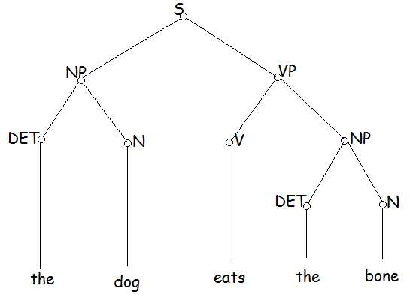

Fig. 3 A parse tree for "the dog eats the bone"

Syntactic analysis is done by applying a grammar rules for a language to determine the validity of the constructed sentences. The simplest grammar is the Context-Free Grammar (CFG). The CFG rules for the above parse tree can be as shown in Fig. 4.

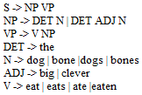

Fig. 4 Context Free Grammar Example

As the examples illustrates, CFG's are very easy to define. However, they have some serious issues that come with this simplicity. The grammar does not effectively handle the differentiation between singular and plural and also if inefficient with passive sentences. While the above grammar rules perfectly form a sentence like "the dog eats the bone" or "the dogs ate the bone", it could also result in grammatically wrong sentences such as "the dogs eats the bone" or even absurd sentences such as "the dogs eaten the clever bones" or even "the bone ate the dog"!
To handle these issues, two techniques, namely Transformational Grammar and Augmented Transition Network were developed.
Transformational Grammar: Consider the sentences "John wrote a poem on the spring season" and "A poem on the spring season was written by John". Naom Chomsky proposed that these sentences originate from a deeper and more abstract structure that was a true representation of the semantics of the sentence even though they differ on the surface structure i.e word order. verb form, etc. The basic idea is to use the CFG to generate a parse tree but add onto it specific tags to differentiate similar but slightly different forms like plural or passive sentences. These tags are then used to transform the parse tree so that the pluralness was transmitted to every part of the tree and the required syntax checks could be enforced. Transformations were nothing but a context-sensitive grammar that mapped a parse tree to a related parse tree.
Transformational grammar was more effective in dealing with natural language than simple CFG but, in comparison, fared poorly as far as computational effectiveness is concerned. As mentioned above, it is a generative model i.e. it is good at generating a sentence from a starting symbol 'S'. However, running the model backwards to analyze a complete sentence to find interpretation was a difficult task. This was because the transformations were done on the trees and not on the string of words itself and therefore are highly non-deterministic when applied backwards.
Augmented Transition Networks: In an attempt to develop further on Transformational Grammar, a method to represent syntactic grammar in a computationally tractable way that was most times more efficient in producing better understand of natural language than transformational grammar was created called Augmented Transition Network. It build on the idea of using Finite State Machines to parse sentences. But instead of building an automaton, a collection of transition graphs are built. A grammatically correct sentence is parsed if the final state is reached at the end of the sentence.

conclusion
Over the years of research, natural language processing techniques have undergone tremendous development. This paper was written in an attempt to pick two of the most basic techniques and draw a comparison. The paper briefly explains pattern matching and syntactic driven parsing. A thorough understanding of these techniques is a task that could spread over months of literature review. In the short while spent in learning these techniques, it can be concluded that the computational overhead incurred in syntactic driven parsing techniques is worth the cost. It produces efficient results in interpreting and producing a more accurate understanding of natural languages than does pattern matching technique.
There might be other methods that have been developed in more recent times that have improved on the techniques explained in this paper. And it still is a field with considerable room for progress and optimization. Further information on the concepts explained in this paper can be obtained by following the references mentioned in the next section.

References
- Chowdhury, G. 2003. Natural Language Processing, University of Strathclyde. Annual Review of Information Science and Technology, Chapter 2.
- Indurkhya, N and Damerau, F. J. 2010. Handbook of Natural Language Processing, Machine Learning and Pattern Recognition Series.
- Cambria, E. and White, B. 2014. Jumping NLP Curves: A Review of Natural Language Processing Research. IEEE Computational Intelligence Magazine, May 2014.
- Hayes, P. J. and Carbonell, J. G. 1983. A Tutorial on Techniques and Applications for Natural Language Processing. Carnegie Mellon University.
- Weizenbaum, J. January 1966. ELIZA--A Computer Program For the Study of Natural Language Communication Between Man and Machine. Communications of the ACM, Volume 9, Number 1, Pg 36-45.
- Woods, W. A. December 1969. Augmented Transition Networks for Natural Language Analysis. Harvard University.

