





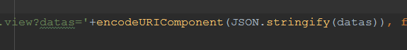





设置编码规则:

Map<String, String> params = new HashMap<>();  
hlsCusAcrInvoiceHd.setDocumentNumber(fndCodingRuleValuesService.getCodeRuleValue(request, hlsCusAcrInvoiceHd.getDocumentCategory(), hlsCusAcrInvoiceHd.getDocumentType(), hlsCusAcrInvoiceHd.getBusinessType(), params));

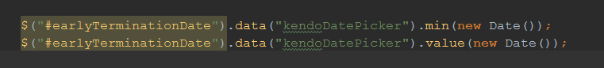

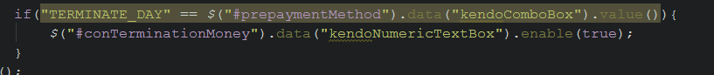

**if**(!Hls.requireInputValidate()){  
 Hls.showErrorMessage("请将必填项填写完整");  
 **return** ;  
}